Electronic Supplementary Material 2 (ESM_2)
Fig. 1 The binding mode of adenosine with α-glucosidase protein. (A) Predicted 3D diagram of adenosine with α-glucosidase complex. (B) The 2D binding mode of adenosine with α-glucosidase protein. (C) The detail binding mode of adenosine with α-glucosidase protein.
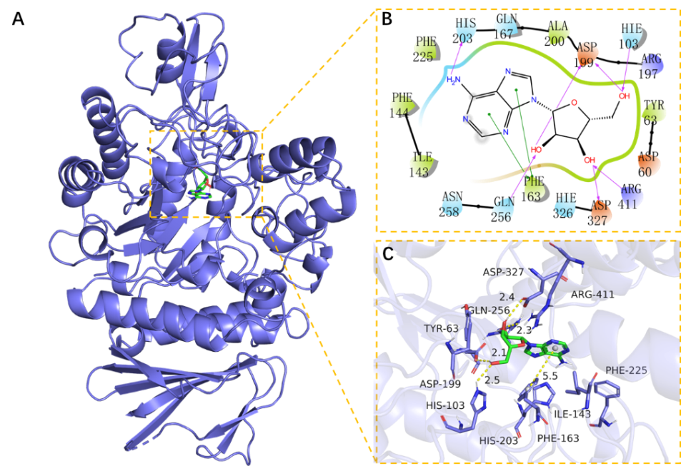

Fig. 2 The binding mode of ergosterol-5,8-peroxide with CASP3 protein. (A) Predicted 3D diagram of ergosterol-5,8-peroxide with CASP3 protein complex. (B) The 2D binding mode of ergosterol-5,8-peroxide with CASP3 protein. (C) The detail binding mode of ergosterol-5,8-peroxide with CASP3 protein.

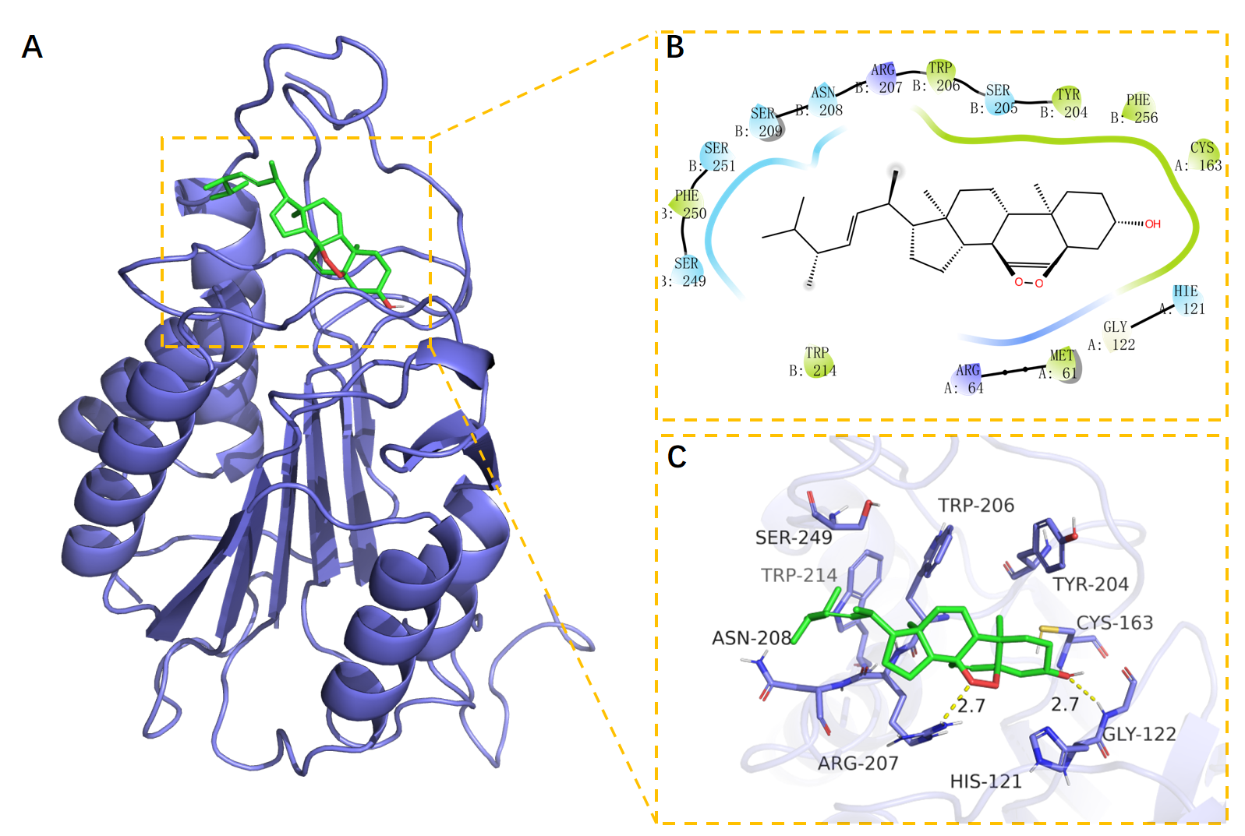

Fig. 3 The binding mode of ergosterol with VP1 protein. (A) Predicted 3D diagram of ergosterol with VP1 complex. (B) The 2D binding mode of ergosterol with VP1 protein. (C) The detail binding mode of ergosterol with VP1 protein.
