Anti-α-glucosidase, anti-proliferative and anti-enterovirus 71 activity of secondary metabolites identified from Grifola frondosa
Junqiang He ª · Wenyu Xiong ª · Lina Zhao ^{a,b} · Bin Liu ^{a,b,**} · Ying Huang ^{a,*}

Electronic Supplementary Material 2 (ESM_2)

Results and discussion
Structure identification of the purified compounds
Compound 1 was obtained as white powder; ESI-MS m/z: 397 [M + H]⁺; C₂₈H₄₄O; ¹H-NMR (CDCl₃-d, 400 MHz) δH: 3.63 (1H, tt, J = 4.4, 11.2 Hz), 2.46 (1H, ddd, J = 2.4, 4.8, 14.4 Hz), 5.56 (1H, dd, J = 2.4, 5.6 Hz), 0.62(3H, s), 0.94 (3H, s), 1.03 (1H, d, J = 6.4 Hz), 5.16 (1H, dd, J = 7.2, 15.2 Hz), 5.22 (1H, dd, J = 6.8, 15.2 Hz), 0.83 (1H, d, J = 6.4 Hz), 0.82 (1H, d, J = 6.4 Hz), 0.91 (1H, d, J = 7.2 Hz); ¹³C-NMR (CDCl₃-d, 100 MHz) δC: 38.5 (C-1), 32.1 (C-2), 70.6 (C-3), 40.9 (C-4), 139.9 (C-5), 119.7 (C-6), 116.4 (C-7), 141.5 (C-8), 46.4 (C-9), 37.2 (C-10), 21.2 (C-11), 39.2 (C-12), 43.0 (C-13), 54.7 (C-14), 23.1 (C-15), 28.4 (C-16), 55.9 (C-17), 12.2 (C-18), 16.4 (C-19), 40.6 (C-20), 21.2 (C-21), 135.7 (C-22), 132.1 (C-23), 43.0 (C-24), 33.2 (C-25), 19.8 (C-26), 20.1 (C-27), 17.8 (C-28). The NMR data of compound 1 was in accordance with those of ergosterol[1].
Compound 2 was obtained as light yellow oil; ESI-MS m/z: 295 [M + H]⁺; C₁₉H₃₄O₂; ¹H-NMR (CDCl₃-d, 400 MHz) δH: 2.30 (2H, m), 1.58 (2H, m), 1.30 (8H, m), 2.05 (2H, m), 5.35 (2H, m), 2.77 (2H, t, J = 6.4 Hz), 5.35 (2H, m), 2.05 (2H, m), 1.30 (6H, m), 0.89 (3H, t, J = 7.2 Hz), 3.43 (3H, s); ¹³C-NMR (CDCl₃-d,100 MHz) δC: 173.8 (C-1), 34.2 (C-2), 25.0 (C-3), 29.3 (C-4), 29.4 (C-5), 29.4 (C-6), 29.3 (C-7), 27.3 (C-8), 130.1 (C-9), 128.0 (C-10), 25.7 (C-11), 128.2 (C-12), 130.3 (C-13), 27.3 (C-14), 29.5 (C-15), 31.6 (C-16), 22.7 (C-17), 14.2(C-18), 50.5 (C-19). Compound 2 was identified as methyl linoleate[2].
Compound 3 was obtained as white powder; ESI-MS m/z: 270 [M] ⁺; C₁₇H₃₄O₂; ¹H-NMR (DMSO-d6,400 MHz) δH: 2.15 (2H, t, J = 7.6 Hz), 1.46 (2H, m), 1.22 (26H, m), 0.83 (3H, t, J = 7.2 Hz); ¹³C-NMR (DMSO-d6,100 MHz) δC: 174.4(C-1), 33.7 (C-2), 31.5 (C-3), 29.3 (C-4), 29.3 (C-5), 29.3 (C-6), 29.3 (C-7), 29.3 (C-8), 29.3 (C-9), 29.3 (C-10), 29.1 (C-11), 28.9 (C-12), 28.8 (C-13), 28.7 (C-14), 24.6 (C-15), 22.3 (C-16), 13.9 (C-17). Compound 3 was identified as heptadecanoic acid[3].
Compound 4 was obtained as white powder; ESI-MS m/z: 123 [M + H]₊; C₆H₆N₂O; ¹H-NMR (DMSO-d6, 400 MHz) δH: 9.02 (1H, d, J = 2.0 Hz), 8.20 (1H, dt, J = 2.0, 8.0 Hz), 7.49 (1H, ddd, J = 0.8, 4.8, 8.0 Hz), 8.70 (1H, dd, J = 1.6, 4.8 Hz), 8.17 (1H, br s), 7.62 (1H, br s); ¹³C-NMR (DMSO-d6,100 MHz) δC: 152.0 (C-2), 129.7 (C-3), 135.2 (C-4), 123.5 (C-5), 148.7 (C-6), 166. (C-7). The NMR data of compound 4 were in agreement with previously published data for nicotinamide[4].
Compound 5 was obtained as white powder; ESI-MS m/z: 428 [M] ⁺; C₂₈H₄₄O₃; ¹H-NMR (CDCl3-d, 400 MHz) δH: 3.97 (1H, m), 6.50 (1H, d, J = 8.4 Hz), 6.24 (1H, d, J = 8.4 Hz), 0.84 (3H, s), 0.88 (3H, s), 0.99 (3H, d, J = 6.4 Hz), 5.13 (1H, dd, J = 8.4, 15.2 Hz), 5.21 (1H, dd, J = 7.6, 15.2 Hz); ¹³C-NMR (CDCl3-d, 100 MHz) δC: 34.8 (C-1), 30.2 (C-2), 66.6 (C-3), 37.1 (C-4), 82.3 (C-5), 135.5 (C-6), 130.9 (C-7), 79.6 (C-8), 51.2 (C-9), 37.0 (C-10), 20.8 (C-11), 39.5 (C-12), 44.7 (C-13), 51.8 (C-14), 23.5 (C-15), 28.8 (C-16), 56.3 (C-17), 13.0 (C-18), 18.3 (C-19), 39.9 (C-20), 21.0 (C-21), 135.3 (C-22), 132.4 (C-23), 42.9 (C-24), 33.2 (C-25), 20.1 (C-26), 19.8 (C-27), 19.8 (C-28). The NMR data of compound 5 was in accordance with those of ergosterol-5,8-peroxide[5].
Compound 6 was obtained as white powder; ESI-MS m/z: 267 [M + Na]⁺; C₉H₁₂N₂O₆; ¹H-NMR (CD₃OD-d4, 400 MHz) δH: 5.70 (1H, d, J = 8.0 Hz), 8.02 (1H, d, J = 8.0 Hz), 5.90 (1H, d, J = 4.8 Hz), 4.18 (1H, m), 4.15 (1H, m), 4.01 (1H, m), 3.84 (1H, m), 3.96 (1H, m); ¹³C-NMR (CD₃OD-d4,100 MHz) δC: 152.4 (C-2), 166.2 (C-4), 102.6 (C-5), 142.7 (C-6), 90.6 (C-1'), 71.3 (C-2'), 75.7 (C-3'), 86.3 (C-4'), 62.2 (C-5'). Compound 6 was identified as uridine[6].
Compound 7 was obtained as white powder; ESI-MS m/z: 268 [M] ⁺; C₁₀H₁₃N₅O₄; ¹H-NMR (DMSO-d6, 400 MHz) δH: 8.13 (1H, s), 7.36 (2H, br s, NH2), 8.35 (1H, s), 5.87 (1H, d, J = 6.0 Hz), 5.46 (1H, overlapped, OH-2'), 4.60 (1H, t, J = 5.6 Hz), 5.24 (1H, br s, OH-3'), 4.13 (1H, dd, J = 3.2, 4.8 Hz), 3.96 (1H, q, J = 3.2 Hz), 5.46 (1H, overlapped, OH-5'), 3.67(1H, dd, J = 12.0, 3.6 Hz), 3.54(1H, br d, J = 12.0 Hz); ¹³C-NMR (DMSO-d6, 100 MHz) δC: 152.4 (C-2), 149.1 (C-4), 119.4 (C-5), 156.2 (C-6), 140.0 (C-8), 87.9(C-1'), 73.4 (C-2'), 70.7 (C-3'), 85.9(C-4'), 61.7 (C-5'). Compound 7 was identified as adenosine[7].
Compound 8 was obtained as light yellow oil; ESI-MS m/z: 279 [M + H]⁺; C₁₆H₂₂O₄; ¹H-NMR (CD₃OD-d4, 400 MHz) δH: 7.72 (2H, dd, J = 3.2, 5.6 Hz), 7.61 (2H, dd, J = 3.2, 5.6 Hz), 4.29 (4H, t, J = 6.4), 1.72 (4H, m), 1.46 (4H, m), 0.98 (6H, t, J = 7.2); ¹³C-NMR (CD₃OD-d4, 100 MHz) δC: 133.5 (C-1), 133.5 (C-2), 129.9 (C-3), 132.3 (C-4), 132.3 (C-5), 129.9 (C-6), 169.3 (C-7), 66.6 (C-8), 31.7 (C-9), 20.3 (C-10), 14.1 (C-11), 169.3 (C-7'), 66.6 (C-8'), 31.7 (C-9'), 20.3 (C-10'), 14.1 (C-11'). Compound 8 was identified as dibutyl phthalate[8].
Molecular modeling docking
The crystal structure of the complex of adenosine with α-glucosidase (Fig. 1) reveals that adenosine could locate deeply in the ligand-binding pocket and form four H-bond interactions including (1) the amino group that acts as the H-bond donor to interact with His-203; (2) the 2'-hydroxyl group that makes H-bond contact with Gln-256 by acting as the H-bond donor and also serves as the H-bond acceptor to interact with Asp-199; (3) the 3'-hydroxyl group that as the H-bond donor to interact with Asp-327 and also serves as the H-bond acceptor to interact with Arg-411; and (4) the 5'-hydroxyl group that as the H-bond donor to interact with Asp-199 and also serves as the H-bond acceptor to interact with Hie-103. Additionally, the Purine scaffold of adenosine makes a hydrophobic π-π interaction with He-163, His-103, Tyr-63, Ile-143. The above model results showed that adenosine has high binding capacity with α-glucosidase.
The binding mode of ergosterol-5,8-peroxide and CASP3 protein is shown in Fig. 2. The hydroxyl and epoxy atoms of ergosterol-5,8-peroxide can act as H-bond receptors to form hydrogen bonds with Gly-122 and Arg-207, and the H-bond distance is short, which is far less than the traditional H-bond 3.5 Å, indicating that the binding ability is strong. Moreover, ergosterol-5,8-peroxide has a strong hydrophobicity and can form hydrophobic interaction with Trp-206, Trp-214, His-121, Tyr-204, which plays an important role in stabilizing molecules.
As shown in Fig. 3, the docking model of ergosterol with VP1 showed that ergosterol could enter the receptor binding pocket by locating its perhydrocyclopentanophenanthrene core scaffold in the middle of the pocket of VP1. Ergosterol mainly interacts with the pocket by its 3-hydroxyl group acting as the H-bond acceptor to interact with Glu-124. Ergosterol could be stabilized by several hydrophobic interactions with the active site residues Ile-111, Ile-113, Val-123, Ala-275, Trp-203, Ala-224, Pro-226. Alanine in EV71 epitope is an amino acid that is favorable for host binding[9], indicating that ergosterol can prevent EV71 viruses from entering host cells possibly by binding with EV71 through Alanine.

References
1. Li J, Chen Q, Zeng Y, et al (2012) A new phenol compound from endophytic Phomopsis sp. DC01. Nat Prod Res 26: 2008-2012. https://doi.org/10.1080/14786419.2011.637218
2. Tokita M, Morita M (2014) Identification of new geometric isomers of methyl linoleate hydroperoxide and their chromatographic behavior. Biosci Biotechnol Biochem 64: 1044-1046. https://doi.org/10808600
3. Collier TL, Hwang Y, Ramasamy R, et al (2002) Synthesis and initial evaluation of 17-(11)C-heptadecanoic acid for measurement of myocardial fatty acid metabolism. J Nucl Med 43: 1707-1714. https://www.researchgate.net/publication/11002230
4. Yin W, Liu J, Zhang G (2013) Chemical constituents of Osmanthus fragrans fruits. Zhongguo Zhong Yao Za Zhi. 38: 4329-4334. https://doi.org/10.4268/cjcmm20132427
5. Xu Y, Zhang H, Yu C, et al (2008) Norcyperone, a novel skeleton norsesquiterpene from Cyperus rotundus L Molecules 13: 2474-2481. https://doi.org/10.3390/molecules13102474

6. Marlen MR, Inés PMH, Norberto MA et al (2017) Comparison of the diastereoisomeric excess of uridine, inosine and adenosine cyanohydrins determined by HPLC-DAD and ¹H NMR. Ncleos Nucleot Nucl 36(10): 652-665. https://doi.org/10.1080/15257770.2017.1375516
7. Domondon DL, He W, De Kimpe N et al (2004) Beta-Adenosine, a bioactive compound in grass chaff stimulating mushroom production. Phytochemistry 65: 181-187. https://doi.org/10.1016/j.phytochem.2003.11.004
8. Savard ME, Miller JD, Blais LA, et al (1994) Secondary metabolites of Penicillium bilaii strain PB-50. Mycopathologia 127: 19-27. https://doi.org/10.1007/BF01104007
9. Liu YS, Zhou JH, Chen HT et al (2011) The characteristics of the synonymous codon usage in enterovirus 71 virus and the effects of host on the virus in codon usage pattern. Infect Genet Evol 11: 1168-1173. https://doi.org/10.1016/j.meegid.2011.02.018

Fig. 1 The binding mode of adenosine with α-glucosidase protein. (A) Predicted 3D diagram of adenosine with α-glucosidase complex. (B) The 2D binding mode of adenosine with α-glucosidase protein. (C) The detail binding mode of adenosine with α-glucosidase protein.
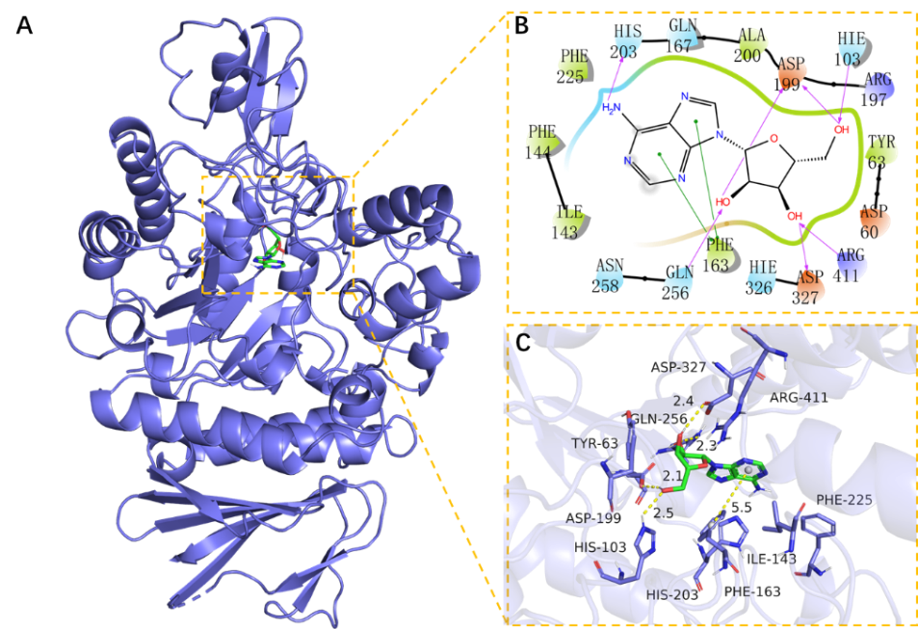

Fig. 2 The binding mode of ergosterol-5,8-peroxide with CASP3 protein. (A) Predicted 3D diagram of ergosterol-5,8-peroxide with CASP3 protein complex. (B) The 2D binding mode of ergosterol-5,8-peroxide with CASP3 protein. (C) The detail binding mode of ergosterol-5,8-peroxide with CASP3 protein.
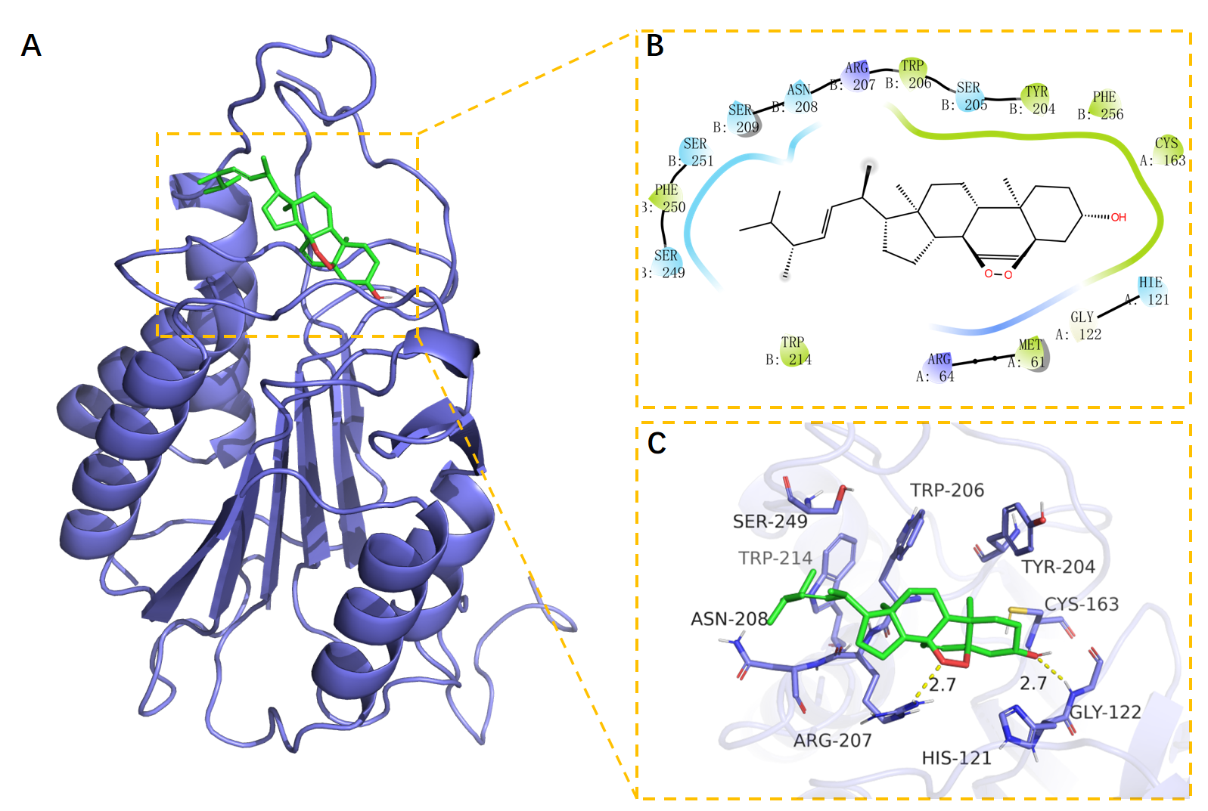

Fig. 3 The binding mode of ergosterol with VP1 protein. (A) Predicted 3D diagram of ergosterol with VP1 complex. (B) The 2D binding mode of ergosterol with VP1 protein. (C) The detail binding mode of ergosterol with VP1 protein.
