Supplementary Material

Delineation of Sedimentary Basin Structure beneath the Banyumas Basin, Central Java, Indonesia, Using Ambient Seismic Noise Tomography

Ahmad Setiawan^{1,2*}, Zulfakriza Zulfakriza^{3,4}, Andri Dian Nugraha^{3,4}, Shindy Rosalia^{3,4}, Awali Priyono³, Sri Widiyantoro^{3,4,5}, David P. Sahara^{3,4}, Marjiyono Marjiyono², Januar H. Setiawan², Eko Budi Lelono², Asep K. Permana², Hidayat Hidayat^{1,2}
¹Graduate Program of Geophysical Engineering, Faculty of Mining and Petroleum Engineering, Institut Teknologi Bandung, Jalan Ganesa No. 10, Bandung 40132, Indonesia
²Center for Geological Survey, Geological Agency of Indonesia, Ministry of Energy and Mineral Resources, Indonesia, Jalan Diponegoro No. 57, Bandung 40122, Indonesia
³Global Geophysics Research Group, Faculty of Mining and Petroleum Engineering, Institut Teknologi Bandung, Jalan Ganesa No. 10, Bandung 40132, Indonesia.

⁴Center for Earthquake Science and Technology, Institut Teknologi Bandung, Jalan Ganesa No. 10, Bandung 40132, Indonesia.
⁵Faculty of Engineering, Maranatha Christian University, Bandung 40164, Indonesia.
*E-mail: ahmad.setiawan@esdm.go.id

Supplementary Table S1: Facies analysis data of Jati-1 well (Junursyah 2018)
No | Formation | Top (m) | Bottom (m)
1 | Halang Fm. | 75 | 1250
2 | Rambatan Fm. | 1250 | 2450
3 | Penanjung Fm. | 4328 | 4433
4 | Nusakambangan Fm. | 4433 | 4505

Supplementary Figures

Supplementary Figure S1 : Plot of 1,291 group velocity dispersion curves of Rayleigh wave in the 1s-10s period with a range of group velocity values of 0.4 km/s - 3.2 km/s.

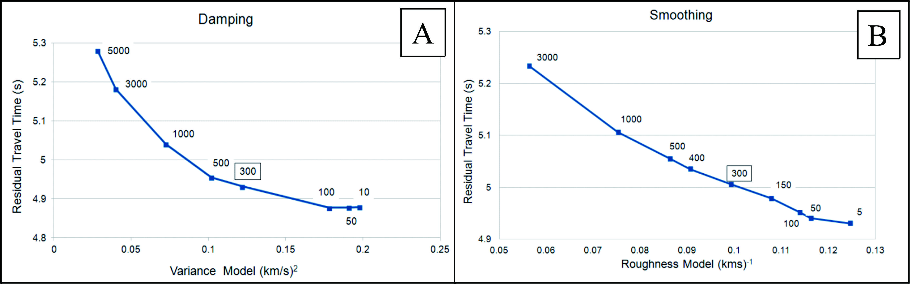
Supplementary Figure S2 : The trade-off curve of the regularization damping and smoothing parameters in the 1s period. (A) The search for damping values is varied from 5,000 to 10 and a damping number of 300 is obtained. (B) The search for smoothing values is varied from 3,000 to 5 and a smoothing number of 300 is obtained.
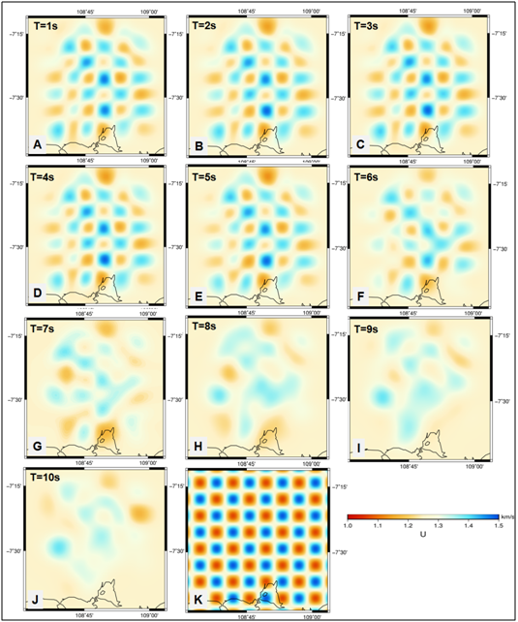
Supplementary Figure S3 : Inversion of the synthetic model of group velocity with Checkerboard Resolution Test (CRT) in each period with a cell size of ~ 6.5 km², damping, and smoothing factors of 300. (A) 1s, (B) 2s, (C) 3s, ( D) 4s, (E) 5s, (F) 6s, (G) 7s, (H) 8s, (I) 9s, (J) 10s, (K) initial synthetic models. Checkerboard patterns of synthetic models can be relatively recovered (recovery) in the period 1s-6s.

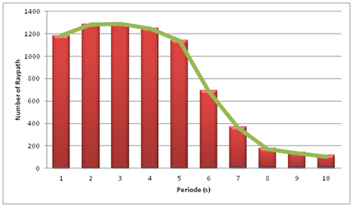
Supplementary Figure S4 : The amount of ray path in each Rayleigh wave propagation period extracted from the dispersion curve. The amount of ray path tends to decrease with increasing periods.

