Supplementary Material
Research on Chemical Intermediates
Removal of antimony and aniline from wastewater by PMS combined with electrocoagulation
Wenjie Dong ^{1, *}, Yu Shu ², Ao Cai ², Yuehong Huang ³, Beimeng Qi ², Jingrao Zhao ², Hailu Fu ²
¹ Zhejiang Scientific Research Institute of Transport, Zhejiang, 310012, P. R. China
² College of quality and safety engineering, Jiliang University, Zhejiang, 310018, P. R. China
³ Lin'an Branch of Hangzhou Municipal Ecology and Environment Bureau, Zhejiang, 311300, P. R. China
*Corresponding author, E-mail: dwenjie@cjlu.edu.cn

Contents:
This supporting material provides additional information (4 Figures):
- Fig. S1. Illustration of the EC/PMS system.
- Fig. S2. Possible degradation pathway of Aniline in EC/PMS system.
- Fig. S3. EDX images of flocs after wastewater treatment using EC/PMS.
- Fig. S4. XRD analysis of flocs generated by the reaction.

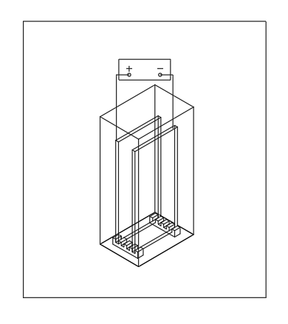
Figure S1. Illustration of the EC/PMS system

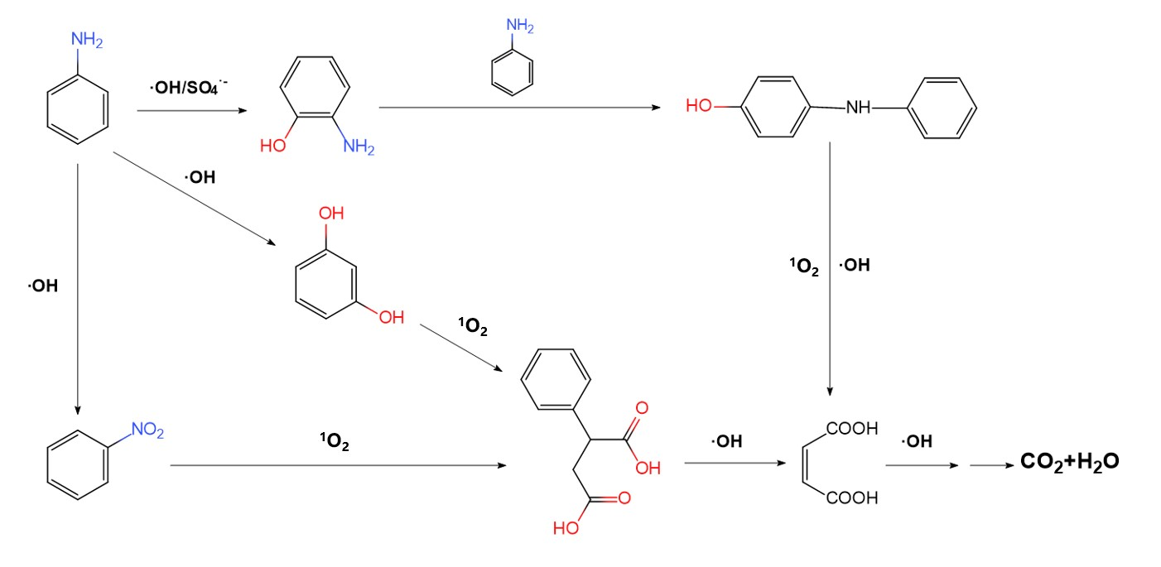
Fig. S2. Possible degradation pathway of Aniline in EC/PMS system.

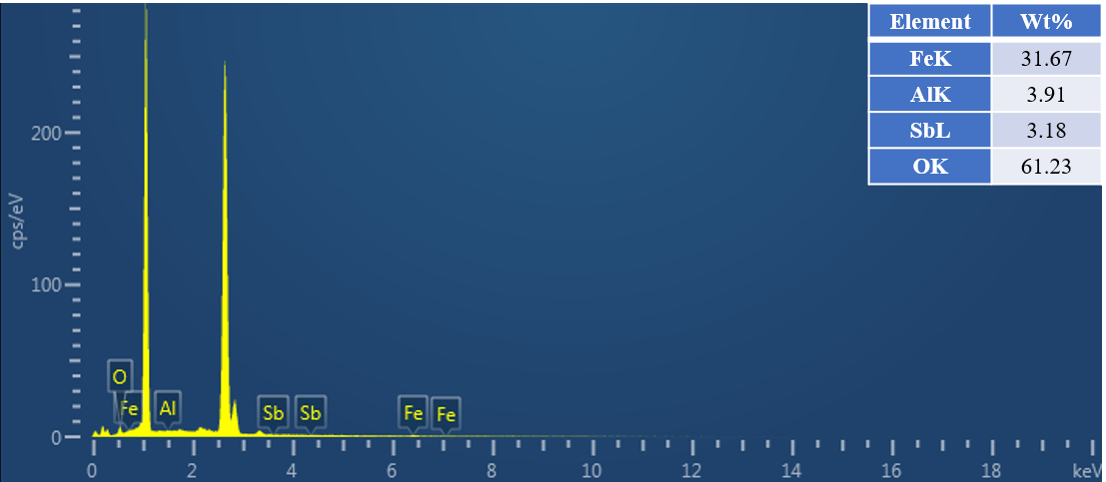
Fig. S3. EDX images of flocs after wastewater treatment using EC/PMS.

Fig. S4. XRD analysis of flocs generated by the reaction.

