Supplementary Materials for

Intra-genus dysbiosis of Streptococcus in tonsillar microbiota is associated with host immune features in rheumatoid arthritis
Jing Li^{1,2†*}, Shenghui Li^{3,4†}, Jiayang Jin^{1,2†}, Ruochun Guo⁴, Yuebo Jin^{1,2}, Yan Zhong^{1,2,5}, Xiaohong Xiang^{1,2}, Xiaolin Sun^{1,2}, Jianping Guo^{1,2}, Hua Ye^{1,2}, Wenjing Xiao^{1,2,6}, Yuan An^{1,2}, Xuan Zhang^{7,8}, BinBin Xia^{7,8}, Rentao Yang⁴, Yuanjie Zhou⁴, Lijun Wu⁵, Junjie Qin⁴, Jing He^{1,2}, Jun Wang^{7,8}*, Zhanguo Li^{1,2,9,10}*

* Corresponding authors
Prof. Zhanguo Li, Email: li99@bjmu.edu.cn.
Prof. Jun Wang, Email: junwang@im.ac.cn
Dr. Jing Li, Email: muzijing1026@163.com.
†These authors contributed equally to this work.

This PDF file includes:
Figs. S1 to S6

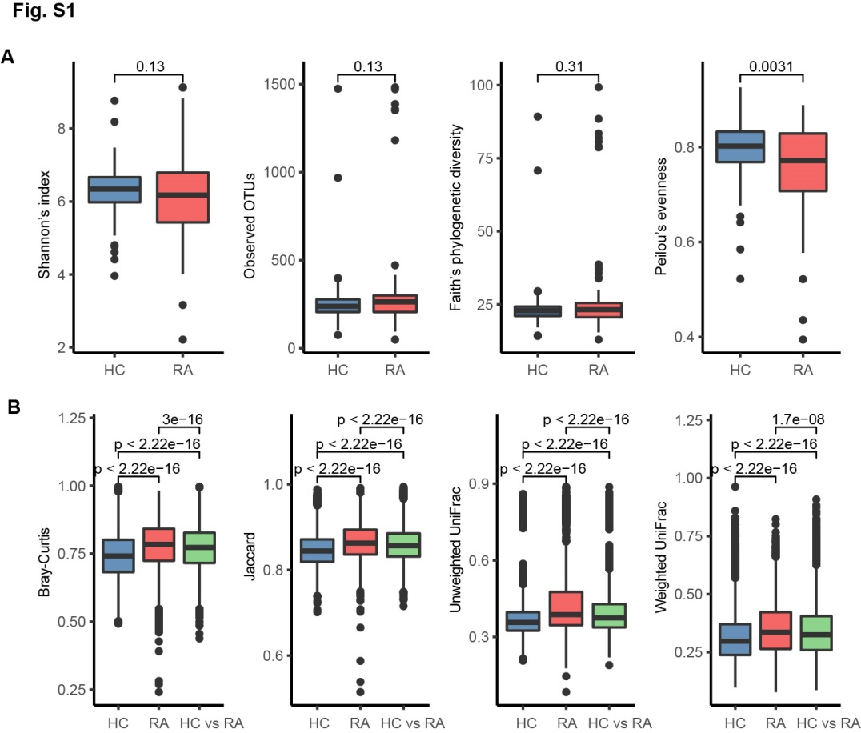
Supplementary Figure 1. The alternations of microbial diversity in RA tonsillar microbiota. (A and B) Comparison of α (A) and β (B) diversity indexes of tonsillar microbiota between healthy controls (HC) and rheumatoid arthritis (RA) patients. Boxes depicted the interquartile ranges (IQRs) between the first and third quartiles, and the line inside the box denoted the median; whiskers represented the lowest or highest values within 1.5 times IQR from the first or third quartiles. Dots represented data point beyond the whiskers. RA, n=121; HC, n=99. P-values were calculated using Spearman’s rank correlation test.

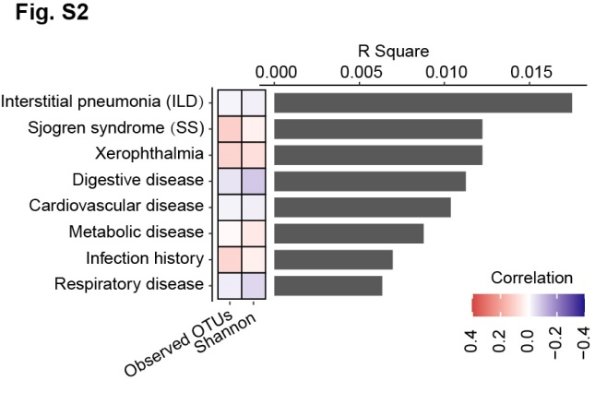
Supplementary Figure 2. The associations of extra-articular manifestations of RA patients with the tonsillar microbiota. The associations of extra-articular manifestations of RA patients with the inter-individual variation, diversity and richness of tonsillar microbiota. The bar plot indicates the explained variation of each factor in the inter-individual variation of microbial composition (Bray-Curtis distance). The heatmaps beside the bar plot showed the correlation coefficients of each factor with Shannon’s index of diversity and observed OTUs, respectively. Color key for correlation is shown.

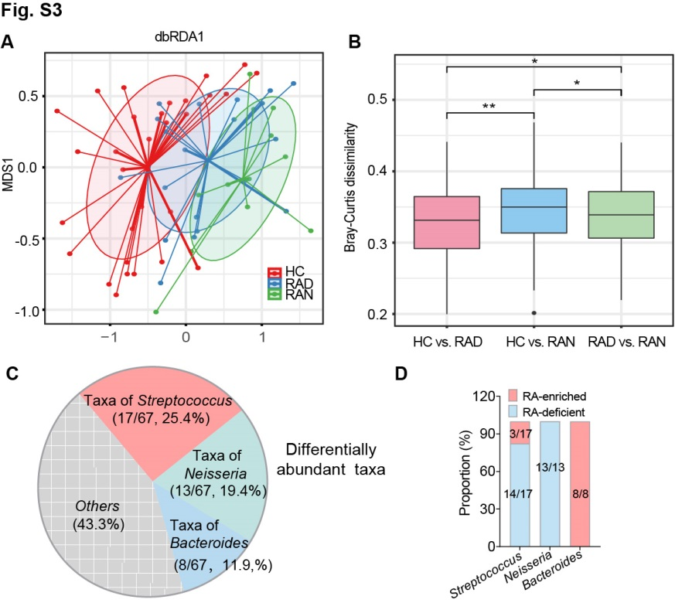
Supplementary Figure 3. The tonsillar microbiome is partially restored in RA patients with medication. (A) Distance-based redundancy analysis (dbRDA) of Bray-Curtis dissimilarity among the microbial compositions of healthy controls (HC, n = 30), RA patients with drug treatment (RAD, n = 20) and without drugs (RAN, n = 12). Samples were shown at the primary constrained axis (CAP1) and primary multidimensional scaling axis (MDS1), and lines connected samples in the same group. (B) Bray-Curits dissimilarly analysis among healthy controls, RA patients with drug treatment (RAD) or without drugs (RAN). Analysis was performed at the species profiles, P values were calculated using Wilcoxon rank-sum test. *P < 0.05, **P < 0.01. (C) Pie diagram showing the differentially abundant taxa between RA patients and healthy controls. (D) The proportions of bacteria that enriched or deficient in RA among Streptococcus, Neisseria, and Bacteroides.

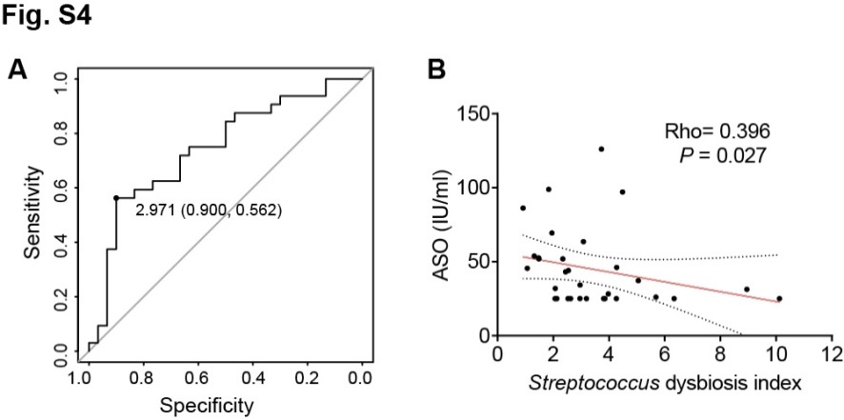
Supplementary Figure 4. Intra-genus dysbiosis of Streptococcus in tonsillar microbiota was closely correlated with host immuno-inflammatory responses. (A) ROC analysis identified 2.971% as the threshold for Streptococcus dysbiosis. (B) The correlations between tonsillar Streptococcus dysbiosis index and serum level of anti-streptolysin O (ASO, n=31). P-values were calculated by using Mann-Whitney U test or Spearman’s correlation test.

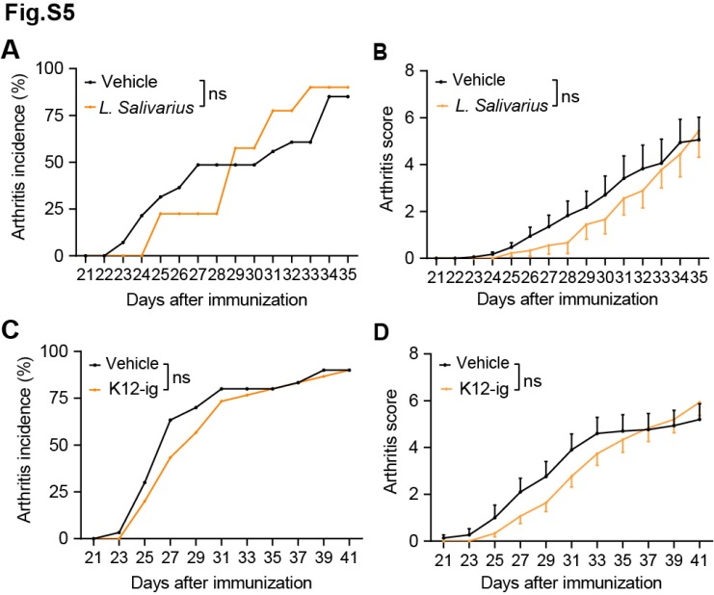
Supplementary Figure 5. Inoculation with L. Salivarius intra-orally and intra-nasally or S. salivarius intragastrically showed no protection from arthritis in CIA mice. (A and B) Incidence and clinical scores of arthritis in CIA mice with or without L. Salivarius (1*10⁸cfu/mice) treatment intra-orally and intra-nasally. Vehicle, n=17; L. Salivarius: Lactobacillus salivarius, n=9. (C and D) Incidence and clinical scores of arthritis in CIA mice with or without S. salivarius K12 (1*10⁹cfu/mice) inoculation. n=30 per group. ig: intragastric administration. Data were pooled from two independent experiments and expressed as mean ± SEM. Significance determined using Kaplan-Meier analysis with log-rank test (A and C) or two-way ANOVA followed by Tukey's multiple comparisons test (B and D). ns: non-significant.

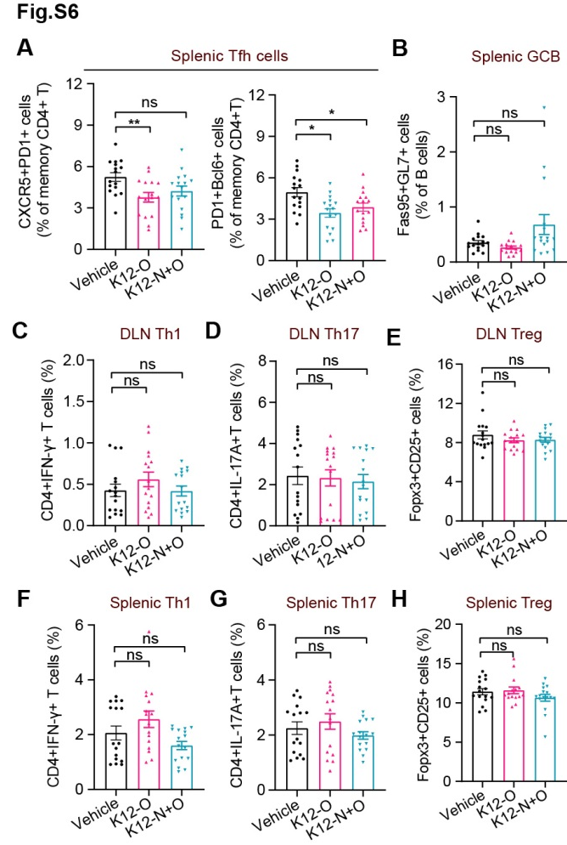
Supplementary Figure 6. S. salivarius suppresses immune responses in experimental arthritis. (A-H) Graphs of frequencies of Tfh (A, CD4⁺CD44⁺CXCR5⁺PD1⁺Bcl6⁺), GCB (B, B220⁺CD4⁻Fas95⁺GL-7⁺), Th1 (C and F, CD4⁺IFN-γ⁺), Th17 (D and G, CD4⁺IL-17A⁺), and Treg (E and H, CD4⁺CD25⁺Fopx3⁺) cells in the spleen of indicated mice. n=16 per group. Data were pooled from two independent experiments and expressed as mean ± SEM. Significance determined using Mann-Whitney U test (A-F). *P < 0.05, **P < 0.01, ns: non-significant.

