SUPPLEMENT
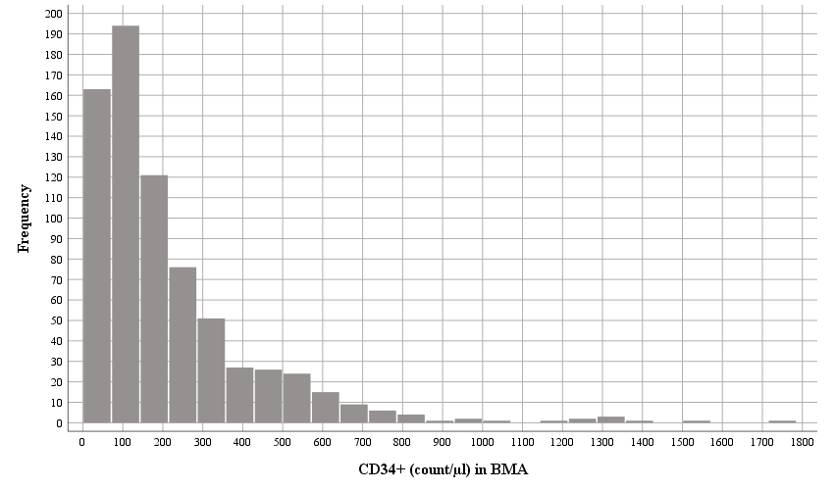
Figure S1 Frequencies of CD34+ cells (count/µl) in bone marrow aspirate (BMA).

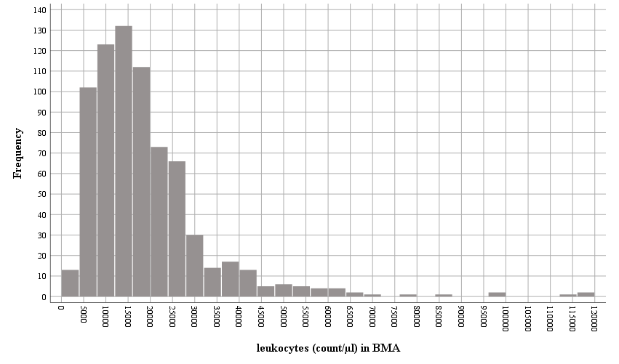
Figure S2 Frequencies of leukocytes (count/µl) in bone marrow aspirate (BMA).

Supplement Table S1 Correlations between age (years) and cell counts.
Spearman's rho |  |  |  | Age  (years) | Bone marrow aspirate |  |  |  |  | Concentrate |  |  |  |  | BMA of  concentrate
 |  |  |  | Age  (years) | CD34⁺ |  | Leukocyte |  | CD34⁺ of  leukocytes | CD34⁺ |  | Leukocyte |  | CD34⁺ of  leukocytes | BMA of  concentrate
 |  |  |  | Age  (years) | (cells/µl) | (cells/µl/kg) | (cells/µl) | (cells/µl/kg) | (%) | (cells/µl) | (cells/µl/kg) | (cells/µl) | (cells/µl/kg) | (%) | BMA of  concentrate
Age (years) |  |  | CC | 1.000 | -0.601** | -0.827** | -0.249** | -0.762** | -0.591** | -0.285** | -0.712** | 0.144** | -0.482** | -0.570** | 0.300**
 |  |  | p-value | . | <0.001 | <0.001 | <0.001 | <0.001 | <0.001 | <0.001 | <0.001 | <0.001 | <0.001 | <0.001 | <0.001
 |  |  | N | 729 | 729 | 729 | 729 | 729 | 729 | 729 | 729 | 729 | 729 | 729 | 729
Bone marrow aspirate | CD34⁺ | (cells/µl) | CC | -0.601** | 1.000 | 0.903** | 0.687** | 0.777** | 0.709** | 0.520** | 0.680** | 0.127** | 0.474** | 0.552** | -0.453**
Bone marrow aspirate | CD34⁺ | (cells/µl) | p-value | <0.001 | . | <0.001 | <0.001 | <0.001 | <0.001 | <0.001 | <0.001 | 0.001 | <0.001 | <0.001 | <0.001
Bone marrow aspirate | CD34⁺ | (cells/µl) | N | 729 | 729 | 729 | 729 | 729 | 729 | 729 | 729 | 729 | 729 | 729 | 729
Bone marrow aspirate | CD34⁺ | (cells/µl/kg) | CC | -0.827** | 0.903** | 1.000 | 0.528** | 0.896** | 0.738** | 0.429** | 0.786** | -0.021 | 0.555** | 0.622** | -0.452**
Bone marrow aspirate | CD34⁺ | (cells/µl/kg) | p-value | <0.001 | <0.001 | . | <0.001 | <0.001 | <0.001 | <0.001 | <0.001 | 0.571 | <0.001 | <0.001 | <0.001
Bone marrow aspirate | CD34⁺ | (cells/µl/kg) | N | 729 | 729 | 729 | 729 | 729 | 729 | 729 | 729 | 729 | 729 | 729 | 729
Bone marrow aspirate | Leukocyte | (cells/µl) | CC | -0.249** | 0.687** | 0.528** | 1.000 | 0.714** | 0.043 | 0.307** | 0.329** | 0.288** | 0.362** | 0.090* | -0.386**
Bone marrow aspirate | Leukocyte | (cells/µl) | p-value | <0.001 | <0.001 | <0.001 | . | <0.001 | 0.242 | <0.001 | <0.001 | <0.001 | <0.001 | 0.015 | <0.001
Bone marrow aspirate | Leukocyte | (cells/µl) | N | 729 | 729 | 729 | 729 | 729 | 729 | 729 | 729 | 729 | 729 | 729 | 729
Bone marrow aspirate | Leukocyte | (cells/µl/kg) | CC | -0.762** | 0.777** | 0.896** | 0.714** | 1.000 | 0.406** | 0.306** | 0.683** | 0.020 | 0.568** | 0.424** | -0.456**
Bone marrow aspirate | Leukocyte | (cells/µl/kg) | p-value | <0.001 | <0.001 | <0.001 | <0.001 | . | <0.001 | <0.001 | <0.001 | 0.590 | <0.001 | <0.001 | <0.001
Bone marrow aspirate | Leukocyte | (cells/µl/kg) | N | 729 | 729 | 729 | 729 | 729 | 729 | 729 | 729 | 729 | 729 | 729 | 729
Bone marrow aspirate | CD34⁺  of  leukocytes | (%) | CC | -0.591** | 0.709** | 0.738** | 0.043 | 0.406** | 1.000 | 0.421** | 0.620** | -0.102** | 0.310** | 0.698** | -0.273**
Bone marrow aspirate | CD34⁺  of  leukocytes | (%) | p-value | <0.001 | <0.001 | <0.001 | 0.242 | <0.001 | . | <0.001 | <0.001 | 0.006 | <0.001 | <0.001 | <0.001
Bone marrow aspirate | CD34⁺  of  leukocytes | (%) | N | 729 | 729 | 729 | 729 | 729 | 729 | 729 | 729 | 729 | 729 | 729 | 729
Concentrate | CD34⁺ | (cells/µl) | CC | -0.285** | 0.520** | 0.429** | 0.307** | 0.306** | 0.421** | 1.000 | 0.816** | 0.663** | 0.710** | 0.466** | 0.482**
Concentrate | CD34⁺ | (cells/µl) | p-value | <0.001 | <0.001 | <0.001 | <0.001 | <0.001 | <0.001 | . | <0.001 | <0.001 | <0.001 | <0.001 | <0.001
Concentrate | CD34⁺ | (cells/µl) | N | 729 | 729 | 729 | 729 | 729 | 729 | 729 | 729 | 729 | 729 | 729 | 729
Concentrate | CD34⁺ | (cells/µl/kg) | CC | -0.712** | 0.680** | 0.786** | 0.329** | 0.683** | 0.620** | 0.816** | 1.000 | 0.354** | 0.809** | 0.631** | 0.159**
Concentrate | CD34⁺ | (cells/µl/kg) | p-value | <0.001 | <0.001 | <0.001 | <0.001 | <0.001 | <0.001 | <0.001 | . | <0.001 | <0.001 | <0.001 | <0.001
Concentrate | CD34⁺ | (cells/µl/kg) | N | 729 | 729 | 729 | 729 | 729 | 729 | 729 | 729 | 729 | 729 | 729 | 729
Concentrate | Leukocyte | (cells/µl) | CC | 0.144** | 0.127** | -0.021 | 0.288** | 0.020 | -0.102** | 0.663** | 0.354** | 1.000 | 0.702** | -0.284** | 0.548**
Concentrate | Leukocyte | (cells/µl) | p-value | <0.001 | 0.001 | 0.571 | <0.001 | 0.590 | 0.006 | <0.001 | <0.001 | . | <0.001 | <0.001 | <0.001
Concentrate | Leukocyte | (cells/µl) | N | 729 | 729 | 729 | 729 | 729 | 729 | 729 | 729 | 729 | 729 | 729 | 729
Concentrate | Leukocyte | (cells/µl/kg) | CC | -0.482** | 0.474** | 0.555** | 0.362** | 0.568** | 0.310** | 0.710** | 0.809** | 0.702** | 1.000 | 0.110** | 0.258**
Concentrate | Leukocyte | (cells/µl/kg) | p-value | <0.001 | <0.001 | <0.001 | <0.001 | <0.001 | <0.001 | <0.001 | <0.001 | <0.001 | . | 0.003 | <0.001
Concentrate | Leukocyte | (cells/µl/kg) | N | 729 | 729 | 729 | 729 | 729 | 729 | 729 | 729 | 729 | 729 | 729 | 729
Concentrate | CD34⁺  of  leukocytes | (%) | CC | -0.570** | 0.552** | 0.622** | 0.090* | 0.424** | 0.698** | 0.466** | 0.631** | -0.284** | 0.110** | 1.000 | -0.073*
Concentrate | CD34⁺  of  leukocytes | (%) | p-value | <0.001 | <0.001 | <0.001 | 0.015 | <0.001 | <0.001 | <0.001 | <0.001 | <0.001 | 0.003 | . | 0.050
Concentrate | CD34⁺  of  leukocytes | (%) | N | 729 | 729 | 729 | 729 | 729 | 729 | 729 | 729 | 729 | 729 | 729 | 729
BMA of  concentrate |  |  | CC | 0.300** | -0.453** | -0.452** | -0.386** | -0.456** | -0.273** | 0.482** | 0.159** | 0.548** | 0.258** | -0.073* | 1.000
 |  |  | p-value | <0.001 | <0.001 | <0.001 | <0.001 | <0.001 | <0.001 | <0.001 | <0.001 | <0.001 | <0.001 | 0.050 | .
 |  |  | N | 729 | 729 | 729 | 729 | 729 | 729 | 729 | 729 | 729 | 729 | 729 | 729
Abbreviations: BMA, bone marrow aspirate; CC, correlation coefficient;
**. Correlation is significant at the 0.01 level (2-tailed); *. Correlation is significant at the 0.05 level (2-tailed).

Supplement Table S2. Comparisons of cell counts between age groups, gender, and diagnose related groups
 | Bone marrow aspirate |  |  |  |  | Post-centrifuge concentrate
 | CD34⁺ |  | Leukocytes |  | CD34⁺  of  leukocytes | CD34⁺ |  | Leukocytes |  | CD34⁺  of  leukocytes | Concentration  of  BMA
 | (cells/µl) | (cells/µl/kg) | (cells/µl) | (cells/µl/kg) | (%) | (cells/µl) | (cells/µl/kg) | (cells/µl) | (cells/µl/kg) | (%)
Age groups
Children  (n=445) | 226  [140, 382] | 9.8  [5.1, 16.6] | 17900  [1250, 25350] | 731.0  [421.0, 1121.1] | 1.34  [1.03, 1.77] | 940  [497.5, 1526.3] | 35.6  [18.8, 73.9] | 80300  [45550, 124550] | 3031.4  [1692.7, 4975.5] | 1.30  [0.90, 1.74] | 3.8  [2.2, 6.8]
Adults  (n=284) | 75  [47, 112] | 1.0  [0.7, 1.6] | 12800  [8275, 18500] | 176.0  [110.0, 271.8] | 0.62  [0.38, 0.88] | 520  [269, 1065] | 7.6  [3.9, 14.6] | 95700  [47400, 168950] | 1280.4  [702.2, 2345.9] | 0.60  [0.41, 0.88] | 6.9  [3.4, 13.8]
P-value*  (children vs. adults) | <0.001 | <0.001 | <0.001 | <0.001 | <0.001 | <0.001 | <0.001 | <0.001 | <0.001 | <0.001 | <0.001
Gender
Female  (n=187) | 144  [76, 255] | 3.7  [1.4, 11.8] | 15800  [9800, 23200] | 435.3  [244.2, 914.3] | 0.97  [0.63, 1.41] | 700  [340, 1313] | 19.4  [7.5, 45.9] | 82000  [41100, 134700] | 2200.0  [1139.1, 4464.3] | 0.96  [0.57, 1.45] | 4.6  [2.5, 8.8]
Male  (n=542) | 147  [75, 292] | 4.3  [1.1, 11.8] | 15750  [10375, 23350] | 410.3  [177.1, 879.2] | 1.08  [0.65, 1.57] | 821  [379, 1403] | 20.0  [8.4, 43.2] | 86550  [47375, 139150] | 2146.3  [1118.9, 3929.9] | 0.99  [0.62, 1.56] | 4.8  [2.5, 8.9]
P-value*  (female vs. male) | 0.386 | 0.680 | 0.779 | 0.185 | 0.229 | 0.114 | 0.953 | 0.446 | 0.416 | 0.318 | 0.730
DRG
spinal cord injury  (n=151) | 91  [58, 144] | 1.2  [0.8, 2.1] | 13600  [9800, 18500] | 201.3  [132.9, 306.9] | 0.69  [0.45, 0.93] | 680  [325, 1300] | 10.3  [4.7, 19.5] | 108800  [55300, 177500] | 1660.0  [818.8, 2900.0] | 0.68  [0.47, 0.95] | 6.9  [3.5, 14.3]
amyotrophic lateral sclerosis  (n=97) | 73  [40, 118] | 0.9  [0.6, 1.6] | 12100  [7800, 18450] | 172.2  [106.4, 301.6] | 0.63  [0.33, 0.83] | 470  [281, 839] | 6.7  [3.8, 12.5] | 97400  [43150, 162550] | 1285.4  [704.1, 2290.7] | 0.53  [0.32, 0.81] | 6.6  [2.9, 14.6]
autism  (n=263) | 270  [174, 440] | 10.2  [5.0, 16.7] | 19600  [14300, 26700] | 722.9  [416.7, 1062.5] | 1.38  [1.03, 1.78] | 940  [520, 940] | 32.3  [17.0, 58.0] | 74500  [42500, 116800] | 2336.1  [1453.8, 4150.0] | 1.32  [0.97, 1.85] | 3.4  [2.1, 5.7]
cerebral palsy  (n=149) | 183  [107, 273] | 10.2  [5.5, 16.4] | 14100  [9800, 22400] | 818.2  [439.4, 1201.1] | 1.31  [0.98, 1.79] | 950  [412, 1524] | 49.4  [21.7, 93.1] | 90900  [52300, 128000] | 4215.4  [2208.5, 7336.5] | 1.22  [0.76, 1.67] | 5.0  [2.1, 8.6]
neurodegenerative diseases  (n=37) | 70  [41, 108] | 1.0  [0.5, 1.8] | 13300  [7450, 20800] | 193.8  [96.0, 298.9] | 0.60  [0.35, 0.98] | 455  [229, 1051] | 7.1  [2.5, 15.6] | 79700  [41150, 174500] | 1004.0  [557.8, 2419.4] | 0.68  [0.26, 0.91] | 6.0  [3.9, 10.6]
muscle dystrophy  (n=19) | 101  [54, 238] | 3.2  [1.8, 6.2] | 14300  [10300, 25400] | 390.8  [300.0, 851.9] | 0.77  [0.61, 1.36] | 790  [385, 1395] | 25.5  [7.4, 39.9] | 88500  [64300, 139700] | 2957.1  [1268.0, 4296.3] | 0.95  [0.64, 1.38] | 6.5  [2.6, 10.8]
neurological diseases  (n=13) | 58  [45, 116] | 0.96  [0.77, 2.47] | 9700  [6750, 12700] | 188.7  [100.2, 270.2] | 0.90  [0.64, 1.05] | 300  [147, 670] | 6.4  [2.8, 13.5] | 32800  [26150, 63750] | 618.9  [395.5, 1522.8] | 0.79  [0.61, 1.18] | 4.4  [2.5, 9.5]
P-value**  (within DRG groups) | <0.001 | <0.001 | <0.001 | <0.001 | <0.001 | <0.001 | <0.001 | <0.001 | <0.001 | <0.001 | <0.001
Abbreviation: DRG, diagnose related groups.
Data are shown as median [interquartile range]. *Mann-Whitney U test; **Kruskal Wallis test

