Supporting Information
Tree-Invent: A novel molecular generative model constrained with topological tree

Mingyuan Xu¹, Hongming Chen^{1, *}
¹ Guangzhou National Laboratory, No. 9 XingDaoHuanBei Road, Guangzhou International Bio Island, Guangzhou 510005, Guangdong Province, China
*Correspondence e-mail: chen_hongming@gzlab.ac.cn;

Routine S1. sample $A^{M},E^{M}$from APD for Node add action.:
$$def sample_{add}\left(APD\right):$$
$$id_{add}=choice\left(APD\right)$$
$A^{M},E^{M}=\left\{\begin{aligned}id_{add},0 if id_{add}<|A^{M}| \\ None,1 if id_{add}≥|A^{M}|\end{aligned}\right.$
$return A^{M},E^{M}$

Routine S2. sample$V_{add}^{R},A^{R},F,B_{add},V_{conn}^{R},B_{conn}^{R},E^{R}$from $APD_{ring}$ for ring node generation action.:
$def sample_{ring}(APD_{ring})$:
$$id_{ring}=choice\left(APD_{ring}\right)$$
$$L_{R_{add}}= product\left(V_{max}^{R},\left|A^{R}\right|,\left|F\right|,\left|B\right|\right)$$
$$R_{add}=APD_{ring}\left[:L_{R_{add}}\right].reshape\left(V_{max}^{R},\left|A^{R}\right|,\left|F\right|,\left|B\right|\right)$$
$$V_{add},A^{R},F,B_{add}=\left\{\begin{aligned}unzip\left(index\left(APD_{ring}\left[id_{ring}\right],R_{add}\right)\right) if id_{ring}<L_{R_{add}} \\ None,None,None,None if id_{ring}≥L_{R_{add}}\end{aligned}\right.$$
$$L_{R_{conn}}=product\left(V_{max}^{R},\left|B\right|\right)$$
$R_{conn}=APD_{ring}\left[product\left(V_{max}^{R}\&,\left|A^{R}\right|,\left|F\right|,\left|B\right|\right):-2\right]$
$$V_{conn}^{R},B_{conn}^{R}$$
$$=\left\{\begin{aligned}unzip\left(index\left(APD_{ring}\left[id_{ring}\right],R_{conn}\right)\right) if L_{R_{add}}<id_{ring}<L_{R_{add}}+L_{R_{conn}} \\ None,None if id_{ring}>L_{R_{add}}+L_{R_{conn}}\end{aligned}\right.$$
$E^{R}=\left\{\begin{aligned}1 if id_{add}=L_{R_{add}}+L_{R_{conn}}+1 \\ 0 if id_{add}≠L_{R_{add}}+L_{R_{conn}}+1\end{aligned}\right.$
$return V_{add}^{R},A^{R},F,B_{add},V_{conn}^{R},B_{conn}^{R},E^{R}$

Routine S3. Sample $V_{conn}^{M},B^{M}$ from $APD_{conn}$ for node connect action.
$$\operatorname{def}{sample_{conn}\left(APD_{conn}\right)}:$$
$$id_{conn}=choice\left(APD_{conn}\right)$$
$$V_{conn}^{M},B_{conn}^{M}=unzip(index(APD_{conn}\left[id_{conn}\right],APD_{conn}.reshape(V_{max}^{M},|B|)))$$
$return V_{conn}^{M},B_{conn}^{M}$

Algorithm S1. Generation of $M_{add}$ with predefined conditions about node $C_{add}$.
$$i=0;M_{add}=[]$$
$$for i in range(N_{step}^{max}):$$
$$M_{add}^{i}=ones(\left|A^{M}\right|)$$
$$if C_{add}^{i}!=None:$$
$$N_{R}^{max},N_{R}^{min},N_{A}^{max},N_{A}^{min},N_{aro}^{max},N_{aro}^{min},N_{br}^{max},N_{br}^{min}=unzip(C_{add}^{i})$$
$$for j in range\left(\left|A^{M}\right|\right):$$
$if N_{R}^{j}>N_{R}^{max} or N_{R}^{j}<N_{R}^{min}:$
$$M_{add}^{i}\left[j\right]=0$$
$$for k in range\left(N_{A}\right):$$
$if N_{A}^{j}\left[k\right]>N_{A}^{max}[k]$:
$$M_{add}^{i}\left[j\right]=0$$
$if N_{aro}^{j}>N_{aro}^{max} or N_{aro}^{j}<N_{aro}^{min}:$
$M_{add}^{i}\left[j\right]=0$
$if N_{br}^{j}>N_{br}^{max} or N_{br}^{j}<N_{br}^{min}:$
$M_{add}^{i}\left[j\right]=0$
$M_{add}.append(M_{add}^{i})$

Algorithm S2. Generation of $M_{conn}$ with predefined conditions about node $C_{conn}$.
$$i=0$$
$M_{conn}$=[]
$$for i in range\left(N_{step}^{max}\right):$$
$$M_{conn}^{i}=ones\left(V_{M}^{max},3\right)$$
$if C_{i}!=None$:
$G_{conn},B_{conn},A_{conn}=unzip(C_{conn}^{i})$
$$for j in range\left(V_{M}^{max}\right):$$
$$if G_{id}\left[j\right]≠G_{conn}:$$
$$M_{conn}^{i}\left[j\right]=0$$
$$else:$$
$$if A\left[j\right]∌A_{conn} :$$
$$M_{conn}^{i}\left[j\right]=0$$
$$else:$$
$for k in range\left(3\right)$:
$$if k ∌ B_{conn}:$$
$$M_{conn}^{i}\left[j,k\right]=0$$
$M_{conn}.append(M_{conn}^{i})$

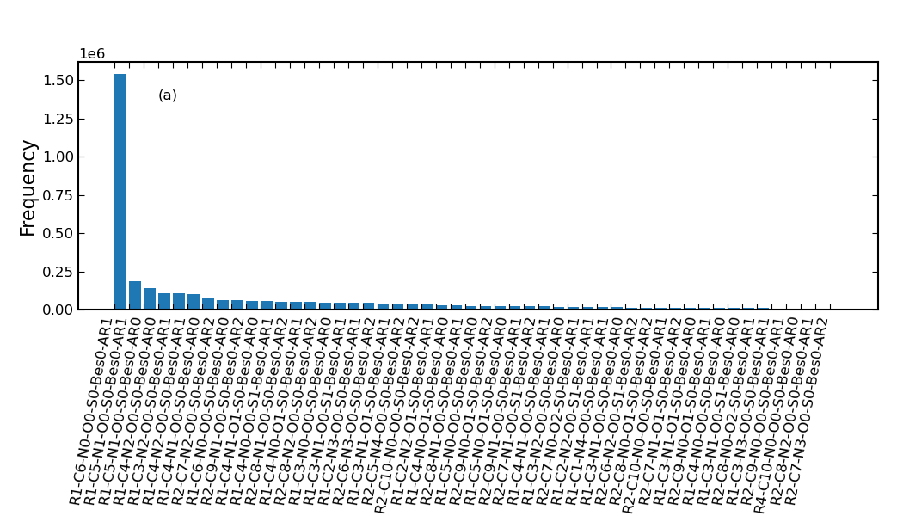
Figure S1. The frequency of top 50 class of ring systems in GuacaMol datasets

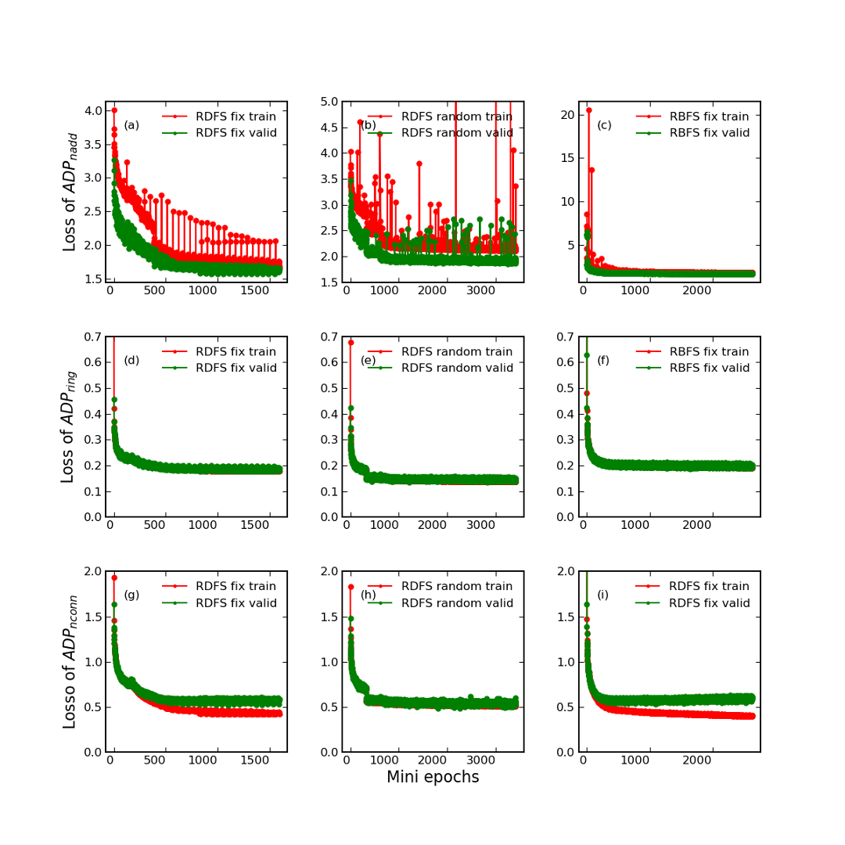
Figure S2. The evolution of $Loss_{add}$ (a),$Loss_{ring}$(b) and $Loss_{conn}$(c) of $Node_{add}$ module in training sets and validation sets. Evolution of losses of $Ring_{gen}$ (d~f) and $Node_{conn}$ (g~i)

