Supplementary data 1. Sampling dates of Tetraclita kuroshioensis in this study (annual sampling).
Year | Month | Date | Lunar phase | Year | Month | Date | Lunar phase
2019 | July | 13th | Full moon -4 | 2020 | January | 8th | Full moon -3
 |  | 15th | Full moon -2 |  | February | 9th | Full moon
 |  | 17th | Full moon |  |  | 11th | Full moon +2
 |  | 20th | Full moon +3 |  | March | 6th | Full moon -4
 | August | 17th | Full moon +2 |  |  | 8th | Full moon -2
 |  | 19th | Full moon +4 |  |  | 10th | Full moon
 | September | 12th | Full moon -2 |  |  | 13th | Full moon +3
 |  | 14th | Full moon |  | April | 5th | Full moon -3
 |  | 16th | Full moon +2 |  |  | 8th | Full moon
 |  | 18th | Full moon +4 |  |  | 10th | Full moon +2
 | October | 11th | Full moon -3 |  | May | 7th | Full moon -2
 |  | 12th | Full moon -2 |  |  | 9th | Full moon
 |  | 14th | Full moon |  | June | 6th | Full moon
 |  | 16th | Full moon +2 |  |  | 8th | Full moon +2
 | November | 9th | Full moon -3 |  | July | 5th | Full moon
 |  | 10th | Full moon -2 |  |  | 7th | Full moon +2
 |  | 12th | Full moon |  | August | 4th | Full moon
 |  | 15th | Full moon +3 |  |  | 7th | Full moon +3
 | December | 8th | Full moon -4 |  | September | 4th | Full moon +2
 |  | 10th | Full moon -2 |  | October | 2nd | Full moon
 |  | 12th | Full moon |  |  | 4th | Full moon +2
 |  | 14th | Full moon +2

Supplementary data 2. Sampling dates of Tetraclita kuroshioensis in this study (early, peak, and late reproductive season).
Year | Month | Date | Moon phase
2021 | April | 4th | Last quarter moon
 |  | 10th | New moon -2
 |  | 12th | New moon
 |  | 14th | New moon +2
 |  | 20th | First quarter moon
 |  | 25th | Full moon -2
 |  | 27th | Full moon
 |  | 29th | Full moon +2
 | August | 6th | New moon -2
 |  | 8th | New moon
 |  | 10th | New moon +2
 |  | 16th | First quarter moon
 |  | 20th | Full moon -2
 |  | 22nd | Full moon
 |  | 24th | Full moon +2
 |  | 30th | Last quarter moon
 | October | 4th | New moon -2
 |  | 6th | New moon
 |  | 8th | New moon +2
 |  | 13th | First quarter moon
 |  | 18th | Full moon -2
 |  | 20th | Full moon
 |  | 22th | Full moon +2
 |  | 29th | Last quarter moon

Supplementary data 3. Correspondence graph between ovarian tissue observation and direct observation. Development was classified into 5 stages, which are spent stage (Stage 0 and 1), recovery stage (Stage 2), growing stage (Stage 3), pre-mature stage (Stage 4), and mature stage (Stage 5). Oo; oocyte. Bar = 100µm and 500µm.

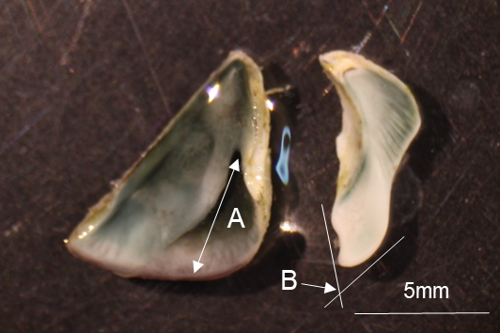

Supplementary data 4. The identified trait of Tetraclita kuroshioensis. The left is scutum, and the right is tergum. A; The distance between the articular ridge-basal margin, B; The spur angle of the tergum. Bar = 5mm.

Supplementary data 5. COI primers used in this study.
Primer label | Sequence (5’-3’) | Reference | Year
LCO1490 | GGTCAACAAATCATAAAGATATTGG | Folmer et al. | 1994
HCO2198 | TAAACTTCAGGGTGACCAAAAAATCA | Folmer et al. | 1994
jgLCO1490 | TITCIACIAAYCAYAARGAYATTGG | Geller et al. | 2013
jgHCO2198 | TAIACYTCIGGRTGICCRAARAAYCA | Geller et al. | 2013

Supplementary data 6. Phylogenetic analysis of the Tetraclita COI region. One-thousand replicates of the Bootstrap were performed, and the values were displayed on the internal nodes. Tetraclita pacifica and Tesseropora pacifica are synonyms of Tetraclita kuroshioensis. Tetraclita COI 1-5 show the COI region sequences of the species used in this study.

Supplementary data 7. Histological classification of development of ovary (A, B, C, D, and E) and testis (F, G, H, I, and J) of Tetraclita kuroshioensis. Development was classified into 5 stages, which are spent stage (A and F), recovery stage (B and G), growing stage (C and H), pre-mature stage (D and I), and mature stage (E and J). Oo; oocyte, Se; seminal vesicle, Te; testis. Bar = 100µm.

