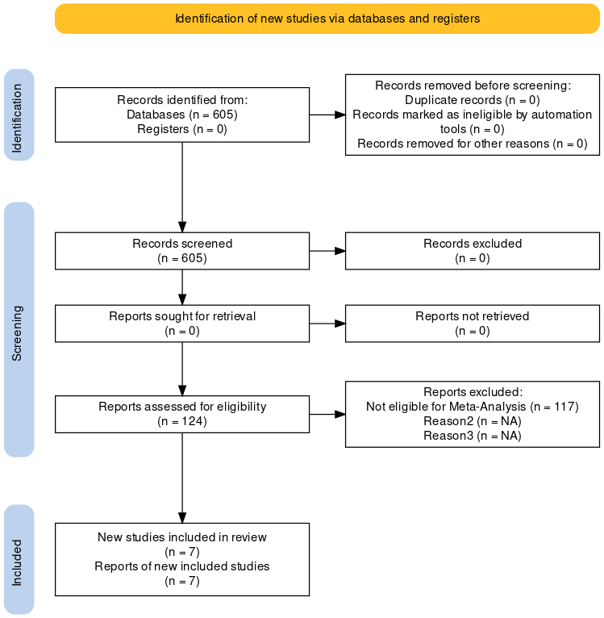
Figure 1. Flow graph of included and excluded studies (placed at the end of Description of studies section)

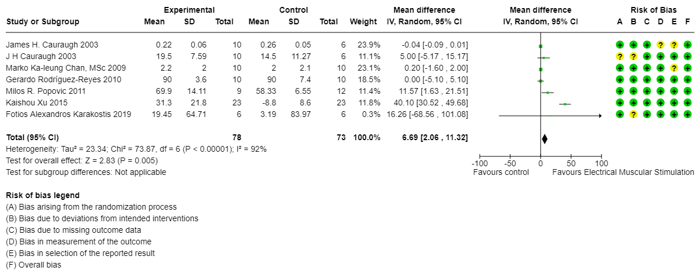
Figure 2. Forest plot and risk of bias for seven studies include the comparison between them (placed at the end of Effects of interventions section)

