RESULTS
Within-experiment bleaching responses
Fv/Fm values taken during CBASS became significantly lower with each subsequent treatment over 32.9°C (T p < 0.0001; Fig. S2A), and treatments 32.9°C and lower were not different from one another. Fv/Fm declined by 49% under 34.3°C and 82% under 35.6°C compared to the control treatment of 27.5°C. Under the LT experiment, LT-OW end Fv/Fm values decreased by 42% compared to initial Fv/Fm values. LT-OW Fv/Fm initial values were on average 1.7-fold higher than end values (Welch’s p < 0.0001). LT-Control end Fv/Fm values were significantly higher than LT-OW end values, but only for Upper Keys genotypes (T x G p < 0.05). CBASS total chlorophyll (µg/cm²; square-root transformed) in the 34.3°C treatment declined by 45% and 85% declines were detected in the 35.6°C treatment in comparison to the CBASS control (T p = 0.001; Fig. S2B). Under the LT experiment, there was a significant effect of treatment on all genotypes’ total chlorophyll (TxG p < 0.0001; Fig. S2B), where chlorophyll declined by 92% under LT-OW (0.94 ± 0.44 µg/cm²) compared to LT-Control (10.93 ± 3.46 µg/cm²). Host protein (µg/cm²; square-root transformed) was much more variable and did not differ across CBASS treatments (T p > 0.05; Fig. S2C). Protein values ranged from 22.82 ± 11.29 µg/cm² (35.6°C) to 50.23 ± 11.9 µg/cm² (27.5°C) in the CBASS experiment. In the LT experiment, host protein declined by 58% in the LT-OW compared to LT-Control (T p < 0.001; Fig. S2C), although there was no treatment effect for genotypes LK31, LK50, and UK70 (TxG p > 0.05).

TABLES & FIGURES
Table S1. Coral Genotype Source Location
Genotype | Habitat | Site Name | Latitude | Longitude
LK31 | Offshore Patch Reef | Porkys | 24.548 | -81.457
LK41 | Offshore Patch Reef | Haslun's | 24.553 | -81.438
LK50 | Mid-channel Reef | 1.8nm WSW of Wonderland | 24.549 | -81.533
LK62 | Mid-channel Reef | Super Stag | 24.530 | -81.641
LK7 | Mid-channel Reef | Wonderland | 24.560 | -81.501
UK12 | Offshore Patch Reef | Plantation Key | 24.952 | -80.489
UK19 | Mid-channel Reef | Tavernier | 24.988 | -80.468
UK70 | Offshore Patch Reef | Inshore from Molasses Trench | 25.013 | -80.407
UK76 | Forereef | Lower Matecumbe | 24.822 | -80.656
UK80 | Offshore Patch Reef | Shallow patch reef near U10 | 25.021 | -80.401
Table S2. Summary of daily mean ± SD water quality parameters for the long-term (LT) Control and Ocean Warming (OW) treatment tanks (Temperature, DO [Dissolved Oxygen], Salinity, pH, Photosynthetically Active Radiation [PAR], Flow).
Treatment | Temp (°C) | DO (mg L⁻¹) | DO (%) | Salinity (ppt) | pH_{NBS} | PAR (µmol m⁻² sec⁻¹) | Flow (L hr⁻¹)
Control | 26.92 ± 0.34 | 5.67 ± 0.28 | 87.58 ± 4.25 | 37.40 ± 0.53 | 8.08 ± 0.05 | 423.98 ± 216.24 | 21.92 ± 0.63
OW | 30.84 ± 0.61 | 5.54 ± 0.34 | 91.02 ± 5.47 | 37.38 ± 0.63 | 8.09 ± 0.05 | 418.51 ± 218.97 | 21.86 ± 0.64

Table S3. Summary of carbonate chemistry parameters for the long-term experiment. Water was collected from the main holding tank (“Header Tank”) and poisoned with mercuric chloride twice a week prior to analysis (pH_{T} [total scale], pCO2 [partial pressure of CO₂], DIC [Dissolved Inorganic Carbon], HCO₃₋ [Bicarbonate], CO²⁻₃ [Carbonate], Ωar [Saturation state of seawater with respect to aragonite], TA [Total Alkalinity]).
 | pH_{T} | pCO₂ | DIC | HCO₃₋ | CO²⁻₃ | Ωar | TA
Header Tank | 7.99 ± 0.08 | 490.29 ± 111.89 | 2084.04 ± 69.98 | 1848.71 ± 79.20 | 222.32 ± 35.79 | 3.51 ± 0.57 | 2397.92 ± 80.95

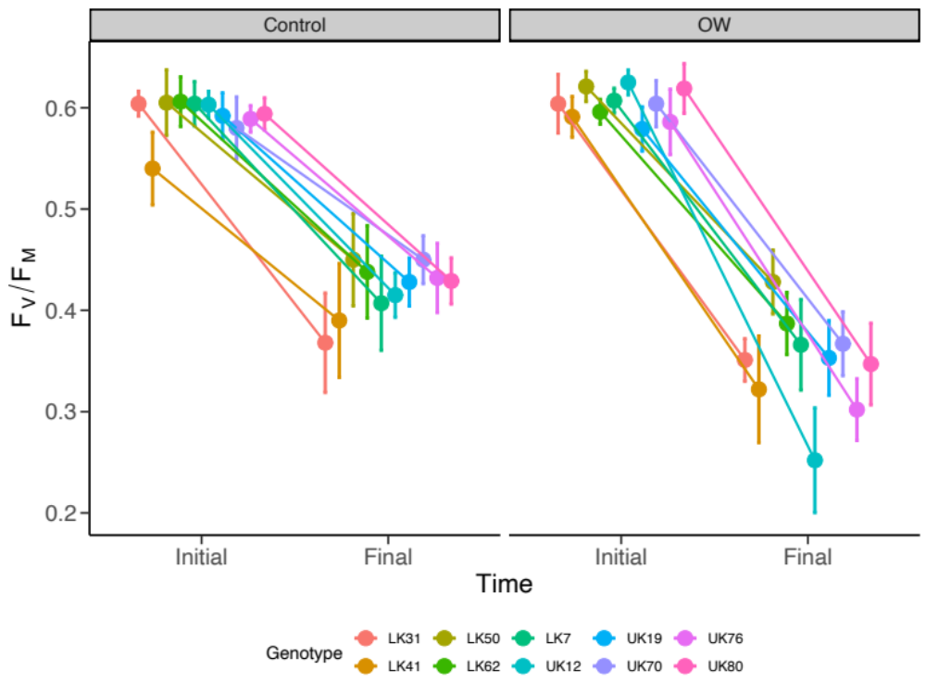
Figure S1. Evidence for photoacclimation over time under LT exposure. Mean (±95% CI) values for each genotype are separated by treatment- Control and OW.

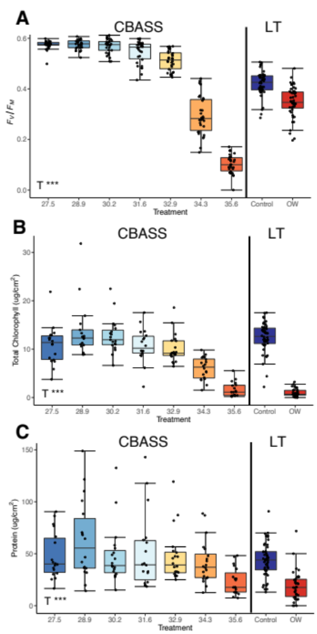
Figure S2. Median boxplots of phenotypic traits of (A) Fv/Fm, (B) total chlorophyll (µg cm⁻²), and (C host soluble protein (µg cm⁻²) measured by treatment in the LT and CBASS experiment. Boxplots for each trait are separated by experiment type, with significant effects treatment (T) reported (*p<0.05, **p<0.01, ***p<0.0001).

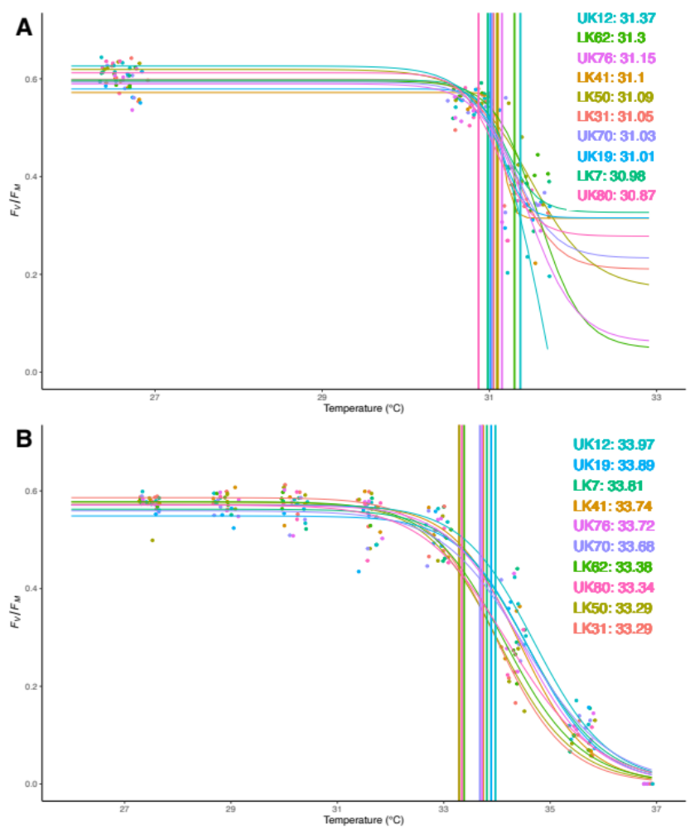
Figure S3. ED25 values of each genotype under (A) LT-OW and (B) CBASS. Fv/Fm values were fit against temperature using a log-logistic dose-response curve. Although non-significant, genotypes are ordered by ED25 values.

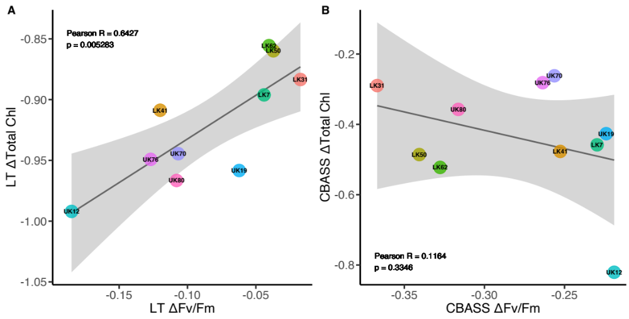
Figure S4. Correlations of the linear relationship between Fv/Fm and chlorophyll a (µg cm⁻²) for (A) LT-OW and (B) CBASS 34.3°C treatments. Linear regression results are reported and the gray-shaded area represents 95% confidence intervals.

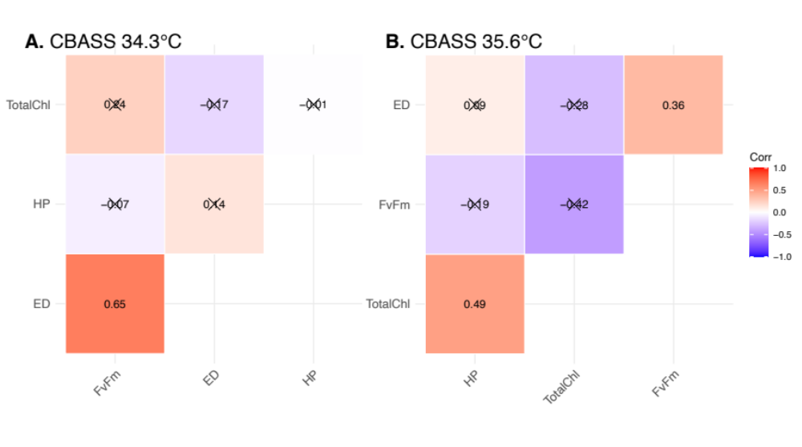
Figure S5. Correlation plot matrix among all bleaching traits (ED50 [ED], Fv/Fm, total chlorophyll, and host protein [HP]) for the CBASS treatments of (A) 34.3°C and (B) 35.6°C. Numbers inside boxes represent Pearson correlation coefficients and “X” represents non-significance.

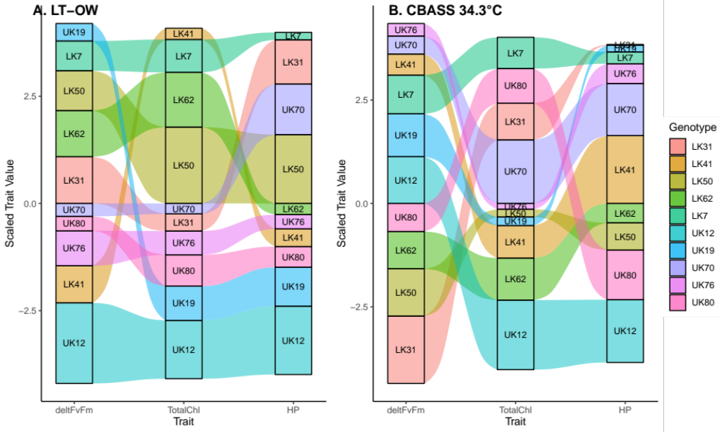
Figure S6. Alluvial plot for ranked genotypic scaled trait values across bleaching traits measured under (A) LT-OW and (B) CBASS 34.3°C. Strata (boxes) are in descending order and sized based on scaled trait value between adjacent genotypes (colors).

