Supplement
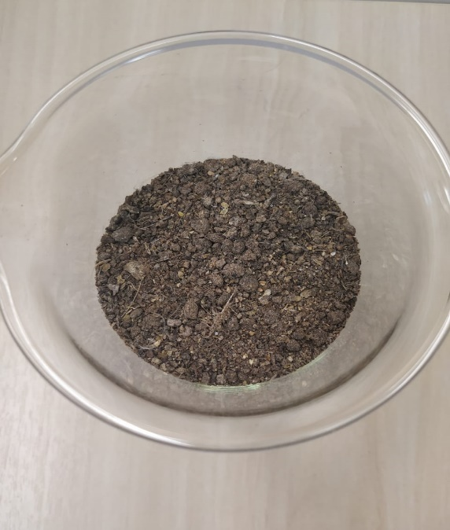
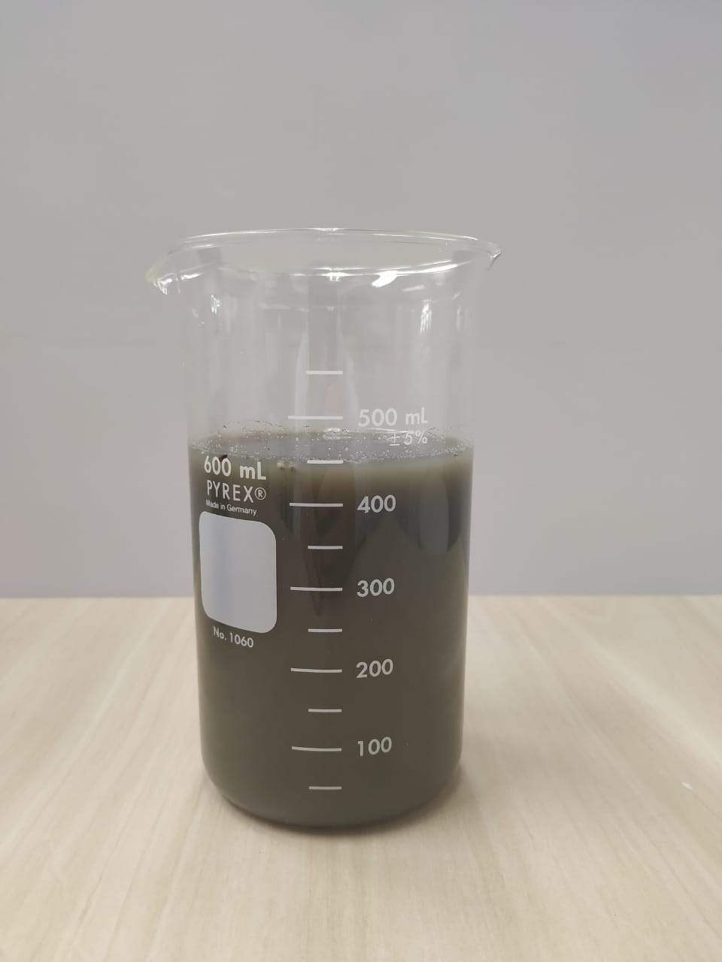
a
b

Figure 4: a) swine manure (SM) and b) poultry litter (PL).
Source: the author.

Table 4: Analysis of variance (ANOVA) (Quadratic model) - Biogas
SoV | SS | nDF | MS | CalcF | p
Regression | 42270.3451 | 5 | 8454.07 | 12 - SG | 0
Waste | 4934.36459 | 7 | 704.909
F. Adjustment | 2242.666667 | 1 | 2242.67 | 5 | 0.07
Pure error | 2691.69792 | 6 | 448.616
Total | 47204.7097 | 12
% explained variation |  |  |  | 90
% max. of explainable variation |  |  |  | 94
Caption: SoV: source of variation; SS: sum of squares; nDF: number of degrees of freedom; MS: mean square; CalcF: calculated F-value; ρ: significance level; SV: significant value.

Table 5: Analysis of variance (ANOVA) (Quadratic model) - Methane
SoV | SS | nDF | MS | CalcF | p
Regression | 25434.888 | 5 | 5086.978 | 14.21 - SG | 0
Waste | 2505.881 | 7 | 357.983
F. Adjustment | 1204.1667 | 1 | 1204.167 | 5.55 | 0.06
Pure error | 1301.7143 | 6 | 216.9524
Total | 27940.769 | 12
% explained variation |  |  |  | 91
% max. of explainable variation |  |  |  | 95
Caption: SoV: source of variation; SS: sum of squares; nDF: number of degrees of freedom; MS: mean square; CalcF: calculated F-value; ρ: significance level; SV: significant value.

