Genome DNA sequencing
The strain genomic DNA was isolated by using Fungi DNA Extraction Kit (Solarbio, Beijing) method. Internal transcribed spacer (ITS) fragment of the fungal genomic DNA was amplified by PCR with forward and reverse primers (ITS1:5'-TCCG TAGG TGAA CCTG CGG-3’, ITS2: 5'-TCCT CCGC TTAT TGAT ATGC-3’). PCR amplification was applied after DNA purification. The PCR reaction mixture (50 μL) consisted of genomic DNA (2 μL), 10 mM deoxyribonucleotide triphosphate mixture (1 μL), 10X PCR buffer (4μL), each of 10 μM forward and reverse primers (2 μL), Taq DNA polymerase (0.4 μL ,5 U/μL⁻¹, Sigma-Aldrich Inc. Mo, USA), and autoclaved MilliQ water (38.6 μL). The thermo cycling conditions consisted of an initial denaturation step of 95℃ for 4 min, followed by 35 cycles of 95℃ for 30s, 59℃ for 1 min, and a final extension at 74℃ for 7 min in an Eppendorf Master Cycler gradient PCR system. Gel excised ITS product was purified with 5PRIME kit following manufacturer’s protocol after visualization on 1% agarose gel. PCR products were detected by agarose gel electrophoresis and sequenced by Shanghai Personal Gene Technology Co., Ltd (Shanghai, China) using whole-genome shotgun (WGS) approach. The DNA libraries were prepared on an Illumina NovaSeq platform (Illumina, San Diego, California, USA) with Next-Generation Sequencing (NGS) technology.
Genome assembly and annotation
The de novo genome assembly was performed using A5-miseq v20150522 [1] and SPAdesv3.9.0 [2] using default parameters, adjusted by pilon v1.18[3] after total DNA was extracted and purified, and the completeness of genome assembly was assessed using BUSCO（Benchmarking Universal Single-Copy Orthologs http://busco.ezlab.org, v3.0.2）[4]. Gene model prediction was carried out using two pipelines: De novo prediction using Augustus（version 3.03）[5], GlimmerHMM（version 3.0.1）[6] and SNAP (version 2006-07-28）[7], respectively, and homology prediction of near-source species using exonerate (version 2.2.0, http://www.ebi.ac.uk/about/vertebrate-genomics/software/). The results were integrated using EVidenceModeler（version r2012-06-25）[8].
Protein encoding gene sequence alignment was conducted by using Diamond (version 0.9.10,111)[9]. Predicted genes were functionally annotated using blastp 75(BLAST 2.2.28+) against five databases, namely, Carbohydrate-Active enZYmes Database (http://www.cazy.org)(CAZy) [10], EggNOG[11], KEGG [12], swiss-prot and GO [13] database. The critical value of the sequence alignment was selected as 1e⁻⁶.

1. Coil, D., G. Jospin, and A.E. Darling, A5-miseq: an updated pipeline to assemble microbial genomes from Illumina MiSeq data. Bioinformatics, 2015. 31(4): p. 587-9.
2. Bankevich, A., et al., SPAdes: a new genome assembly algorithm and its applications to single-cell sequencing. J Comput Biol, 2012. 19(5): p. 455-77.
3. Walker, B.J., et al., Pilon: an integrated tool for comprehensive microbial variant detection and genome assembly improvement. PLoS One, 2014. 9(11): p. e112963.
4. Waterhouse, R.M., et al., BUSCO Applications from Quality Assessments to Gene Prediction and Phylogenomics. Mol Biol Evol, 2018. 35(3): p. 543-548.
5. Stanke, M. and B. Morgenstern, AUGUSTUS: a web server for gene prediction in eukaryotes that allows user-defined constraints. Nucleic Acids Res, 2005. 33(Web Server issue): p. W465-7.
6. Majoros, W.H., M. Pertea, and S.L. Salzberg, TigrScan and GlimmerHMM: two open source ab initio eukaryotic gene-finders. Bioinformatics, 2004. 20(16): p. 2878-9.
7. Korf, I., Gene finding in novel genomes. BMC Bioinformatics, 2004. 5: p. 59.
8. Haas, B.J., et al., Automated eukaryotic gene structure annotation using EVidenceModeler and the Program to Assemble Spliced Alignments. Genome Biol, 2008. 9(1): p. R7.
9. Buchfink, B., C. Xie, and D.H. Huson, Fast and sensitive protein alignment using DIAMOND. Nat Methods, 2015. 12(1): p. 59-60.
10. Krogh, A., et al., Predicting transmembrane protein topology with a hidden Markov model: application to complete genomes. J Mol Biol, 2001. 305(3): p. 567-80.
11. Huerta-Cepas, J., et al., Fast Genome-Wide Functional Annotation through Orthology Assignment by eggNOG-Mapper. Mol Biol Evol, 2017. 34(8): p. 2115-2122.
12. Moriya, Y., et al., KAAS: an automatic genome annotation and pathway reconstruction server. Nucleic Acids Res, 2007. 35(Web Server issue): p. W182-5.
13. Finn, R.D., et al., InterPro in 2017-beyond protein family and domain annotations. Nucleic Acids Res, 2017. 45(D1): p. D190-d199.
Table S1 Details of strains downloaded from NCBI
Strain | Accession Number
A. aculeatus ATCC 16872 | MRCK00000000
A.awamori IFM 58123 | BDHI00000000
A.clavatus NRRL 1 | AAKD00000000
A.flavus NRRL 3357 | NW_002477237
A.fumigatus Af293 | NC_007195
A.glaucus CBS 516.65 | SAMN02194406
A.luchuensis CBS 106.47 | KV878236 MRBP01000000
A.minisclerotigenes | SWDZ00000000
A.nidulans FGSC A4 | BN001301
A.niger CBS 513.88 | NC_007445
A.nomiae NRRL 13137 | JNOM00000000
A.oryzae RIB40 | NC_008282
A.saccharolyticus JOP 1030-1 | NC_008282
A.terreus NIH2624 | NT_165972
A.tubingensis | BLWE00000000
Penicillium expansum MD-8 | JQFZ00000000
DFY1 | JACCEF000000000

Table S2 Evaluation of completeness of genome assembly
Property |  | Number/Value | Percent (%)
Complete BUSCOs |  | 4178 | 99.7%
Complete and single-copy BUSCOs |  | 4170 | 99.5%
Complete and duplicated BUSCOs |  | 8 | 0.2%
Fragmented BUSCOss |  | 0 | 0%
Missing BUSCOs |  | 13 | 0.4%
Total BUSCO groups searched |  | 4191 | 100%
Scaffold | Total sequence number | 47
Scaffold | N20 Number | 3
Scaffold | N50 Number | 8
Scaffold | N90 Number | 20
Scaffold | N Number | 353
Scaffold | N rate % |  | 1e-05
Scaffold | GC content % |  | 50.04
 | Sequences greater than 1 kb | 47
Total genes length |  | 14161793
Total genes number |  | 8755
Total exons number |  | 25938
CDSs percentage of genome |  |  | 36.21%

Table S3 CAZy annotation about malt related hydrolase
Entry | Gene List
isomalto-dextranase (EC 3.2.1.94) | scaffold2.t9(GH27)  scaffold1.t227(GH27) | scaffold8.t126(GH27)
sucrase-isomaltase (EC 3.2.1.48) | scaffold2.t9(GH27)  scaffold10.t204(GH31) | scaffold10.t368(GH31)
sucrase-isomaltase (EC 3.2.1.10) | scaffold2.t236(GH31)  scaffold2.t642(GH31)  scaffold3.t578(GH31)  scaffold4.t191(GH31) | scaffold4.t457(GH31)  scaffold9.t92(GH31)  scaffold10.t204(GH31)  scaffold10.t368(GH31)
maltose phosphorylase (EC 2.4.1.8) | scaffold2.t23(GH65)
GH: Glycoside Hydrolases

Fig.S1 Cultivations with selective supplement in different cultures within 7 days or 30 days(above), and the relative yields of mycelia (below).
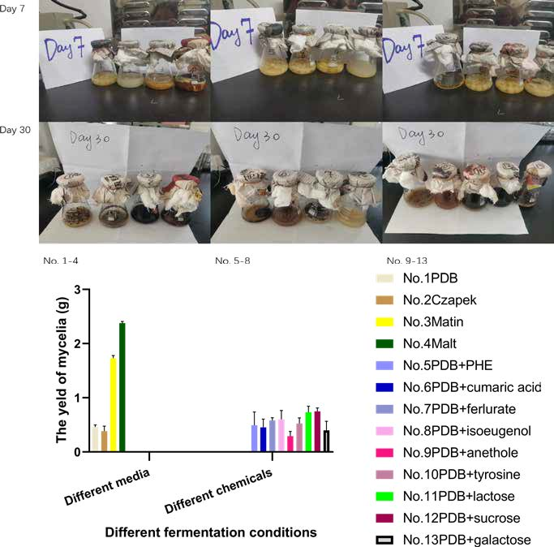

Fig.S2 Annotations by CAZy classification (A), GO classification (B), KEGG pathway classification (C) and eggnog classification (D).

