S.I: Development of an integrated indicator to assess the multi-dimensional global environmental impact of crop production

Mark A. A. Jwaideh¹ and Carole Dalin¹
¹Institute for Sustainable Resources, University College London, United Kingdom

Table 1.1: Comparison of previous research for global environmental impact from agriculture
Publication | Spatial Resolution | Number of Countries | Period | Method | Food Commodities | Environmental Indicators | Economic/ Social dimensions used | Result
Springmann et al., (2018) | National Scale | 159 | 2010 and 2050 | Planetary Boundary Analysis | Not food specific – considers 62 food products | - GHG Emissions  - Cropland Use  - Bluewater use  - Nitrogen Application  - Phosphorus Application | NO | - Environmental impacts could increase by 50-90% between 2010 and 2050 from food production
Chaudhary et al., (2018) | National scale | 156 | 2011 | Composite Indicator Score | Not food specific – considers 94 food products | - Ecosystem Status  - GHG Emissions  - Blue Water Consumption  - Land Use  - Non-Renewable Energy Use  - Biodiversity Footprint | Yes – 25 Indicators in total | - High income countries have higher environmental impacting scores for indicators.
Gerten et al., (2020) | 30 Arcmin | 30 arcmin resolution | 1980-2009 | Planetary Boundary Analysis | 12 crop products  Average of livestock products | - Biosphere integrity  - Land-system Change  - Human Freshwater Use  - N Flows | NO | - Half of current global food production depends on planetary boundary transgression
Bene et al., (2019) | National Scale | 97 | Post 2000 | Composite Indicator score | Not food specific | - GHG Emissions  - Water Quality  - Water withdrawal  - Soil Quality | Yes – 27 indicators in total | - Inconclusive results due to lack of data availability – greatest impact in Eastern Asia
Poore & Nemecek, (2018) | Not Spatial Specific | 119 – ~ 38,000 farm level studies | 2010 | LCA Meta-Analysis | 40 specific food products (Livestock and Crops) | - GHG Emissions  - Land use  - Acidification potential  - Eutrophication Potential  - Scarcity of Water | NO | - Impacts of the same product can vary by 50-folds amongst different farm level studies.  - Lowest impact animal product exceeds those of vegetable substitutes
Clark and Tilman, (2017) | Not Spatial Specific | Farm level studies mainly in high income nations | Before 2015 | LCA Meta-Analysis | Not food specific - 90 food products (Livestock, Crops and aquaculture food systems) | - GHG Emissions  - Land use  - Energy Use  - Acidification potential  - Eutrophication Potential | NO | - Meat products have impacts 100 times greater than plant-based foods
Zhang et al., (2020) | National Scale | At least 80 countries | 2000 & 2015 | Indicator score | Not food specific | - Water availability  - Nitrogen Surplus  - Phosphorus Surplus  - Land Cover Change  - Total GHG emissions  - Soil Erosion | Yes – 17 Indicators in total | - Middle-income countries and densely populated countries have high impacting environmental scores
This Study | Global – 5 Arcmin | 5 arcmin Resolution | Circa 2000 | Composite Indicator Score | 16 Crop Specific Products | - GHG Emissions  - Water Debt  - Land Use Biodiversity loss  - Marine Biodiversity loss from N use  - Freshwater Biodiversity Loss from P use | NO | - Environmental Impacts heavily reliant on crop production levels  - Strong spatial variations between crops and environmental impacts  - More synergies exist between indicators than trade-offs

Land-Use Methodology
This study applied the LC IMPACT LCA framework through works conducted by Chaudhary et al., (2015) to estimate the biodiversity loss caused through land occupation of 17 crop products globally.
The approach proposed by Chaudhary et al., (2015) uses countryside species-area relationships (SAR0 for calculating ecoregion specific marginal and average characterization factors (CFs) for biodiversity loss for both land occupation and transformation. Land occupation considers land which is intended for crop production and is halted towards achieving a natural reference state. Land transformation (land-use change) is land which is modified to make it suitable for agricultural production. Here we only consider land occupation as our crop input data is circa 2000 solely.
- Chaudhary et al., (2015) method to develop the land use characterisation factor is done in four steps. The relative changes in species richness is calculated by comparing the local species richness of different land use types with the (semi-) natural regional reference situation (de Baan 2013b, Koellner 2013a).
- The local CFs are fed into the countryside species area relationship model to calculate species extinctions due to land use. The model predicts the absolute loss of species for each of the five taxa and provides regional characterization factors in the unit ‘regional species los per unit of land occupied or transformed in 804 terrestrial ecoregions.
- CFs calculated using SAR treat all species equally, whether the species resent in an ecoregion are critically threatened or widely distributed. The third step weghts CFS depending on vulnerability scores (Verones et al. 2013) of each species present in a particular region to derive weighted CFs in the unit ‘ global species lost per unit of land occupied or transformed in 804 terrestrial ecoregions. The CFs calculated in step 2 using SAR and without vulnerability scores are referred to as unweighted CFs.
- The modelled species lost for each taxon (mammals, birds, amphibians, reptiles and plants) are aggregated to derive ecosystem quality loss in the final endpoint unit – global fraction of potentially disappeared species (PDF). The Impact pathway is described in figure 1. The detailed methodology is explained in Chaudary et al., 2015.
These steps develop the Charterisation Factor (CF) and are further described by Chaudary et al., (2015) within LC IMPACT Land Stress. We multiplied the CF with the crop-specific land area to calculate the Occupational Land use Biodiversity Loss (OLBL):
$${OLBL}_{PDF}= {Crp}_{Ha}*{CF}_{Occ_Loss}$$
Where Crp_{Ha} is the crop specific area, CF_{Occ_Loss} is the occupation impact caused to mammals, birds, amphibians, reptiles, and plants measured as the potential disappearing fraction of species per area (PDF/m²).

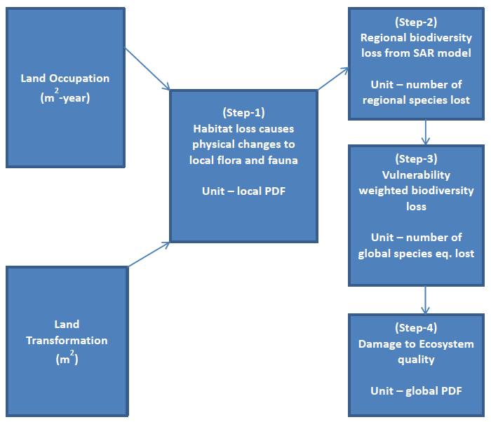
Figure 1: Cause-effect chain for ecosystem ecosystem quality impacts by land use and the modelled impact pathway (taken from Chaydhary et al., (2015) LC-IMPACT Land Stress).

Table 1.2PLANTdex intensities percentile scores and ranges for individual crops globally.
 | Percentiles
Crop | min | 1^st | 5^th | 25^th | 50^th, | 75^th | 95th^th | 99^th | Max | Range
Barley | 0.09 | 0.36 | 0.40 | 0.46 | 0.51 | 0.57 | 0.64 | 0.69 | 0.82 | 0.73
Cassava | 0.02 | 0.29 | 0.34 | 0.41 | 0.46 | 0.52 | 0.58 | 0.62 | 0.94 | 0.93
Cotton | 0.15 | 0.34 | 0.41 | 0.49 | 0.55 | 0.61 | 0.70 | 0.74 | 0.97 | 0.81
Groundnut | 0.14 | 0.29 | 0.35 | 0.41 | 0.46 | 0.51 | 0.59 | 0.64 | 0.94 | 0.80
Maize | 0.14 | 0.34 | 0.38 | 0.45 | 0.50 | 0.56 | 0.64 | 0.70 | 0.98 | 0.84
Millet | 0.05 | 0.33 | 0.37 | 0.43 | 0.47 | 0.51 | 0.59 | 0.67 | 0.96 | 0.92
Oilplam | 0.04 | 0.15 | 0.25 | 0.35 | 0.40 | 0.46 | 0.52 | 0.56 | 0.77 | 0.73
Potato | 0.11 | 0.33 | 0.38 | 0.46 | 0.51 | 0.57 | 0.65 | 0.73 | 0.99 | 0.88
Rapeseed | 0.22 | 0.32 | 0.36 | 0.42 | 0.47 | 0.53 | 0.60 | 0.66 | 0.87 | 0.65
Rice | 0.26 | 0.37 | 0.42 | 0.49 | 0.54 | 0.59 | 0.67 | 0.72 | 0.93 | 0.67
Rye | 0.15 | 0.31 | 0.35 | 0.41 | 0.46 | 0.52 | 0.59 | 0.66 | 0.85 | 0.70
Sorghum | 0.18 | 0.30 | 0.35 | 0.41 | 0.46 | 0.51 | 0.57 | 0.63 | 0.93 | 0.75
Soybean | 0.12 | 0.38 | 0.43 | 0.50 | 0.55 | 0.61 | 0.68 | 0.72 | 1.00 | 0.88
Sugarbeet | 0.07 | 0.30 | 0.36 | 0.43 | 0.48 | 0.53 | 0.62 | 0.69 | 0.81 | 0.75
Sugarcane | 0.02 | 0.16 | 0.25 | 0.40 | 0.46 | 0.51 | 0.57 | 0.62 | 0.81 | 0.79
Wheat | 0.11 | 0.33 | 0.38 | 0.44 | 0.49 | 0.55 | 0.64 | 0.71 | 0.88 | 0.77
Range | 0.25 | 0.23 | 0.18 | 0.15 | 0.15 | 0.15 | 0.17 | 0.18 | 0.23

Table 1.3 PLANTdex total percentile scores and ranges for individual crops globally.
 | Percentiles
Row | min | 1^st | 5^th | 25^th | 50^th, | 75^th | 95th^th | 99^th | Max | Range
Barley | 0.00 | 0.60 | 0.66 | 0.75 | 0.80 | 0.85 | 0.89 | 0.91 | 0.94 | 0.93
Cassava | 0.12 | 0.60 | 0.66 | 0.74 | 0.79 | 0.82 | 0.87 | 0.91 | 0.96 | 0.84
Cotton | 0.25 | 0.58 | 0.66 | 0.73 | 0.77 | 0.81 | 0.88 | 0.90 | 0.94 | 0.69
Groundnut | 0.11 | 0.55 | 0.61 | 0.69 | 0.76 | 0.81 | 0.86 | 0.89 | 0.94 | 0.83
Maize | 0.31 | 0.63 | 0.70 | 0.77 | 0.82 | 0.86 | 0.91 | 0.94 | 0.97 | 0.67
Millet | 0.02 | 0.58 | 0.63 | 0.70 | 0.75 | 0.80 | 0.85 | 0.89 | 0.94 | 0.92
Oilplam | 0.08 | 0.54 | 0.65 | 0.74 | 0.78 | 0.83 | 0.90 | 0.94 | 0.99 | 0.91
Potato | 0.01 | 0.56 | 0.64 | 0.73 | 0.79 | 0.83 | 0.87 | 0.89 | 0.94 | 0.93
Rapeseed | 0.17 | 0.58 | 0.63 | 0.70 | 0.74 | 0.80 | 0.87 | 0.89 | 0.94 | 0.76
Rice | 0.21 | 0.62 | 0.67 | 0.74 | 0.81 | 0.86 | 0.93 | 0.95 | 0.99 | 0.78
Rye | 0.04 | 0.57 | 0.62 | 0.70 | 0.75 | 0.80 | 0.86 | 0.88 | 0.92 | 0.88
Sorghum | 0.36 | 0.57 | 0.62 | 0.71 | 0.75 | 0.81 | 0.87 | 0.90 | 0.96 | 0.60
Soybean | 0.21 | 0.59 | 0.65 | 0.72 | 0.77 | 0.82 | 0.89 | 0.92 | 0.96 | 0.75
Sugarbeet | 0.20 | 0.56 | 0.65 | 0.73 | 0.80 | 0.85 | 0.89 | 0.91 | 0.95 | 0.75
Sugarcane | 0.28 | 0.64 | 0.71 | 0.77 | 0.81 | 0.85 | 0.91 | 0.94 | 1.00 | 0.72
Wheat | 0.02 | 0.61 | 0.67 | 0.76 | 0.83 | 0.88 | 0.91 | 0.93 | 0.96 | 0.94
Range | 0.36 | 0.11 | 0.10 | 0.08 | 0.08 | 0.08 | 0.07 | 0.07 | 0.08

GHG Vs LD | GHG Vs NMBL | GHG vs WD | GHG vs PFBL
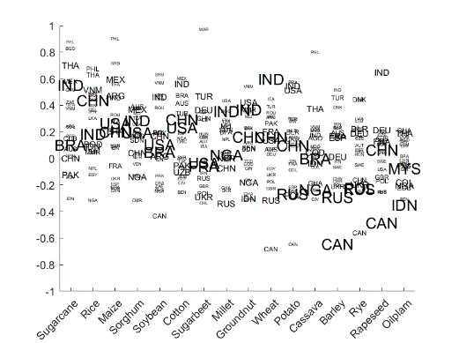 | 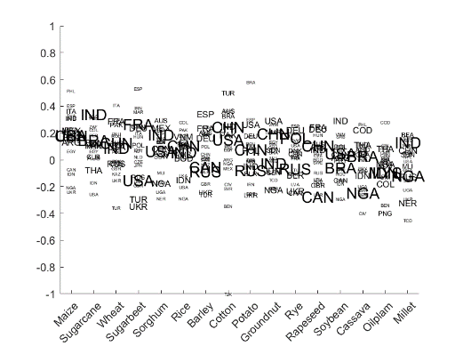 | 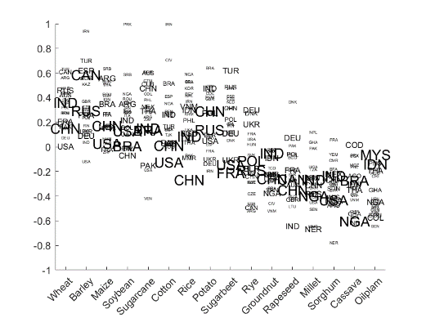 | 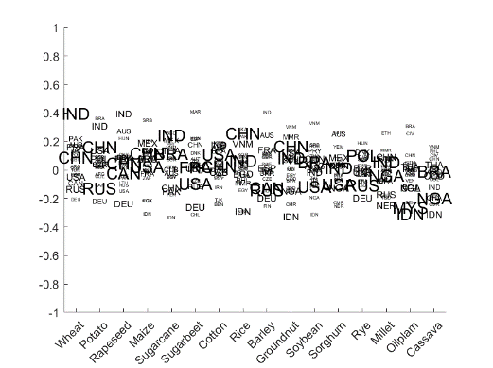
OLBL vs NMBL | OLBL vs PMBL | NMBL vs PFBL | WD vs OLBL
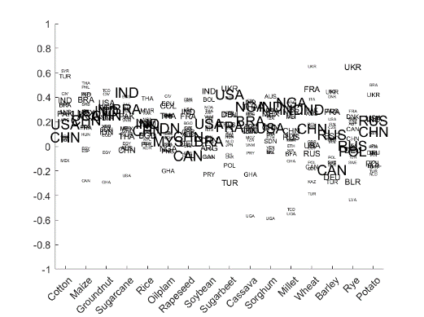 | 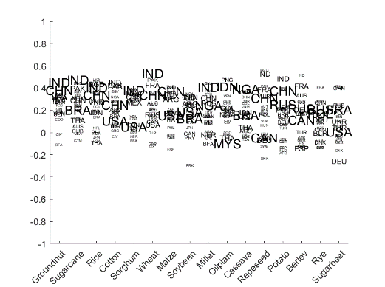 | 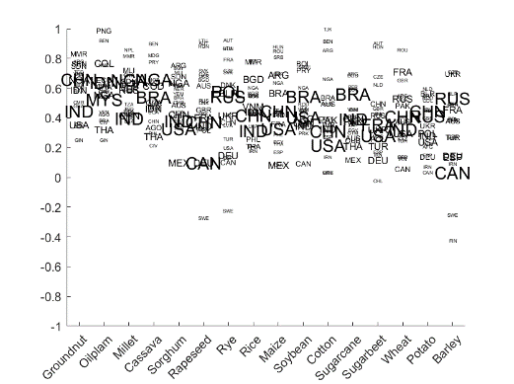 | 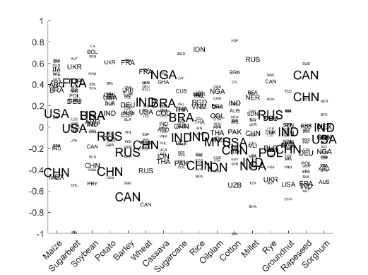
WD vs NMBL | WD vs PFBL
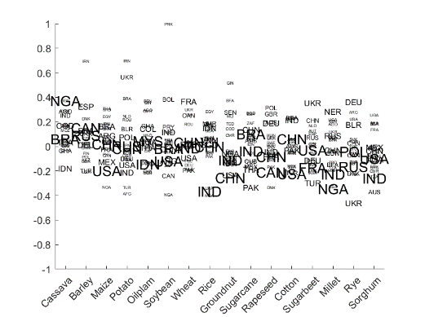 | 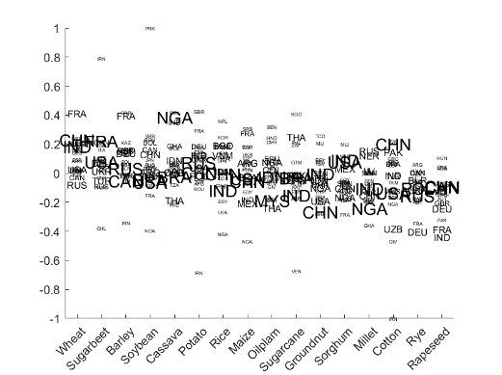 | Figure 2: Correlation plots for each pairing of indicators showing the variations of correlations per crop for the top 20 countries of its production. Crops are ordered by their average positive correlation.

