Supplementary Materials for
Blockade of OX40/OX40L signaling using anti-OX40L delays disease progression in murine lupus

Graphical Abstract

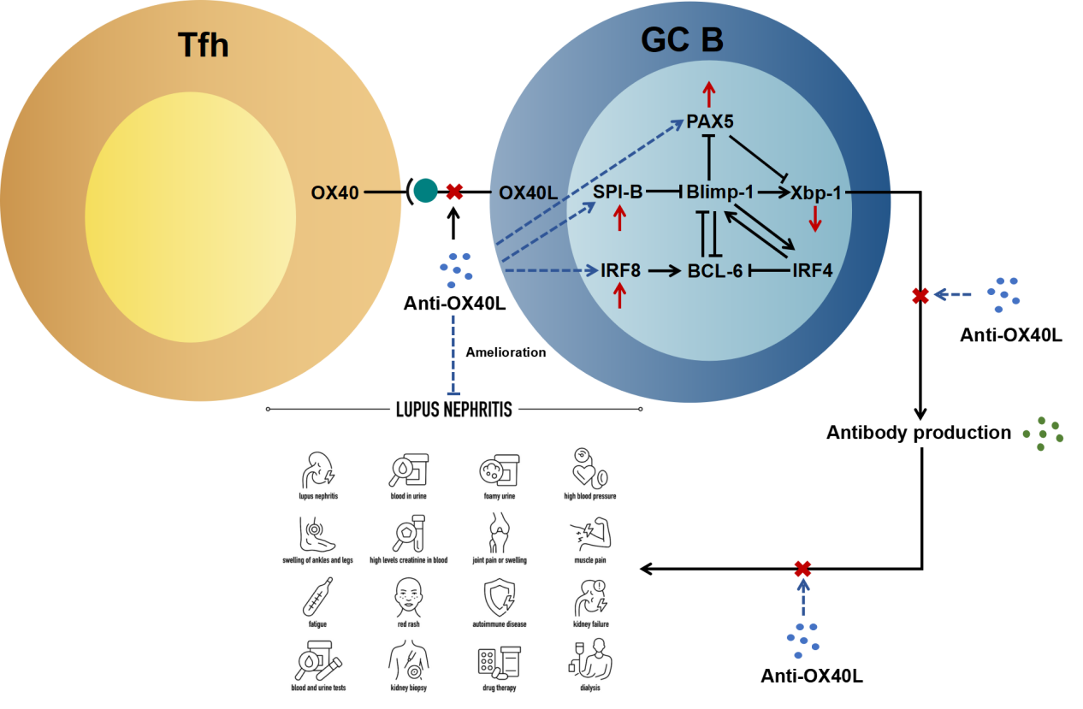

- Upregulation of OX40 on Tfh cells promotes their contact with OX40L-expressing GC B.
- Activation of OX40/OX40L signaling promotes B cell differentiation and antibody production.
- Blocking OX40/OX40L signaling inhibits ASCs differentiation and antibody production through the up-regulation of SPI-B, IRF8, and PAX5, and down-regulation of Xbp-1 in B cells and delays lupus progress.

Supplementary Fig 1. Anti-OX40L-mediated response of splenic immune cells in MRL/lpr mice. (a) Representative flow cytometry diagrams and statistical analysis of the percentages of CD4⁺ cells, CD8⁺ cells, CD4⁺ TCM cells, CD4⁺ TEM cells, CD4⁺ TEMRA cells, CD8⁺ TCM cells, CD8⁺ TEM cells, and CD8⁺ TEMRA cells in the spleens of the MRL/lpr mice. (b) Representative flow cytometry diagrams and statistical analysis of the percentages of naïve B cells, memory B cells, GC B cells, plasmablast cells, plasma cells in the spleens of the MRL/lpr mice. Horizontal bars represent the mean ± SEM. n = 11 in MRL/lpr group (4 mice died); n = 10 in MRL/Lpr + CTX treated group (1 mouse died); n = 11 in MRL/lpr+Anti-OX40L treated group (2 mice died). *p < 0.05, **p < 0.01, ***p < 0.001, ****p < 0.0001.

Supplementary Fig 2. Anti-OX40L’s function in mRNA levels of pro-inflammatory cytokines (IL-1α, IL-1β, IL-6, IL-9, IL-17A, IFN-α, TNF-α, APRIL, BAFF), and markers of inflammatory cells (BCMA, CD4, CD8, CD11b, CD19, CD45, CD138) in the kidney of MRL/Lpr mice. Horizontal bars represent the mean ± SEM. *p < 0.05.

Supplementary Fig 3. The KLH-induced response in anti-OX40L treated mice. Representative flow cytometry diagrams and statistical analysis of the percentages of CD4+ TCM cells, CD4+ TEM cells, CD4+ TEMR cells and Tfh cells in the spleens of the C57 mice. Horizontal bars represent the mean ± SEM. n = 5 in C57 blank group (no KLH immunization); n = 7 in C57+KLH treated group; n=6 in C57+KLH+anti-OX40L treated group. *p < 0.05, **p < 0.01, ***p < 0.001.

Supplementary Table 1
Primers for qRT-PCR
Species | Gene | Direction | Sequence (5’→3’)
Mouse | IL-1α | Former | GCACCTTACACCTACCAGAGT
 |  | Reverse | AAACTTCTGCCTGACGAGCTT
Mouse | IL-1β | Former | TGGACCTTCCAGGATGAGGACA
 |  | Reverse | GTTCATCTCGGAGCCTGTAGTG
Mouse | IL-2 | Former | GTGCTCCTTGTCAACAGCG
 |  | Reverse | GGGGAGTTTCAGGTTCCTGTA
Mouse | IL-4 | Former | GGTCTCAACCCCCAGCTAGT
 |  | Reverse | GCCGATGATCTCTCTCAAGTGAT
Mouse | IL-5 | Former | CTCTGTTGACAAGCAATGAGACG
 |  | Reverse | TCTTCAGTATGTCTAGCCCCTG
Mouse | IL-6 | Former | CTGCAAGAGACTTCCATCCAG
 |  | Reverse | AGTGGTATAGACAGGTCTGTTGG
Mouse | IL-9 | Former | ATGTTGGTGACATACATCCTTGC
 |  | Reverse | TGACGGTGGATCATCCTTCAG
Mouse | IL-13 | Former | AGACCAGACTCCCCTGTGCA
 |  | Reverse | TGGGTCCTGTAGATGGCATTG
Mouse | IL-17A | Former | TCCAGAAGGCCCTCAGACTA
 |  | Reverse | CTCGACCCTGAAAGTGAAGG
Mouse | IL-21 | Former | GGACCCTTGTCTGTCTGGTAG
 |  | Reverse | TGTGGAGCTGATAGAAGTTCAGG
Mouse | TNF-α | Former | CCTGTAGCCCACGTCGTAG
 |  | Reverse | GGGAGTAGACAAGGTACAACCC
Mouse | IFN-α | Former | ATGAACGCTACACACTGCATC
 |  | Reverse | CCATCCTTTTGCCAGTTCCTC
Mouse | IFN-β | Former | CAGCTCCAAGAAAGGACGAAC
 |  | Reverse | GGCAGTGTAACTCTTCTGCAT
Mouse | IFN-γ | Former | ATGAACGCTACACACTGCATC
 |  | Reverse | CCATCCTTTTGCCAGTTCCTC
Mouse | BAFF | Former | ACACTGCCCAACAATTCCTG
 |  | Reverse | TCGTCTCCGTTGCGTGAAATC
Mouse | APRIL | Former | CTTTCGGTTGCTCTTTGGTTG
 |  | Reverse | CGACAGCACAAGTCACAGC
Mouse | CCL2 | Former | CAGCCAGATGCAATCAATGCC
 |  | Reverse | TGGAATCCTGAACCCACTTCT
Mouse | CCL7 | Former | GCTGCTTTCAGCATCCAAGTG
 |  | Reverse | CCAGGGACACCGACTACTG
Mouse | CCL8 | Former | TCTACGCAGTGCTTCTTTGCC
 |  | Reverse | AAGGGGGATCTTCAGCTTTAGTA
Mouse | CD3 | Former | ATGCGGTGGAACACTTTCTGG
 |  | Reverse | GCACGTCAACTCTACACTGGT
Mouse | CD4 | Former | TCCTAGCTGTCACTCAAGGGA
 |  | Reverse | TCAGAGAACTTCCAGGTGAAGA
Mouse | CD8 | Former | CCGTTGACCCGCTTTCTGT
 |  | Reverse | CGGCGTCCATTTTCTTTGGAA
Mouse | CD11b | Former | ATGGACGCTGATGGCAATACC
 |  | Reverse | TCCCCATTCACGTCTCCCA
Mouse | CD19 | Former | GGAGGCAATGTTGTGCTGC
 |  | Reverse | ACAATCACTAGCAAGATGCCC
Mouse | CD45 | Former | ATGGTCCTCTGAATAAAGCCCA
 |  | Reverse | TCAGCACTATTGGTAGGCTCC
Mouse | CD138 | Former | CTTTGTCACGGCAGACACCTT
 |  | Reverse | GACAGAGGTAAAAGCAGTCTCG
Mouse | BCMA | Former | GCGCAACAGTGTTTCCACAG
 |  | Reverse | CGCTTGGATCACAGTAAGGCT
Mouse | β-actin | Former | GTGACGTTGACATCCGTAAAGA
 |  | Reverse | GCCGGACTCATCGTACTCC

