Supporting Information
Polymeric micelles with chiral diamine-Ru (II) catalysts for asymmetric transfer hydrogenation of ketones in water
Lianpei Zhou¹, Peipei Ji¹, Xiuwu Wang¹, Dongming Qi^{1,2}, and Tao Chen^{1,2}*

1. Zhejiang Provincial Engineering Research Center for Green and Low-carbon Dyeing & Finishing, Zhejiang Sci-Tech University, Hangzhou 310018
2. Key Laboratory of Green Cleaning Technology & Detergent of Zhejiang Province, Lishui, 323000

Preparation of NB-NHS
The preparation of NB-NHS refers to the our previous report.^{[1]} Exo-bicyclo[2.2.1] hept-5-ene-2-carboxylic acid (Exo-NB-COOH) (1.00 g, 7.24 mmol) was dissolved in DCM (12 mL). The solution of NHS (0.83 g, 7.24 mmol) in DCM (8 mL) was added to the above solution by stirring in an ice bath. DCC and DMAP were added and stirred until completely dissolved. The ice bath was removed and the reaction was continued for another 12 h. After the reaction, the solids were removed by filtration, the filtrates was washed with saturated NaCl aqueous solution (10 mL × 2), and dried over anhydrous magnesium sulfate. After filtration, the solvent was removed by a rotary evaporator, and NB-NHS was purified by column chromatography using dichloromethane: ethyl acetate = 10:1 as an eluting mixture to afford NB-NHS as a white solid (1.25g, 75%). ¹H NMR (400 MHz, CDCl₃) δ 6.24 – 6.11 (m, 2H), 3.27 (s, 1H), 3.00 (s, 1H), 2.84 (s, 4H), 2.51 (dd, J = 9.0, 3.6 Hz, 1H), 2.05 (dt, J = 12.0, 4.0 Hz, 1H), 1.58 – 1.53 (m, 2H), 1.45 (d, J = 8.9 Hz, 1H).
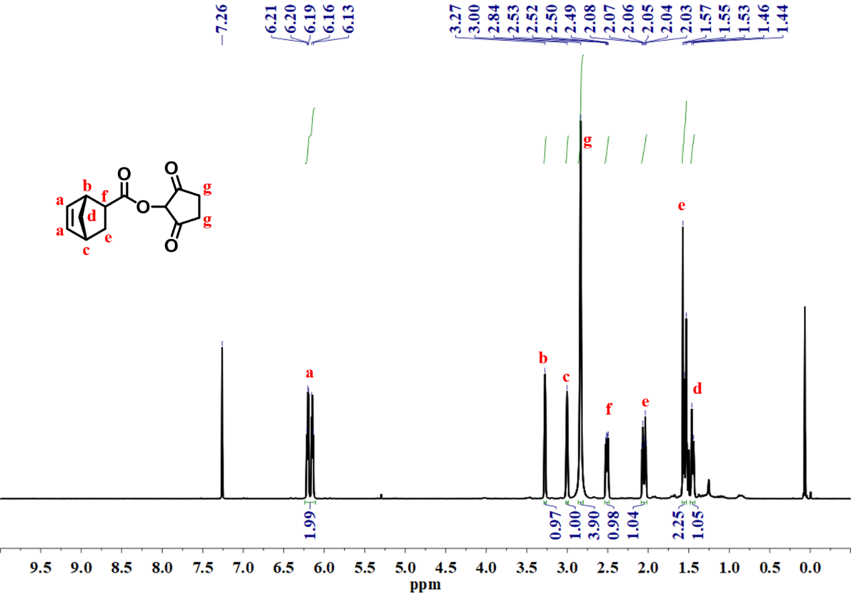
Figure S1. ¹H NMR spectrum of NB-NHS (400 MHz, CDCl₃)

Synthesis of NB-PEG₂₀₀₀
The preparation of NB-PEG₂₀₀₀ refers to the literature.^{[2]} Exo-NB-COOH (1.33 g, 9.66 mmol), PEG₂₀₀₀ (12.89 g, 6.44 mmol), EDC·HCl (1.85 g, 9.66 mmol), and DMAP (0.16 g 1.29 mmol) were dissolved in DCM (20 mL) in turn and refluxed at 70 ºC for three days. Then, the reaction mixture was washed by saturated NaCl and saturated NaHCO₃ aqueous solutions consequently. After filtration, the organic phase was dried over anhydrous magnesium sulfate. The solvent was removed in vacuum and the crude product was precipitated in cold ether to obtain a white solid NB-PEG₂₀₀₀ (11.78 g, 86 %). ¹H NMR (400 MHz, CDCl₃) δ 6.11 (ddd, J = 14.7, 5.6, 3.0 Hz, 2H), 4.24 (dd, J = 5.6, 4.3 Hz, 2H), 3.72 – 3.68 (m, 2H), 3.64 (s, 149H), 3.37 (s, 3H), 3.04 (s, 1H), 2.91 (s, 1H), 2.25 (dd, J = 10.1, 4.4 Hz, 1H), 1.52 (d, J = 8.3 Hz, 1H), 1.36 (s, 2H), 1.25 (s, 1H).
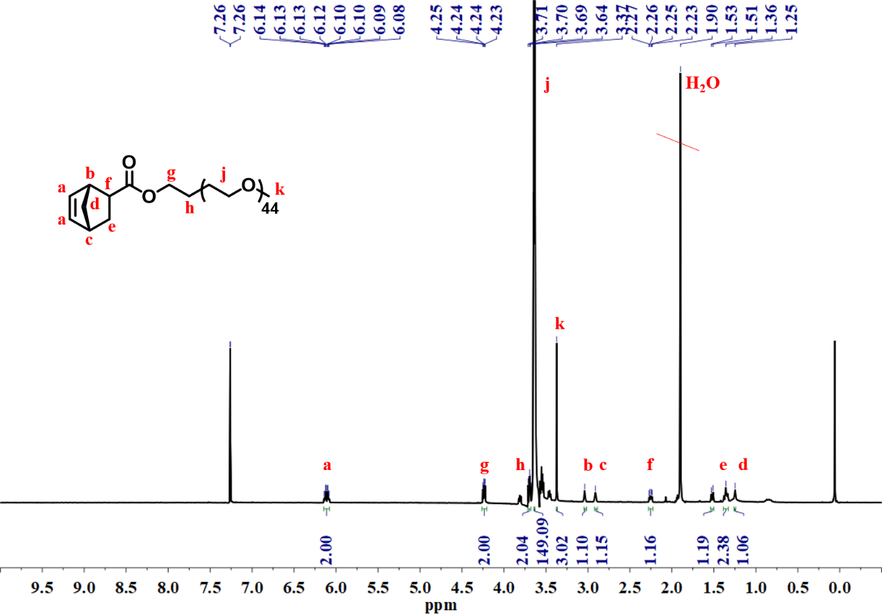Figure S2. ¹H NMR spectrum of NB-PEG₂₀₀₀ (400 MHz, CDCl₃)

Synthesis of tert-butyl ((1S,2S)-2-amino-1,2-diphenylethyl) carbamate (DPEN-Boc)
DPEN (1.93 g, 9.09 mmol) and 30 mL methanol were charged in a 100 mL round bottom flask. The mixture of HCl aqueous solution (36%, 1 mL, 10.91 mmol) and CH₃OH (10 mL) was slowly dropped into the above solution, and the reaction was stirred at 0 ºC for 15 min. Then (BOC)₂O (2.78 g, 12.73 mmol) in CH₃OH (15 mL) was added dropwise, and the resulting mixture was stirred at 0 °C for 10 min, and lastly was transferred to room temperature for 4 h. The solution was diluted with 2 mL water, then most of the volatiles were removed in vacuum. After the residue was dissolved in 20 mL water, the water layer was washed with 20 mL ether twice, the water layer was alkalized with 2 M NaOH, and then extracted with DCM for 3 times. The combined organic phase was dried over anhydrous sodium sulfate. After filtration, the organic solvent was removed by rotary evaporation. The crude product was purified by column chromatography with petroleum ether: ethyl acetate = 1:3 as eluent to afford DPEN-Boc as a white solid (1.56 g, 79 %). ¹H NMR (400 MHz, CDCl₃) δ 7.35 – 7.25 (m, 10H), 5.83 (d, J = 8.2 Hz, 1H), 4.86 (s, 1H), 4.34 (s, 1H), 1.74 (s, 2H), 1.33 (s, 9H).
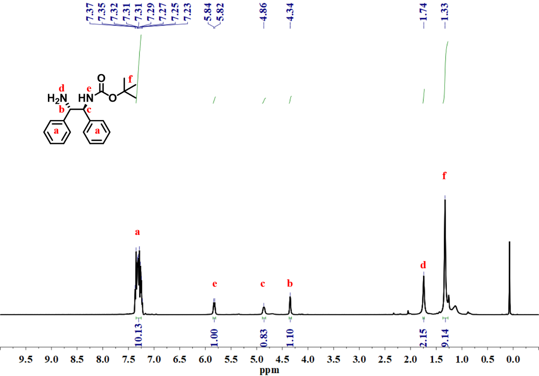
Figure S3. ¹H NMR spectrum of DPEN-Boc (400 MHz, CDCl₃)

Synthesis of tert-butyl ((1S,2S)-2-((1R,4R)-bicyclo-[2.2.1] hept-5-ene-2-carboxamido)-1,2-diphenylethyl) carbamate (NB-DPEN-Boc)
DPEN-Boc (1.40 g, 4.48 mmol) and TEA (50 µL, 0.30 mmol) were dissolved in 10 mL of DCM. The mixture was stirred in an ice bath until the solid was completely dissolved. Then a solution of NB-NHS (1.47 g, 6.27 mmol) in DCM (10 mL) was added dropwise to the above solution. The ice bath was then removed and the reaction solution was stirred at room temperature for 24 h. The mixture was washed with saturated NaCl aqueous solution (20 mL × 3) and the organic phase was dried over anhydrous sodium sulfate. After filtration, the organic solvent was removed by rotary evaporation. The crude product was purified by column chromatography using DCM : ethyl acetate = 15:1 as an eluting mixture to obtain NB-DPEN-Boc (1.11 g, 57 %). ¹H NMR (400 MHz, CDCl₃) δ 7.27 – 7.03 (m, 12H), 6.85 (s, 1H), 6.11 (d, J = 19.9 Hz, 2H), 5.48 (dd, J = 22.7, 8.0 Hz, 1H), 5.24 – 5.17 (m, 1H), 4.89 (dd, J = 18.7, 8.3 Hz, 1H), 2.94 (d, J = 33.1 Hz, 2H), 2.03 (d, J = 8.3 Hz, 1H), 1.91 (s, 2H), 1.66 (s, 2H), 1.44 (d, J = 10.2 Hz, 9H).

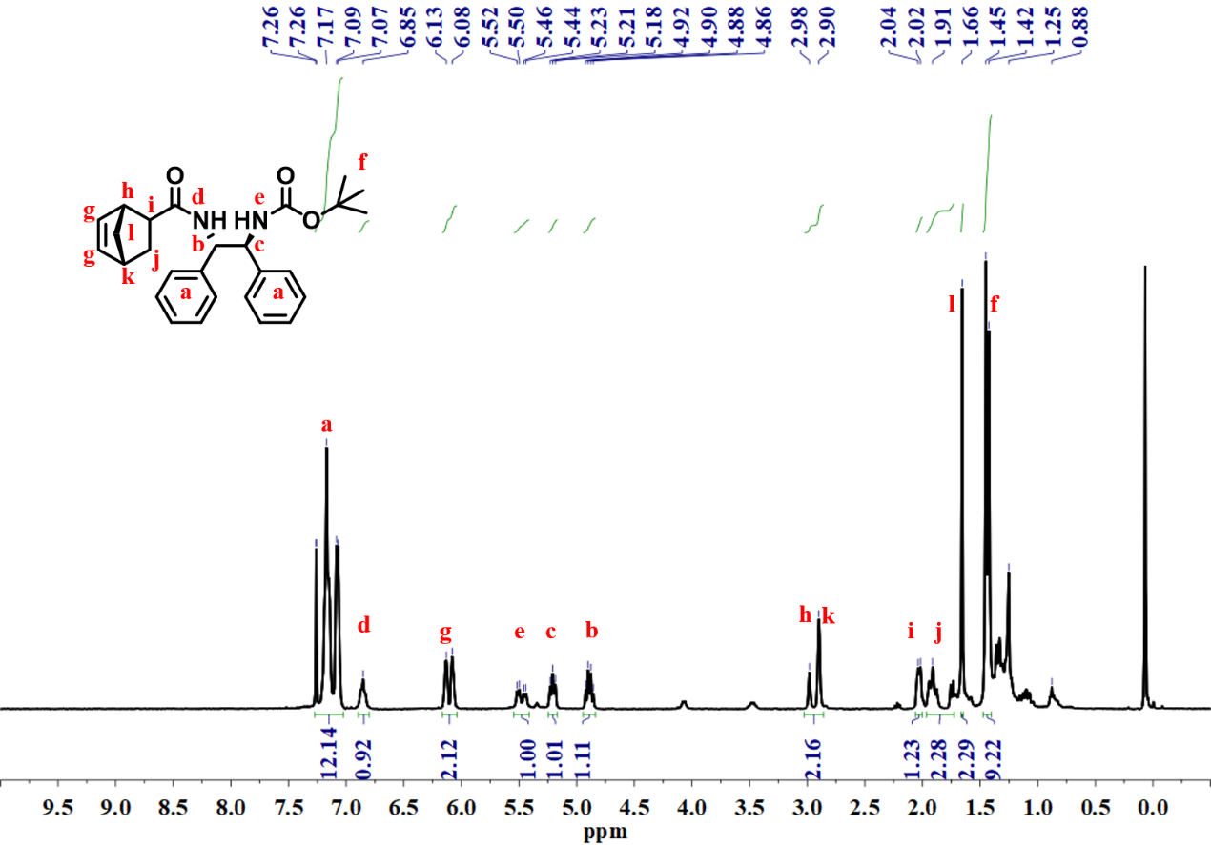
Figure S4. ¹H NMR spectrum of NB-DPEN-Boc (400 MHz, CDCl₃)

Synthesis of P(DPEN-Boc)₄ and P(DPEN-Boc)₇
The conversions of the polymerization were calculated from the unsaturated double bond of norbornene of the polymer and the proton number of the benzene ring of the chiral diamine ligand (Eq. 1) from ¹H NMR spectra (Figures S5, S6). The degree of polymerization (DP) of DPEN-Boc was calculated according to the monomer amount and its conversion.
$conv.\%=\frac{\frac{a}{10}-\frac{g}{2}}{\frac{a}{10}}×100\%$ (Eq. S1)
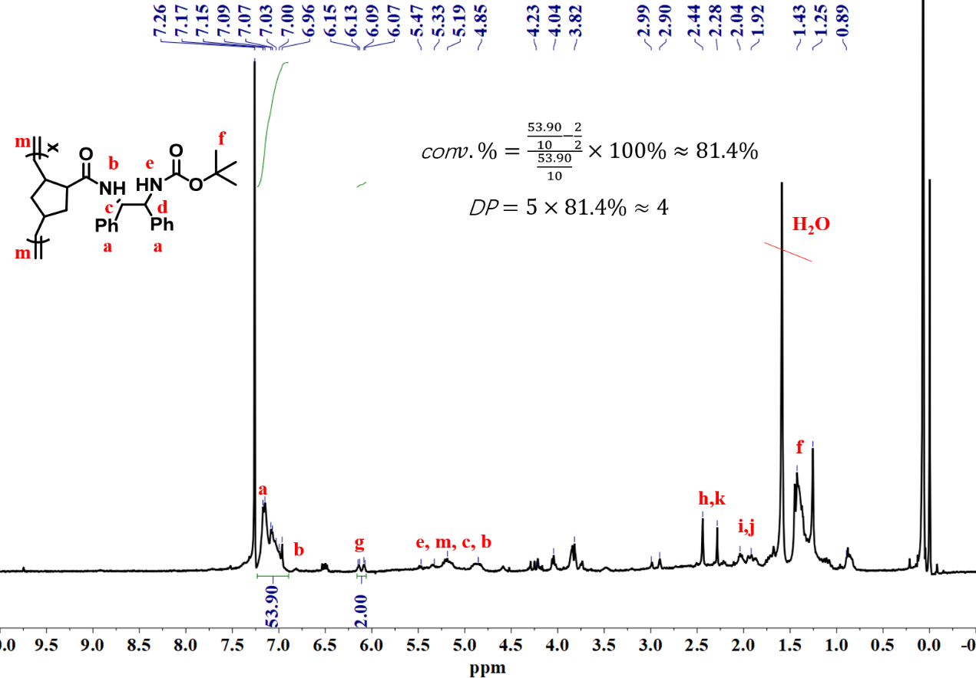
Figure S5. ¹H NMR spectrum of P(DPEN-Boc)₄ (400 MHz, CDCl₃)
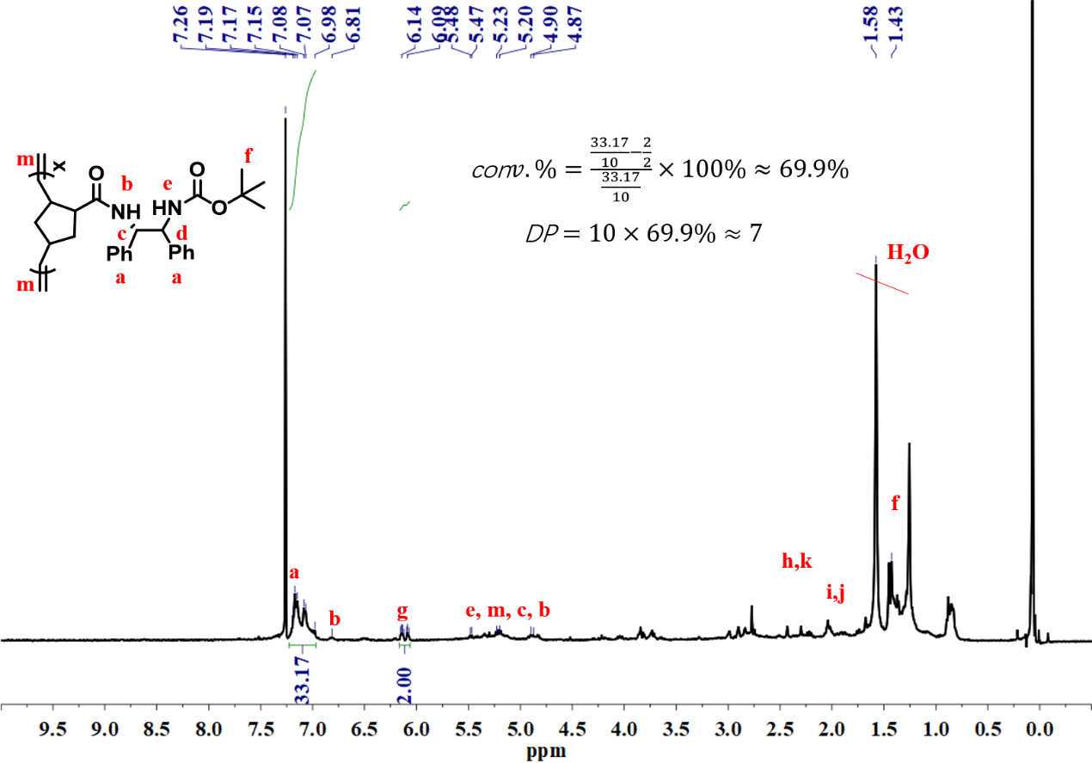
Figure S6. ¹H NMR spectrum of P(DPEN-Boc)₇ (400 MHz, CDCl₃)

Synthesis of P(DPEN-Boc)₄-co-P(PEG₂₀₀₀)₁₅ and P(DPEN)₇-co-P(PEG₂₀₀₀)₂₀
The conversions of NB-PEG₂₀₀₀ were determined by the unsaturated double bond of norbornene on the main chain of the polymer and the proton number of the terminal methyl of methoxy-PEG (Eq. S2) from ¹H NMR spectra (Figure S7 and S8).
$conv.\%=\frac{\frac{o}{3}-\frac{g}{2}}{\frac{o}{3}}×100\%$ (Eq. S2)
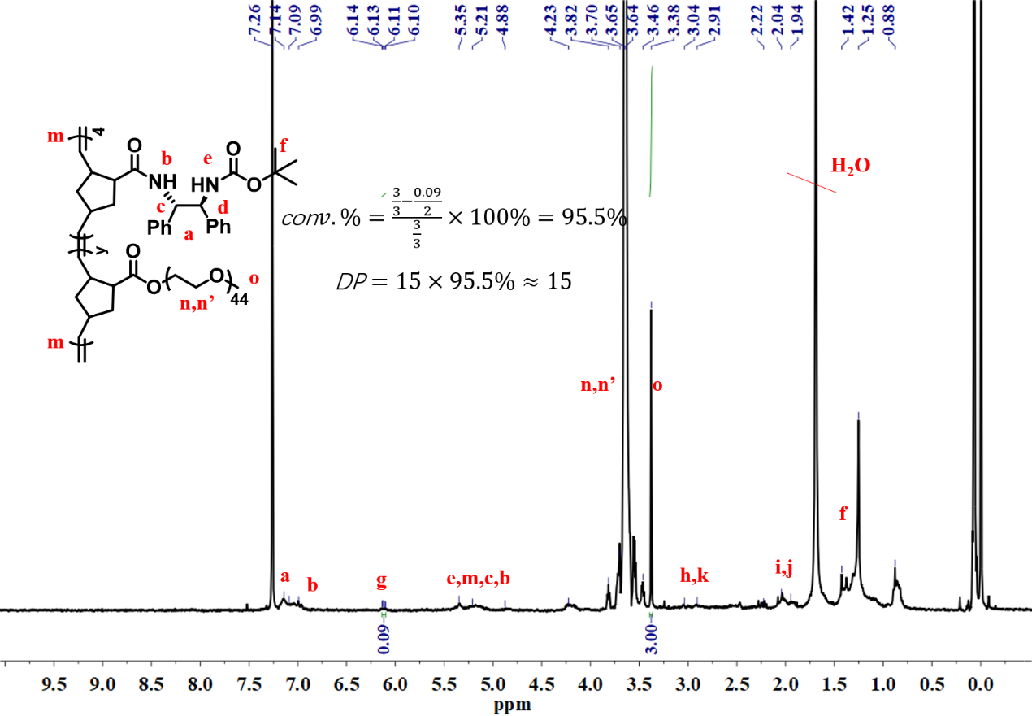
Figure S7. ¹H NMR spectrum of P(DPEN-Boc)₄-co-P(PEG₂₀₀₀)₁₅ (400 MHz, CDCl₃)

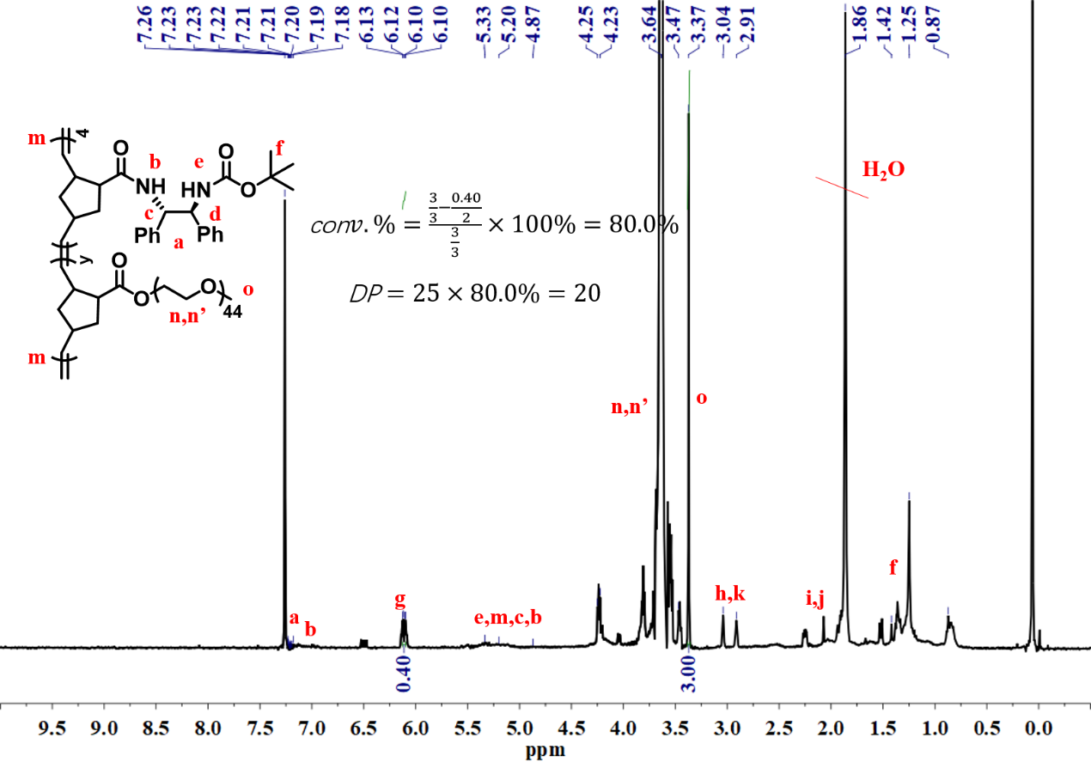
Figure S8. ¹H NMR spectrum of P(DPEN-Boc)₇-co-P(PEG₂₀₀₀)₂₀ (400 MHz, CDCl₃)

Synthesis of P(DPEN)₄-co-P(PEG₂₀₀₀)₁₅ and P(DPEN)₇-co-P(PEG₂₀₀₀)₂₀
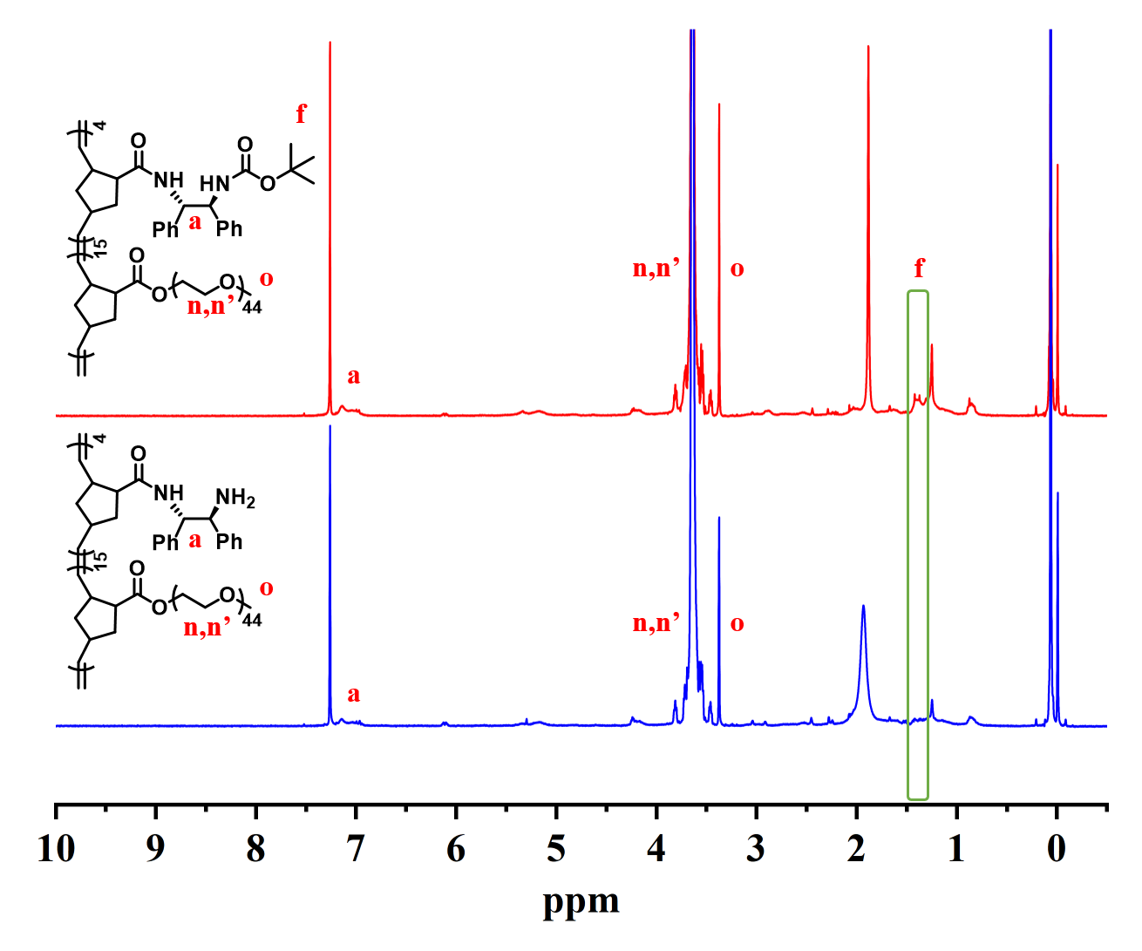
Figure S9. ¹H NMR spectrum of P(DPEN)₄-co-P(PEG₂₀₀₀)₁₅ (400 MHz, CDCl₃)

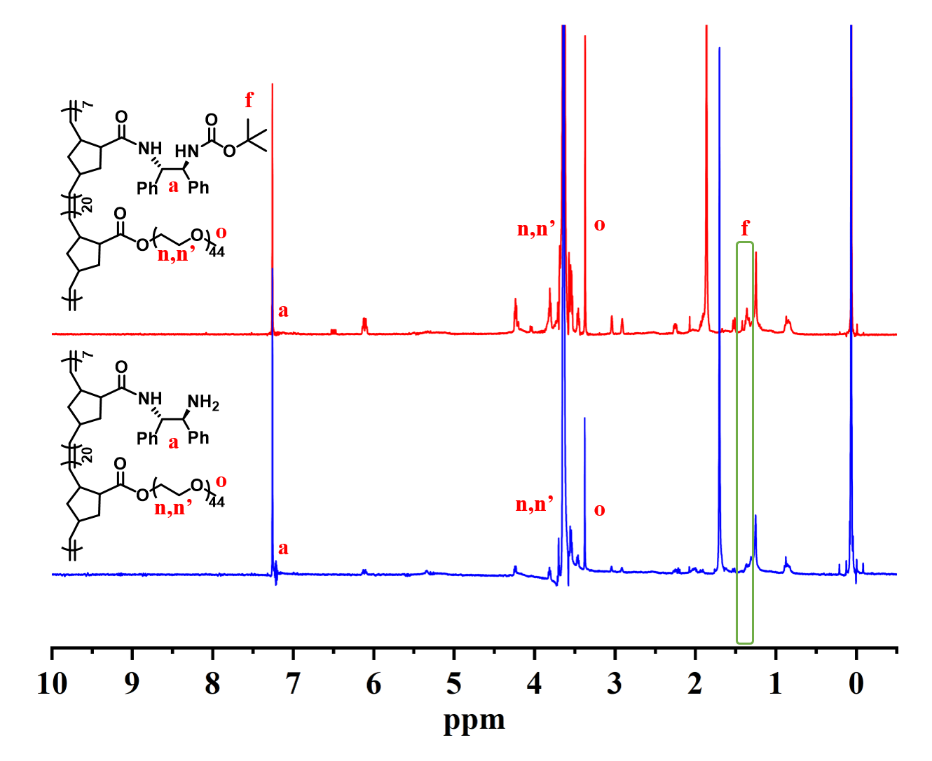
Figure S10. ¹H NMR spectrum of P(DPEN)₇-co-P(PEG₂₀₀₀)₂₀ (400 MHz, CDCl₃)

Reference
[1] Huang, J.; Zhu, X.; Wang, Y.; Min, Y.; Li, X.; Zhang, R.; Qi, D.; Hua, Z.; Chen, T. Polymer 2022, 255, 125173.
[2] Lin, Q.; Li, L.; Tang, M.; Uenuma, S.; Samanta, J.; Li, S.; Jiang, X.; Zou, L.; Ito, K.; Ke, C. Chem 2021, 7 (9), 2442-2459.

