Supporting Information
Text S1 The characteristics analysis of the CeO₂@CNT membrane
Table S1 The properties of the spiked surface water and spiked secondary effluent samples
Table S2 The properties of the actual secondary effluent samples
Table S3 Primer pairs used to quantify the 16SrRNA gene, antibiotic resistance genes and the mobile genetic element intΙ1
Fig. S1 Configuration of the electrified membrane reactor
Fig. S2 Physicochemical characteristics of the CeO₂@CNT membrane
Fig. S3 The ARGs removal of individual NaClO (a) and Ce₂O@CNT membrane (b): the spiked surface water

Text S1 The characteristics analysis of the CeO₂@CNT membrane
The morphologies of the CeO₂@CNT membrane were observed using a field emission scanning electron microscope (SEM) (Regulus8100, Hitachi, Japan) with an elemental analysis energy dispersive spectrometer (EDAX EDS Octane Elect Super-70mm², America) with 5 kV accelerating voltage. The analyses were performed at a working distance of 7.2-9.7 mm with a magnification of 50 K or 100 K. The samples were coated with gold films to enhance the conductivity and secondary electron emission characteristics and to avoid surface charging under electron beam.
The crystalline structure of the CeO₂@CNT membrane was analyzed with an X-ray diffraction (XRD) technique was conducted on a Bruker advance D8, Germany using Cu Kα radiation in a 2θ range of 5-90° under an accelerating voltage of 40kV and the current 30mA. The scan rate was 6℃/min, the step size was 0.02°, the test speed was 0.1sec/step, the entry wavelength was 0.15118nm. The crystal structure of the CeO₂@CNT membrane was analyzed using MDI jade software.
Linear sweep voltammetry (LSV), Electrochemical Impedance Spectroscopy (EIS) and current versus time (I-t) curve of the CeO₂@CNT membrane were carried out in conventional three-electrode electrochemical cells driven by a CHI660D electrochemical workstation (Shanghai Cenhua Instrument Co., Ltd., China). The counter electrode was a ruthenium-iridium titanium plate (4 cm × 5 cm), and a Ag/AgCl electrode was used as the reference electrode. LSV analysis were performed in 10 mM NaClO solution at a scan rate of 0.01 V/s with the voltage changed from 0 V to 3 V. EIS measurements were performed in the 10 mM NaClO solution at frequencies of 1·10⁻¹Hz - 1∙10⁶ Hz with a signal amplitude of 5 mV at the init potential of 0 V. The I-t curves ofthe CNT@CeO₂ membrane were completed in 10mM NaClO solution. The operation time lasted 600s, aeration was given at 200 seconds, and antibiotics were added at 400 seconds. The sensitivity is 1× e⁻⁴.

Table S1 The properties of the spiked surface water and spiked secondary effluent samples
Water samples |  | Spiked surface water | Spiked Secondary effluent
pH |  | 7.0 ± 0.1 | 8.1 ± 0.1
SS, mg/L |  | 4.5 ± 0.8 | 1.3 ± 0.2
Conductivity, uS/cm |  | 520 ± 14 | 1357 ± 53
TOC, mg/L |  | 2.4 ± 0.3 | 14.3 ± 2.4
Abundance of genes, log/mL | sul1 | 5.35 ± 0.15 | 5.42 ± 0.14
Abundance of genes, log/mL | intI1 | 5.24 ± 0.09 | 5.41 ± 0.28
Abundance of genes, log/mL | 16SrRNA | 6.87 ± 0.13 | 6.59 ± 0.15

Table S2 The properties of the actual secondary effluent samples
Water samples |  | The actual secondary effluent
pH |  | 8.1 ± 0.1
SS, mg/L |  | 14.5 ± 0.7
Conductivity, uS/cm |  | 1670 ± 56
TOC, mg/L |  | 14.3 ± 2.4
Copy number of genes, mL⁻¹ | sul1 | 9 ± 5
Copy number of genes, mL⁻¹ | tetA | 62 ± 6
Copy number of genes, mL⁻¹ | intI1 | 88 ± 6
Copy number of genes, mL⁻¹ | 16SrRNA | 13158 ± 242

Table S3 Primer pairs used to quantify the 16SrRNA gene, antibiotic resistance genes and the mobile genetic element intΙ1
Target Genes | Primer | Primer Sequence (5’ to 3’) | Amplimer (bp)
sul1 | sul1-F | CGCACCGGAAACATCGCTGCAC | 163
sul1 | sul1-R | TGAAGTTCCGCCGCAAGGCTCG | 163
tetA | tetA-F | CAGGCAGGTGGATGAGGAA | 174
tetA | tetA -R | GGCAGGCAGAGCAAGTAGAG | 174
intΙ1 | Int1-F | GGCTTCGTGATGCCTGCTT | 146
intΙ1 | Int1-R | CATTCCTGGCCGTGGTTCT | 146
16SrRNA | 16S338F | ACTCCTACGGGAGGCAGCAG | 181
16SrRNA | 16S-518R | ATTACCGCGGCTGCTGG | 181

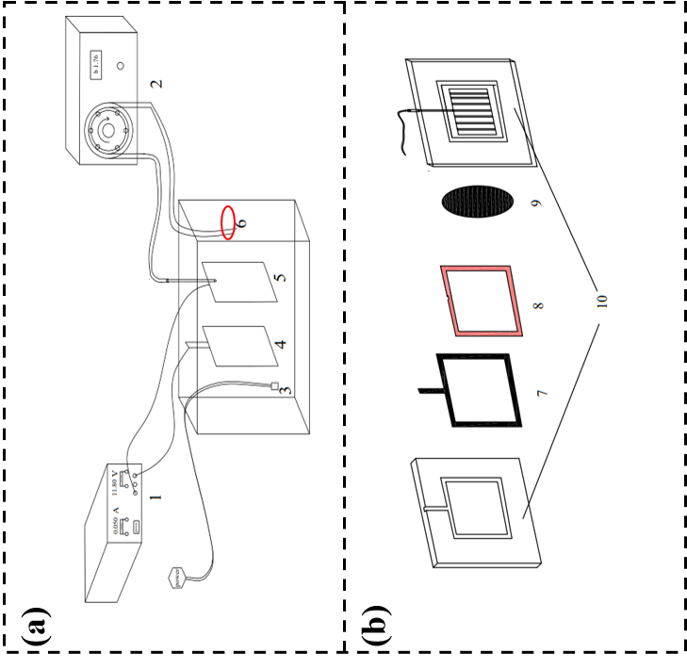

Fig. S1 Configuration of the electrified membrane reactor
(a) and the flat sheet membrane module (b). (1: DC electrical supply; 2: peristaltic pump; 3: aerator; 4: anode; 5: flat sheet membrane module; 6: the sample outlet; 7: titanium ring; 8: rubber gasket; 9: cathode; 10: plexiglass frame.
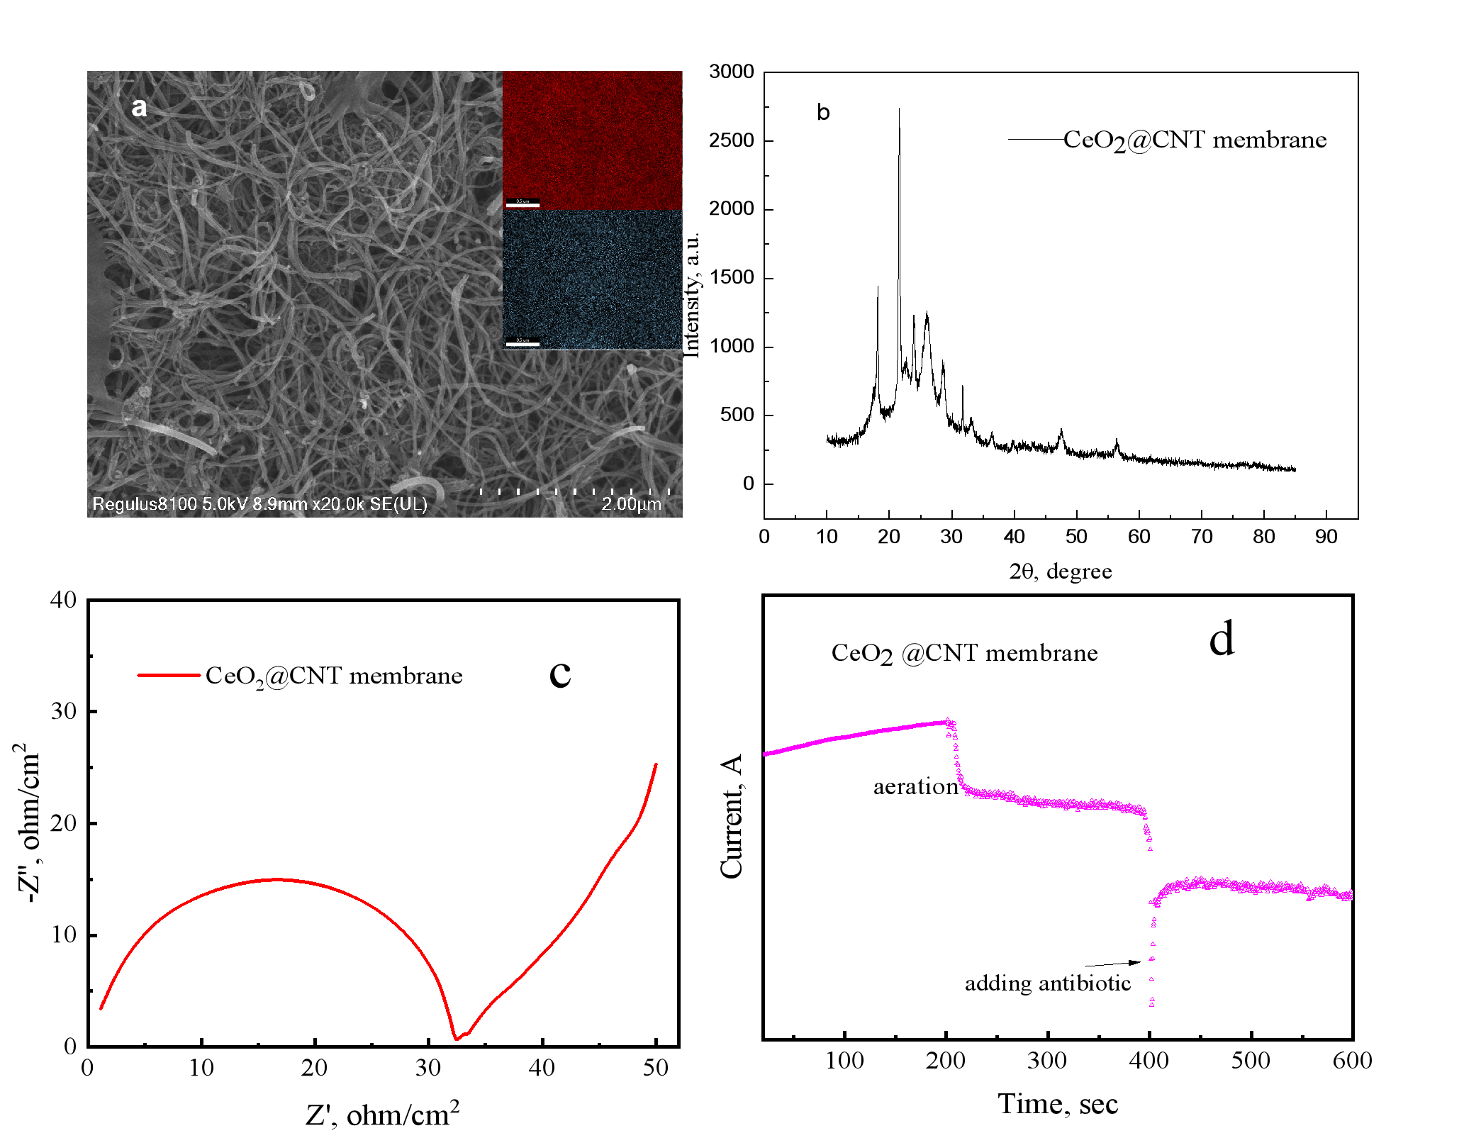

Fig. S2 Physicochemical characteristics of the CeO₂@CNT membrane
(a) SEM-EDS image, (b) XRD patterns, (c) EIS Nyquist plots and (d) I-t curve

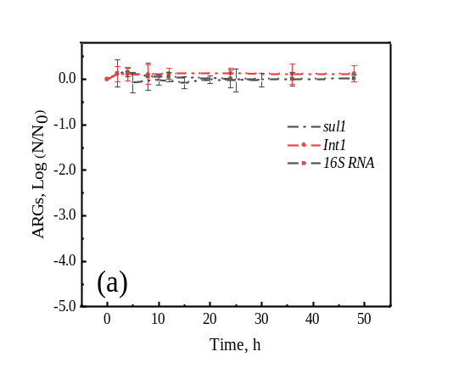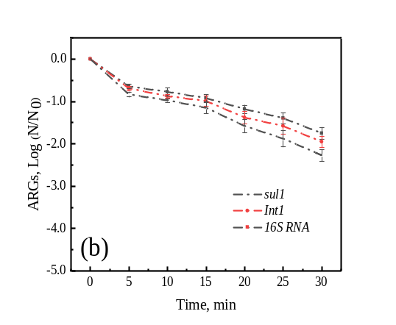

Fig. S3 The ARGs removal of individual NaClO (a) and Ce₂O@CNT membrane(b): the spiked surface water

