Supplementary data

Liquid phase oxidation of cyclopentanone over metal-free carbon catalysts

Dana Gašparovičová*, Milan Králik, Blažej Horváth, Tomáš Soták, Pavol Hudec

Slovak University of Technology in Bratislava, Faculty of Chemical and Food Technology, Institute of Organic Chemistry, Catalysis and Petrochemistry, Radlinského 9, 812 37 Bratislava, Slovakia

*Corresponding author: Dana Gašparovičová, e-mail: dana.gasparovicova@stuba.sk

Received [Dates will be filled in by the Editorial office]

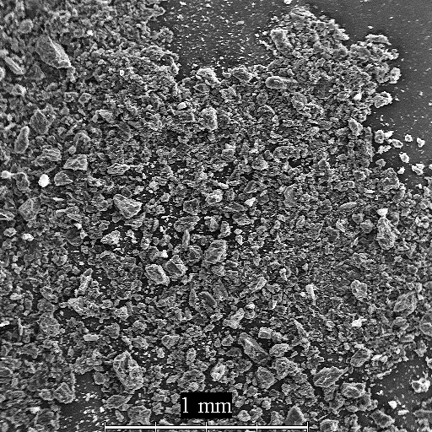
Fig. S1. Electron microscopy image of the Norit sample (CNH) treated with HCl and dried at 105 °C. Magnification 100x.

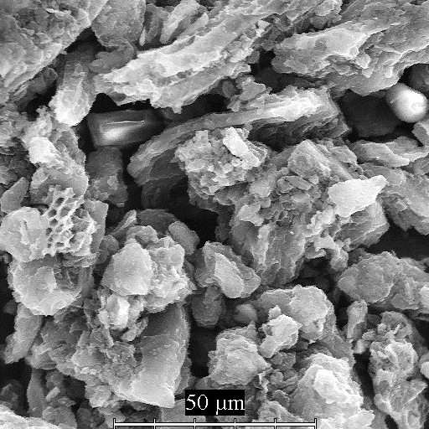
Fig. S2. Electron microscopy image of the Norit sample (CNH) treated with HCl and dried at 105 °C. Magnification 2000x.
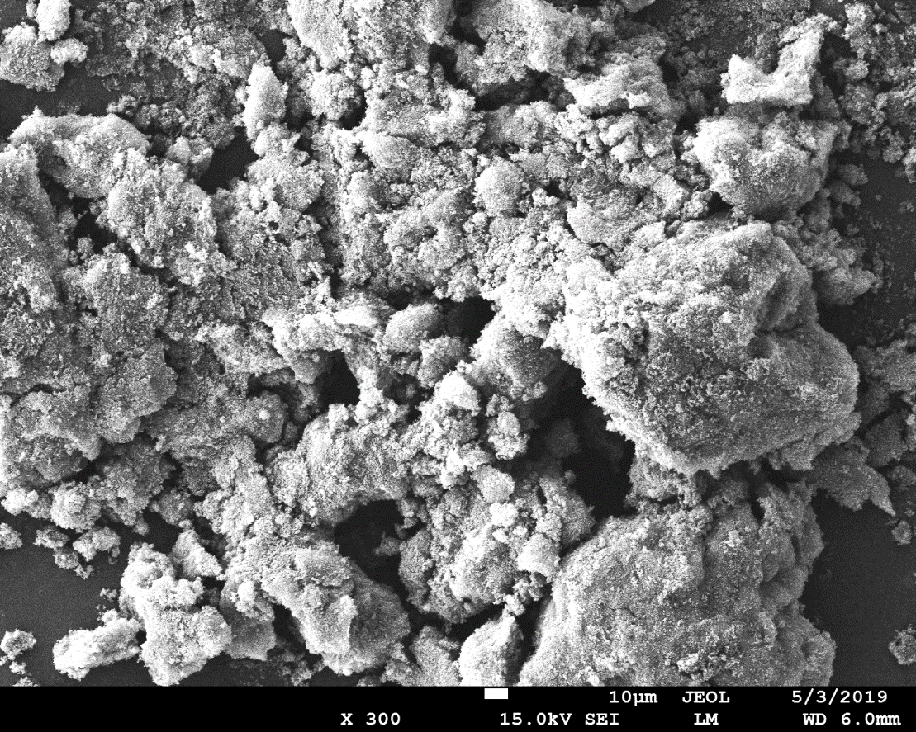
Fig. S3. Electron microscopy image of the Vulcan sample (CVHa) treated with HCl and dried at 105 °C. Magnification 300x.

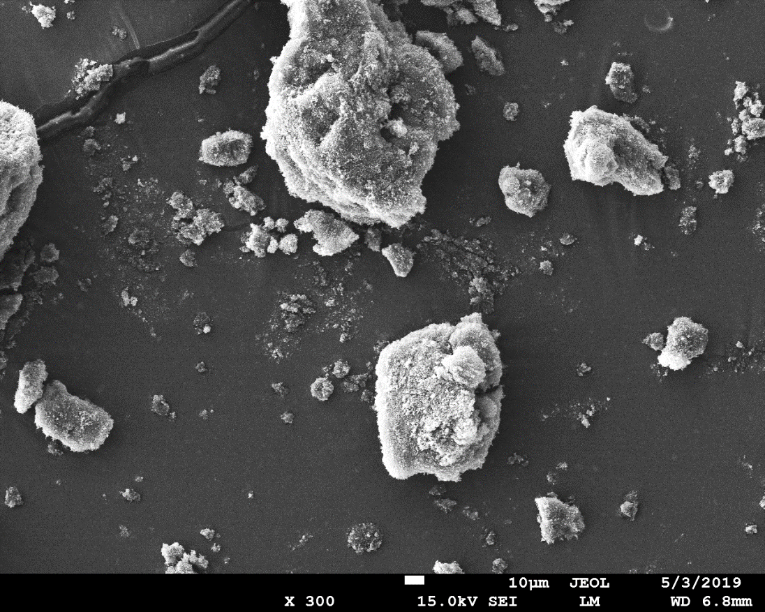
Fig. S4. Electron microscopy image of the Vulcan sample (CVU950) treated with HCl, treated with urea and calcined at 950 °C. Magnification 300x.
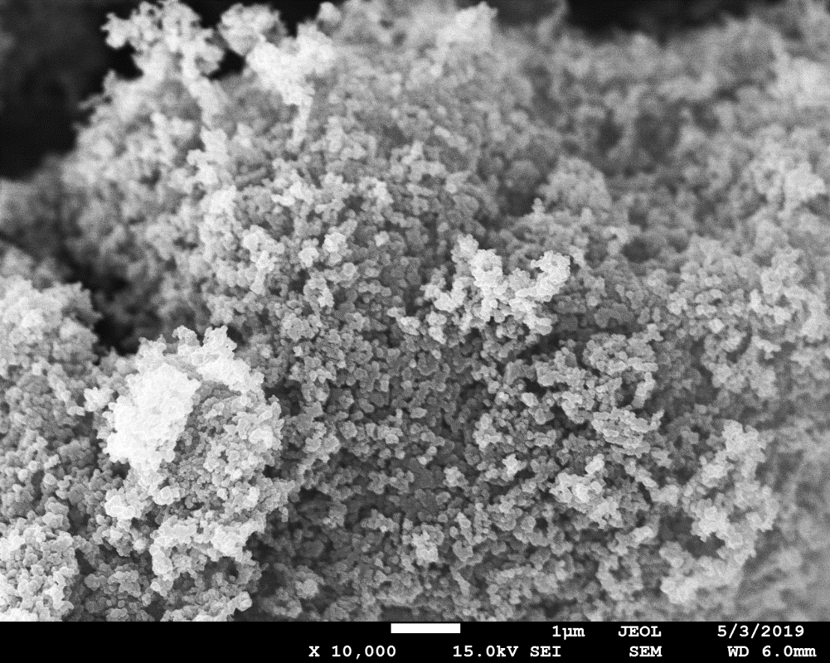
Fig. S5. Electron microscopy image of the Vulcan sample (CVHa) treated with HCl and dried at 105 °C. Magnification 10.000x.

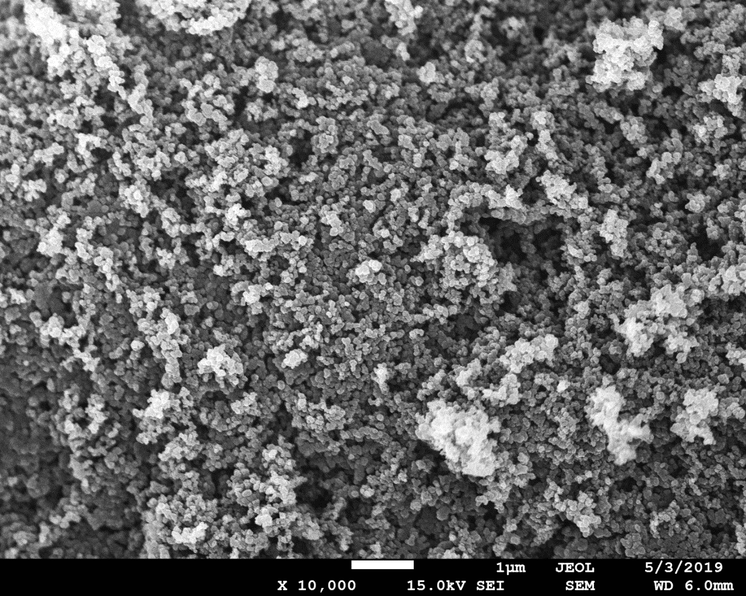
Fig. S6. Electron microscopy image of the Vulcan sample (CVU950) treated with HCl, treated with urea and calcined at 900 °C. Magnification 10.000x.
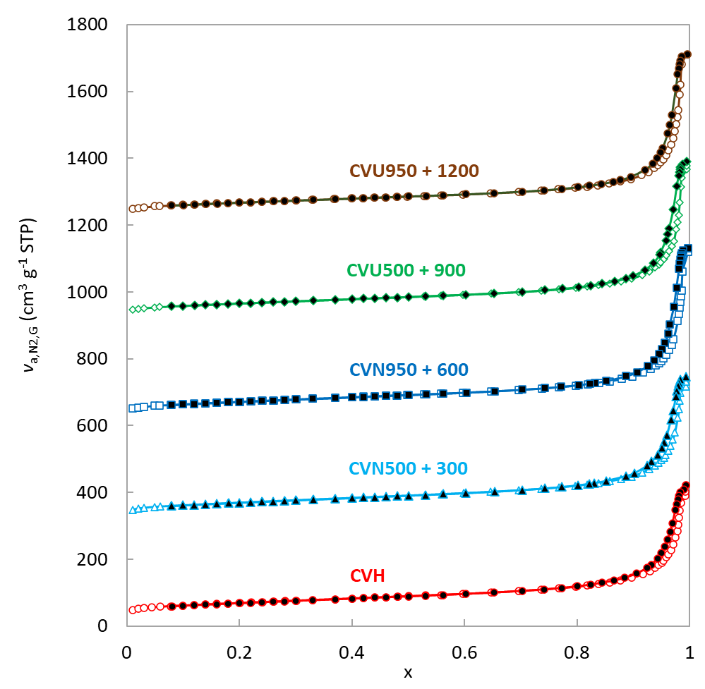
Fig. S7. Adsorption-desorption isotherms (x = p/p⁰).

Table S1. Textural parameters of modified activated carbons prepared from Norit SX plus and Vulcan XC72 (CABOT) estimated by the Micromeritics ASAP 2020
Parameter | CNH | CVHa | CVHb | CVN500 | CVN950 | CVU500 | CVU950
S_{1par} (m² g⁻¹) | 855 | 231 | 232 | 234 | 238 | 220 | 225
S_{BET} (m² g⁻¹) | 847 | 232 | 233 | 235 | 240 | 221 | 226
S_{Langm} (m² g⁻¹) | 1283 | 360 | 359 | 365 | 370 | 343 | 348
S_{t,micro} (m² g⁻¹) | 464 | 63 | 68 | 59 | 70 | 60 | 71
S_{t,ext} (m² g⁻¹) | 384 | 169 | 165 | 176 | 170 | 161 | 155
S_{BJH,ads} (m² g⁻¹) | 396 | 191 | 188 | 197 | 193 | 183 | 177
S_{BJH,des} (m² g⁻¹) | 425 | 181 | 181 | 189 | 183 | 173 | 168
V_{tot} (cm³ g ⁻¹) | 0.831 | 0.570 | 0.629 | 0.645 | 0.626 | 0.683 | 0.65
V_{t,micro} (cm³ g ⁻¹) | 0.244 | 0.033 | 0.035 | 0.031 | 0.036 | 0.031 | 0.037
V_{BJH,ads} (cm³ g ⁻¹) | 0.611 | 0.641 | 0.768 | 0.654 | 0.808 | 0.728 | 0.777
V_{BJH,des} (cm³ g ⁻¹) | 0.635 | 0.632 | 0.759 | 0.671 | 0.798 | 0.738 | 0.767
D_{4V/A,BET} (nm) | 7.8 | 19.7 | 21.6 | 21.9 | 20.9 | 24.7 | 23.0
D_{4V/A,BJH,ads} (nm) | 6.2 | 26.8 | 32.7 | 26.6 | 33.4 | 31.9 | 35.1
D_{4V/A,BJH,des} (nm) | 6.0 | 27.9 | 33.5 | 28.5 | 34.9 | 34.1 | 36.4

Acronyms in Table S1
Acronym
S_{1par} (m² g⁻¹) | Single point surface area at p/p° ≅ 0.3
S_{BET} (m² g⁻¹) | BET Surface Area
S_{Langm} (m² g⁻¹) | Langmuir Surface Area
S_{t,micro} (m² g⁻¹) | t-Plot Micropore Area
S_{t,ext} (m² g⁻¹) | t-Plot External Surface Area
S_{BJH,ads} (m² g⁻¹) | BJH Adsorption cumulative surface area of pores between 1.7 nm and 300 nm diameter
S_{BJH,des} (m² g⁻¹) | BJH Desorption cumulative surface area of pores between 1.7 nm and 300 nm diameter
V_{tot} (cm³ g ⁻¹) | Single point adsorption total pore volume of pores at 0.98 < p/p°< 0.99
V_{t,micro} (cm³ g ⁻¹) | t-Plot micropore volume
V_{BJH,ads} (cm³ g ⁻¹) | BJH Adsorption cumulative volume of pores between 1.7 and 300 nm diameter
V_{BJH,des} (cm³ g ⁻¹) | BJH Desorption cumulative volume of pores between 1.7 and 300 nm diameter
D_{4V/A,BET} (nm) | Adsorption average pore width (4V/A by BET)
D_{4V/A,BJH,ads} (nm) | BJH Adsorption average pore diameter (4V/A)
D_{4V/A,BJH,des} (nm) | BJH Desorption average pore diameter (4V/A)

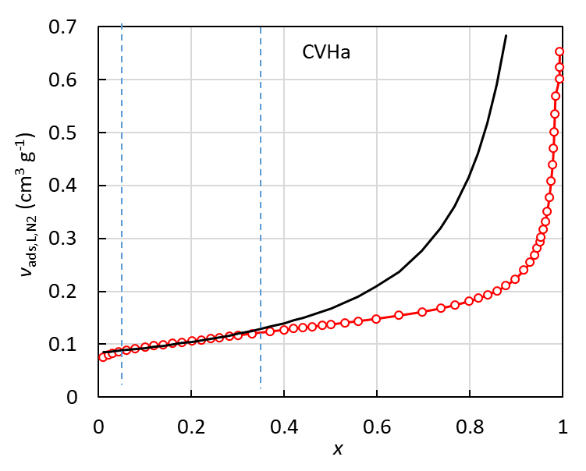 | 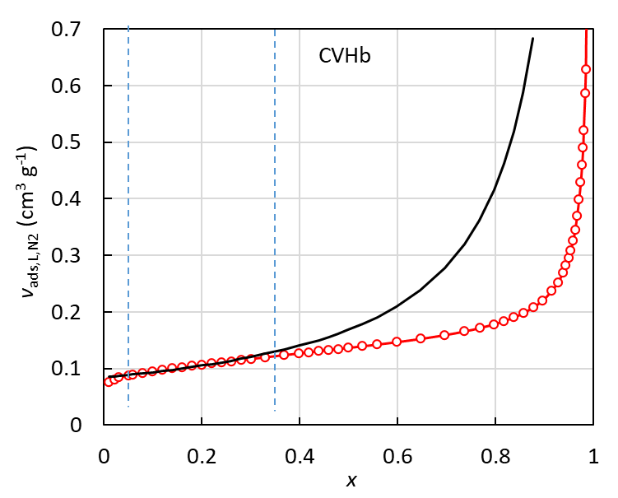
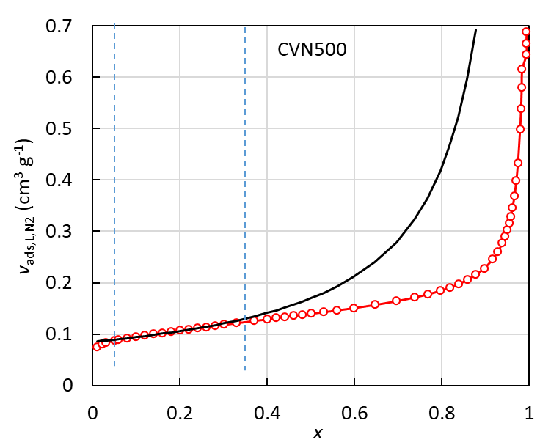 | 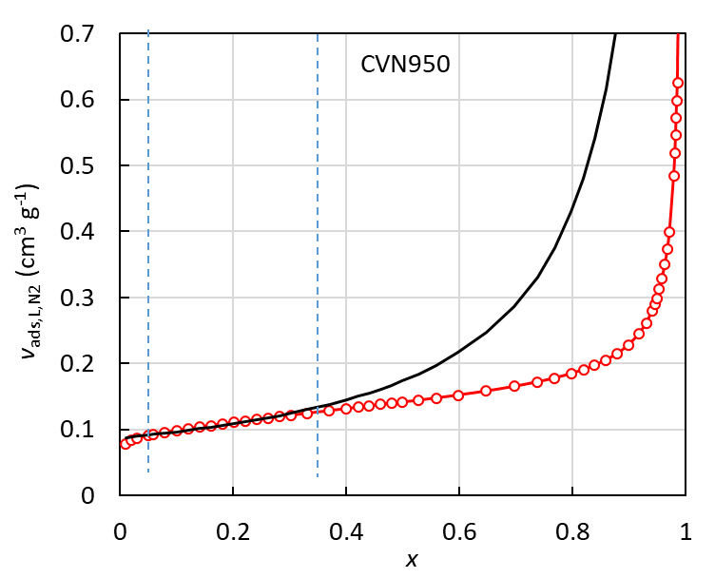
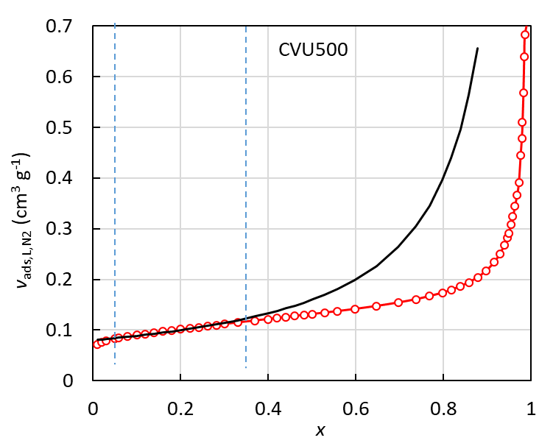 | 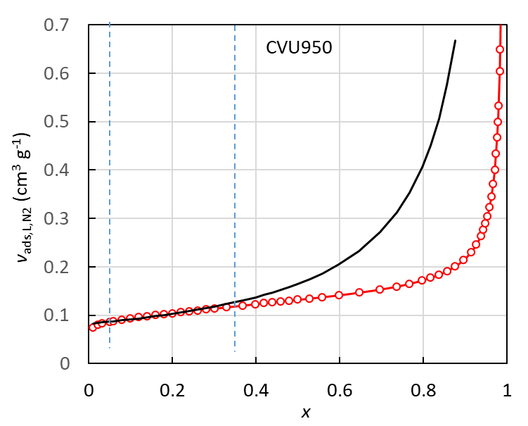

Fig. S8. One parameter BET model (solid line) and measured data (red circles).

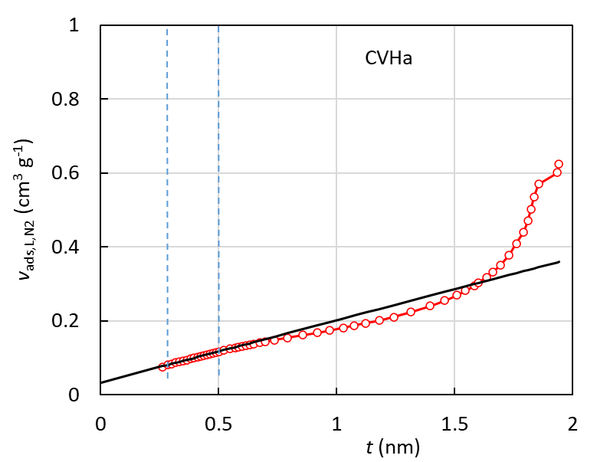 | 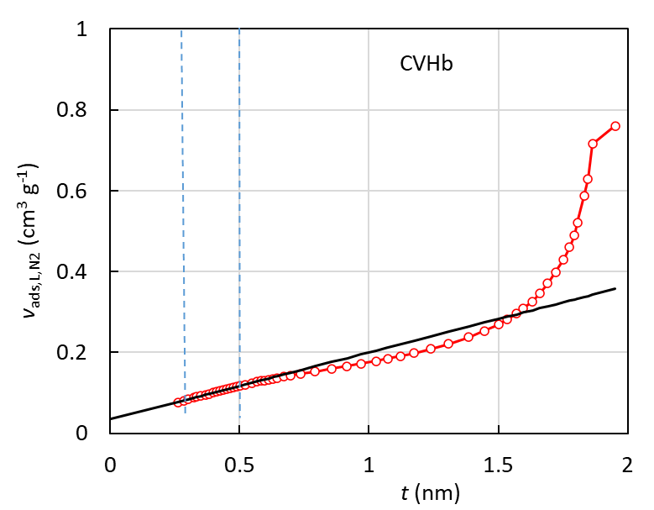
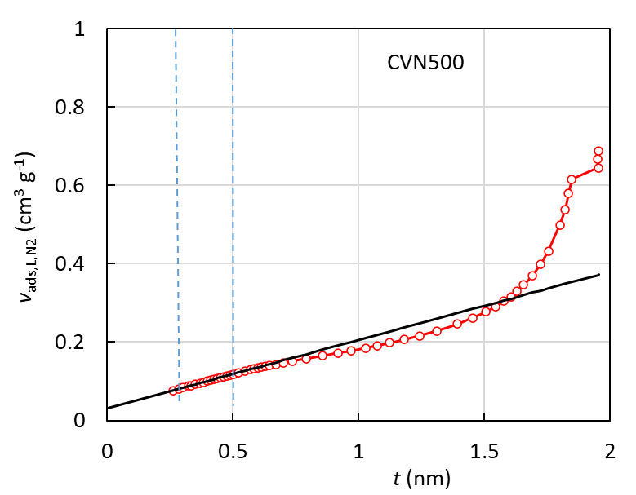 | 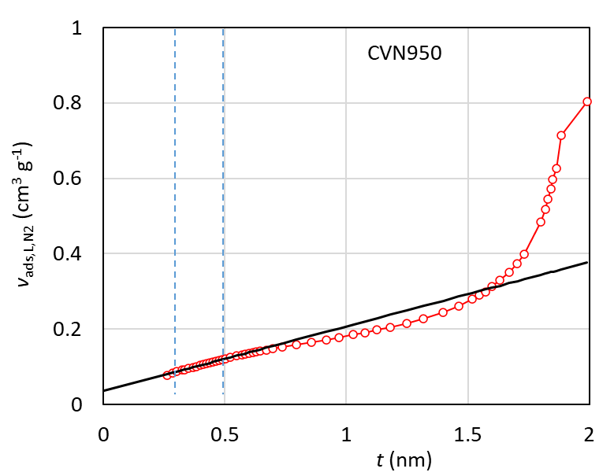
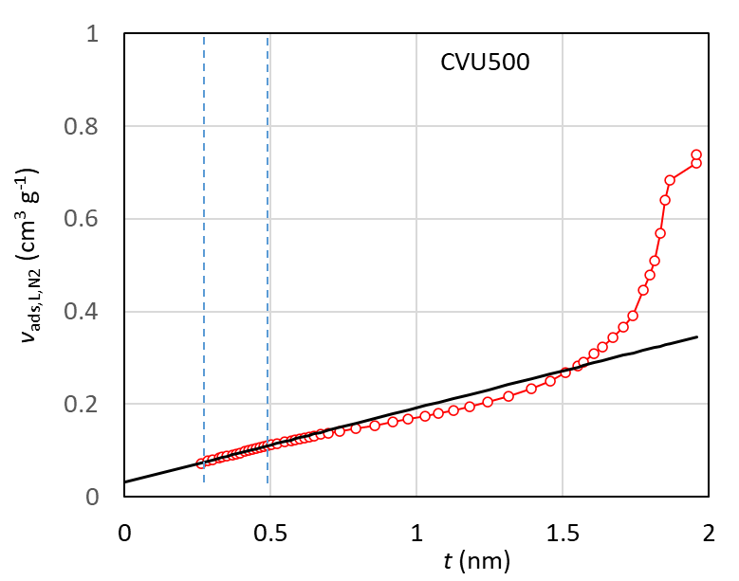 | 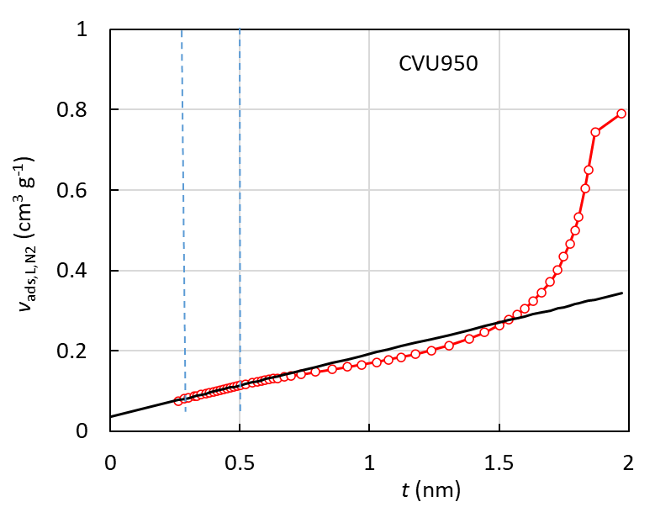

Fig. S9. t-plot (solid line) and measured data (red circles).

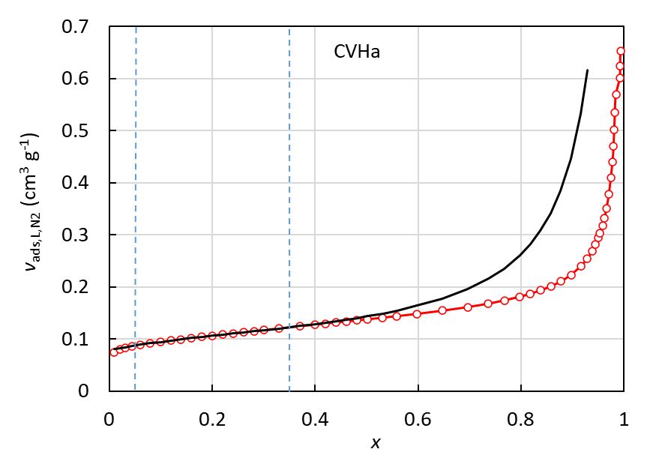 | 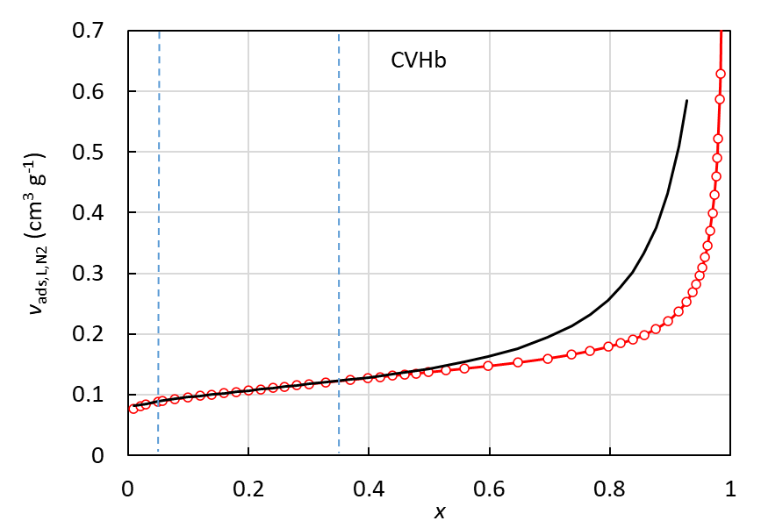
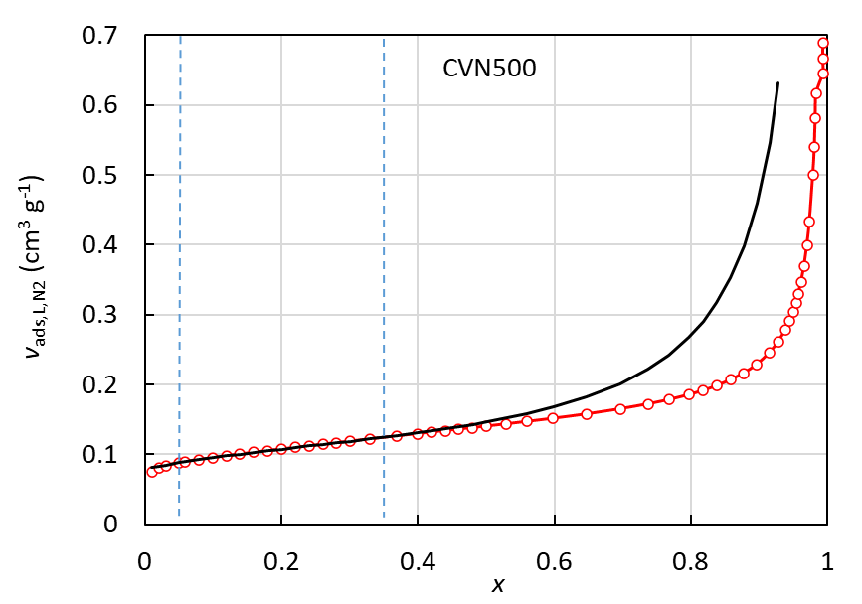 | 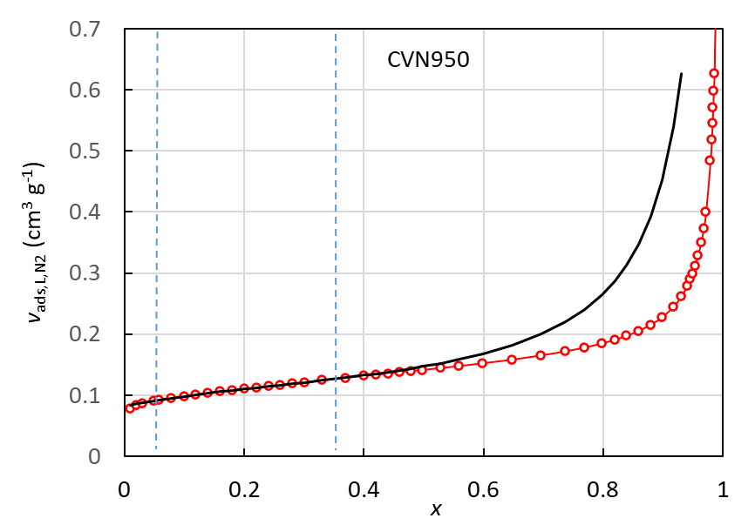
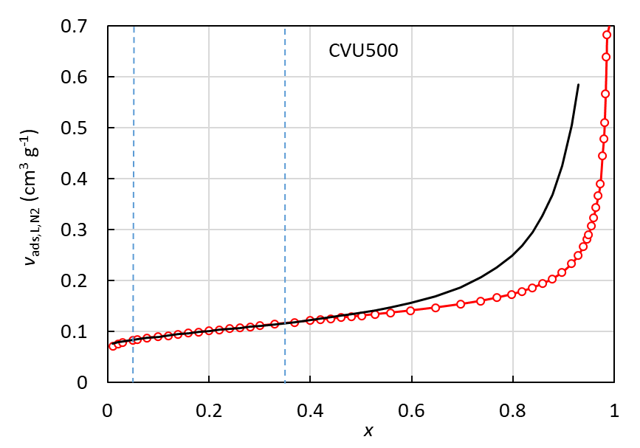 | 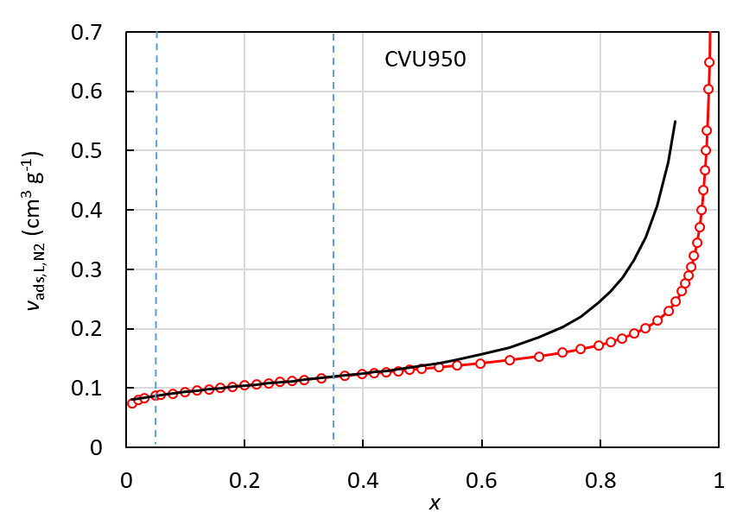

Fig. S10. BET isotherm model with micropores (solid line) and measured data (red circles).

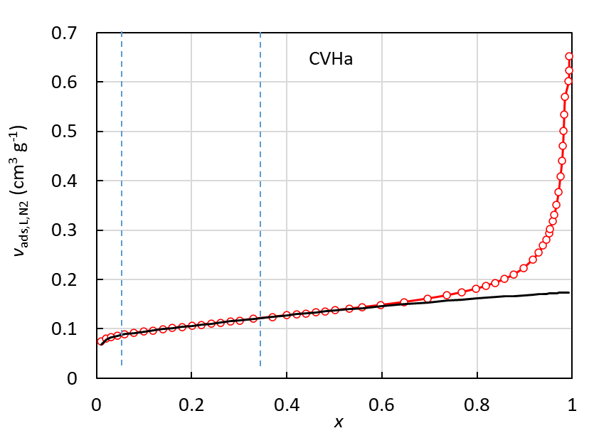 | 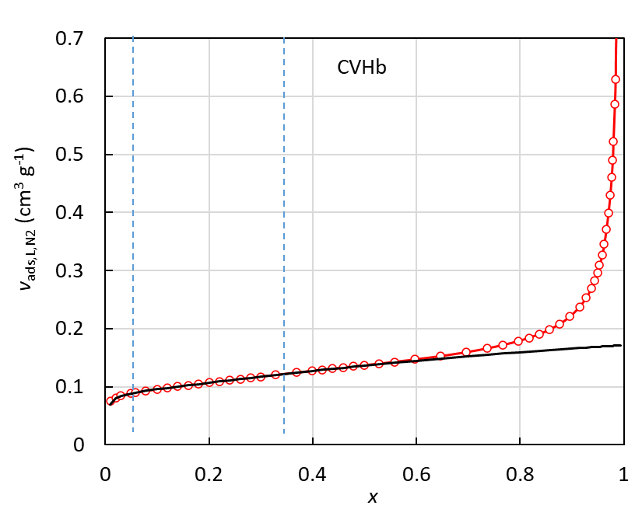
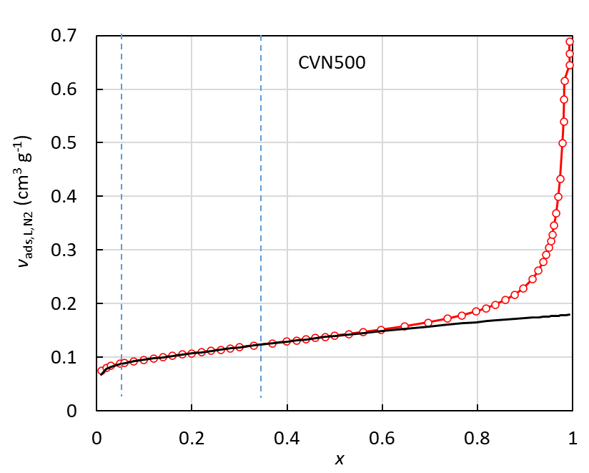 | 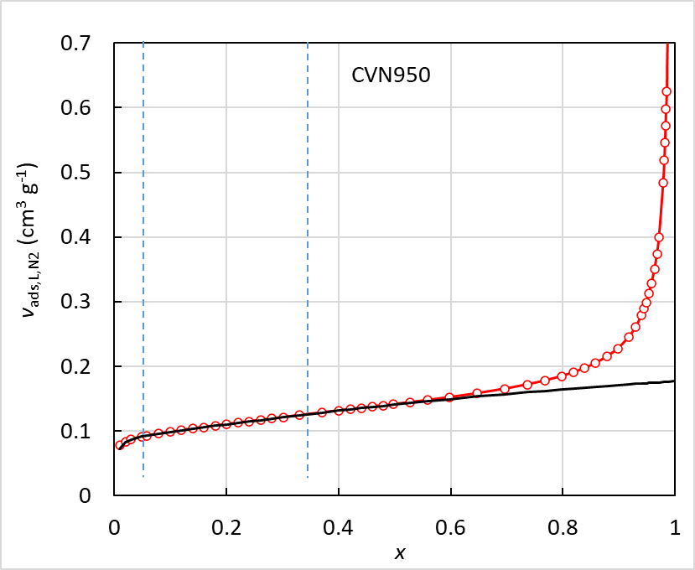
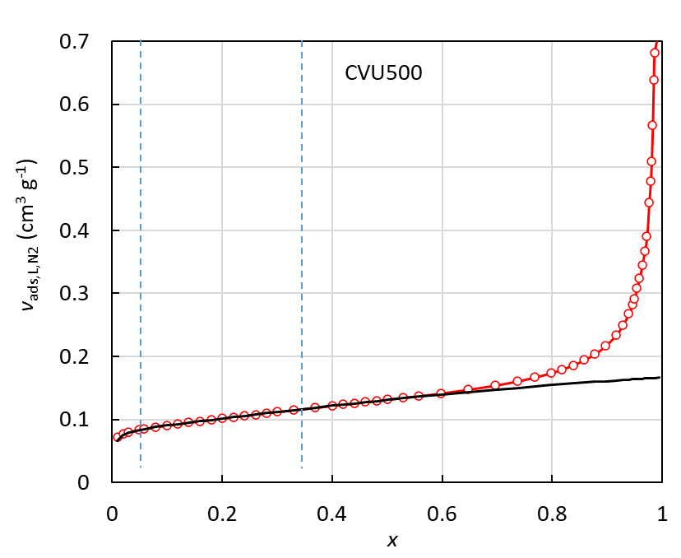 | 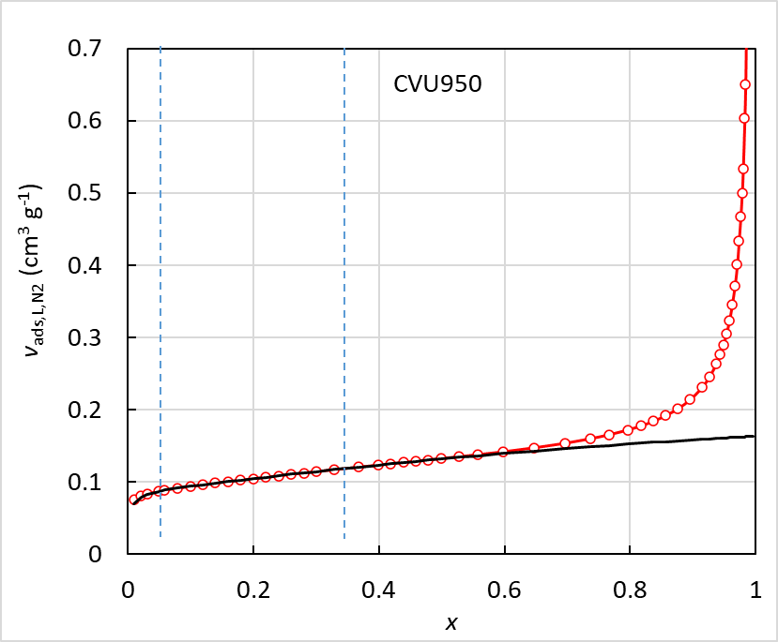

Fig. S11. n-layer BET isotherm model (n ≅ 3) (solid line) and measured data (red circles).

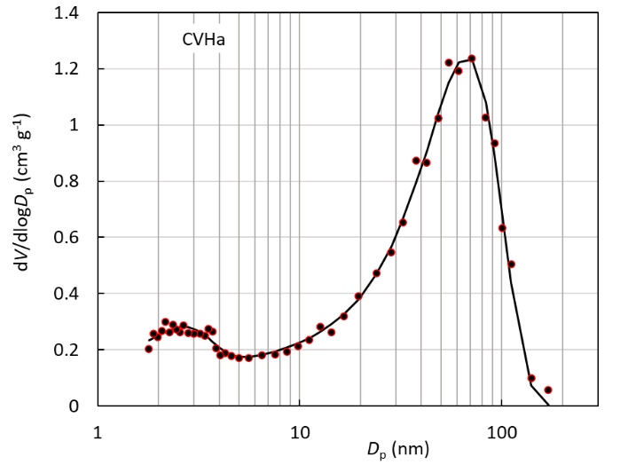 | 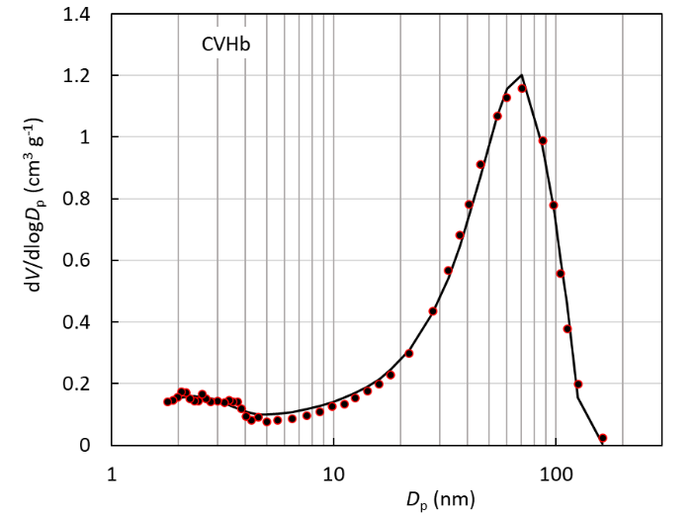
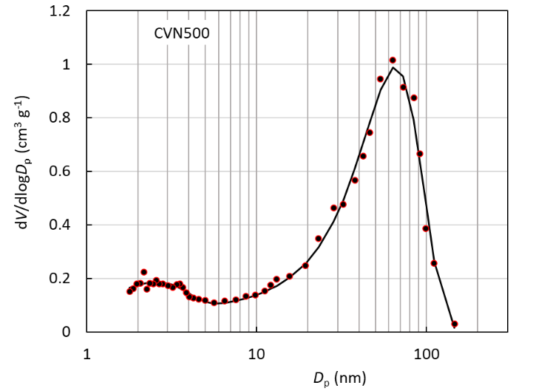 | 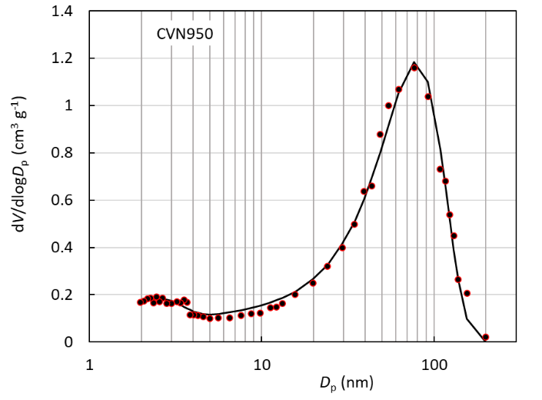
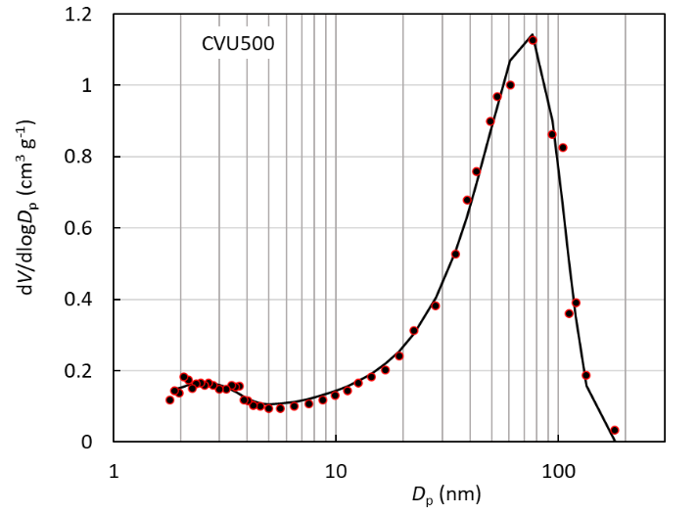 | 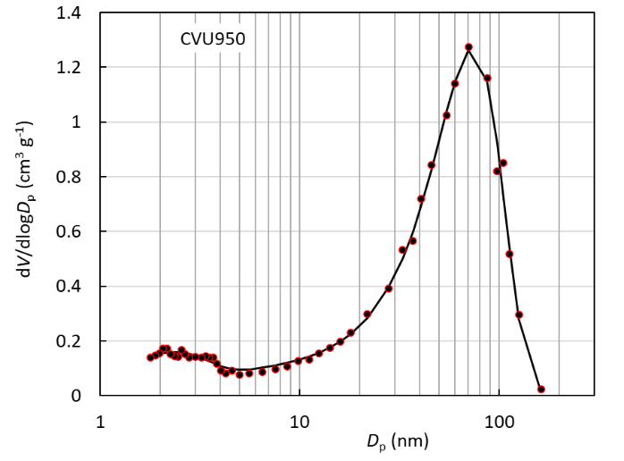

Fig. S12. Pore size distribution, BJH method.

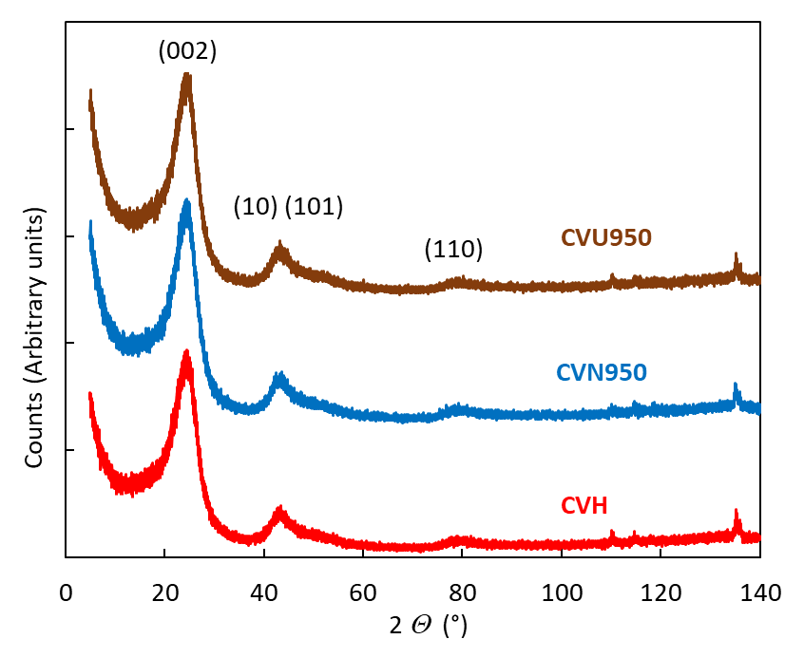
Fig. S13. XRD patterns for carbon samples. Numbers in brackets indicate Miller indices for the hexagonal carbon structure.

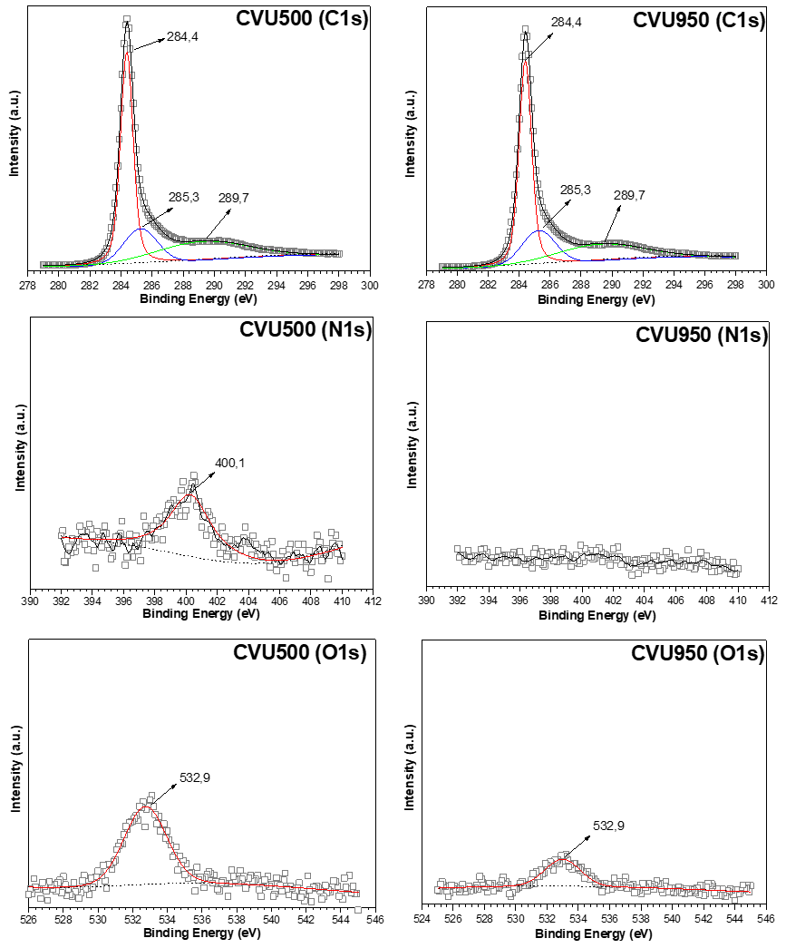
Fig. S14. XPS patterns of selected CV catalysts.

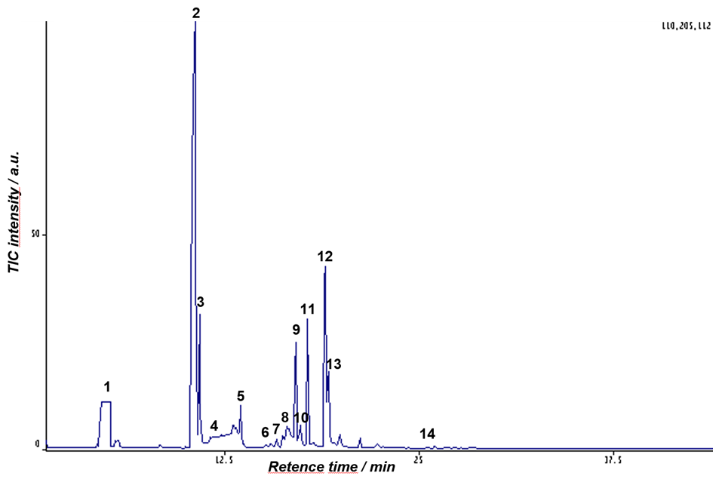
Fig. S15. Chromatogram from the GC-MS analysis of the sample from reaction mixture from the oxidation of cyclopentanone over CVU950 catalyst in methanol (reaction conditions: 90 °C, 0.45 MPa, 210 min).

Table S2. Identified components on the base GS-MS analysis denoted in Fig. S15
No. | Ret. Time | Name
1 | 4.54 – 5,18 | Methanol
2 | 10.35 – 10,69 | Cyclopentanone
3 | 10.89 | 1-Methoxycyclopentene
4 | 11.53 | Pentanoic acid, methyl ester
5 | 13.51 | Dimethoxycyclopentane
6 | 15.36 | 5-Oxopentanoic acid, methyl ester
7 | 15.88 | Butanedioic acid, dimethyl ester
8 | 16.25 | δ-Valerolactone
9 | 17.08 | 5-Hydroxypentanoic acid, methyl ester
10 | 17.77 | Butanedioic acid, methyl ester
11 | 17.85 | Pentanedioc acid, dimethyl ester
12 | 18.94 | Pentanoic acid, 5,5-dimethoxy-, methyl ester
13 | 19.16 | Pentanedioic acid, methyl ester
14 | 26.02 | Decanedioic acid, dimethyl ester

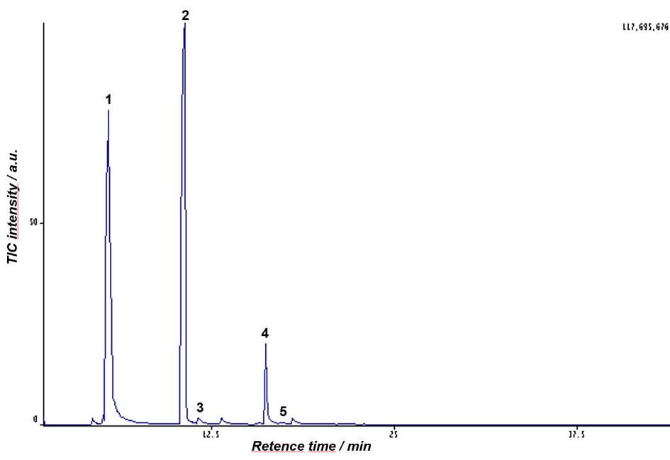
Fig. S16. Chromatogram from the GC-MS analysis of the sample of reaction mixture from the oxidation of cyclopentanone over CVU950 catalyst treated by diethyl ether (reaction conditions: 90 °C, 0.45 MPa, 210 min).

Table S3. Identified components on the base GS-MS analysis (Fig. S16)
No. | Ret. Time | Name
1 | 5.30 | Diethyl ether
2 | 10.50 | Cyclopentanone
3 | 11.70 | 2-Cyclopenten-1-one
4 | 16.25 | δ-Valerolactone
5 | 17.20 | 5-Oxopentanoic acid

