Supporting Information

Breaking 1.7V open circuit voltage in large area transparent perovskite solar cells using bulk and interfaces passivation.

Diego Di Girolamo^{1,*}, Guillaume Vidon², Jessica Barichello¹, Francesco Di Giacomo¹, Farshad Jafarzadeh¹, Barbara Paci³, Amanda Generosi³, , Minjin Kim², Luigi Angelo Castriotta¹, Mathieu Frégnaux⁴, Jean-François Guillemoles², Philip Schulz², Daniel Ory^{5,6}, Stefania Cacovich², Aldo Di Carlo^{1,3}, Fabio Matteocci^{1,*,#}

- CHOSE – Centre for Hybrid and Organic Solar Energy, Department of Electronic Engineering, University of Rome ‘‘Tor Vergata’’, via del Politecnico 1, 00133, Roma, ItalyInstitut Photovoltaïque d'Ile-de-France (IPVF), UMR 9006, CNRS, Ecole Polytechnique, IP Paris, Chimie Paristech, PSL, 91120 Palaiseau, France
- ISM-CNR, Istituto di Struttura della Materia, Consiglio Nazionale delle Ricerche, Roma 00133, Italy
- Institut Lavoisier de Versailles (ILV), Université de Versailles Saint-Quentin-en-Yvelines, Université Paris-Saclay, CNRS, UMR 8180, 45 avenue des Etats-Unis, 78035 Versailles CEDEX, France
- Institut Photovoltaïque d’Île-de-France (IPVF), 18 Boulevard Thomas Gobert, Palaiseau 91120, France
- Électricité de France (EDF), R&D, 18 Boulevard Thomas Gobert, Palaiseau 91120, France

Methods
Materials
Anhydrous dimethylsulfoxide (DMSO) (99.9%), Ethylacetate (99%, anhydrous), Titanium diisopropoxide (bis-acetylacetonate), Lithium bis(trifluoromethanesulfonyl)imide salt (Li-TFSI) (99.95%), 4-tert-butyl pyridine (tBP, 96%), Niobium ethoxide was purchased from Sigma Aldrich. PbBr₂ (99.99%) was purchased by TCI Chemical. Formamidinium bromide (FABr, 99.98%), neo-Pentylammonium chloride, iso-Pentylammonium chloride were purchased from Great Cell Materials. PTAA (10kDa) was purchased from Solaris Chem. Tin(IV) oxide, 15% in H₂O colloidal dispersion was purchased from Alfa Aesar.

Device Fabrication
Transparent perovskite solar cells have been fabricated using patterned FTO substrates (2.2 mm-thick TEC15 Pilkington, 15 Ω/square) on 25x25 mm² substrate area by using nanosecond pulsed laser (Nd:YVO₄, λ = 355 nm, 15 ns, pulsed at 80 kHz with a fluence per pulse of 715 mJ cm⁻²). The patterned substrates were cleaned in an ultrasonic bath, using de-ionized water and soap and finally IPA (10 min for each cleaning step). Screen-printed Silver contacts (DuPont 7713) are deposited over FTO photoanodes.
The 40 nm-thick TiO₂ compact layer (c-TiO₂) is deposited by spray pyrolysis at 460°C starting from a precursor solution made up of titanium diisopropoxide bis(acetylacetonate), acetylacetone and ethanol in a 3:2:45 volume ratio. 2% Nb doping is made by adding Niobium Ethoxide in the precursor solution. SnO₂ nanoparticle-based ink at 1:20 v/v in deionized water is deposited on Nb:TiO₂ coated substrate using spin coating at 4000rpm for 20s. Then, the substrates are annealed at 120°C for 20 minutes. After the annealing, the substrates are transferred to a nitrogen filled glove box for the perovskite deposition. A stoichiometric perovskite solution (FAPbBr₃) is prepared by mixing 1 M PbBr₂ and 1 M FaBr in DMSO solvent. Ionic liquid precursor is added to the FAPbBr₃ solution before the use. Then, the FAPbBr₃ perovskite films are deposited by spin coating at 4000 rpm for 20s using solvent quenching method on warm substrates (60°C). Ethylacetate (200 µl) is dropped after 10 seconds. The samples are then annealed at 80 °C for 10 minutes. Neo-Pentylammonium chloride (NEO) and iso-Pentylammonium chloride (ISO) solutions are prepared at 1mg/ml concentration in 2-propanol. ISONEO solution is prepared by mixing 1:1 v/v the prepared ISO and NEO stock solutions. All the solutions are deposited by spin coating at 4000rpm for 20s. The PTAA solution was prepared by dissolving 10 mg of the PTAA powder in 1 ml of toluene solvent and doped using TBP (10µl/ml) and Li-TFSI (5µl/ml, stock solution: 170mg/ml in acetonitrile). The PTAA films are deposited by spin coating at 4000 rpm for 20 seconds. Low temperature ITO deposition was performed by using an industrial in-line magnetron sputtering (KENOSISTEC S.R.L., KS 400 In-Line) at 1.1∙10⁻³ mBar and 90W RF power. Inert Ar gas is purged in the chamber (40sccm) during the ITO deposition to activate the Ar⁺ plasma. The sample holder is moved below the ITO cathode with 120 cm/min speed for 200 cycles to achieve 220 nm as thickness.
An antireflection coating of porous Al₂O₃ was deposited by spin coating a 5 wt % dispersion of Al₂O₃ nanoparticles in 2-propanol at 3000 rpm for 30s. After spin coating, the film was dryed at 80 °C for 2 minutes. The porosity of the film reduces the refractive index compared to bulk Al₂O₃ and provide a facile method to reduce the reflections at the ITO/air interface. 80nm-thick MgF₂ layer was deposited as front ARC layer by thermal evaporation at 0.3A/s.
For ST-PSC modules, P1, P2 and P3 etching processes have been performed by using a raster scanning laser (Wophotonics, Yb:KGW, λ = 355 nm, 5 ps, pulsed at 2000 kHz with a fluence per pulse for patterning cells and for P1, P2 and P3 of 40.85, 29.06 and 21.23 mJ cm⁻², respectively). P2 is performed by placing 6 lines beside different fluences of about 1 mJ cm² variation, with an average fluence per pulse of 29.06 mJ cm⁻². Module layout is composed by a 60mmx60mm substrate size, formed by six series connected cells with 7.38mm*45mm cell width and height, P1-P2-P3 interconnection of 160um, 19.926 cm² active area and 97.83% geometrical fill factor.

X-Ray Diffraction (XRD)
A Panalytical Empyrean Diffractometer was used to perform X-ray diffraction measurements in reflection mode. The ka fluorescence lines (K-Alpha1 [Å] = 1,54060; K-Alpha2 [Å] = 1,54443) of a Cu-anode were selected as impinging radiation and a solid-state hybrid Pix’cel 3D detector, working in 1D linear mode, accomplished the detection. High angle XRD measurements were collected in the 10°< 2J < 70° angular range and Bragg Brentano configuration was adopted focusing the impinging beam with fixed divergent slits (1/4°-1/2°). Low angle acquisitions (2.5°< 2J < 20°) were obtained narrowing down the slits dimensions to (1/32°-1/16°) to detect 2D structures.
Scanning Electron Microscopy (SEM)
Scanning Electron Microscopy (SEM) experiments were performed by using a TESCAN Analytics VEGA instrument.

Atomic Force Microscopy (AFM)
Morphological surface characteristics of FAPbBr₃ samples were investigated using an in house developed Atomic Force Microscope (AFM), mounting a 30µm*30µm scanner. Several portions of the samples were monitored in non-contact mode by means of aluminum coated standard tapping AFM probes (Nanosensors), combining high operation stability with outstanding sensitivity and fast scanning ability. Images ranging from 30*30 to 10*10 µm (500 points/image) were collected.
Photoluminescence Imaging (Hyperspectral)
A home-built microscope was used to image the samples with an x10 objective lens (Olympus). The illumination source is a 405nm LED (Thorlabs) imaged onto the sample and filtered with a 450nm short pass filter (Thorlabs FESH450). The power under the objective was set at 100 mW/cm². A dichroic mirror (Thorlabs DMLP490) is used to filter out the excitation light and the photoluminescence as well a 500nm long pass filter (Thorlabs FEL500). The collected light is sent to the hyperspectral imaged (from Photon etc.) and finally onto a CCD camera. Samples were measured in protective N₂ atmosphere. A calibration procedure is applied to the acquired data as explained in previous work ¹ as well as a rectification of the data cubes. A home-made software is used to extract the quasi Fermi Level Splitting from the acquired data based on the generalized Planck’s law of radiation² and on the Katahara Hillhouse model³.
Photoluminescence Imaging (TR-FLIM)
A home-built microscope was used to perform TR-FLIM imaging with x20 objective lens (Olympus). The illumination consisted in a pulsed white laser (NKT Photonics Fianium) filtered in the range 400-480 nm. The repetition rate was set to 153KHz and the fluence under the objective was in the order of magnitude of 1e9 ph/cm²/pulse. A dichroic mirror (DMLP490) was used as well as a 532nm bandpass filter (Thorlabs) to separate excitation and photoluminescence. An EMCCD gated camera (PiMax4 from Princeton Instruments) was used to obtain the TR-FLIM acquisition. Samples were measured in protective N2 atmosphere. The data was treated with a home-made Matlab code to extract the decay time images.
UV/vis Transmittance and AVT calculation
The transmittance spectra were acquired using a UV/vis spectrophotometer (Shimadzu UV-2550) equipped with an integrating sphere. The baseline spectrum (without sample) is acquired before the transmittance of the devices in order to discard the fluctuations of the lamp installed in our spectrophotometer. Each transmittance spectra is then normalized with respect to the baseline spectrum following this equation:

$$T\left(λ\right)=\frac{T_{device }\left(λ\right)∙100 }{T_{baseline}\left(λ\right)}$$

The AVT value is calculated by the following equation:
$$AVT=\frac{\int_{380}^{780}{T\left(λ\right)∙S\left(λ\right)∙P\left(λ\right) dλ}}{\int_{380}^{780}{S\left(λ\right)∙P\left(λ\right) dλ}}$$

Where λ is the wavelength, P(λ) is the photopic response of the human eye and P(λ) represents the solar photon flux for the AM1.5G standard conditions. The AVT and CRI values are calculated using the spreadsheet reported from Yang et al.⁴

Supporting Figures

Figure S1. Planar SEM images of FTO/c-TiO₂:SnO₂/FAPbBr₃ samples acquired at 10Kx (scale bar is 5µm) and 50Kx (scale bar is 1µm) magnifications using REF, NEO, ISO and ISONEO passivation strategies.

Figure S2. Planar 20x20 µm² sized AFM images of FTO/c-TiO₂:SnO₂/FAPbBr₃ samples using REF, NEO, ISO and ISO-NEO passivation strategies. 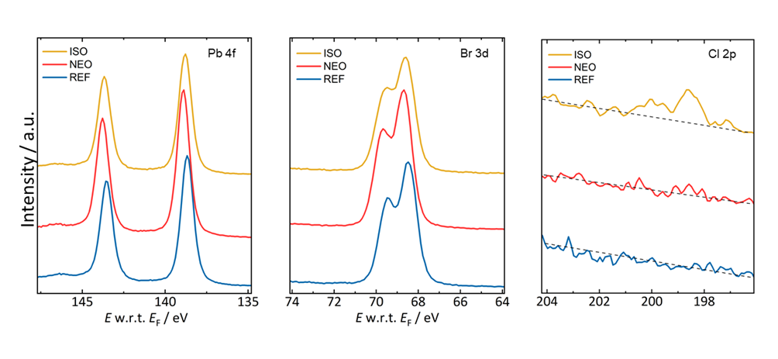
Figure S3. XPS-UPS measurements. X-ray photoemission spectroscopy (XPS) core level scans of the free surfaces of the REF, NEO and ISO samples, showing the Pb 4f, Br 3d and Cl 2p regions. During the XPS measurements transient peak shifts (<0.3 eV) occur that are related to the creation of defect states due to X-ray beam damage that change the Fermi level position at the surface⁵.

Sun Calibration, J-V and MPPT characterization
The photovoltaic performance of the ST-PSCs have been measured following a specific procedure resumed in Figure Sx. Firstly, we performed the calibration of the Sun Simulator measuring the Jsc of our calibrated reference c-Si cell (RR226-O, RERA Solutions). Following this standard calibration procedure, we experienced a remarkable underestimation of our Jsc values when compared with the integrated Jsc measured from EQE. In fact, we always found a mismatch factor (MF) value around 73% calculated in average from a batch of ST-PSCs. In order to tackle this issue, we measured the irradiance spectrum of the Class A Sun Simulator (ABET Sun 2000) at the calibrated lamp intensity using a spectrometer (equipped with an optical fiber). The results are resumed in Figure Sx where the measured irradiance spectrum is compared with respect to the AM1.5g spectrum. The results confirm a remarkable irradiance intensity mismatch in the wavelength region of interest for FAPbBr₃ absorption (300-550nm) leading to the underestimation of the Jsc value in ST-PSC. Following this calibration procedure well established in literature, we could rescale the Jsc value of the ST-PSCs by applying the mismatch factor correction. As possible way out is the calibration of the Sun simulator adjusting the Xenon lamp current in order to minimize the spectral mismatch with the AM1.5g in the region of interest (300-550nm). Using this calibration, here after called SunAdj we found negligible variation between the Jsc measured under J-V and integrated from EQE.
Interestingly, we evaluated the PV results using both calibration procedures showing the following Jsc values: 4.8mA/cm² using calibration with c-Si cell, 6.5mA/cm² using SunAdj and 6.5 mA/cm² when rescaled by the MF (0.73). The integrated Jsc from EQE is 6.5mA/cm². Obviously, the Jsc discrepancies lead to variations in the claimed PCE values equal to 5.1-5.6%, 7.1-7.6% and 6.9-7.8%, respectively. SunAdj and MF calibration procedures match quite well with the integrated Jsc. In order to avoid post-production of the dataset, we prefer to validate the PV performance by using SunAdj calibration procedure. This procedure is then updated measuring the irradiance spectra in SunAdj condition during the ageing of the Xenon lamp.

PL MODELS
Steady-state PL
The absolute photoluminescence data were fitted with the generalized Planck’s law by:
$$I_{PL}\left(E\right)=\frac{\frac{2π}{h^{3}c^{2}}E^{2}a\left(E\right)}{\exp\left(\frac{E-Δμ}{kT}\right)}$$
Where h is the Planck’s constant, c the speed of light, E the photon energy, a(E) the absorptivity of the sample taking into account sub-band gap absorption, Δµ the QFLS, and kT the thermal energy of the charge carriers.
The absorption is described by an ideal band-band term convoluted with a sub-bandgap absorption, in which the tail states are represented by an exponent factor θ.

Time –resolved PL
To obtain the decay time, we fitted a bi-exponential decay locally on the average values of the TR-FLIM cubes. The decay time is the long characteristic time of the bi-exponential decay.

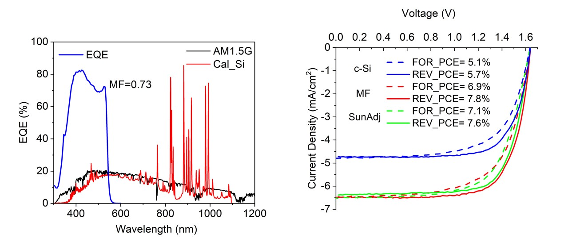
Figure S4. Calibration procedure for wide-bandgap ST-PSC. a. Comparison between the irrandiance spectra of the AM1.5G and the one used for calibration with calibrated c-Si cell. Typical EQE spectrum is reported giving a mismatch factor of 0.73. b. J-V curves measured under several conditions about sun simulator calibration: -c-Si (by using certified c-Si cell), SunAdj (by increasing the sun intensity) and MF (by applying the correction using Mismatch factor).
The PV performance are evaluated measuring consecutive J-V measurements under forward and reverse scan directions interspersed from a MPPT tracking of 120s following the scheme reported in Figure S5. Then, the EQE spectra of ST-PSCs are measured for validation of the measured Jsc values.

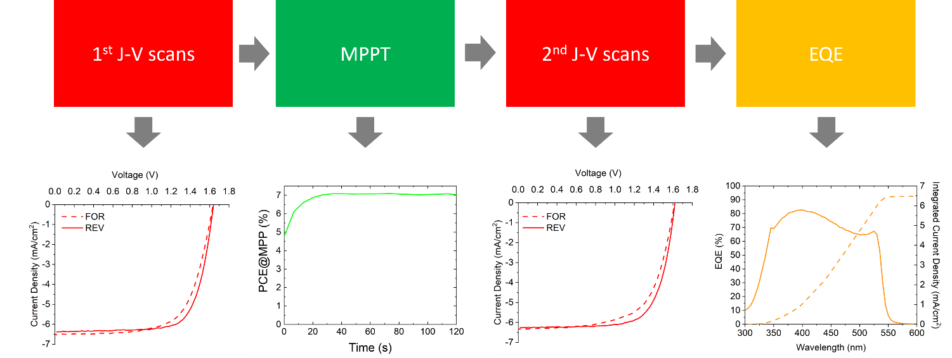
Figure S5. Testing Procedure for PV performance evaluation. MPP tracking is intersected between two J-V scans both under forwar and reverse scan. Finally, EQE is used to validate the measured Jsc during the J-V scan using SunAdj calibration procedure.

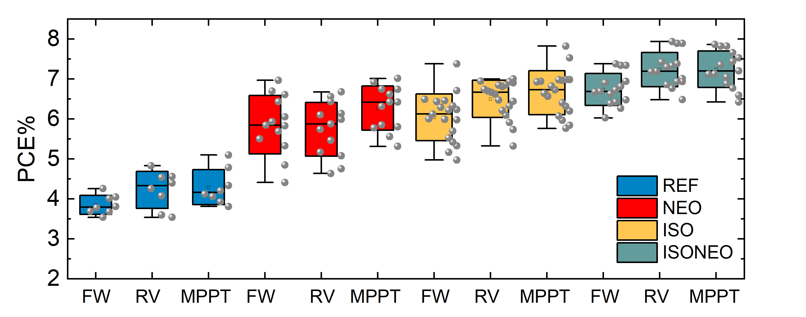
Figure S6. Box chart of PCE results measured from J-V curves (Forward FW and Reverse RV) and MPPT of ST-PSCs using REF, NEO, ISO and ISO-NEO passivation schemes.
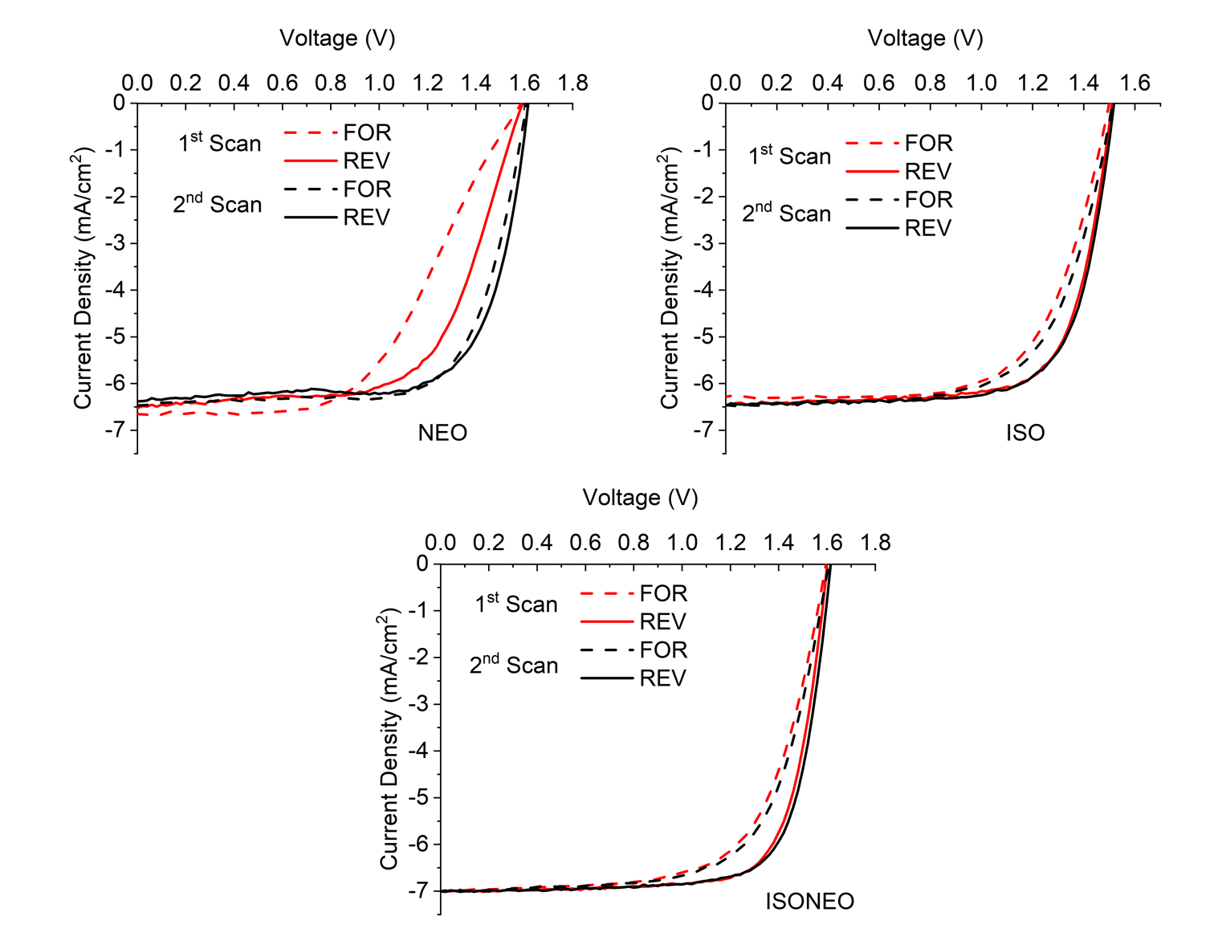
Figure S7. J-V characteristics of ST-PSC measured at 1Sun AM1.5G illumination condition under forward and reverse scan directions varying the passivation strategy (NEO, ISO and ISONEO)
Figure S8. Box chart of FF and Jsc results extracted from J-V curves of ST-PSCs using REF, NEO, ISO and ISO-NEO passivation schemes.
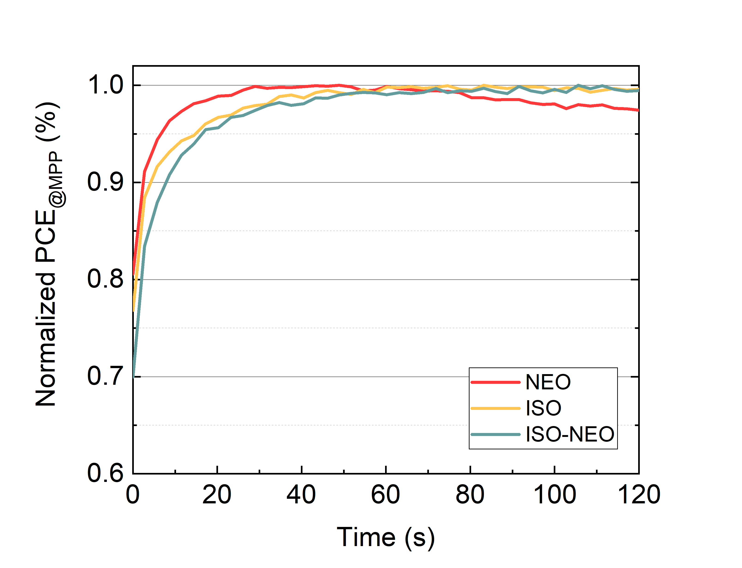
Figure S9. Normalized PCE behaviors during MPPT tracking of 120s by varying the passivation scheme.

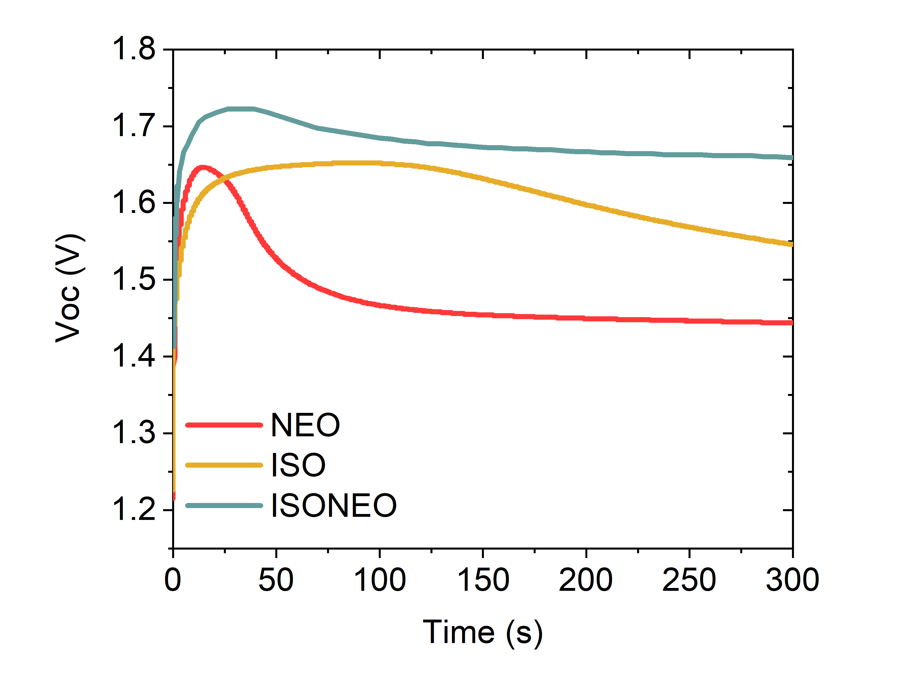
Figure S10. Voc tracking of the ST-PSC devices varying the passivation strategy (NEO, ISO and ISONEO) at 1Sun illumination condition for 300s.

Figure S11. Statistical PCE results (RV, FW and MPPT) measured at day 1 and after 2-4 weeks storage. The ST-PSCs are maintained in dark under shelf-life conditions in air at 40% RH.
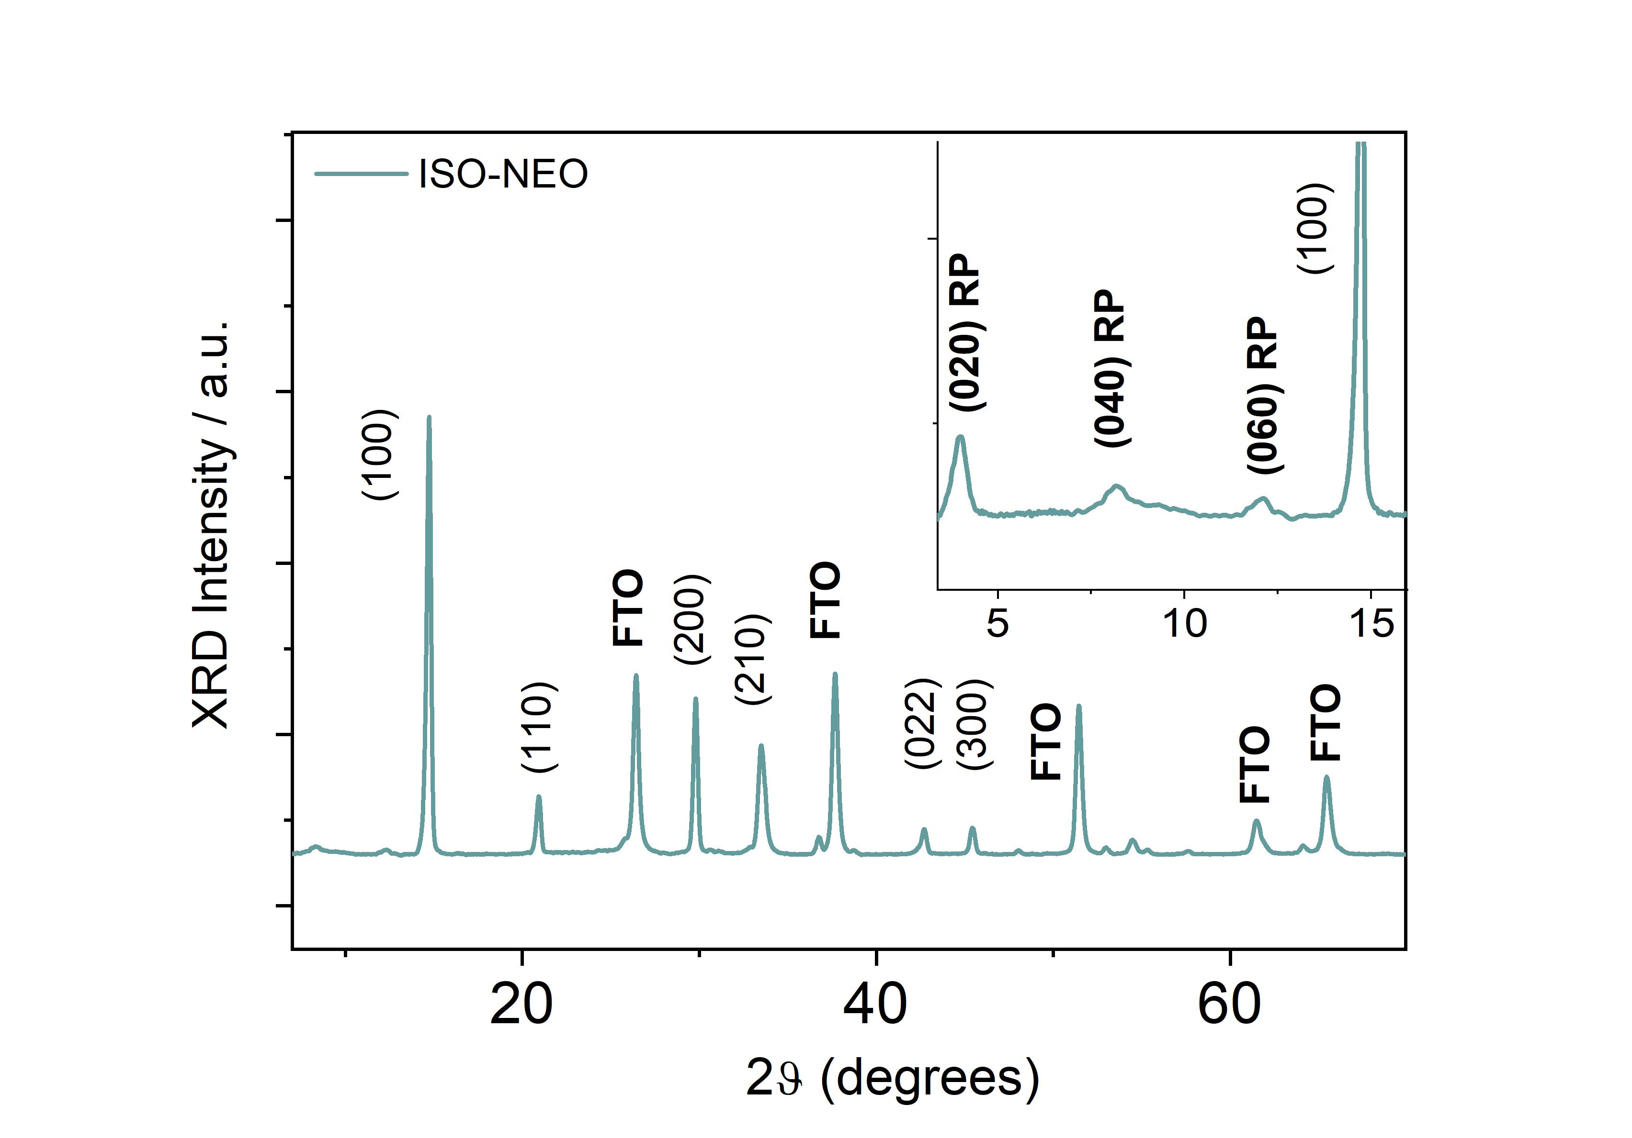
Figure S12. XRD patterns (low and high 2theta angles) collected for ISO-NEO sample.
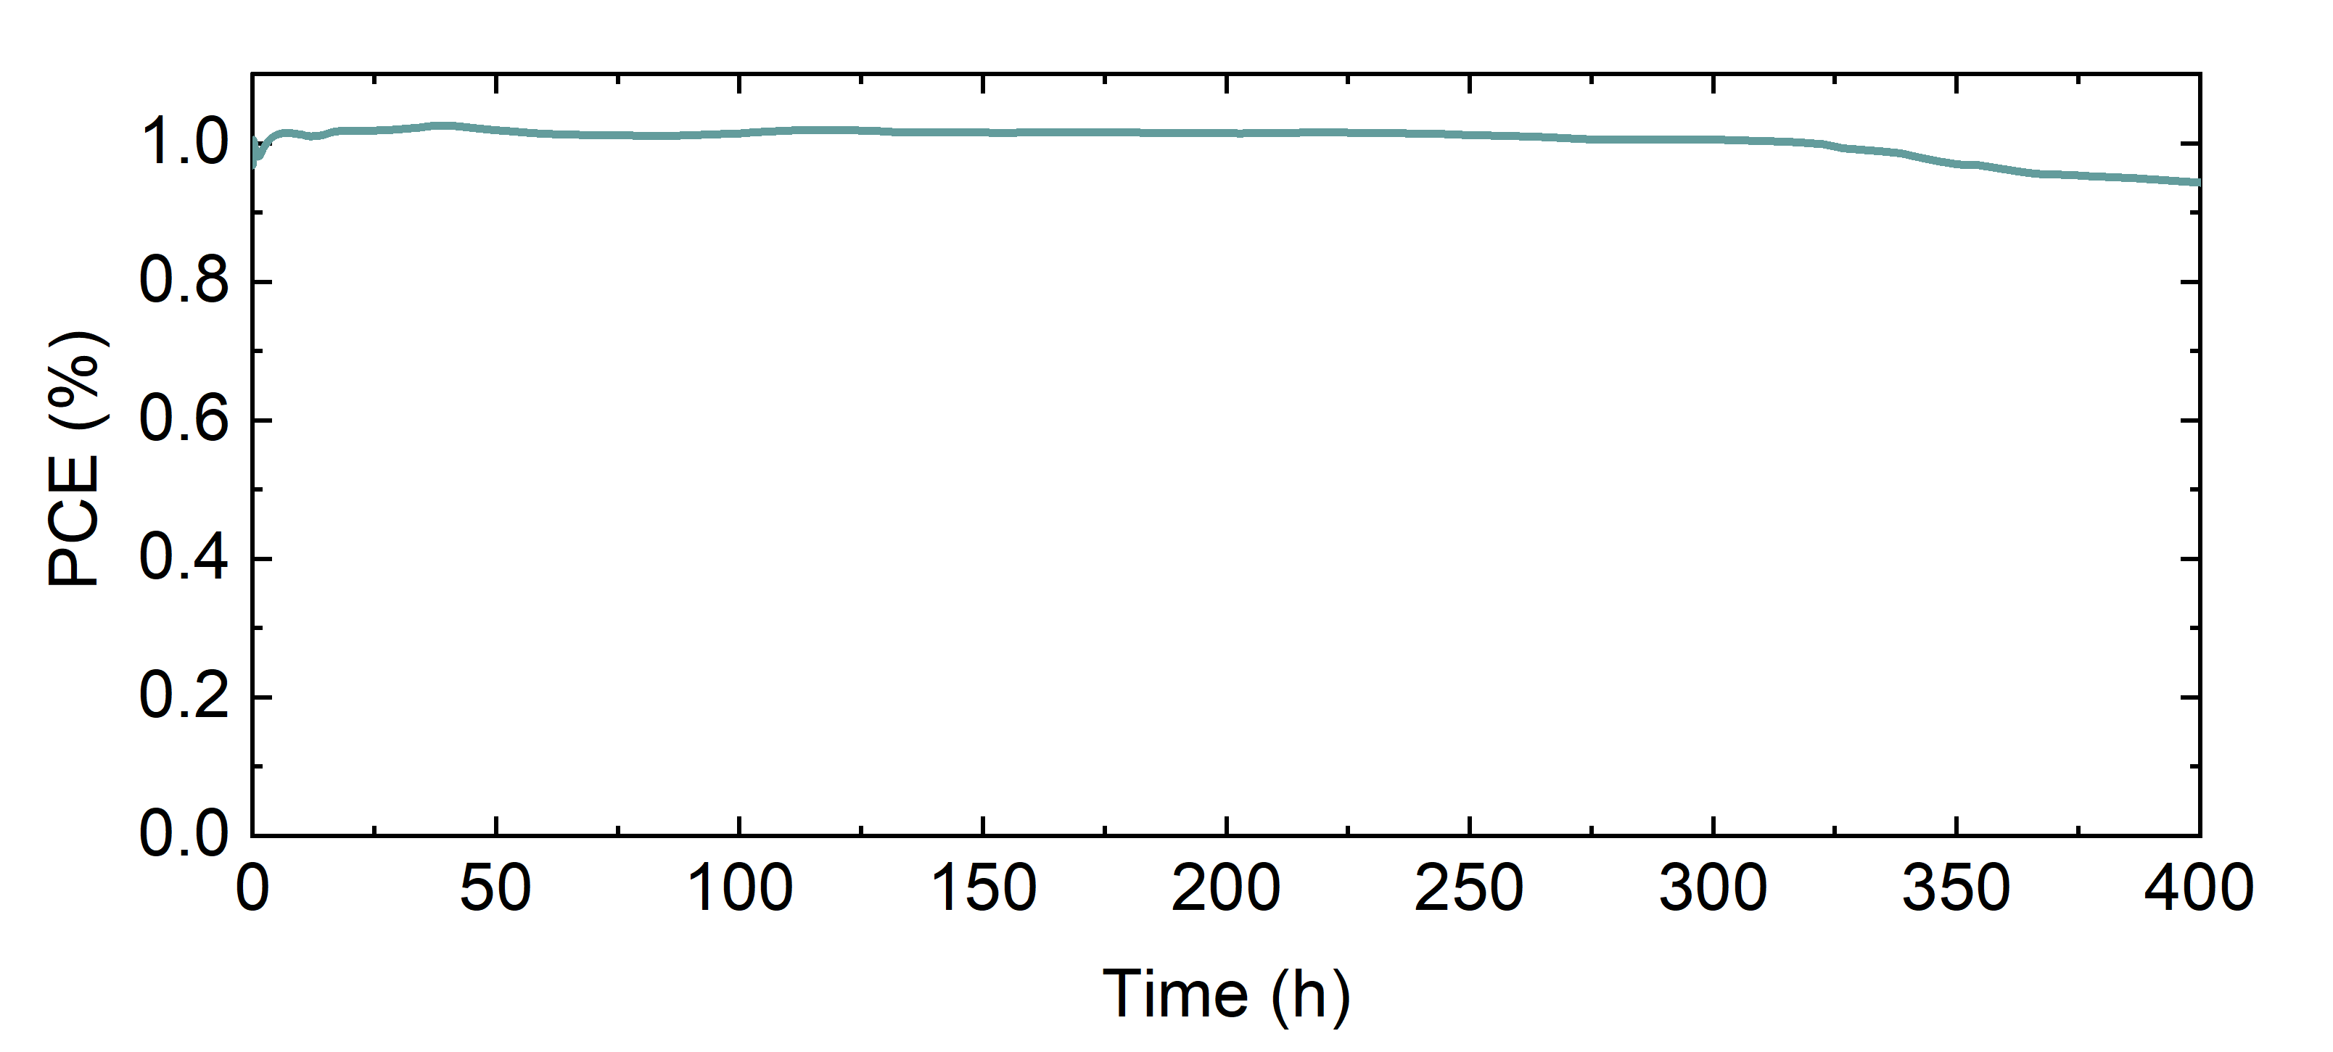
Figure S13. Prolonged Light soaking test at MPP for ISONEO sample made in air without using any encapsulation procedure.

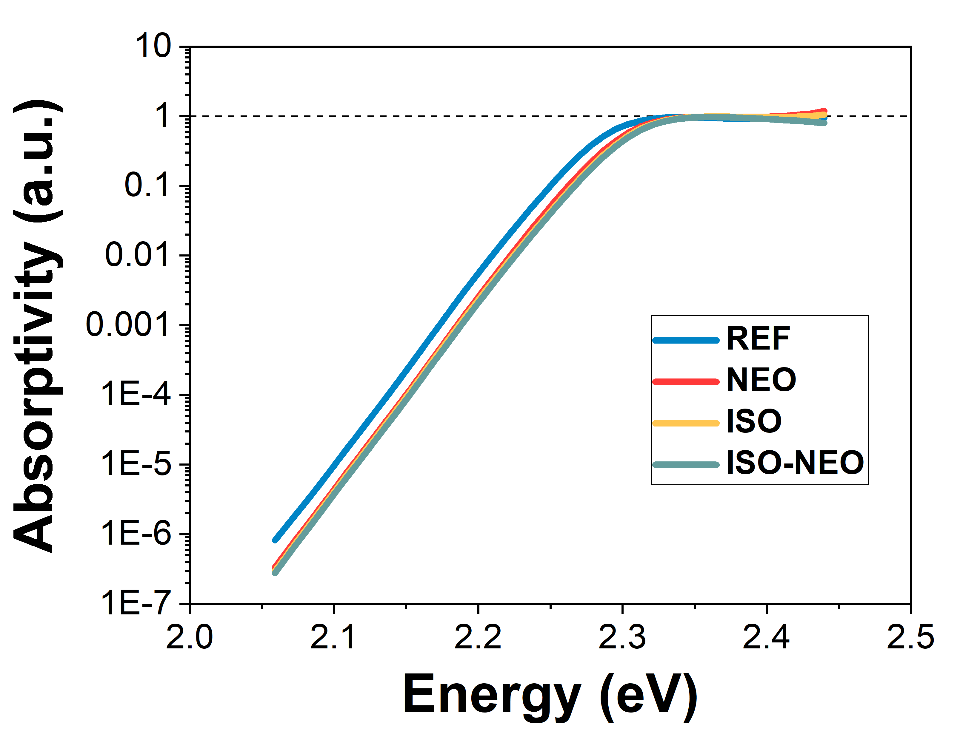
Figure S14. Absorptivity of the reference, NEO, ISO and ISO/NEO samples.

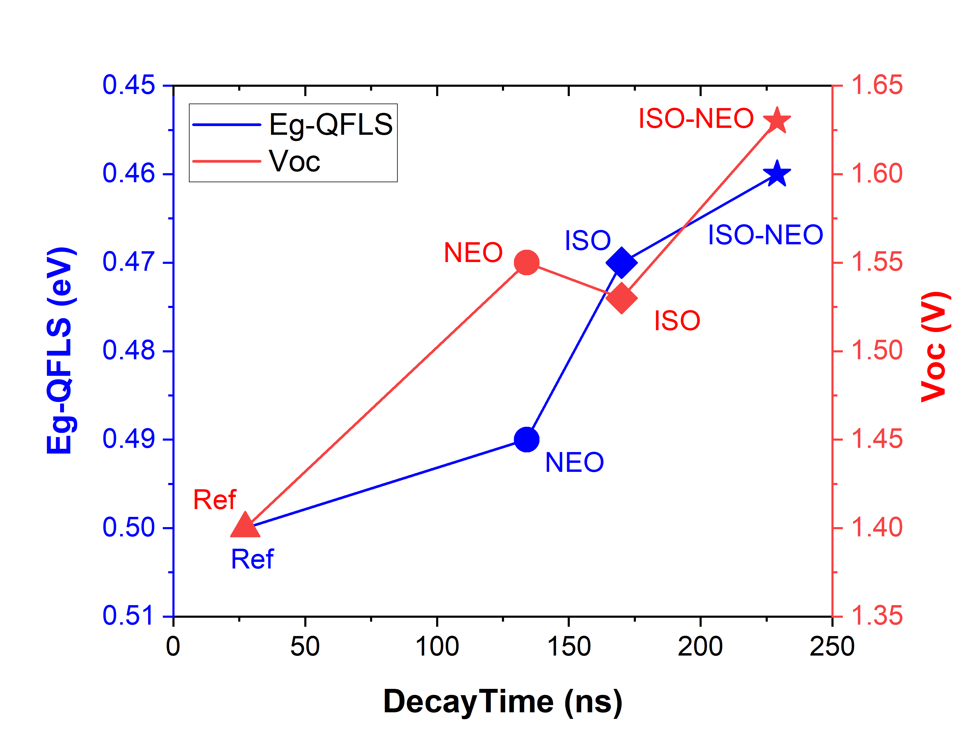
Figure S15. Link between electrical and optical properties of stacks and devices for REF, NEO, ISO, ISO-NEO passivation strategies.
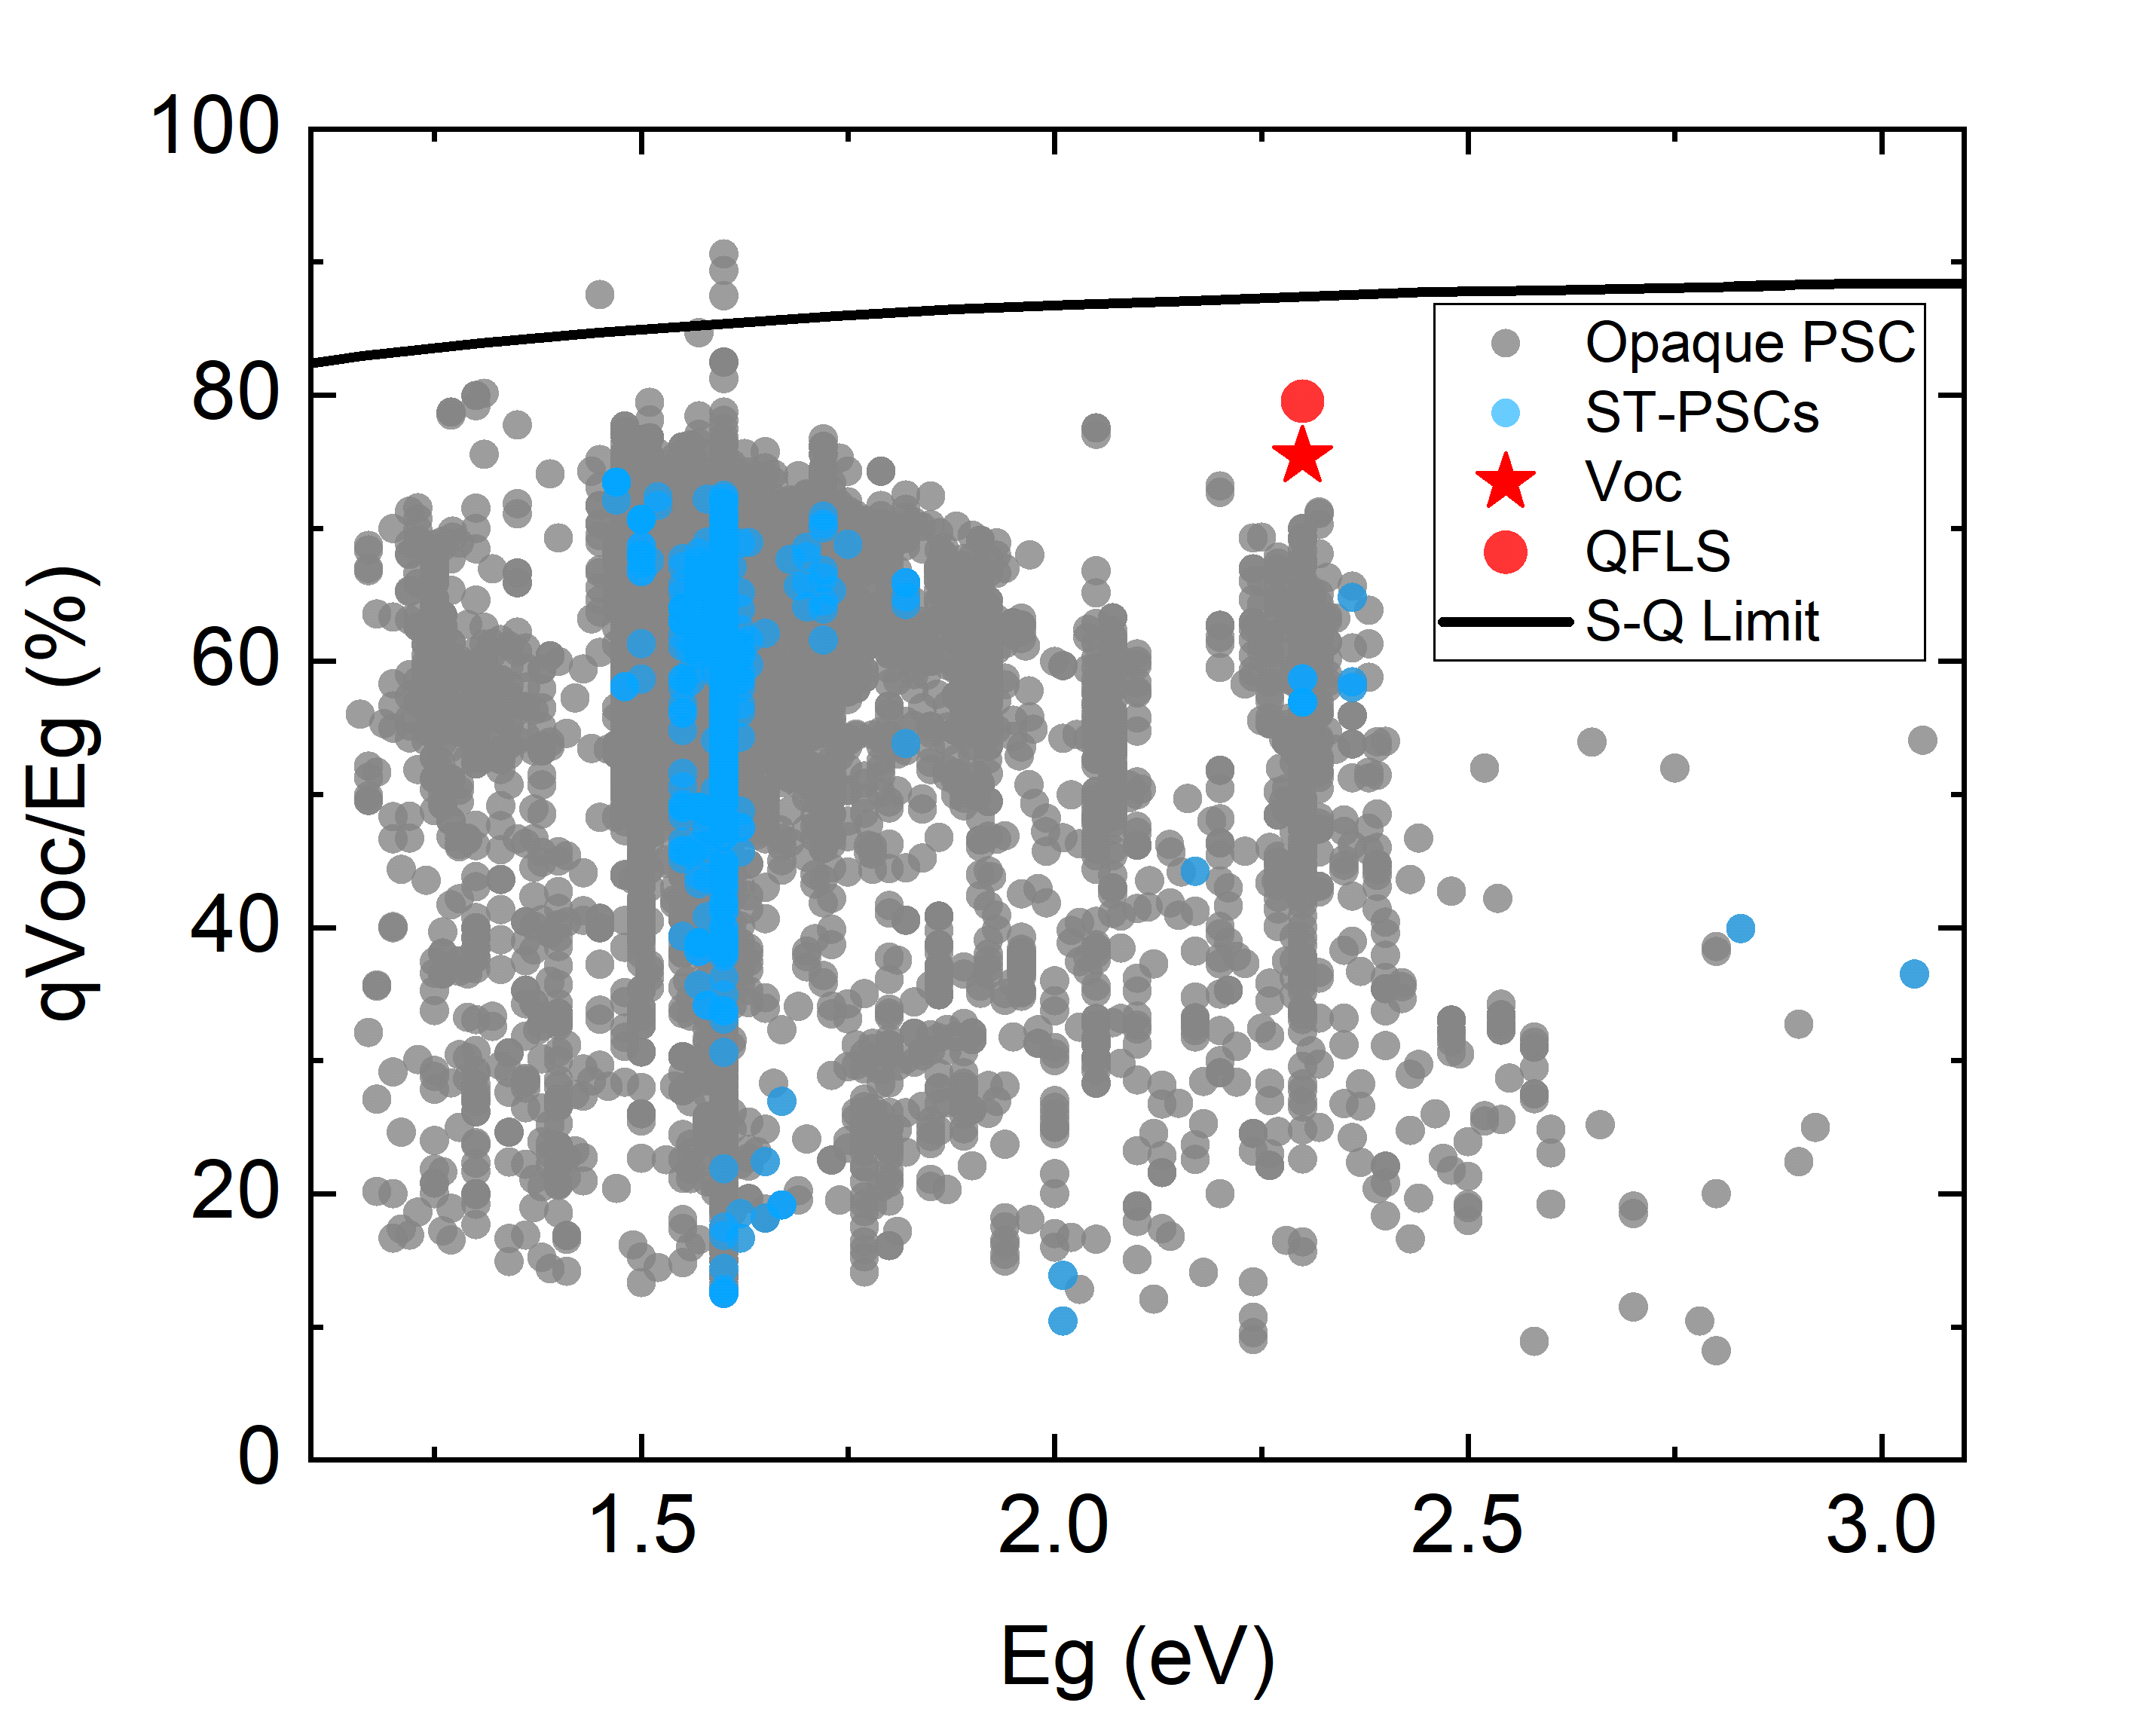
Figure S16. Literature survey of qVOc/Eg v. Eg graph for PSC devices. qVOc/Eg v. Eg graph reporting the literature results for ST-PSCs and Opaque PSCs devices. Reds stars represent the QFLS and Voc values measured for ST-PSC in this paper. The black line represent the S-Q limit reported from Ruhle et al. (reported as ref. num 38 in the main).
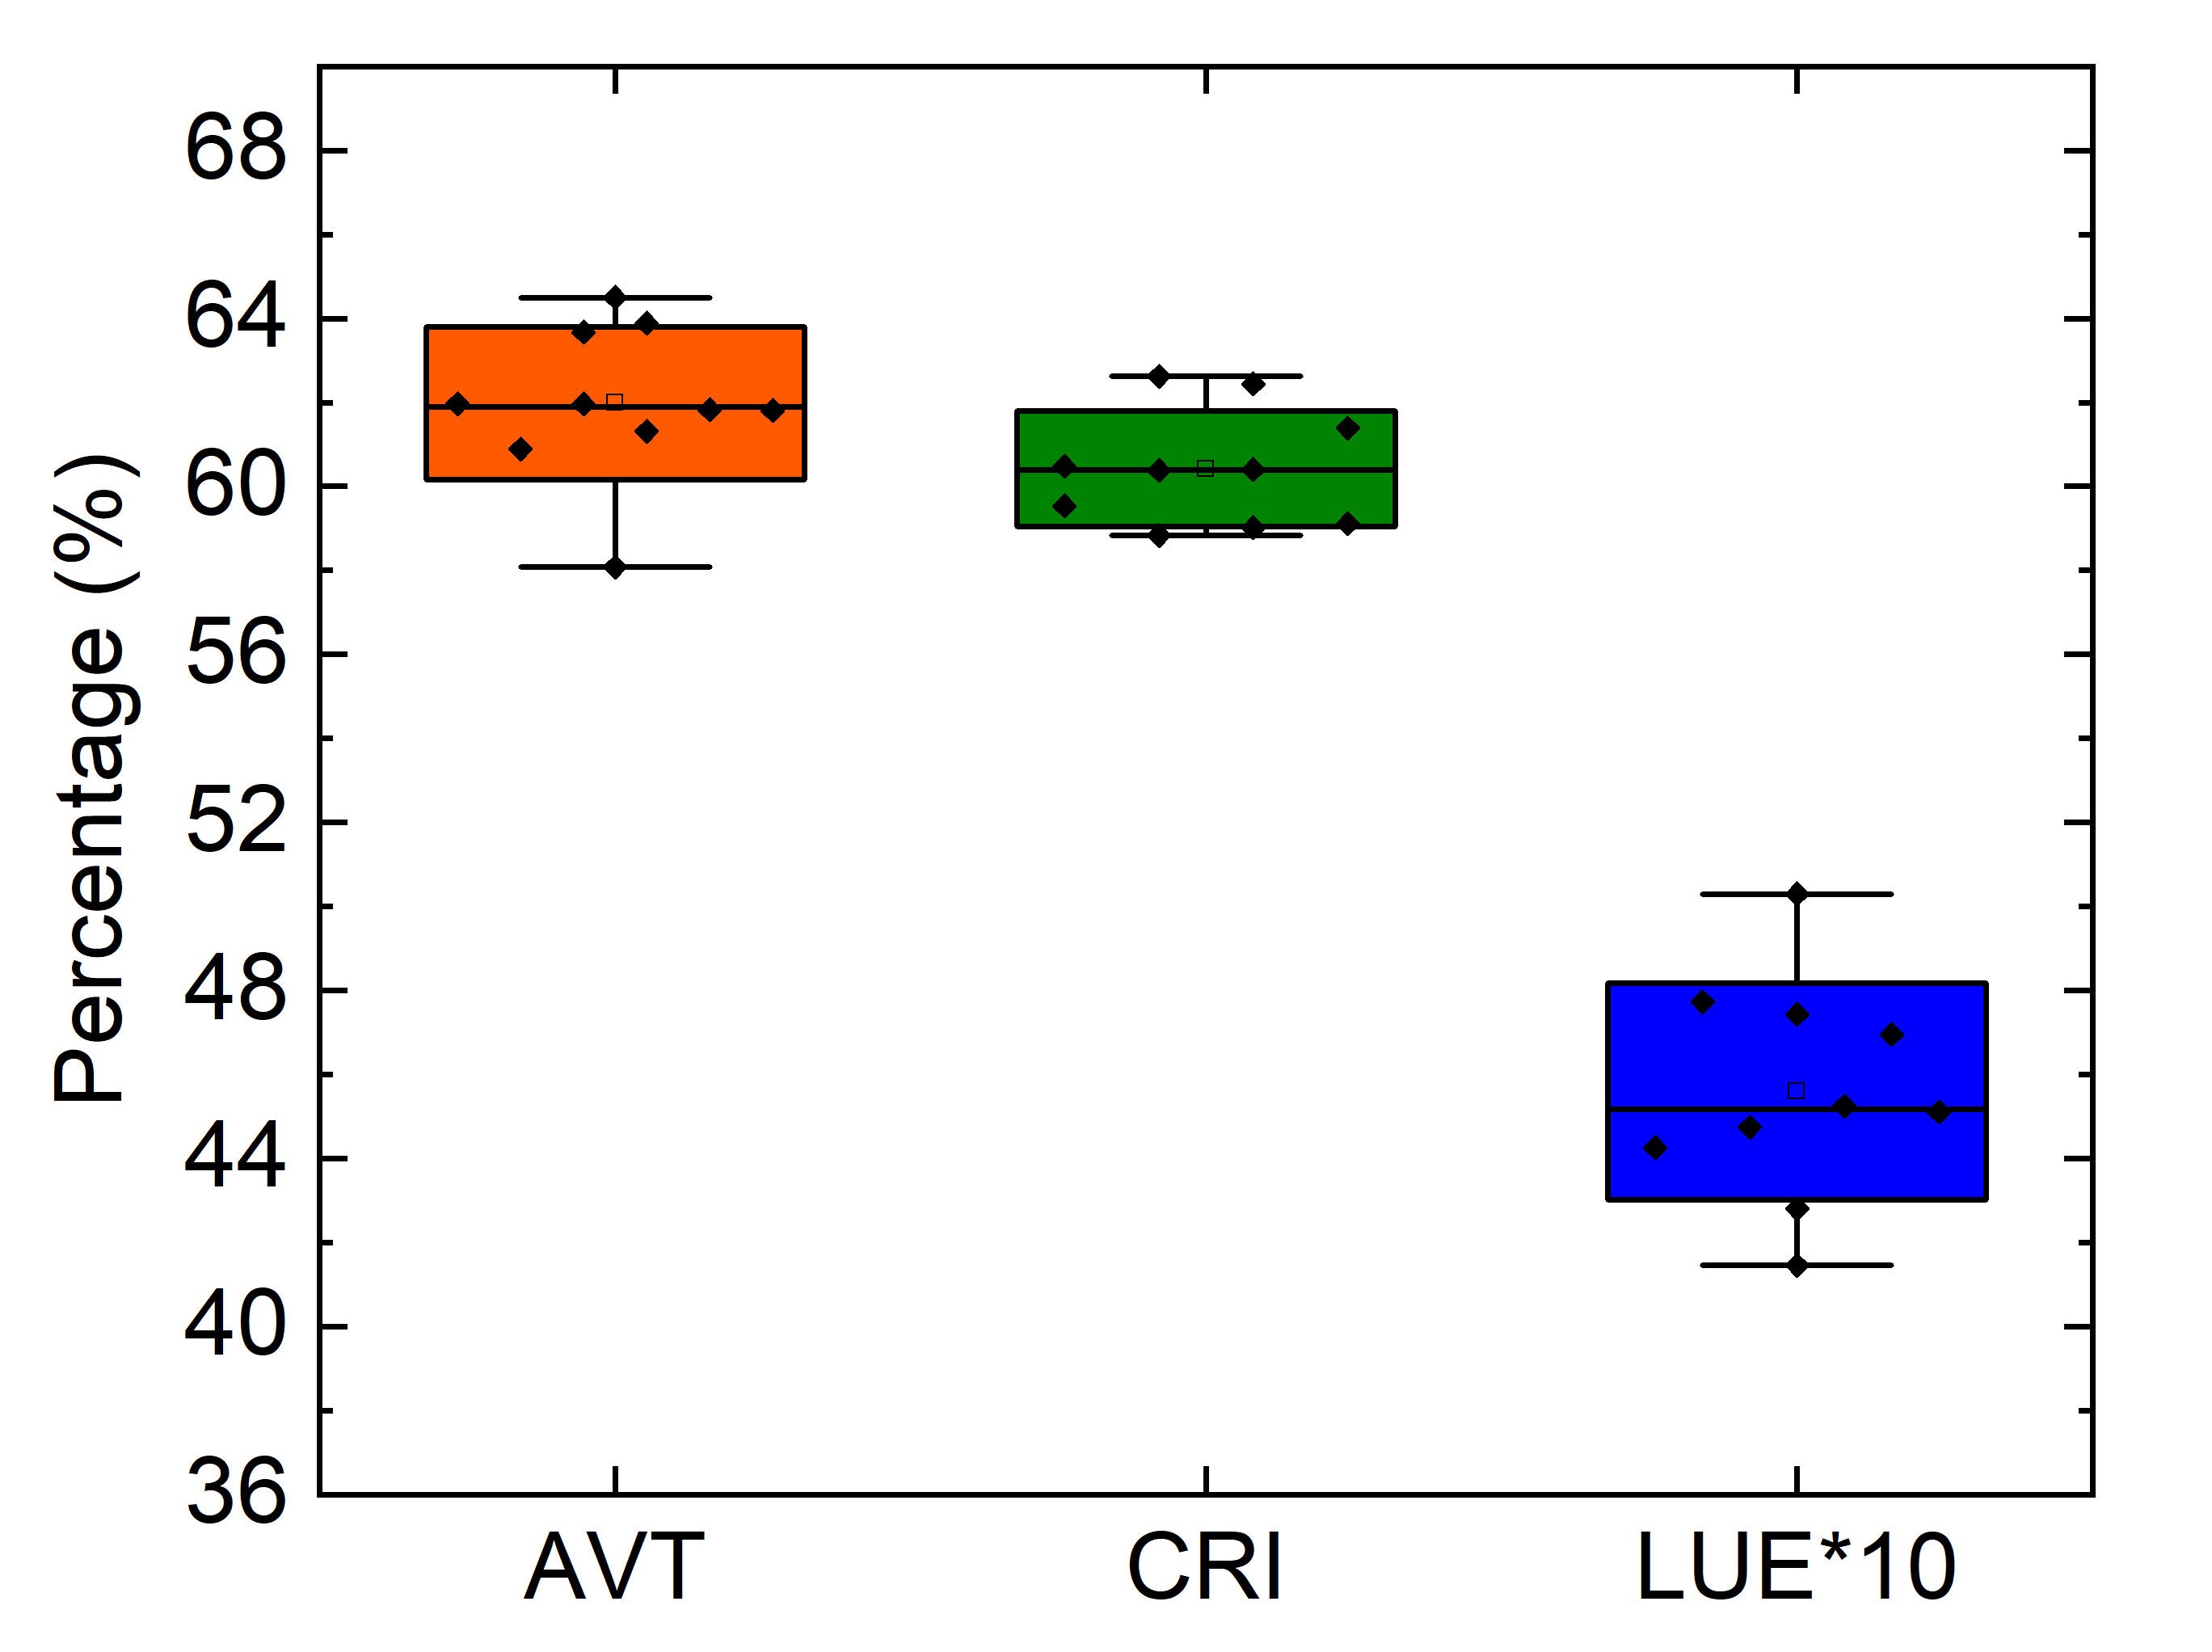
Figure S17. Key Performing Indexes (KPIs) in TPV. AVT, CRI and LUE box plots measured in a batch of ten ST-PSC cells using the following device stack: FTO/c-TiO₂:SnO₂/FAPbBr₃/2D ISO-NEO/PTAA/ITO. No light management tools are applied.

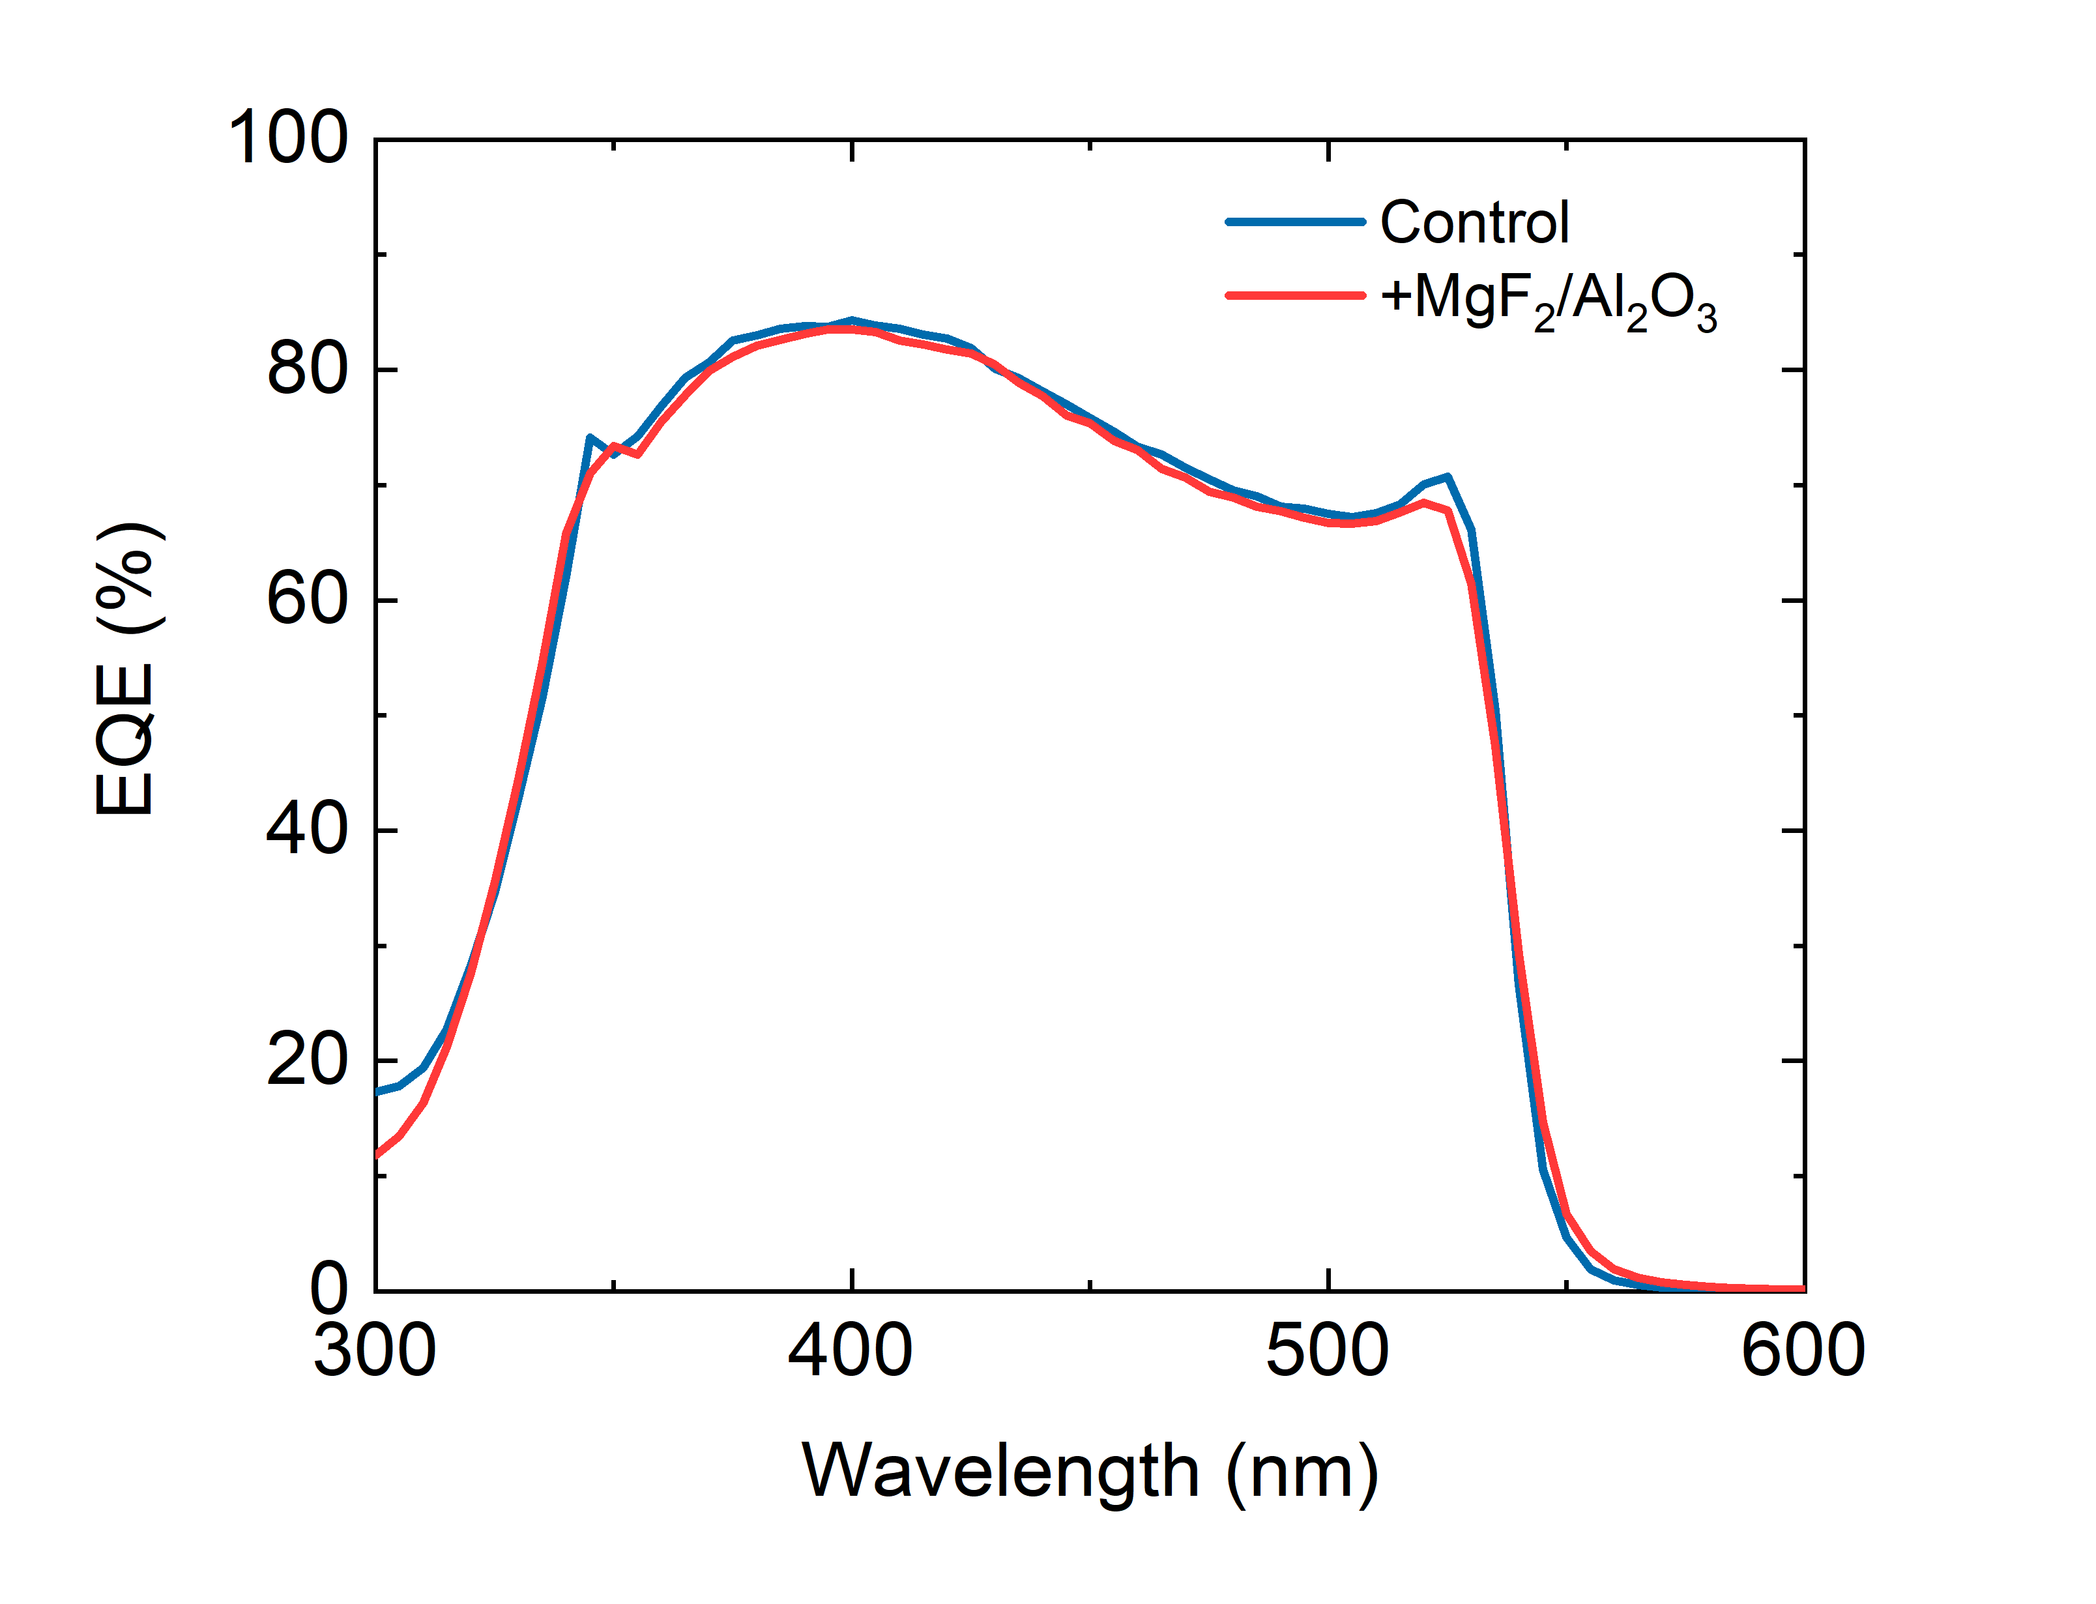
Figure S18. EQE spectra of the ST-PSCs with (+MgF₂/Al₂O₃) and without light management (control).
Bifaciality
An important feature of transparent solar cells is their bifaciality, which allows the devices to exploit also light impinging from the back interface, with an energy yield up to 120% depending on the albedo. A bifaciality factor can be defined as:
$$ϕ=\frac{J_{sc}^{Back}}{J_{sc}^{Front}}$$
Where: J_{SC}^{Back} is the current density obtained when illuminating the solar cell from the back side and J_{SC}^{Front} is the current density obtained when illuminating the solar cell from the front side.
The Figure S19 a-b show the J-V characteristics and IPCE spectra of an optimized ST-PSC device, concerning the light management and ISONEO passivation scheme, by varying the illumination side (front and rear).

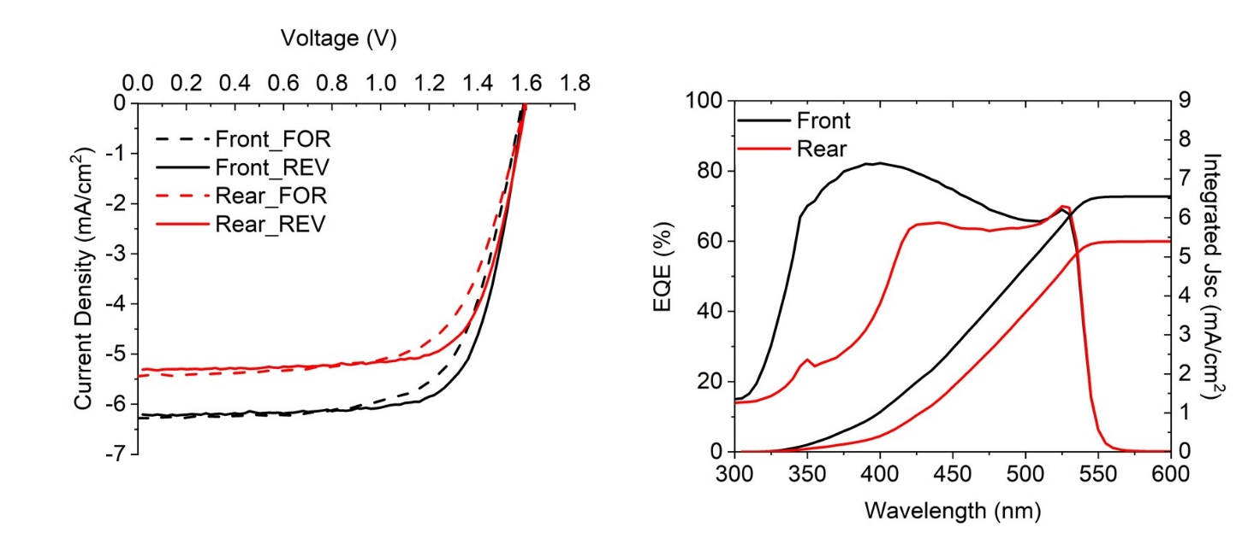
Figure S19. Testing the ST-PSC devices in bifacial mode. a. J-V curves measured at AM1.5G 1Sun illumination condition under reverse and forward scan directions varying the illumination side: Front (black curves) and Rear (red curves). b. EQE spectra and Integrated Jsc current varying the illumination side.
Figure S20. Indoor illumination. J-V curve of ST-PSC under artificial indoor light conditions at 200, 500, 1000 Lux.

Figure S21. Statistical results of PV parameters in a batch of eight ST-PSM modules. The results are obtained from J-V curves measured at 1Sun AM1.5G illumination condition under forward and reverse scan directions a. Open-circuit Voltage, Voc (V); b. Fill Factor, FF (%); c. Short-circuit Current, Isc (mA); d. Power Conversion Efficiency, PCE (%).

References

1 Delamarre, A., Lombez, L. & Guillemoles, J.-F. Contactless mapping of saturation currents of solar cells by photoluminescence. Applied Physics Letters 100, doi:10.1063/1.3697704 (2012).
2 Rau, U. Reciprocity relation between photovoltaic quantum efficiency and electroluminescent emission of solar cells. Physical Review B 76, 085303, doi:10.1103/PhysRevB.76.085303 (2007).
3 Katahara, J. K. & Hillhouse, H. W. Quasi-Fermi level splitting and sub-bandgap absorptivity from semiconductor photoluminescence. Journal of Applied Physics 116, doi:10.1063/1.4898346 (2014).
4 Yang, C., Liu, D., Bates, M., Barr, M. C. & Lunt, R. R. How to Accurately Report Transparent Solar Cells. Joule 3, 1803-1809, doi:https://doi.org/10.1016/j.joule.2019.06.005 (2019).
5 Béchu, S., Ralaiarisoa, M., Etcheberry, A. & Schulz, P. Photoemission Spectroscopy Characterization of Halide Perovskites. Advanced Energy Materials 10, 1904007, doi:https://doi.org/10.1002/aenm.201904007 (2020).

