Supplementary Material

Extracellular vesicles-transmitted miR-21a-5p altered microglia polarization after hypoxia-ischemic injury in neonatal mice via STAT3 pathways

Danqing Xin¹, Yijing Zhao¹, Tingting Li¹, Hongfei Ke¹, Chengcheng Gai¹, Xiaofan Guo², Wenqiang Chen³, Dexiang Liu^{4*}, and Zhen Wang^{1**}
¹Department of Physiology, School of Basic Medical Sciences, Cheeloo College of Medicine, Shandong University, Jinan, Shandong, 250012, P.R. China
²Department of Neurology, Loma Linda University Health, Loma Linda, CA 92354, USA
³Qilu Hospital, Cheeloo College of Medicine, Shandong University, Jinan, Shandong, P.R. China
⁴Department of Medical Psychology and Ethics, School of Basic Medicine Sciences, Cheeloo College of Medicine, Shandong University, Jinan, Shandong, 250012, P.R. China

Supplementary method
1. CCK8 assay
Cell Counting Kit-8 (CCK-8) assay (Yiyuan Biotechnologies, Guangzhou, China) was conducted for the analysis of cell viability through the addition of 10 μl CCK-8 solution in each well (96-well plates). After incubated under 5% CO₂ air environment at 37 °C for 3 h, cells were measured in Microplate Reader (Thermo Fisher Scientific, PA, USA) at 450 nm.
2. Brain water content
Three days after HI injury, the brains were removed for measuring brain water content. Briefly, the left and right hemispheres are separated and weighed and then placed in an oven (105°C) to dry for 2 d and weighed again. Brain water content was calculated as described [1].
3. Measurement of infarct ratio
Three days after HI injury, the whole brain tissue was frozen at ‐20 °C for 30 min, and then the brain tissue was cut into 4 slices with a thickness of about 2 mm along the coronal plane and immersed in 2 % 2, 3, 5- triphenyl tetrazolium chloride (TTC) solution at 37 ℃ for 20 min. and infarct volume was quantified as described above [1].
4. Immunofluorescence staining
After brain tissue sections were dewaxed and antigen repaired, slices were treated with the following primary antibodies: p-STAT3 (1:100), Iba-1 (1:100), CD16 (1:100), or CD206 (1:100) overnight at 4 °C. Slices were incubated with secondary antibody: Alexa Fluor® 594 AffiniPure Goat Anti-Rabbit IgG (H+L) (1:100) and Alexa Fluor® 488 AffiniPure Goat Anti-Mouse IgG (H+L) (1:100) for 30 min at 37 °C. Finally, slices were stained nucleus with DAPI at room temperature for 5 min. The above fluorescence images were obtained by Pannoramic MIDI (3D HISTECH, Hungary).

5. RNA isolation and reverse transcriptase quantitative real-time PCR (qRT-PCR)
Total RNA of BV-2 cells and brain tissue was extracted with Ultrapure RNA Kit (CoWin Biosciences, China) in accordance with the manufacturer’s protocol. EVs RNA extraction was conducted using the SeraMir EVs RNA Extraction Kit (System Biosciences, USA) following isolation of EVs using ExoQuick-TCTM (System Biosciences, USA). cDNA was synthesized using a reverse transcription kit (TOYOBO, Osaka, Japan). The qRT-PCR reaction was performed using the SYBR Green PCR master mix (Aidlab biotechnologies CO.Ltd, Beijing, China) in the Bio-rad IQ5 Real Time PCR System (Bio-Rad, USA) with use of gene-specific primer pairs (GenePharma, Shanghai, China) (shown in Table S2). The expression level was standardized relative to the internal (β-actin or U6) and the relative expression level was evaluated using the 2^{-ΔΔCT} method.
6. RT-PCR analysis
EVs RNA extraction and cDNA synthesis were carried out as described above. cDNA for miR-21a-5p was subsequently amplified by PCR with specific primers (shown in Table S2). Reaction products were separated by electrophoresis on 1.2% agarose/TAE gel containing 0.1% GoldView (vol/vol), and run at 90 V for 30 min. The image was detected with use of the Tanon Imaging System (Tanon-2500).
7. Western blot analysis
EVs, BV-2 cells or ipsilateral cortex were homogenized in RIPA buffer containing protease/phosphatase inhibitors and PMSF for 10 min and then centrifuged at 13800 × g for 10 min at 4 °C. Protein samples were separated with SDS-PAGE gels for 30 min at 80 V and 1 h at 120 V and then transferred to PVDF membrane at 300 mA at least 1 h (The specific time depends on the target molecular weight). Following blocked in 5% non-fat milk for 1 h. Blots were probed using the primary antibodies: STAT3, p-STAT3, TSG101, CD9, Calnexin, GM130, Cytochrome C1, Lamin A/C, β-actin at 4°C overnight. The next day, secondary antibodies were incubated to membrane for 1 h room temperature. The chemiluminescent signal was developed with use of ECL kit reagents (MILLIPORE, USA) and then detected with use of the Tanon Imaging System (Tanon-4600).

Reference
1. Xin, D., et al., Mesenchymal stromal cell-derived extracellular vesicles modulate microglia/macrophage polarization and protect the brain against hypoxia-ischemic injury in neonatal mice by targeting delivery of miR-21a-5p. Acta Biomater, 2020. 113: p. 597-613.

Supplementary Table
Table S1 Reagent in this study
Reagent | Catalog number |  | Company
Mouse anti-β-actin | TA-09 |  | Zhongshan Golden Bridge  Biotechnology (Beijing, China)
Mouse Iba-1 antibody | GB12105 |  | Servicebio (Wuhan, China)
Mouse monoclonal NeuN antibody | ab104224 |  | Abcam (Cambridge, UK)
Rabbit monoclonal TSG101 antibody | ab125011 |  | Abcam (Cambridge, UK)
Rabbit Polyclonal Calnexin antibody | 10427-2-AP |  | Proteintech Group (Rosemont, IL, USA)
Rabbit monoclonal CD9 antibody | ab92726 |  | Abcam (Cambridge, UK)
Mouse monoclonal GM130 antibody | sc-55590 |  | Santa Cruz (Oregon, USA)
Mouse monoclonal Lamin A/C antibody | sc-376248 |  | Santa Cruz (Oregon, USA)
Mouse monoclonal Cytochrome C1 antibody | sc-514435 |  | Santa Cruz (Oregon, USA)
FITC anti-mouse/rat CD29 Antibody | 102205 |  | Biolegend (San Diego, CA, USA)
PE/Cy7 anti-mouse/human CD44 Antibody | 103029 |  | Biolegend (San Diego, CA, USA)
FITC anti-mouse CD31 Antibody | 102405 |  | Biolegend (San Diego, CA, USA)
APC anti-mouse Sca-1 Antibody | 108125 |  | Biolegend (San Diego, CA, USA)
FITC anti-mouse/human CD11b Antibody | 101206 | Biolegend (San Diego, CA, USA)
APC anti-mouse CD45 Antibody | 103112 |  | Biolegend (San Diego, CA, USA)
FITC anti-mouse CD14 Antibody | 123307 |  | Biolegend (San Diego, CA, USA)
PE anti-mouse CD19 Antibody | 115507 |  | Biolegend (San Diego, CA, USA)
PerCP anti-mouse Ly6G Antibody | 46-9668-80 |  | Invitrogen (Carlsbad, CA, USA)
APC anti-mouse CD117 Antibody | 105811 |  | Biolegend (San Diego, CA, USA)
Alexa Fluor® 594 AffiniPure Goat Anti-Rabbit IgG (H+L) | 111-585-003 |  | Jackson ImmunoResearch Inc  (PA, USA)
Alexa Fluor® 488 AffiniPure Goat Anti-Mouse IgG (H+L) | 115-545-003 |  | Jackson ImmunoResearch Inc  (PA, USA)
Peroxidase-conjugated goat anti-rabbit IgG | ZB-2301 |  | Zhongshan Golden Bridge Biotechnology (Beijing, China)
Peroxidase-conjugated goat mouse IgG | ZB-2305 |  | Zhongshan Golden Bridge Biotechnology (Beijing, China)
Enhanced chemiluminescence and PVDF membranes | No. IPVH00010 |  | Millipore  (Billerica, MA, USA)
PhosSTOP phosphatase inhibitor | P1082 |  | Roche Diagnostics GmbH (Indianapolis, IN, USA)
RIPA | P0013B |  | Beyotime Institute of Biotechnology (Jiangsu, China)
PMSF | ST506-2 |  | Beyotime Institute of Biotechnology (Jiangsu, China)
BCA protein assay kit | CW0014S |  | CWBIO (Haimen, Jiangsu, China)
ECL kit | WBKLS0100 |  | Millipore  (Billerica, MA, USA)
TTC | T8877-10G |  | Sigma-Aldrich (St. Louis, MO, USA)
SYBR Green PCR master mix | PC3301 |  | Aidlab Biotechnologies (Beijing, China)
Revert Aid First Strand cDNA Synthesis Kit | FSQ-101 |  | TOYOBO (Osaka, Japan)
Ultrapure RNA Kit | 01761/20114-1 |  | CWBIO (Beijing, China)

Table S2. The sequences used in the present study as follows:
Name | Primer sequence (5’→3’)
β-actin | F primer：CAAGCACCTTGGAAGAGGAG
 | R primer：AAGGCCAAACACAGCATACC
iNOS | F primer：CAAGCACCTTGGAAGAGGAG
 | R primer：CCTTTCAGTCCTTTGCAAGC
CD206 | F primer：: CAAGGAAGGTTGGCATTTGT
 | R primer：CTGGCTGTTGCAAGACTGAC
IL-10 | F primer：CCAAGCCTTATCGGAAATGA
 | R primer：TTTTCACAGGGGAGAAATCG
TGF-β | F primer：TGCGCTTGCAGAGATTAAAA
 | R primer：CGTCAAAAGACAGCCACTCA
TNF-α | F primer：CGGGCAGGTCTACTTTGGAG
 | R primer：ACCCTGAGCCATAATCCCCT
IL-1β | F primer：TGCCACCTTTTGACAGTGATG
 | R primer：TGATGTGCTGCTGCGAGATT
U6 | F primer：CAGCACATATACTAAAATTGGAACG
 | R primer：ACGAATTTGCGTGTCATCC
mmu-miR-21a-5p | Sense：ACGTTGTGTAGCTTATCAGACTG
 | Antisense：AATGGTTGTTCTCCACACTCTC
mimics negative control | Sense: UUCUCCGAACGUGUCACGUTT
 | Antisense: ACGUGACACGUUCGGAGAATT
mmu-miR-21a-5p mimics | Sense: UAGCUUAUCAGACUGAUGUUGA
 | Antisense: AACAUCAGUCUGAUAAGCUAUU
mmu-miR-21a-5p inhibitor | UCAACAUCAGUCUGAUAAGCUA
Inhibitor negative control | CAAACACCAUUGUCACACUCCA

Supplementary figure
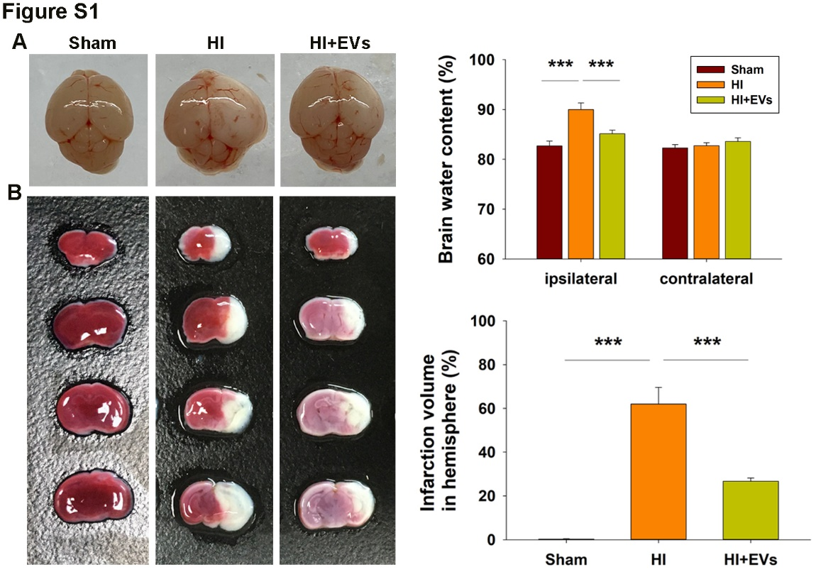
Figure S1 MSCs-EVs suppressed HI-induced edema and infarct at 3 d post-HI insult
(A) Representative brain pictures at 3 d following HI. Brain water content was assessed at 3 d following HI and quantification of brain water content is presented for each group. N = 4/group. (B) Complete sets of brain slices from a representative animal (TTC staining) are shown. Infarct volume (white area) was quantized, N = 4/group. Values represent the mean ± SD, ***p<0.001 according to ANOVA with Bonferroni correction.
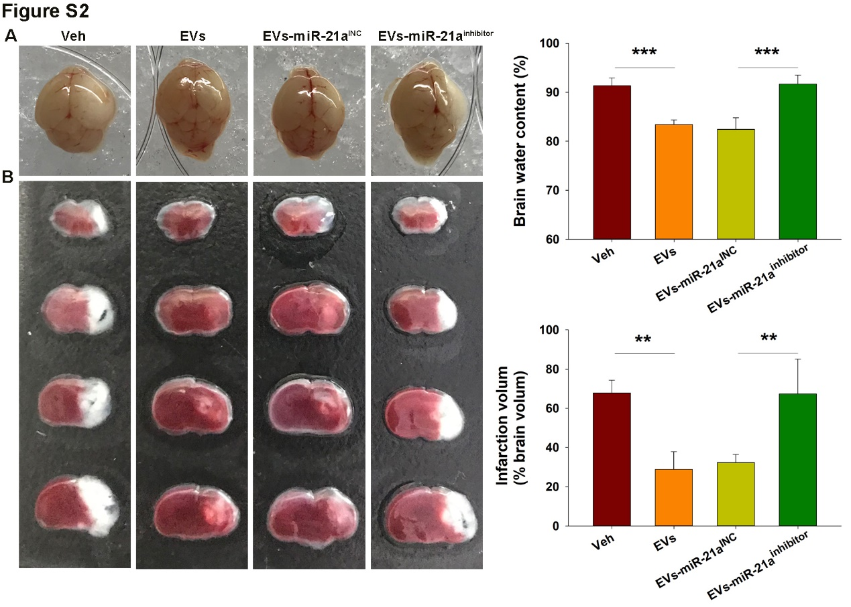Figure S2 MiR-21a-5p regulated neuroprotection effects of MSCs-EVs following HI
(A) Representative brain pictures at 72 h following HI in each group as treated with vehicle (Veh) or EVs injection, including MSCs-EVs, MSCs-EVs pretreated with the miR-21a-5p inhibitor (EVs-miR-21a^{inhibitor}), or the miR-21a-5p inhibitor negative control (EVs-miR-21a^{INC}). N = 4/group. (B) Complete sets of brain slices from a representative animal (TTC staining) are shown. Infarct volume (white area) was quantized, N = 4/group. Values represent the mean ± SD, **p<0.01, ***p<0.001 according to ANOVA with Bonferroni correction.

