Appendix
joint
Table 4: Skewness/Kurtosis tests for Normality 2008

Variable | Obs Pr(Skewness) Pr(Kurtosis) adj chi2(2) Prob>chi2
+
score | 1,076 0.3181 0.5240 1.41 0.4953

Figure 16
Figure 17

Table 5:Skewness/Kurtosis tests for Normality 2016

joint
Variable | Obs Pr(Skewness) Pr(Kurtosis) adj chi2(2) Prob>chi2
+
score | 1,071 0.5777 0.3327 1.25 0.5351

Figure 18

joint
Table 6: Skewness/Kurtosis tests for Normality 2012

Variable | Obs Pr(Skewness) Pr(Kurtosis) adj chi2(2) Prob>chi2
+
score | 1,075 0.8548 0.6229 0.28 0.8714

Figure 19

The prove of 2.31ab:
I assume that the supporters of A are those from location [a, b] and supporters who are indifferent of B and C believe that that there is a location c that $\int_{c}^{1}{e(x)dx > ev(n, A)}$.

For the indifferent supporters of B and C who locate at n, the difference of estimated votes is:

𝑏
𝑒𝑣(𝑛, 𝐴) = ∫
𝑓(𝑥) ∗ 𝜙(𝑥 − 𝑛)
2

𝑑𝑥

𝑎 ∫−2 (𝑧) ∗ (𝑧 − 𝑛)𝑧
𝑤ℎ𝑒𝑟𝑒 𝜙 𝑖𝑠 𝑡ℎ𝑒 𝑑𝑒𝑛𝑠𝑖𝑡y 𝑓𝑢𝑛𝑐𝑡𝑖𝑜𝑛 𝑜𝑓 𝑠𝑡𝑎𝑛𝑑𝑎𝑟𝑑 𝑛𝑜𝑟𝑚𝑎𝑙 𝑑𝑖𝑠𝑡𝑟𝑖𝑏𝑢𝑡𝑖𝑜𝑛
For simplicity, the quality of the information is normalized to 1

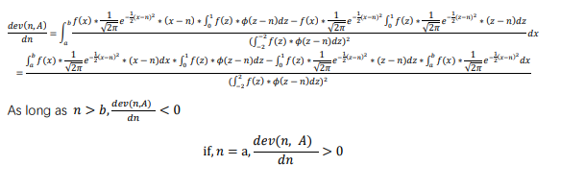
The prove of 2.32
Assume the location is n, and ∫𝑛+𝑎 (𝑥) = 0.5. Assume that A has more votes than B, there
𝑛−𝑎

are two situations:
- A and B intercepts at a point less than n+a at the left side while 𝑦𝐴(𝑛) > 𝑦𝐵(𝑛)
- A and B intercepts at a point more than n+a at the left side while 𝑦𝐴(𝑛) < 𝑦𝐵(𝑛)
If C has more votes than A:
- C and A intercepts at a point less than n+a at the left side while 𝑦𝐶(𝑛) > 𝑦𝐴(𝑛)
- C and A intercepts at a point more than n+a at the left side while 𝑦𝐶(𝑛) < 𝑦𝐴(𝑛)

Situations a.c and a,d ensure that C and B intercepts at a point less than n+a at the left side while 𝑦𝐶(𝑛) > 𝑦𝐵(𝑛)

Situations b.c and b,d ensure that C and B intercepts at a point more than n+a at the left side while 𝑦𝐶(𝑛) < 𝑦𝐵(𝑛)

The prove of 2016 election
To solve 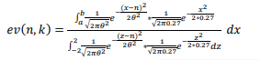
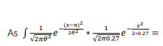$\frac{5\sqrt{6}θe^{\frac{27n^{2}}{2θ^{2}\left(100θ^{2}+27\right)}-\frac{n^{2}}{{2θ}^{2}}}\operatorname{erf}\left(\frac{\sqrt{100θ^{2}+27x}}{3\sqrt{6}θ}-\frac{3\sqrt{6}n}{2θ\sqrt{100θ^{2}+27}}\right)}{2\sqrt{300πθ^{4}+81πθ^{2}}}+c$

𝑒𝑣(𝑛, 𝑘) =$\frac{\operatorname{erf}\left(\frac{100bθ^{2}-27n+27b}{3\sqrt{600θ^{4}+162θ^{2}}}\right)-\operatorname{erf}\left(\frac{100aθ^{2}-27n+27a}{3\sqrt{600θ^{4}+162θ^{2}}}\right)}{\operatorname{erf}\left(\frac{100aθ^{2}+27n+54}{3\sqrt{600θ^{4}+162θ^{2}}}\right)+\operatorname{erf}\left(\frac{200θ^{2}-27n+54}{3\sqrt{600θ^{4}+162θ^{2}}}\right)}$

The prove of 2012 election
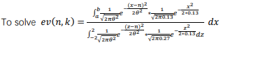

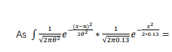

$$\frac{5\sqrt{26}θe^{\frac{{(13n-16θ^{2})}^{2}}{26θ^{2}\left(100θ^{2}+13\right)}-\frac{n^{2}}{{2θ}^{2}}-\frac{32}{325}}\operatorname{erf}\left(\frac{\sqrt{100θ^{2}+13x}}{\sqrt{26}θ}-\frac{13n-16θ^{2}}{\sqrt{26}θ\sqrt{100θ^{2}+13}}\right)}{2\sqrt{1300πθ^{4}+169πθ^{2}}}+c$$

𝑒𝑣(𝑛, 𝑘) =
$$\frac{\operatorname{erf}\left(\frac{(100\sqrt{26}b+16\sqrt{26})θ^{2}-13\sqrt{26}n+13\sqrt{26}b}{26\sqrt{100θ^{4}+13θ^{2}}}\right)-\operatorname{erf}\left(\frac{(100\sqrt{26}a+16\sqrt{26})θ^{2}-13\sqrt{26}n+13\sqrt{26}a}{26\sqrt{100θ^{4}+13θ^{2}}}\right)}{\operatorname{erf}\left(\frac{216\sqrt{26}θ^{2}-13\sqrt{26}n+{26}^{\frac{3}{2}}}{26\sqrt{100θ^{4}+13θ^{2}}}\right)+\operatorname{erf}\left(\frac{184\sqrt{26}θ^{2}+13\sqrt{26}n+{26}^{\frac{3}{2}}}{26\sqrt{100θ^{4}+13θ^{2}}}\right)}$$
Then these results can be computed in Mathmatica to manipulate 𝜃² to compare the (𝑛, 𝑘) of each voters.

