High-performance Na-doped LiFePO₄ cathode material derived from acid-washed iron red for the simultaneous immobilization of multi-metals
Jun Cong^{a,b,d}, Shao-hua Luo^{a,b,d *}, Kun Li^{a,b,d}, Jia-chen Wang^{a,b,d}, Ya-feng Wang^{a,b,d}, Sheng-xue Yan^{a,b,d}, Peng-wei Li^{a,c,d}
a. School of Materials Science and Engineering, Northeastern University, Shenyang 110819, PR China
b. School of Resources and Materials, Northeastern University at Qinhuangdao, Qinhuangdao 066004, PR China
c. Department of Chemistry and Bioscience, Aalborg University, 9220 Aalborg, Denmark
d. Key Laboratory of Dielectric and Electrolyte Functional Material Hebei Province, Qinhuangdao, PR China
*Corresponding author: School of Resources and Materials, Northeastern University at Qinhuangdao, Qinhuangdao, 066004, China.
E-mail address: tianyanglsh@163.com (S.-h. Luo)

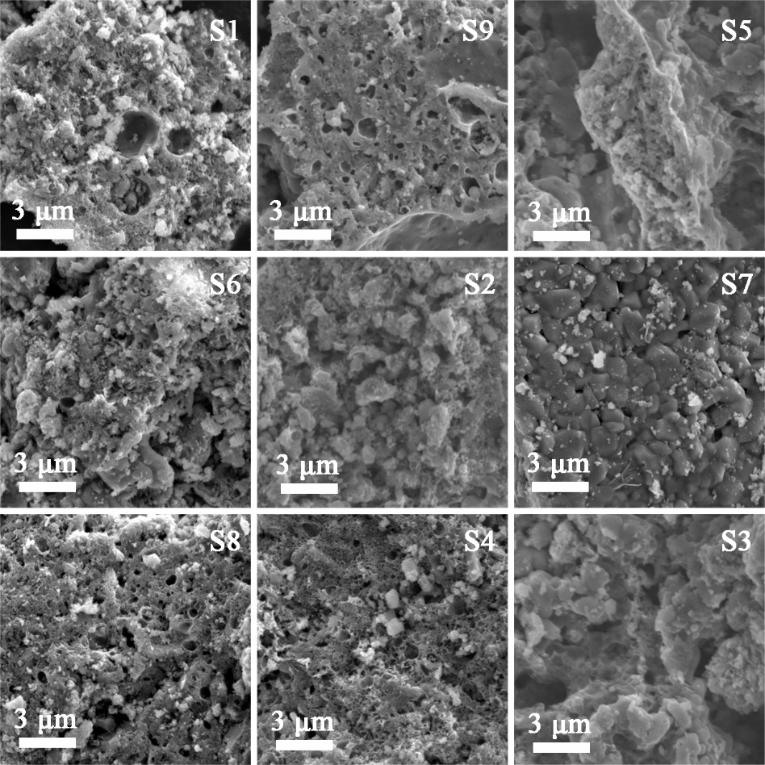
Fig. S1. SEM analysis of orthogonal experiments.
Fig. S2. The full-range XPS spectrum spectra of the samples.

