Supplementary Information: Observation of transition from superfluorescence to polariton condensation in CsPbBr₃ quantum dots film
Danqun Mao^{1*}, Linqi Chen^{2*}, Zheng Sun^{1,3#}, Min Zhang¹, Zhe-Yu Shi¹, Yongsheng, Hu¹, Long Zhang², Jian Wu^{1,3,4,5,} Hongxing, Dong^{2#}, Wei Xie^{1#}, Hongxing Xu^{1,6,7}
¹State Key Laboratory of Precision Spectroscopy, East China Normal University, Shanghai, 200241, China
²Key Laboratory of Materials for High-Power Laser, Shanghai Institute of Optics and Fine Mechanics, Chinese Academy of Sciences, 201800 Shanghai, China
³Collaborative Innovation Center of Extreme Optics, Shanxi University, Taiyuan, Shanxi 030006, China
⁴Chongqing Key Laboratory of Precision Optics, Chongqing Institute of East China Normal University, Chongqing 401121, China
⁵CAS Center for Excellence in Ultra-intense Laser Science, Shanghai 201800, China
⁶School of Physics and Technology, Center for Nanoscience and Nanotechnology, and Key Laboratory of Artificial Micro- and Nano-structures of Ministry of Education, Wuhan University, Wuhan 430072, China;
⁷Wuhan Institute of Quantum Technology, Wuhan 430206, China; School of Microelectronics, Wuhan University, Wuhan 430072, China
*These authors contributed equally to this work
#Email: zsun@lps.ecnu.edu.cn;hongxingd@siom.ac.cn;wxie@phy.ecnu.edu.cn;

I: Burnham–Chiao ring effect of CsPbBr₃ QD thin film.
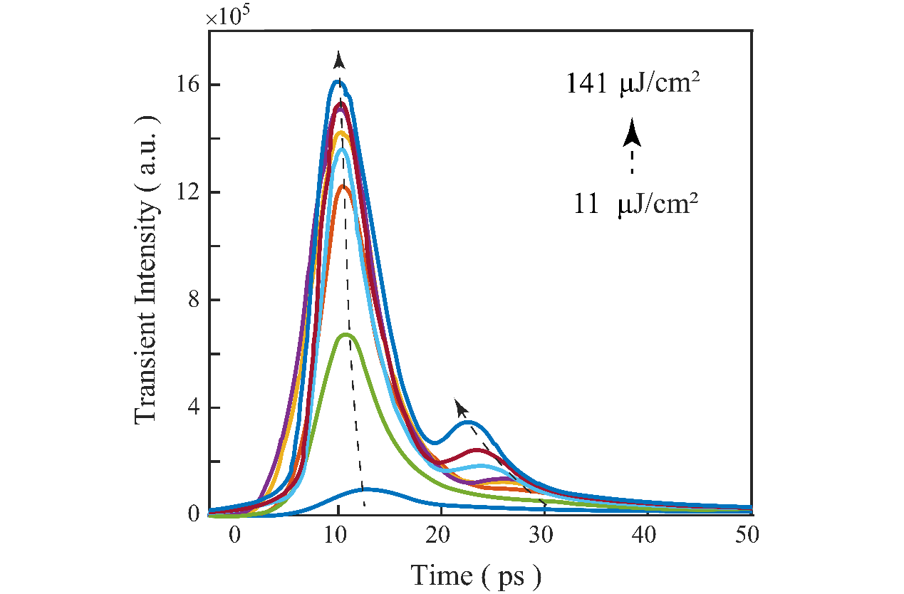
Fig. S1. | Time-resolved photoluminescence spectra under different pump densities.

II: The time-correlated Coherence of Independent Exciton and Cooperative Excitons.
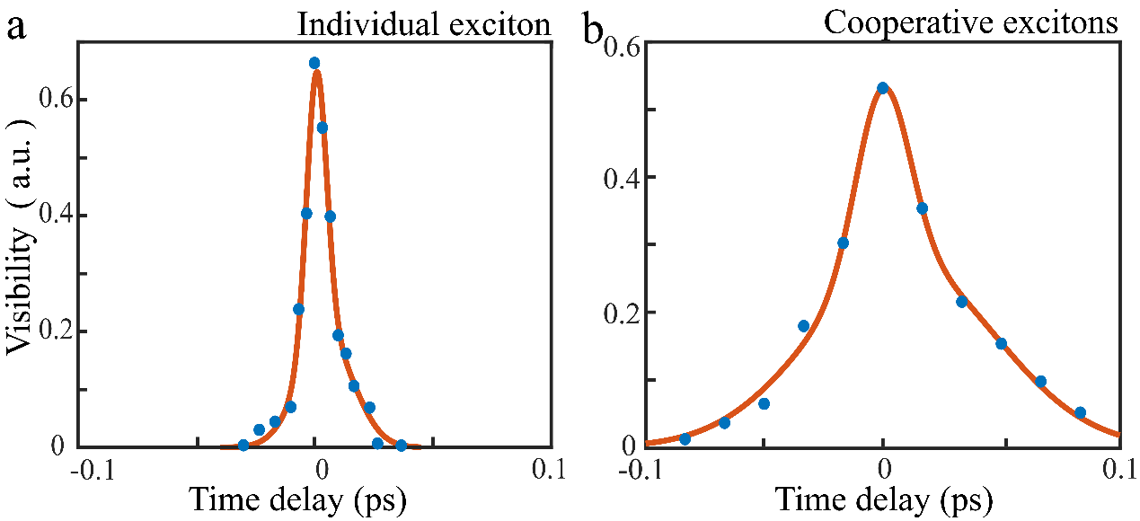
Fig. S2. | a, b, Time-correlated coherence between independent excitons (unassembled monodispersed CsPbBr₃ QDs) and cooperative excitons (CsPbBr₃ QDs thin film). The coherence times are 40 fs and 200 fs, respectively.

Ⅲ: The time-correlated Coherence of CEPC
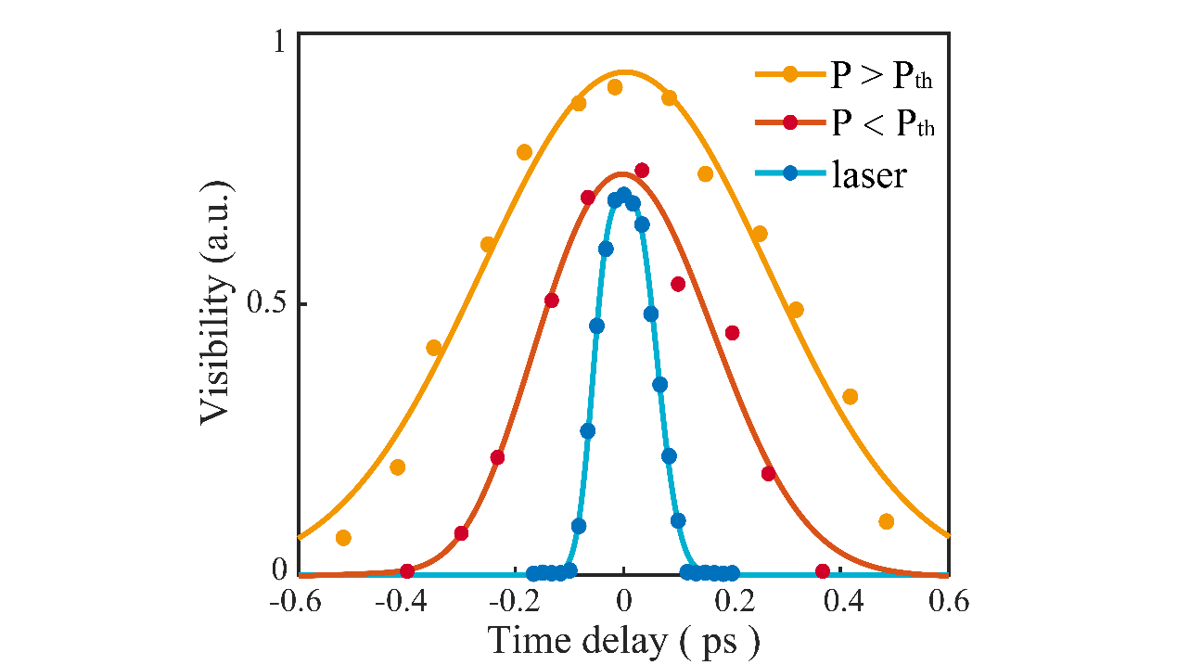
Fig. S3. | The time-correlated Coherence of above, below the CEPC threshold, and the pump laser. The Gaussian fitted coherence times are 1.2 ps, 0.8 ps and 0.2 ps respectively.

Ⅳ: Coupling between the cooperative excitons and the first Bragg mode at different locations.
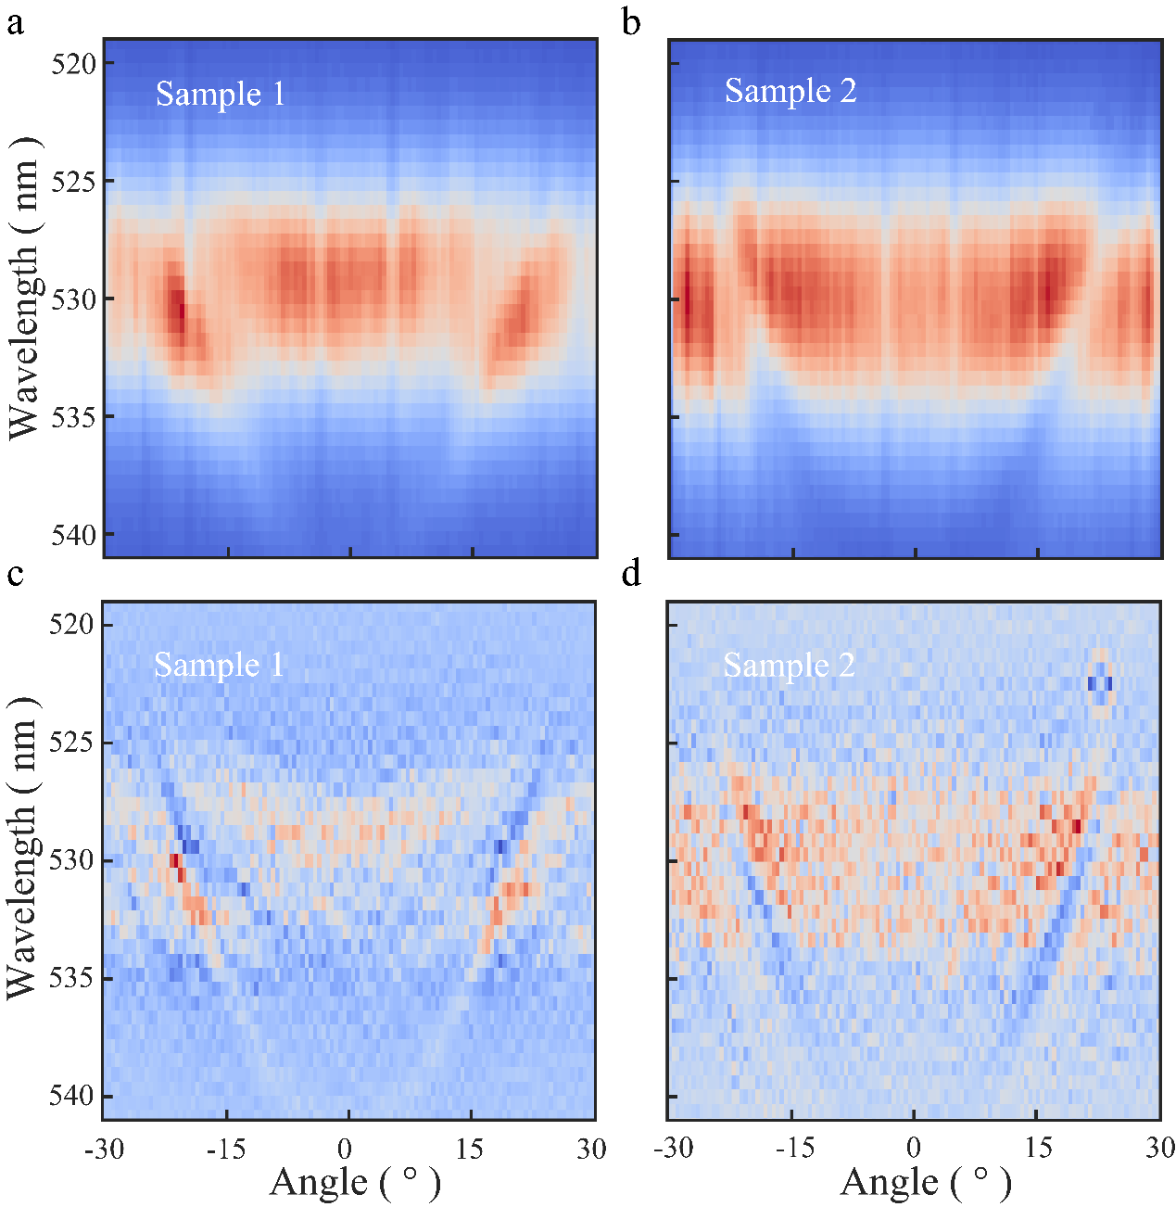
Fig. S4. | a-b, Angle-resolved photoluminescence spectrum under the excitation density below the threshold for the closely packed QD thin film. The anti-crossing dispersion feature and the opened energy gap are well resolved. c-d, Second-order derivative processed data for Figure a-b respectively.

Ⅴ: Coupling between individual exciton and the first-order Bragg mode.
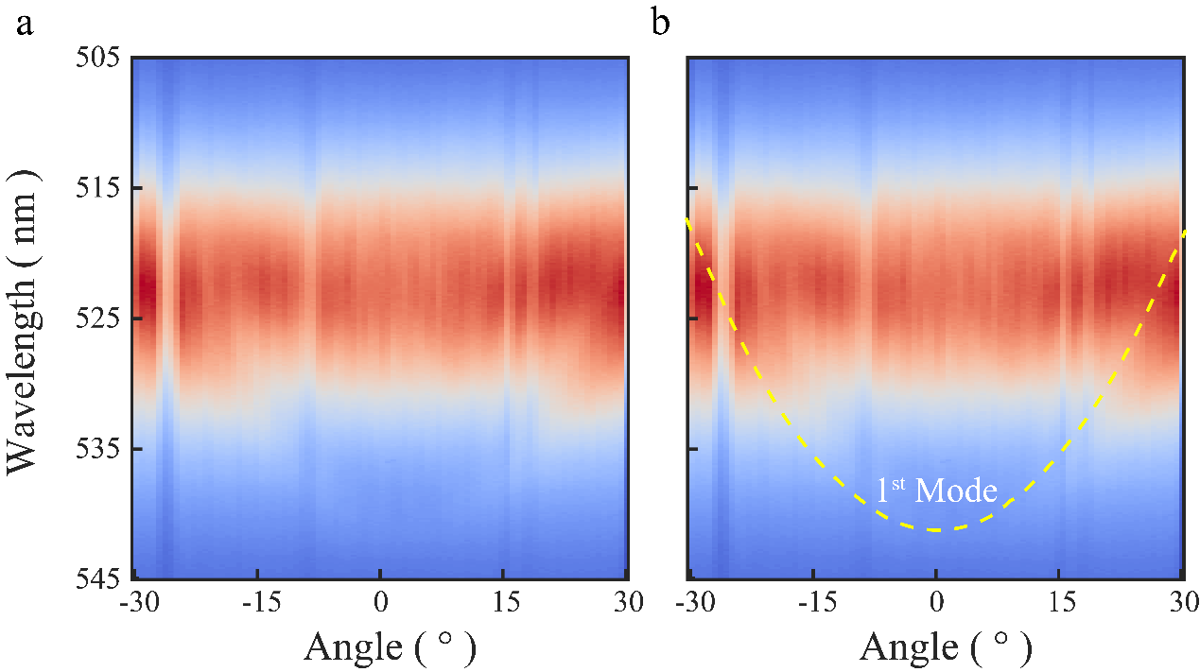

Fig. S5. | a, The weak coupling of the individual quantum dot and first-order Bragg mode for the dispersed QDs on DBR. b, The yellow dotted line follows the dispersion of the first-order Bragg mode for guidance.

Ⅵ: Theoretical Model:
Conventional open system Dickie model usually discusses the decay of a few two-level atoms under the assumption that the system always couples to a vacuum light field. In this part, we shall generalize this model and assume that the system couples to a stimulated radiation field with average photon number $n_{p}$ instead. The many-particle Lindblad master equation should then be written as [1]
$∂_{t}ρ=-\frac{γ}{2}\left(n_{p}+1\right)\left\{S^{+}S^{-},ρ\right\}-\frac{γ}{2}n_{p}\left\{S^{-}S^{+},ρ\right\}+γ\left(n_{p}+1\right)S^{-}{ρS}^{+}+γn_{p}S^{+}{ρS}^{-}$ (1)
Here $ρ$ is the density matrix for N two-level (spin-$1/2$) degrees of freedom, $γ$ is the single-atom decay rate, and $S^{±}=\sum_{i=1}^{N}{σ_{i}^{±}}$ satisfies the commutation relation for the su(2) Lie algebra.
Now if we decompose the Hilbert space $H$ of these N spin ${-1}/2$ according to the irreducible representation of the su(2) Lie algebra of $S^{±}$, we have $H=H_{N/2}⊕+⋯$. Here $H_{N/2}$ is only irreducible representation space with dimension $N+1$ (or one may call it the spin-$N/2$ representation), which contains all the cooperative states of these N spins. A simple basis of $H_{N/2}$ would be
$\left.\left|\frac{N}{2}\right.,\frac{N}{2}\right\rangle ,\left.\left|\frac{N}{2}\right.,\frac{N}{2}-1\right\rangle ,⋯\left.\left|\frac{N}{2}\right.,-\frac{N}{2}\right\rangle$ (2)
And we have following relations for the su(2) operators
$S^{Z}\left.\left|N/2\right.,m\right\rangle =m\left.\left|N/2\right.,m\right\rangle , S^{±}\left.\left|N/2\right.,m\right\rangle =\sqrt{\left(N/2∓m\right)\left(N/2±m+1\right)}\left.\left|N/2\right.,m±1\right\rangle$ (3)
where $S^{Z}=\frac{1}{2}\sum_{i}{σ_{i}^{Z}}$.
Because of the permutation symmetry of eq. (1), every irreducible representation spaces are decoupled. We may thus consider the evolution restricted in this subspace and write
$ρ=\sum_{m,m^{'}}{p_{m,m^{'}}}\left.\left|N/2\right.,m\right\rangle \left\langle \left.\left|N/2\right.,m^{'}\right|\right.$ (4)
with $\sum_{m,m}{p_{m,m}=1}$. The master eq. (2) can now be translated into
$∂_{t}p_{m,m^{'}}=-\frac{γ}{2}\left(n_{p}+1\right)\left[\left(\frac{N}{2}+m\right)\left(\frac{N}{2}-m+1\right)+\left(\frac{N}{2}+m^{'}\right)\left(\frac{N}{2}-m^{'}+1\right)\right]p_{m,m^{'}}$
$+γ\left(n_{p}+1\right)\sqrt{\left(\frac{N}{2}-m\right)\left(\frac{N}{2}+m+1\right)}\sqrt{\left(\frac{N}{2}-m^{'}\right)\left(\frac{N}{2}+m^{'}+1\right)}p_{m+1,m^{'}+1}$
$$-\frac{γ}{2}n_{p}\left[\left(\frac{N}{2}-m\right)\left(\frac{N}{2}+m+1\right)+\left(\frac{N}{2}-m^{'}\right)\left(\frac{N}{2}+m^{'}+1\right)\right]p_{m,m^{'}}$$
$+γn_{p}\sqrt{\left(\frac{N}{2}+m\right)\left(\frac{N}{2}-m+1\right)}\sqrt{\left(\frac{N}{2}+m^{'}\right)\left(\frac{N}{2}-m^{'}+1\right)}p_{m-1,m^{'}-1}$ (5)
Clearly, we see that the above equations are decoupled with respect to different $m-m^{'}$. If we are only interested in the average of the $S^{Z}$ operator, we have
$〈S^{Z}〉=tr\left(ρS^{Z}\right)=\sum_{m}{{mp}_{m,m}}$ (6)
Therefore, one may only consider the $m=m^{'}$ sector of eq. (5). The previous derivation ignores the phase of the light field and exciton. When superfluorescence occurs, the collective radiation is dominant at this phase and the absorption term can be ignored. In addition, consider the dephase ($γ_{dp}$) of matter, we can reduce to following $N+1$ coupled equations,
$$∂_{t}p_{m,m^{'}}=-γ\left(n_{p}+1\right)\left(\frac{N}{2}+m\right)\left(\frac{N}{2}-m+1\right)p_{m,m}$$
$-γ_{dp}p_{m,m}+γ\left(n_{p}+1\right)\left(\frac{N}{2}-m\right)\left(\frac{N}{2}+m+1\right)p_{m+1,m+1}+γ_{dp}p_{m+1,m+1}$ (7)
Note that the second line describes the process of the absorption of a background photon, and if we ignore it, the above equations are equivalent to eq. (12) in the supplementary information of Ref. [2].
The photon number $n_{p}$ changes due to the loss of the cavity and the radiation of the two-level atoms. The radiation rate I should be given by
$I=γ\left(n_{p}+1\right)\sum_{m}{\left(\frac{N}{2}+m\right)\left(\frac{N}{2}-m+1\right)}p_{m,m}$ (8)
The change rate of the photon number $n_{p}$ should then given by
$∂_{t}n_{p}=I-{γ_{c}n}_{p}$ (9)
where ${t_{c}=1/γ}_{c}$ is the lifetime of the cavity photon.

To be noted, the corresponding parameters of the theoretical curves in Figure 5f are $γ=3.5×{10}^{-4} {ps}^{-1}$, $γ_{c}=1.1 {ps}^{-1}$ and $γ_{dp}=0.015 {ps}^{-1}$.

[1] M. O. Scully and M. S. Zubairy, Quantum optics (1999).
[2] C. Zhou, Y. Zhong, H. Dong, W. Zheng, J. Tan, Q. Jie, A. Pan, L. Zhang, and W. Xie, Nature Communications 11, 329 (2020).

