Appendix A. Examples of roadside space conflicts from Baidu Streetview images
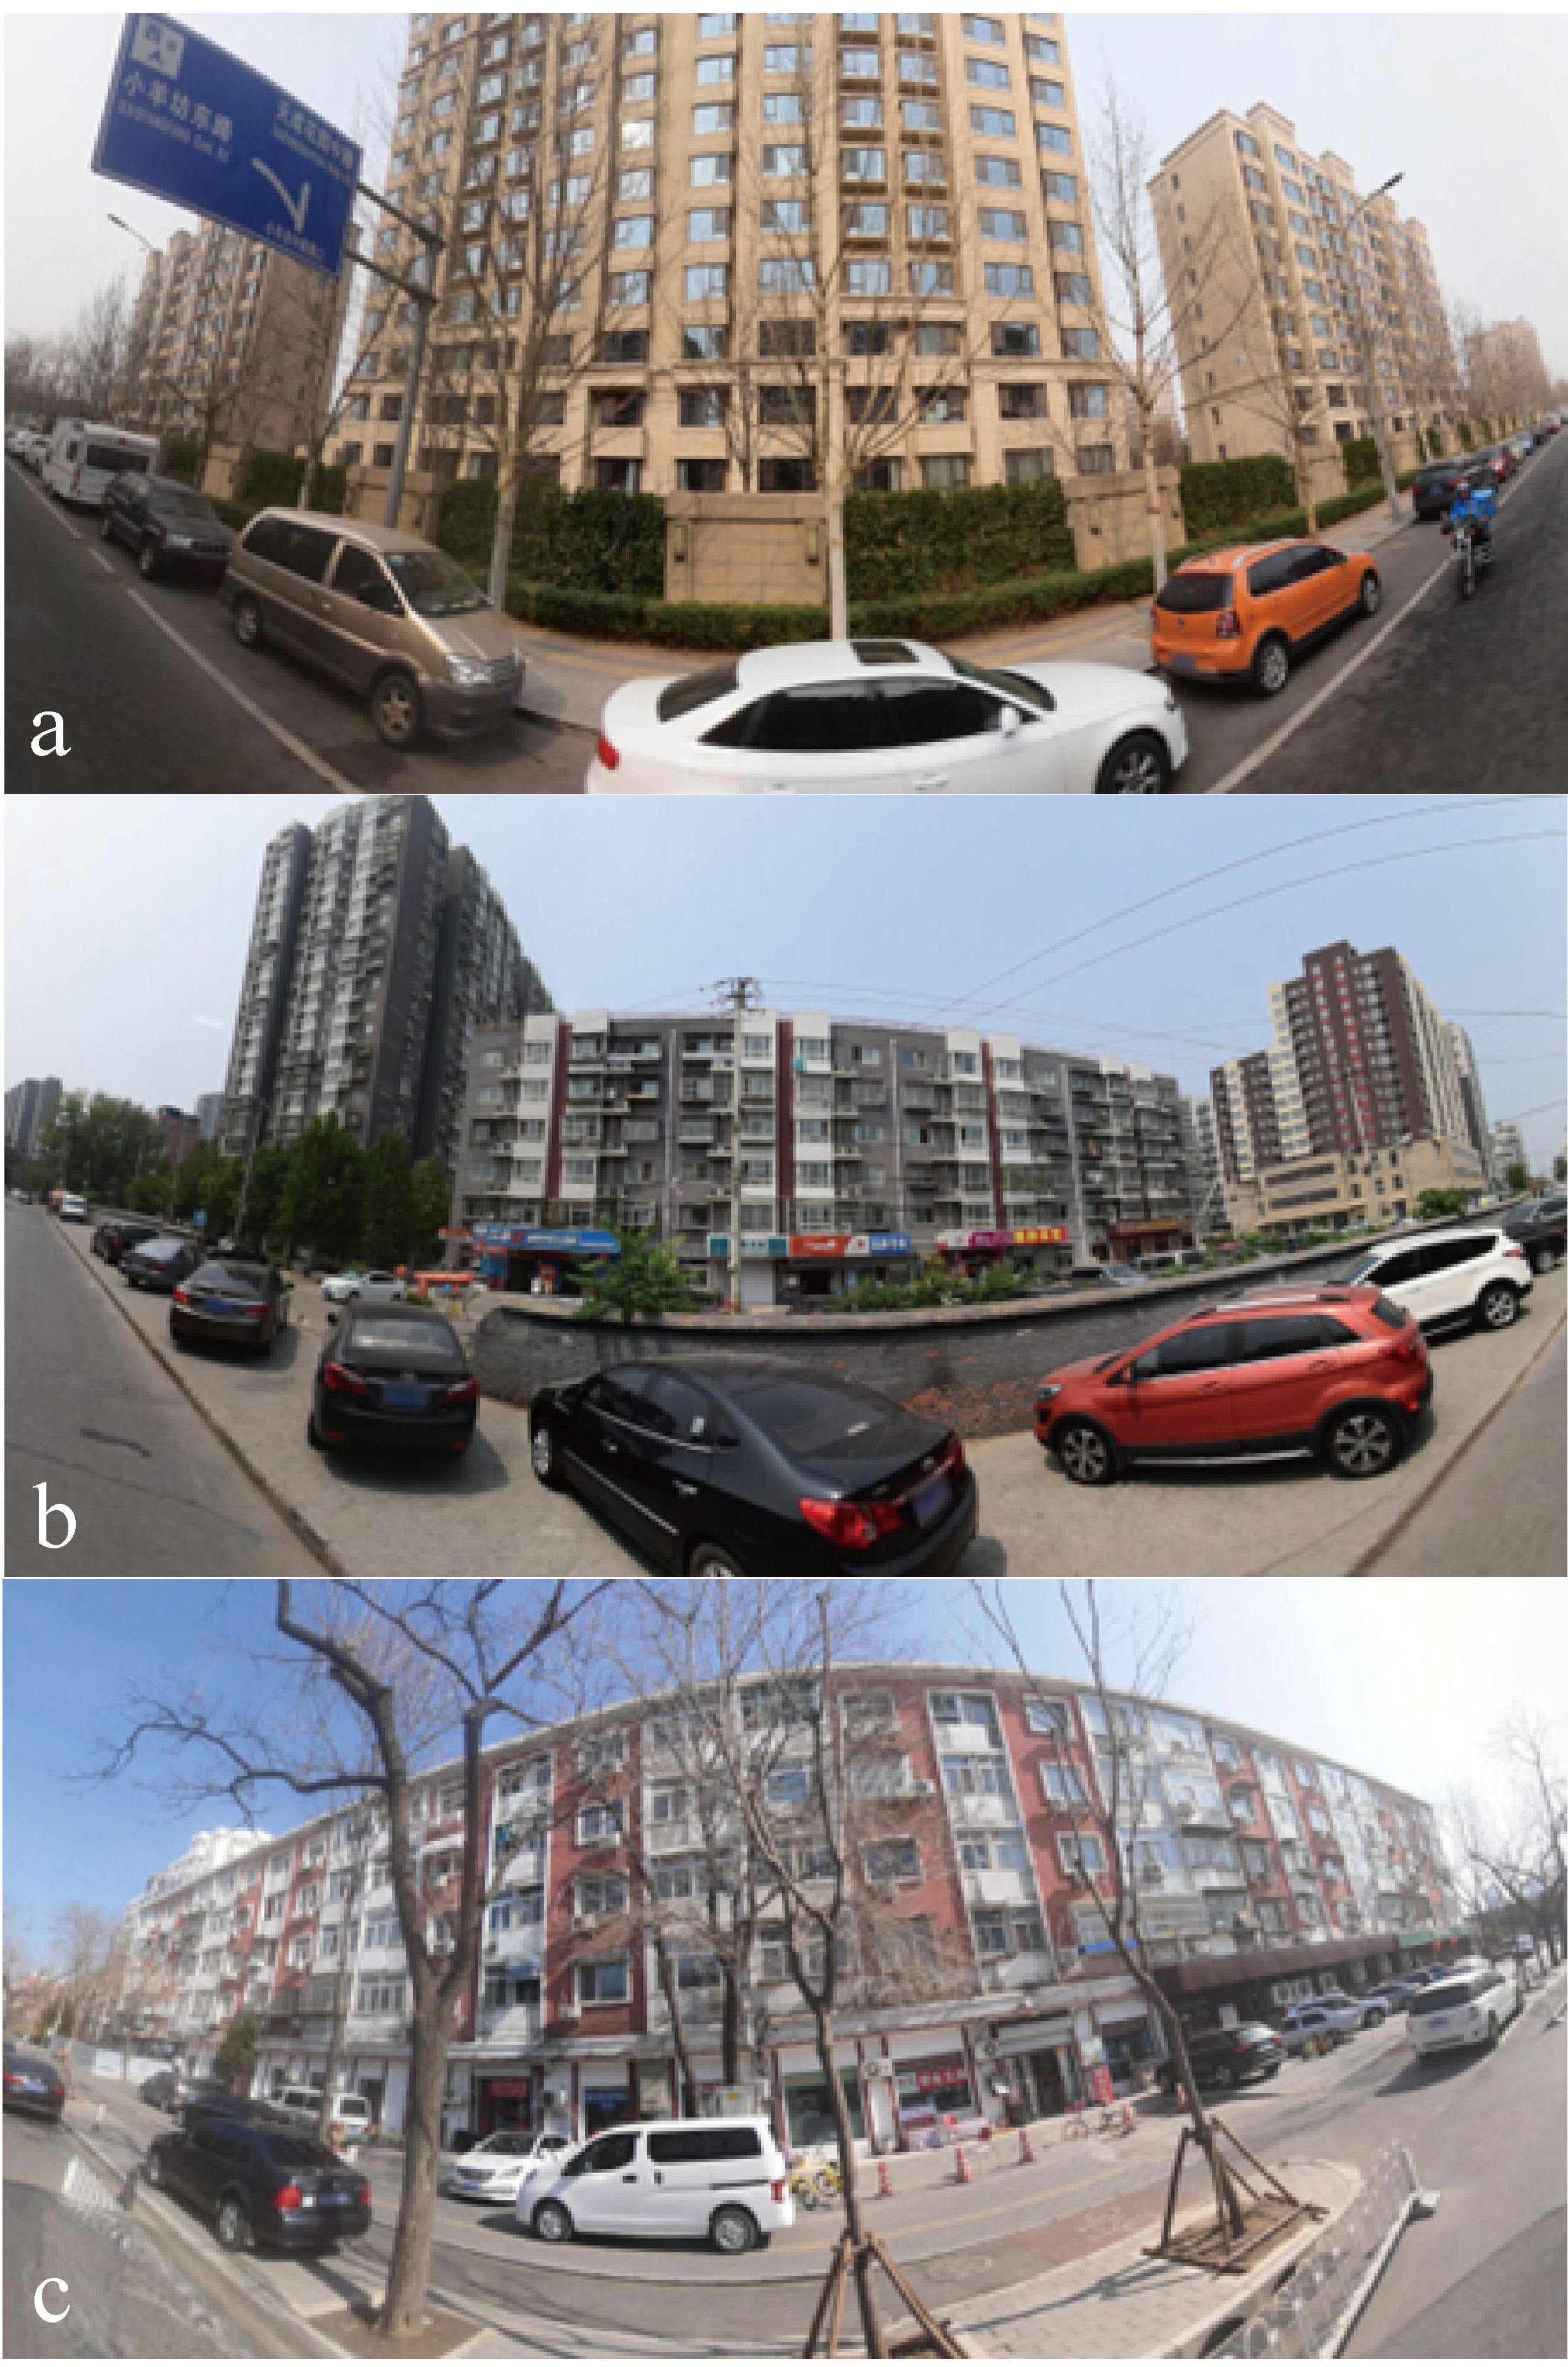
a. Vehicle-bike (V-B) conflicts; b. Vehicle-pedestrian (V-P) conflicts; c. Both types of conflicts
Appendix B. Sensitivity analysis results
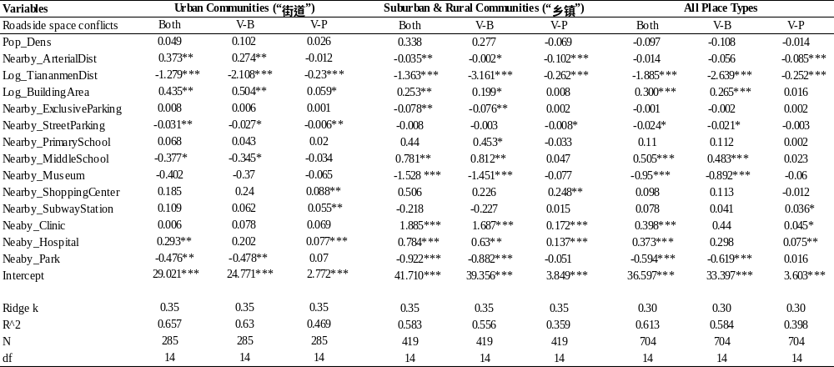
⁎⁎⁎p < 0.01, ⁎⁎p < 0.05, ⁎p < 0.1
Appendix C. Places that have been identified with greater potential to be regenerated based on the specific plan----Urban Design Guidelines for Beijing Street Regeneration and Governance
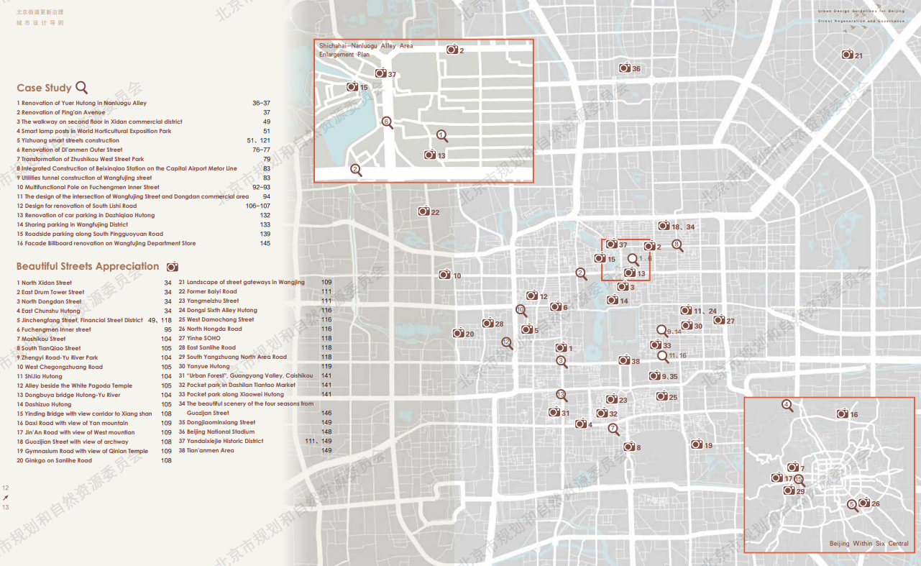
Source: http://ghzrzyw.beijing.gov.cn/biaozhunguanli/bz/cxgh/202106/t20210623_2419742.html, Beijing Municipal Commission of Planning and Natural Resources.

