Supporting Information
3D toilet-paper based carbon fiber for excellent solar assisted steam generation performance
Xidong Suo^{1, *}, Yao Li¹, Peiqi Liu¹, Yingying Li¹, Cuirong Guo¹, Jie Yang^{1, *}, Hongtao Qiao¹, Sheng Han^{2, *}, Chenqi Liu¹, Aiping yin¹
Xidong Suo, Yao Li, Peiqi Liu, Yingying Li contributed equally to this work.
Corresponding Author: Xidong Suo, Jie Yang, Sheng Han
Xidong Suo
xidsuo@126.com
Jie Yang
yangjie_10@126.com
Sheng Han
hansheng654321@sina.com

Yao Li
1191871264@qq.com
Peiqi Liu
2249421306@qq.com
Yingying Li
2646335895@qq.com
Cuirong Guo
2923185329@qq.com
Hongtao Qiao
469494248@qq.com
Chenqi Liu
1550525329@qq.com
Aiping yin
Aipingyin1964@163.com
¹Department of Chemistry, Xinzhou Normal University, No. 1 Dun Qi Street, Xinzhou, Shan Xi, 034000, China
²School of Chemical and Environmental Engineering, Shanghai Institute of Technology, Shanghai, 201418, China
Keywords: 3D solar steam generation, toilet paper, porous carbon materials, carbon fiber.

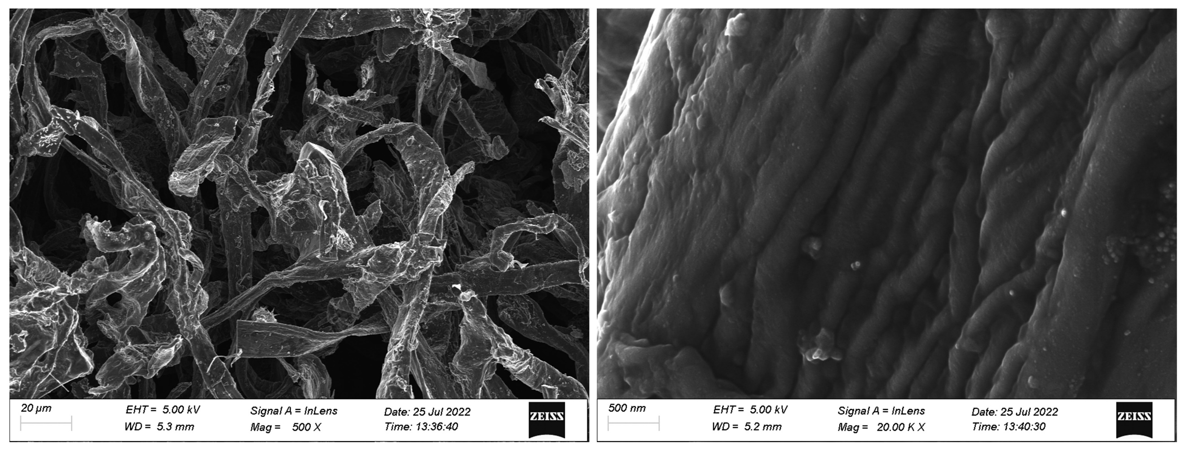
Figure S1. SEM images of CTP.

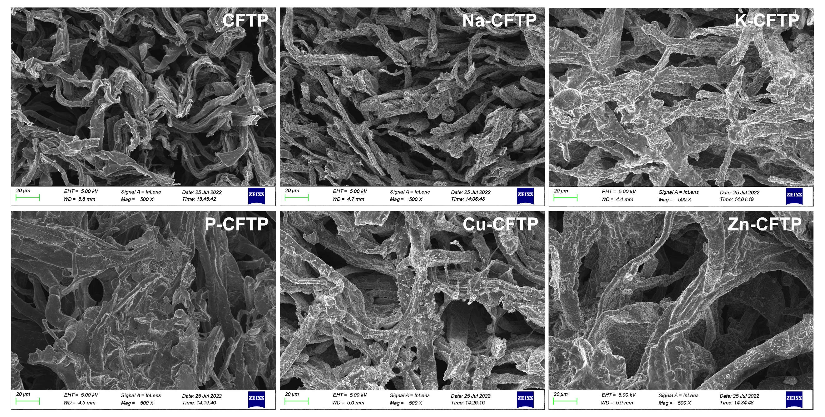
Figure S2. SEM images of CFTP based evaporator.

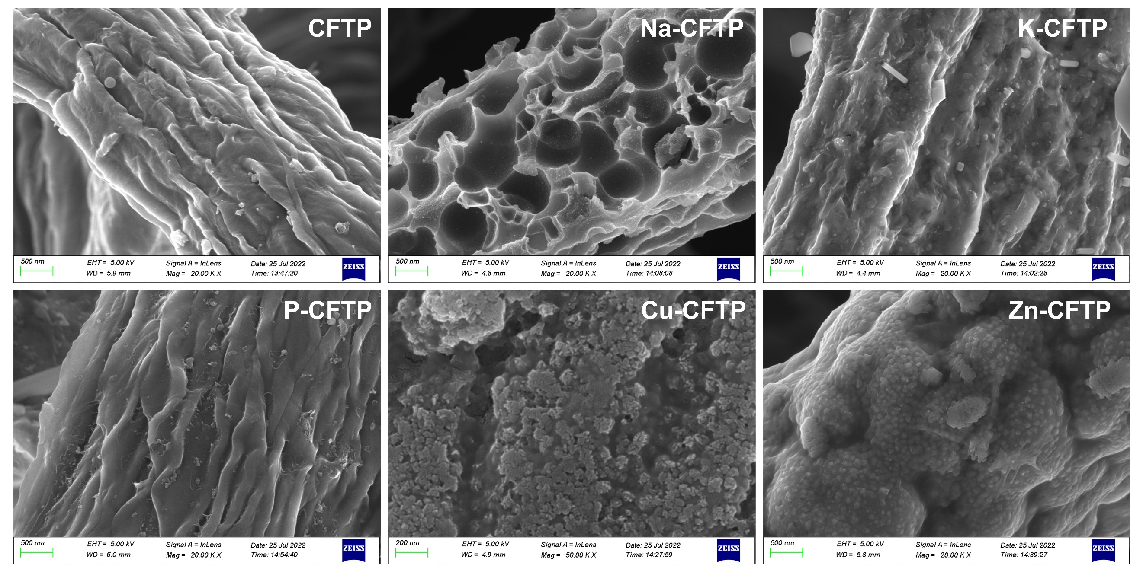
Figure S3. SEM images of CFTP based evaporator.

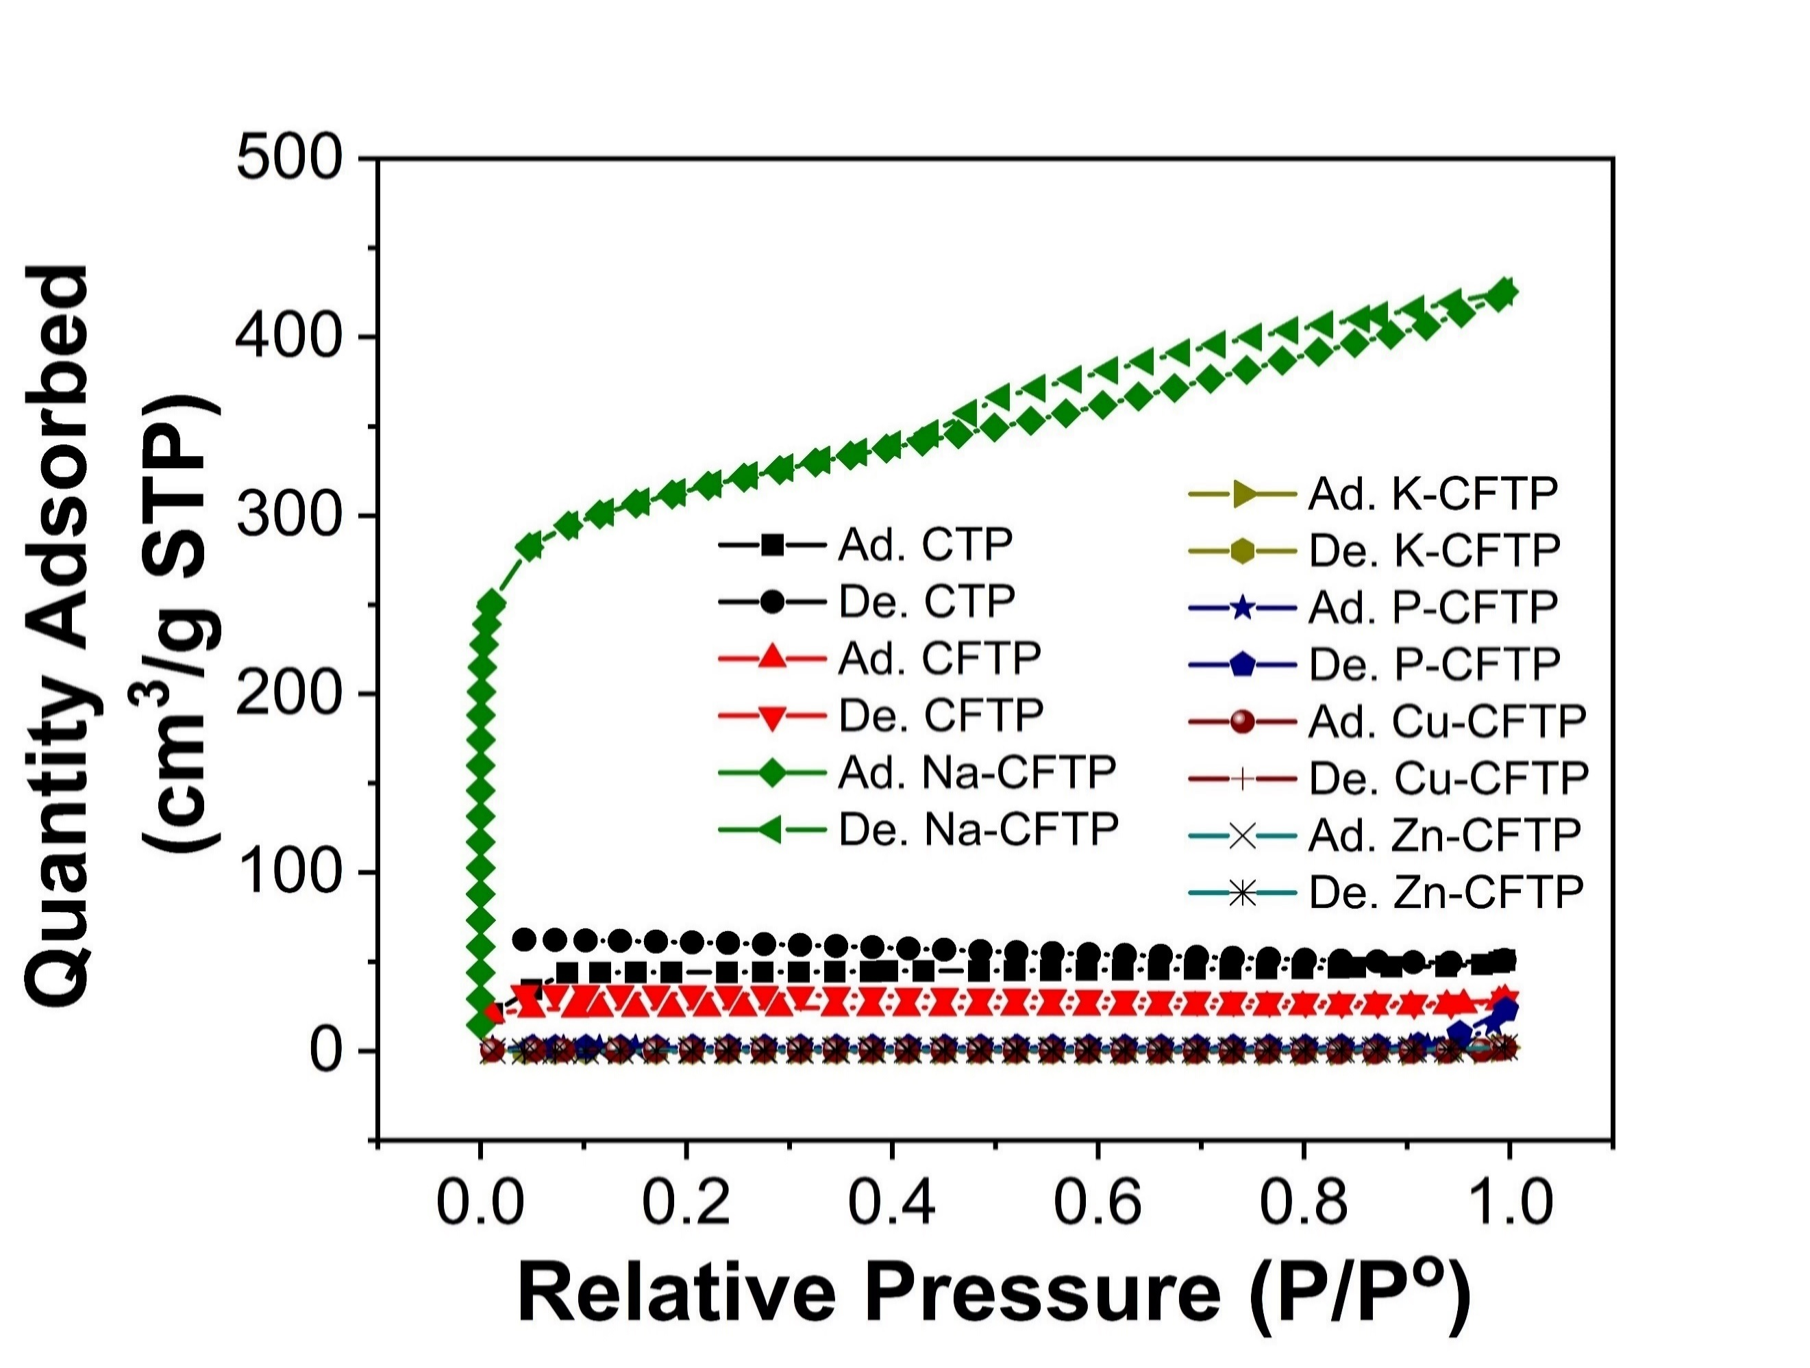
Figure S4. N₂ adsorption–desorption curves of TP based evaporator.

Table S1. BET surface area of the samples.
Samples | CTP | CFTP | Na-CFTP | K-CFTP | P-CFTP | Cu-CFTP | Zn-CFTP
Surface area (m² g⁻¹) | 178.8 | 91.9 | 1164.1 | 1.9 | 7.6 | 1.3 | 1.8

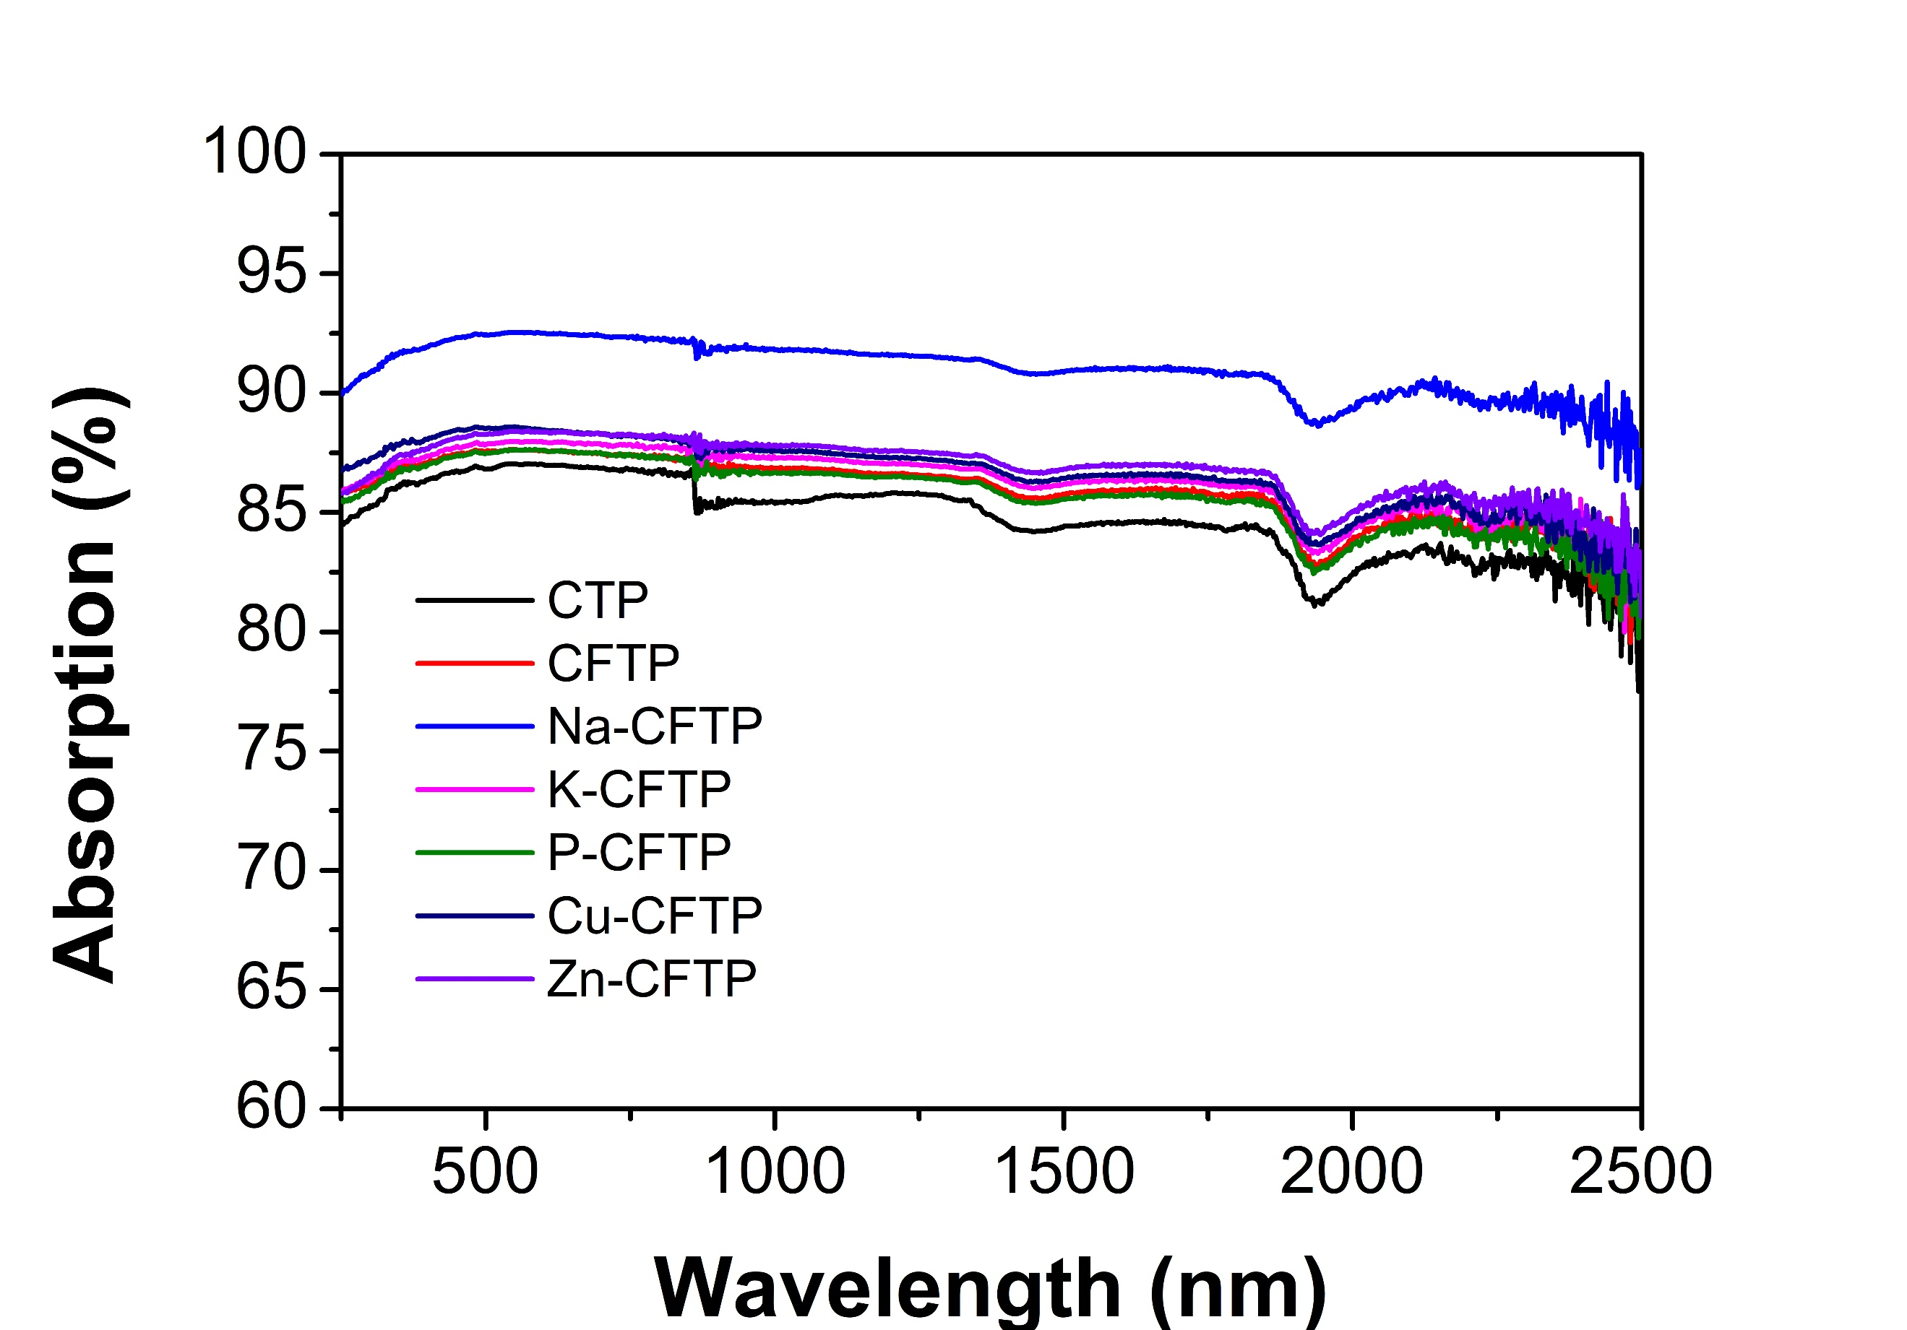
Figure S5. UV–vis-NIR absorption curve of TP based evaporators.

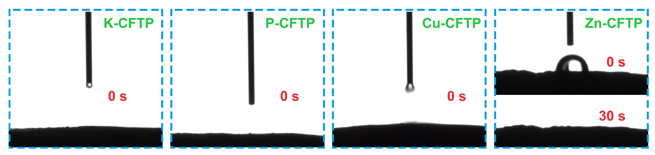
Figure S6. Water contact angle for K-CFTP, P-CFTP, Cu-CFTP and Zn-CFTP.

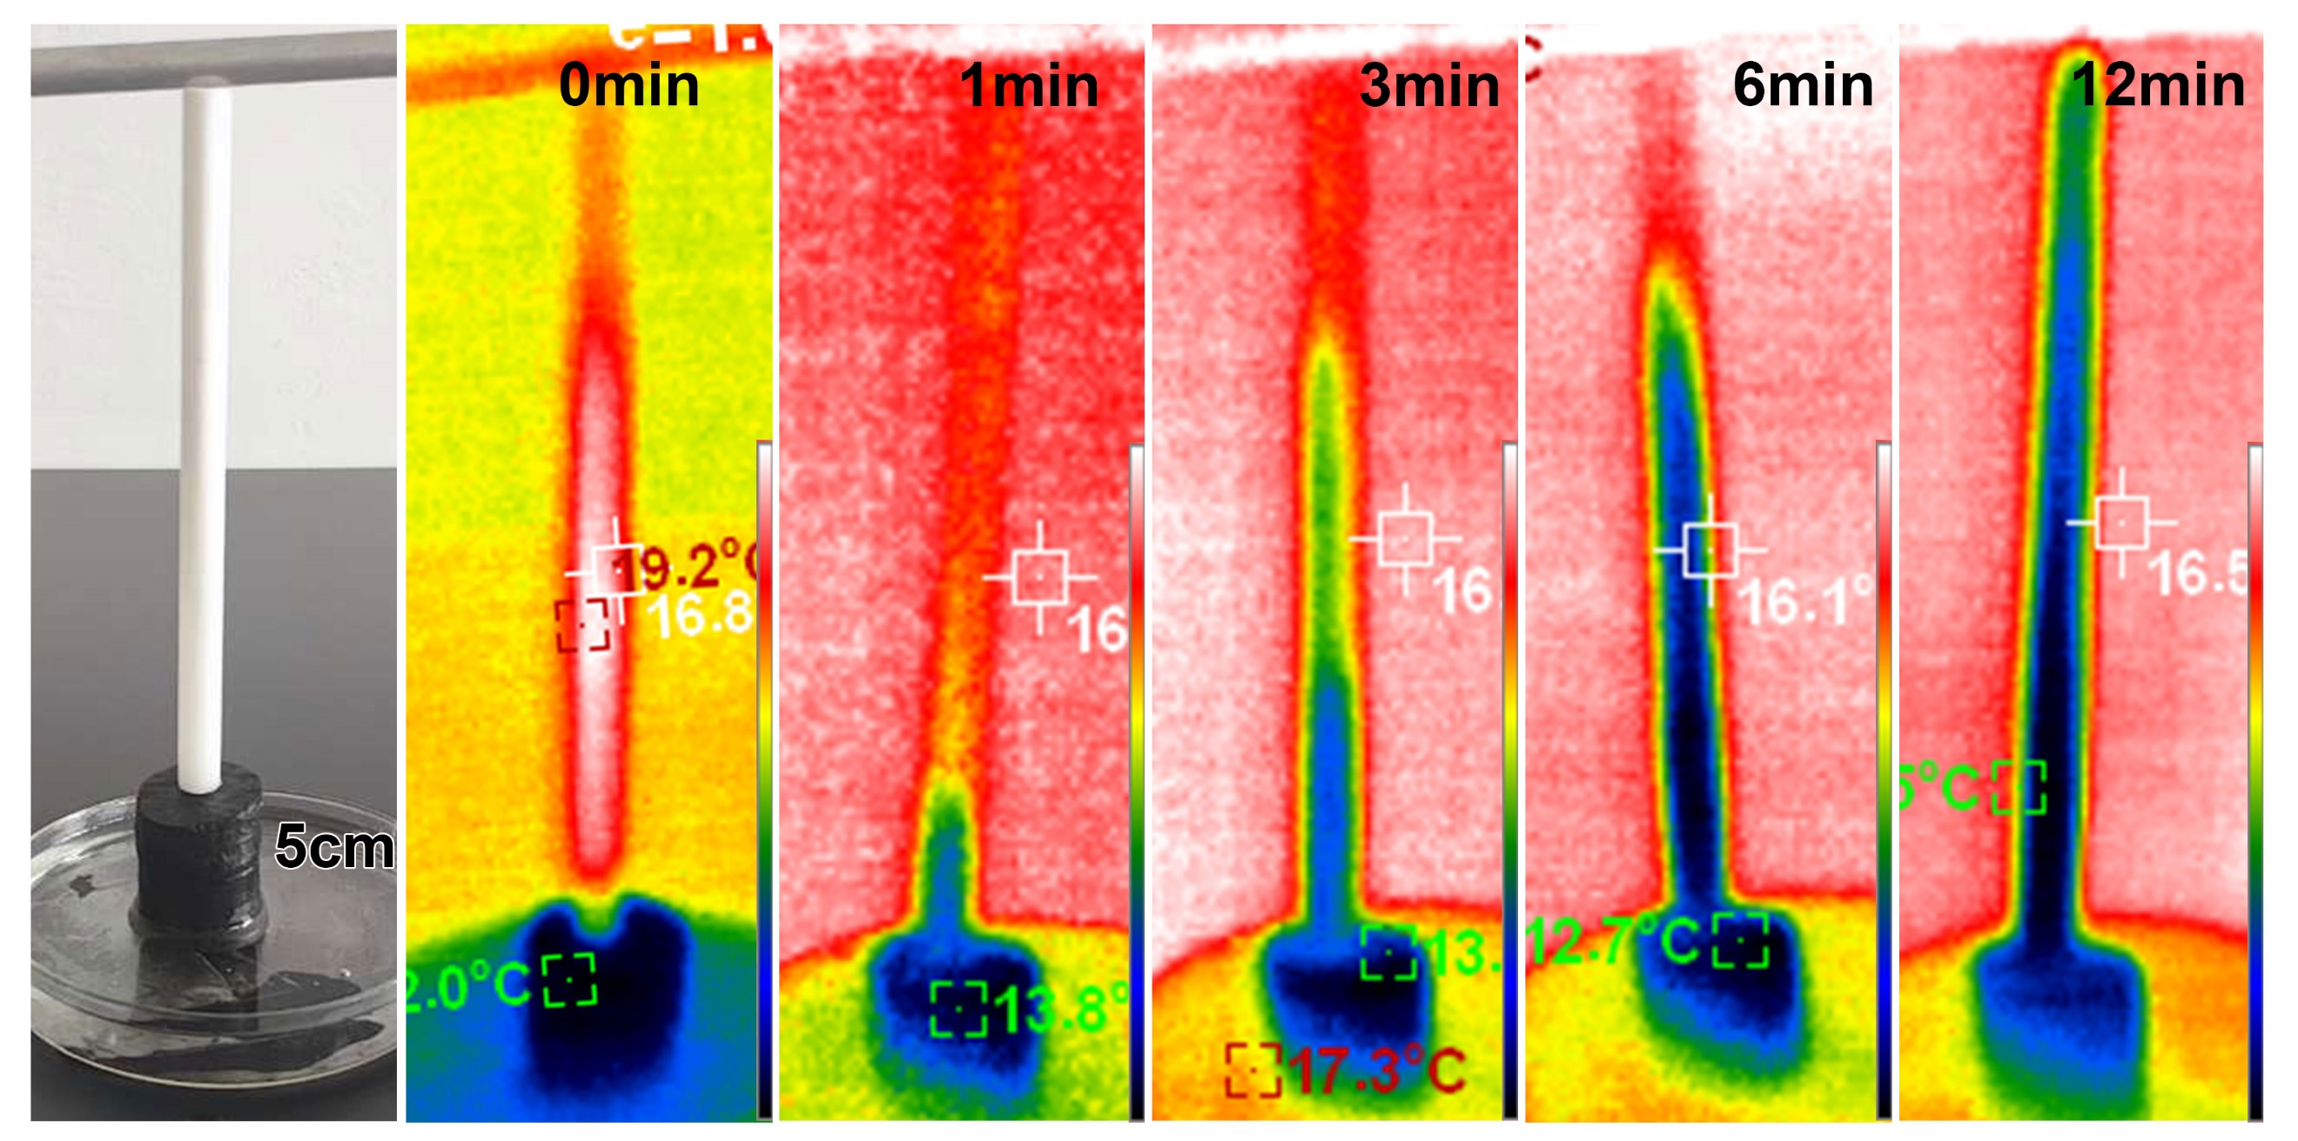
Figure S7. Water transporting performance of different height Na-CFTP based evaporator.

