Supplementary Tables
Supplementary table 1 Two groups of proteins full length
Genotype | No. | Gene | Description | Folding rate | whole sequence
 |  |  |  |  | Full length | α-helix |  | β-strand
 |  |  |  |  |  | length | % | length | %
Unfavorable prognostic genes | 1 | FAM83A | family with sequence similarity 83 member A | 11.60 | 294 | 84 | 28.57 | 45 | 15.31
Unfavorable prognostic genes | 2 | GALNT2 | polypeptide N-acetylgalactosaminyltransferase 2 | 9.15 | 590 | 162 | 27.46 | 131 | 22.20
Unfavorable prognostic genes | 3 | LOXL2 | lysyl oxidase like 2 | -13.90 | 774 | 37 | 4.78 | 285 | 36.82
Unfavorable prognostic genes | 4 | FSTL3 | follistatin like 3 | -18.10 | 263 | 56 | 21.29 | 56 | 21.29
Unfavorable prognostic genes | 5 | BCAR3 | BCAR3 adaptor protein, NSP family member | 16.70 | 825 | 238 | 28.85 | 34 | 4.12
Unfavorable prognostic genes | 6 | CMIP | c-Maf inducing protein | 3.81 | 620 | 380 | 61.29 | 18 | 2.90
Unfavorable prognostic genes | 7 | IER5L | immediate early response 5 like | -27.00 | 237 | 74 | 31.22 | 0 | 0.00
Unfavorable prognostic genes | 8 | MYO1E | myosin IE | 18.60 | 1108 | 520 | 46.93 | 109 | 9.84
Unfavorable prognostic genes | 9 | SP6 | Sp6 transcription factor | 31.00 | 376 | 21 | 5.59 | 25 | 6.65
Unfavorable prognostic genes | 10 | COL22A1 | collagen type XXII alpha 1 chain | 16.60 | 1626 | 80 | 4.92 | 115 | 7.07
Unfavorable prognostic genes | 11 | LDHA | lactate dehydrogenase A | 0.08 | 332 | 157 | 47.29 | 73 | 21.99
Unfavorable prognostic genes | 12 | L1CAM | L1 cell adhesion molecule | 14.60 | 1257 | 19 | 1.51 | 656 | 52.19
Unfavorable prognostic genes | 13 | PLCD3 | phospholipase C delta 3 | 17.20 | 789 | 261 | 33.08 | 145 | 18.38
Unfavorable prognostic genes | 14 | ITGB1 | integrin subunit beta 1 | -25.40 | 798 | 126 | 15.79 | 200 | 25.06
Unfavorable prognostic genes | 15 | LAMC2 | laminin subunit gamma 2 | -5.82 | 1111 | 448 | 40.32 | 40 | 3.60
Unfavorable prognostic genes | 16 | SERPINE1 | serpin family E member 1 | 7.52 | 402 | 115 | 28.61 | 125 | 31.09
Unfavorable prognostic genes | 17 | STK24 | serine/threonine kinase 24 | 2.77 | 431 | 162 | 37.59 | 44 | 10.21
Unfavorable prognostic genes | 18 | GPRIN1 | G protein regulated inducer of neurite outgrowth 1 | 21.70 | 1008 | 37 | 3.67 | 4 | 0.40
Unfavorable prognostic genes | 19 | RCN1 | reticulocalbin 1 | 3.23 | 331 | 196 | 59.21 | 2 | 0.60
Unfavorable prognostic genes | 20 | PLIN3 | perilipin 3 | -0.96 | 434 | 324 | 74.65 | 0 | 0.00
Unfavorable prognostic genes | Average |  |  | 4.17 | 680.30 | 174.85 | 25.70 | 105.35 | 15.49
Genotype | No. | Gene | Descriptio | Folding rate | whole sequence
 |  |  |  |  | Full length | α-helix |  | β-strand
 |  |  |  |  |  | length | % | length | %
Favorable prognostic genes | 1 | ZNF512 | zinc finger protein 512 | 16.90 | 490 | 124 | 25.31 | 43 | 8.78
Favorable prognostic genes | 2 | MOAP1 | modulator of apoptosis 1 | -6.62 | 351 | 212 | 60.40 | 11 | 3.13
Favorable prognostic genes | 3 | HLF | HLF transcription factor, PAR bZIP family member | -20.20 | 295 | 117 | 39.66 | 0 | 0.00
Favorable prognostic genes | 4 | FAM117A | family with sequence similarity 117 member A | -20.30 | 453 | 17 | 3.75 | 0 | 0.00
Favorable prognostic genes | 5 | SLC11A2 | solute carrier family 11 member 2 | 1.47 | 561 | 128 | 22.82 | 0 | 0.00
Favorable prognostic genes | 6 | RRAGB | Ras related GTP binding B | -8.09 | 346 | 120 | 34.68 | 92 | 26.59
Favorable prognostic genes | 7 | TMEM168 | transmembrane protein 168 | -8.36 | 697 | 241 | 34.58 | 40 | 5.74
Favorable prognostic genes | 8 | MYLIP | myosin regulatory light chain interacting protein | 4.74 | 445 | 128 | 28.76 | 107 | 24.04
Favorable prognostic genes | 9 | ZNF77 | zinc finger protein 77 | 4.53 | 545 | 31 | 5.69 | 177 | 32.48
Favorable prognostic genes | 10 | TTC39B | tetratricopeptide repeat domain 39B | 8.80 | 614 | 370 | 60.26 | 0 | 0.00
Favorable prognostic genes | 11 | THYN1 | thymocyte nuclear protein 1 | 21.70 | 225 | 43 | 19.11 | 40 | 17.78
Favorable prognostic genes | 12 | ANKRD65 | ankyrin repeat domain 65 | 3.81 | 399 | 200 | 50.13 | 0 | 0.00
Favorable prognostic genes | 13 | DBP | D-box binding PAR bZIP transcription factor | 36.20 | 325 | 109 | 33.54 | 3 | 0.92
Favorable prognostic genes | 14 | GNG7 | G protein subunit gamma 7 | 3.24 | 68 | 36 | 52.94 | 0 | 0.00
Favorable prognostic genes | 15 | INPP5J | inositol polyphosphate-5-phosphatase J | 6.39 | 639 | 107 | 16.74 | 108 | 16.90
Favorable prognostic genes | 16 | MARCHF9 | membrane associated ring-CH-type finger 9 | -5.07 | 346 | 52 | 15.03 | 21 | 6.07
Favorable prognostic genes | 17 | SMIM4 | small integral membrane protein 4 | -2.56 | 70 | 35 | 50.00 | 7 | 10.00
Favorable prognostic genes | 18 | SLC47A1 | solute carrier family 47 member 1 | 1.54 | 570 | 103 | 18.07 | 0 | 0.00
Favorable prognostic genes | 19 | CA11 | carbonic anhydrase 11 | 24.10 | 328 | 61 | 18.60 | 84 | 25.61
Favorable prognostic genes | 20 | PPFIBP2 | PPFIA binding protein 2 | -6.51 | 876 | 617 | 70.43 | 6 | 0.68
Favorable prognostic genes | Average |  |  | 4.98 | 432.15 | 142.55 | 32.99 | 36.95 | 8.55
Supplementary table 2 Unfavorable prognostic genes α-helix and β-strand sectional length
No. | Gene | Section I |  | Section II |  | Section III |  | Section IV
No. | Gene | α-helix length | β-strand length | α-helix length | β-strand length | α-helix length | β-strand length | α-helix length | β-strand length
1 | FAM83A | 42 | 0 | 11 | 8 | 10 | 37 | 21 | 0
2 | GALNT2 | 46 | 9 | 49 | 34 | 58 | 20 | 9 | 68
3 | LOXL2 | 3 | 60 | 10 | 75 | 13 | 71 | 11 | 79
4 | FSTL3 | 16 | 13 | 12 | 13 | 19 | 20 | 9 | 10
5 | BCAR3 | 29 | 23 | 19 | 2 | 57 | 3 | 133 | 6
6 | CMIP | 121 | 0 | 104 | 0 | 101 | 0 | 54 | 18
7 | IER5L | 56 | 0 | 15 | 0 | 3 | 0 | 0 | 0
8 | MYO1E | 128 | 42 | 144 | 29 | 215 | 13 | 33 | 25
9 | SP6 | 4 | 0 | 0 | 0 | 4 | 8 | 13 | 17
10 | COL22A1 | 80 | 110 | 0 | 5 | 0 | 0 | 0 | 0
11 | LDHA | 39 | 15 | 42 | 15 | 41 | 19 | 35 | 24
12 | L1CAM | 6 | 188 | 9 | 189 | 0 | 165 | 4 | 114
13 | PLCD3 | 61 | 38 | 104 | 12 | 76 | 22 | 20 | 73
14 | ITGB1 | 54 | 50 | 55 | 59 | 0 | 54 | 17 | 37
15 | LAMC2 | 2 | 21 | 2 | 16 | 169 | 3 | 275 | 0
16 | SERPINE1 | 55 | 3 | 33 | 28 | 20 | 48 | 7 | 46
17 | STK24 | 27 | 30 | 47 | 12 | 52 | 0 | 36 | 2
18 | GPRIN1 | 9 | 0 | 0 | 0 | 0 | 0 | 28 | 4
19 | RCN1 | 48 | 0 | 55 | 2 | 51 | 0 | 42 | 0
20 | PLIN3 | 76 | 0 | 83 | 0 | 83 | 0 | 82 | 0
Average |  | 45.10 | 30.10 | 39.70 | 24.95 | 48.60 | 24.15 | 41.45 | 26.15

Supplementary table 3 Unfavorable prognostic genes α-helix% and β-strand% of sectional length
No. | Gene | Folding rate  per sec | Section I |  | Section II |  | Section III |  | Section IV
No. | Gene | Folding rate  per sec | α-helix% | β-strand% | α-helix% | β-strand% | α-helix% | β-strand% | α-helix% | β-strand%
1 | FAM83A | 11.60 | 57.14 | 0.00 | 14.97 | 10.88 | 13.61 | 50.34 | 28.57 | 0.00
2 | GALNT2 | 9.15 | 31.19 | 6.10 | 33.22 | 23.05 | 39.32 | 13.56 | 6.10 | 46.10
3 | LOXL2 | -13.90 | 1.55 | 31.01 | 5.17 | 38.76 | 6.72 | 36.69 | 5.68 | 40.83
4 | FSTL3 | -18.10 | 24.33 | 19.77 | 18.25 | 19.77 | 28.90 | 30.42 | 13.69 | 15.21
5 | BCAR3 | 16.70 | 14.06 | 11.15 | 9.21 | 0.97 | 27.64 | 1.45 | 64.48 | 2.91
6 | CMIP | 3.81 | 78.06 | 0.00 | 67.10 | 0.00 | 65.16 | 0.00 | 34.84 | 11.61
7 | IER5L | -27.00 | 94.51 | 0.00 | 25.32 | 0.00 | 5.06 | 0.00 | 0.00 | 0.00
8 | MYO1E | 18.60 | 46.21 | 15.16 | 51.99 | 10.47 | 77.62 | 4.69 | 11.91 | 9.03
9 | SP6 | 31.00 | 4.26 | 0.00 | 0.00 | 0.00 | 4.26 | 8.51 | 13.83 | 18.09
10 | COL22A1 | 16.60 | 19.68 | 27.06 | 0.00 | 1.23 | 0.00 | 0.00 | 0.00 | 0.00
11 | LDHA | 0.08 | 46.99 | 18.07 | 50.60 | 18.07 | 49.40 | 22.89 | 42.17 | 28.92
12 | L1CAM | 14.60 | 1.91 | 59.82 | 2.86 | 60.14 | 0.00 | 52.51 | 1.27 | 36.28
13 | PLCD3 | 17.20 | 30.93 | 19.26 | 52.72 | 6.08 | 38.53 | 11.15 | 10.14 | 37.01
14 | ITGB1 | -25.40 | 27.07 | 25.06 | 27.57 | 29.57 | 0.00 | 27.07 | 8.52 | 18.55
15 | LAMC2 | -5.82 | 0.72 | 7.56 | 0.72 | 5.76 | 60.85 | 1.08 | 99.01 | 0.00
16 | SERPINE1 | 7.52 | 54.73 | 2.99 | 32.84 | 27.86 | 19.90 | 47.76 | 6.97 | 45.77
17 | STK24 | 2.77 | 25.06 | 27.84 | 43.62 | 11.14 | 48.26 | 0.00 | 33.41 | 1.86
18 | GPRIN1 | 21.70 | 3.57 | 0.00 | 0.00 | 0.00 | 0.00 | 0.00 | 11.11 | 1.59
19 | RCN1 | 3.23 | 58.01 | 0.00 | 66.47 | 2.42 | 61.63 | 0.00 | 50.76 | 0.00
20 | PLIN3 | -0.96 | 70.05 | 0.00 | 76.50 | 0.00 | 76.50 | 0.00 | 75.58 | 0.00

Supplementary table 4 Favorable prognostic genes α-helix and β-strand sectional length
No. | Gene | Section I |  | Section II |  | Section III |  | Section IV
No. | Gene | α-helix length | β-strand length | α-helix length | β-strand length | α-helix length | β-strand length | α-helix length | β-strand length
1 | ZNF512 | 25 | 40 | 34 | 25 | 25 | 40 | 34 | 25
2 | MOAP1 | 45 | 38 | 59 | 70 | 45 | 38 | 59 | 70
3 | HLF | 36 | 14 | 0 | 67 | 36 | 14 | 0 | 67
4 | FAM117A | 0 | 17 | 0 | 0 | 0 | 17 | 0 | 0
5 | SLC11A2 | 27 | 29 | 40 | 32 | 27 | 29 | 40 | 32
6 | RRAGB | 9 | 33 | 44 | 34 | 9 | 33 | 44 | 34
7 | TMEM168 | 59 | 45 | 72 | 65 | 59 | 45 | 72 | 65
8 | MYLIP | 33 | 50 | 40 | 5 | 33 | 50 | 40 | 5
9 | ZNF77 | 27 | 4 | 0 | 0 | 27 | 4 | 0 | 0
10 | TTC39B | 84 | 59 | 110 | 117 | 84 | 59 | 110 | 117
11 | THYN1 | 4 | 16 | 0 | 23 | 4 | 16 | 0 | 23
12 | ANKRD65 | 49 | 52 | 49 | 50 | 49 | 52 | 49 | 50
13 | DBP | 25 | 14 | 0 | 70 | 25 | 14 | 0 | 70
14 | GNG7 | 14 | 14 | 8 | 0 | 14 | 14 | 8 | 0
15 | INPP5J | 49 | 39 | 19 | 0 | 49 | 39 | 19 | 0
16 | MARCHF9 | 15 | 11 | 22 | 4 | 15 | 11 | 22 | 4
17 | SMIM4 | 10 | 3 | 6 | 16 | 10 | 3 | 6 | 16
18 | SLC47A1 | 22 | 23 | 22 | 36 | 22 | 23 | 22 | 36
19 | CA11 | 28 | 4 | 18 | 11 | 28 | 4 | 18 | 11
20 | PPFIBP2 | 209 | 198 | 91 | 119 | 209 | 198 | 91 | 119
Average |  | 38.50 | 6.95 | 35.15 | 9.75 | 31.70 | 11.10 | 37.20 | 9.15

Supplementary table 5 Favorable prognostic genes α-helix% and β-strand% of sectional length
No. | Gene | Folding rate per sec | Section I |  | Section II |  | Section III |  | Section IV
No. | Gene | Folding rate per sec | α-helix% | β-strand% | α-helix% | β-strand% | α-helix% | β-strand% | α-helix% | β-strand%
1 | ZNF512 | 16.90 | 20.41 | 8.16 | 32.65 | 11.43 | 27.76 | 12.24 | 20.41 | 3.27
2 | MOAP1 | -6.62 | 51.28 | 10.26 | 43.30 | 2.28 | 67.24 | 0.00 | 79.77 | 0.00
3 | HLF | -20.20 | 48.81 | 0.00 | 18.98 | 0.00 | 0.00 | 0.00 | 90.85 | 0.00
4 | FAM117A | -20.30 | 0.00 | 0.00 | 15.01 | 0.00 | 0.00 | 0.00 | 0.00 | 0.00
5 | SLC11A2 | 1.47 | 19.25 | 0.00 | 20.68 | 0.00 | 28.52 | 0.00 | 22.82 | 0.00
6 | RRAGB | -8.09 | 10.40 | 25.43 | 38.15 | 25.43 | 50.87 | 23.12 | 39.31 | 32.37
7 | TMEM168 | -8.36 | 33.86 | 0.00 | 25.82 | 0.00 | 41.32 | 10.33 | 37.30 | 12.63
8 | MYLIP | 4.74 | 29.66 | 31.46 | 44.94 | 19.78 | 35.96 | 22.47 | 4.49 | 22.47
9 | ZNF77 | 4.53 | 19.82 | 16.88 | 2.94 | 33.03 | 0.00 | 40.37 | 0.00 | 39.63
10 | TTC39B | 8.80 | 54.72 | 0.00 | 38.44 | 0.00 | 71.66 | 0.00 | 76.22 | 0.00
11 | THYN1 | 21.70 | 7.11 | 3.56 | 28.44 | 17.78 | 0.00 | 35.56 | 40.89 | 14.22
12 | ANKRD65 | 3.81 | 49.12 | 0.00 | 52.13 | 0.00 | 49.12 | 0.00 | 50.13 | 0.00
13 | DBP | 36.20 | 30.77 | 3.69 | 17.23 | 0.00 | 0.00 | 0.00 | 86.15 | 0.00
14 | GNG7 | 3.24 | 82.35 | 0.00 | 82.35 | 0.00 | 47.06 | 0.00 | 0.00 | 0.00
15 | INPP5J | 6.39 | 30.67 | 18.78 | 24.41 | 18.78 | 11.89 | 27.54 | 0.00 | 2.50
16 | MARCHF9 | -5.07 | 17.34 | 0.00 | 12.72 | 8.09 | 25.43 | 0.00 | 4.62 | 16.18
17 | SMIM4 | -2.56 | 57.14 | 0.00 | 17.14 | 0.00 | 34.29 | 40.00 | 91.43 | 0.00
18 | SLC47A1 | 1.54 | 15.44 | 0.00 | 16.14 | 0.00 | 15.44 | 0.00 | 25.26 | 0.00
19 | CA11 | 24.10 | 34.15 | 6.10 | 4.88 | 52.44 | 21.95 | 21.95 | 13.41 | 21.95
20 | PPFIBP2 | -6.51 | 95.43 | 0.00 | 90.41 | 0.00 | 41.55 | 0.00 | 54.34 | 2.74

Supplementary table 6 Two group length tests of Normality
 | Full length | Kolmogorov-Smirnovª |  |  | Shapiro-Wilk
 | Full length | Statistic | df | Sig. | Statistic | df | Sig.
lengths | Unfavorable | 0.188 | 20 | 0.061 | 0.909 | 20 | 0.060
lengths | Favorable | 0.107 | 20 | 0.200* | 0.976 | 20 | 0.870
a. Lilliefors Significance Correction
*. This is a lower bound of the true significance.

Supplementary table 7 Two second structure of two groups protein contends length
Group | Unfavorable group |  | Favorable group
Group | α-helix length | β-strand length | α-helix length | β-strand length
n | 20 | 20 | 20 | 20
Mean | 174.85 | 105.35 | 142.55 | 36.95
Std. Deviation | 145.83 | 149.5 | 140.75 | 50.45

Supplementary table 8 Two second structure of two groups protein Tests of Normality
 | contends | Kolmogorov-Smirnovª |  |  | Shapiro-Wilk
 | contends | Statistic | df | Sig. | Statistic | df | Sig.
grouplengths | una-helix | 0.185 | 20 | 0.071 | 0.886 | 20 | 0.023
grouplengths | unb-strand | 0.245 | 20 | 0.003 | 0.659 | 20 | 0.000
grouplengths | faa-helix | 0.291 | 20 | 0.000 | 0.741 | 20 | 0.000
grouplengths | fab-strand | 0.246 | 20 | 0.002 | 0.765 | 20 | 0.000
- Lilliefors Significance Correction

Supplementary table 9 Unfavorable group internal α-helix length
 | Section I | Section II | Section III | Section IV
n | 20 | 20 | 20 | 20
Mean | 45.1 | 39.7 | 48.6 | 41.45
Std. Deviation | 36.27 | 41.22 | 58.52 | 63.41

Supplementary table 10 Unfavorable group internal α-helix length Tests of Normality
 | uahsections | Kolmogorov-Smirnovª |  |  | Shapiro-Wilk
 | uahsections | Statistic | df | Sig. | Statistic | df | Sig.
Uahselength | S1 | 0.132 | 20 | .0200* | 0.910 | 20 | 0.063
Uahselength | S2 | 0.192 | 20 | 0.051 | 0.859 | 20 | 0.008
Uahselength | S3 | 0.203 | 20 | 0.030 | 0.799 | 20 | 0.001
Uahselength | S4 | 0.297 | 20 | 0.000 | 0.612 | 20 | 0.000
a. Lilliefors Significance Correction
*. This is a lower bound of the true significance.

Supplementary table 11 Comparison of unfavorable group α-helix four sections length with non-parametric test
 | Section I | Section II | Section III | Section IV
Section I |  | 0.461 | 0.62 | 0.221
Section II | 0.461 |  | 0.841 | 0.718
Section III | 0.62 | 0.841 |  | 0.738
Section IV | 0.221 | 0.718 | 0.738

Supplementary table 12 Unfavorable group internal β-strand length
 | Section I | Section II | Section III | Section IV
n | 20 | 20 | 20 | 20
Mean | 30.1 | 24.95 | 24.15 | 26.15
Std. Deviation | 46.45 | 43.65 | 39.13 | 33.22

Supplementary table 13 Unfavorable group internal β-strand length Tests of Normality
 | ubsections | Kolmogorov-Smirnovª |  |  | Shapiro-Wilk
 | ubsections | Statistic | df | Sig. | Statistic | df | Sig.
Ubsselength | SI | 0.258 | 20 | 0.001 | 0.683 | 20 | 0.000
Ubsselength | S2 | 0.284 | 20 | 0.000 | 0.593 | 20 | 0.000
Ubsselength | S3 | 0.272 | 20 | 0.000 | 0.654 | 20 | 0.000
Ubsselength | S4 | 0.216 | 20 | 0.016 | 0.797 | 20 | 0.001
a. Lilliefors Significance Correction

Supplementary table 14 Unfavorable group β-strand four sections length compare with non-parametric test
 | Section I | Section II | Section III | Section IV
Section I |  | 0.816 | 0.718 | 0.925
Section II | 0.816 |  | 0.904 | 0.82
Section III | 0.718 | 0.904 |  | 0.698
Section IV | 0.925 | 0.82 | 0.698

Supplementary table 15 Favorable group internal α-helix length compare
 | Section I | Section II | Section III | Section IV
n | 20 | 20 | 20 | 20
Mean | 38.5 | 35.15 | 31.7 | 37.2
Std. Deviation | 44.94 | 42 | 31.95 | 37.16

Supplementary table 16 Favorable group internal α-helix length Tests of Normality
 | fahesections | Kolmogorov-Smirnovª |  |  | Shapiro-Wilk
 | fahesections | Statistic | df | Sig. | Statistic | df | Sig.
Fahlengths | S1 | 0.258 | 20 | 0.001 | 0.647 | 20 | 0.000
Fahlengths | S2 | 0.244 | 20 | 0.003 | 0.618 | 20 | 0.000
Fahlengths | S3 | 0.169 | 20 | 0.135 | 0.883 | 20 | 0.020
Fahlengths | S4 | 0.163 | 20 | 0.172 | 0.870 | 20 | 0.012
a. Lilliefors Significance Correction

Supplementary table 17 Favorable group α-helix four sections length compare with non-parametric test
 | Section I | Section II | Section III | Section IV
Section I |  | 0.841 | 0.56 | 0.819
Section II | 0.841 |  | 0.779 | 0.989
Section III | 0.56 | 0.779 |  | 0.698
Section IV | 0.819 | 0.989 | 0.698

Supplementary table 18 Favorable group internal β-strand length compare
 | Section I | Section II | Section III | Section IV
n | 20 | 20 | 20 | 20
Mean | 6.95 | 9.75 | 11.1 | 9.15
Std. Deviation | 11.22 | 14.85 | 15.97 | 14.12

Supplementary table 19 Favorable group internal β-strand length Tests of Normality
 | Fbsections | Kolmogorov-Smirnovª |  |  | Shapiro-Wilk
 | Fbsections | Statistic | df | Sig. | Statistic | df | Sig.
fbslengths | S1 | 0.288 | 20 | 0.000 | 0.682 | 20 | 0.000
fbslengths | S2 | 0.299 | 20 | 0.000 | 0.711 | 20 | 0.000
fbslengths | S3 | 0.307 | 20 | 0.000 | 0.736 | 20 | 0.000
fbslengths | S4 | 0.258 | 20 | 0.001 | 0.712 | 20 | 0.000
a. Lilliefors Significance Correction

Supplementary Table 20 Favorable group β-strand four sections length compare with non-parametric test
 | Section I | Section II | Section III | Section IV
Section I |  | 0.82 | 0.738 | 0.718
Section II | 0.82 |  | 0.925 | 0.925
Section III | 0.738 | 0.925 |  | 0.947
Section IV | 0.718 | 0.925 | 0.947

Supplementary Table 21 two groups two second structure sections length compare with non-parametric test
Group | α-helix vs. β-strand
Group | Section I | Section II | Section III | Section IV
Unfavorable | 0.026 | 0.149 | 0.114 | 0.277
Favorable | 0.001 | 0.001 | 0.082 | 0.035

Supplementary table 21 Unfavorable group Proteins folding dynamic curves and 3D structures
No. | Name | Early, backbone, and sidechain trends | α-helix and β-strand trends | 3D structures
1 | FAM83A | 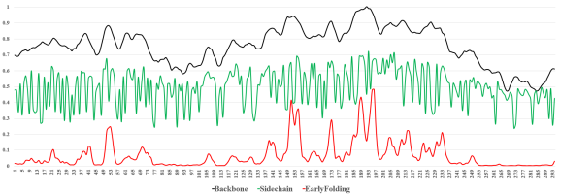 | 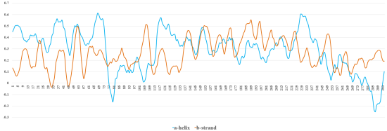 | 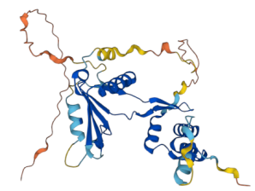
2 | GALNT2 | 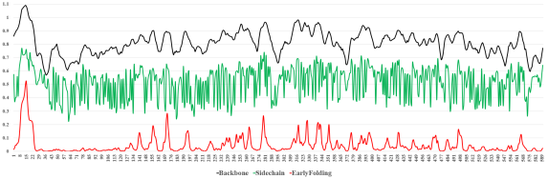 | 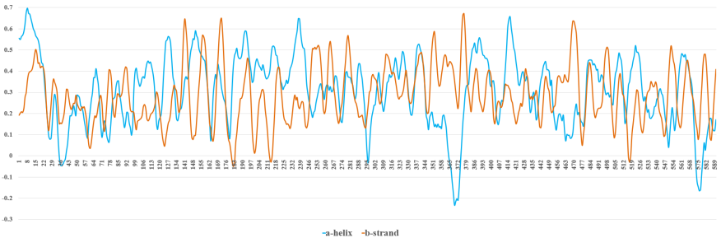 | 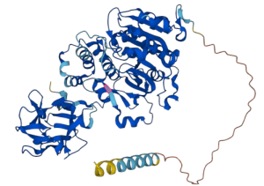
3- | LOXL2 | 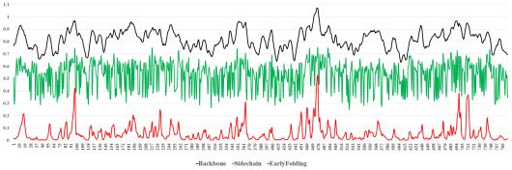 | 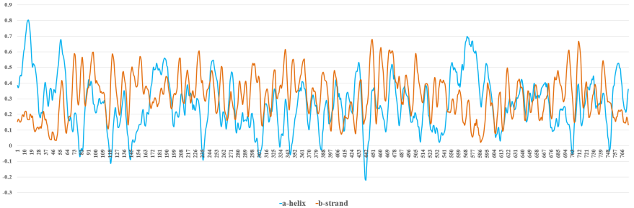 | 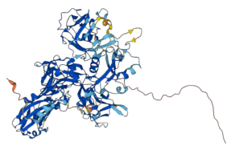
4 | FSTL3 | 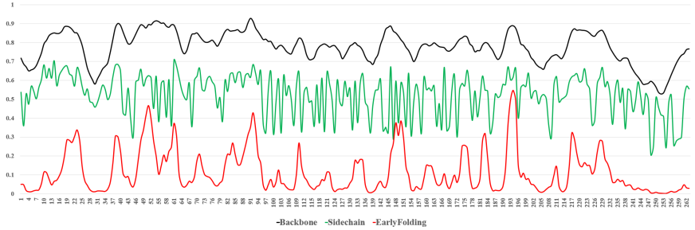 | 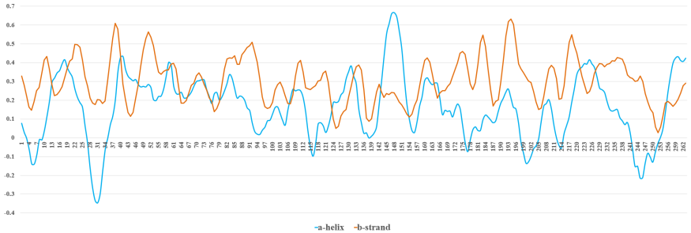 | 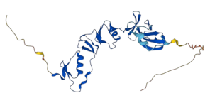
5 | BCAR3 | 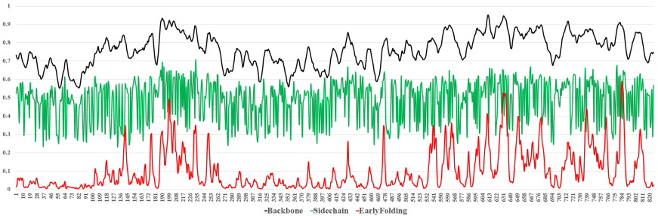 | 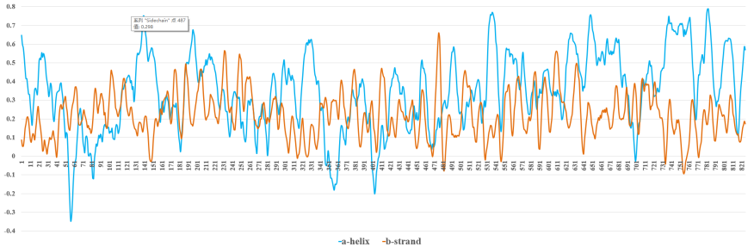 | 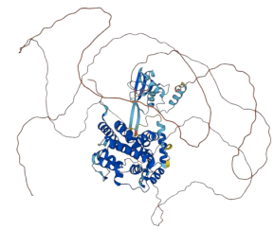
6 | CMIP | 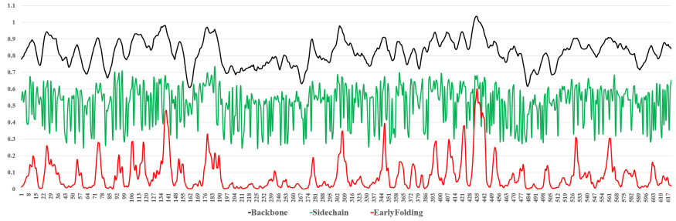 | 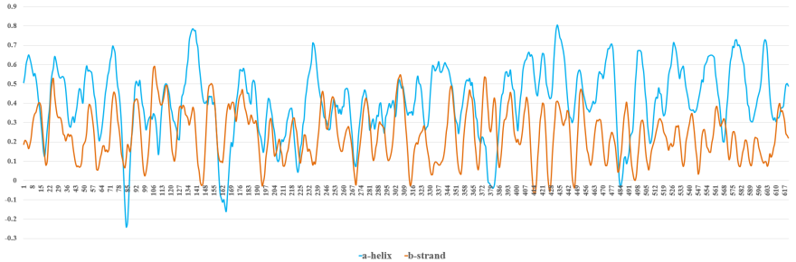 | 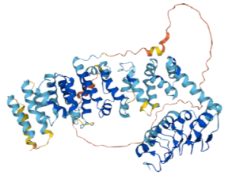
7 | IER5L | 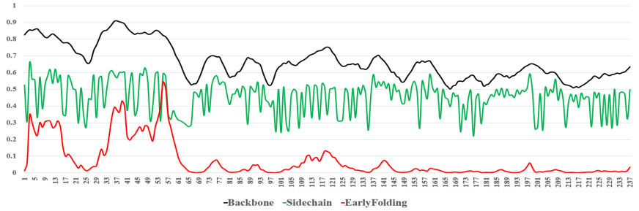 | 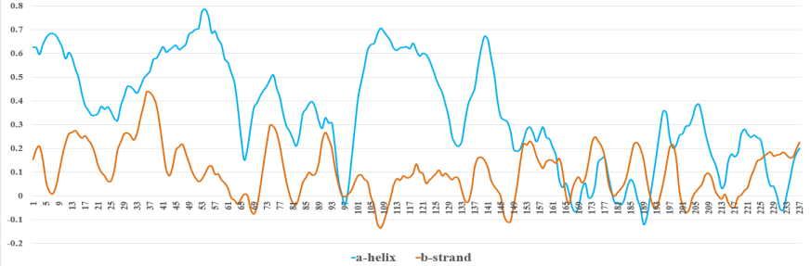 | 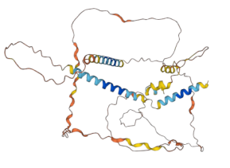
8 | MYO1E | 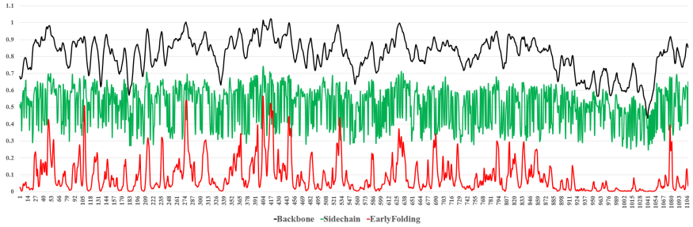 | 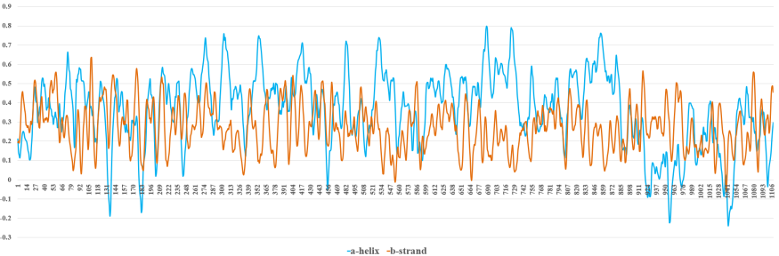 | 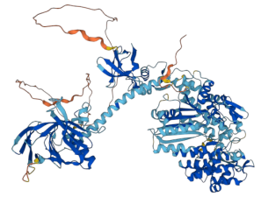
9 | SP6 | 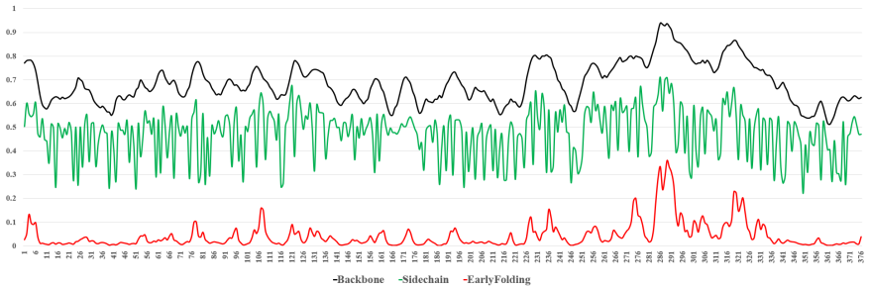 | 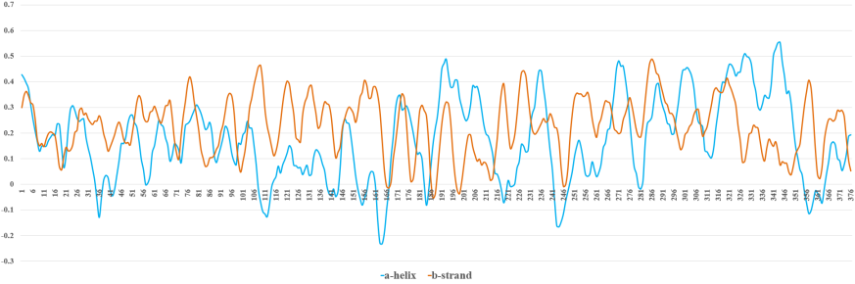 | 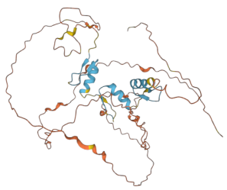
10 | COL22A1 | 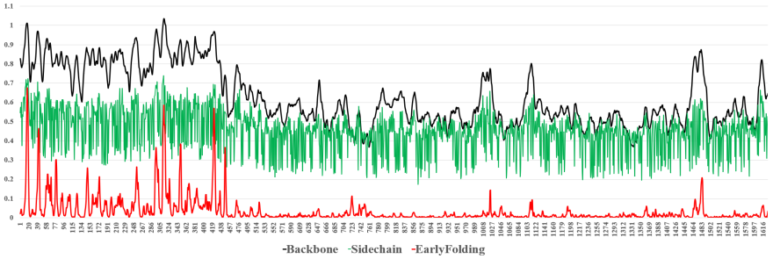 | 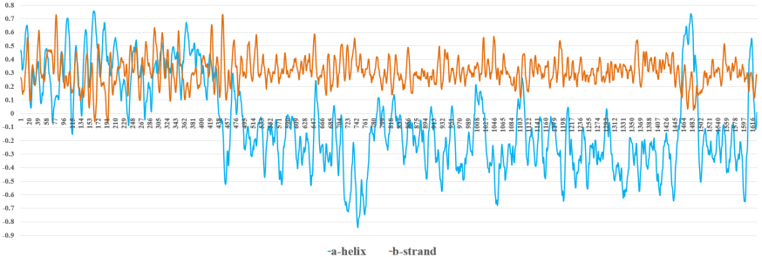 | 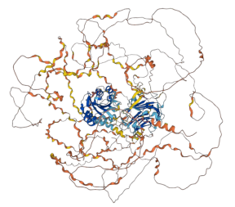
11 | LDHA | 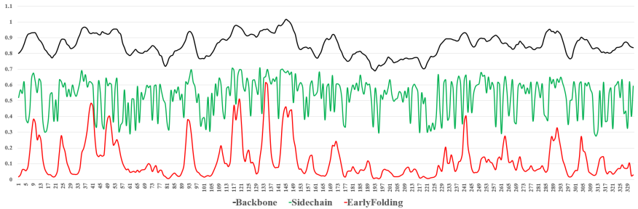 | 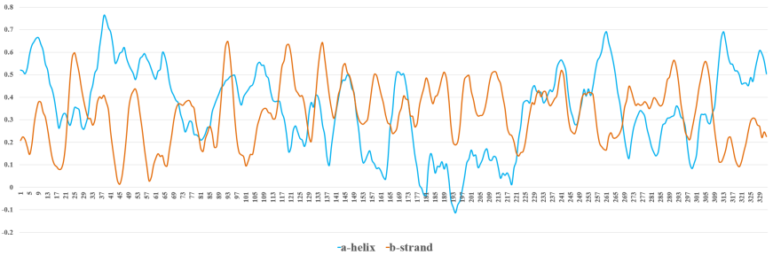 | 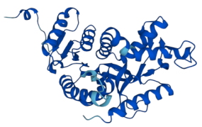
12 | L1CAM | 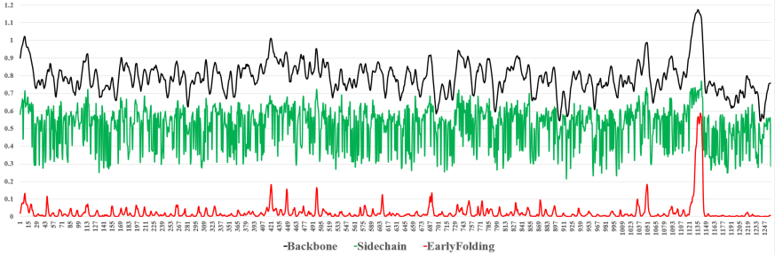 | 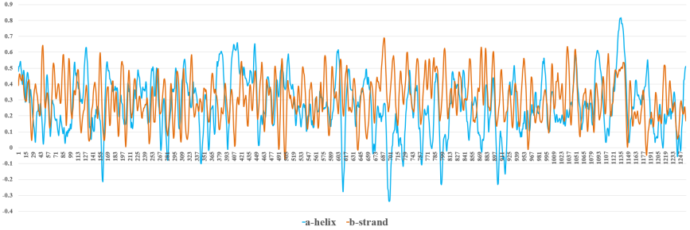 | 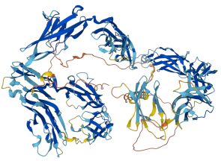
13 | PLCD3 | 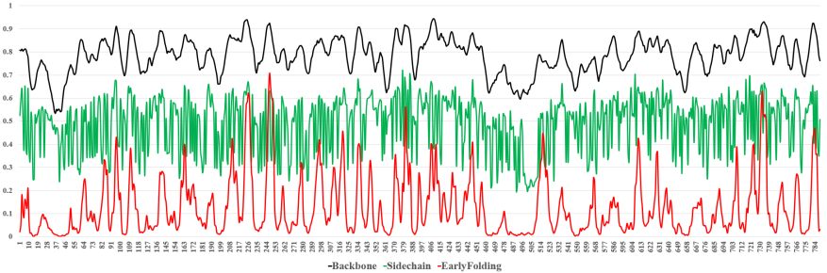 | 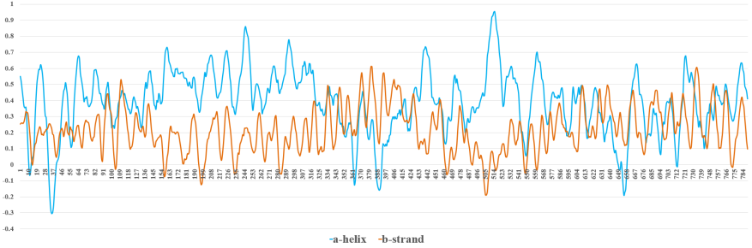 | 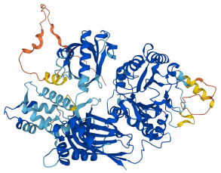
14 | ITGB1 | 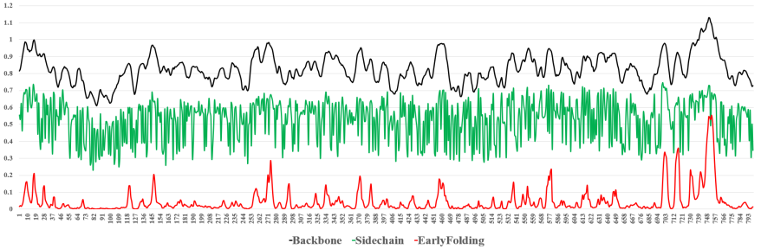 | 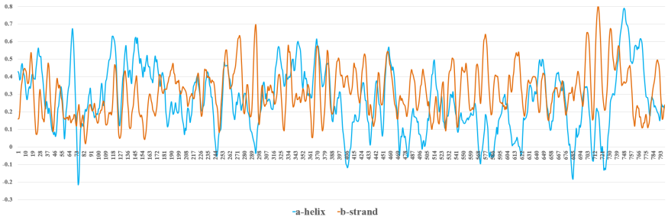 | 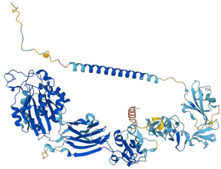
15 | LAMC2 | 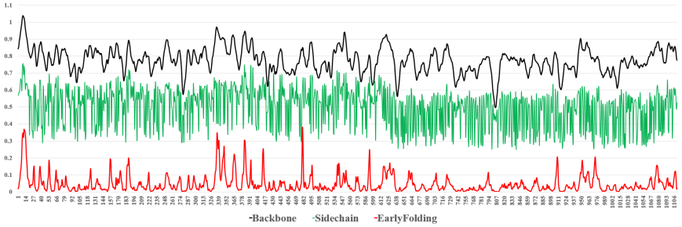 | 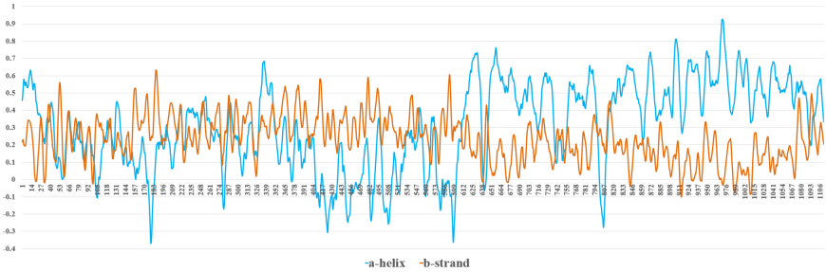 | 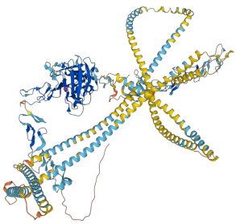
16 | SERPINE1 | 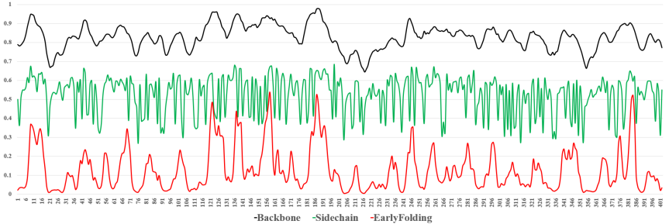 | 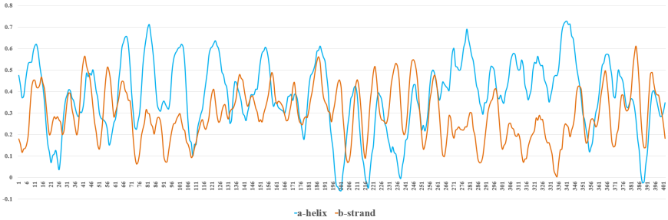 | 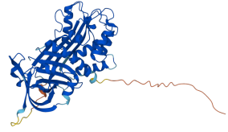
17 | STK24 | 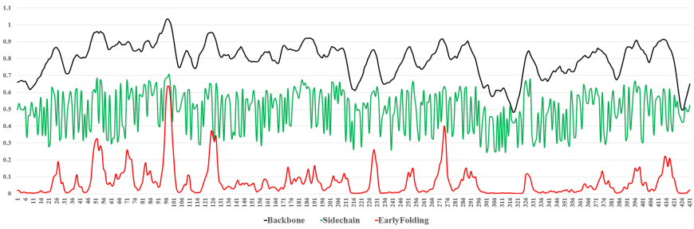 | 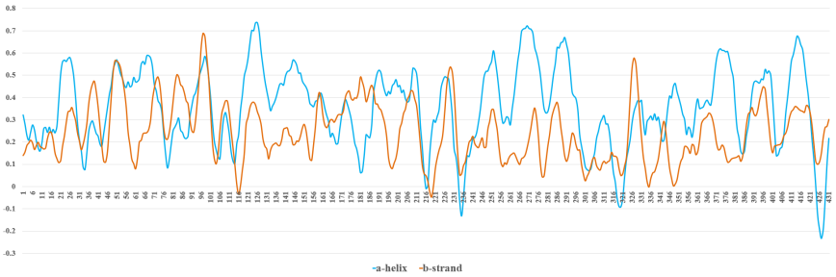 | 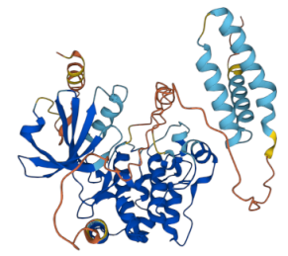
18 | GPRIN1 | 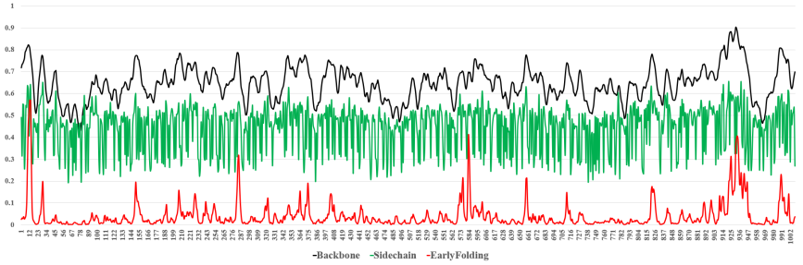 | 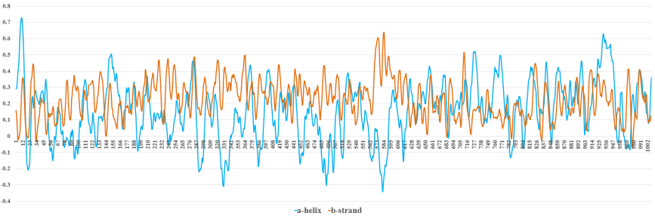 | 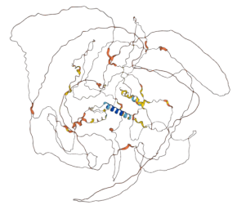
19 | RCN1 | 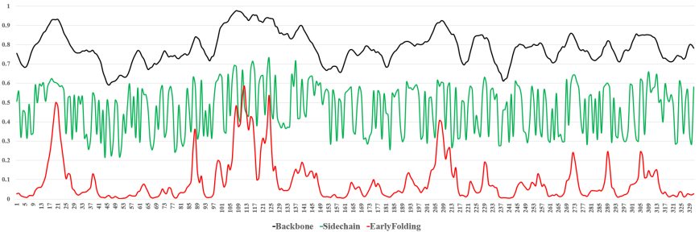 | 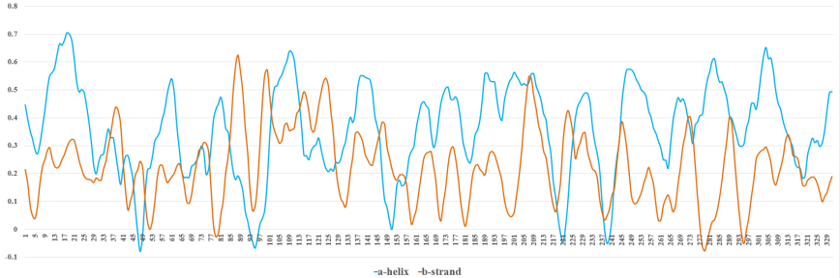 | 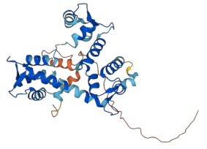
20 | PLIN3 | 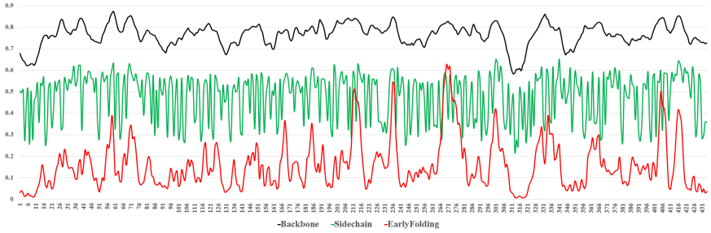 | 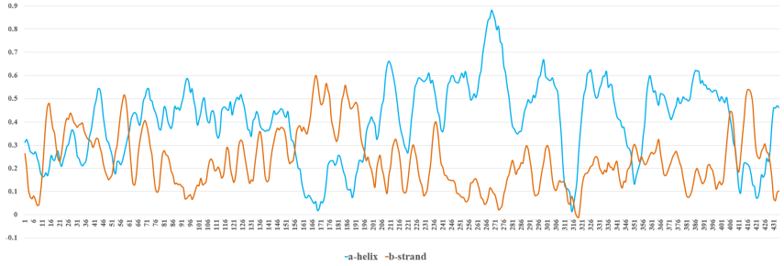 | 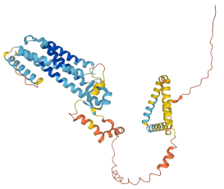

Supplementary table 23 Favorable group Proteins folding dynamic curves and 3D structures
No. | Name |  | Early, backbone, and sidechain trends |  | α-helix and β-strand trends |  | 3D structures
1 | ZNF512 |  | 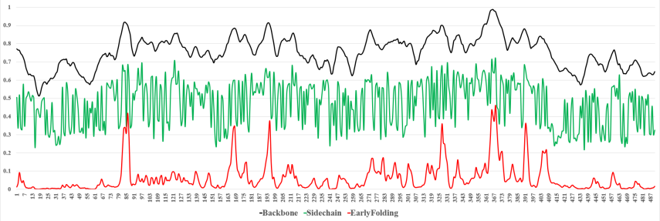 |  | 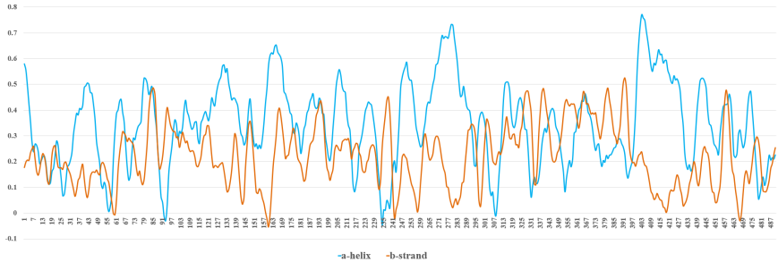 |  | 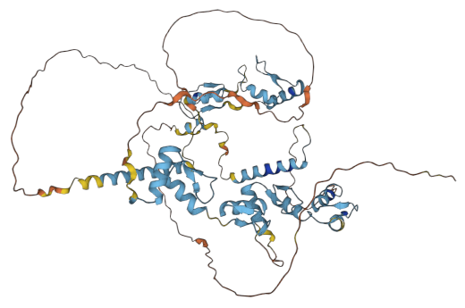
2 | MOAP1 |  | 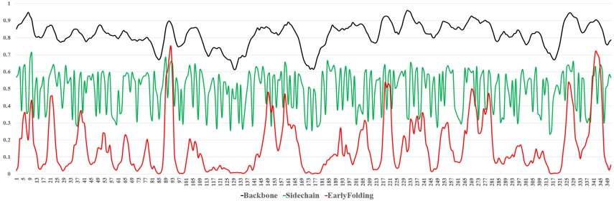 |  | 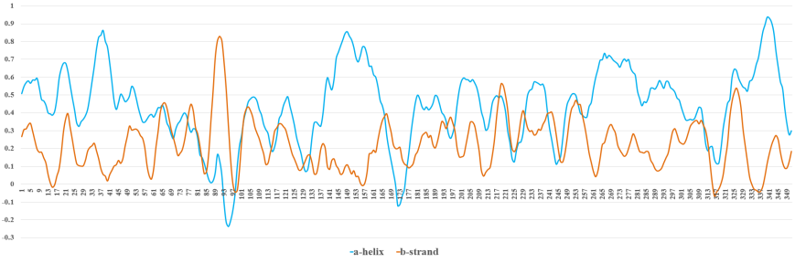 |  | 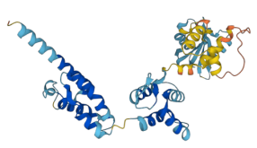
3 | HLF |  | 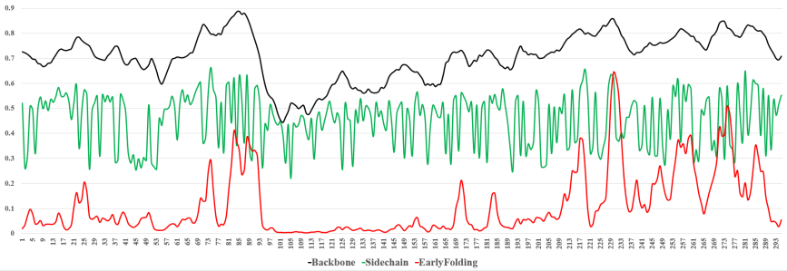 |  | 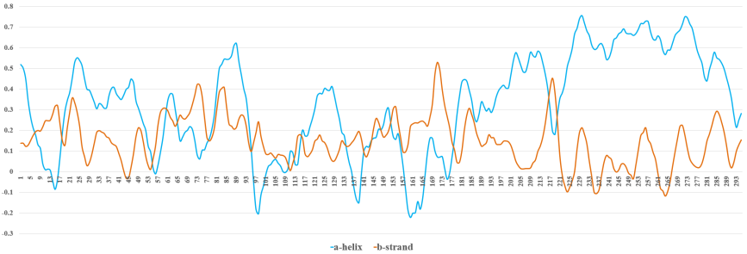 |  | 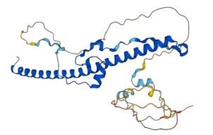
4 | FAM117A |  | 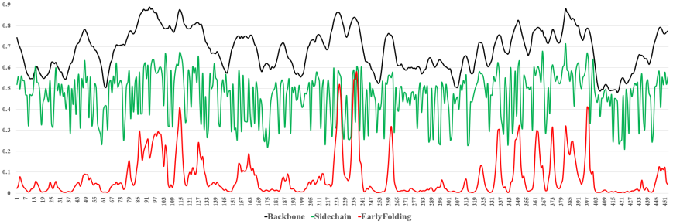 |  | 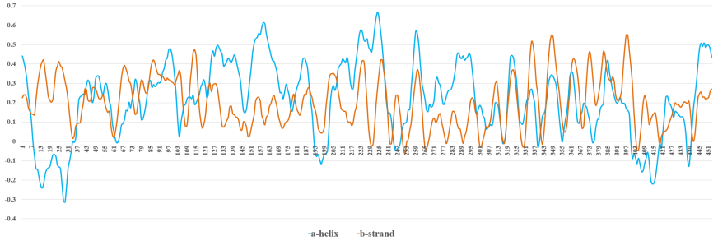 |  | 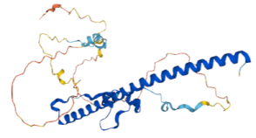
5 | SLC11A2 |  | 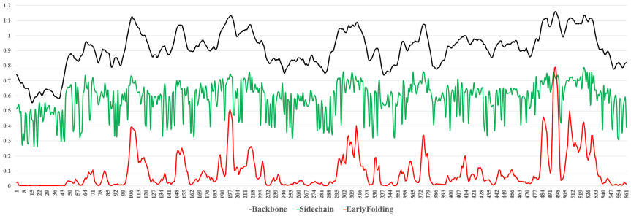 |  | 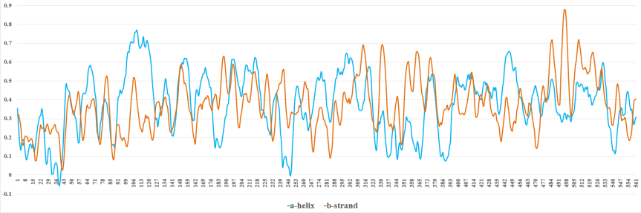 |  | 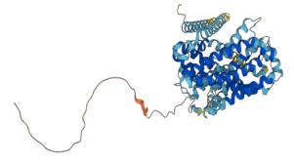
6 | RRAGB |  | 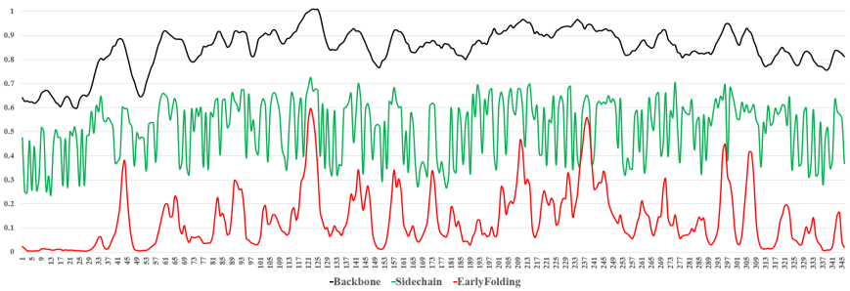 |  | 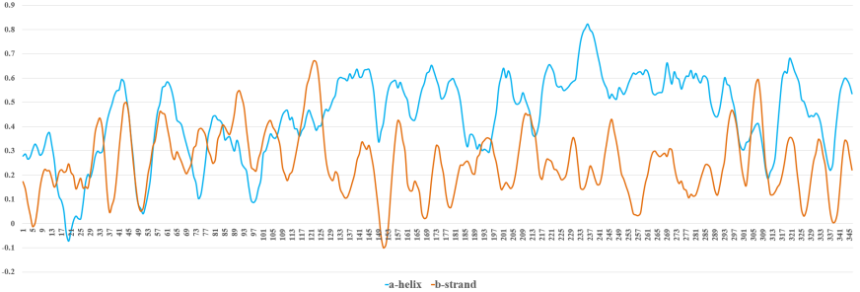 |  | 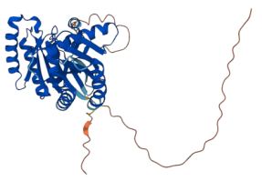
7 | TMEM168 |  | 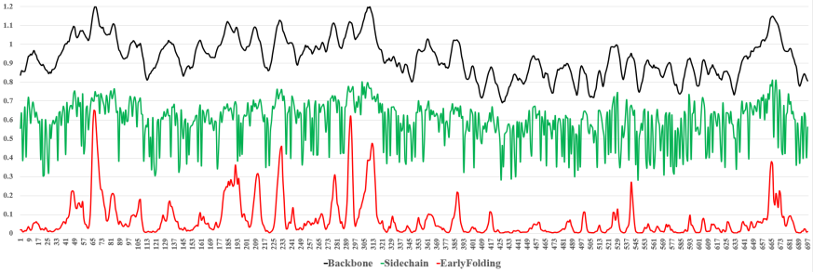 |  | 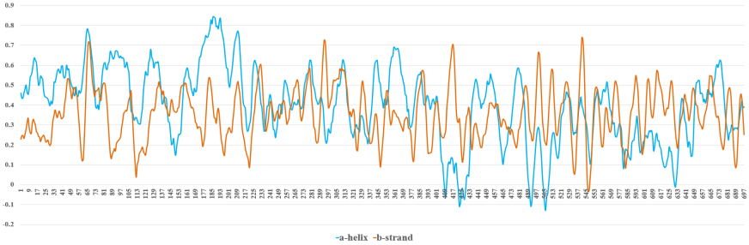 |  | 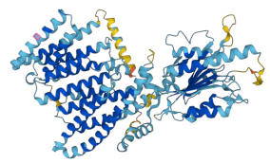
8 | MYLIP |  | 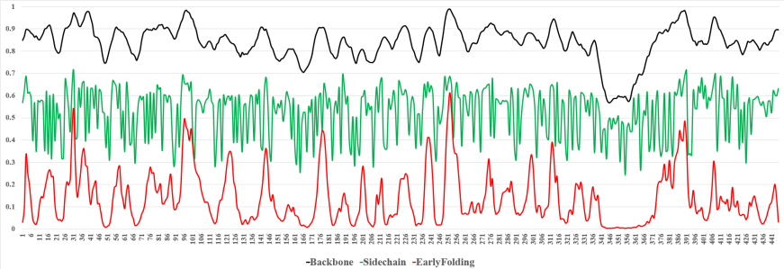 |  | 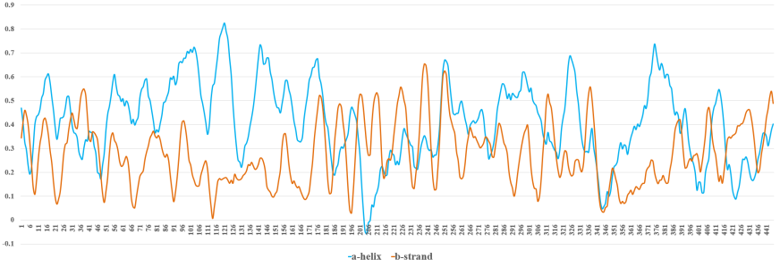 |  | 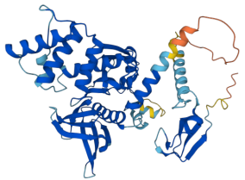
9 | ZNF77 |  | 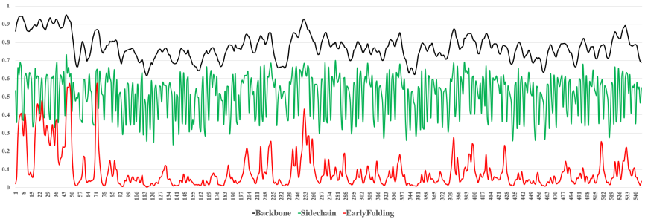 |  | 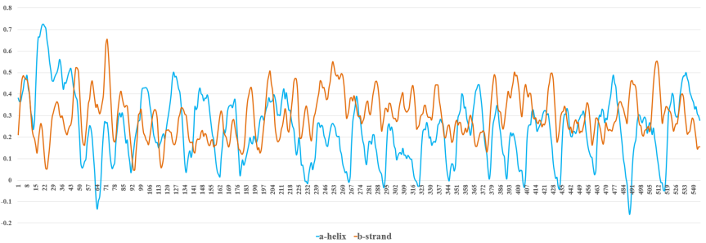 |  | 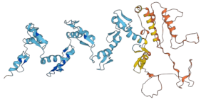
10 | TTC39B |  | 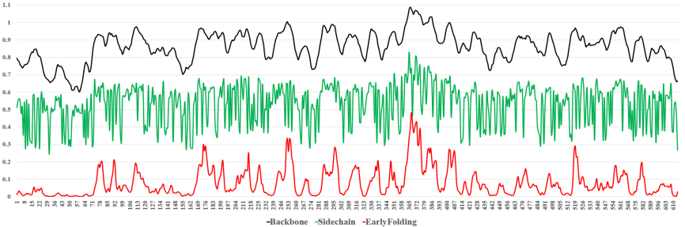 |  | 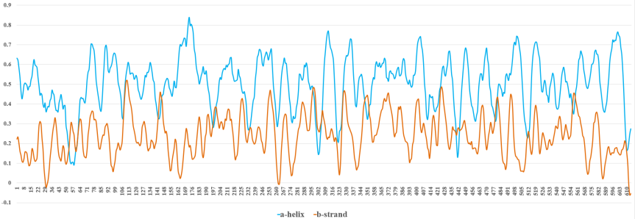 |  | 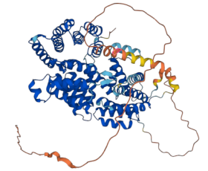
11 | THYN1 |  | 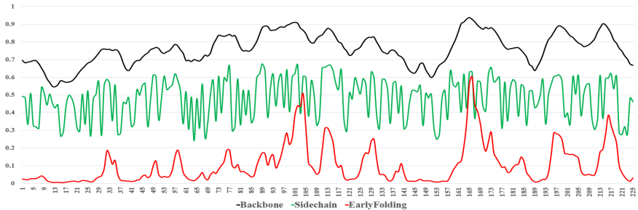 |  | 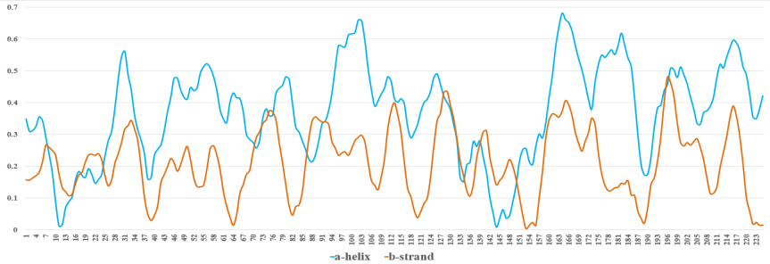 |  | 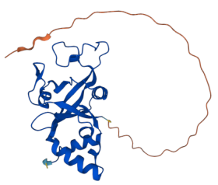
12 | ANKRD65 |  | 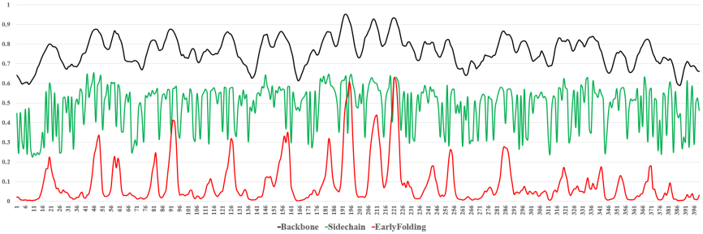 |  | 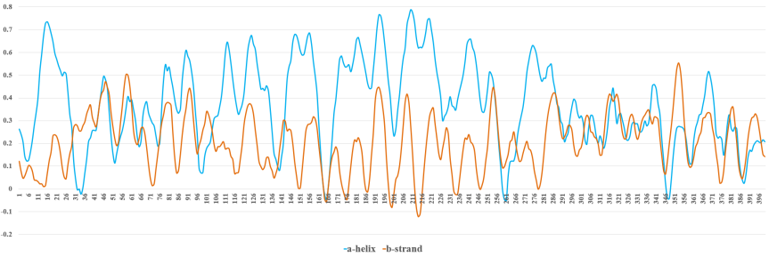 |  | 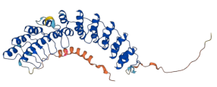
13 | DBP |  | 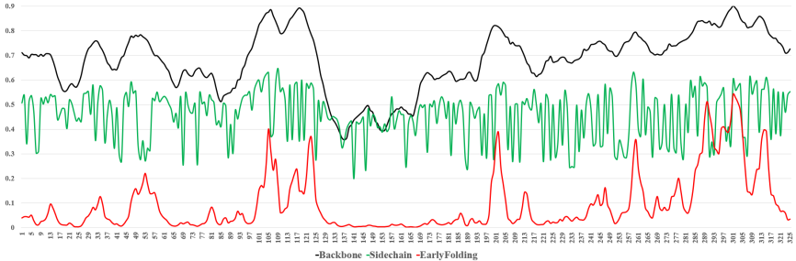 |  | 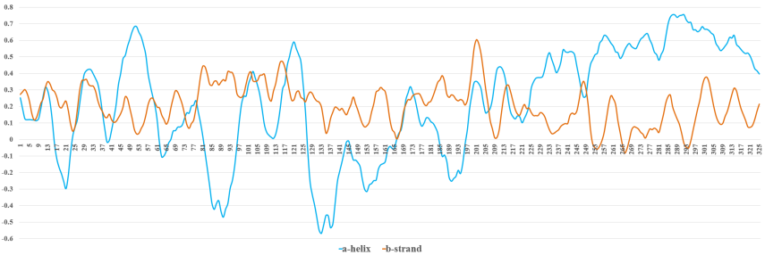 |  | 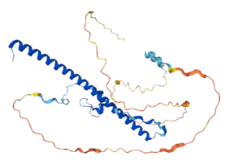
14 | GNG7 | 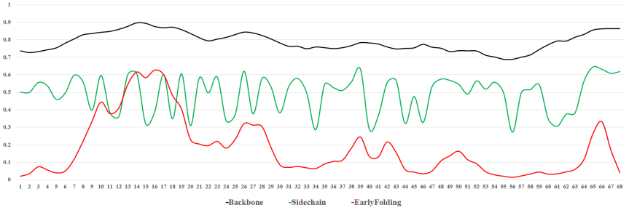 |  | 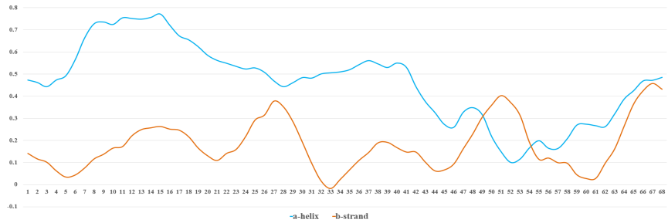 |  | 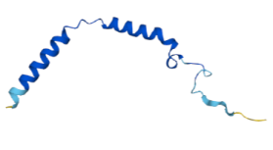
15 | INPP5J | 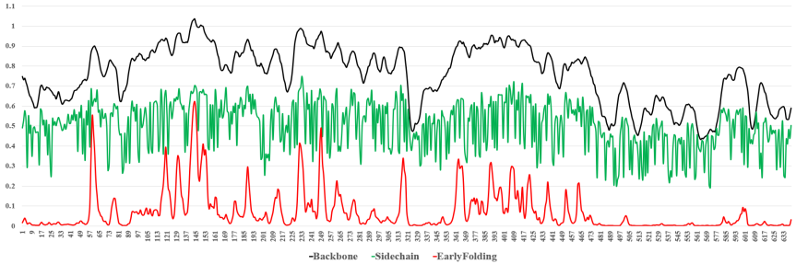 |  | 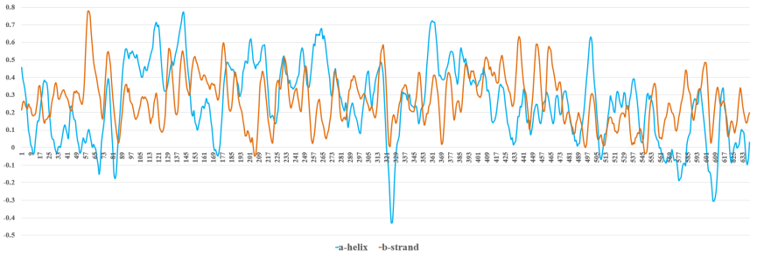 |  | 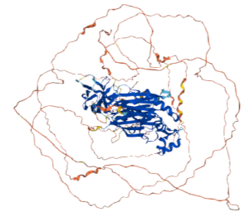
16 | MARCHF9 | 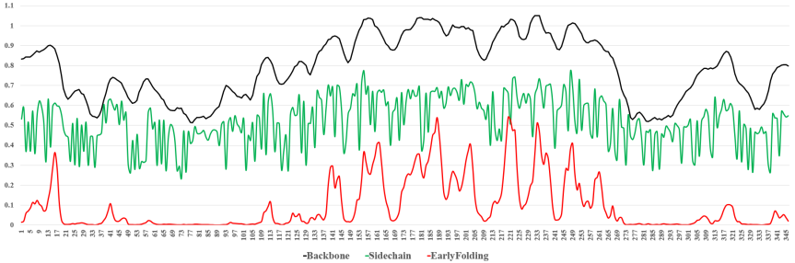 |  | 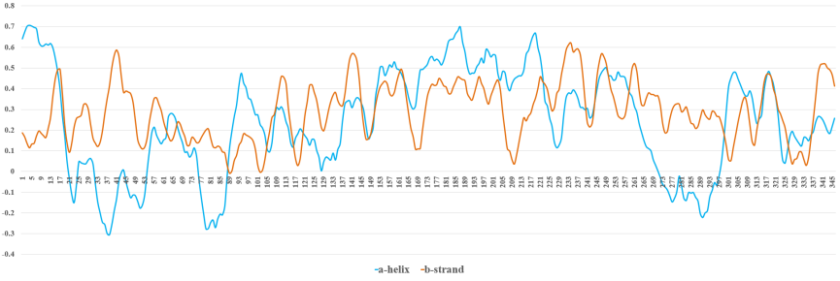 |  | 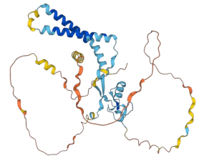
17 | SMIM4 | 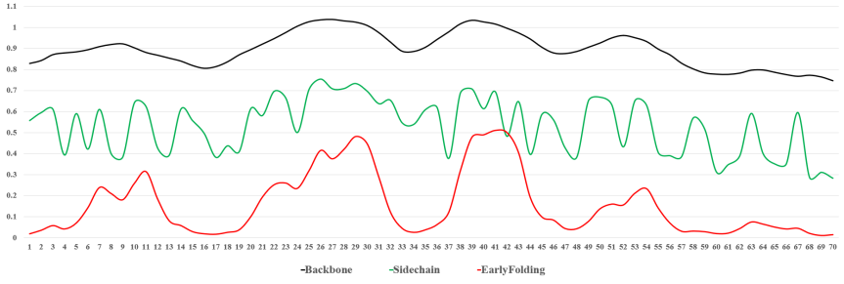 |  | 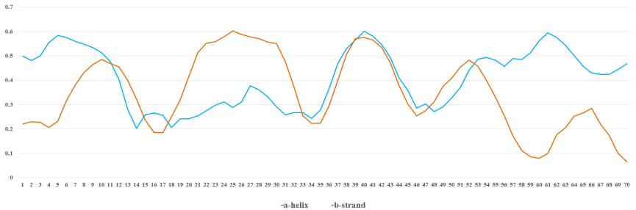 |  | 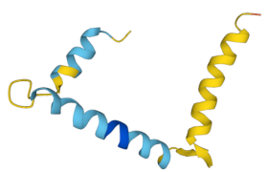
18 | SLC47A1 | 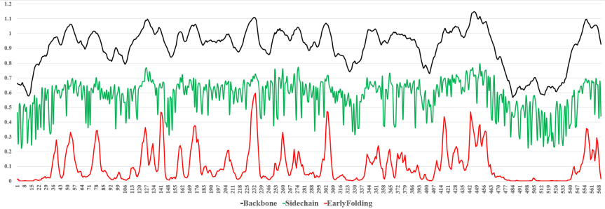 |  | 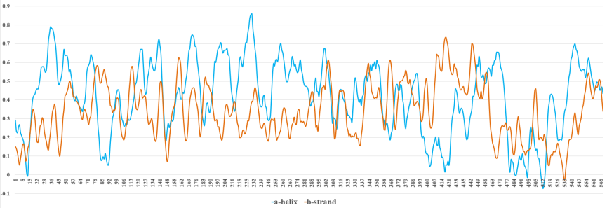 |  | 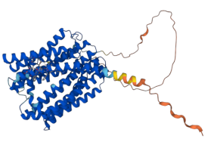
19 | CA11 | 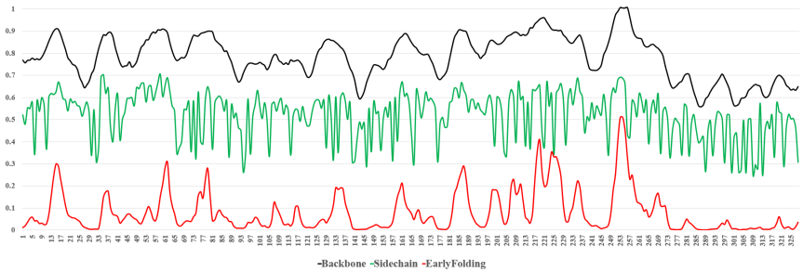 |  | 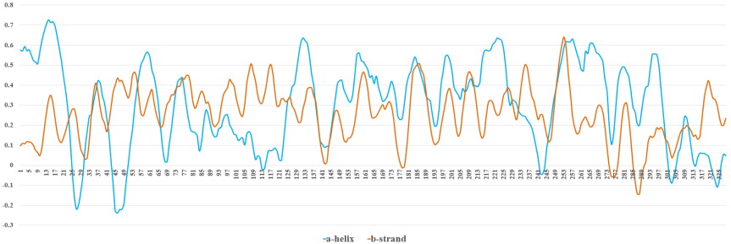 |  | 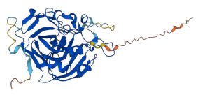
20 | PPFIBP2 | 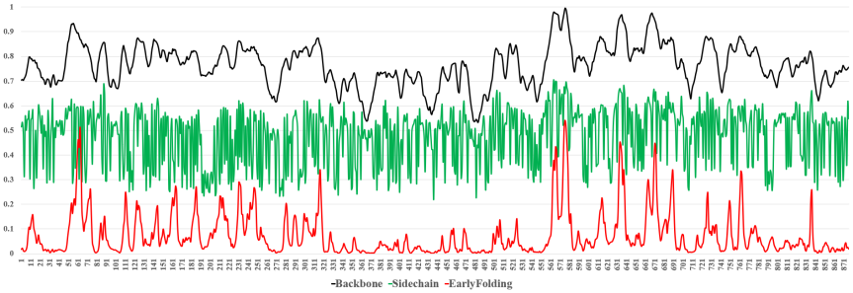 |  | 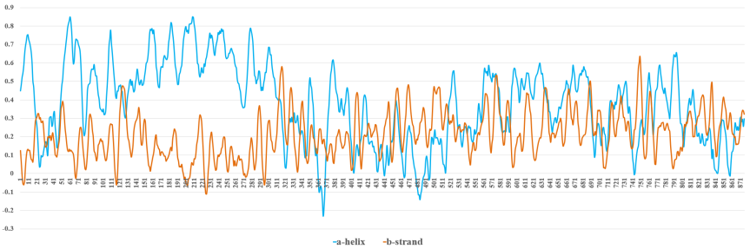 |  | 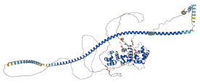

Supplementary table 24 Predicted folding rates in a set of 77 two and three-state proteins
PDB code | Experimental | ln(kf) predicted | Deviation
All-a proteins
1LMB | 8.50 | 8.45 | 0.05
2ABD | 6.55 | 6.33 | 0.22
1IMQ | 7.31 | 7.20 | 0.11
2PDD | 9.80 | 9.54 | 0.26
1HRC | 8.76 | 8.66 | 0.10
1YCC | 9.62 | 9.74 | -0.12
256B | 12.20 | 12.42 | -0.22
1VII | 11.52 | 11.47 | 10.05
1BDD | 11.75 | 11.72 | 0.03
1l8W | 1.61 | 1.61 | 0.00
1ENH | 10.53 | 10.49 | 0.04
1EBD | 9.68 | 9.90 | -0.22
1A6N | 1.10 | 1.20 | -0.10
1CEI | 5.80 | 5.95 | -0.15
2CRO | 3.70 | 3.82 | -0.12
2A5E | 3.50 | 3.43 | 0.07
All-b proteins
1NYF | 4.54 | 4.34 | 0.20
1PKS | -1.05 | -0.62 | -0.43
1SHG | 1.41 | 1.57 | -0.16
1SRL | 4.04 | 4.09 | -0.05
1FNF-9 | -0.91 | -0.96 | 0.05
1TEN | 1.06 | 1.22 | -0.16
1WIT | 0.41 | 0.18 | 0.23
1CSP | 6.98 | 6.75 | 0.23
1MJC | 5.24 | 5.70 | -0.46
2AIT | 4.20 | 4.05 | 0.15
1PNJ | -1.10 | -1.77 | 0.67
1SHF | 4.50 | 4.78 | -0.28
1C9O | 7.20 | 7.24 | -0.04
1G6P | 6.30 | 6.11 | 0.19
1LOP | 6.60 | 6.57 | 0.03
1PIN | 9.44 | 9.63 | -0.19
1C8C | 6.91 | 7.04 | -0.13
1PSF | 3.22 | 3.53 | -0.31
1FNF | 5.48 | 5.36 | 0.12
1HNG | 2.89 | 2.60 | 0.29
1HX5 | 0.74 | 0.75 | -0.01
1TIT | 3.47 | 3.57 | -0.10
1IFC | 3.40 | 3.38 | 0.02
1EAL | 1.30 | 1.20 | 0.10
1OPA | 1.40 | 1.07 | 0.33
1CBI | -3.20- | -2.68 | -0.52
Mixed-class proteins
1APS | -1.48 | -1.18 | -0.30
1HDN | 2.70 | 2.45 | 0.25
1URN | 5.73 | 5.36 | 0.37
2HQI | 0.18 | 0.47 | -0.29
1PBA | 6.80 | 6.92 | -0.12
1BNI | 2.60 | 2.90 | -0.30
2LZM | 4.10 | 4.14 | -0.04
1SCE | 4.20 | 4.46 | -0.26
1GXT | 4.38 | 4.15 | 0.23
2A5E | 3.50 | 3.71 | -0.21
1AON | 0.80 | 1.46 | -0.66
1PHP (N-TERMINAL) | 2.30 | 2.02 | 0.28
1PHP (C-TERMINAL) | -3.45 | -3.71 | 0.26
1qop (a-Subunit) | -2.53 | -2.76 | 0.23
1qop (b-Subunit) | -6.91 | -6.86 | -0.05
1BNI | 2.60 | 2.90 | -0.30
2LZM | 4.10 | 4.14 | -0.04
1SCE | 4.20 | 4.46 | -0.26

Supplementary Figures

a b
Supplementary Fig 1 Two groups structure full length comparison
The results from the t test showed that the average length of proteins in the unfavourable group was significantly longer than that in the favourable group. And in the cross-comparison, the β-strand average length in the favourable group was significantly longer than that in the unfavourable group, with no significant differences in α-helix length.

a b c d
Supplementary Fig 2 Two group proteins different sectional contends comparison
The internal average section length of each group did not differ

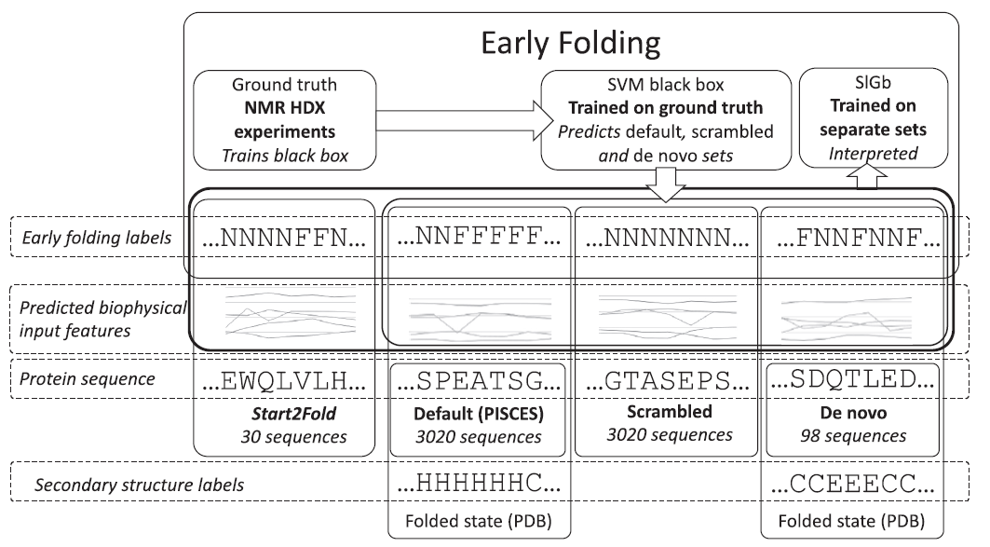
Supplementary Fig 3 Overview of the datasets and workflow of Different stages.
For each dataset and each prediction, every amino acid was further labelled whether it was a single (S) early folding or nonearly folding residue or whether it appeared at the beginning (B), middle (M) or end (E) of a given early folding or nonearly folding fragment

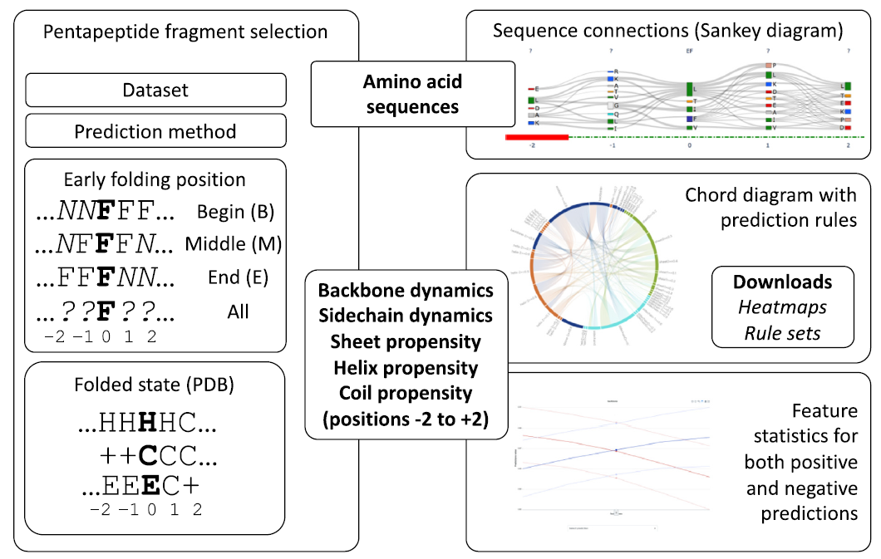
Supplementary Fig 4 Overview of the available data interpretation and analysis
Sankey plot are available for all fragments where the inter-amino acid connections can be explored. Chord diagrams and heatmaps visualize the rules for the per-fragment trained predictor, as well as an overview of the distributions of the features used for the prediction for these fragments.

