Table 3 The practice of landscape digitization in Nanxun ancient town
The practice of landscape digitization in Nanxun ancient town
Landscape zone | Representative landscape | Digital gene  principle | Digital pattern | Digital conversion | Digital conversion case
Littlelotus  village cultural zone | Jiaye Library  The Liu Family Temple  Littlelotus village  Jiaye LibraryGarden  InscriptionGallery | Digital protection | Digital communication  Digital form | Multimodal video  Three-dimensional modeling  Cultural IP | 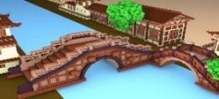
 |  |  |  |  | 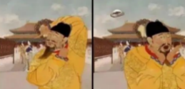
Littlelotus  village cultural zone |  | Digital utility | Digital experience  Digital function | Intelligent cloud service Digital collection  Virtual digital person | 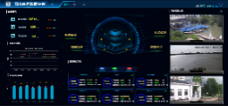
 |  |  |  |  | 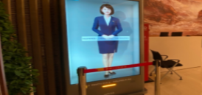
Sino-Western cultural exchange zone | The Liu Ancestral Hall  ZhangShiming'sformer residence  Hiroei Palace  Chongde Hall  NanxunCatholic Church  NanxunChristian Church  Nanxun silk industry Hall | Digital extension  Digital protection | Digital communication  Digital experience | Digital literature tour  Three-dimensional modeling  Virtual roaming | 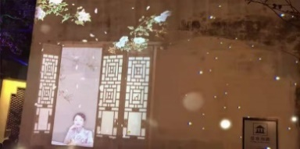
Sino-Western cultural exchange zone |  | Digital integration | Digital function  Digital communication | NFT  Digital collection  Cultural IP AIGC  Digital exhibition | 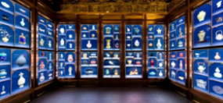
 |  |  |  |  | 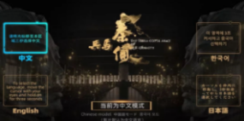
Ancient bridge drainage system zone | Public dock  Nanxun Three Bridge  Intangible cultural Heritage Exhibition Hall | Digital extension  Digital integration | Digital experience  Digital form | AR  Digitalliterature tour  Digital marketing | 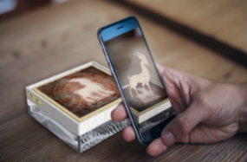
Baijianlou traditional residence group zone | Baijianloutraditional residence group  ZhangJingjiang'sformer residence  DitangOld Road | Digital extension  Digital integration | Digital function | Virtual roaming  XR Immersion experience  digital game | 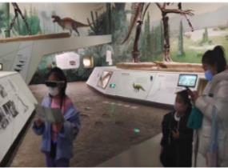
Images from digital conversion case of scenic spots in the order of 1. Author drawing ;2.6 Palace Museum; 3.5 Zhouzhuang ancient town 4. Major Memorial Hall of the Communist Party of China 7. Terracotta Army Exhibition Hall 8. The Mogao Grottoes in Dunhuang 9. Shandong Museum

