Supplementary Material
Title:
CRF regulates pain sensation by enhancement of corticoaccumbal excitatory synaptic transmission
Authors:
Weinan Zhao ^{1,2,3†}, Xiao-Yi Wang ^{1,2,3†}, Sun-Hui Xia^{1,2,3†}, Yu Ma^{1,2,3}, He Li^{1,2,3}, Yu-Mei Yu^{1,2,3}, Zheng Xu^{1,2,3}, Jun-Xia Yang ^{1,2,3}, Peng Wu ^{1,2,3}, Hongxing Zhang ^{1,2,3}, Hai-Lei Ding ^{1,2,3 *}, Jun-Li Cao^{1,2,3,4 *}
Affiliations:
¹Jiangsu Province Key Laboratory of Anesthesiology, Xuzhou Medical University, Xuzhou, Jiangsu 221004, China;
²Jiangsu Province Key Laboratory of Anesthesia and Analgesia Application Technology, Xuzhou Medical University, Xuzhou, Jiangsu 221004, China;
³NMPA Key Laboratory for Research and Evaluation of Narcotic and Psychotropic Drugs, Xuzhou Medical University, Xuzhou, Jiangsu 221004, China;
⁴Department of Anesthesiology, The Affiliated Hospital of Xuzhou Medical University, Xuzhou, Jiangsu 221002, China

Corresponding authors:
Jun-Li Cao: Department of Anesthesiology, The Affiliated Hospital of Xuzhou Medical University, Xuzhou 221002, China; Jiangsu Province Key Laboratory of Anesthesiology, Xuzhou Medical University, Xuzhou 221004, China. Telephone: 86-516-83262686, Email: caojl0310@aliyun.com.
Hai-Lei Ding: Jiangsu Province Key Laboratory of Anesthesiology, Xuzhou Medical University, Xuzhou 221004, China. Telephone: 86-516-83262686, Email: haileimdar@yahoo.com.
†These authors contributed equally to this work.

List of Supplementary Materials
Present a list of the Supplementary Materials in the following format.
Materials and Methods
Fig. S1 to Fig S13 for multiple supplementary figures

Contents
- Abbreviations
- Methods
  - Animals
  - Chronic neuropathic pain model
  - Measurement of thermal and mechanical pain thresholds
  - Reagents
  - Viruses
  - Viral injection and optical fiber/cannula implantation
  - Microinjections for pharmacological manipulation.
  - Monosynaptic tracing and chemogenetic manipulation
  - Slice preparation for electrophysiology
  - Ex vivo electrophysiology
  - qRT–PCR
  - Immunohistology and confocal imaging
  - Western blotting
  - Data analysis and statistics

- Supplementary Figures
Fig. S1 - CRF signaling in NAcC and regulation of pain sensation
Fig. S2 - The neuronal excitability in NAcC under chronic neuropathic pain state
Fig. S3 - CCI surgery did not affect the RMP and threshold current in NAcS neurons
Fig. S4 - The effect of CRF or ɑ-helical CRF perfusion on RMP and threshold current in NAcS neurons
Fig. S5 - The upstream brain regions of NAcS-projecting CRF neurons
Fig. S6 - Chemogenetic inhibition of the mPFCCRF→NAcS circuit attenuated CCI-induced pain sensation
Fig. S7 - Acute real-time optogenetic inhibition of the mPFC^{CRF}→NAcS circuit did not affect pain sensation in naïve mice
Fig. S8 - Single chemogenetic activation of the mPFCCRF→NAcS circuit did not affect pain sensation in naïve mice
Fig. S9 - CCI did not affect the AMPAR/NMDAR amplitude ratio in the NAcS-receiving neurons
Fig. S10 - Mapping neuronal projections from NAcS to mPFC
Fig. S11 - The changes of threshold potential and RMP in the NAcS-receiving neurons in CCI mice
Fig. S12 - The effect of CRF or ɑ-helical CRF perfusion on RMP in NAcS-receiving neurons
Fig. S13 - CCI surgery did not affect the IPSCs of NAcS-receiving neurons

- References

1. Abbreviations
Acsf, artificial cerebrospinal fluid
eAPs, evoked action potentials by depolarizing current injections
Aca, anterior commissure anterior part
ACC, anterior cingulate cortex
Amy, amygdala
AMPAR, α-amino-3-hydroxy-5-methyl-4-isoxazolepropionic acid receptor
CRF, corticotropin releasing factor
CCI, chronic constrictive injury
Contra, contralateral
GABA_{A}R, γ-aminobutyric acid receptors
Ipsi, ipsilateral
leEPSCs, light-evoked excitatory postsynaptic currents
mPFC, medial prefrontal cortex
NAcS, nucleus accumbens shell
NAcC, nucleus accumbens core
NBQX, 2,3-dioxo-6-nitro-7-sulfamoyl-benzo[f]quinoxaline
NMDAR, N-methyl-D-aspartate receptor
PPR, paired-pulse ratio
PWLs, paw withdraw latencies
PWTs, paw withdraw thresholds
PVT, paraventricular thalamus
RMP, resting membrane potential
sEPSCs, spontaneous excitatory postsynaptic currents
sIPSCs, spontaneous inhibitory postsynaptic currents

2. Materials and Methods

2.1 Animals. All experiments were reviewed and approved by the Animal Care and Use Committee of Xuzhou Medical University, and performed in accordance with the National Institutes of Health Guidelines and Use of Laboratory Animals and the Committee for Research and Ethical Issues of the International Association for the Study of Pain. Mice were group-housed (maximum five mice per cage) under a 12-h light/dark cycle (light from 8:00 A.M. to 8:00 P.M.), with food and water available ad libitum. The ambient temperature was maintained at 21-22°C with 55% relative humidity. Only C57BL/6 J male mice (8–13 weeks old) of normal weight (22-24g) were used for all studies. All behavioral tests were conducted during the light period, and the investigators were blinded to experimental conditions during testing.

2.2 Chronic neuropathic pain model. Chronic constrictive injury (CCI) surgery was conducted as the protocol described in our previous research ¹. Mice were anesthetized with a mixture of ketamine and xylazine (100 mg/kg and 10 mg/kg, i.p.). After the nerves were exposed at the mid-thigh level ², three ligatures (4-0 silk) were placed around the nerve proximal to the trifurcation with 1 mm between each ligature. The ligatures were loosely tied until a short flick of the ipsilateral hind limb was observed. Animals in the sham group received surgery without nerve ligation, and erythromycin ointment was applied locally following the suture. After suture and sterilization, mice were cared in a recovery cage.

2.3 Measurement of thermal and mechanical pain thresholds. Paw withdraw latencies (PWLs) tests were measured using the Hargreaves test ³ with an IITC plantar analgesia meter (IITC Life Science, Inc.). In a quiet environment (room temperature: 23 ± 2°C), mice were placed in polyethylene cages separately on a glass platform and allowed to accommodate the apparatus for 1-2 h ⁴. A radiant heat source beneath the glass was used to stimulate the plantar surface of the hind paw. Before testing, heat intensity was adjusted to produce a baseline of 10-15 s. A cutoff time was set at 20 s to prevent tissue damage. Flinching, flicking, and trembling were considered positive responses. The measurements were in triplicate at 10-min intervals and the mean was calculated as the PWL.
To estimate mechanical paw withdraw thresholds (PWTs), a simplified up-and-down (SUDO) method with von Frey filaments (USA, North Coast) was employed ⁵. In brief, mice were placed in polyethylene cages separately on an elevated metallic wire mesh platform. Before testing, mice were allowed to acclimatize to the environment for 1-2h (room temperature: 23 ± 2 °C). Testing started with the midrange filament of 0.4 g strength. Subsequent filaments were decided according to the up-down method, and 5 consecutive touches were applied at 5-min intervals for rest. The filaments were pressed against the plantar surface and held for 3 seconds. Positive responses were noted when mice withdrew their hind paw during this time. The 50%PWT calculated as50％PWT＝10[log(Xf)+κδ], Xf = value (in log units) of the final von Frey filament used; κ = tabular value (see Appendix from reference ⁶) for the pattern of positive/negative responses, and δ = mean difference (in log units) between stimuli (here, 0.411).

2.4 Reagents. CRF (HY-P1533, MedChemExpress, Shanghai, China) and ɑ-helical CRF (HY-P1294, MedChemExpress, Shanghai, China) were dissolved by saline before administration. CNO (HY-17366, MedChemExpress, Shanghai, China) was dissolved by DMSO and injected 1 h before behavioral test at a dose of 1 mg/kg. Cholera toxin subunit B (recombinant), Alexa Fluor® 555 conjugate (C22843, Thermo Fisher scientific, Shanghai, China) was injected into NAc core and shell to label the location of microinjection. NBQX (0373, Tocris bioscience, China), D-AP5 (0106, Tocris bioscience, China), picrotoxin (HY-101391, MedChemExpress, Shanghai, China) and tetrodotoxin (R11179, Thermo Fisher scientific, Shanghai, China) were used to investigate the potential mechanism for the acting effect of CRF.

2.5 Viruses. The viral vectors were purchased from Brain VTA: AAV-CRF-eYFP (2/R, 5.88E + 12 viral genome/ml [vg/ml]); AAV-CRF-Cre (2/R, 2.24E + 12 viral genome/ml [vg/ml]); AAV-Efla-DIO-mCherry (2/9, 5.67E1 + 2 vg/ml); AAV-Efla-DIO-eYFP (2/9, 5.37E + 2 vg/ml); AAV-Efla-DIO-hM4D(Gi)-mCherry (2/9, 2.63E + 12 vg/ml); AAV-EF1α-DIO-hM3D(Gq)-mCherry (2/9, 2.23E + 12 vg/ml); AAV-Efla-DIO-NpHR3.0-eYFP (2/9, 1.46E + 12 vg/ml); AAV-EF1a-DIO-ChR2-mCherry (2/9, 1.79 12 vg/ml); AAV- CRF -WGA-Cre (2/9, 2.83E 12 vg/ml).

2.6 Viral injection and optical fiber/cannula implantation. Mice were anesthetized with sodium pentobarbital (40 mg/kg, i.p.) for unilateral stereotaxic injection of viruses into the nucleus accumbens shell (NAcS; AP: + 1.5; ML: + 0.55; DV: − 4.7; mm relative to bregma; AP, ML, and DV denote anteroposterior, mediolateral and dorsoventral distance from the bregma, respectively), nucleus accumbens core (NAcC; AP: + 1.4 ML: + 0.9; DV: − 4.5; mm relative to bregma) and medial prefrontal cortex (mPFC; AP: + 2.1 ML: + 0.35; DV: − 2.5; mm relative to bregma).
The coordinates were measured from the bregma according to the mouse atlas. We injected 200 nl of the virus into each location at a rate of 100 nl/min with a 33-gauge Hamilton syringe needle (Hamilton Company Inc., Reno, USA). The syringe was not removed until 15 min after the end of infusion to allow diffusion of the virus.
To allow for projection-specific targeting of mPFC^{CRF}→NAcS projection terminals in the NAcS, optical fibers (length 4.7 mm, NA 0.22; NEWDOON, China) were implanted over the NAcS (AP: + 1.5; ML: ± 0.55; DV: − 4.5; mm relative to bregma) unilaterally. The optical fiber was connected to a laser source using an optical fiber sleeve (NEWDOON, China). Mice performed behavioral tests after habituation for 2 hours.
For pharmacological experiments, a bilateral cannula (RWD Life Technology Co., Ltd., Shenzhen, China) was implanted above the NAc core (AP: + 1.4; ML: ± 0.9; DV: − 4.4; mm relative to bregma) or NAcS (AP: + 1.5; ML: ± 0.5; DV: − 4.6; mm relative to bregma) for infusion. Two stainless steel screws were implanted in the skull for support. The cannula and screws were held in place with dental cement. A stainless-steel obturator was inserted into each guide cannula to prevent blockage. Only mice with the correct locations of optical fibers/cannulas and viral expression were used for further analysis.
2.7 Microinjections for pharmacological manipulation. The unilateral microinjections of CRF and helical-CRF were administered by using 33-gauge stainless steel injectors that extended 1.0 mm (length of injector tip, 3.7 mm; NAc shell) or 1.0 mm (length of injector tip, 3.5 mm; NAc core) via the pre-installed cannula. The injection volume was 0.1 μl and this was infused over 60 s. The infusion speed was regulated by a RWD Apparatus syringe pump (model R462) and the pump was equipped with 10 μl syringes (Hamilton, Rena, NE). The syringes were connected to the injectors with Tygon microbore PVC tubing (0.25 mm ID × 0.76 mm OD). The injectors were left in place for 120 s postinjection to allow diffusion from the injector tip. The dummy stylets were re-inserted immediately after the injectors were removed.

2.8 Monosynaptic tracing and chemogenetic manipulation. In order to trace the downstream monosynaptic receiving neurons from the mPFC^{CRF}→NAcS circuit in CCI mice, we injected 200 nl virus of AAV-CRF-WGA-Cre into the mPFC and 200 nl virus of AAV-Efla-DIO-mCherry into the NAcS in contralateral side to the CCI-affected paw. This strategy makes the NAcS neurons, which is innervated by mPFC^{CRF}→NAcS circuit to express mCherry. Twenty-one days after injection, mice were killed for brain slice of mPFC and NAc.
To inhibit the neurons dominated by mPFC^{CRF}→NAcS circuit, 200 nl virus of AAV-CRF-WGA-Cre was injected into the mPFC contralateral to the CCI, and 200 nl virus of AAV-Efla-DIO-hM4D(Gi)-mCherry was injected into the NAcS at the same time. This strategy makes the NAcS neurons, which is innervated by mPFC^{CRF}→NAcS circuit to express Gi and mCherry. Twenty-one days after injection, CNO (1mg/kg, i.p.) was injected to inhibit these neurons.

2.9 Slice preparation for electrophysiology. Mice were deeply anesthetized with isoflurane (1.5–3.0%). Using a microslicing vibratome (DTK-1000, Ted Pella, Inc., CA, USA), each brain was removed after decapitation and slices (thickness, 300mm) were then cut in a solution containing (in mM): 135 N-methyl-d-glutamine, 1 KCl, 1.2 KH₂PO₄, 0.5 CaCl₂, 1.5 MgCl₂, 20 choline-HCO_{3,} and 11 Glucose, saturated with 95%O₂/5%CO₂ (pH 7.4). Slices were incubated in the artificial cerebrospinal fluid (ACSF) containing (in mM): 119 NaCl, 2.5 KCl, 2.5 CaCl₂, 1.3 MgCl₂, 1 NaH₂PO₄, 26.2 NaHCO_{3,} and 11 Glucose, with the osmolality adjusted to 280–290 mOsm/kg. Slices were placed in the ACSF saturated with 95% O₂/5% CO₂ at 32 °C for 30 min and then held at 20-22 °C for at least 30 min before experimentation.

2.10 Ex vivo electrophysiology. All recordings were made in the mPFC and nucleus accumbens (NAc) contralateral to the manipulated sciatic nerve. The ACSF was heated to 31-33°C by passing the solution through a feedback-controlled in-line heater (Warner, CT) before entering the recording chamber. The signal was acquired via a MultiClamp 700B amplifier (Molecular Devices, Union City, CA, USA), low-pass filtered at 2.8 kHz, digitized at 10 kHz, and analyzed with Clampfit 10.7 software (Molecular Devices, Sunnyvale, CA, USA).
For cell-attached recordings, the patch pipettes (3 to 8 megohms) were filled with 130 mM K-methanesulfate, 10 mM KCl, 3 mM adenosine triphosphate (ATP)–Na⁺, 0.5 mM guanosine triphosphate (GTP)–Na⁺, 0.4 mM EGTA, 10 mM HEPES, and 7.5 mM phosphocreatine (Na2) (pH adjusted to 7.45 with KOH, osmolarity adjusted to 276 to 280 mOsm). The recording was performed in gap-free mode. The mCherry positive cells in NAcS or mPFC were firstly recorded for a 3 mins baseline, then went through a 1 min CNO perfusion. Only one cell was recorded from a single brain slice after CNO application.
Neuronal excitability recordings in response to depolarization were performed in whole-cell current-clamp mode. The patch pipettes (3 to 8 megohms) were filled with 130 mM K-methanesulfate, 10 mM KCl, 3 mM adenosine triphosphate (ATP)–Na⁺, 0.5 mM guanosine triphosphate (GTP)–Na⁺, 0.4 mM EGTA, 10 mM HEPES, and 7.5 mM phosphocreatine (Na2) (pH adjusted to 7.45 with KOH, osmolarity adjusted to 276 to 280 mOsm). Neurons were given increasingly depolarizing current steps at +50-pA intervals ranging from -50 to +200 Pa (in mPFC) or +50-pA intervals ranging from 0 to +300 Pa (in NAc), allowing us to measure AP generation in response to membrane depolarization (5-s duration). Neurons were kept at −70 mV (in mPFC) or −80 mV (in NAc) with manual direct current injection between pulses. Rheobase current was defined as the first current step capable of eliciting one action potential. Synaptic transmission blockade was achieved by adding 2,3-Dioxo-6-nitro-1,2,3,4-tetrahydrobenzo (NBQX; 10 μM), picrotoxin (100 μM), and _{D, L}-2-amino-5-phosphonovaleric acid (D-AP5; 50 μM) to block AMPAR-, GABA_{A}R-, and NMDAR-mediated synaptic transmission, respectively. 1 min after bath application of CRF or ɑ-helical CRF, the recordings of excitability were obtained. Only one cell was recorded from a single brain slice after drug application.
The internal solution for spontaneous excitatory postsynaptic currents (sEPSCs) recording was the same as that used for excitability recordings. Light-evoked excitatory postsynaptic currents (leEPSCs) were recorded with picrotoxin (100 μM) and tetrodotoxin (1 μM) added to the cerebrospinal fluid. To evoke synaptic transmission using ChR2, postsynaptic recordings from neurons in NAcS were made in areas of high ChR2 terminal infectivity while activating ChR2 with 473 nm blue light delivered by an LED (Polygon400, Mightex, Canada) directed through the objective with a light intensity of < 20 mW. Firstly, 1 min bath application of CRF or ɑ-helical CRF was executed after 3 mins recording of baseline, then at least 3 minutes of EPSCs were recorded. Only one cell was recorded from a single brain slice after drug application.
In order to calculate the paired-pulse ratio (PPR), we used a paired-pulse stimulation (50 ms interval, 1 ms duration) protocol to record the AMPAR excitatory postsynaptic currents (EPSCs) of NAcS neurons at −80 mV in voltage-clamp mode. PPR was calculated as the peak amplitude ratio of the first to the second EPSC. As the PPR was affected by photostimulation intensity, we induced EPSCs with photostimulation at different light intensities and calculated the PPR for each photostimulation intensity in each NAcS neuron. The PPR is the ratio of the amplitude of the second EPSC to that of the first, reflecting presynaptic release probability; a lower PPR correlates with a higher release probability ⁷.
For spontaneous inhibitory postsynaptic currents (sIPSCs) recording, NBQX (10 μM), was added to the cerebrospinal fluid, and electrodes (3 to 8 megohms) were filled with a cesium-based internal solution containing (in mM):15 cesium methanesulfonic acid, 120 CsCl, 8 NaCl, 10 Hepes, 0.5 EGTA, 2 MgATP, 0.3 Na₃GTP, 5 QX-314, 7.5 Phosphocreatine (pH 7.4).
For the recording of the AMPAR/NMDAR amplitude ratio (A/N ratio): AMPAR EPSCs were recorded at -80 mV, and NMDAR EPSCs were recorded at +40 mV in voltage-clamp mode. Picrotoxin (100 μM) was added to the ACSF to prevent contamination from inhibitory postsynaptic currents. For each NAcS neuron, the same photostimulation intensity and duration were used to evoke AMPAR and NMDAR EPSCs. We recorded the first set of AMPAR EPSCs at -80 mV and then recorded NMDAR EPSCs at +40 mV. To quantify AMPAR EPSCs, we averaged the first and second sets of AMPAR EPSCs recorded before and after the recording of NMDAR EPSCs and calculated the peak amplitude of averaged AMPAR EPSCs. To quantify NMDAR EPSCs, we averaged NMDAR EPSC traces and measured the mean amplitudes of the averaged NMDAR EPSCs between 47.5 ms and 52.5 ms after the onset of photostimulation. As AMPAR EPSCs completely disappeared 50 ms after photostimulation, EPSCs recorded at +40 mV 50 ms after stimulation onset were not contaminated with AMPAR EPSCs and reflected NMDAR EPSCs⁸. Then, we calculated the amplitude ratio of AMPAR EPSCs to NMDAR EPSCs.

2.11 qRT–PCR. Total RNA from the tissue blocks of NAc and mPFC was extracted by an RNA purification kit (B518651, Sangon Biotech, Shanghai, China). The cDNA was generated by reverse transcription of total RNA (500 ng-1 µg) with a HiScript II Q RT SuperMix (R223-01, Vazyme, Nanjing, China), following by the preparation of 20 µL reaction mixtures in trice with a ChamQ SYBR Color qPCR Master Mix (Q421-01, Vazyme, Nanjing, China). Subsequently, qRT-PCR was performed with a Light Cycler 480 II (Roche Diagnostics, Switzerland, Rotkreuz), following the quantification of CRF standardized by GAPDH. Finally, the results were analyzed by the comparative CT method (2^{–∆∆CT}).
The sequences of the primers (Sangon Biotech, Shanghai, China) are as follows:
Crf, TTCTATAATGAGCTGCGTGTG (forward) and TTCATCGATGCCACAGGATTC (reverse);
Gapdh, GGTGAAGGTCGGTGTGAACG (forward) and CTCGCTCCTGGAAGATGGTG (reverse) ^{9, 10}.

2.12 Immunohistology and confocal imaging. Staining with c-Fos was used to assess the effect of the CCI surgery on neuronal activity in mPFC^{CRF}→NAcS projection. Seven days after CCI/sham surgery, mice were then transcardially perfused with 0.1M PBS and 4% paraformaldehyde in PBS. The brain was then removed and fixed in 4% paraformaldehyde buffer at 4°C overnight. After fixation, the brain was cryoprotected in 30% sucrose (wt/vol) at 4°C. Coronal brain sections (30 mm thick) were prepared by a frozen section microtome (CM1950, Leica Microsystems). Two to four sections were sampled from each mouse (the detailed N values can be found in the figure legends). The brain sections with fluorescent protein expression were direct covers, lipped in mounting medium, and visualized by a laser scanning confocal microscope (LSM 880, Carl Zeiss). For immunofluorescent staining, the sections were washed in PBS for 15min, incubated with a quick antigen retrieval solution (P0090, Biyuntian, China) for 5min, and subsequentially blocked for 1h with a PBS solution containing 1% BSA and 0.25% Triton X-100. According to the experimental needs, the sections were incubated with the primary antibodies overnight (rabbit anti-c-Fos [1:500, 2250], Cell Signaling Technology, or mouse anti-CaMKIIα [1:500], MA1-048, Thermo Fisher Scientific). After being washed in PBS for 15 min, the sections were tagged with secondary antibodies for 2 h (anti-rabbit Alexa-594 [1:200], A21207, Thermo Fisher Scientific, or anti-mouse Alexa-594 [1:200], A21203, Thermo Fisher Scientific). As controls, adjacent sections were incubated without primary antibody or without antibodies. Finally, the sections were mounted onto glass slides; 20× and 40× images were obtained using a confocal microscope (LSM 880, Carl Zeiss). To acquire the full area, image tiles were performed using Zeiss software. For fluorescent imaging, the same settings, including laser power, gain value, pinhole size, and line scans, were used to acquire a series of sections.

2.13 Western blotting. mPFC or NAc brain tissues contralateral to the sham/CCI affected paw were respectively stripped from the brain and sonicated subsequently in 200 μL lysis buffer containing phosphatase and protease inhibitors. Following the centrifuge (12000 rpm, 15 min), the supernatants were collected for protein concentration assay by an OD-assay facility (Thermo Scientific, USA). Proteins (40 μg per lane) were electrophoresed in a 10% SDS-PAGE and transferred onto PVDF membranes (Millipore, USA). The membranes were rinsed in triple and blocked in a 3% BSA solution (V900933, Sigma-Aldrich, China) for 2 h at room temperature, followed by incubation at 4°C overnight with the primary rabbit anti-β-actin (1:1000, 20536-1-AP, Proteintech, China) and rabbit anti-CRF (1:1000, ab184238, Abcam, China). Then the membranes were thrice washed and incubated with the secondary antibody conjugated to alkaline phosphatase (1:1000, VA006, Vicmed, China) for 2 h at room temperature. Afterward, the bands were visualized by a coloring solution composed of BCIP (S381C, Promega, USA) and NBT (S380C, Promega, USA). The grayscale of CRF protein was analyzed and standardized by that of β-actin.

2.14 Data analysis and statistics. Prior to further analysis, each dataset was subjected to a normality test using the Shapiro–Wilk test. For datasets that were normally distributed, parametric tests of the variance and group differences (paired, unpaired t tests, one-way or two-way ANOVA with repeated measures followed by Bonferroni post-tests) were used. Otherwise, the non-parametric Wilcoxon matched–pairs signed rank test, Mann Whitney Rank Sum Test, and the Kruskal Wallis One Way ANOVA on ranks with Uncorrected Dunn’s test were used. Statistical analyses were conducted with GraphPad Prism 7.0 software (GraphPad Software) without specification. All data are shown ± standard error to the mean (SEM). The Detailed descriptions can be found in the figure legends. Statistical significance was set at four levels (*p < 0.05, **p < 0.01, ***p < 0.001, ****p < 0.0001).

3. Supplementary Figures

Figure S1. CRF signaling in NAcC and regulation of pain sensation. A Schematic and histological verification of microinjection sites of the NAcC. Scale bar, 200 μm. B Intra-NAcC microinjection of ɑ-helical CRF before behavioral testing on day 7 after CCI surgery does not change the PWLs (left) and 50%PWTs (right) in CCI-affected hind paws. n = 6 mice/group. PWL: group, F _{(3, 24)} = 75.31, p < 0.0001; CCI + Acsf versus CCI + ɑ-helical CRF, 0.5h p = 0.0.9427, 1h p = 0.6055. 50%PWTs: group, F _{(3, 24)} = 23.88, p < 0.0001; CCI + Acsf versus CCI + ɑ-helical CRF, 0.5h p = 0.9725, 1h p = 0.9569. C Experimental timeline. The ɑ-helical CRF was microinjected to NAcC daily for five days after CCI surgery. PWLs and 50%PWTs were assessed at 8 hours after intra-NAcC injection. D Statistics showing repeated NAcC injection of ɑ-helical CRF failed to influence the PWLs (left) and 50%PWTs (right) of CCI mice. n = 7 mice/group. PWLs: group, F _{(3, 24)} = 82.25, p < 0.0001. 50%PWTs: group, F _{(3, 24)} = 65.69, p < 0.0001. E Intra-NAcC microinjection of CRF before behavioral testing failed to change the PWLs (left) and 50%PWTs (right) in naïve mice. n = 6 - 7 mice/group. PWL: group, F _{(3, 21)} = 0.3457, p = 0.7926; Acsf versus CRF 50nm, 0.5h p = 0.9798. 50%PWTs: group, F _{(3, 21)} = 0.1312, p = 0.9404; Acsf versus CRF 50nm, 0.5h p = 0.939. F Experimental timeline. The CRF was microinjected to NAcC daily for five days. PWLs and 50%PWTs were assessed at 8 hours after intra-NAcS injection. G Statistics showing repeated NAcC injection of CRF failed to influence the PWLs (left) and 50%PWTs (right) of naïve mice. n = 6 mice/group. PWLs: group, F _{(1, 10)} = 0.01766, p = 0.8969. 50%PWTs: group, F _{(1, 10)} = 3.266, p = 0.1009.
Data was analyzed by (B, D, E, G) two-way ANOVA followed by Bonferroni’s test for multiple comparisons. Error bars indicate SEM. Acsf, artificial cerebrospinal fluid; CTB, Cholera Toxin Subunit B; NAcC, nucleus accumbens core.

Figure S2. The neuronal excitability in NAcC under chronic neuropathic pain state. A Schematic and a DIC image of electrophysiological recording in NAcC at day7 after the sham or CCI surgery. Scale bar, 10 μm. B (left) Sample of whole-cell patch-clamp recording of eAPs in NAcC neurons from sham and CCI mice in response to depolarizing current injections with synaptic transmission intact. (right) Quantitative data showing the number of spikes in response to current step magnitude in NAcC neurons did not differ between sham and CCI mice. n _{sham} = 21 cells from 6 mice, n _{CCI} = 27 cells from 6 mice. Group, F _{(1, 40)} = 0.8311, p = 0.3674. C (left) RMP of NAcC neurons were not different between sham and CCI groups. n _{sham} = 21 cells from 6 mice, n _{CCI} = 21 cells from 6 mice. t ₍₄₀₎ = 0.8247, p = 0.4144. (right) Rheobase current were not different between sham and CCI groups. n _{sham} = 21 cells from 6 mice, n _{CCI} = 21 cells from 6 mice. Summary, p = 0.6597.
Data was analyzed by (B) two-way ANOVA followed by Bonferroni’s test for multiple comparisons, (C) unpaired t test for two group comparisons or (C) Mann-Whitney test. Error bars indicate SEM. NAcC, nucleus accumbens core; RMP, resting membrane potential.

Figure S3. CCI surgery did not affect the RMP and rheobase current in NAcS neurons. A With synaptic transmission intact, (left) RMP of NAcS neurons were not different between sham and CCI groups. n _{sham} = 21 cells from 6 mice, n _{CCI} = 27 cells from 6 mice. t ₍₄₆₎ = 1.305, p = 0.1985, unpaired t test. (right) Rheobase current were not different between sham and CCI groups. n _{sham} = 21 cells from 6 mice, n _{CCI} = 27 cells from 6 mice. Summary, p = 0.3499, Mann-Whitney test. B With fast synaptic transmission blocked, (left) RMP of NAcS neurons were not different between sham and CCI groups. n _{sham} = 23 cells from 6 mice, n _{CCI} = 21 cells from 6 mice. t ₍₄₂₎ = 0.7973, p = 0.4297, unpaired t test. (right) Rheobase current were not different between sham and CCI groups. n _{sham} = 23 cells from 6 mice, n _{CCI} = 21 cells from 6 mice. Summary, p = 0.9270, Mann-Whitney test.
Data was analyzed by (A, B) unpaired t test for two group comparisons or Mann-Whitney test. Error bars indicate SEM. NAcS, nucleus accumbens shell; RMP, resting membrane potential.

Figure S4. The effect of CRF or ɑ-helical CRF perfusion on RMP and Rheobase current in NAcS neurons. A In CCI mice, (left) ɑ-helical CRF perfusion failed to influence the RMP of neurons in NAcS. n = 17 cells from 6 mice. t ₍₁₆₎ = 1.06, p = 0.305, paired t test. (right) ɑ-helical CRF perfusion failed to influence the rheobase current of neurons in NAcS significantly. n = 17 cells from 6 mice. Summary, p = 0.0625, Wilcoxon test. B In sham mice, (left) CRF perfusion failed to influence the RMP of neurons in NAcS. n = 17 cells from 6 mice. t ₍₁₆₎ = 0.3995, p = 0.6948, paired t test. (right) CRF perfusion did not affect the rheobase current. n = 17 cells from 6 mice. Summary, p = 0.0850, Wilcoxon test. C In CCI mice with synaptic transmission blocked, (left) ɑ-helical CRF perfusion failed to influence the RMP of neurons in NAcS. n = 12 cells from 3 mice. t ₍₂₂₎ = 1.284, p = 0.2125, paired t test. (right) ɑ-helical CRF perfusion failed to influence the rheobase current of neurons in NAcS significantly. n = 12 cells from 3 mice. Summary, p = 0.25, Wilcoxon test. D In sham mice with synaptic transmission blocked, (left) CRF perfusion failed to influence the RMP of neurons in NAcS. n = 12 cells from 3 mice. t ₍₂₂₎ = 1.3, p = 0.2071, paired t test. (right) Rheobase current was not influenced by CRF perfusion. n = 12 cells from 3 mice. Summary, p = 0.5000, Wilcoxon test.
Data was analyzed by (A, B, C, D) Wilcoxon test, or paired t test. Error bars indicate SEM. NAcS, nucleus accumbens shell; NAcC, nucleus accumbens core; RMP, resting membrane potential.

Figure S5. The upstream brain regions of NAcS-projecting CRF neurons. A Schematic of the virus injection for retrograde tracing and typical confocal image indicating the injection point of NAcS. B Typical confocal image showing the eYFP-labeled neurons in the pain-related brain regions. C Quantification of pain-related CRF-expressing cells projecting to the NAcS. n = 3 mice. Ipsilateral mPFC, 51.07 ± 9.501; Contralateral mPFC, 5.38 ± 1.96; Paraventricular thalamus (PVT), 3.388 ± 2.324; Basolateral amygdala (BLA), 6.701 ± 3.068; Hippocampus (Hip), 16.18 ± 11.87; Thalamus, 14.81 ± 11.47; Anterior Cingulate Cortex (ACC), 2.474 ± 1.253. D Representative confocal images showing the eYFP positive neurons in mPFC co-labelled with CRF. E Quantitative results showing that the majority of the eYFP positive neurons in mPFC were co-labeled by CRF. n = 6 slices from 3 mice, 98.13 ± 1.14. G Representative confocal images showing the mPFC^{CRF}→NAcS projection neurons co-labelled with CaMKIIɑ. F Quantitative results showing that the majority of the CRF neurons in mPFC were co-labeled by CaMKIIɑ. n = 10 slices from 4 mice, 70.22 ± 2.89. NAcS, nucleus accumbens shell; aca, anterior commissure anterior part; mPFC, medial prefrontal cortex.

Figure S6. Chemogenetic inhibition of the mPFC^{CRF}→NAcS circuit attenuated CCI-induced pain sensation. A Experimental timeline. B Schematic of the virus injection for chemogenetic inhibition of mPFC^{CRF}→NAcS circuit. C Chemogenetic inhibition of the mPFC^{CRF}→NAcS circuit in the NAc increased PWLs (left) and 50%PWTs (right) in CCI mice. n = 7 mice/group. PWL: group, F _{(2, 18)} = 48.42, p < 0.0001; CCI + eYFP versus CCI + Gi, CNO p = 0.0002. 50%PWTs: group, F _{(2, 18)} = 27.85, p < 0.0001; CCI + eYFP versus CCI + Gi, CNO p = 0.0489. D Chemogenetic inhibition of the mPFC^{CRF}→NAcS circuit did not affect the PWLs (left) and 50%PWTs (right) in naïve mice. n = 6 mice/group. PWLs: group, F _{(1, 10)} = 1.473, p = 0.2528; eYFP versus Gi, CNO p = 0.5143. 50%PWTs: group, F _{(1, 10)} = 0.2382, p = 0.636; eYFP versus Gi, CNO p = 0.9649. E Experimental timeline. The chemogenetic inhibition of mPFC^{CRF}→NAcS circuit was performed daily for seven days. PWLs and PWTs were assessed at 8 hours after activation. F Repeated chemogenetic inhibition of mPFC^{CRF}→NAcS circuit increased the PWLs in CCI mice, and this effect lasted for 2 days after the manipulation is terminated. n = 5 mice/group. Group, F _{(3, 16)} = 202, p < 0.0001; eYFP versus Gi, 7d p = 0.0003, 8d p = 0.022. G Repeated chemogenetic inhibition of mPFC^{CRF}→NAcS circuit increased the 50%PWTs in CCI mice, and this effect lasted for 2 days after the manipulation is terminated. n = 5 mice/group. Group, F _{(3, 16)} = 39.17, p < 0.0001; eYFP versus Gi, 7d p = 0.0136, 8d p = 0.0346.
Data analyzed by (C, D, F, G) two-way ANOVA followed by Bonferroni’s test for multiple comparisons. *p < 0.05; **p < 0.01. Error bars indicate SEM. NAcS, nucleus accumbens shell; mPFC, medial prefrontal cortex.

Figure S7. Acute real-time optogenetic inhibition of the mPFC^{CRF}→NAcS circuit did not affect pain sensation in naïve mice. A Schematic of the virus injection for optogenetic inhibition of mPFC^{CRF}→NAcS circuit. B Acute real-time optogenetic inhibition of the mPFC^{CRF}→NAcS circuit in the NAc terminals did not affect the PWLs (left) and 50%PWTs (right) in naïve mice. n = 6 mice/group. PWL: group, F _{(1, 10)} = 0.0211, p =0.8847; eYFP versus NpHR, During-stim p = 0.708. 50%PWTs: group, F _{(1, 10)} = 0.1214, p = 0.7347; eYFP versus NpHR, During-stim p = 0.8796.
Data analyzed by (B) two-way ANOVA followed by Bonferroni’s test for multiple comparisons. Error bars indicate SEM. NAcS, nucleus accumbens shell; mPFC, medial prefrontal cortex.

Figure S8. Single chemogenetic activation of the mPFC^{CRF}→NAcS circuit did not affect pain sensation in naïve mice. A Chemogenetic activation of the mPFC^{CRF}→NAcS circuit in the NAcS terminals did not affect the PWLs in naïve mice. n = 5 mice/group. Group, F _{(1, 10)} = 0.0018, p = 0.9666; mCherry versus Gq, CNO p = 0.9601. B Chemogenetic activation of the mPFC^{CRF} did not affect in the NAcS terminals did not affect the 50%PWTs in naïve mice. n = 5 mice/group. Group, F _{(1, 10)} = 0.0611, p =0.8097; mCherry versus Gq, CNO p = 0.9810.
Data was analyzed by (A, B) two-way ANOVA followed by Bonferroni’s test for multiple comparisons. Error bars indicate SEM. NAcS, nucleus accumbens shell; mPFC, medial prefrontal cortex.

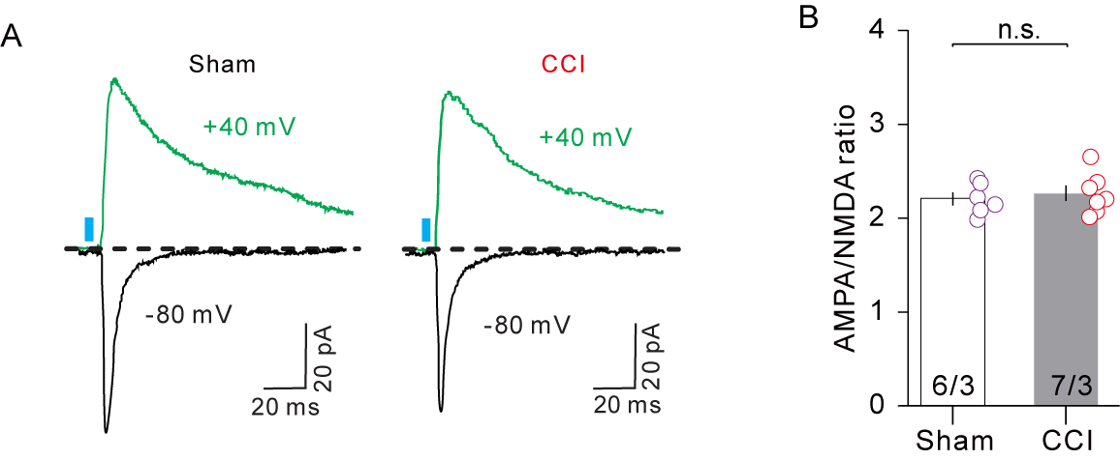

Figure S9. CCI did not affect the AMPAR/NMDAR amplitude ratio in the NAcS-receiving neurons. A Traces of EPSCs induced by blue light, which activated ChR2-expressing mPFC CRF-containing inputs. EPSCs were recorded at −80 mV, and +40 mV in voltage-clamp mode in the same NAcS neurons. B Comparison of the AMPAR/NMDAR ratio in the NAcS-receiving neurons between the sham and CCI groups. n _{sham} = 6 cells from 3 mice, n _{CCI} = 7 cells from 3 mice. t ₍₁₁₎ = 0.4522 p = 0.6599, unpaired t test. NAcS, nucleus accumbens shell. Error bars indicate SEM. NAcS, nucleus accumbens shell.

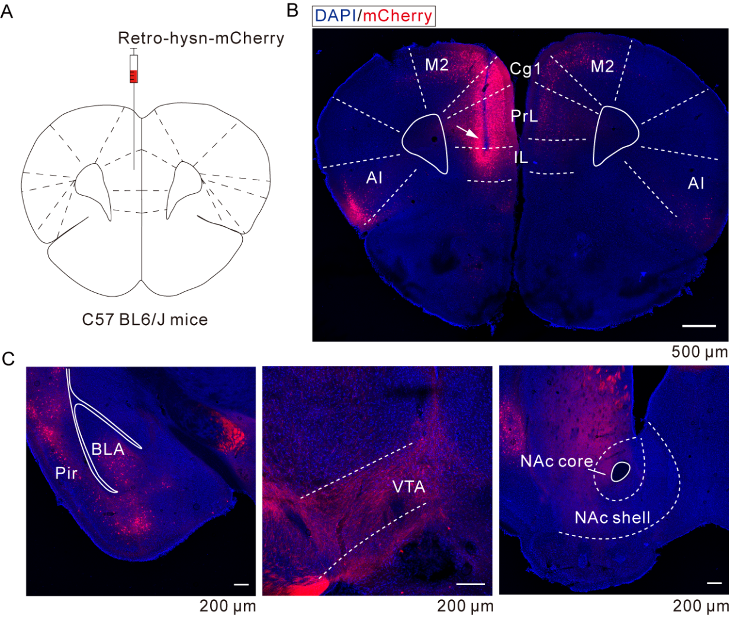

Figure S10. Mapping neuronal projections from NAcS to mPFC. A Schematic of the virus injection for the retrograde trace of mPFC-projecting neurons. B Example confocal images of the injection point of mPFC, and the mCherry-positive neurons from the mPFC, secondary motor cortex (M2), cingulate cortex area 1 (Cg1), agranular insular cortex (AI). Scale bar, 500 μm. C Example confocal images of the mCherry-positive neurons from the piriform cortex (Pir), basolateral amygdala (BLA), ventral tegmental area (VTA), and example confocal images showing that no neuron was labeled by mCherry in NAcS. Scale bars, 200 μm. NAcS, nucleus accumbens shell; mPFC, medial prefrontal cortex.

Figure S11. The changes of rheobase current and RMP in the NAcS-receiving neurons in CCI mice. A Rheobase current in mCherry-labeled NAcS neurons was lower in CCI mice. n _{sham} = 20 cells from 5 mice, n _{CCI} = 20 cells from 5 mice. p = 0.043, Mann - Whitney test. B RMP of mCherry-labeled neurons in NAcS was not different between sham and CCI groups. n _{sham} = 20 cells from 5 mice, n _{CCI} = 20 cells from 5 mice. t ₍₃₈₎ = 1.262, p = 0.2148, unpaired t test. Error bars indicate SEM. NAcS, nucleus accumbens shell; RMP, resting membrane potential.

Figure S12. The effect of CRF or ɑ-helical CRF perfusion on RMP in NAcS-receiving neurons. A ɑ-helical CRF perfusion did not affect the RMP of mCherry-labeled neurons in NAcS in CCI mice. n = 9 cells from 4 mice, t ₍₈₎ = 1.609, p = 0.1462, paired t test. B CRF perfusion did not affect the RMP of mCherry-labeled neurons in NAcS in sham mice. n = 6 cells from 3 mice. t ₍₅₎ = 1.834, p = 0.1261, paired t test. Error bars indicate SEM. NAcS, nucleus accumbens shell. Error bars indicate SEM. Acsf, artificial cerebrospinal fluid; NAcS, nucleus accumbens shell; RMP, resting membrane potential.

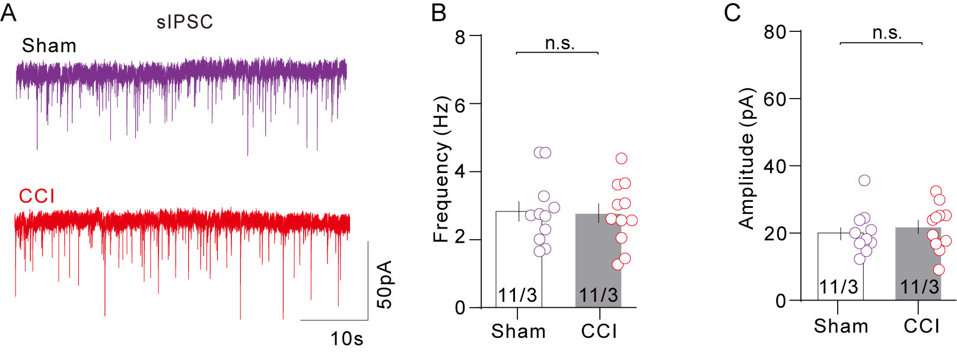

Figure S13. CCI surgery did not affect the IPSCs of NAcS-receiving neurons. A Example recordings of sIPSC in mCherry-labeled NAcS neurons from sham and CCI mice. B No significant difference was detected in the sIPSC frequency of mCherry-labeled neurons in NAcS between sham and CCI mice. n _{sham} = 11 cells from 3 mice, n _{CCI} = 11 cells from 3 mice. t ₍₂₀₎ = 1.493, p = 0.1513. C No significant difference was detected in the sIPSC amplitude of mCherry-labeled neurons in NAcS between sham and CCI mice. n _{sham} = 11 cells from 3 mice, n _{CCI} = 11 cells from 3 mice. t ₍₂₀₎ = 0.3409, p = 0.7367.
Data analyzed by (B, C) unpaired t test for two group comparisons. Error bars indicate SEM. NAcS, nucleus accumbens shell; sIPSC, spontaneous inhibitory postsynaptic currents.

4. References

1. Wang HR, Hu SW, Zhang S, Song Y, Wang XY, Wang L et al. KCNQ Channels in the Mesolimbic Reward Circuit Regulate Nociception in Chronic Pain in Mice. Neurosci Bull 2021; 37(5): 597-610.

2. Zhang S, Yang XN, Zang T, Luo J, Pan Z, Wang L et al. Astroglial MicroRNA-219-5p in the Ventral Tegmental Area Regulates Nociception in Rats. Anesthesiology 2017; 127(3): 548-564.

3. Hargreaves K, Dubner R, Brown F, Flores C, Joris J. A new and sensitive method for measuring thermal nociception in cutaneous hyperalgesia. Pain 1988; 32(1): 77-88.

4. Liao HY, Lin YW. Electroacupuncture reduces cold stress-induced pain through microglial inactivation and transient receptor potential V1 in mice. Chin Med 2021; 16(1): 43.

5. Bonin RP, Bories C, De Koninck Y. A simplified up-down method (SUDO) for measuring mechanical nociception in rodents using von Frey filaments. Molecular pain 2014; 10: 26.

6. Chaplan SR, Bach FW, Pogrel JW, Chung JM, Yaksh TL. Quantitative assessment of tactile allodynia in the rat paw. Journal of neuroscience methods 1994; 53(1): 55-63.

7. Li H, Penzo MA, Taniguchi H, Kopec CD, Huang ZJ, Li B. Experience-dependent modification of a central amygdala fear circuit. Nature neuroscience 2013; 16(3): 332-339.

8. Kim WB, Cho JH. Encoding of contextual fear memory in hippocampal-amygdala circuit. Nat Commun 2020; 11(1): 1382.

9. Sari DK, Kuwahara S, Tsukamoto Y, Hori H, Kunugita N, Arashidani K et al. Effect of prolonged exposure to low concentrations of formaldehyde on the corticotropin releasing hormone neurons in the hypothalamus and adrenocorticotropic hormone cells in the pituitary gland in female mice. Brain Res 2004; 1013(1): 107-116.

10. Pan Z, Zhu LJ, Li YQ, Hao LY, Yin C, Yang JX et al. Epigenetic modification of spinal miR-219 expression regulates chronic inflammation pain by targeting CaMKIIγ. J Neurosci 2014; 34(29): 9476-9483.

