Supplementary Data
Cellular and Molecular Characterization of CADASIL Using In Vitro Models of Vascular Smooth Muscle Cells and Blood Vessel Organoids
So Been Lee^{1,2,#}, MS, Hyo Suk Nam^{3,#},MD, PhD, Seungyeon Oh¹, Seung Bin Na¹, Hyun Kyu Kim⁴,PhD.can, Hyeowoo La¹, PhD.can, Man Ryul Lee⁴,PhD, Kwonho Hong¹,PhD, and Jeong Tae Do, PhD^{1,2*}
Supplementary Figures
Supplementary Figure 1. Patient information
(A) Profile of cognitive domain scores. Language and visual memories were within normal ranges. However, attention, language, visuospatial function, and frontal executive functions, were below normal. (B) Brain MR study. Extensive deep and periventricular white matter hyperintensity and diffuse cortical atrophy is noted. (C) DNA-sequencing confirmed point mutations (c. 224G>A, p. Arg75Gln) in NOTCH3 exon3 in the CADASIL iPSC. (D) CADASIL iPSCs showed a normal karyotype.
Supplementary Figure 2. Western blot analysis of BVOs.
Western blot data for relative CD31 protein expression normalized by GAPDH. Data are presented as mean ± SD, n=3. Student’s t-test: ** p < 0.01.
Supplementary Figure 3. Single cell-RNA sequencing of blood vessel organoids.
(A) Quality control of samples for non-filtered (left) and filtered (right) cell number, UMI counts per cell, genes detected per cell, mitochondria ratio, and complexity. (B) UMAP embedding of differentiation direction information. Dotted lines indicated main direction of differentiation. (C) Violin plots showing the expression of typical markers related to NOTCH3 signaling (JAG1, HES1), endothelial differentiation (PECAM1, GATA2), and ER stress (XBP1, ATF6).
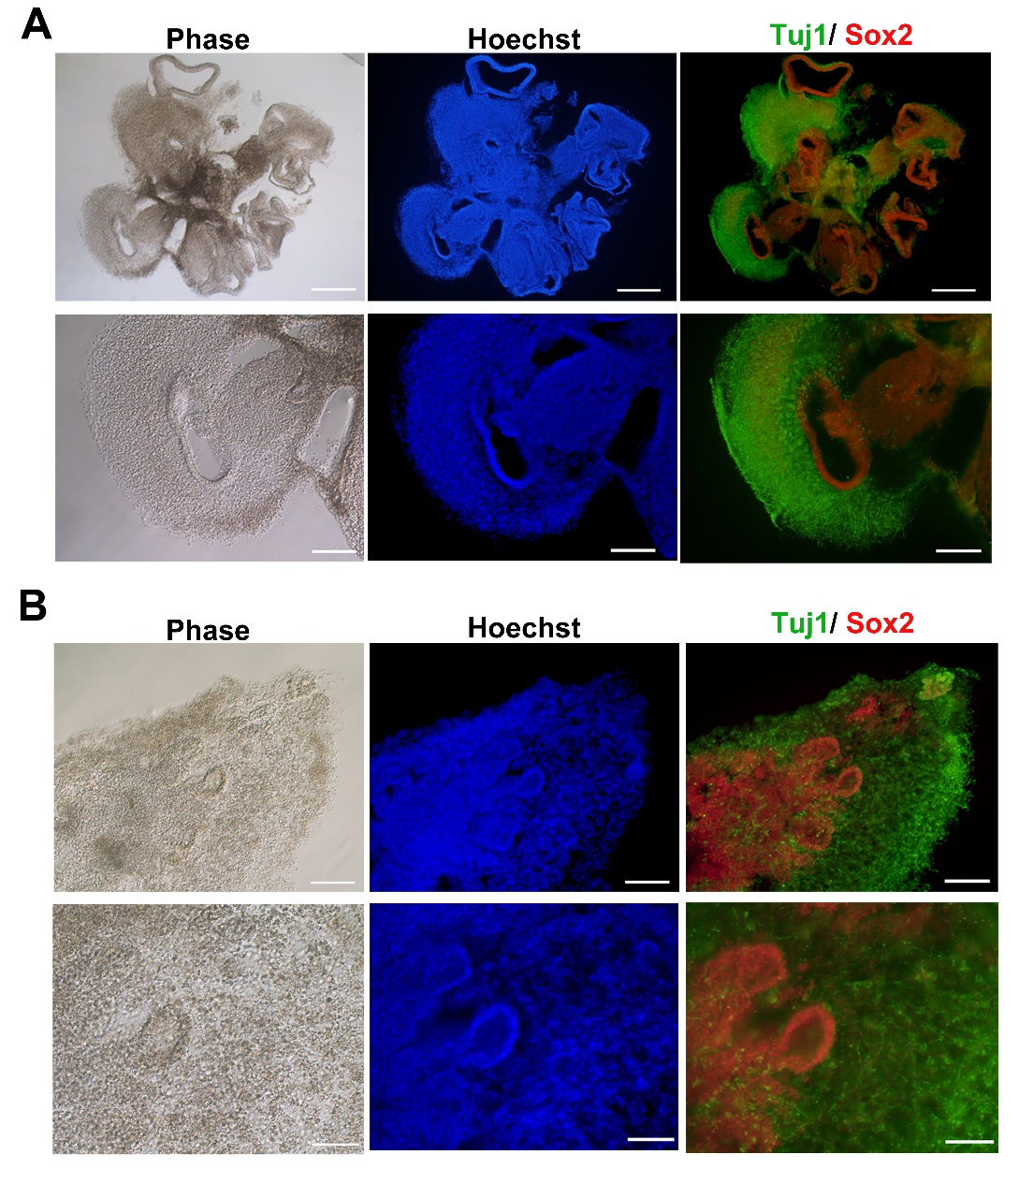
Supplementary Figure 4. Generation of cerebral organoids.
(A) Immunofluorescence of sectioned cerebral organoids of control iPSCs for Tuj1 (green) and Sox2 (red). Scale bar = 500 μm (upper), 200 μm (bottom). (B) Immunofluorescence of sectioned cerebral organoids of CADASIL iPSCs for Tuj1 (green) and Sox2 (red). Scale bar = 200 μm (upper), 100μm (bottom).

