Supplementary Information

Molar-scale formate production via enzymatic hydration of industrial off-gases

Jinhee Lee¹†, Suk Min Kim¹†*, Byoung Wook Jeon¹, Ho Won Hwang¹, Eleni G. Poloniataki¹, Sanghyung Lee², Ho Won Ra³, Jeong-Geol Na⁴, Jinwon Lee⁴ and Yong Hwan Kim^{1,5}*
¹School of Energy and Chemical Engineering, Ulsan National Institute of Science and Technology (UNIST), 50 UNIST-gil, Ulsan 44919, Republic of Korea
²Environment and Energy Research Team, Research and Development Center, Hyundai Steel, 1480 Bukbusaneop-ro, Dangjin 31719, Republic of Korea
³Climate Change Research Division, Korea Institute of Energy Research (KIER), 152 Gajeong-ro, Daejeon 34129, Republic of Korea
⁴Department of Chemical and Biomolecular Engineering, 35 Baekbeom-ro, Sogang University, Seoul 04107, Republic of Korea
⁵Graduate School of Carbon Neutrality, Ulsan National Institute of Science and Technology (UNIST), 50 UNIST-gil, Ulsan 44919, Republic of Korea

†These authors contributed equally.
*Corresponding authors:
Suk Min Kim, e-mail: smkimlife@unist.ac.kr
Yong Hwan Kim, e-mail: metalkim@unist.ac.kr
Supplementary Tables S1‒S8 and Figures S1‒S14
Supplementary Table 1 | Enzymes utilizing CO and CO₂.
Group | Name  (EC number) | Classification | Origin | PDB code | Mediator use | Reference
Carbon monoxide dehydrogenase (CODH) | Ni‒Fe CODH  (1.2.7.4) | Homodimeric CODH | Carboxydothermus hydrogenoformans | Oxygen-sensitive type: 1SU6, 1SU7, 1SU8, 1SUF, 3B51, 3B52, 3B53, 3I39, 5FLE, 2YIV, 4UDX, 4UDY Less oxygen-sensitive type: 6ELQ, 7ERR, 7XDM, 7XDN, 7XDP | BV, EV | This study
Carbon monoxide dehydrogenase (CODH) | Ni‒Fe CODH  (1.2.7.4) | Homodimeric CODH | Desulfovibrio vulgaris | 6B6V, 6B6W, 6B6X, 6B6Y, 6DC2, 6ONC, 6OND, 6ONS, 6VWY, 6VWZ, 6VX0, 6VX1 | MV | Source⁵⁸
Carbon monoxide dehydrogenase (CODH) | Ni‒Fe CODH  (1.2.7.4) | Homodimeric CODH | Rhodospirillum rubrum | 1JQK | BV, MV | Source⁵⁹
Carbon monoxide dehydrogenase (CODH) | Ni‒Fe CODH  (1.2.7.4) | Homodimeric CODH | Thermococcus onnurineus NA1 | ‒ | BV, EV | This study
Carbon monoxide dehydrogenase (CODH) | Ni‒Fe CODH  (1.2.7.4) | Homodimeric CODH | Thermococcus sp. AM4 | 6T7J | MV | Source³⁴
Carbon monoxide dehydrogenase (CODH) | Ni‒Fe CODH  (1.2.7.4) | Heteromeric ACS/CODH complex | Clostridium autoethanogenum | 6YTT, 6YU9, 6YUA | MV | Source⁶⁰
Carbon monoxide dehydrogenase (CODH) | Ni‒Fe CODH  (1.2.7.4) | Heteromeric ACS/CODH complex | Methanosarcina barkeri | 3CF4 | MV | Source⁶¹
Carbon monoxide dehydrogenase (CODH) | Ni‒Fe CODH  (1.2.7.4) | Heteromeric ACS/CODH complex | Moorella thermoacetica | 3I01, 3I04, 1MJG, 1OAO, 6X5K, 2Z8Y | MV | Source⁶²
Formate dehydrogenase (FDH) | Non-metal FDH  (1.17.1.9) | Non-metal containing | Arabidopsis thaliana | 3JTM, 3N7U, 3NAQ | NAD⁺ | Source⁶³
Formate dehydrogenase (FDH) | Non-metal FDH  (1.17.1.9) | Non-metal containing | Candida boidinii | 2FSS, 2J6I, 5DN9, 5DNA, 6D4B, 6D4C | NAD⁺ | Source⁶⁴
Formate dehydrogenase (FDH) | Non-metal FDH  (1.17.1.9) | Non-metal containing | Chaetomium thermophilum | 6T8Y, 6T8Z, 6T92, 6T94 | NAD⁺ | Source⁶⁵
Formate dehydrogenase (FDH) | Non-metal FDH  (1.17.1.9) | Non-metal containing | Granulicella mallensis | 4XYB, 4XYG, 6T8C, 6T8J, 6T9W, 6T9X, 6TB6 | NADP⁺ | Source⁶⁶
Formate dehydrogenase (FDH) | Non-metal FDH  (1.17.1.9) | Non-metal containing | Moraxella sp.C-1 | 2GSD, 3FN4 | NAD⁺ | Source⁶⁷
Formate dehydrogenase (FDH) | Non-metal FDH  (1.17.1.9) | Non-metal containing | Physcomitrium patens | 7ARZ
Formate dehydrogenase (FDH) | Non-metal FDH  (1.17.1.9) | Non-metal containing | Pseudomonas sp. 101 | 2GO1, 2GUG, 2NAC, 2NAD, 6JUJ, 6JUK, 6JWG, 6JX1 | NAD⁺, NAD | Source⁶⁸
Formate dehydrogenase (FDH) | Non-metal FDH  (1.17.1.9) | Non-metal containing | Thiobacillus sp. KNK65MA | 3WR5 | NAD⁺ | This study
Formate dehydrogenase (FDH) | Mo FDH  (1.17.1.9) | Mo (molybdenum) containing | Cupriavidus necator | 6VW7, 6VW8 | BV, EV, NAD⁺ | Source⁶⁹  Source⁷⁰
Formate dehydrogenase (FDH) | Mo FDH  (1.17.1.9) | Mo (molybdenum) containing | Escherichia coli | 1AA6, 1FDI, 1FDO, 1KQF, 1KQG, 2IV2 | BV | Source⁷¹
Formate dehydrogenase (FDH) | Mo FDH  (1.17.1.9) | Mo (molybdenum) containing | Methanospirillum hungatei | 7BKB, 7BKC, 7BKC, 7BKD, 7BKE | BV | Source⁷²
Formate dehydrogenase (FDH) | Mo FDH  (1.17.1.9) | Mo (molybdenum) containing | Rhodobacter capsulatus | 6TG9, 6TGA | EV | This study
Formate dehydrogenase (FDH) | W FDH  (1.17.1.9) | W (tungsten) containing | Desulfovibrio gigas | 1H0H | BV, MV | Source⁷³
Formate dehydrogenase (FDH) | W FDH  (1.17.1.9) | W (tungsten) containing | Desulfovibrio vulgaris | 6SDR, 6SDV | BV, MV | Source^{74,75}
Formate dehydrogenase (FDH) | W FDH  (1.17.1.9) | W (tungsten) containing | Methanothermobacter wolfeii | 5T5I, 5T5M, 5T61
Formate dehydrogenase (FDH) | W FDH  (1.17.1.9) | W (tungsten) containing | Methylobacterium extorquens | 7E5Z | BV, EV, NAD⁺ | This study
The data was sourced from a reference of main manuscript³⁰.
Supplementary Table 2 | Mediator-dependent Gibbs free energy of CO hydration.
Type of reaction | Reaction equation | Standard redox potential, E₀ (mV)* | Change in standard Gibbs free energy, ΔG₀ (kJ/mol) | Reference
MV reduction | MV²⁺ + e‒ → MV^{+•} | ‒446 | 86.1 | Source⁷⁶
EV reduction | EV²⁺ + e‒ → EV^{+•} | ‒449 | 86.6 | Source⁷⁶
BV reduction | BV²⁺ + e‒ → BV^{+•} | ‒359 | 69.3 | Source⁷⁶
NAD⁺ reduction | NAD⁺ + e‒ + H⁺ → NADH | ‒315 | 61.0 | Source⁷⁷
CO oxidation | CO (g) + H₂O → CO₂ (g) + 2 H⁺ + 2 e‒ | 520 | ‒100.3 | Source⁷⁸
with MV²⁺ | CO (g) + H₂O + 2 MV²⁺ → CO₂ (g) + 2 H⁺ + 2 MV^{+•} | 74† | ‒14.3 | This study
with EV²⁺ | CO (g) + H₂O + 2 EV²⁺ → CO₂ (g) + 2 H⁺ + 2 EV^{+•} | 71† | ‒13.7 | This study
with BV²⁺ | CO (g) + H₂O + 2 BV²⁺ → CO₂ (g) + 2 H⁺ + 2 BV^{+•} | 161† | ‒31.1 | This study
with NAD⁺ | CO (g) + H₂O + NAD⁺ → CO₂ (g) + H⁺ + NADH | 204† | ‒39.4 | This study
CO₂ reduction | CO₂ (g) + H⁺ + 2 e‒ → HCO₂‒ (aq) | ‒430 | 83.0 | Source⁷⁸
with MV^{+•} | CO₂ (g) + H⁺ + 2 MV^{+•} → HCO₃‒ + 2 MV²⁺ | 16† | ‒3.1 | This study
with EV^{+•} | CO₂ (g) + H⁺ + 2 EV^{+•} → HCO₃‒ + 2 EV²⁺ | 19† | ‒3.7 | This study
with BV^{+•} | CO₂ (g) + H⁺ + 2 BV^{+•} → HCO₃‒ + 2 BV²⁺ | ‒71† | 13.7 | This study
with NADH | CO₂ (g) + NADH → HCO₃‒ + NAD⁺ | ‒114† | 22.0 | This study
CO hydration‡ | CO (g) + H₂O → HCO₂‒ (aq) + H⁺ | 90 | ‒17.4 | This study
* The standard redox potential (E₀), under standard conditions (pH 7 and 25°C), is derived from each respective reference.
† The standard redox potential (E₀) is calculated inversely from the standard Gibbs free energy (ΔG₀) using the equation E₀ = ‒ΔG₀/nF. F represents Faraday's constant (approximately 96,485 J/mol e‒), and n denotes the number of moles of electrons involved.
‡ The values for standard redox potential (E_{o}) and standard Gibbs free energy (ΔG₀) for CO hydration are derived from the summation of the values from CO oxidation and CO₂ reduction. The resulting ΔG₀ value of ‒17.4 kJ/mole suggests that this reaction occurs spontaneously.

Supplementary Table 3 | The CO₂ affinities in FDHs with metal active sites.
Group (EC no.) | Name | Substrate* | K_{m} (mM) | Temp. (°C)/pH | References
FDH (1.17.1.9) | MeFDH1 | CO₂ | 3.903 ± 0.475 | 30°C/pH 6.3 | This study
 | RcFDH | CO₂ | 0.250 ± 0.028 | 30°C/pH 6.3 | This study
The CO₂ affinities for MeFDH1 and RcFDH were analyzed. The K_{m} values were obtained by spectrophotometrically measuring the CO₂ reduction reactions at pH 6.3 and 30°C in a 200 mM potassium phosphate buffer with 0.12 mM reduced EV and varying concentrations of sodium bicarbonate (3‒100 mM). The data represent the mean ± S.D., determined from n= 3 independent experiments. Abbreviations: FDH, formate dehydrogenase; red, reduced; Me, Methylobacterium extorquens; Rc, Rhodobacter capsulatus.
Supplementary Table 4 | Gas compositions of industrial off-gas and waste plastic syngas.
 |  | COG | BFG | LDG | SRF-derived gas
Component  (%) | CO | 6.2 ± 0.1 | 25.5 ± 0.3 | 49.4 ± 1.9 | 7.7 ± 0.9
Component  (%) | CO₂ | 2.4 ± 0.1 | 23.6 ± 0.2 | 19.3 ± 0.6 | 42.8 ± 3.1
Component  (%) | H₂ | 55.4 ± 0.5 | 3.8 ± 0.2 | 1.4 ± 0.4 | 2.6 ± 0.6
Component  (%) | N₂ | 8.6 ± 0.6 | 46.7 ± 0.1 | 29.2 ± 1.9 | 38.5 ± 7.4
Component  (%) | CH₄/C_{m}H_{n} | 27.3 ± 0.5 | ‒ | ‒ | 8.5 ± 2.7
Component  (%) | O₂ | 0.1 ± 0.02 | 0.01 ± 0.00 | 0.01 ± 0.02 | ‒
Reference |  | Source^{25,30} |  |  | Source³⁰
This data is modified from references^{25,30}. The gas composition data represents the varying component ratios of CO and CO₂ in different real off-gases. Industrial off-gases (COG, BFG, LDG) were captured from the Hyundai Steel process, while waste plastic syngas was captured from SRF gasification at the Korea Institute of Energy Research. SRF means solid recovered fuels.

Supplementary Table 5 | Overview of biocatalytic production from gaseous substrates.
Product | Catalysis | Name | Source | Related enzymes | Gas substrate type‡ | Gas substrate | Position | Titer (mM) | Productivity (mmol/g/h or mmol/m²/h) | Yield (%) | Reference
Formate | Enzymatic catalysis | CO hydration | Carboxydothermus hydrogenoformans, Methylobacterium extorquens | Ni-CODH, W-FDH | Real off-gas | LDG | In vitro | 1800.0 | 61.4 | 100 | This study
Formate | Enzymatic catalysis | CbFDH/BeCA | Candida boidinii | CA, FDH | Single | CO₂ | In vitro | 0.2 | 1.4 | ND | Source⁷⁹
Formate | Enzymatic catalysis | CbFDH/PpFALDH/ScADH | Candida boidinii | FDH, FALDH, ADH, GDH, CA | Single | CO₂ | In vitro | 0.1 | 21.0 | ND | Source⁸⁰
Formate | Enzymatic catalysis | CnFDH/PsGDH | Cupriavidus necator | Mo-FDH, GDH | Single | CO₂ | In vitro | 1.1 | 0.0022 | 3.93 | Source⁸¹
Formate | Whole-cell catalysis | AwWC | Acetobacterium woodii | Ni-CODH, FDH | Real off-gas | BFG | In vivo | 53.1 | 0.06 |  | Source²³
Formate | Whole-cell catalysis | AwHDCR | Acetobacterium woodii | FDH, H2ase | Single | HCO₃⁻ | In vivo | 280.0 | 30.0 | 16.7 | Source⁹
Formate | Whole-cell catalysis | CcWC | Clostridium carboxidivorans | W-FDH | Single | HCO₃⁻ | In vivo | 14.5 | 0.01 | 5.4 | Source⁸²
Formate | Whole-cell catalysis | DdWC | Desulfovibrio desulfuricans | Mo-FDH | Single | CO₂ | In vivo | 45.0 | 7.0 | ND | Source⁸³
Formate | Whole-cell catalysis | PfWC | Pyrococcus furiosus | FDH | Single | HCO₃⁻ | In vivo | 44.0 | 0.03 | 17.6 | Source⁸²
Formate | Electrocatalysis† | ClFDH | Clostridium ljungdahlii | FDH | Single | CO₂/HCO₃⁻ | In vitro | 6.0 | 14.2 | ND | Source⁸⁴
Formate | Electrocatalysis† | EcFDH | Escherichi coli | Mo-FDH | Single | HCO₃⁻ | In vitro | 0.000431 | 3.6 | ND | Source⁸⁵
Formate | Electrocatalysis† | MmHDR | Methanococcus maripaludis heterodisulfide reductase supercomplex | HDR complex | Single | CO₂ | In vitro | 13.0 | 1.2 | ND | Source⁸⁶
Formate | Photocatalysis | ClFDH | Clostridium ljungdahlii | FDH | Single | CO₂/HCO₃⁻ | In vitro | 0.002 | 0.98 | ND | Source⁸⁷
Methanol | Enzymatic catalysis | CbFDH/PpFALDH/SsADH | Candida boidinii | FDH, FALDH, ADH, PTDH | Single | CO₂ | In vitro | 0.9 | 1.4 | ND | Source⁸⁸
Ethanol | Whole-cell catalysis | CcWC | Clostridium carboxidivorans P7 | ‒ | Real off-gas | Producer gas | In vivo | 108.5 | 0.45 | ND | Source⁸⁹
Ethanol | Whole-cell catalysis | ClWC | Clostridium ljungdahlii | ‒ | Mixed | CO/CO₂/H₂ | In vivo | 91.2 | 1.9 | ND | Source⁹⁰
Ethanol | Whole-cell catalysis | BmWC | Butyribacterium methylotrophicum | ‒ | Mixed | CO/CO₂/H₂ | In vivo | 0.00043 | 0.0081 | ND | Source⁹¹
Ethanol | Whole-cell catalysis | CaWC | Clostridium autoethanogenum | H2ase, FDH | Mixed | CO/CO₂/H₂ | In vivo | 31.0 | 10.5 | ND | Source⁹²
Ethanol | Whole-cell catalysis | MsWC | Moorella sp. HUC22-1 | ACDH, ADH | Mixed | CO₂/H₂ | In vivo | 124.8 | 17.3 | ND | Source⁹³
Isobutanol,  3-Methyl-1-butanol | Whole-cell catalysis | CnWC | Cupriavidus necator | ‒ | Single | CO₂ | In vivo | 1.8 | 2.0 | ND | Source⁹⁴
2,3-Butanediol | Whole-cell catalysis | SeWC | Synechococcus elongatus PCC 7942 | ‒ | Single | HCO₃⁻ | In vivo | 63.2 | 0.30 | ND | Source⁹⁵
Methane | Electrocatalysis† | MtWC | Methanothermobacter thermoautotrophicus | ‒ | Single | CO₂ | In vitro | 27.2 | 46.0 | ND | Source⁹⁶
To compare yield, titer, and productivity, we utilized values from research studies referenced in the review article⁹⁷ and from recently published relevant studies. When not provided, we based our calculations on measurements reported in the associated references.
†For electrocatalysis and photocatalysis, productivity was expressed in mmol/m²/h.
‡Gas substrates were classified into three types according to the number of materials used. CO₂ and bicarbonate were considered as the same substrate.
§ND, not determined. Cases where yield could not be calculated due to the continuous flow method application were denoted as 'not determined (ND)'.
Abbreviations: ADH, alcohol dehydrogenase; ACDH, acetaldehyde dehydrogenase; CA, carbonic anhydrase; FALDH, formaldehyde dehydrogenase; FDH, formate dehydrogenase; GDH, glucose dehydrogenase; HDR, heterodisulfide reductase; HDCR, hydrogen-dependent CO₂ reductase; H2ase, hydrogenase; Mo-FDH, molybdenum-containing FDH; Ni-CODH, nickel-containing carbon monoxide dehydrogenase; PTDH, phosphite dehydrogenase; W-FDH, tungsten-containing FDH; WC, whole-cell catalyst.
Supplementary Table 6 | The list of genes used in this study.
Group | Name | Origin | Gene (Uniprot code) | Vector | Host | Reference
CODH | ChCODH2 WT | Carboxydothermus hydrogenoformans | cooS2 (Q9F8A8) | pET28a(+) | E. coli BL21 | Source²⁵
CODH | ChCODH2 A559W | C. hydrogenoformans | ‒ | pET28a(+) | E. coli BL21 | Source²⁵
CODH | ChCODH4 | C. hydrogenoformans | cooS4 (Q3AE44) | pET28a(+) | E. coli BL21 | Source²⁵
CODH | ToCODH | Thermococcus onnurineus | cooS (B6YWP3) | pET28a(+) | E. coli BL21 | Source³³
FDH | MeFDH1 | Methylobacterium extorquens AM1 | fdh1A (C5ATT7)  fdh1B (C5ATT6) | pCM110 | M. extorquens | Source³⁵
FDH | RcFDH | Rhodobacter capsulatus | fdhA (D5AQH0)  fdhB (D5AQH1)  fdhC (D5AQH2)  fdhE (D5AQG8) | pTrcHis A | E. coli MC1061 | Source³⁷
FDH | TsFDH | Thiobacillus species KNK65MA | fdh (Q76EB7) | pUC57 | E. coli BL21 | Source³⁸
pRKISC | ISC Fe-S cluster assembly proteins | Azotobacter vinelandii, | iscS (O31269)  iscU (O31270) | pRK415 | E. coli BL21 | Source⁵⁰
pRKISC | ISC Fe-S cluster assembly proteins | Escherichia coli | iscA (P0AAC8)  hscB (P0A6L9)  hscA (P0A6Z1) | pRK415 | E. coli BL21 | Source⁵⁰
pRKISC | ISC Fe-S cluster assembly proteins | Haemophilus influenzae | fdx (P44428) | pRK415 | E. coli BL21 | Source⁵⁰
In the study, the CODHs and FDHs used were prepared for protein expression as described in previous references from our research group. For detailed information, refer to the methods section.
Supplementary Table 7 | Purity of formate salts from the enCOH reaction.
Category† | HCOONa | HCOOK | HCOONH₄
Produced formate concentration (M) | 1.1 | 1.2 | 1.8
Collected volume (mL) | 83.0 | 94.0 | 89.0
Produced formate moles (mmol) | 91.3 | 113.7 | 162.0
Total purified product mass (g) ‡ | 4.8 | 7.9 | 5.9
Purified formate salt mass (g) | 4.3 | 7.5 | 5.4
Formate salt molecular weight (g/mol) | 68.0 | 84.1 | 63.1
Purified formate salt moles (mmol) | 63.2 | 89.2 | 85.6
Purity (%) | 88.8 | 94.6 | 92.1
† During 64 hours of enCOH with LDG, products were collected as formate salts (HCOONa, HCOOK, HCOONH₄), each neutralized with a different agent (NaOH, KOH, NH₄OH).
‡ The total purified product refers to the dried salt-type powder separated by activated carbon.
*Purity (%) = (mass of formate salt) / (mass of total purified product).
Supplementary Table 8 | EnCOH enzyme preparation for 10 L reactor field operation.
Category | ChCODH2 A559W | MeFDH1
Enzyme for 10L reaction (kU) | 100 | 200
Specific activity (U·mg^{‒1}) | 4,800 ± 580 | 25.4 ± 2.5
Cell mass (g wet weight·L^{‒1}) | 7.9 | 40.3
Enzyme yield (mg protein·mg cell^{‒1}) | 5.3 | 15.0
Total enzyme activity (kU·L^{‒1}) | 199 | 15.9
Volume required (L) | 0.5 | 12.6

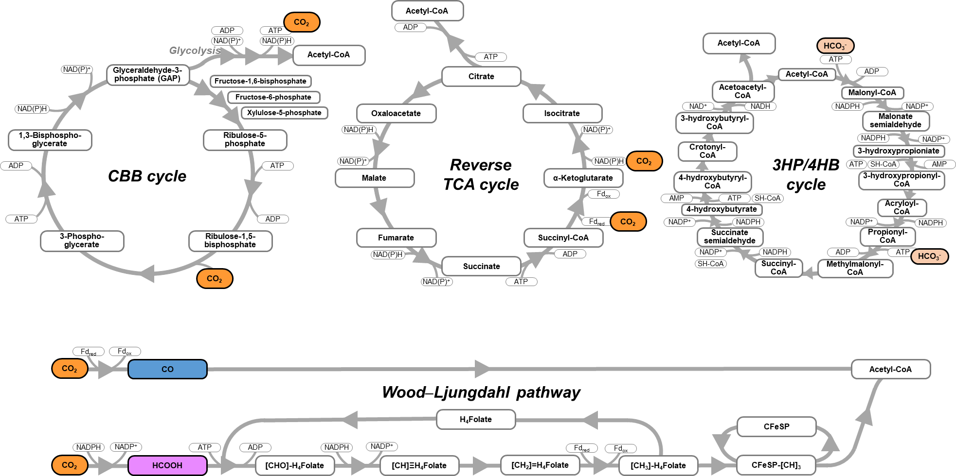

Supplementary Figure 1 | The linear Wood‒Ljungdahl pathway and various circular cycles for CO₂ fixations. Circular cycles, namely the Calvin‒Benson‒Bassham (CBB), reverse Tricarboxylic Acid (TCA), and 3-Hydroxypropionate/4-Hydroxybutyrate (3HP/4HP) cycles, are known to be involved in CO₂-fixation. The information regarding these CO₂-fixation pathways is modified from a reference source¹².
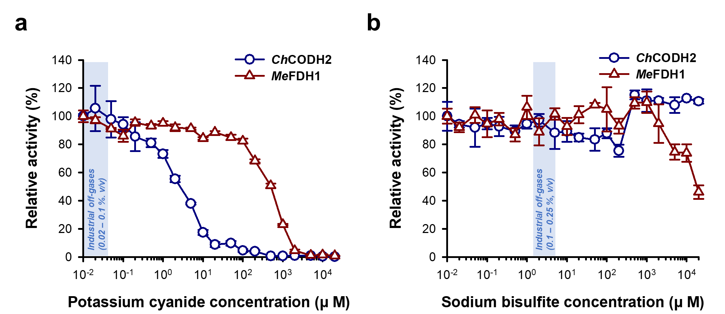

Supplementary Figure 2 | enCOH enzymes’ response to toxic inhibitors existing industrial off-gases. a, Cyanide effects of ChCODH2 and MeFDH1. b, SO_{x} effects of ChCODH2 and MeFDH1. In the inhibition test, residual activities of enCOH enzyme CODH and FDH were measured by conducting reactions at pH 6.5 and 30°C, varying concentrations of different inhibitors (cyanide and SO_{x}). The data represent the mean ± S.D., determined from n= 3 independent experiments.

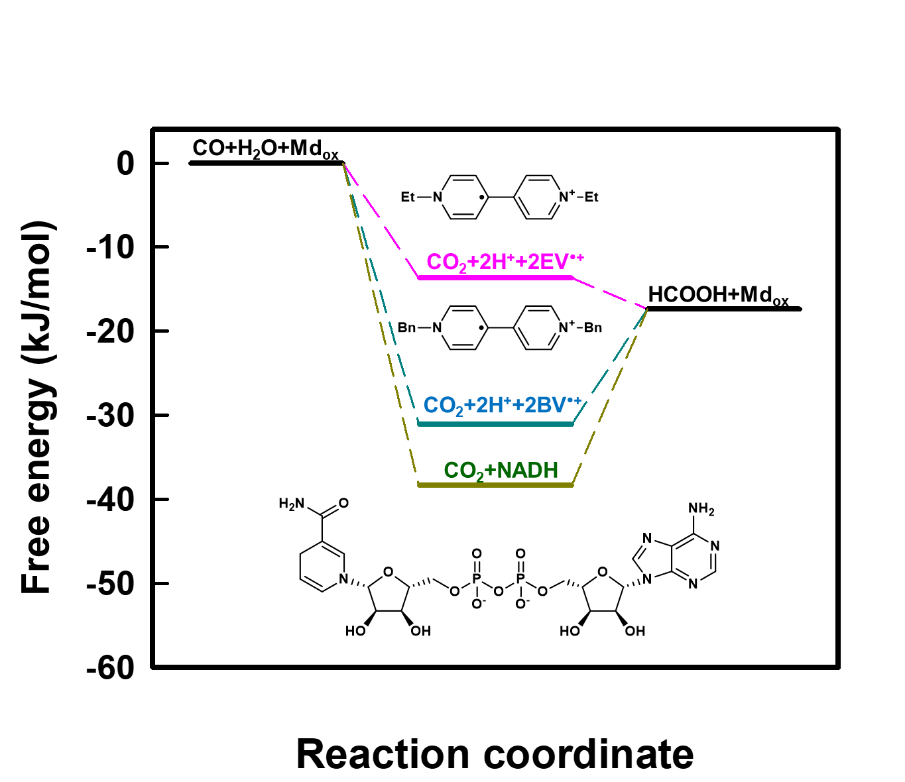

Supplementary Figure 3 | Gibbs free energy depending on three mediators in CO hydration. The Gibbs free energy for each mediator was calculated based on the redox potential at pH 7 and 25°C. Among the three mediators, only EV exhibited spontaneous reactivity in both CO oxidation and CO₂ reduction reactions. All redox potentials used were derived from the reference values listed in Supplementary Table 2.

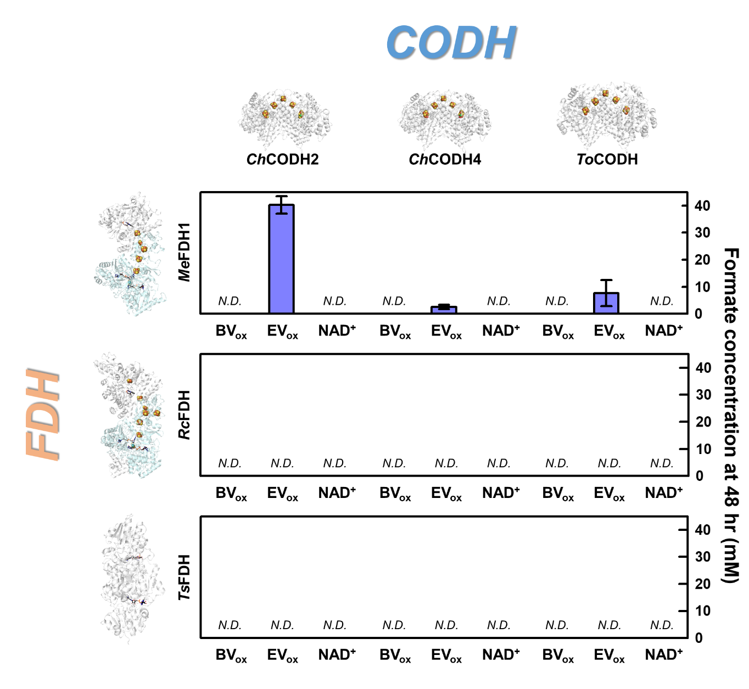
Supplementary Figure 4 | Formate production as a mediator type through CODH‒FDH combination. The productivity of formate, observed over a period of 48 hours, was evaluated using a combination of CODH and FDH, with three different mediators: BV_{ox}, EV_{ox}, and NAD⁺. The data represent the mean ± S.D., determined from n= 3 independent experiments.

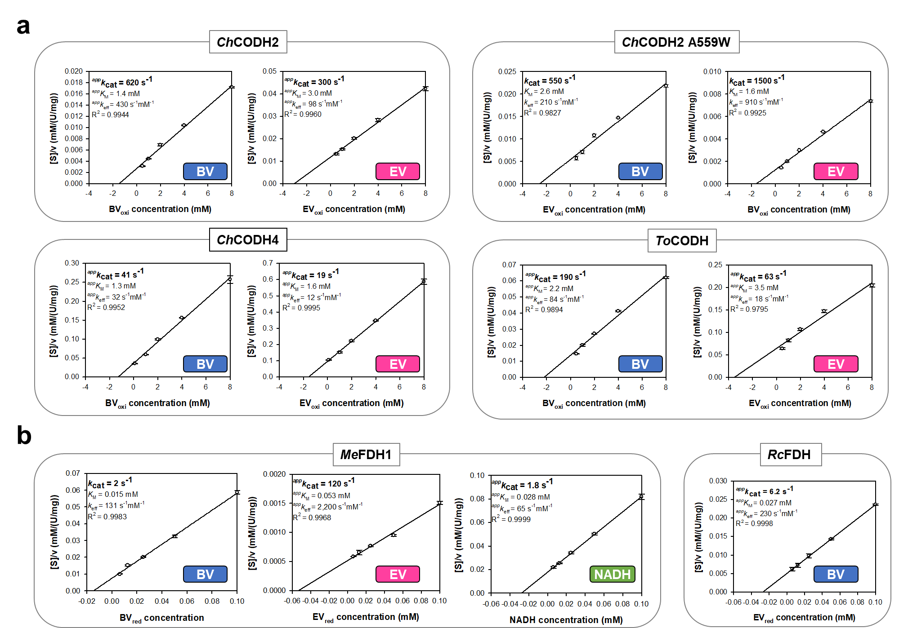

Supplementary Figure 5 | Hanes‒Woolf plots of the enCOH enzymes. The kinetic properties of CODHs and FDHs for mediators were estimated from Hanes–Woolf plots. a, CODHs. b, FDHs. The values of k_{cat} were calculated from V_{max} for BV, EV, and NADH. The data represent the mean ± S.D. determined from n= 3 independent experiments.

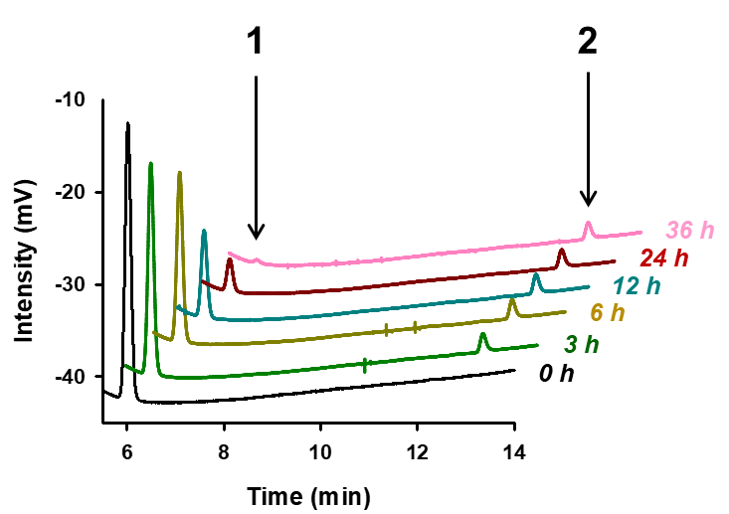

Supplementary Figure 6 | Analysis of gaseous compounds during enCOH reaction by gas chromatography. The gas substrates CO and intermediate CO₂ changes during the enCOH reaction were analyzed by GC, utilizing a close enzyme reaction system. Over a period of 36 hours, a gradual decrease in CO concentration and a sustained level of CO₂ concentration after 3 hours of initial reaction were observed. The products were identified by comparison with authentic standards (peak 1, CO; peak 2, CO₂).

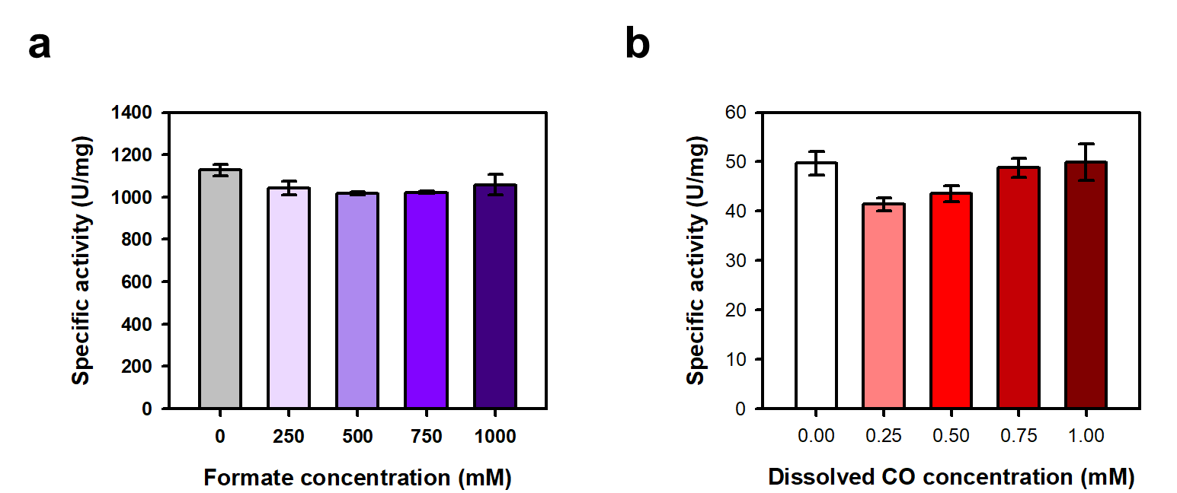

Supplementary Figure 7 | Inhibitory cross-talks. a, Formate effect on ChCODH2. b, CO effect on MeFDH1. The data represent the mean ± S.D., determined from n= 3 independent experiments.

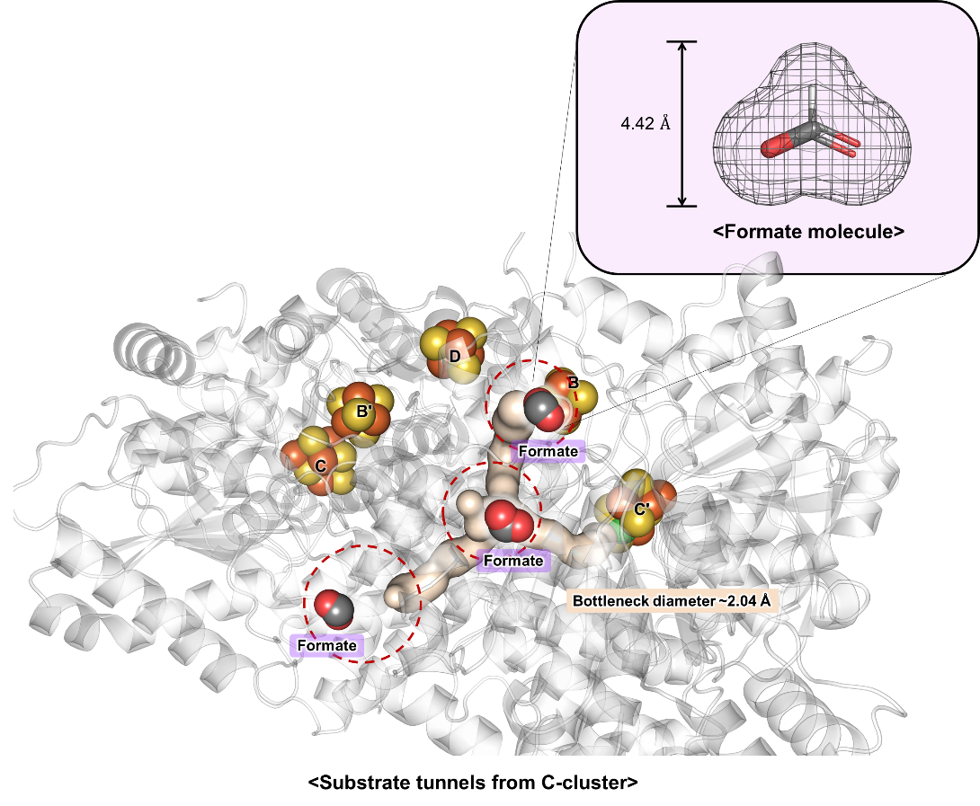

Supplementary Figure 8 | Formate' inability to traverse substrate tunnels due to size constraints. The overall size of formate is calculated to be 4.42 Å (a grey mesh). The distance between H and O is 1.7 Å, with the Van der Waals radius of H being 1.2 Å and the Van der Waals radius of O being 1.52 Å. Moreover, the bottleneck diameter of the substrate tunnels, derived from the C-cluster in ChCODH2, was measured to be approximately 2.04 Å. It is predicted that the size of formate molecules hinders their entry at the entrance of the substrate tunnels (depicted by a red dot). The substrate tunnels were predicted to pass through CAVER analysis⁹⁸.

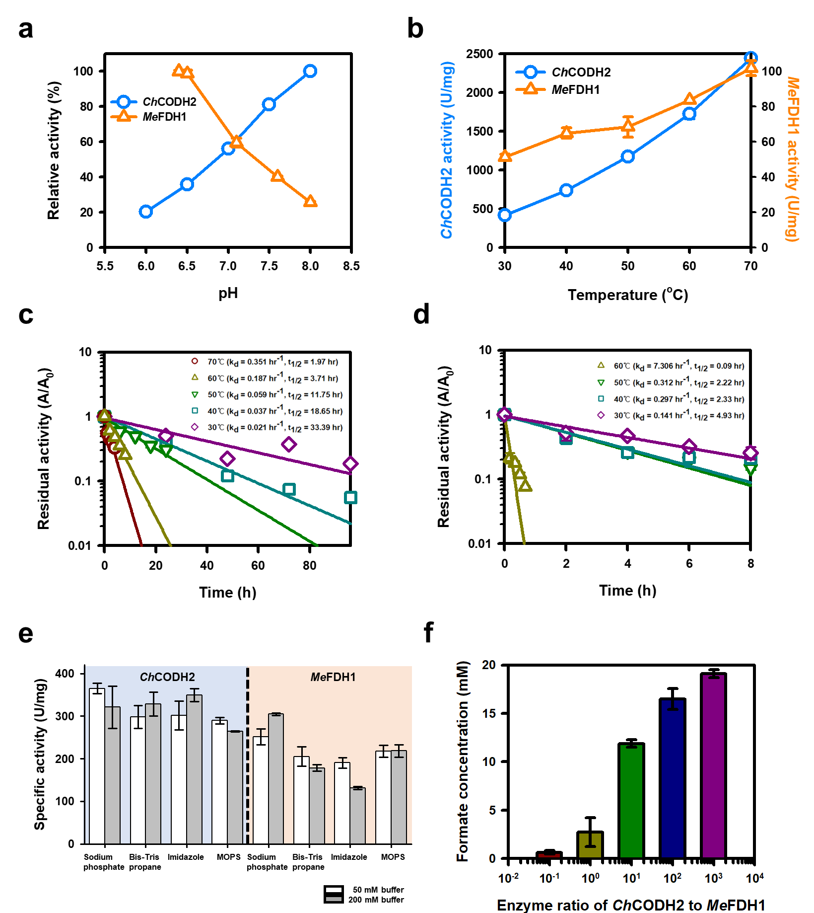

Supplementary Figure 9 | Physicochemical conditions and the enzyme ratio for enCOH system. a, pH profiles of ChCODH2 and MeFDH1. b, Temperature profile of ChCODH2 and MeFDH1. c, Kinetic stability profile of ChCODH2. d, Kinetic stability of MeFDH1. e, Effect of buffers to ChCODH2 and MeFDH1. f, Enzyme ratio of ChCODH2 to MeFDH1. The data represent the mean ± S.D., determined from n= 3 independent experiments.

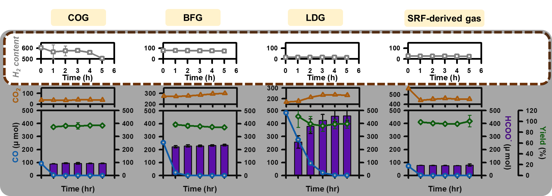

Supplementary Figure 10 | H2 gas component changes during enCOH reaction. During the enCOH enzyme reaction, changes in the gas components of CO and CO₂, as well as the variation in the amount of H₂ gas, were measured using GC analysis. It observed that the initial amount of hydrogen present in each real off-gas sample remained constant throughout the reaction, without any changes. The data represent the mean ± S.D., determined from n= 3 independent experiments.

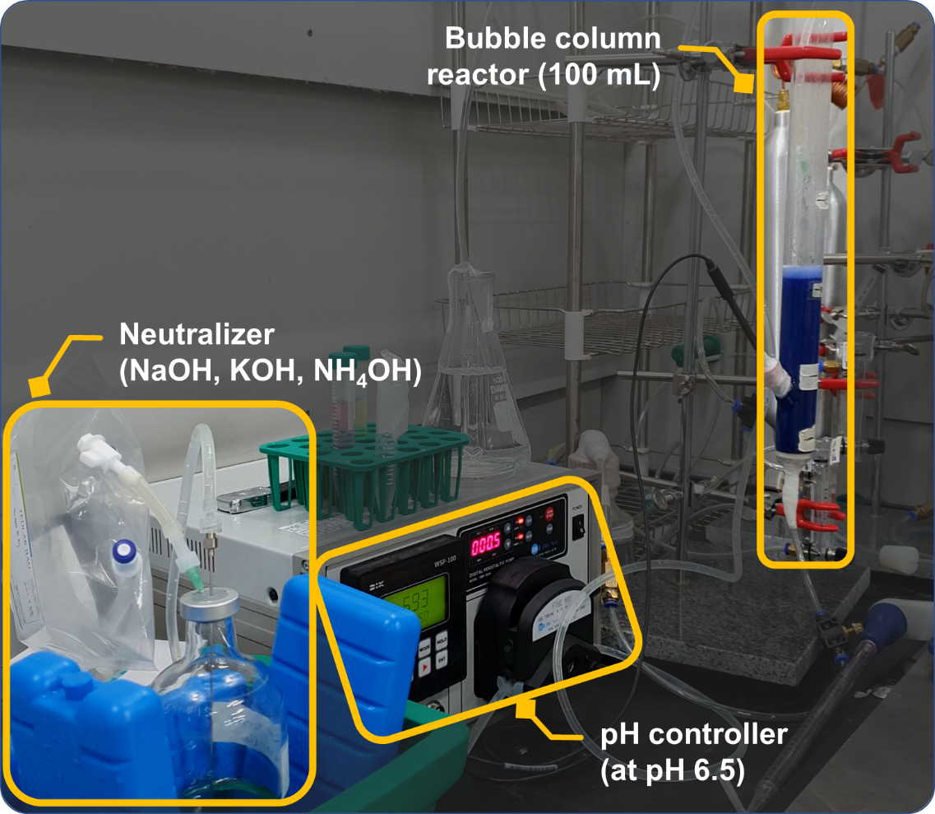

Supplementary Figure 11 | Operation of 100 mL-scale reactor. The 100 mL-scale enzyme reactor in the form of a gas bubble column was fabricated for the enzymatic reaction of enCOH in continuous gas supply. The gas bubble column design was chosen due to its large surface area, high gas transfer rate, reaction efficiency, simplicity of structure, ease of handling, and scalability advantages in enzymatic reactions with gas substrates. Real LDG gas was supplied to the enzyme reactor via a tube at a volume of 100 mL, and within the reactor, the CO hydration reaction was carried out at room temperature by immobilized enCOH enzymes. The pH of the reactor was maintained at 6.5 through the supply of neutralizer to counter the production of formate. The generated formate was observed through HPLC analysis.

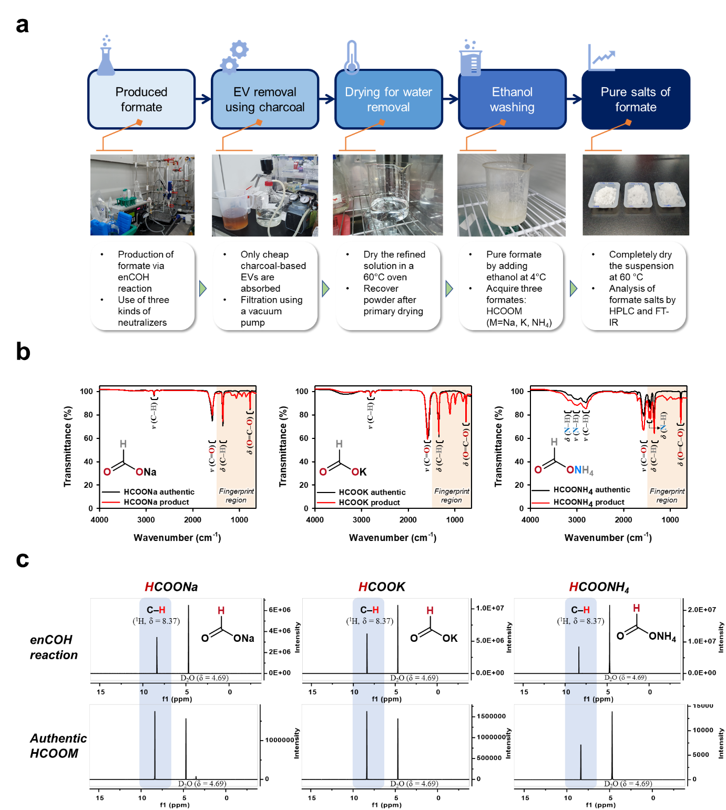

Supplementary Figure 12 | Salt formate analysis and its separation. a, Diagram of formate separation. b, FT-IR of formate salts. c, ¹H NMR of three formate salts. Additionally, the hydrogen atoms of formate salts were observed in the ¹H-NMR spectrum⁹⁹, with D₂O as the reference (D₂O, δ = 4.69 ppm; formate, δ = 8.37 ppm).

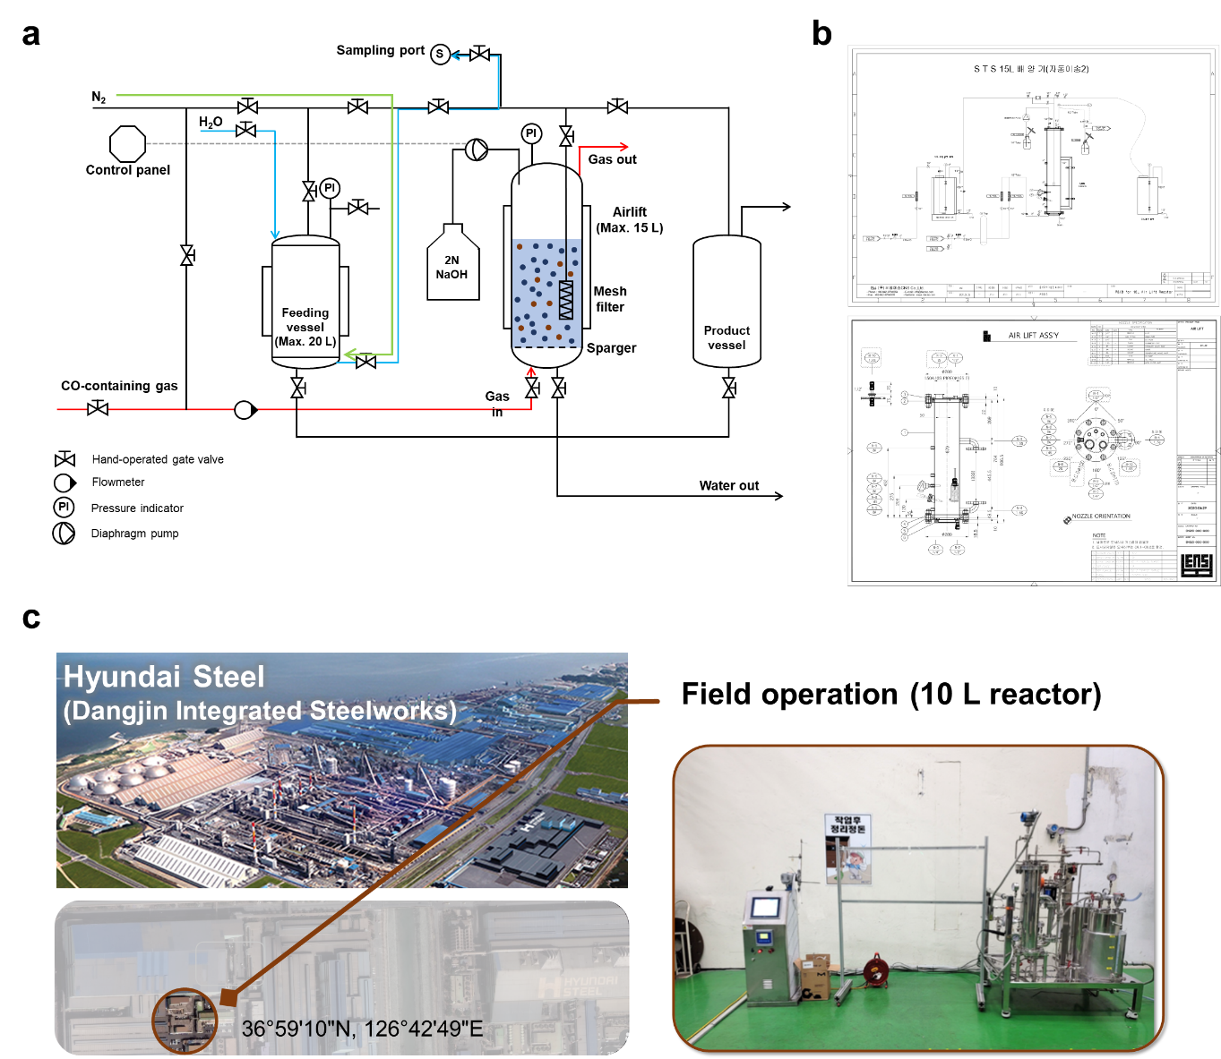

Supplementary Figure 13 | Field operation of 10 L enCOH reactor. a, Process flow diagram. b, Piping and instrumentation diagram. c, Reactor site and installation view.

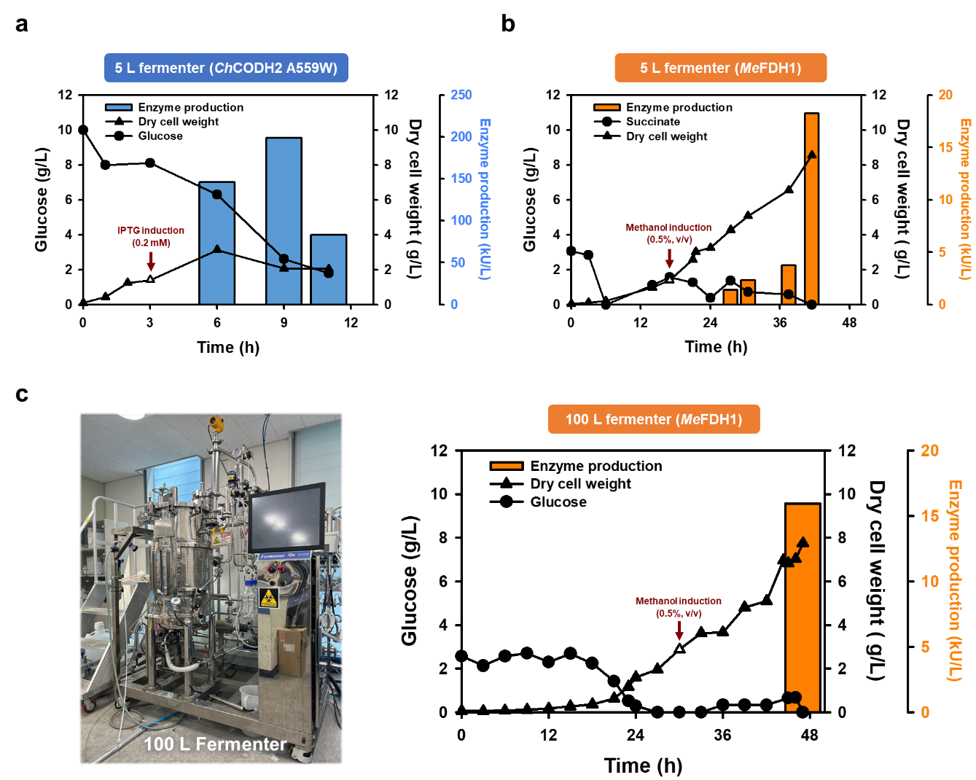
Supplementary Figure 14 | Large-scale production of enCOH enzymes via fermentation. a, Expression of ChCODH2 A559W enzyme in a 5 L fermenter. b, Expression of MeFDH1 enzyme in a 5 L fermenter. c, 100 L fermenter and large-scale expression of MeFDH1 enzyme. The expression of enCOH enzymes utilized 5 L and 100 L fermenters. Given the relatively low activity of MeFDH1 compared to ChCODH2 A559W, large-scale enzyme production was necessary for operating a 10 L enzyme reactor at Hyundai Steel, prompting not only 5 L but also 100 L fermentation production. During MeFDH1 fermentation production, the carbon source succinate was added to increase protein yield.

