SUPPLEMENTARY INFORMATION

Supplementary table
Structures of (A) amino acids, (B) dipeptides, (C) tripeptides, and (D) decanoic acid/decanoate in free and assembled forms.

A. Amino acids
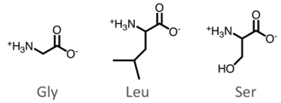

- Dipeptides
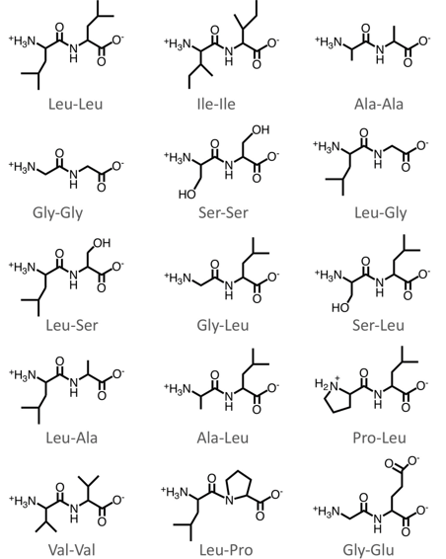
- Tripeptides

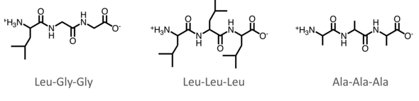

- Decanoic acid/decanoate in free and assembled forms

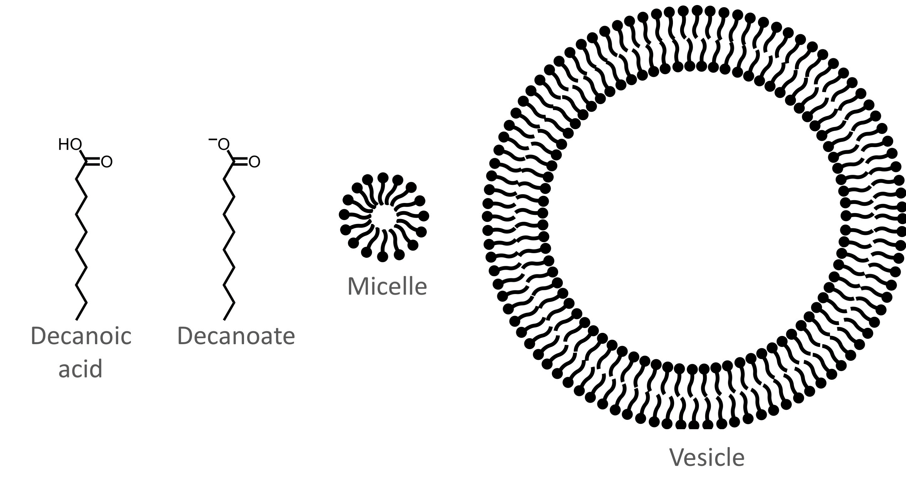

Supplementary Videos

Supplementary video 1. This video shows the docking of L-Leu-L-Leu to a dodecanoic acid bilayer as described in the Methods. Carbon atoms are cyan, hydrogen white, nitrogen dark blue, oxygen red, potassium ions brown and chloride ions blue. The video shows 20 ns of the 100 ns simulation.

Supplementary video 2. This video shows the docking of Ala-Ala to a dodecanoic acid bilayer as described in the Methods. Carbon atoms are cyan, hydrogen white, nitrogen dark blue, oxygen red, potassium ions brown and chloride ions blue. The video shows 20 ns of the 100 ns simulation.

Supplementary video 3. This video shows the docking of Leu-Ser to a dodecanoic acid bilayer as described in the Methods. Carbon atoms are cyan, hydrogen white, nitrogen dark blue, oxygen red, potassium ions brown and chloride ions blue. The video shows 20 ns of the 100 ns simulation.

