Annex1-Eligibility Criteria-PICO
WORKFORCE INTELLIGENCE FROM OPEN SOURCES: HEALTH WORKFORCE VACCINATION
Page 1

Record ID

The study population is or includes Health care workers Yes No
(Students are not participants)

The study addresses COVID-19 vaccination Yes No

The study addresses HCW’s requirements for vaccine acceptance by the population
Yes No
(According to review question 1)

The study describes policies and strategies for vaccine acceptance by the population
Yes No
(According to review question 2)

The study describes approaches to improve vaccination teams´ quality and productivity
Yes No
(According to review question 3)

The study describes enablers and barriers for COVID-19 vaccination among Health care workers
Yes No
(According to review question 4)

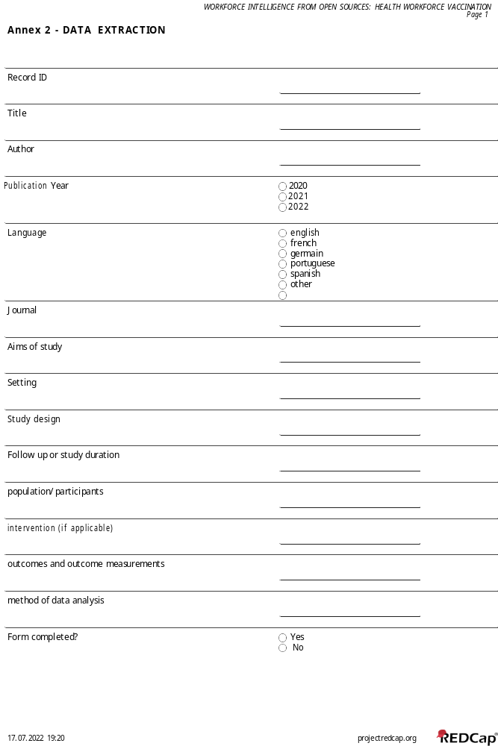

Annex 3 – Search strategies per review question

DATABASE | SEARCH STRATEGIES – QUESTION 1  Q1 “What are countries’ requirements to ensure COVID-19 vaccination coverage for the target population?”
PUBMED | ((((COVID-19[mh] OR SARS-CoV-2[mh] OR Severe Acute Respiratory Syndrome Coronavirus 2[tiab] OR Coronavirus Disease 2019[tiab] OR 2019 Novel Coronavirus[tiab] OR 2019 New Coronavirus[tiab] OR Wuhan Coronavirus[tiab] OR COVID-19[tiab] OR SARS-CoV-2[tiab] OR 2019-nCoV[tiab] OR HCoV-19[tiab] OR nCoV-2019[tiab] OR Novel Coronavirus 2019-nCoV[tiab] OR Alpha Variant[tiab] OR Beta Variant[tiab] OR Gama Variant[tiab] OR Delta Variant[tiab] OR Delta Plus Variant[tiab] OR Omicron Variant[tiab] OR Lambda Variant[tiab]) AND (COVID-19 Vaccines[mh] OR Vaccination[mj] OR Vaccination Coverage[mj] OR Vaccination Coverage[tiab] OR Vaccination[tiab] OR Immunization[tiab] OR Vaccine*[tiab] OR Antivaccine[tiab] OR Anti-vaccine[tiab] OR Anti-vaccination[tiab] OR Coverage[ti] OR Infection*[ti])) AND (Vaccination Refusal[mh] OR Acceptance*[ti] OR Hesitanc*[ti] OR Refusal[ti] OR Acceptability[ti] OR Knowledge[ti] OR Attitude*[ti] OR Practice*[ti] OR Intention*[ti] OR Barrier*[ti] OR Enabler*[ti] OR Determinant*[ti])) AND (Health Workforce[mj] OR Workforce*[tiab] OR Health Manpower[tiab] OR Health Personnel[mj] OR Health Personnel*[tiab] OR Health Care Provider*[tiab] OR Healthcare Provider*[tiab] OR Health Care Worker*[tiab] OR Healthcare Worker*[tiab] OR Health Care Professional*[tiab] OR Healthcare Professional*[tiab] OR Human Resources for Health[tiab] OR Health Worker*[tiab] OR Allied Health Professional*[tiab] OR Healthcare Assistant*[tiab] OR Health Care Assistant*[tiab] OR Healthcare Support Worker*[tiab] OR Health Care Support Worker*[tiab] OR Caregivers[mj] OR Caregiver*[tiab] OR Licensed Practical Nurses[mj] OR Nursing Staff[mj] OR Nurses[mj] OR Nurse*[tiab] OR Nursing Personnel*[tiab] OR Nursing Staff*[tiab] OR Professional Nurse*[tiab] OR Nursing Associate*[tiab] OR Nursing Professional*[tiab] OR Nursing Assistant*[tiab] OR Auxiliary Nurse*[tiab] OR Nursing Auxiliar*[tiab] OR Licensed Practical Nurse*[tiab] OR Nursing Team*[tiab] OR Dentist*[tiab] OR Doctor*[tiab] OR Physicians[mj] OR Physician*[tiab] OR Pharmacist*[tiab] OR Physiotherapist*[tiab] OR Midwive*[tiab] OR Community Health Worker*[tiab] OR Community-Based Provider*[tiab] OR Laboratory Staff*[tiab] OR Paramedical Staff*[tiab] OR Paramedical Personnel*[tiab] OR Paramedic*[tiab])) NOT (Letter*[tw] OR Editorial*[tw] OR Release*[tw]) AND (English[lang] OR Portuguese[lang] OR Spanish[lang] OR French[lang] OR Italian[lang] OR Hindi[lang]) AND ("2020/01/01"[PDAT] : "2022/03/01"[PDAT])
EMBASE | ('coronavirus disease 2019'/exp OR '2019 novel coronavirus disease':ti,ab OR '2019 novel coronavirus epidemic':ti,ab OR '2019 novel coronavirus infection':ti,ab OR '2019-ncov disease':ti,ab OR '2019-ncov infection':ti,ab OR 'COVID - 19':ti,ab OR 'COVID - 19 induced pneumonia':ti,ab OR 'covid 2019':ti,ab OR 'covid-19':ti,ab OR 'covid-19 induced pneumonia':ti,ab OR 'covid-19 pneumonia':ti,ab OR 'covid19':ti,ab OR 'sars coronavirus 2 infection':ti,ab OR 'sars coronavirus 2 pneumonia':ti,ab OR 'sars-cov-2 disease':ti,ab OR 'sars-cov-2 infection':ti,ab OR 'sars-cov-2 pneumonia':ti,ab OR 'sars-cov2 disease':ti,ab OR 'sars-cov2 infection':ti,ab OR 'sarscov2 disease':ti,ab OR 'sarscov2 infection':ti,ab OR 'wuhan coronavirus disease':ti,ab OR 'wuhan coronavirus infection':ti,ab OR 'coronavirus disease 2019':ti,ab OR 'coronavirus disease 2019 pneumonia':ti,ab OR 'coronavirus disease-19':ti,ab OR 'coronavirus infection 2019':ti,ab OR 'ncov 2019 disease':ti,ab OR 'ncov 2019 infection':ti,ab OR 'new coronavirus pneumonia':ti,ab OR 'novel coronavirus 2019 disease':ti,ab OR 'novel coronavirus 2019 infection':ti,ab OR 'novel coronavirus disease 2019':ti,ab OR 'novel coronavirus infected pneumonia':ti,ab OR 'novel coronavirus infection 2019':ti,ab OR 'novel coronavirus pneumonia':ti,ab OR 'paucisymptomatic coronavirus disease 2019':ti,ab OR 'severe acute respiratory syndrome 2':ti,ab OR 'severe acute respiratory syndrome 2 pneumonia':ti,ab OR 'severe acute respiratory syndrome cov-2 infection':ti,ab OR 'severe acute respiratory syndrome coronavirus 2 infection':ti,ab OR 'severe acute respiratory syndrome coronavirus 2019 infection':ti,ab OR 'Alpha Variant':ti,ab OR 'Beta Variant':ti,ab OR 'Gama Variant':ti,ab OR 'Delta Variant':ti,ab OR 'Delta Plus Variant':ti,ab OR 'Omicron Variant':ti,ab OR 'Lambda Variant':ti,ab) AND ('sars-cov-2 vaccine'/exp OR vaccine*:ti,ab OR vaccination:ti,ab OR immunization:ti,ab OR antivaccine:ti,ab OR 'anti vaccine':ti,ab) AND (acceptance:ti OR hesitancy:ti OR refusal:ti OR acceptability:ti OR knowledge:ti OR attitude*:ti OR practice*:ti OR intention*:ti OR barrier*:ti OR enabler*:ti OR determinant*:ti) AND ('health workforce'/mj OR 'health care labour force':ti,ab OR 'health care manpower':ti,ab OR 'health care work force':ti,ab OR 'health care workforce':ti,ab OR 'health labor force':ti,ab OR 'health labour force':ti,ab OR 'health manpower':ti,ab OR 'health work force':ti,ab OR 'health workforce':ti,ab OR 'healthcare labor force':ti,ab OR 'healthcare labour force':ti,ab OR 'healthcare manpower':ti,ab OR 'healthcare work force':ti,ab OR 'healthcare workforce':ti,ab OR 'health care labor force':ti,ab OR 'health care personnel'/mj OR 'health care personnel*':ti,ab OR 'health care practitioner*':ti,ab OR 'health care professional*':ti,ab OR 'health care provider*':ti,ab OR 'health care worker*':ti,ab OR 'health personnel*':ti,ab OR 'health worker*':ti,ab OR 'healthcare personnel':ti,ab OR 'healthcare practitioner':ti,ab OR 'healthcare professional':ti,ab OR 'healthcare provider':ti,ab OR 'healthcare worker*':ti,ab OR 'caregiver'/mj OR 'caregiver*':ti,ab OR 'human resources for health':ti,ab OR 'licensed practical nurse'/mj OR 'licensed practical nurse*':ti,ab OR 'licensed vocational nurse':ti,ab OR 'nursing staff'/mj OR 'hospital nursing staff':ti,ab OR 'nurse staffing':ti,ab OR 'nursing manpower':ti,ab OR 'nursing personnel':ti,ab OR 'nursing staff':ti,ab OR 'nurse'/mj OR 'nurse*':ti,ab OR 'nursing associate*':ti,ab OR 'nursing assistant'/mj OR 'nursing assistant*':ti,ab OR 'auxiliary nurse*':ti,ab OR 'nursing auxiliar*':ti,ab OR 'team nursing'/mj OR 'team nursing':ti,ab OR 'dentist'/mj OR 'dentist*':ti,ab OR 'physician'/mj OR 'doctor*':ti,ab OR 'physician*':ti,ab OR 'private physician':ti,ab OR 'pharmacist'/mj OR 'pharmacist*':ti,ab OR 'physiotherapist'/mj OR 'physical therapist*':ti,ab OR 'physiotherapist*':ti,ab OR 'midwife'/mj OR 'midwife':ti,ab OR 'midwifery':ti,ab OR 'midwives':ti,ab OR 'health auxiliary'/mj OR 'auxiliary health worker':ti,ab OR 'community health worker*':ti,ab OR 'medical auxiliary':ti,ab OR 'community-based provider*':ti,ab OR 'laboratory staff*':ti,ab OR 'paramedical personnel'/mj OR 'healthcare assistant':ti,ab OR 'healthcare support worker':ti,ab OR 'para medical personnel':ti,ab OR 'paramedical personnel':ti,ab OR 'paramedical professional':ti,ab OR 'paramedical staff':ti,ab) NOT ('letter*':ti,ab OR 'editorial*':ti,ab OR 'release*':ti,ab) AND ([english]/lim OR [french]/lim OR [hindi]/lim OR [italian]/lim OR [portuguese]/lim OR [spanish]/lim) AND [01-01-2020]/sd NOT [01-03-2022]/sd AND [embase]/lim NOT ([embase]/lim AND [medline]/lim)
SCOPUS | ALL(COVID-19 OR SARS-CoV-2 OR "Severe Acute Respiratory Syndrome Coronavirus 2" OR "Coronavirus Disease 2019" OR "2019 Novel Coronavirus" OR "2019 New Coronavirus" OR "Wuhan Coronavirus" OR 2019-nCoV OR HCoV-19 OR nCoV-2019 OR "Novel Coronavirus 2019-nCoV" OR "Alpha Variant" OR "Beta Variant" OR "Gama Variant" OR "Delta Variant" OR "Delta Plus Variant" OR "Omicron Variant" OR "Lambda Variant") AND ALL("COVID-19 Vaccines" OR Vaccination OR "Vaccination Coverage" OR "Vaccination Coverage" OR Vaccination OR Immunization OR Vaccine* OR autovaccine OR Anti-vaccine OR Anti-vaccination OR Coverage OR Infection*) AND TITLE(Acceptance* OR Hesitanc* OR Refusal OR Acceptability OR Knowledge OR Attitude* OR Practice* OR Intention* OR Barrier* OR Enabler* OR Determinant*) AND TITLE("Health Workforce" OR "Health Workforces" OR "Health Manpower" OR "Health Personnel" OR "Health Personnels" OR "Health Care Providers" OR "Healthcare Providers" OR "Health Care Workers" OR "Healthcare Workers" OR "Health Care Professionals" OR "Healthcare Professionals" OR Caregiver* OR "Licensed Practical Nurses" OR "Nursing Staff" OR Nurse* OR "Nursing Personnel" OR "Professional Nurses" OR "Nursing Associate" OR "Nursing Professionals" OR "Nursing Assistant" OR "Auxiliary Nurses" OR "Nursing Auxiliary" OR "Licensed Practical Nurses" OR "Nursing Team" OR Dentists OR Doctors OR Physicians OR Pharmacists OR Physiotherapists OR Midwives OR "Community Health Workers" OR "Community-Based Providers" OR "Laboratory Staff" OR "Paramedical Staff" OR "Paramedical Personnel") AND (LIMIT-TO(DOCTYPE, "ar")) AND (LIMIT-TO(LANGUAGE, "English") OR LIMIT-TO(LANGUAGE, "Spanish") OR LIMIT-TO(LANGUAGE, "French") OR LIMIT-TO(LANGUAGE, "Portuguese")) OR LIMIT-TO(LANGUAGE, "Italian")) OR LIMIT-TO(LANGUAGE, "Hindi")) AND (LIMIT-TO(PUBYEAR, 2022) OR LIMIT-TO(PUBYEAR, 2021) OR LIMIT-TO(PUBYEAR, 2020))
BVS/LILACS | (covid-19 OR sars-cov-2 OR "Severe Acute Respiratory Syndrome Coronavirus 2" OR "Coronavirus Disease 2019" OR "2019 Novel Coronavirus" OR "2019 New Coronavirus" OR "Wuhan Coronavirus" OR 2019-ncov OR hcov-19 OR ncov-2019 OR "Novel Coronavirus 2019-nCoV" OR "Alpha Variant" OR "Beta Variant" OR "Gama Variant" OR "Delta Variant" OR "Delta Plus Variant" OR "Omicron Variant" OR "Lambda Variant") AND ("COVID-19 Vaccines" OR vaccination OR "Vaccination Coverage" OR "Vaccination Coverage" OR vaccination OR immunization OR vaccine* OR antivaccine OR anti-vaccine OR anti-vaccination OR coverage OR vacina* OR anti-vacina OR imunização OR cobertura* OR vacuna* OR antivacuna OR inmunización) AND (acceptance* OR hesitancy OR refusal OR acceptability OR knowledge OR attitude* OR practice* OR intention* OR barrier* OR enabler* OR determinant* OR aceitação* OR hesitação OR rejeição OR recusa OR aceitabilidade OR conhecimento OR atitude* OR prática* OR intenção OR barreira* OR facilitador* OR determinante* OR aceptación* OR vacilación OR rechazo OR aceptabilidad OR conocimiento OR actitud* OR práctica* OR intención* OR barrera* OR facilitador*) AND ("Health Workforce" OR "Health Workforces" OR "Health Manpower" OR "Health Personnel" OR "Health Personnels" OR "Health Care Providers" OR "Healthcare Providers" OR "Health Care Workers" OR "Healthcare Workers" OR "Health Care Professionals" OR "Healthcare Professionals" OR caregiver* OR "Licensed Practical Nurses" OR "Nursing Staff" OR Nurse* OR "Nursing Personnel" OR "Professional Nurses" OR "Nursing Associate" OR "Nursing Professionals" OR "Nursing Assistant" OR "Auxiliary Nurses" OR "Nursing Auxiliary" OR "Licensed Practical Nurses" OR "Nursing Team" OR Dentist* OR Doctor* OR Physicians OR Pharmacist* OR Physiotherapist* OR Midwive* OR "Community Health Workers" OR "Community-Based Providers" OR "Laboratory Staff" OR Paramedical OR "força de trabalho em saúde" OR "recursos humanos em saúde" OR "pessoal de saúde" OR "provedores de saúde" OR "trabalhadores em saúde" OR "profissionais de saúde" OR cuidador* OR enfermeir* OR "equipe de enfermagem" OR "pessoal de enfermagem" OR "profissionais de enfermagem" OR "assistente de enfermagem" OR "auxiliares de enfermagem" OR dentista* OR médico* OR farmacêutico* OR fisioterapeuta* OR parteira* OR "trabalhadores comunitários de saúde" OR "provedores de base comunitária" OR "equipe de laboratório" OR paramédico* OR "personal de salud" OR "recursos humanos en salud" OR "proveedores de salud" OR "trabajadores de la salud" OR "servicios profesionales de salud" OR "personal de enfermería" OR enfermera* OR "personal de enfermería" OR "profesionales de enfermería" OR "auxiliar de enfermería" OR "auxiliares de enfermería" OR partera* OR "trabajadores de salud comunitarios" OR "proveedores comunitarios" OR "personal de laboratorio") AND (db:("LILACS")) AND (year_cluster:[2020 TO 2022])
CINAHL | (COVID-19 OR SARS-CoV-2 OR "Severe Acute Respiratory Syndrome Coronavirus 2" OR "Coronavirus Disease 2019" OR "2019 Novel Coronavirus" OR "2019 New Coronavirus" OR "Wuhan Coronavirus" OR 2019-nCoV OR HCoV-19 OR nCoV-2019 OR "Novel Coronavirus 2019-nCoV" OR "Alpha Variant" OR "Beta Variant" OR "Gama Variant" OR "Delta Variant" OR "Delta Plus Variant" OR "Omicron Variant" OR "Lambda Variant") AND ("COVID-19 Vaccines" OR Vaccination OR "Vaccination Coverage" OR "Vaccination Coverage" OR Vaccination OR Immunization OR Vaccine* OR Antivaccine OR Anti-vaccine OR Anti-vaccination OR Coverage OR Infection*) AND TI(Acceptance* OR Hesitanc* OR Refusal OR Acceptability OR Knowledge OR Attitude* OR Practice* OR Intention* OR Barrier* OR Enabler* OR Determinant*) AND ("Health Workforce" OR "Health Workforces" OR "Health Manpower" OR "Health Personnel" OR "Health Personnels" OR "Health Care Providers" OR "Healthcare Providers" OR "Health Care Workers" OR "Healthcare Workers" OR "Health Care Professionals" OR "Healthcare Professionals" OR Caregiver* OR "Licensed Practical Nurses" OR "Nursing Staff" OR Nurse* OR "Nursing Personnel" OR "Professional Nurses" OR "Nursing Associate" OR "Nursing Professionals" OR "Nursing Assistant" OR "Auxiliary Nurses" OR "Nursing Auxiliary" OR "Licensed Practical Nurses" OR "Nursing Team" OR Dentists OR Doctors OR Physicians OR Pharmacists OR Physiotherapists OR Midwives OR "Community Health Workers" OR "Community-Based Providers" OR "Laboratory Staff" OR "Paramedical Staff" OR "Paramedical Personnel") AND (LA English OR LA Portuguese OR LA Spanish OR LA French OR LA Italian OR LA Hindi) AND (PY 2020 OR PY 2021 OR PY 2022)
WHO  COVID-19 | (ti:(covid-19 OR sars-cov-2 OR "Severe Acute Respiratory Syndrome Coronavirus 2" OR "Coronavirus Disease 2019" OR "2019 Novel Coronavirus" OR "2019 New Coronavirus" OR "Wuhan Coronavirus" OR 2019-ncov OR hcov-19 OR ncov-2019 OR "Novel Coronavirus 2019-nCoV" OR "Alpha Variant" OR "Beta Variant" OR "Gama Variant" OR "Delta Variant" OR "Delta Plus Variant" OR "Omicron Variant" OR "Lambda Variant")) AND (ti:("Health Workforce" OR "Health Workforces" OR "Health Manpower" OR "Health Personnel" OR "Health Personnels" OR "Health Care Providers" OR "Healthcare Providers" OR "Health Care Workers" OR "Healthcare Workers" OR "Health Care Professionals" OR "Healthcare Professionals" OR caregiver* OR "Licensed Practical Nurses" OR "Nursing Staff" OR nurse* OR "Nursing Personnel" OR "Professional Nurses" OR "Nursing Associate" OR "Nursing Professionals" OR "Nursing Assistant" OR "Auxiliary Nurses" OR "Nursing Auxiliary" OR "Licensed Practical Nurses" OR "Nursing Team" OR dentist* OR doctor* OR physicians OR pharmacist* OR physiotherapist* OR midwive* OR "Community Health Workers" OR "Community-Based Providers" OR "Laboratory Staff" OR paramedical OR "força de trabalho em saúde" OR "recursos humanos em saúde" OR "pessoal de saúde" OR "provedores de saúde" OR "trabalhadores em saúde" OR "profissionais de saúde" OR cuidador* OR enfermeir* OR "equipe de enfermagem" OR "pessoal de enfermagem" OR "profissionais de enfermagem" OR "assistente de enfermagem" OR "auxiliares de enfermagem" OR dentista* OR médico* OR farmacêutico* OR fisioterapeuta* OR parteira* OR "trabalhadores comunitários de saúde" OR "provedores de base comunitária" OR "equipe de laboratório" OR paramédico* OR "personal de salud" OR "recursos humanos en salud" OR "proveedores de salud" OR "trabajadores de la salud" OR "servicios profesionales de salud" OR "personal de enfermería" OR enfermera* OR "personal de enfermería" OR "profesionales de enfermería" OR "auxiliar de enfermería" OR "auxiliares de enfermería" OR partera* OR "trabajadores de salud comunitarios" OR "proveedores comunitarios" OR "personal de laboratorio")) AND db:("GREY-COVIDWHO" OR "WHOIRIS")
GOOGLE  SCHOLAR | allintitle: ("COVID-19 Vaccines" OR "COVID-19 Vaccination" OR "COVID-19 Vaccine") AND ("Health Workforce" OR "Health Personnel" OR "Health Personnels" OR "Healthcare Workers" OR "Healthcare Professionals")

DATABASE | SEARCH STRATEGIES – QUESTION 2  Q2“How are countries managing COVID-19 policy, regulation, prioritization, and mandatory vaccination of the target population?”
PUBMED | (((COVID-19[mj] OR SARS-CoV-2[mj] OR Severe Acute Respiratory Syndrome Coronavirus 2[tiab] OR Coronavirus Disease 2019[tiab] OR 2019 Novel Coronavirus[tiab] OR 2019 New Coronavirus[tiab] OR Wuhan Coronavirus[tiab] OR COVID-19[tiab] OR SARS-CoV-2[tiab] OR 2019-nCoV[tiab] OR HCoV-19[tiab] OR nCoV-2019[tiab] OR Novel Coronavirus 2019-nCoV[tiab] OR Alpha Variant[tiab] OR Beta Variant[tiab] OR Gamma Variant[tiab] OR Delta Variant[tiab] OR Delta Plus Variant[tiab] OR Omicron Variant[tiab] OR Lambda Variant[tiab]) AND (Immunization Programs[mj] OR Immunization Program*[tiab] OR Mass Vaccination[mj] OR Mass Vaccination*[tiab] OR Mass Immunization*[tiab] OR Vaccination Programm*[tiab] OR Vaccine Programm*[tiab] OR Vaccination Team*[tiab] OR Vaccine Team*[tiab] OR Vaccination Campaign*[tiab] OR Vaccine Campaign*[tiab] OR Vaccination*[ti] OR Anti-vaccine[ti] OR Anti-vaccination[ti])) AND (Acceptance*[ti] OR Hesitanc*[ti] OR Refusal[ti] OR Acceptability[ti] OR Barrier*[ti] OR Enabler*[ti] OR Challenge*[ti] OR Facilitator*[ti] OR Performance*[ti] OR Improvement*[ti] OR Optimizer*[ti] OR Strateg*[ti] OR Mechanism*[ti] OR Tool*[ti] OR Productivit*[ti] OR Success*[ti])) NOT (Letter*[tw] OR Editorial*[tw] OR Release*[tw]) AND (English[lang] OR Portuguese[lang] OR Spanish[lang] OR French[lang] OR Italian[lang] OR Hindi[lang]) AND ("2020/01/01"[PDAT] : "2022/03/01"[PDAT])
EMBASE | ('coronavirus disease 2019'/mj OR '2019 novel coronavirus disease':ti,ab OR '2019 novel coronavirus epidemic':ti,ab OR '2019 novel coronavirus infection':ti,ab OR '2019-ncov disease':ti,ab OR '2019-ncov infection':ti,ab OR 'COVID - 19':ti,ab OR 'COVID - 19 induced pneumonia':ti,ab OR 'covid 2019':ti,ab OR 'covid-19':ti,ab OR 'covid-19 induced pneumonia':ti,ab OR 'covid-19 pneumonia':ti,ab OR 'covid19':ti,ab OR 'sars coronavirus 2 infection':ti,ab OR 'sars coronavirus 2 pneumonia':ti,ab OR 'sars-cov-2 disease':ti,ab OR 'sars-cov-2 infection':ti,ab OR 'sars-cov-2 pneumonia':ti,ab OR 'sars-cov2 disease':ti,ab OR 'sars-cov2 infection':ti,ab OR 'sarscov2 disease':ti,ab OR 'sarscov2 infection':ti,ab OR 'wuhan coronavirus disease':ti,ab OR 'wuhan coronavirus infection':ti,ab OR 'coronavirus disease 2019':ti,ab OR 'coronavirus disease 2019 pneumonia':ti,ab OR 'coronavirus disease-19':ti,ab OR 'coronavirus infection 2019':ti,ab OR 'ncov 2019 disease':ti,ab OR 'ncov 2019 infection':ti,ab OR 'new coronavirus pneumonia':ti,ab OR 'novel coronavirus 2019 disease':ti,ab OR 'novel coronavirus 2019 infection':ti,ab OR 'novel coronavirus disease 2019':ti,ab OR 'novel coronavirus infected pneumonia':ti,ab OR 'novel coronavirus infection 2019':ti,ab OR 'novel coronavirus pneumonia':ti,ab OR 'paucisymptomatic coronavirus disease 2019':ti,ab OR 'severe acute respiratory syndrome 2':ti,ab OR 'severe acute respiratory syndrome 2 pneumonia':ti,ab OR 'severe acute respiratory syndrome cov-2 infection':ti,ab OR 'severe acute respiratory syndrome coronavirus 2 infection':ti,ab OR 'severe acute respiratory syndrome coronavirus 2019 infection':ti,ab OR 'Alpha Variant':ti,ab OR 'Beta Variant':ti,ab OR 'Gama Variant':ti,ab OR 'Delta Variant':ti,ab OR 'Delta Plus Variant':ti,ab OR 'Omicron Variant':ti,ab OR 'Lambda Variant':ti,ab) AND ('immunization program*':ti,ab OR 'mass immunization'/mj OR 'mass immunisation' OR 'mass immunization' OR 'mass vaccination' OR 'vaccination'/mj OR 'vaccination program':ti,ab OR 'vaccination programme':ti,ab OR 'vaccine programm*':ti,ab OR 'vaccination team*':ti,ab OR 'vaccine team*':ti,ab OR 'vaccination campaign*':ti,ab OR 'vaccine campaign*':ti,ab OR vaccination*:ti OR 'anti vaccine':ti OR 'anti vaccination*':ti) AND ('vaccination refusal'/mj OR 'refusal of vaccination':ti OR 'vaccination refusal':ti OR 'vaccine refusal':ti OR acceptance:ti OR hesitancy:ti OR refusal:ti OR acceptability:ti OR intention*:ti OR barrier*:ti OR enabler*:ti OR determinant*:ti OR facilitator*:ti OR performance*:ti OR improvement*:ti OR optimizer*:ti OR strateg*:ti OR mechanism*:ti OR productivit*:ti OR tool*:ti OR success*:ti) AND ([english]/lim OR [french]/lim OR [hindi]/lim OR [italian]/lim OR [portuguese]/lim OR [spanish]/lim) AND [01-01-2020]/sd NOT [03-01-2022]/sd AND [embase]/lim NOT ([embase]/lim AND [medline]/lim)
SCOPUS | TITLE(COVID-19 OR SARS-CoV-2 OR "Severe Acute Respiratory Syndrome Coronavirus 2" OR "Coronavirus Disease 2019" OR "2019 Novel Coronavirus" OR "2019 New Coronavirus" OR "Wuhan Coronavirus" OR 2019-nCoV OR HCoV-19 OR nCoV-2019 OR "Novel Coronavirus 2019-nCoV" OR "Alpha Variant" OR "Beta Variant" OR "Gamma Variant" OR "Delta Variant" OR "Delta Plus Variant" OR "Omicron Variant" OR "Lambda Variant") AND TITLE("Immunization Program" OR "Immunization Programs" OR "Mass Vaccination" OR "Mass Immunization" OR "Vaccination Programme" OR "Vaccination Programmes" OR "Vaccine Programme" OR "Vaccine Programmes" OR "Vaccination Team" OR "Vaccination Teams" OR "Vaccine Team" OR "Vaccine Teams" OR "Vaccination Campaign" OR "Vaccination Campaignes" OR "Vaccine Campaigne" OR "Vaccine Campaignes" OR Vaccination OR Immunization OR Antivaccine OR Anti-Vaccine OR Anti-Vaccination) AND TITLE(Refusal OR Acceptance* OR Hesitancy OR Acceptability OR Intention* OR Barrier* OR Enabler* OR Facilitator* OR Performance* OR Improvement* OR Optimizer* OR Strateg* OR Productivit* OR Mechanism* OR Productivity* OR Tool* OR Success*) AND (LIMIT-TO(DOCTYPE, "ar")) AND (LIMIT-TO(LANGUAGE, "English") OR LIMIT-TO(LANGUAGE, "Spanish") OR LIMIT-TO(LANGUAGE, "French") OR LIMIT-TO(LANGUAGE, "Portuguese")) OR LIMIT-TO(LANGUAGE, "Italian")) OR LIMIT-TO(LANGUAGE, "Hindi")) AND (LIMIT-TO(PUBYEAR, 2022) OR LIMIT-TO(PUBYEAR, 2021) OR LIMIT-TO(PUBYEAR, 2020))
LILACS | (covid-19 OR sars-cov-2 OR "Severe Acute Respiratory Syndrome Coronavirus 2" OR "Coronavirus Disease 2019" OR "2019 Novel Coronavirus" OR "2019 New Coronavirus" OR "Wuhan Coronavirus" OR 2019-ncov OR hcov-19 OR ncov-2019 OR "Novel Coronavirus 2019-nCoV" OR "Alpha Variant" OR "Beta Variant" OR "Gamma Variant" OR "Delta Variant" OR "Delta Plus Variant" OR "Omicron Variant" OR "Lambda Variant") AND ("Immunization Program" OR "Immunization Programs" OR "Mass Vaccination" OR "Mass Immunization" OR "Vaccination Programme" OR "Vaccination Programmes" OR "Vaccine Programme" OR "Vaccine Programmes" OR "Vaccination Team" OR "Vaccination Teams" OR "Vaccine Team" OR "Vaccine Teams" OR "Vaccination Campaign" OR "Vaccination Campaignes" OR "Vaccine Campaigne" OR "Vaccine Campaignes" OR vaccination OR immunization OR antivaccine OR anti-vaccine OR anti-vaccination OR "Programa de imunização" OR "Programas de imunização" OR "Vacinação em massa" OR "Imunização em massa" OR "Programa de vacinação" OR "Programas de vacinação" OR "Equipe de vacinação" OR "Equipes de vacinação" OR "Campanha de vacinação" OR "Campanhas de vacinação" OR anti-vacina OR imunização OR "Programa de vacunación" OR "Programas de vacunación" OR "Inmunización masiva" OR "Inmunizaciónes masivas" OR "Equipo de vacunación" OR "Equipos de vacunación" OR "Campaña de vacunación" OR "Campañas de vacunación" OR antivacuna OR inmunización) AND ti:(refusal OR acceptance* OR hesitancy OR refusal OR acceptability OR intention* OR barrier* OR enabler* OR facilitator* OR performance* OR improvement* OR optimizer* OR strateg* OR mechanism* OR productivit* OR tool* OR success* OR aceitação* OR hesitação OR rejeição OR recusa OR aceitabilidade OR intenção OR barreira* OR facilitador* OR melhoria* OR otimização OR estrategia* OR mecanismo* OR produtividade OR ferramenta* OR sucesso OR aceptación* OR vacilación OR rechazo OR aceptabilidad OR conocimiento OR barrera* OR mejora* OR optimización OR productividad OR herramienta* OR exito) AND (db:("LILACS")) AND (year_cluster:[2000 TO 2022])
CINAHL | (COVID-19 OR SARS-CoV-2 OR "Severe Acute Respiratory Syndrome Coronavirus 2" OR "Coronavirus Disease 2019" OR "2019 Novel Coronavirus" OR "2019 New Coronavirus" OR "Wuhan Coronavirus" OR 2019-nCoV OR HCoV-19 OR nCoV-2019 OR "Novel Coronavirus 2019-nCoV" OR "Alpha Variant" OR "Beta Variant" OR "Gamma Variant" OR "Delta Variant" OR "Delta Plus Variant" OR "Omicron Variant" OR "Lambda Variant") AND TI("Immunization Program" OR "Immunization Programs" OR "Mass Vaccination" OR "Mass Immunization" OR "Vaccination Programme" OR "Vaccination Programmes" OR "Vaccine Programme" OR "Vaccine Programmes" OR "Vaccination Team" OR "Vaccination Teams" OR "Vaccine Team" OR "Vaccine Teams" OR "Vaccination Campaign" OR "Vaccination Campaignes" OR "Vaccine Campaigne" OR "Vaccine Campaignes" OR Vaccination OR Immunization OR Antivaccine OR Anti-Vaccine OR Anti-Vaccination) AND TI(Refusal OR Acceptance* OR Hesitancy OR Acceptability OR Intention* OR Barrier* OR Enabler* OR Facilitator* OR Performance* OR Improvement* OR Optimizer* OR Strateg* OR Productivit* OR Mechanism* OR Productivity* OR Tool* OR Success*) AND (LA English OR LA Portuguese OR LA Spanish OR LA French OR LA Italian OR LA Hindi) AND (PY 2020 OR PY 2021 OR PY 2022)
WHO  COVID-19 | tw:((covid-19 OR sars-cov-2 OR "Severe Acute Respiratory Syndrome Coronavirus 2" OR "Coronavirus Disease 2019" OR "2019 Novel Coronavirus" OR "2019 New Coronavirus" OR "Wuhan Coronavirus" OR 2019-ncov OR hcov-19 OR ncov-2019 OR "Novel Coronavirus 2019-nCoV" OR "Alpha Variant" OR "Beta Variant" OR "Gama Variant" OR "Delta Variant" OR "Delta Plus Variant" OR "Omicron Variant" OR "Lambda Variant") AND ("Immunization Program" OR "Immunization Programs" OR "Mass Vaccination" OR "Mass Immunization" OR "Vaccination Programme" OR "Vaccination Programmes" OR "Vaccine Programme" OR "Vaccine Programmes" OR "Vaccination Team" OR "Vaccination Teams" OR "Vaccine Team" OR "Vaccine Teams" OR "Vaccination Campaign" OR "Vaccination Campaignes" OR "Vaccine Campaigne" OR "Vaccine Campaignes" OR Vaccination OR Immunization OR Antivaccine OR Anti-Vaccine OR Anti-Vaccination) AND (Refusal OR Acceptance* OR Hesitancy OR Acceptability OR Intention* OR Barrier* OR Enabler* OR Facilitator* OR Performance* OR Improvement* OR Optimizer* OR Strateg* OR Productivit* OR Mechanism* OR Productivity* OR Tool* OR Success*)) AND db:("GREY-COVIDWHO" OR "WHOIRIS") AND (year_cluster:[2020 TO 2022])
GOOGLE  SCHOLAR | allintitle: (covid-19 OR sars-cov-2 OR "Severe Acute Respiratory Syndrome Coronavirus 2" OR "Coronavirus Disease 2019" OR "2019 Novel Coronavirus" OR "2019 New Coronavirus" OR "Wuhan Coronavirus" OR 2019-ncov OR hcov-19 OR ncov-2019 OR "Novel Coronavirus 2019-nCoV" OR "Alpha Variant" OR "Beta Variant" OR "Gama Variant" OR "Delta Variant" OR "Delta Plus Variant" OR "Omicron Variant" OR "Lambda Variant") AND (Vaccine* OR Vaccination* OR Immunization* OR Antivaccine* OR Anti-Vaccine* OR Anti-Vaccination*) AND (Refusal OR Acceptance* OR Hesitancy OR Acceptability OR Intention* OR Barrier* OR Enabler* OR Facilitator* OR Performance* OR Improvement* OR Optimizer* OR Strateg* OR Productivit* OR Mechanism* OR Productivit* OR Tool* OR Success*)

DATABASE | SEARCH STRATEGIES – QUESTION 3  Q3 “What are the barriers and mechanisms involved in improving vaccination teams’ performance and productivity?”
PUBMED | (((COVID-19[mh] OR SARS-CoV-2[mh] OR Severe Acute Respiratory Syndrome Coronavirus 2[tiab] OR Coronavirus Disease 2019[tiab] OR 2019 Novel Coronavirus[tiab] OR 2019 New Coronavirus[tiab] OR Wuhan Coronavirus[tiab] OR COVID-19[tiab] OR SARS-CoV-2[tiab] OR 2019-nCoV[tiab] OR HCoV-19[tiab] OR nCoV-2019[tiab] OR Novel Coronavirus 2019-nCoV[tiab] OR COVID-19 Vaccine*[tiab] OR COVID-19 Vaccination[tiab] OR Alpha Variant[tiab] OR Beta Variant[tiab] OR Gama Variant[tiab] OR Delta Variant[tiab] OR Delta Plus Variant[tiab] OR Omicron Variant[tiab] OR Lambda Variant[tiab]) AND (Health Workforce[mj] OR Workforce*[tiab] OR Health Manpower[tiab] OR Health Personnel[mj] OR Health Personnel*[tiab] OR Health Care Provider*[tiab] OR Healthcare Provider*[tiab] OR Health Care Worker*[tiab] OR Healthcare Worker*[tiab] OR Health Care Professional*[tiab] OR Healthcare Professional*[tiab] OR Human Resources for Health[tiab] OR Health Worker*[tiab] OR Allied Health Professional*[tiab] OR Healthcare Assistant*[tiab] OR Health Care Assistant*[tiab] OR Healthcare Support Worker*[tiab] OR Health Care Support Worker*[tiab] OR Caregivers[mj] OR Caregiver*[tiab] OR Licensed Practical Nurses[mj] OR Nursing Staff[mj] OR Nurses[mj] OR Nurse*[tiab] OR Nursing Personnel*[tiab] OR Nursing Staff*[tiab] OR Professional Nurse*[tiab] OR Nursing Associate*[tiab] OR Nursing Professional*[tiab] OR Nursing Assistant*[tiab] OR Auxiliary Nurse*[tiab] OR Nursing Auxiliar*[tiab] OR Licensed Practical Nurse*[tiab] OR Nursing Team*[tiab] OR Dentist*[tiab] OR Doctor*[tiab] OR Physicians[mj] OR Physician*[tiab] OR Pharmacist*[tiab] OR Physiotherapist*[tiab] OR Midwive*[tiab] OR Community Health Worker*[tiab] OR Community-Based Provider*[tiab] OR Laboratory Staff*[tiab] OR Paramedical Staff*[tiab] OR Paramedical Personnel*[tiab] OR Paramedic*[tiab])) AND (Requirement*[ti] OR Qualification*[ti] OR Precondition*[ti] OR Requisite*[ti] OR Prerequisite*[ti] OR Abilit*[ti] OR Skill*[ti])) NOT (Letter*[tw] OR Editorial*[tw] OR Release*[tw]) AND (English[lang] OR Portuguese[lang] OR Spanish[lang] OR French[lang] OR Italian[lang] OR Hindi[lang]) AND ("2020/01/01"[PDAT] : "2022/03/01"[PDAT])
EMBASE | ('coronavirus disease 2019'/exp OR '2019 novel coronavirus disease':ti,ab OR '2019 novel coronavirus epidemic':ti,ab OR '2019 novel coronavirus infection':ti,ab OR '2019-ncov disease':ti,ab OR '2019-ncov infection':ti,ab OR 'COVID - 19':ti,ab OR 'COVID - 19 induced pneumonia':ti,ab OR 'covid 2019':ti,ab OR 'covid-19':ti,ab OR 'covid-19 induced pneumonia':ti,ab OR 'covid-19 pneumonia':ti,ab OR 'covid19':ti,ab OR 'sars coronavirus 2 infection':ti,ab OR 'sars coronavirus 2 pneumonia':ti,ab OR 'sars-cov-2 disease':ti,ab OR 'sars-cov-2 infection':ti,ab OR 'sars-cov-2 pneumonia':ti,ab OR 'sars-cov2 disease':ti,ab OR 'sars-cov2 infection':ti,ab OR 'sarscov2 disease':ti,ab OR 'sarscov2 infection':ti,ab OR 'wuhan coronavirus disease':ti,ab OR 'wuhan coronavirus infection':ti,ab OR 'coronavirus disease 2019':ti,ab OR 'coronavirus disease 2019 pneumonia':ti,ab OR 'coronavirus disease-19':ti,ab OR 'coronavirus infection 2019':ti,ab OR 'ncov 2019 disease':ti,ab OR 'ncov 2019 infection':ti,ab OR 'new coronavirus pneumonia':ti,ab OR 'novel coronavirus 2019 disease':ti,ab OR 'novel coronavirus 2019 infection':ti,ab OR 'novel coronavirus disease 2019':ti,ab OR 'novel coronavirus infected pneumonia':ti,ab OR 'novel coronavirus infection 2019':ti,ab OR 'novel coronavirus pneumonia':ti,ab OR 'paucisymptomatic coronavirus disease 2019':ti,ab OR 'severe acute respiratory syndrome 2':ti,ab OR 'severe acute respiratory syndrome 2 pneumonia':ti,ab OR 'severe acute respiratory syndrome cov-2 infection':ti,ab OR 'severe acute respiratory syndrome coronavirus 2 infection':ti,ab OR 'severe acute respiratory syndrome coronavirus 2019 infection':ti,ab OR 'covid-19 vaccination':ti,ab OR 'covid-19 vaccine':ti,ab OR 'Alpha Variant':ti,ab OR 'Beta Variant':ti,ab OR 'Gama Variant':ti,ab OR 'Delta Variant':ti,ab OR 'Delta Plus Variant':ti,ab OR 'Omicron Variant':ti,ab OR 'Lambda Variant':ti,ab) AND ('health workforce'/mj OR 'health care labour force':ti,ab OR 'health care manpower':ti,ab OR 'health care work force':ti,ab OR 'health care workforce':ti,ab OR 'health labor force':ti,ab OR 'health labour force':ti,ab OR 'health manpower':ti,ab OR 'health work force':ti,ab OR 'health workforce':ti,ab OR 'healthcare labor force':ti,ab OR 'healthcare labour force':ti,ab OR 'healthcare manpower':ti,ab OR 'healthcare work force':ti,ab OR 'healthcare workforce':ti,ab OR 'health care labor force':ti,ab OR 'health care personnel'/mj OR 'health care personnel*':ti,ab OR 'health care practitioner*':ti,ab OR 'health care professional*':ti,ab OR 'health care provider*':ti,ab OR 'health care worker*':ti,ab OR 'health personnel*':ti,ab OR 'health worker*':ti,ab OR 'healthcare personnel':ti,ab OR 'healthcare practitioner':ti,ab OR 'healthcare professional':ti,ab OR 'healthcare provider':ti,ab OR 'healthcare worker*':ti,ab OR 'caregiver'/mj OR 'caregiver*':ti,ab OR 'human resources for health':ti,ab OR 'licensed practical nurse'/mj OR 'licensed practical nurse*':ti,ab OR 'licensed vocational nurse':ti,ab OR 'nursing staff'/mj OR 'hospital nursing staff':ti,ab OR 'nurse staffing':ti,ab OR 'nursing manpower':ti,ab OR 'nursing personnel':ti,ab OR 'nursing staff':ti,ab OR 'nurse'/mj OR 'nurse*':ti,ab OR 'nursing associate*':ti,ab OR 'nursing assistant'/mj OR 'nursing assistant*':ti,ab OR 'auxiliary nurse*':ti,ab OR 'nursing auxiliar*':ti,ab OR 'team nursing'/mj OR 'team nursing':ti,ab OR 'dentist'/mj OR 'dentist*':ti,ab OR 'physician'/mj OR 'doctor*':ti,ab OR 'physician*':ti,ab OR 'private physician':ti,ab OR 'pharmacist'/mj OR 'pharmacist*':ti,ab OR 'physiotherapist'/mj OR 'physical therapist*':ti,ab OR 'physiotherapist*':ti,ab OR 'midwife'/mj OR 'midwife':ti,ab OR 'midwifery':ti,ab OR 'midwives':ti,ab OR 'health auxiliary'/mj OR 'auxiliary health worker':ti,ab OR 'community health worker*':ti,ab OR 'medical auxiliary':ti,ab OR 'community-based provider*':ti,ab OR 'laboratory staff*':ti,ab OR 'paramedical personnel'/mj OR 'healthcare assistant':ti,ab OR 'healthcare support worker':ti,ab OR 'para medical personnel':ti,ab OR 'paramedical personnel':ti,ab OR 'paramedical professional':ti,ab OR 'paramedical staff':ti,ab) AND (requirement*:ti OR qualification*:ti OR precondition*:ti OR requisite*:ti OR prerequisite*:ti OR abilit*:ti OR skill*:ti) AND ([english]/lim OR [french]/lim OR [hindi]/lim OR [italian]/lim OR [portuguese]/lim OR [spanish]/lim) AND [01-01-2020]/sd NOT [01-03-2022]/sd AND [embase]/lim NOT ([embase]/lim AND [medline]/lim)
SCOPUS | ALL(COVID-19 OR SARS-CoV-2 OR "Severe Acute Respiratory Syndrome Coronavirus 2" OR "Coronavirus Disease 2019" OR "2019 Novel Coronavirus" OR "2019 New Coronavirus" OR "Wuhan Coronavirus" OR 2019-nCoV OR HCoV-19 OR nCoV-2019 OR "Novel Coronavirus 2019-nCoV" OR "Alpha Variant" OR "Beta Variant" OR "Gama Variant" OR "Delta Variant" OR "Delta Plus Variant" OR "Omicron Variant" OR "Lambda Variant") AND TITLE("Health Workforce" OR "Health Workforces" OR "Health Manpower" OR "Health Personnel" OR "Health Personnels" OR "Health Care Providers" OR "Healthcare Providers" OR "Health Care Workers" OR "Healthcare Workers" OR "Health Care Professionals" OR "Healthcare Professionals" OR Caregiver* OR "Licensed Practical Nurses" OR "Nursing Staff" OR Nurse* OR "Nursing Personnel" OR "Professional Nurses" OR "Nursing Associate" OR "Nursing Professionals" OR "Nursing Assistant" OR "Auxiliary Nurses" OR "Nursing Auxiliary" OR "Licensed Practical Nurses" OR "Nursing Team" OR Dentists OR Doctors OR Physicians OR Pharmacists OR Physiotherapists OR Midwives OR "Community Health Workers" OR "Community-Based Providers" OR "Laboratory Staff" OR "Paramedical Staff" OR "Paramedical Personnel") AND TITLE(Requirement* OR Qualification* OR Precondition* OR Requisite* OR Prerequisite* OR Abilit* OR Skill*) AND (LIMIT-TO(DOCTYPE, "ar")) AND (LIMIT-TO(LANGUAGE, "English") OR LIMIT-TO(LANGUAGE, "Spanish") OR LIMIT-TO(LANGUAGE, "French") OR LIMIT-TO(LANGUAGE, "Portuguese")) OR LIMIT-TO(LANGUAGE, "Italian")) OR LIMIT-TO(LANGUAGE, "Hindi")) AND (LIMIT-TO(PUBYEAR, 2022) OR LIMIT-TO(PUBYEAR, 2021) OR LIMIT-TO(PUBYEAR, 2020))
BVS/LILACS | (covid-19 OR sars-cov-2 OR "Severe Acute Respiratory Syndrome Coronavirus 2" OR "Coronavirus Disease 2019" OR "2019 Novel Coronavirus" OR "2019 New Coronavirus" OR "Wuhan Coronavirus" OR 2019-ncov OR hcov-19 OR ncov-2019 OR "Novel Coronavirus 2019-nCoV" OR "COVID-19 Vaccines" OR "COVID-19 Vaccination" OR "Alpha Variant" OR "Beta Variant" OR "Gama Variant" OR "Delta Variant" OR "Delta Plus Variant" OR "Omicron Variant" OR "Lambda Variant") AND ("Health Workforce" OR "Health Workforces" OR "Health Manpower" OR "Health Personnel" OR "Health Personnels" OR "Health Care Providers" OR "Healthcare Providers" OR "Health Care Workers" OR "Healthcare Workers" OR "Health Care Professionals" OR "Healthcare Professionals" OR caregiver* OR "Licensed Practical Nurses" OR "Nursing Staff" OR Nurse* OR "Nursing Personnel" OR "Professional Nurses" OR "Nursing Associate" OR "Nursing Professionals" OR "Nursing Assistant" OR "Auxiliary Nurses" OR "Nursing Auxiliary" OR "Licensed Practical Nurses" OR "Nursing Team" OR Dentist* OR Doctor* OR Physicians OR Pharmacist* OR Physiotherapist* OR Midwive* OR "Community Health Workers" OR "Community-Based Providers" OR "Laboratory Staff" OR Paramedical OR "força de trabalho em saúde" OR "recursos humanos em saúde" OR "pessoal de saúde" OR "provedores de saúde" OR "trabalhadores em saúde" OR "profissionais de saúde" OR cuidador* OR enfermeir* OR "equipe de enfermagem" OR "pessoal de enfermagem" OR "profissionais de enfermagem" OR "assistente de enfermagem" OR "auxiliares de enfermagem" OR dentista* OR médico* OR farmacêutico* OR fisioterapeuta* OR parteira* OR "trabalhadores comunitários de saúde" OR "provedores de base comunitária" OR "equipe de laboratório" OR paramédico* OR "personal de salud" OR "recursos humanos en salud" OR "proveedores de salud" OR "trabajadores de la salud" OR "servicios profesionales de salud" OR "personal de enfermería" OR enfermera* OR "personal de enfermería" OR "profesionales de enfermería" OR "auxiliar de enfermería" OR "auxiliares de enfermería" OR partera* OR "trabajadores de salud comunitarios" OR "proveedores comunitarios" OR "personal de laboratorio") AND (ti:(requirement* OR qualification* OR precondition* OR requisite* OR prerequisite* OR abilit* OR skill*)) AND ( db:("LILACS"))
CINAHL | (COVID-19 OR SARS-CoV-2 OR "Severe Acute Respiratory Syndrome Coronavirus 2" OR "Coronavirus Disease 2019" OR "2019 Novel Coronavirus" OR "2019 New Coronavirus" OR "Wuhan Coronavirus" OR 2019-nCoV OR HCoV-19 OR nCoV-2019 OR "Novel Coronavirus 2019-nCoV" OR "COVID-19 Vaccines" OR "COVID-19 Vaccination" OR "Alpha Variant" OR "Beta Variant" OR "Gama Variant" OR "Delta Variant" OR "Delta Plus Variant" OR "Omicron Variant" OR "Lambda Variant") AND ("Health Workforce" OR "Health Workforces" OR "Health Manpower" OR "Health Personnel" OR "Health Personnels" OR "Health Care Providers" OR "Healthcare Providers" OR "Health Care Workers" OR "Healthcare Workers" OR "Health Care Professionals" OR "Healthcare Professionals" OR Caregiver* OR "Licensed Practical Nurses" OR "Nursing Staff" OR Nurse* OR "Nursing Personnel" OR "Professional Nurses" OR "Nursing Associate" OR "Nursing Professionals" OR "Nursing Assistant" OR "Auxiliary Nurses" OR "Nursing Auxiliary" OR "Licensed Practical Nurses" OR "Nursing Team" OR Dentists OR Doctors OR Physicians OR Pharmacists OR Physiotherapists OR Midwives OR "Community Health Workers" OR "Community-Based Providers" OR "Laboratory Staff" OR "Paramedical Staff" OR "Paramedical Personnel") AND TI(Requirement* OR Qualification* OR Precondition* OR Requisite* OR Prerequisite* OR Abilit* OR Skill*) AND (LA English OR LA Portuguese OR LA Spanish OR LA French OR LA Italian OR LA Hindi) AND (PY 2020 OR PY 2021 OR PY 2022)
WHO  COVID-19 | (COVID-19 OR SARS-CoV-2 OR "Severe Acute Respiratory Syndrome Coronavirus 2" OR "Coronavirus Disease 2019" OR "2019 Novel Coronavirus" OR "2019 New Coronavirus" OR "Wuhan Coronavirus" OR 2019-nCoV OR HCoV-19 OR nCoV-2019 OR "Novel Coronavirus 2019-nCoV" OR "COVID-19 Vaccines" OR "COVID-19 Vaccination" OR "Alpha Variant" OR "Beta Variant" OR "Gama Variant" OR "Delta Variant" OR "Delta Plus Variant" OR "Omicron Variant" OR "Lambda Variant") AND ("Health Workforce" OR "Health Workforces" OR "Health Manpower" OR "Health Personnel" OR "Health Personnels" OR "Health Care Providers" OR "Healthcare Providers" OR "Health Care Workers" OR "Healthcare Workers" OR "Health Care Professionals" OR "Healthcare Professionals" OR Caregiver* OR "Licensed Practical Nurses" OR "Nursing Staff" OR Nurse* OR "Nursing Personnel" OR "Professional Nurses" OR "Nursing Associate" OR "Nursing Professionals" OR "Nursing Assistant" OR "Auxiliary Nurses" OR "Nursing Auxiliary" OR "Licensed Practical Nurses" OR "Nursing Team" OR Dentists OR Doctors OR Physicians OR Pharmacists OR Physiotherapists OR Midwives OR "Community Health Workers" OR "Community-Based Providers" OR "Laboratory Staff" OR "Paramedical Staff" OR "Paramedical Personnel") AND (Requirement* OR Qualification* OR Precondition* OR Requisite* OR Prerequisite* OR Abilit* OR Skill*) AND db:("GREY-COVIDWHO" OR "WHOIRIS")
GOOGLE  SCHOLAR | allintitle: (COVID-19 OR SARS-CoV-2 OR "Severe Acute Respiratory Syndrome Coronavirus 2" OR "Coronavirus Disease 2019" OR "2019 Novel Coronavirus" OR "2019 New Coronavirus" OR "Wuhan Coronavirus" OR 2019-nCoV OR HCoV-19 OR nCoV-2019 OR "Novel Coronavirus 2019-nCoV" OR "COVID-19 Vaccines" OR "COVID-19 Vaccination" OR "Alpha Variant" OR "Beta Variant" OR "Gama Variant" OR "Delta Variant" OR "Delta Plus Variant" OR "Omicron Variant" OR "Lambda Variant") AND ("Health Workforce" OR "Health Workforces" OR "Health Manpower" OR "Health Personnel" OR "Health Personnels" OR "Health Care Providers" OR "Healthcare Providers" OR "Health Care Workers" OR "Healthcare Workers" OR "Health Care Professionals" OR "Healthcare Professionals" OR Caregiver* OR "Licensed Practical Nurses" OR "Nursing Staff" OR Nurse* OR "Nursing Personnel" OR "Professional Nurses" OR "Nursing Associate" OR "Nursing Professionals" OR "Nursing Assistant" OR "Auxiliary Nurses" OR "Nursing Auxiliary" OR "Licensed Practical Nurses" OR "Nursing Team" OR Dentists OR Doctors OR Physicians OR Pharmacists OR Physiotherapists OR Midwives OR "Community Health Workers" OR "Community-Based Providers" OR "Laboratory Staff" OR "Paramedical Staff" OR "Paramedical Personnel") AND (Requirement* OR Qualification* OR Precondition* OR Requisite* OR Prerequisite* OR Abilit* OR Skill*)

DATABASE | SEARCH STRATEGIES – QUESTION 4  Q4 “What are the main barriers and enablers for countries to obtain the desired or required COVID-19 vaccination coverage for HCW and the target population?”
PUBMED | ((((COVID-19[mh] OR SARS-CoV-2[mh] OR Severe Acute Respiratory Syndrome Coronavirus 2[tiab] OR Coronavirus Disease 2019[tiab] OR 2019 Novel Coronavirus[tiab] OR 2019 New Coronavirus[tiab] OR Wuhan Coronavirus[tiab] OR COVID-19[tiab] OR SARS-CoV-2[tiab] OR 2019-nCoV[tiab] OR HCoV-19[tiab] OR nCoV-2019[tiab] OR Novel Coronavirus 2019-nCoV[tiab] OR Alpha Variant[tiab] OR Beta Variant[tiab] OR Gama Variant[tiab] OR Delta Variant[tiab] OR Delta Plus Variant[tiab] OR Omicron Variant[tiab] OR Lambda Variant[tiab) AND (COVID-19 Vaccines[mh] OR Vaccination[mj] OR Vaccination Coverage[mj] OR Vaccination Coverage[tiab] OR Vaccination[tiab] OR Immunization[tiab] OR Vaccine*[tiab])) AND (Health Workforce[mj] OR Workforce*[tiab] OR Health Manpower[tiab] OR Health Personnel[mj] OR Health Personnel*[tiab] OR Health Care Provider*[tiab] OR Healthcare Provider*[tiab] OR Health Care Worker*[tiab] OR Healthcare Worker*[tiab] OR Health Care Professional*[tiab] OR Healthcare Professional*[tiab] OR Human Resources for Health[tiab] OR Health Worker*[tiab] OR Allied Health Professional*[tiab] OR Healthcare Assistant*[tiab] OR Health Care Assistant*[tiab] OR Healthcare Support Worker*[tiab] OR Health Care Support Worker*[tiab] OR Caregivers[mj] OR Caregiver*[tiab] OR Licensed Practical Nurses[mj] OR Nursing Staff[mj] OR Nurses[mj] OR Nurse*[tiab] OR Nursing Personnel*[tiab] OR Nursing Staff*[tiab] OR Professional Nurse*[tiab] OR Nursing Associate*[tiab] OR Nursing Professional*[tiab] OR Nursing Assistant*[tiab] OR Auxiliary Nurse*[tiab] OR Nursing Auxiliar*[tiab] OR Licensed Practical Nurse*[tiab] OR Nursing Team*[tiab] OR Dentist*[tiab] OR Doctor*[tiab] OR Physicians[mj] OR Physician*[tiab] OR Pharmacist*[tiab] OR Physiotherapist*[tiab] OR Midwive*[tiab] OR Community Health Worker*[tiab] OR Community-Based Provider*[tiab] OR Laboratory Staff*[tiab] OR Paramedical Staff*[tiab] OR Paramedical Personnel*[tiab] OR Paramedic*[tiab] OR Health Facilit*[tiab] OR Hospital*[ti] OR Health Institution*[tiab] OR Health*[ti])) AND (Mandatory Programs[mh] OR Policy[mh] OR Polic*[ti] OR Political*[ti] OR Regulation*[ti] OR Prioritization*[ti] OR Prioritize*[ti] OR Prioritise*[ti] OR Mandat*[ti] OR Law[ti] OR Laws[ti] OR Right*[ti] OR Rule*[ti] OR Obligatoriness[ti] OR Regulatory[ti])) NOT (Letter*[tw] OR Editorial*[tw] OR Release*[tw]) AND (English[lang] OR Portuguese[lang] OR Spanish[lang] OR French[lang] OR Italian[lang] OR Hindi[lang]) AND ("2020/01/01"[PDAT] : "2022/03/01"[PDAT])
EMBASE | ('coronavirus disease 2019'/exp OR '2019 novel coronavirus disease':ti,ab OR '2019 novel coronavirus epidemic':ti,ab OR '2019 novel coronavirus infection':ti,ab OR '2019-ncov disease':ti,ab OR '2019-ncov infection':ti,ab OR 'COVID - 19':ti,ab OR 'COVID - 19 induced pneumonia':ti,ab OR 'covid 2019':ti,ab OR 'covid-19':ti,ab OR 'covid-19 induced pneumonia':ti,ab OR 'covid-19 pneumonia':ti,ab OR 'covid19':ti,ab OR 'sars coronavirus 2 infection':ti,ab OR 'sars coronavirus 2 pneumonia':ti,ab OR 'sars-cov-2 disease':ti,ab OR 'sars-cov-2 infection':ti,ab OR 'sars-cov-2 pneumonia':ti,ab OR 'sars-cov2 disease':ti,ab OR 'sars-cov2 infection':ti,ab OR 'sarscov2 disease':ti,ab OR 'sarscov2 infection':ti,ab OR 'wuhan coronavirus disease':ti,ab OR 'wuhan coronavirus infection':ti,ab OR 'coronavirus disease 2019':ti,ab OR 'coronavirus disease 2019 pneumonia':ti,ab OR 'coronavirus disease-19':ti,ab OR 'coronavirus infection 2019':ti,ab OR 'ncov 2019 disease':ti,ab OR 'ncov 2019 infection':ti,ab OR 'new coronavirus pneumonia':ti,ab OR 'novel coronavirus 2019 disease':ti,ab OR 'novel coronavirus 2019 infection':ti,ab OR 'novel coronavirus disease 2019':ti,ab OR 'novel coronavirus infected pneumonia':ti,ab OR 'novel coronavirus infection 2019':ti,ab OR 'novel coronavirus pneumonia':ti,ab OR 'paucisymptomatic coronavirus disease 2019':ti,ab OR 'severe acute respiratory syndrome 2':ti,ab OR 'severe acute respiratory syndrome 2 pneumonia':ti,ab OR 'severe acute respiratory syndrome cov-2 infection':ti,ab OR 'severe acute respiratory syndrome coronavirus 2 infection':ti,ab OR 'severe acute respiratory syndrome coronavirus 2019 infection':ti,ab OR 'Alpha Variant':ti,ab OR 'Beta Variant':ti,ab OR 'Gama Variant':ti,ab OR 'Delta Variant':ti,ab OR 'Delta Plus Variant':ti,ab OR 'Omicron Variant':ti,ab OR 'Lambda Variant':ti,ab) AND ('immunization program*':ti,ab OR 'mass immunization'/exp OR 'mass immunisation' OR 'mass immunization' OR 'mass vaccination' OR 'vaccination'/exp OR 'vaccination program':ti,ab OR 'vaccination programme':ti,ab OR 'vaccine programm*':ti,ab OR 'vaccination team*':ti,ab OR 'vaccine team*':ti,ab OR 'vaccination campaign*':ti,ab OR 'vaccine campaign*':ti,ab OR vaccination*:ti) AND ('health workforce'/mj OR 'health care labour force':ti,ab OR 'health care manpower':ti,ab OR 'health care work force':ti,ab OR 'health care workforce':ti,ab OR 'health labor force':ti,ab OR 'health labour force':ti,ab OR 'health manpower':ti,ab OR 'health work force':ti,ab OR 'health workforce':ti,ab OR 'healthcare labor force':ti,ab OR 'healthcare labour force':ti,ab OR 'healthcare manpower':ti,ab OR 'healthcare work force':ti,ab OR 'healthcare workforce':ti,ab OR 'health care labor force':ti,ab OR 'health care personnel'/mj OR 'health care personnel*':ti,ab OR 'health care practitioner*':ti,ab OR 'health care professional*':ti,ab OR 'health care provider*':ti,ab OR 'health care worker*':ti,ab OR 'health personnel*':ti,ab OR 'health worker*':ti,ab OR 'healthcare personnel':ti,ab OR 'healthcare practitioner':ti,ab OR 'healthcare professional':ti,ab OR 'healthcare provider':ti,ab OR 'healthcare worker*':ti,ab OR 'caregiver'/mj OR 'caregiver*':ti,ab OR 'human resources for health':ti,ab OR 'licensed practical nurse'/mj OR 'licensed practical nurse*':ti,ab OR 'licensed vocational nurse':ti,ab OR 'nursing staff'/mj OR 'hospital nursing staff':ti,ab OR 'nurse staffing':ti,ab OR 'nursing manpower':ti,ab OR 'nursing personnel':ti,ab OR 'nursing staff':ti,ab OR 'nurse'/mj OR 'nurse*':ti,ab OR 'nursing associate*':ti,ab OR 'nursing assistant'/mj OR 'nursing assistant*':ti,ab OR 'auxiliary nurse*':ti,ab OR 'nursing auxiliar*':ti,ab OR 'team nursing'/mj OR 'team nursing':ti,ab OR 'dentist'/mj OR 'dentist*':ti,ab OR 'physician'/mj OR 'doctor*':ti,ab OR 'physician*':ti,ab OR 'private physician':ti,ab OR 'pharmacist'/mj OR 'pharmacist*':ti,ab OR 'physiotherapist'/mj OR 'physical therapist*':ti,ab OR 'physiotherapist*':ti,ab OR 'midwife'/mj OR 'midwife':ti,ab OR 'midwifery':ti,ab OR 'midwives':ti,ab OR 'health auxiliary'/mj OR 'auxiliary health worker':ti,ab OR 'community health worker*':ti,ab OR 'medical auxiliary':ti,ab OR 'community-based provider*':ti,ab OR 'laboratory staff*':ti,ab OR 'paramedical personnel'/mj OR 'healthcare assistant':ti,ab OR 'healthcare support worker':ti,ab OR 'para medical personnel':ti,ab OR 'paramedical personnel':ti,ab OR 'paramedical professional':ti,ab OR 'paramedical staff':ti,ab) AND ('mandatory program'/mj OR 'mandatory program*':ti OR 'policy'/exp OR 'policy':ti OR political*:ti OR regulation*:ti OR prioritization*:ti OR prioritize*:ti OR prioritise*:ti OR mandat*:ti OR 'law':ti OR right*:ti OR rule*:ti OR obligatoriness:ti OR regulatory:ti) AND ([english]/lim OR [french]/lim OR [hindi]/lim OR [italian]/lim OR [portuguese]/lim OR [spanish]/lim) AND [01-01-2020]/sd NOT [03-01-2022]/sd AND [embase]/lim NOT ([embase]/lim AND [medline]/lim)
SCOPUS | ALL(COVID-19 OR SARS-CoV-2 OR "Severe Acute Respiratory Syndrome Coronavirus 2" OR "Coronavirus Disease 2019" OR "2019 Novel Coronavirus" OR "2019 New Coronavirus" OR "Wuhan Coronavirus" OR 2019-nCoV OR HCoV-19 OR nCoV-2019 OR "Novel Coronavirus 2019-nCoV" OR "Alpha Variant" OR "Beta Variant" OR "Gama Variant" OR "Delta Variant" OR "Delta Plus Variant" OR "Omicron Variant" OR "Lambda Variant") AND ALL("Immunization Program" OR "Immunization Programs" OR "Mass Vaccination" OR "Mass Immunization" OR "Vaccination Programme" OR "Vaccination Programmes" OR "Vaccine Programme" OR "Vaccine Programmes" OR "Vaccination Team" OR "Vaccination Teams" OR "Vaccine Team" OR "Vaccine Teams" OR "Vaccination Campaign" OR "Vaccination Campaignes" OR "Vaccine Campaigne" OR "Vaccine Campaignes" OR Vaccination OR Immunization) AND ALL("Health Workforce" OR "Health Workforces" OR "Health Manpower" OR "Health Personnel" OR "Health Personnels" OR "Health Care Providers" OR "Healthcare Providers" OR "Health Care Workers" OR "Healthcare Workers" OR "Health Care Professionals" OR "Healthcare Professionals" OR Caregiver* OR "Licensed Practical Nurses" OR "Nursing Staff" OR Nurse* OR "Nursing Personnel" OR "Professional Nurses" OR "Nursing Associate" OR "Nursing Professionals" OR "Nursing Assistant" OR "Auxiliary Nurses" OR "Nursing Auxiliary" OR "Licensed Practical Nurses" OR "Nursing Team" OR Dentists OR Doctors OR Physicians OR Pharmacists OR Physiotherapists OR Midwives OR "Community Health Workers" OR "Community-Based Providers" OR "Laboratory Staff" OR "Paramedical Staff" OR "Paramedical Personnel") AND TITLE("Mandatory Programs" OR Polic* OR Political* OR Regulation* OR Prioritization* OR Prioritize* OR Prioritise* OR Mandat* OR Law OR Laws OR Right* OR Rule* OR Obligatoriness OR Regulatory) AND (LIMIT-TO(DOCTYPE, "ar")) AND (LIMIT-TO(LANGUAGE, "English") OR LIMIT-TO(LANGUAGE, "Spanish") OR LIMIT-TO(LANGUAGE, "French") OR LIMIT-TO(LANGUAGE, "Portuguese")) OR LIMIT-TO(LANGUAGE, "Italian")) OR LIMIT-TO(LANGUAGE, "Hindi")) AND (LIMIT-TO(PUBYEAR, 2022) OR LIMIT-TO(PUBYEAR, 2021) OR LIMIT-TO(PUBYEAR, 2020))
BVS/LILACS | (covid-19 OR sars-cov-2 OR "Severe Acute Respiratory Syndrome Coronavirus 2" OR "Coronavirus Disease 2019" OR "2019 Novel Coronavirus" OR "2019 New Coronavirus" OR "Wuhan Coronavirus" OR 2019-ncov OR hcov-19 OR ncov-2019 OR "Novel Coronavirus 2019-nCoV" OR "Alpha Variant" OR "Beta Variant" OR "Gama Variant" OR "Delta Variant" OR "Delta Plus Variant" OR "Omicron Variant" OR "Lambda Variant") AND ("COVID-19 Vaccines" OR vaccination OR "Vaccination Coverage" OR "Vaccination Coverage" OR vaccination OR immunization OR vaccine* OR vacina* OR anti-vacina OR imunização OR vacuna* OR inmunización) AND ("Health Workforce" OR "Health Workforces" OR "Health Manpower" OR "Health Personnel" OR "Health Personnels" OR "Health Care Providers" OR "Healthcare Providers" OR "Health Care Workers" OR "Healthcare Workers" OR "Health Care Professionals" OR "Healthcare Professionals" OR caregiver* OR "Licensed Practical Nurses" OR "Nursing Staff" OR Nurse* OR "Nursing Personnel" OR "Professional Nurses" OR "Nursing Associate" OR "Nursing Professionals" OR "Nursing Assistant" OR "Auxiliary Nurses" OR "Nursing Auxiliary" OR "Licensed Practical Nurses" OR "Nursing Team" OR Dentist* OR Doctor* OR Physicians OR Pharmacist* OR Physiotherapist* OR Midwive* OR "Community Health Workers" OR "Community-Based Providers" OR "Laboratory Staff" OR Paramedical OR "força de trabalho em saúde" OR "recursos humanos em saúde" OR "pessoal de saúde" OR "provedores de saúde" OR "trabalhadores em saúde" OR "profissionais de saúde" OR cuidador* OR enfermeir* OR "equipe de enfermagem" OR "pessoal de enfermagem" OR "profissionais de enfermagem" OR "assistente de enfermagem" OR "auxiliares de enfermagem" OR dentista* OR médico* OR farmacêutico* OR fisioterapeuta* OR parteira* OR "trabalhadores comunitários de saúde" OR "provedores de base comunitária" OR "equipe de laboratório" OR paramédico* OR "personal de salud" OR "recursos humanos en salud" OR "proveedores de salud" OR "trabajadores de la salud" OR "servicios profesionales de salud" OR "personal de enfermería" OR enfermera* OR "personal de enfermería" OR "profesionales de enfermería" OR "auxiliar de enfermería" OR "auxiliares de enfermería" OR partera* OR "trabajadores de salud comunitarios" OR "proveedores comunitarios" OR "personal de laboratorio") AND ("Mandatory Programs" OR Polic* OR Political* OR Regulation* OR Prioritization* OR Prioritize* OR Prioritise* OR Mandat* OR Law OR Laws OR Right* OR Rule* OR Obligatoriness OR Regulatory OR Compulsory OR Política* OR Regulamentac* OR Priorizac* OR Priorizar* OR Lei OR Leis OR Direito* OR Regra* OR Obrigac OR Regulac* OR Obrigatoriedade OR Regulación* OR Ley OR Leyes OR Regla* OR Obligación OR Obligatori*) AND (db:("LILACS"))
CINAHL | (COVID-19 OR SARS-CoV-2 OR "Severe Acute Respiratory Syndrome Coronavirus 2" OR "Coronavirus Disease 2019" OR "2019 Novel Coronavirus" OR "2019 New Coronavirus" OR "Wuhan Coronavirus" OR 2019-nCoV OR HCoV-19 OR nCoV-2019 OR "Novel Coronavirus 2019-nCoV" OR "Alpha Variant" OR "Beta Variant" OR "Gama Variant" OR "Delta Variant" OR "Delta Plus Variant" OR "Omicron Variant" OR "Lambda Variant") AND ("Immunization Program" OR "Immunization Programs" OR "Mass Vaccination" OR "Mass Immunization" OR "Vaccination Programme" OR "Vaccination Programmes" OR "Vaccine Programme" OR "Vaccine Programmes" OR "Vaccination Team" OR "Vaccination Teams" OR "Vaccine Team" OR "Vaccine Teams" OR "Vaccination Campaign" OR "Vaccination Campaignes" OR "Vaccine Campaigne" OR "Vaccine Campaignes" OR Vaccination OR Immunization) AND ("Health Workforce" OR "Health Workforces" OR "Health Manpower" OR "Health Personnel" OR "Health Personnels" OR "Health Care Providers" OR "Healthcare Providers" OR "Health Care Workers" OR "Healthcare Workers" OR "Health Care Professionals" OR "Healthcare Professionals" OR Caregiver* OR "Licensed Practical Nurses" OR "Nursing Staff" OR Nurse* OR "Nursing Personnel" OR "Professional Nurses" OR "Nursing Associate" OR "Nursing Professionals" OR "Nursing Assistant" OR "Auxiliary Nurses" OR "Nursing Auxiliary" OR "Licensed Practical Nurses" OR "Nursing Team" OR Dentists OR Doctors OR Physicians OR Pharmacists OR Physiotherapists OR Midwives OR "Community Health Workers" OR "Community-Based Providers" OR "Laboratory Staff" OR "Paramedical Staff" OR "Paramedical Personnel") AND TI("Mandatory Programs" OR Polic* OR Political* OR Regulation* OR Prioritization* OR Prioritize* OR Prioritise* OR Mandat* OR Law OR Laws OR Right* OR Rule* OR Obligatoriness OR Regulatory OR Compulsory)
WHO  COVID-19 | (COVID-19 OR SARS-CoV-2 OR "Severe Acute Respiratory Syndrome Coronavirus 2" OR "Coronavirus Disease 2019" OR "2019 Novel Coronavirus" OR "2019 New Coronavirus" OR "Wuhan Coronavirus" OR 2019-nCoV OR HCoV-19 OR nCoV-2019 OR "Novel Coronavirus 2019-nCoV" OR "Alpha Variant" OR "Beta Variant" OR "Gama Variant" OR "Delta Variant" OR "Delta Plus Variant" OR "Omicron Variant" OR "Lambda Variant") AND ("Immunization Program" OR "Immunization Programs" OR "Mass Vaccination" OR "Mass Immunization" OR "Vaccination Programme" OR "Vaccination Programmes" OR "Vaccine Programme" OR "Vaccine Programmes" OR "Vaccination Team" OR "Vaccination Teams" OR "Vaccine Team" OR "Vaccine Teams" OR "Vaccination Campaign" OR "Vaccination Campaignes" OR "Vaccine Campaigne" OR "Vaccine Campaignes" OR Vaccination OR Immunization) AND ("Health Workforce" OR "Health Workforces" OR "Health Manpower" OR "Health Personnel" OR "Health Personnels" OR "Health Care Providers" OR "Healthcare Providers" OR "Health Care Workers" OR "Healthcare Workers" OR "Health Care Professionals" OR "Healthcare Professionals" OR Caregiver* OR "Licensed Practical Nurses" OR "Nursing Staff" OR Nurse* OR "Nursing Personnel" OR "Professional Nurses" OR "Nursing Associate" OR "Nursing Professionals" OR "Nursing Assistant" OR "Auxiliary Nurses" OR "Nursing Auxiliary" OR "Licensed Practical Nurses" OR "Nursing Team" OR Dentists OR Doctors OR Physicians OR Pharmacists OR Physiotherapists OR Midwives OR "Community Health Workers" OR "Community-Based Providers" OR "Laboratory Staff" OR "Paramedical Staff" OR "Paramedical Personnel") AND ("Mandatory Programs" OR Polic* OR Political* OR Regulation* OR Prioritization* OR Prioritize* OR Prioritise* OR Mandat* OR Law OR Laws OR Right* OR Rule* OR Obligatoriness OR Regulatory OR Compulsory) AND db:("GREY-COVIDWHO" OR "WHOIRIS")
GOOGLE  SCHOLAR | allintitle: (COVID-19 OR SARS-CoV-2 OR "Severe Acute Respiratory Syndrome Coronavirus 2" OR "Coronavirus Disease 2019" OR "2019 Novel Coronavirus" OR "2019 New Coronavirus" OR "Wuhan Coronavirus" OR 2019-nCoV OR HCoV-19 OR nCoV-2019 OR "Novel Coronavirus 2019-nCoV" OR "Alpha Variant" OR "Beta Variant" OR "Gama Variant" OR "Delta Variant" OR "Delta Plus Variant" OR "Omicron Variant" OR "Lambda Variant") AND ("Immunization Program" OR "Immunization Programs" OR "Mass Vaccination" OR "Mass Immunization" OR "Vaccination Programme" OR "Vaccination Programmes" OR "Vaccine Programme" OR "Vaccine Programmes" OR "Vaccination Team" OR "Vaccination Teams" OR "Vaccine Team" OR "Vaccine Teams" OR "Vaccination Campaign" OR "Vaccination Campaignes" OR "Vaccine Campaigne" OR "Vaccine Campaignes" OR Vaccination OR Immunization) AND ("Health Workforce" OR "Health Workforces" OR "Health Manpower" OR "Health Personnel" OR "Health Personnels" OR "Health Care Providers" OR "Healthcare Providers" OR "Health Care Workers" OR "Healthcare Workers" OR "Health Care Professionals" OR "Healthcare Professionals" OR Caregiver* OR "Licensed Practical Nurses" OR "Nursing Staff" OR Nurse* OR "Nursing Personnel" OR "Professional Nurses" OR "Nursing Associate" OR "Nursing Professionals" OR "Nursing Assistant" OR "Auxiliary Nurses" OR "Nursing Auxiliary" OR "Licensed Practical Nurses" OR "Nursing Team" OR Dentists OR Doctors OR Physicians OR Pharmacists OR Physiotherapists OR Midwives OR "Community Health Workers" OR "Community-Based Providers" OR "Laboratory Staff" OR "Paramedical Staff" OR "Paramedical Personnel") AND ("Mandatory Programs" OR Polic* OR Political* OR Regulation* OR Prioritization* OR Prioritize* OR Prioritise* OR Mandat* OR Law OR Laws OR Right* OR Rule* OR Obligatoriness OR Regulatory OR Compulsory)

Annex 4 – CAT GRADE CERQual
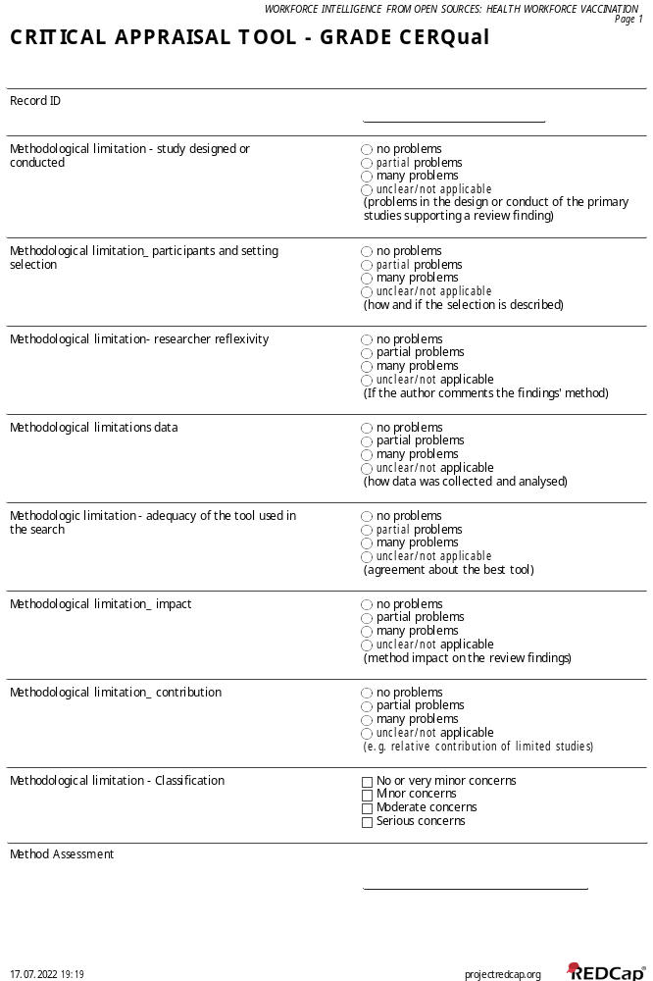
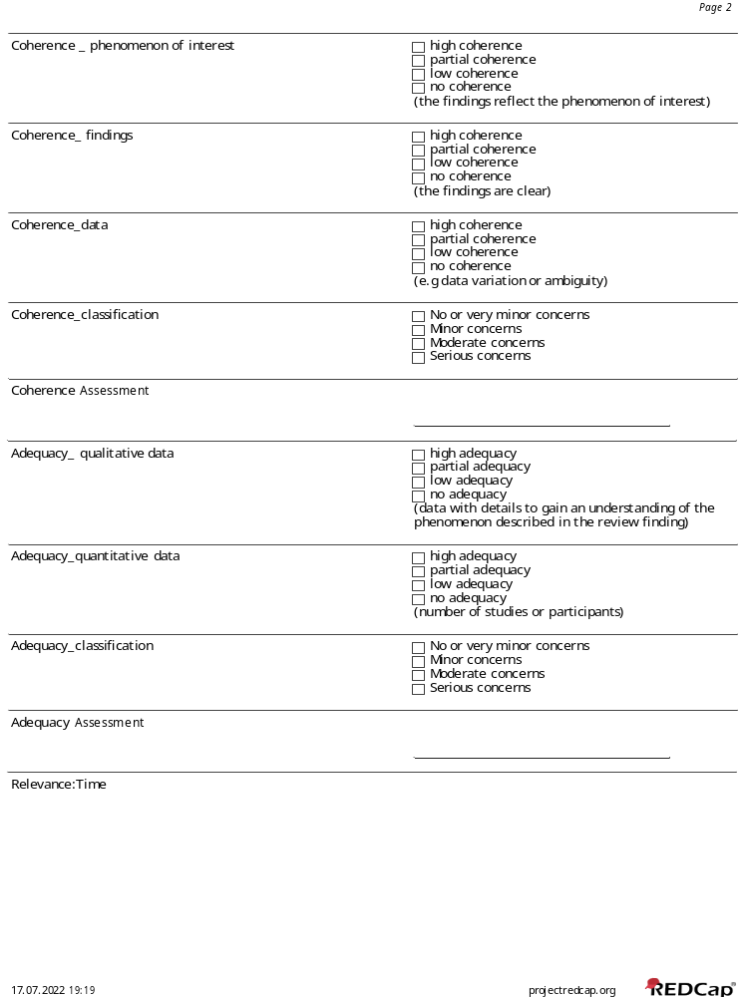
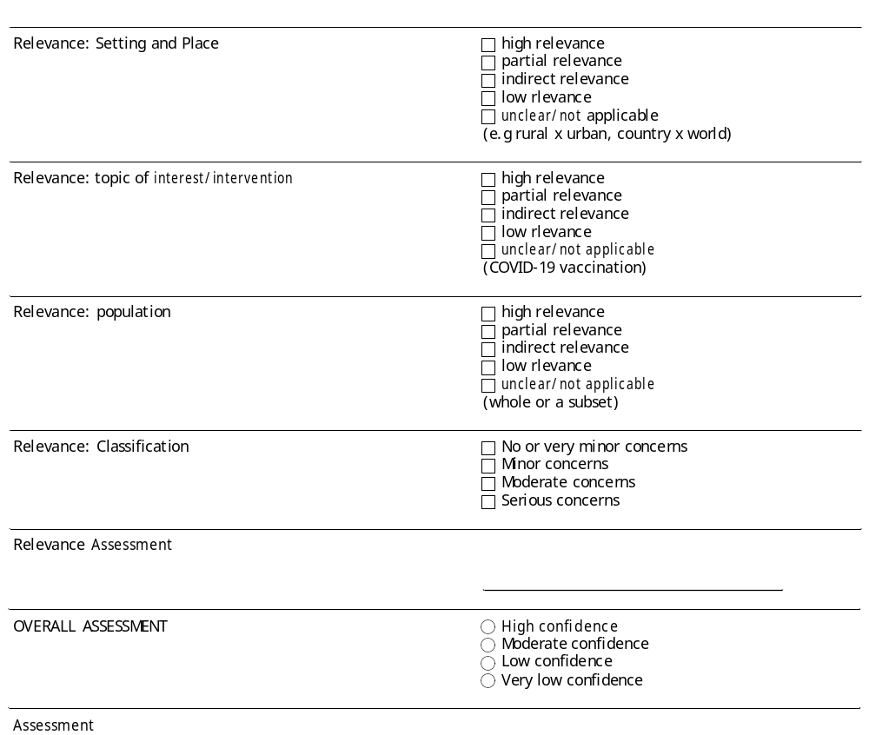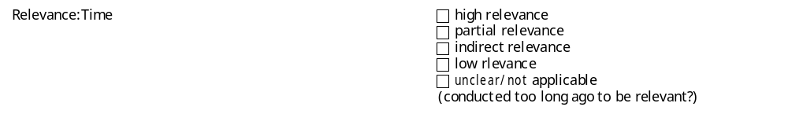

Annex 5 – Quantitative data extraction
 | Question 1 | Question 2 | Question 3 | Question 4
Total | 1,644 | 1,063 | 1,090 | 465
Disagreement | 116 | 77 | 53 | 28
Included | 26 | 37 | 14 | 85
Excluded | 1,638 | 1,026 | 282 | 380
Reasons for exclusion
wrong outcome | 779 | 231 | 171 | 101
wrong population | 431 | 782 | 126 | 216
wrong context | 138 | 115 | 50 | 65
wrong study design | 68 | 125 | 17 | 21
wrong intervention | 213 | 0 | 6 | 0
wrong background | 0 | 568 | 0 | 0

Annex 6 – Excluded articles and reasons for exclusion

Author | Title | Reason for exclusion
Derar H. Abdel-Qader,, Wail Hayajneh,, Abdullah Albassam, Nathir M. Obeidat, , Adel M. Belbeisi, | Pharmacists-physicians collaborative intervention to reduce vaccine hesitancy and resistance: A randomized controlled trial |  | The article is unclear. The results on prevalence are mixed with results of the intervention.
Salmon, By Daniel; Opel, Douglas J; Dudley, Matthew Z  Brewer, Janesse; Breiman, Robert | Reflections On Governance, Communication, And Equity: Challenges And Opportunities In COVID-19 Vaccination |  | Study design
Berry, Sarah D.; Goldfeld, Keith S.; McConeghy, Kevin | Evaluating the Findings of the IMPACT-C Randomized Clinical Trial to Improve COVID-19 Vaccine Coverage in Skilled Nursing Facilities |  | The comparison is between similar groups, but the study´s development is not clear. The findings are not consistent with the objectives.
Gifford, David; Davidson, H. Edward; Han, Lisa; Syme, Maggie | Compulsory Vaccination for Health care Workers in Italy for the Prevention of SARS-CoV-2 Infection |  | Opinion report
Gandhi, Ashvin; Mitchell, Susan L.; Harrison, Jill; Recker, Amy | Considerations for fair prioritization of COVID-19 vaccine and its mandate among Health care personnel |  | Opinion report
Johnson, Kimberly S.; Gravenstein, Stefan; Mor, Vincent | Coronavirus disease 2019 (COVID-19) vaccination preparedness policies in US hospitals |  | The article is original, but the method does not provide details on the research steps.
Cukier, Abigail | COVID-19 Update: Saskatchewan intensive care crisis, new vaccine safety data, and pushback on health worker mandates |  | News article
Gur-Arie, Rachel; Berger, Zackary; Rubinstein Reiss, Dorit | COVID-19 Vaccine Uptake Through the Lived Experiences of Health Care Personnel: Policy and Legal Considerations |  | Literature review without a defined methodology
Almeida, Bruno; Massa, Carla; Souza, Janaína | Uma dose de esperança: o processo de vacinação dos trabalhadores da saúde |  | Qualitative study without an appropriate methodology
Royal Australian College of General Practitioners | Mandatory COVID-19 vaccination for Health care workers including GPs |  | Opinion article

