SUPPLEMENTAL INFIRMATION

Mitochondrial protein import stress augments α-synuclein aggregation and neural damage independent of bioenergetics

Liam P. Coyne*, Arnav Rana*, Xiaowen Wang, Sanaea Bhagwagar, Yumiko Umino, Eduardo C. Solessio, Frank Middleton, & Xin Jie Chen (* equal contribution)

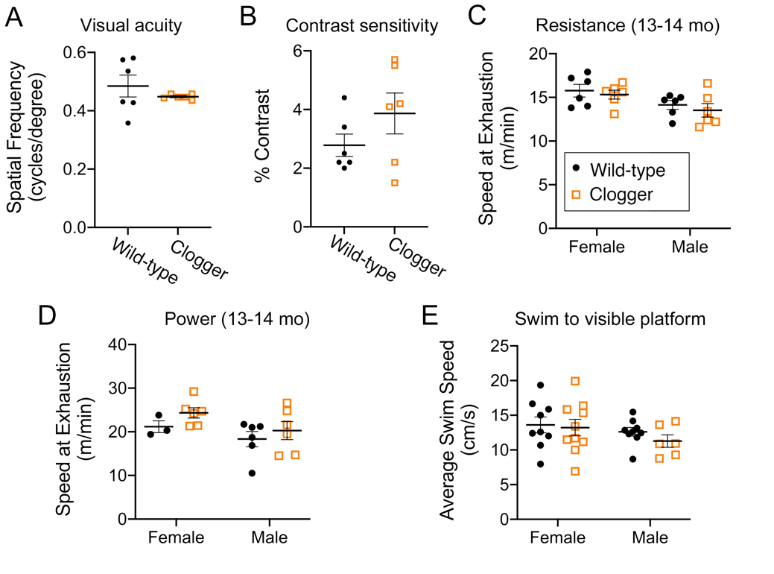

Figure S1. Visual and skeletal muscle functions are not impaired in middle aged clogger mice.
- Visual acuity of clogger mice is intact at 17-18 months of age, as suggested by optomotor response testing (n=3/sex/genotype).
- Visual contrast sensitivity of clogger mice is intact at 17-18 months of age, as suggested by optomotor response testing (n=3/sex/genotype).
- Clogger mice do not show exercise intolerance at 13-14 months of age, as suggested by similar time to exhaustion when forced to run on a slowly accelerating treadmill (“resistance test”) (n=6/sex/genotype).
- Clogger mice do not show exercise intolerance at 13-14 months of age, as suggested by similar time to exhaustion when forced to run on a quickly accelerating treadmill (“power test”) (n=3-6/sex/genotype).
- Clogger mice swim to a visible escape platform at similar average speeds as wild-type mice, suggesting preserved muscle function. These mice were 19-22 months of age (n=6-10/sex/genotype). Horizontal bars indicate average values +/- SEM.

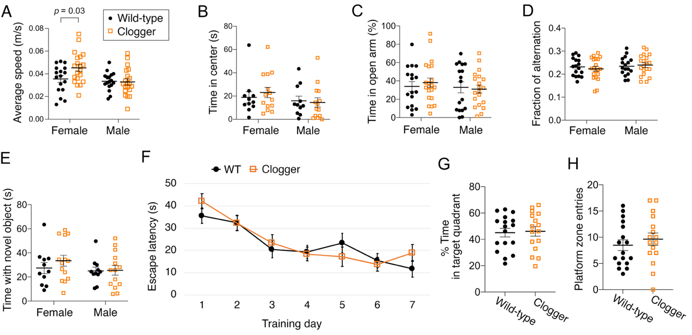
Figure S2. Clogger mice demonstrate sex-dependent increases in locomotor activity, but no changes in anxiety-like behavior or memory.
- Female clogger mice have increased spontaneous locomotor activity. Two independent aged mouse cohorts (14-17 months of age) were monitored in the open field apparatus and average speed throughout the 10 minutes was plotted. Data were analyzed with a two-way ANOVA with Sidak’s multiple comparison’s test. Each dot is a unique mouse (n=17-20/sex/genotype).
- Clogger mice show unchanged levels of anxiety-like behavior, as indicated by the amount of time mice spent in the center vs the edges of the open field apparatus (n=11-14/sex/genotype).
- Clogger mice show unchanged levels of anxiety-like behavior, as indicated by the amount of time mice spent in the open vs closed arms in the elevated plus maze (n=17-21/sex/genotype).
- Clogger mice do not have impaired spatial working memory, as indicated by Y-maze testing (n=17-20/sex/genotype). Fraction of alternation = (# of complete triads) / (# arm entries – 2). A triad is when a mouse enters all three arms consecutively without re-entering a previously visited arm in between.
- Clogger mice do not have impaired long-term object memory, as indicated by the amount of time mice spent interacting with a novel object (n=11-14/sex/genotype).
- Clogger mice do not have spatial learning defects, as indicated by Morris Water Maze testing. Plotted is the average latency to escape from water to a hidden platform during 7 training days (4 trials/day, n=6-10/sex/genotype).
- Clogger mice do not have impaired long-term memory, as indicated by the probe trial after 7 days of training in the Morris Water Maze. The target quadrant of the swimming pool contained the hidden platform during training but was removed for the probe trial (n=6-10/sex/genotype).
- Clogger mice do not have impaired long-term memory, as indicated by the probe trial after 7 days of training in the Morris Water Maze. Plotted is the number of times the mice swam into the “platform zone”, i.e. the area where the hidden platform was during training days. Horizontal bars indicate average values +/- SEM. Mice in this figure were 14-17 months of age.

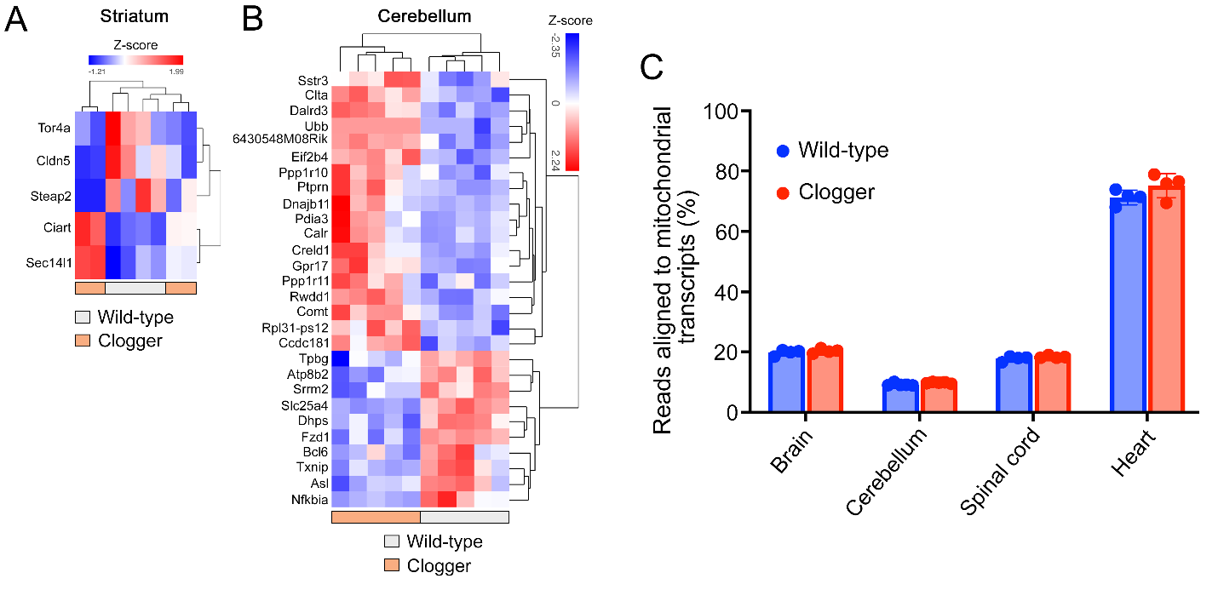

Figure S3. RNA-seq analysis reveal minimal transcriptional changes to the striatum and cerebellum nuclear genes and to mtDNA in different tissues in clogger mice.

- Hierarchical clustering heatmap of all genes that are differentially expressed in the striatum of clogger mice, compared with wild-type (q<0.05).
- Heatmap of all genes that are differentially expressed in the cerebellum of clogger mice, compared with wild-type (q<0.05). Note that Slc25a4 (ANT1) transcript level is consistently lower due to reduced transcription or partial instability of the mutant Ant1^{p.A114P,} ^{A123D} allele (our unpublished observation).
- Comparison of mtDNA-encoded transcripts in the clogger mice compared with the wild-type (24-30 month old), as represented as the percentage of total transcripts detected by RNA-seq.

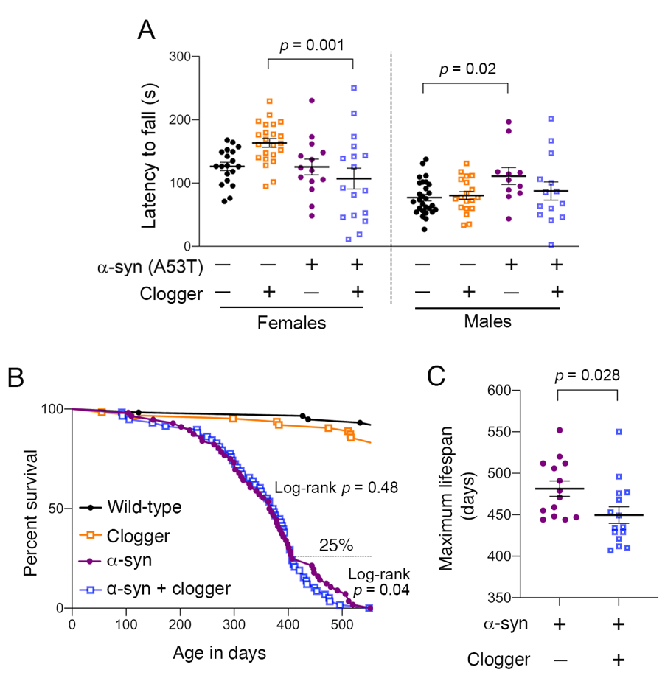

Figure S4. Rotarod and lifespan analyses of wild-type, Clogger, α-syn, and double mutant mice.

- Rotarod testing is consistent with synergistic impairment of motor coordination in double mutant mice. Data were analyzed as in (A), but sexes separated due to significant sex effect (p = 3 x 10⁻⁸), and then re-analyzed by two-way ANOVA with Sidak’s multiple comparison’s test.
- Lifespan analysis of wild-type, Clogger, α-syn, and double mutant mice (n=56-63/genotype). The 25% longest-lived mice depicted in (E) are noted on the graph.
- Maximum lifespan analysis of the 25% longest-lived mice suggests modestly reduced maximal lifespan in double mutant mice. Horizontal bars indicate average values +/- SEM. Data were analyzed by unpaired student’s t test (n=14-15/genotype).

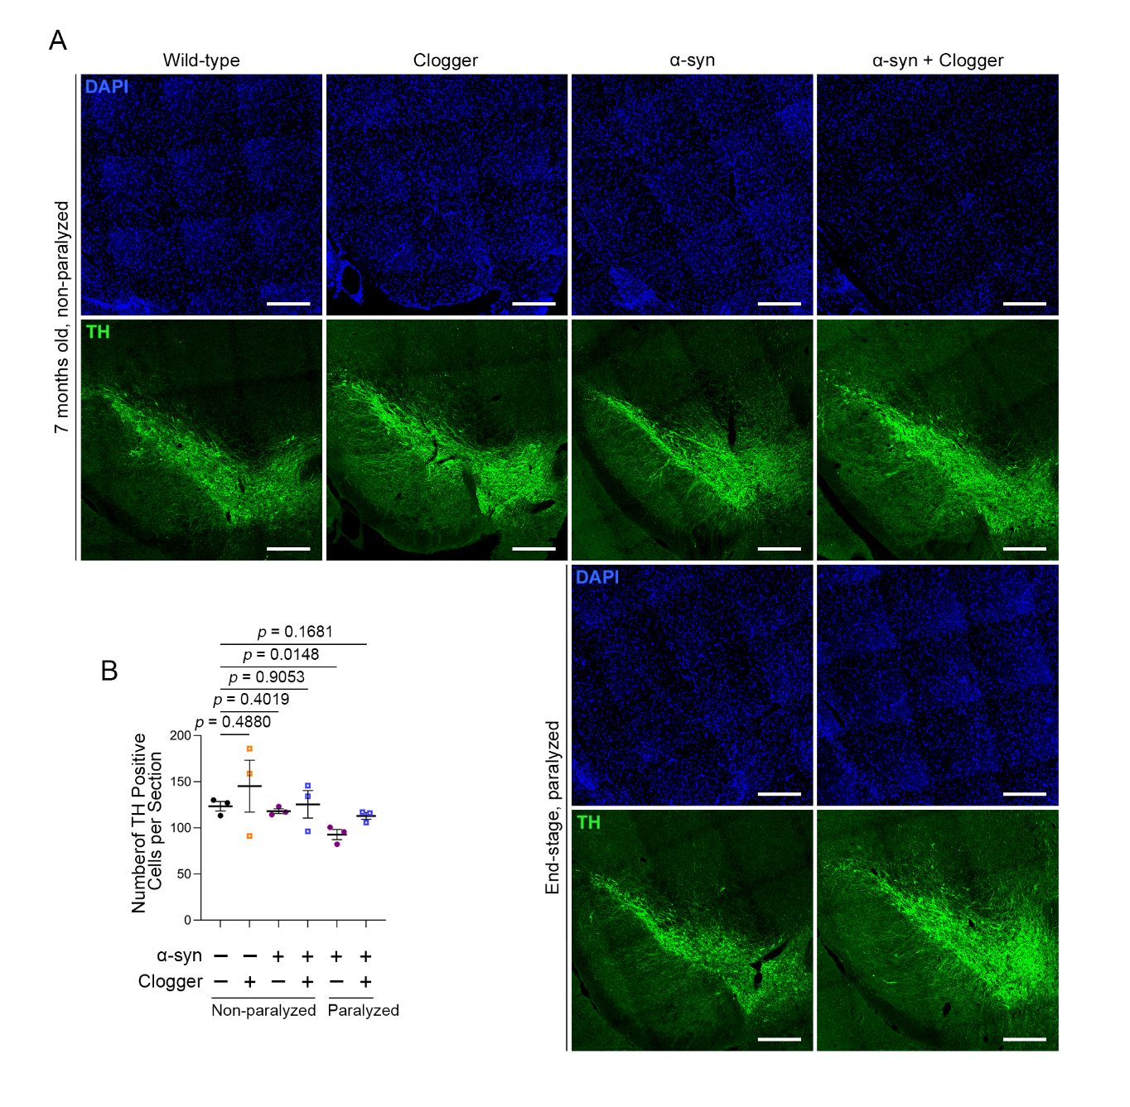

Figure S5. Histologic analysis of dopaminergic cell number in the SNc.
- Representative images from control (Wild-type, Clogger) and end-stage α-syn mice with or without protein import clogging for the counting of dopaminergic neurons probed for tyrosine hydroxylase (TH) within the substantia nigra pars compacta (SNc). Scale bar = 300 microns.
- Counting of dopaminergic neuron number in the SNc

Aggregate data were generated exclusively from similar portions of the SNc of two to three sections per mouse at anatomically distinct levels of the midbrain from two to four biological replicates per genotype. End-stage mice were 12.26-14.76 months of age. Non-paralyzed mice were 7 months of age +/- 2 weeks. P values were derived from student’s t test. Horizontal bars in (B) indicate average values +/-SEM.
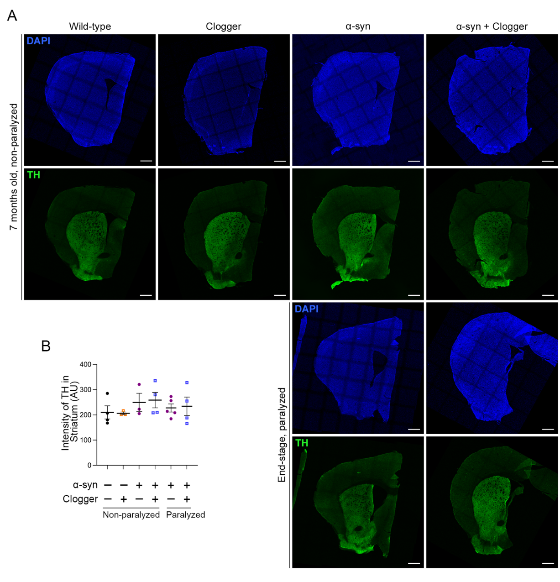

Figure S6. Tyrosine hydroxylase intensity in the striatum.
- Representative images from control (Wild-type, Clogger) and end-stage α-syn mice with or without protein import clogging for the intensity of tyrosine hydroxylase (TH) signal within the striatum. Scale bar = 600 microns.
- Quantification of tyrosine hydroxylase intensity within the striatum.

Aggregate data were generated exclusively from similar portions of the striatum of three to four sections per mouse at anatomically distinct levels from three to five biological replicates per genotype. End-stage mice were 12-15.49 months of age. Non-paralyzed mice were 7 months of age +/- 2 weeks. P values were derived from student’s t test. Horizontal bars in (B) indicate average values +/-SEM.

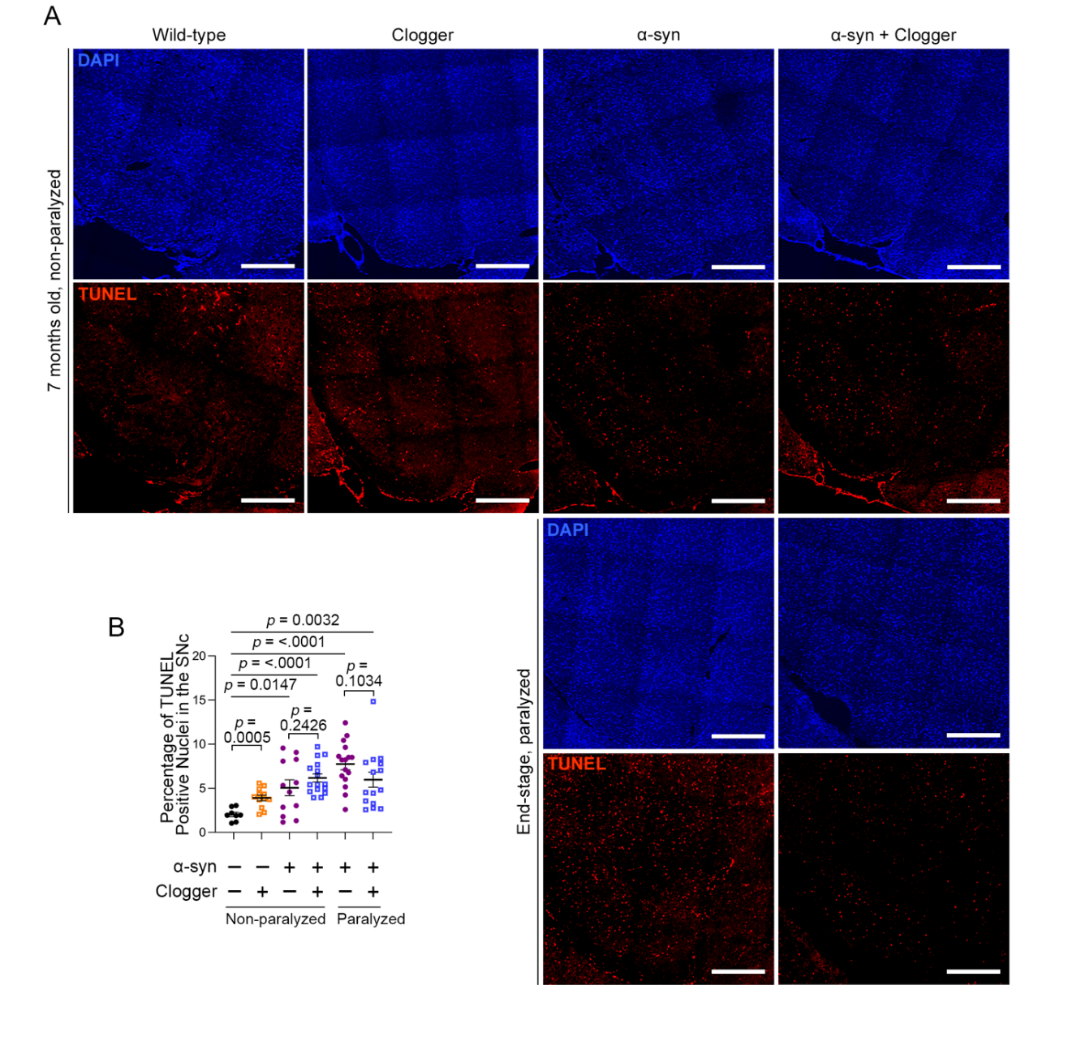
Figure S7. Detection of apoptosis in the SNc.
- Representative images from control (Wild-type, Clogger) and end-stage α-syn mice with or without protein import clogging for the detection of apoptotic nuclei via the terminal deoxynucleotidyl transferase dUTP nick end labeling (TUNEL) assay within the substantia nigra pars compacta (SNc). Scale bar = 400 microns
- Proportion of nuclei within the SNc that are positive for TUNEL puncta.

Aggregate data were generated exclusively from similar portions of the SNc of two to three sections per mouse at anatomically distinct levels of the midbrain from two to four biological replicates per genotype. End-stage mice were 12.26-14.76 months of age. Non-paralyzed mice were 7 months of age +/- 2 weeks. The data points shown in (B) represent the individual technical replicates for each animal. P values were derived from student’s t test. Horizontal bars in (B) indicate average values +/-SEM.

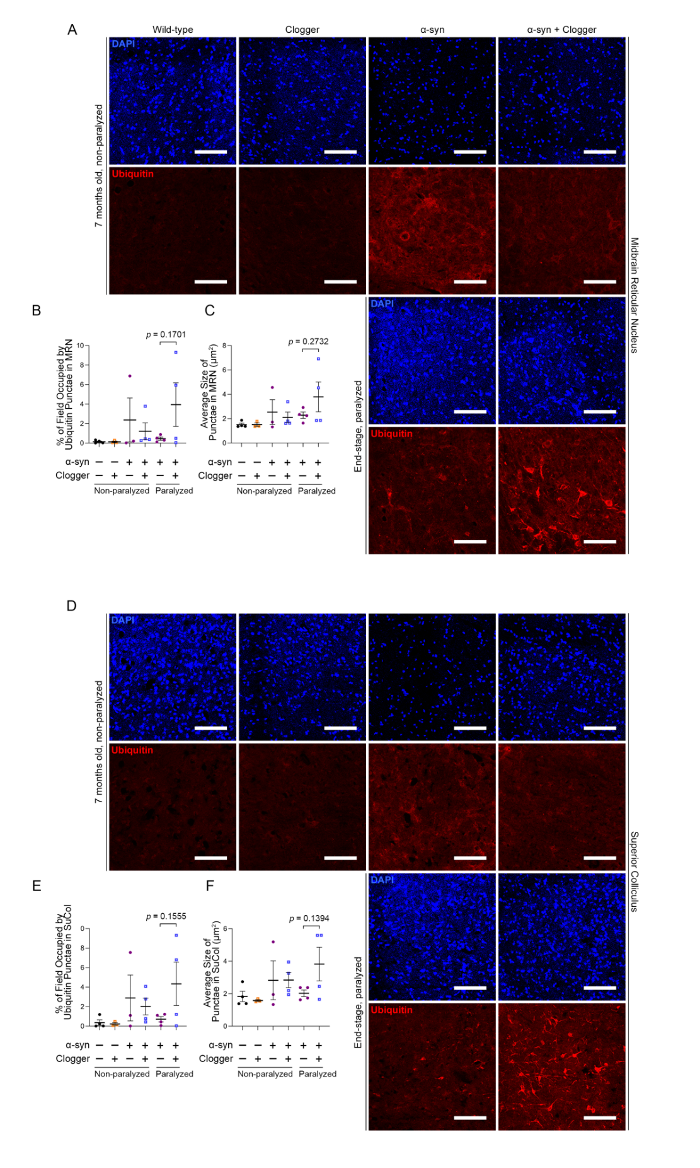

Figure S8: Ubiquitin inclusion bodies in midbrain regions.
- and (D) Representative images from control (Wild-type, Clogger) and end-stage α-syn mice with or without protein import clogging for the formation of ubiquitin positive inclusion bodies in the midbrain reticular nucleus (A) and superior colliculus (D) Scale bar = 100 micros.
- , (C), (E), and (F) quantification of ubiquitin percent occupancy and size within the midbrain reticular nucleus (B) and (C) and the superior colliculus (E) and (F).

Aggregate data were generated exclusively from similar portions of the SNc of two to four sections per mouse at anatomically distinct levels of the midbrain from three to four biological replicates per genotype. End-stage mice were 12-14.76 months of age. Non-paralyzed mice were 7 months of age +/- 2 weeks. P values were derived from student’s t test. Horizontal bars in (B, C, E, and F) indicate average values +/-SEM.

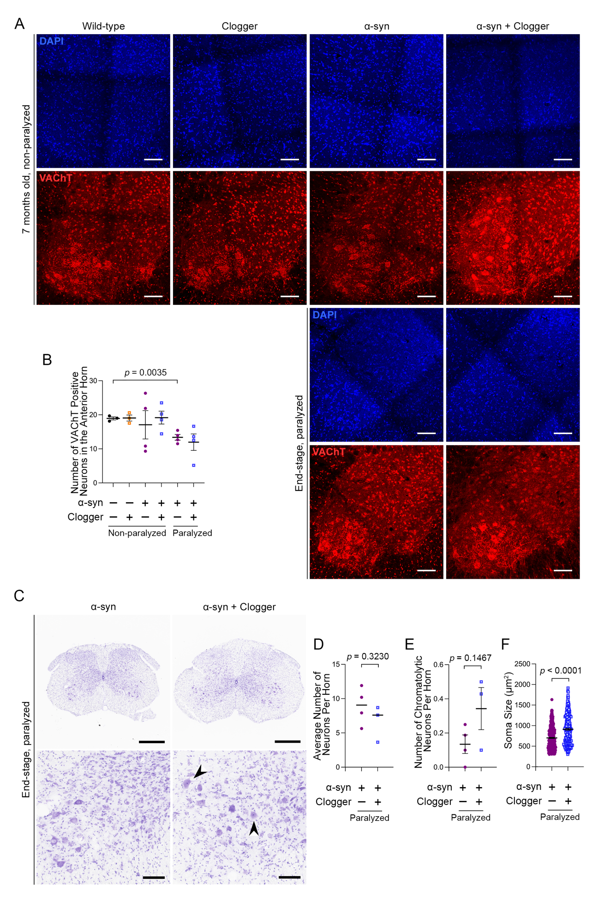

Figure S9. Histologic analysis of motor neurons in the lumbar spinal cord.

- Representative images from control (Wild-type, Clogger) and end-stage α-syn mice with or without protein import clogging, probed for the vesicular acetylcholine transporter (VAChT) Scale bar = 100μm.
- Number of VAChT positive motor neurons in the anterior horn.
- Representative images of nissl stained lumbar spinal cords from end-stage α-syn mice with or without protein import clogging. Top: whole section, scale bar = 500μm. Bottom: magnified view corresponding to anterior horn motor neurons, scale bar = 100μm. Arrowheads represent chromatolytic neurons.
- – (F) Quantification of nissl stain in lumbar spinal cord sections. (D) Average number of motor neurons counted per anterior horn. (E) Average number of atrophic (chromatolytic) motor neurons counted per anterior horn. (F) Comparison of soma sizes.

Aggregate data for VAChT immunofluorescence and nissl staining were generated from the ventral horns of two to eight sections per mouse at anatomically distinct lumbar spinal cord levels from three to four biological replicates per genotype. End-stage mice were 11.51-14.75 months of age. Non-paralyzed mice were 7 months of age +/- 2 weeks. P values were derived from student’s t test. Horizontal bars in (B) and (D-F) indicate average values +/-SEM.

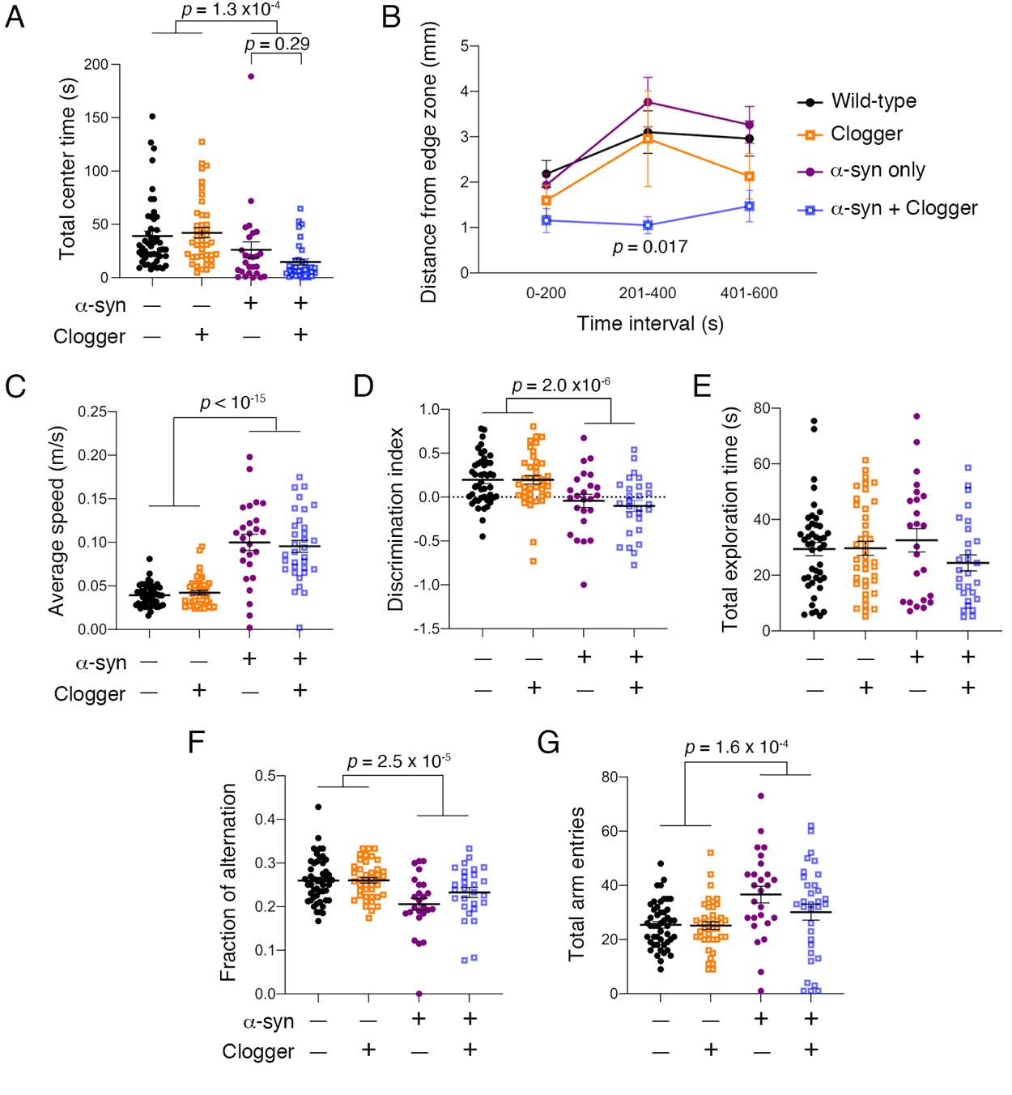

Figure S10. Assessment of anxiety-like behavior, spontaneous locomotion, and memory in wild-type, Clogger, α-syn, and double mutant mice.

- α-synuclein^{A53T} expression significantly increases anxiety-like behavior, as indicated by spending less time in the center zone in the open field test. While clogger protein expression reduced the average time spent in the center zone compared in α-syn transgenics, this was not statistically significant (n=11-29/sex/genotype).
- Open field test data were divided into 200-second epochs, and the average distance from the edge zone while in the center zone was plotted. This showed that double mutant mice tend to stay closest to the edge zone, particularly in the middle epoch. Data were represented as average +/- SEM and were analyzed using two-way repeated measures ANOVA with epoch as the within-subjects variable and a-syn and clogger genotypes as the between-subjects variables, with Geisser-Greenhouse correction for violation of sphericity. A significant interaction effect was detected (Epoch x a-syn x clogger, p = 0.042). Dunnett’s multiple comparisons test detected a significant reduction in average distance from the edge zone for double mutant mice in the middle epoch (p = 0.017, shown as *) (n=11-29/sex/genotype).
- α-synuclein^{A53T} expression significantly increases average speed of spontaneous locomotion in the open field test, which was not affected by the clogger protein (n=11-29/sex/genotype).
- α-synuclein^{A53T} expression significantly impairs long-term object memory in the novel object recognition test, which was not affected by the clogger protein (n=11-27/sex/genotype). For better visualization, the discrimination index was plotted, which = ((time with new object) – (time with old object)) / (total object exploration time).
- α-synuclein^{A53T} expression nor clogger protein expression affected total object exploration time on the probe trial of the novel object recognition test (n=11-27/sex/genotype).
- α-synuclein^{A53T} expression significantly impairs working spatial memory, as suggested by reduced fraction of alternation in the y-maze. This effect was not significantly affected by clogger protein expression (n=25-48/sex/genotype).
- α-synuclein^{A53T} expression significantly increases the total number of arm entries in the Y-maze spontaneous alternation test, which is not affected by clogger protein expression (n=25-48/genotype).

All data in this figure were generated from 8-9 month old mice. Data were first analyzed with three-way ANOVAs probing for effects of sex, α-synuclein^{A53T}, and clogger genotype. With no significant effect or interaction effect from sex, males and females were consolidated, and two-way ANOVAs were performed to simplify post-hoc analyses. For (A), (C), (D), (F), and (G), two-way ANOVA showed a significant main effect of α-synuclien^{A53T} expression, as indicated. Horizontal bars indicate average values +/- SEM.
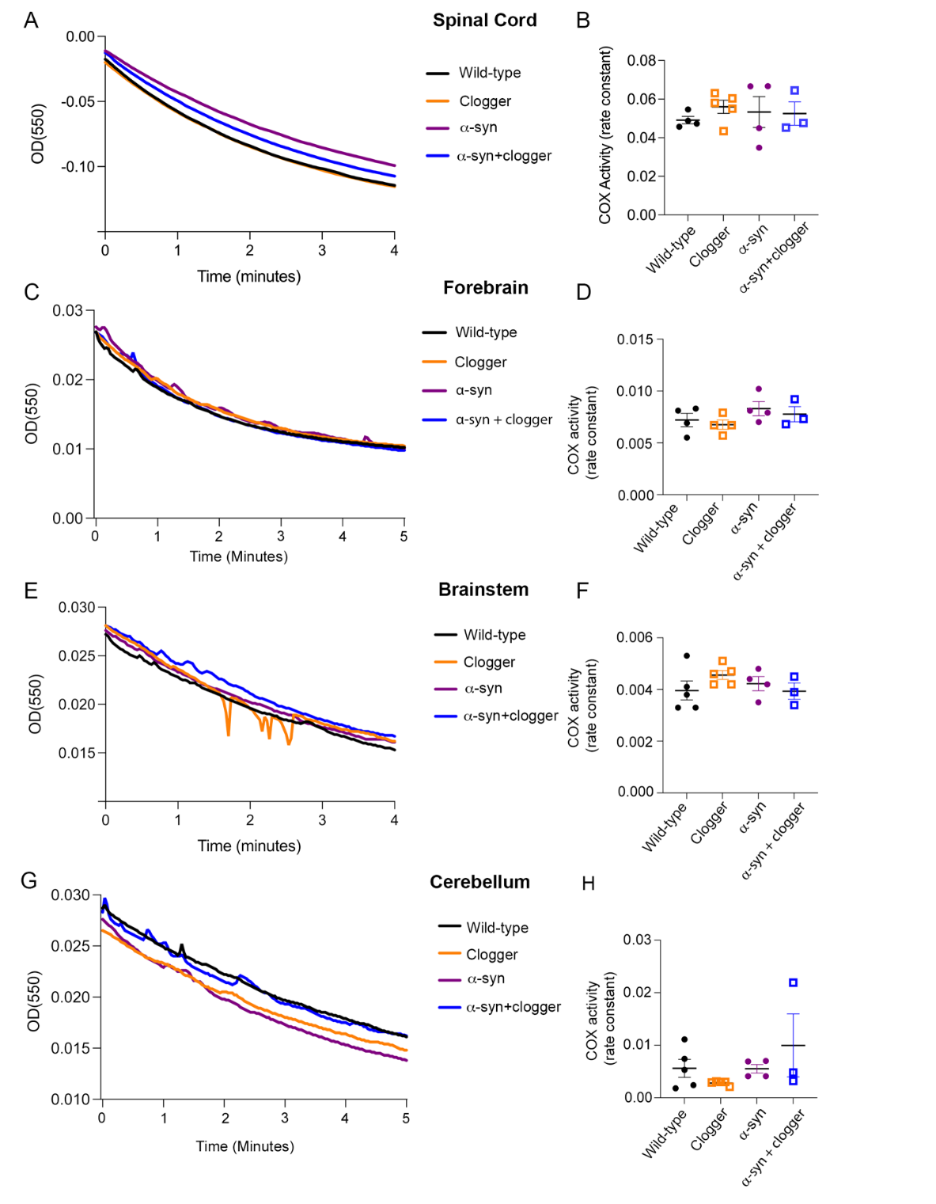

Figure S11. Spectrophotometric assay showing no significant difference in cytochrome c oxidase (COX) activity in spinal cord (A-B) and forebrain (C-D), brainstem (E-F) and Cerebellum (G-H) of 9 months old mice.

(A), (C), (E) and (G) Spectrophotometric traces from assessment of complex IV activity from crude mitochondrial fractions isolated from the indicated regions of the CNS.
(B), (D), (F) and (H) Quantitation of biological replicates of the Complex IV activity rate constants determined from (A), (B), (C) and (G) respectively. Each dot represents an independent biological replicate (n=3-5/genotype). Horizontal bars indicate average values +/- SEM.

All data in this figure were generated from 9-month-old mice +/-2 weeks.

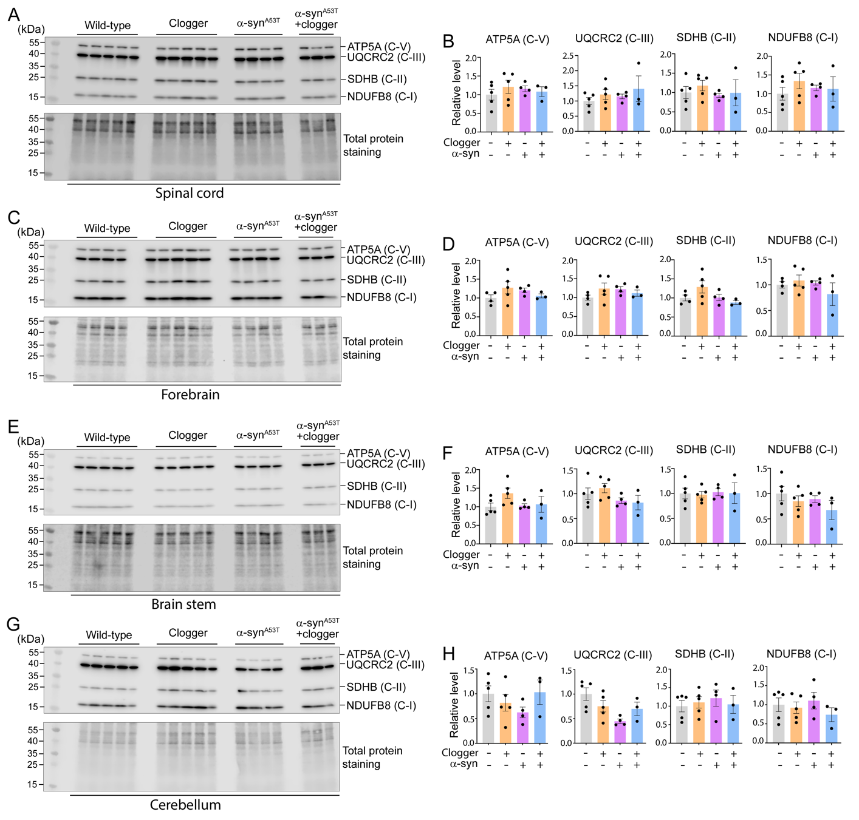

Figure S12. Western blot analysis showing the integrity of the OXPHOS pathway, using a cocktail of antibodies against the indicated mitochondrial proteins. C-I, -II, -III and -V, respiratory complexes I, II, III and V respectively. (A), (C), (E) and (G) crude mitochondria isolated spinal cord, forebrain, brainstem and cerebellum of 9-month-old mice, respectively. (B), (D), (F) and (H) quantification of (A), (C), (E) and (G) respectively. The P values are >0.05 between the four genotypes in all the three regions of CNS, as determined by student’s t test. Each lane/data point represent an individual mouse.

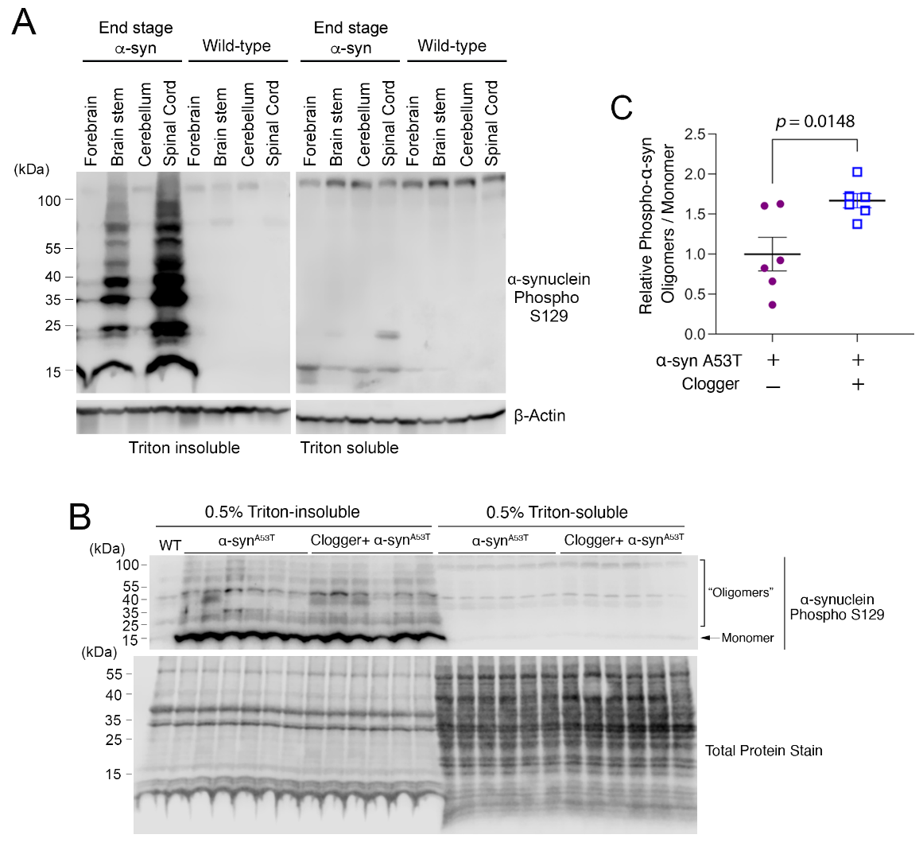

Figure S13. Phosphorylated α-synuclein is preferentially insoluble in the spinal cord of end-stage transgenic α-synuclein(A53T) mice, and may oligomerize preferentially in double mutant mice.
- Immunoblot analysis of central nervous system tissues solubilized with 0.5% triton to assess the tissue distribution of aggregated a-synuclein. Antibody is specific to α-synuclein phosphorylated at Ser129.
- Immunoblot analysis Triton-soluble and insoluble fractions using an antibody specific to a-synuclein phosphorylated at Ser129. Each lane represents an individual mouse.
- Quantification of (B) showing the oligomers/monomer ratio of P-α-syn in Triton-insoluble fractions.

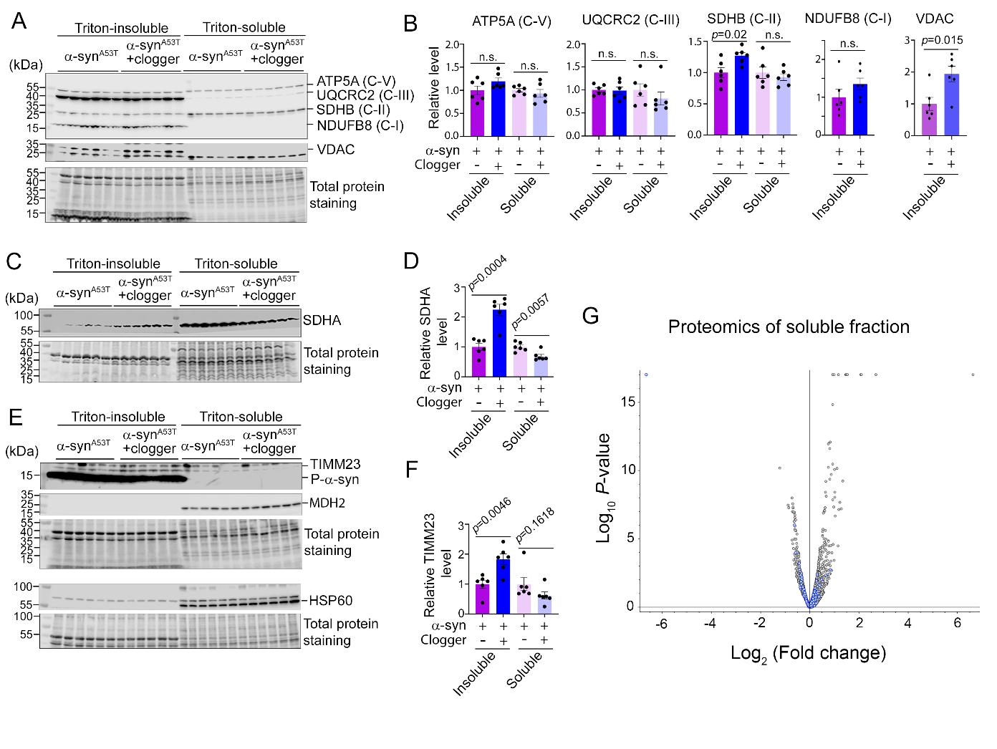
Figure S14. Distribution of a selected panel of mitochondrial proteins in Triton-soluble and insoluble fractions of spinal cord from end-stage α-syn and α-syn + clogger mice.

- Western blotting analysis using a cocktail of antibodies against the indicated mitochondrial proteins. C-I, -II, -III and -V, respiratory complexes I, II, III and V respectively, and an antibody against VDAC.
- Relative levels of proteins in soluble and insoluble fractions quantified from (A).
- Western blotting analysis using an antibody against SDHA.
- Quantification of (C).
- Western blotting analysis using antibodies against TIMM23, HSP60, MDH2 and P- a-syn.
- Quantification of (E). P values were derived from student’s t test. n.s., not significant. Each lane/data point represent an individual mouse.
- Volcano plot of TMT proteomics experiment of Triton-soluble proteins with *** proteins labeled as blue dots.
SUPPLEMENTAL EXCEL TABLES

Supplemental Table 1 – RNA-seq data of spinal cord from Ant1^{p.A114P, A123D}/+ compared with wild-type mice.

Supplemental Table 2 – RNA-seq data of cerebellum from Ant1^{p.A114P, A123D}/+ compared with wild-type mice.

Supplemental Table 3 – RNA-seq data of striatum from Ant1^{p.A114P, A123D}/+ compared with wild-type mice.

Supplemental Table 4 – TMT mass spectrometry analysis of spinal cord Triton-insoluble proteome from Ant1^{p.A114P, A123D}/+ α-syn double mutant compared with α-syn single mutant mice.

Supplemental Table 5 – TMT mass spectrometry analysis of spinal cord Triton-soluble proteome from Ant1^{p.A114P, A123D}/+ α-syn double mutant compared with α-syn single mutant mice.

