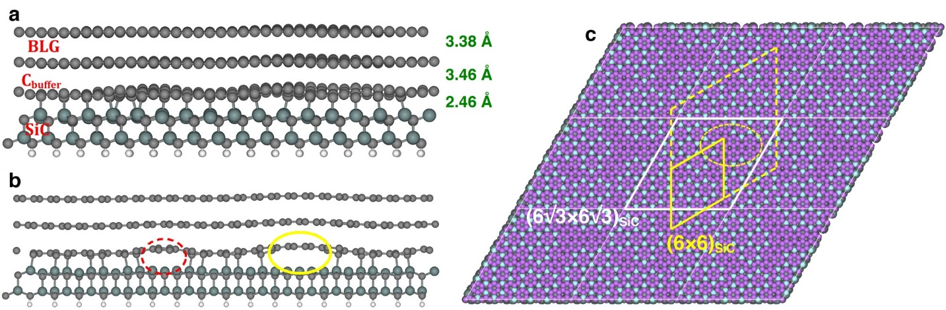
Extended Data Fig. 1 | Density functional theory calculations. a, Side view of fully relaxed structure from our DFT calculations for BLG/SiC(0001) with a supercell $13a_{\text{G}}^{*}×13a_{\text{G}}^{*}$ matching $6\sqrt{3}a_{\text{SiC}}×6\sqrt{3}a_{\text{SiC}}$. The gray, dark cyan, and white balls denote C, Si, and pseudo-H atoms, respectively. The average interlayer spacings⁴⁸ for top layers are indicated. b, Side view of a straight strip cut along the [$1\overline{1}00$] direction with a strip width of about one graphene lattice constant in the middle of the structure in a. The two ellipses schematically illustrate the sp² hybridized C atoms in the C_{buffer} layer, i.e., unbonded from the top Si atoms in contrast to other sp³ hybridized C atoms bonded to the top Si atoms. This structure with the sp² hybridization of unbonded C atoms was obtained after relaxation of the initially sp³ hybridized C atoms bonded to the top Si atoms due to the strain effects and with no electric field. c, Quantitative analysis for the C-Si bonding distance at the interface (top view with all C atoms of BLG are removed for clarity). Light blue and purple balls indicate the C-Si bond length $d<d_{\text{c}}$ and $d>d_{\text{c}}$ ($d_{\text{c}}=2.5 Å)$, respectively. The supercell $6\sqrt{3}a_{\text{SiC}}×6\sqrt{3}a_{\text{SiC}}$ and the corresponding (6$×$6)_{SiC} periodicity are indicated by the white and yellow frames, respectively. The single protrusion per $6\sqrt{3}a_{\text{SiC}}×6\sqrt{3}a_{\text{SiC}}$ unit cell (green contrast in Fig.1c) is marked in b and c by the yellow ellipses.

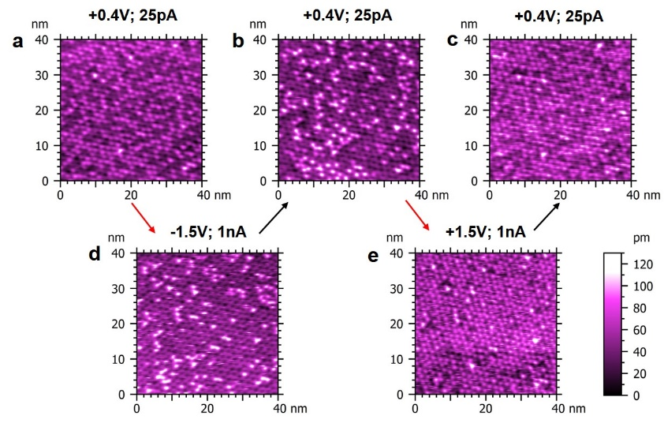
Extended Data Fig. 2 | Hysteresis effect. a-c, STM constant-current topographies of the same surface region under the same, soft scanning conditions. Note the apparent changes in surface densities of protrusions for the same imaging conditions after STM manipulation scans using electric fields of different polarity. after STM manipulation scans. d,e STM constant-current topographies of the same surface region obtained for larger negative and positive sample bias voltages. The arrows present time sequence for data in a-e. Exact scanning conditions are indicated above each panel. The data were collected on an externally prepared BLG/SiC sample (see Methods).

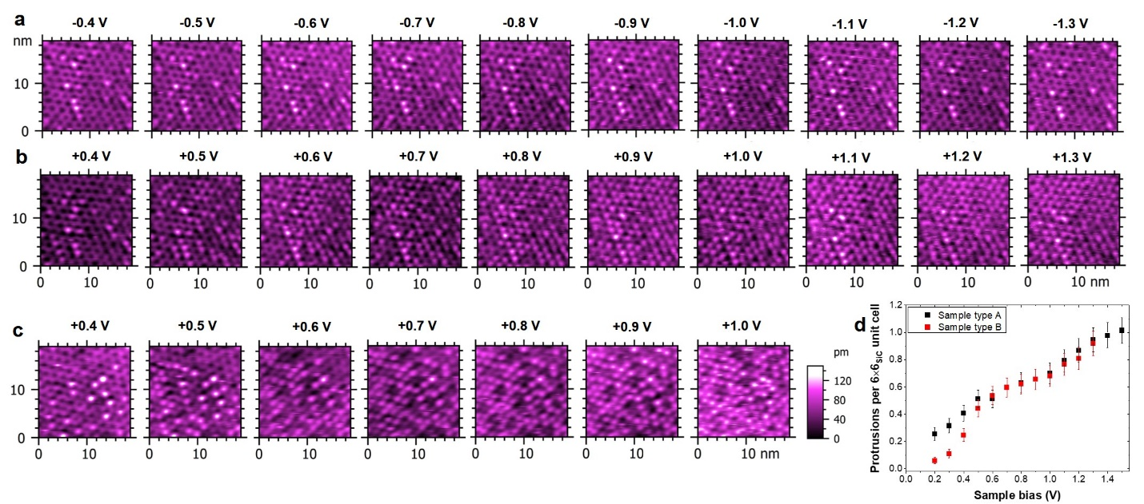
Extended Data Fig. 3 | Sample bias voltage dependence. a-c, STM constant-current ($I=500$ pA) topographies (20 nm × 20 nm) obtained for different sample bias voltages as indicated above each panel. Data in a and b were collected in the same region and they were used to produce Fig.2c. Data in c were collected on an externally synthesized BLG/SiC heterostructure sample²⁶ (see Methods). d, Surface densities of the protrusions as a function of STM positive sample bias voltage ($I=500$ pA) for two types of synthesis methods: ultra-high vacuum annealing (this work, type A) and Si-flux assisted annealing^{24,26} (externally prepared sample, type B, see Methods).

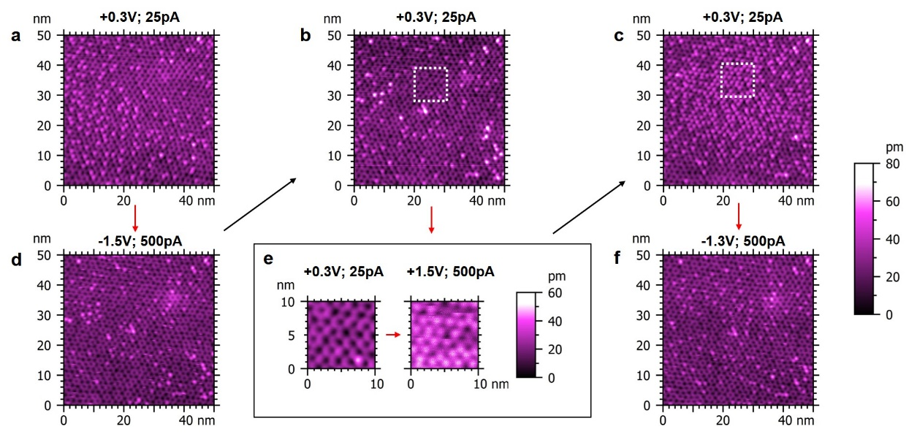
Extended Data Fig. 4 | Nanometer scale patterning. a-c, STM constant-current topographies of the same surface region under the same, soft scanning conditions. d-f, STM constant-current topographies used to manipulate local density of interface protrusions. After the initial imaging (a), the surface region was manipulated with a large negative voltage scanning (d), which decreased the density of protrusions (b). Then a local surface area was chosen as marked by the white, dotted rectangle. It was subsequently imaged and patterned by large positive voltage scanning (e). Under these conditions, the resulting STM-electric field patterned the surface with a local increase in density of interface protrusions extending ~15 nm from the manipulation location (c). Finally, the pattern area was “erased” by large negative voltage scanning (f). The arrows present time sequence for data in a-f. Exact scanning conditions are indicated above each panel.

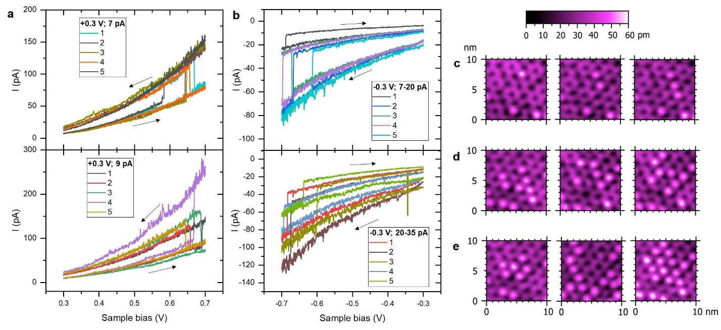
Extended Data Fig. 5 | Manipulation of single (6×6)_{SiC} lattice sites. a, Examples of tunneling current signals registered during positive voltage ramp loops (see arrows) used for the experiment presented in the Supplementary information movies. Vertical tip positions are defined by STM parameters (U₀, I₀) in the labels. b, Examples of tunneling current signals registered during negative voltage ramp loops (see arrows) used for the experiment presented in the Supplementary information movies. Vertical tip positions are defined by STM parameters ($U_{0}$, $I_{0}$) in the labels. c-e, Examples of STM constant-current topographies ($+0.3$ V, 25 pA) of the same surface region used for the experiment presented also in the Supplementary information movies. Single manipulation events in the form of voltage ramp loops (panels a and b) were used in between the images to either generate or eliminate a protrusion depending on voltage polarity. Panel c presents consecutive formation of a three-protrusion line. Panel d presents formation of more complex structures mimicking numerical digits. Panel e presents possibility of formation of local protrusion islands and their inverse (confined regions). Note that due to the complex, electric field related mechanism and interplay between local stress of the interface structure, lateral precision of the above manipulation protocols has limitations. Often a single voltage ramp creates/annihilates additional protrusions in the vicinity of the targeted location. Nevertheless, the process is highly reversible and an intended pattern could be created by a series of consecutive manipulations. The reversibility opens possibility for implantation of autonomous STM pattering procedures and their further optimization.

