Supplementary Tables and Figures

Supplementary Table 1. Inclusion of Weisenfeld awardees among the top 50 authors as ranked by different citation indices, separated by yearly edition of c-score database.
Yearly edition of c-score database | NC | H | Hm | NCS | NCSF | NCSFL | c-score | Author inclusion by any index
2021 | 7 | 8 | 8 | 3 | 5 | 7 | 9 | 11
2020 | 5 | 7 | 7 | 3 | 5 | 6 | 9 | 9
2019 | 4 | 6 | 7 | 4 | 5 | 6 | 8 | 9
2018 | 6 | 7 | 7 | 4 | 5 | 7 | 9 | 10
2017 | 5 | 6 | 6 | 3 | 5 | 7 | 9 | 10

Supplementary Table 2. Results of Tukey’s t-test between top 50 authors by c-score compared to other authors in the database, separated by yearly edition of c-score database.
 | 2017 | 2018 | 2019 | 2020 | 2021
Mean career length^ | (+)* | (+)** | (+)*** | (+)*** | (+)***
Mean change in percentile from previous year^ | NA | (-)*** | (-)*** | (-)*** | (-)***
Mean self-citation percentage | -- | -- | -- | -- | --
Proportion female‡ | -- | -- | -- | -- | --
--p>0.05, *p<0.05, **p<0.01, ***p<0.001
^Wilcox/Mann Whitney U test
‡Chi Square test
(+) indicates the top 50 authors have a higher value than other authors, (-) indicates the opposite

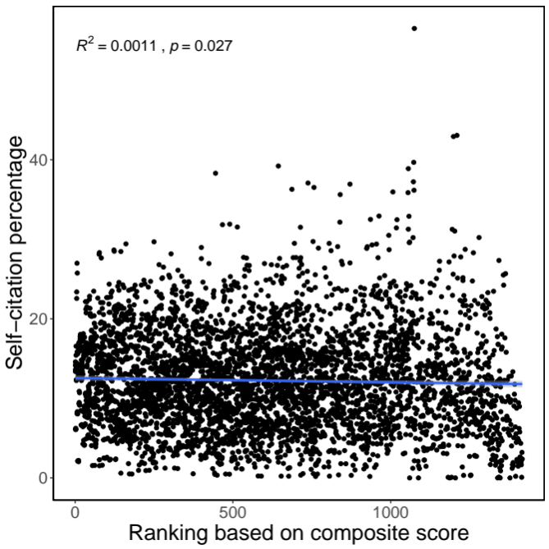

Supplementary Figure 1: Scatterplot of composite score ranking versus self-citation percentage in 2021.

