Athletic Sports Nutrition Knowledge Questionnaire (A-SNKQ)
This short survey is designed to assess the knowledge of Sri Lankan elite athletes regarding general and sports nutrition. Your participation and honest responses will be highly appreciated. The questionnaire takes about 10-15 minutes to complete. For statement-based questions, please indicate whether you agree with the given statements or not. If you do not know the answer to any question, please select the "unsure" option. The information you provided will be kept strictly confidential.
Section 1 – General Nutrition Knowledge

Macronutrients
- Please consider the following food items and select the most abundant macro-nutrient in each food. (Check the one that applies the most)
Food item | Carbohydrates | Proteins | Fats | Unsure
Banana
Beef
Bread
Chicken
Chickpeas
Coconut oil
Coconut sambal
Corn flakes
Dates
Dhal
Dried fish
Egg white
Fish
Oats
Olive oil
Pasta
Peanuts
Rice
String Hoppers
Sweet Potatoes
- Please consider the following food items and indicate whether they are a good source of dietary fibre source or not.
Food item | Yes | No | Unsure
Beef
Fruits
Green leafy vegetables (mallum)
Milk
Vegetables
- For athletes wanting to enhance recovery from physical activity and optimize muscle growth, spreading out protein consumption throughout the day is more effective than consuming it all at once.
Agree ☐
Disagree ☐
Unsure ☐

- The optimum daily protein intake for athletes who have a goal of weight maintenance or weight gain is,
0.3 g/kg BM/day ☐
0.8 g/kg BM/day ☐
1.5 g/kg BM/day ☐
2.5 g/kg BM/day ☐
Unsure

Micronutrients
- Select the micronutrient of which the following foods are a rich source,
(Check the one that applies the most)
Food item | Calcium | Iron | Vitamin C | Unsure
Banana
Beef
Curd
Full cream milk powder
Local mandarins
Sweet potatoes
- Most of the local sour fruits contain a high amount of antioxidants.
Agree ☐
Disagree ☐
Unsure ☐

- You should take vitamin supplements if,
- You feel tired ☐
- You are getting sick often ☐
- Your colleagues also take the same ☐
- You have been told you have a deficiency by a medical professional ☐
- Unsure ☐

Energy balance
- Please consider the following nutrient or substance and indicate whether it provides energy.
Type of nutrient/substance | Yes | No | Unsure
Alcohol
Carbohydrate
Fats
Iron
Proteins
Vitamin B₁₂
- Feeling tired midway through a workout might be a sign of insufficient energy-rich food in one’s diet.
Agree ☐
Disagree ☐
Unsure ☐
- Meeting energy needs promotes optimal performance and recovery after training.
Agree ☐
Disagree ☐
Unsure ☐
- Consuming a sufficient amount of carbohydrates helps to reduce protein breakdown in the body.
Agree ☐
Disagree ☐
Unsure ☐
- During resistance exercises, the body tends to use protein as the main energy source.
Agree ☐
Disagree ☐
Unsure ☐

Hydration
- Please read each of the following signs and state whether it is a method/sign of dehydration after an intense training session.
Method/Sign | Yes | No | Unsure
Assessing urine colour after training
Presence of dry mouth
Presence of loose stools
Feeling of thirst
Measuring urine-specific gravity
- If you lost one kilogram of weight during a training session, how much water do you need to consume after training?
- 0.5 L ☐
- 1.0 L ☐
- 1.5 L ☐
- 2.0 L ☐
- Unsure ☐
- Please consider the following food items and indicate whether it is a rich source of salt.
Food item | Yes | No | Unsure
Jeewani
King coconut water
Marmite
Milk
Watermelon juice

Weight management
- If you want to lose weight, rice should be replaced with which of the following food item? (Check the one that applies the most).
- Chicken curry ☐
- Potato curry ☐
- Dhal curry ☐
- Vegetable salad ☐
- Unsure ☐

Section 2 – Sports Nutrition Knowledge

Carbohydrate loading
- To maximize muscle glycogen stores, carbohydrate loading is best followed by how many hours before the competition?
- 6-12 hours ☐
- 12–24 hours ☐
- 24–48 hours ☐
- 168 hours ☐
- Unsure ☐

Pre-training meals
- Please indicate the correct time gap for the pre-training meals given below.
Food item | 4-hours before exercise | ½-1-hour before exercise | Unsure
Rice and curry
A banana
Boiled chickpeas with coconut
A jam sandwich

Training meals
- Which of the following food/beverage can be taken in the middle of an intense 2-hour training session? (Check all that apply. Please note that minus marks will be given for each incorrect answer)
- Banana ☐
- A small sandwich ☐
- Nuts ☐
- Raw eggs ☐
- Jeewani/ORS ☐
- Unsure ☐

Post-training meals
This section consists of multiple-choice questions, you can select one or more answers for each question.
Please note that minus marks will be given for each incorrect answer.
- Recommended meal/s after two hours of an intense training session is/are,
- A glass of kola kanda ☐
- Milk packet ☐
- A piece of fried chicken ☐
- Boiled chickpeas ☐
- Boiled sweet potatoes ☐
- Bowl of cornflakes with non-fat milk ☐
- Bread with jam ☐
- Two boiled eggs ☐
- White rice with dhal and chicken ☐
- Unsure ☐
- After heavy training athletes should,
- Drink fluids but avoid eating as digestion is impaired after exercise ☐
- Wait until your next meal to avoid overeating and gaining weight ☐
- Eat foods high in carbohydrates and proteins within 30 minutes to 2 hours and eat sooner rather than later if you are training/competing again on the next day ☐
- Eat whatever you can find as soon as possible to avoid low blood glucose ☐
- Unsure ☐

Sports supplements
- What is the amount of whey proteins that should be consumed per serving for optimum muscle building/muscle protein synthesis/recovery?
- 5 g ☐
- 10 g ☐
- 15 g ☐
- 20 g ☐
- Unsure ☐
- What is the recommended daily creatine maintenance dose?
- 2 g ☐
- 5 g ☐
- 7 g ☐
- 10 g ☐
- Unsure ☐
- What is the recommended daily dose of beta-alanine?
- 1 g ☐
- 2 g ☐
- 3 g ☐
- 4 g ☐
- Unsure ☐
- How do you calculate the recommended total dose of the bicarbonate according to body weight?
- 0.1 g/kg ☐
- 0.2 g/kg ☐
- 0.3 g/kg ☐
- 0.4 g/kg ☐
- Unsure ☐
- Which statement about the contribution of sports supplements to the performance of your sport is true?
- Taking supplements is more important than changing your diet if you want to improve your sports performance ☐
- Taking supplements is equally as important as improving your diet if you want to improve your sports performance ☐
- Supplements do not benefit performance and are never needed ☐
- Some supplements can have a small impact on performance but the contribution will depend on the type of supplement and what sport you play ☐
- Unsure ☐

- Please select the most suitable supplement for the main sport event you play. (Check the one that applies the most)
Event | Caffeine | Creatine | Nitrate | Beta-alanine | Bicarbonate
100 m
200 m
100/110 m hurdles
4 x 100 m relay
400 m
400 m hurdles
4 x 400 m relay
800 m
1500 m
3,000 m steeple chase
5,000 m
10,000 m
Race walking
Half marathon
Marathon
Long jump
High jump
Triple jump
Pole vault
Heptathlon
Decathlon

Supplement label reading, alcohol, isotonic drink, and doping
- Which of the following is banned by World Anti-Doping Agency (WADA) for use before the competition?
- Bicarbonate ☐
- Caffeine tablets ☐
- Iron-IV infusion ☐
- Polybion-IV infusion ☐
- Steroid injections ☐
- Whey protein ☐
- Unsure ☐
- Drinking alcohol slows down recovery after training.
Please indicate whether you agree with this statement by checking the appropriate box.
Agree ☐
Disagree ☐
Unsure ☐

- Identify the safe to use supplement put of the following three labels.
- ☐
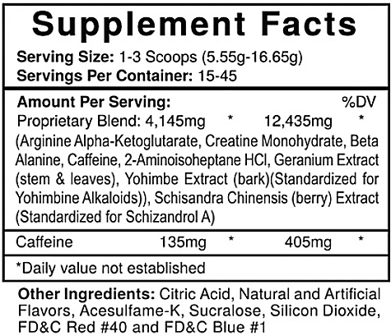

- ☐
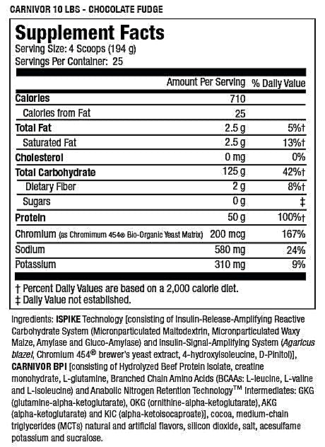

- ☐
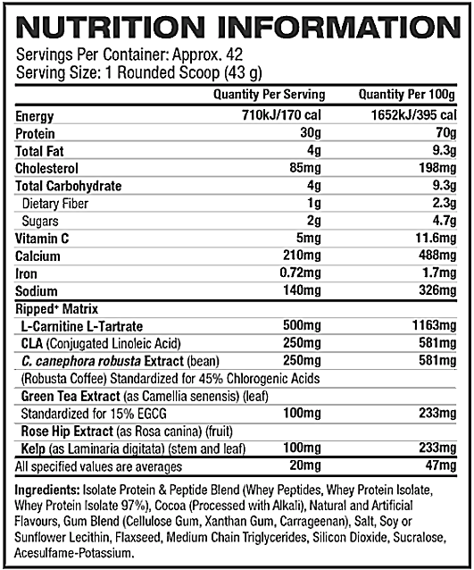

- None of the above ☐
- Unsure ☐
- Which of the following is/ are examples of an isotonic solution?
- Dextrose ☐
- Fruit juice ☐
- Jeewani (ORS) ☐
- Water ☐
- Unsure ☐

RED-S
- ‘Meeting relatively lesser energy than the required amount causes poor performance and serious health issues.’
Please indicate whether you agree with this statement by checking the appropriate box.
Agree ☐
Disagree ☐
Unsure ☐
- ‘It is important not to change your dietary habits during overseas competitions.’
Please indicate whether you agree with this statement by checking the appropriate box.
Agree ☐
Disagree ☐
Unsure ☐

