Glossary

CBD – The Convention of Biological Diversity (https://www.cbd.int/convention/text/), a multilateral treaty signed in 1992 and entered into force the following year. The Convention guides the strategies of national states for the conservation and sustainable use of biological diversity within national jurisdiction, including fair and equitable sharing of benefits arising from the use of genetic resources.

UNCLOS – The United Nations Convention on the Law of the Sea, a multilateral treaty which entered into force in 1994. It established a legal framework for marine space and maritime activities, including but not limited to governance regimes in national jurisdiction waters, exclusive economic zones, continental shelf and beyond that.

ABNJ – Areas Beyond National Jurisdictions, parts of the global ocean in accordance with UNCLOS that none of the nations has exclusive sovereignty for in terms of governance and management of resources. ABNJ include the water column (“High Seas”) and the seabed (“The Area”).

MGR – Marine Genetic Resources. Political term, originally defined in the CBD as “any material of marine plant, animal, microbial or other origin containing functional units of heredity of actual or potential value”.

DSI – Digital Sequence Information. A placeholder term that refers the digitalized marine genetic resources, including nucleic acid and protein sequence data. The term is used in multiple multilateral agreements, including the International Treaty on Plant Genetic Resources for Food and Agriculture (https://www.fao.org/plant-treaty/en/) and the recently signed High Seas treaty but doesn’t have a clear definition yet.

Marine bioprospecting – Systematic search for genes and biological compounds of marine origin (natural products) that have a real or potential economic use. The process of finding new natural products through application of cell and molecular biology, high-throughput sequencing, and bioinformatics methods is relevant to biotechnology, agriculture, pharmaceutical and cosmetics products, energy production, production of industrial materials, biomonitoring, and bioremediation.

Natural product – A natural substance produced from biological molecules isolated from living organisms and/or genetic material extracted from them.

Patent application – A request to national authority or World Intellectual Property Organization (WIPO) to protect intellectual property creations such as inventions, including new products. Patents are always granted by national patent bureaus.

Nucleotide – a basic building block of nucleic acid molecules, including DNA. DNA nucleotides are defined by their molecular bases (with different chemical structure) and called guanine, cytosine, adenine, and thymine.

Genetic sequence – A sequence of nucleotides that form nucleic acid molecules. Patent applications might include multiple genetic sequences (up to a few thousands). Comes as an attachment to patent applications (can be up to a few thousand)

Protein – a basic building block of cellular functionality. Proteins are responsible for the majority of biological functions, including catalysis of chemical reactions, molecular transport, signaling, synthesis and DNA repair, etc.

Gene length – Length of nucleotide sequence, regardless of its function and inner structure

GC-content - the number of guanine-cytosine nucleotide pairs divided by DNA sequence length. The metric is used to estimate within- and between genome variation.

Patent bureaus and genetic sequences
Patenting is a common step in protecting product research and development processes. The company must acquire a patent in each country in order for the resulting technological solution to have worldwide protection (or protection in a group of countries that are members of the Patent Cooperation Treaty (PCT). However, securing patent protection across multiple jurisdictions entails considerable expense that also extends to costs of translating a patent application into the national language as well as patent and attorneys' fees. By using the PCT system, an inventor who files a patent application in one nation may keep the priority date while submitting the application in the division of a second nation that is a PCT party. Applicants interested in obtaining international patent protection may submit a PCT application, which could eventually be moved to the national phase in the target nations. The PCT process allows an inventor to delay up to 2.5 years before deciding whether to patent their invention in a certain nation while maintaining the innovation’s priority (Stack 2011). However, it is also possible to file an application with one of the national patent bureaus instead of submitting an “international” patent application through PCT, in accordance with the law of that country.
In spite of major dissimilarities between different patent offices and patenting practices (Jefferson et al., 2015; Blasiak et al., 2018) across the globe, gene patents data is accessible for the public interest. If genetic resources are associated with patent applications, the corresponding genetic sequence data is stored in one of the online data repositories (EMBL-EBI; DDBJ; NCBI that together form INSDC). Being a part of INSDC, the GenBank patent division database accumulates nucleotide sequence listings associated with patent claims submitted to the US Patent and Trademark Office (USPTO), European Patent Bureau (EPO), Japan Patent Office (JPO), Korean Intellectual Property Office (KIPO), enabling public access to the data.
1. Stack, A. J. International Patent Law: Cooperation, Harmonization, and an Institutional Analysis of WIPO and the WTO. Edward Elgar, (2011).
2. Jefferson, O. A., et al., 2015. Public disclosure of biological sequences in global patent practice. World Patent Information, 43, 12–24 (2015).
3. Blasiak, R., et al. Corporate control and global governance of marine genetic resources. Science Advances, 4, (2018).
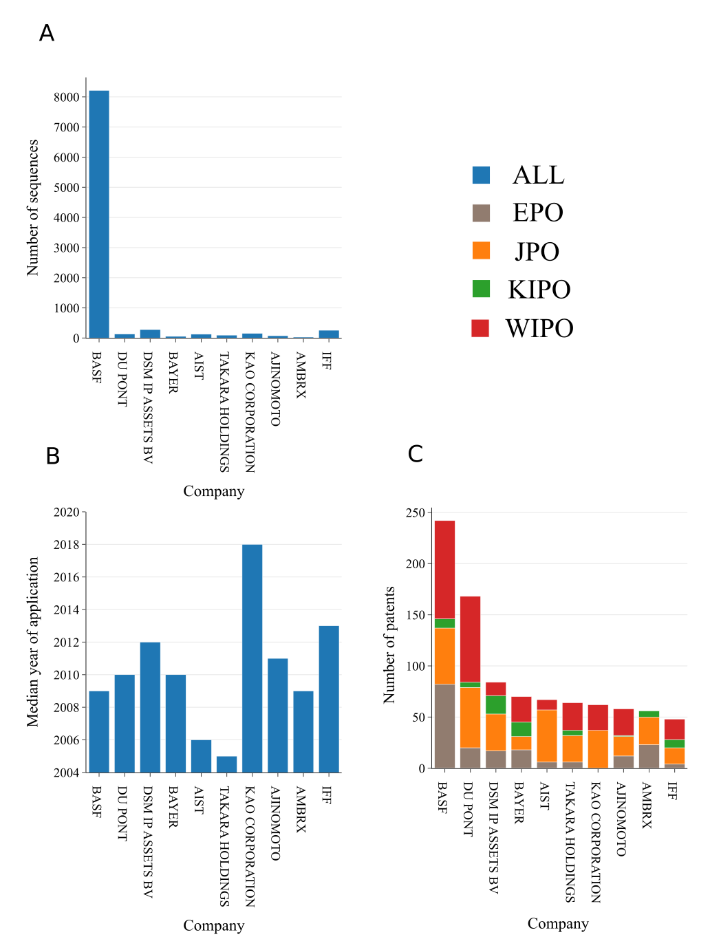
Figure S1. Top 10 largest patent applicants that referenced sequences with marine origin. A Number of sequences included in patent applications. B. Median year of application. C. Number of patent applications color coded by patent system in which application was submitted.

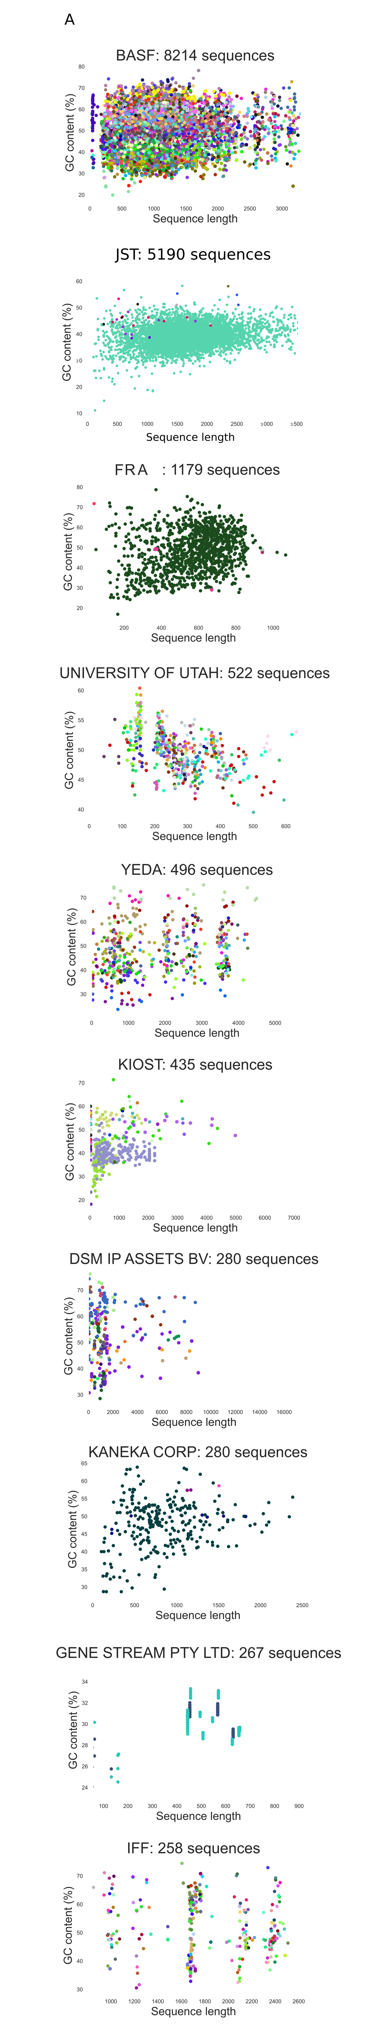 | 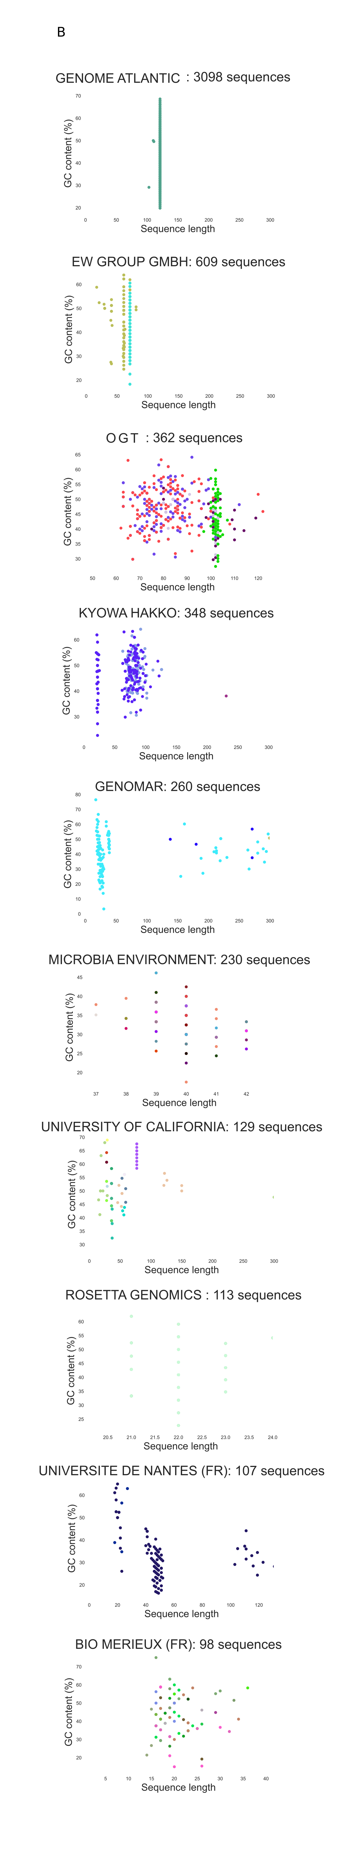
Figure S2. Patent applicants that referenced the largest number of genetic sequences with marine origin. A Sequences with gene length larger than the minimal protein length (150 nucleotides). B. Sequences with gene length shorter than the minimal protein length. Patent applicants often patent short sequences with same sequence length to use them for DNA amplification but long sequences tend to differ.

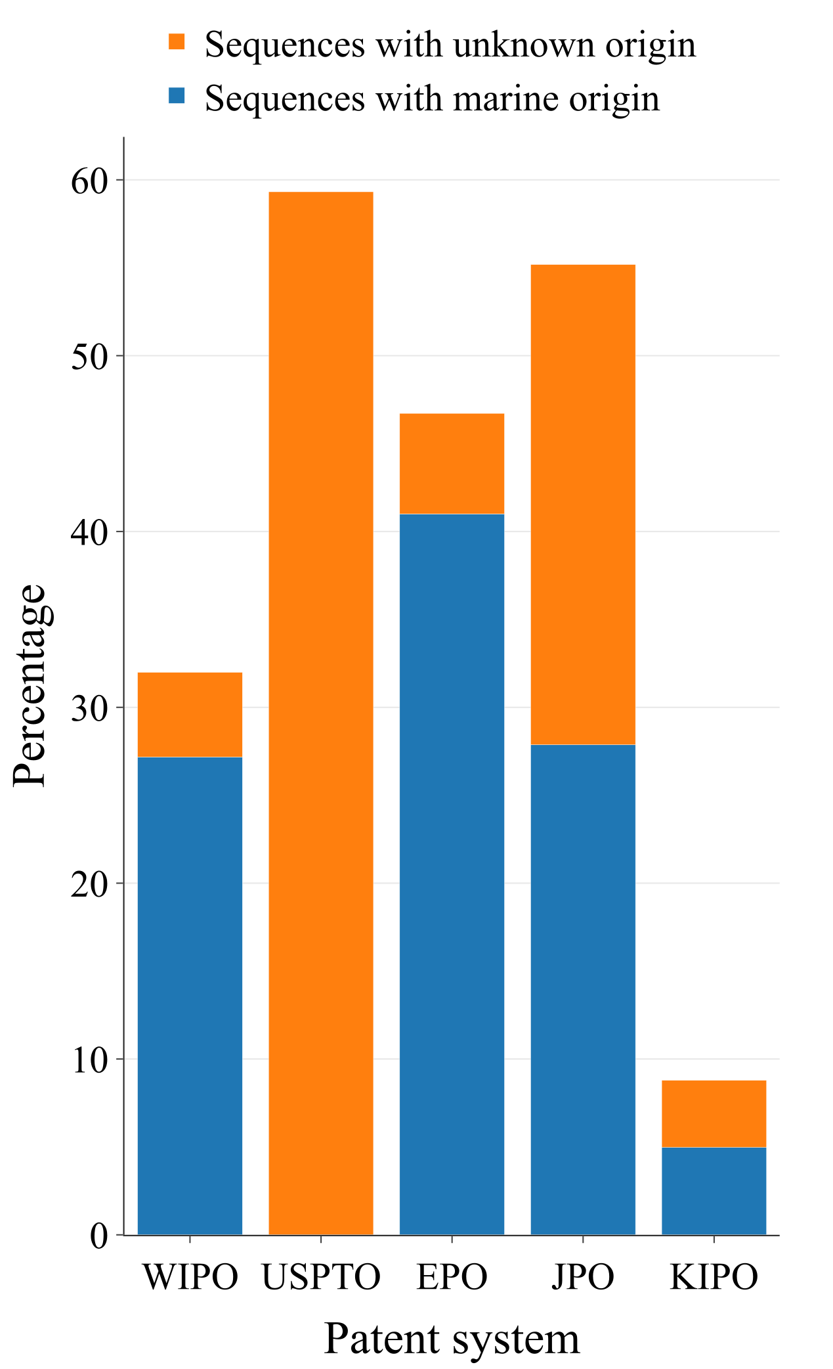

Figure S3. Summary statistics for sequences with marine and unknown origin aggregated by patent system in which application was submitted. Nearly 60% of all sequences with unknown origin were submitted in USPTO.

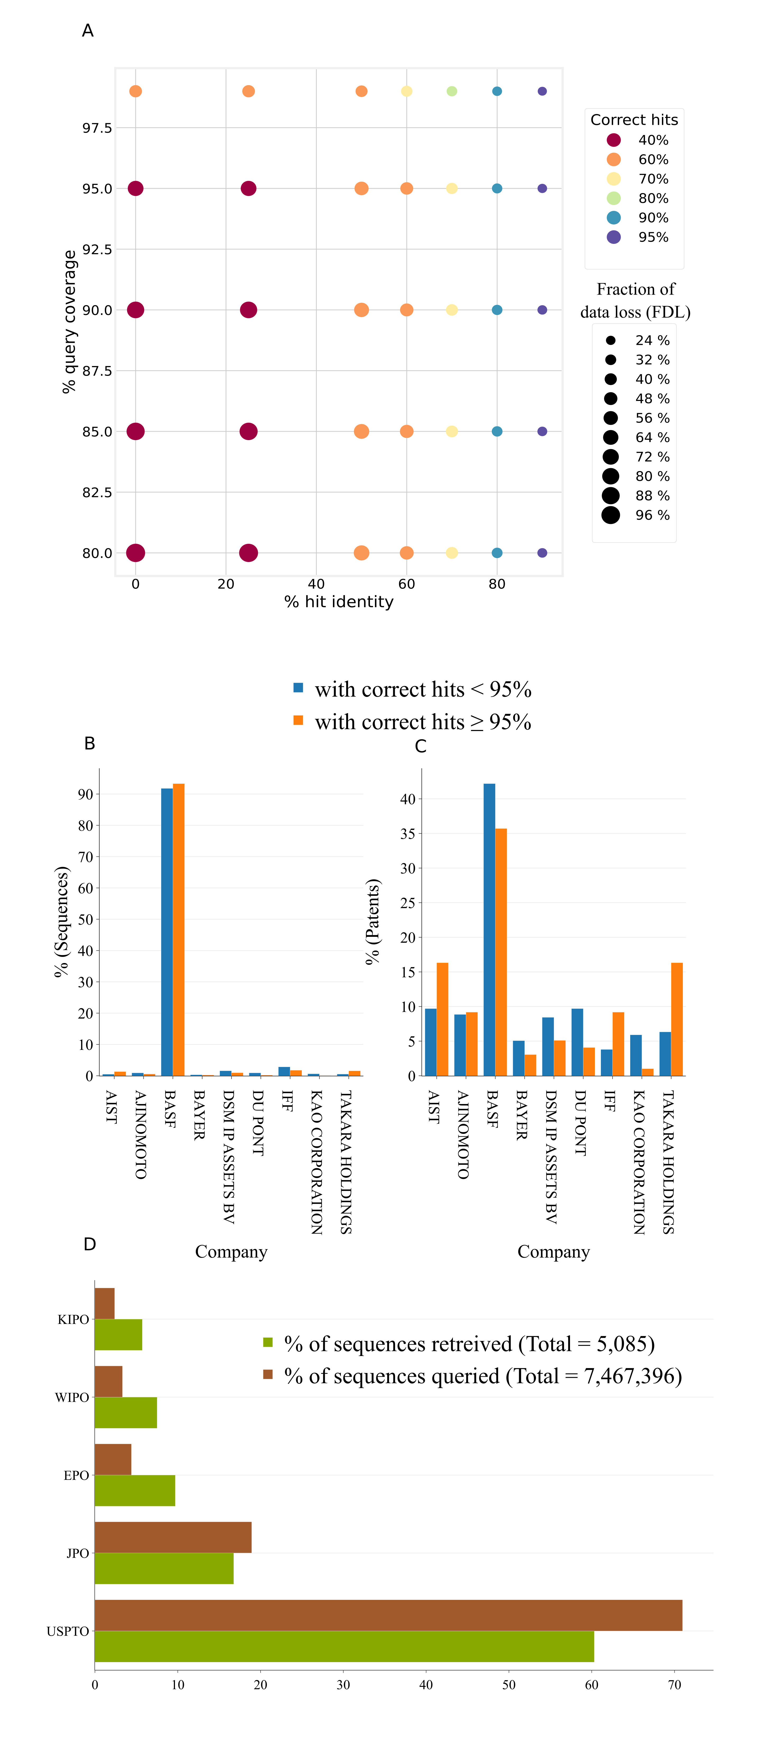

Figure S4. Sequence similarity model performance and bias checks. A. BlastX sequence similarity model performance and parameter search. Sequence alignments with query coverage equal or greater 80%, and percentage identify equal or greater than 95% resulted in 95% of correct species. B. Bias check for even distribution of sequences across largest applicants, for alignments with 95% percentage identify and lower. C. Bias check for even distribution of patents across largest applicants, for alignments with 95% percentage identify and lower. D. Bias check for even distribution of sequences across patent systems, for all searched and correctly identified sequences.

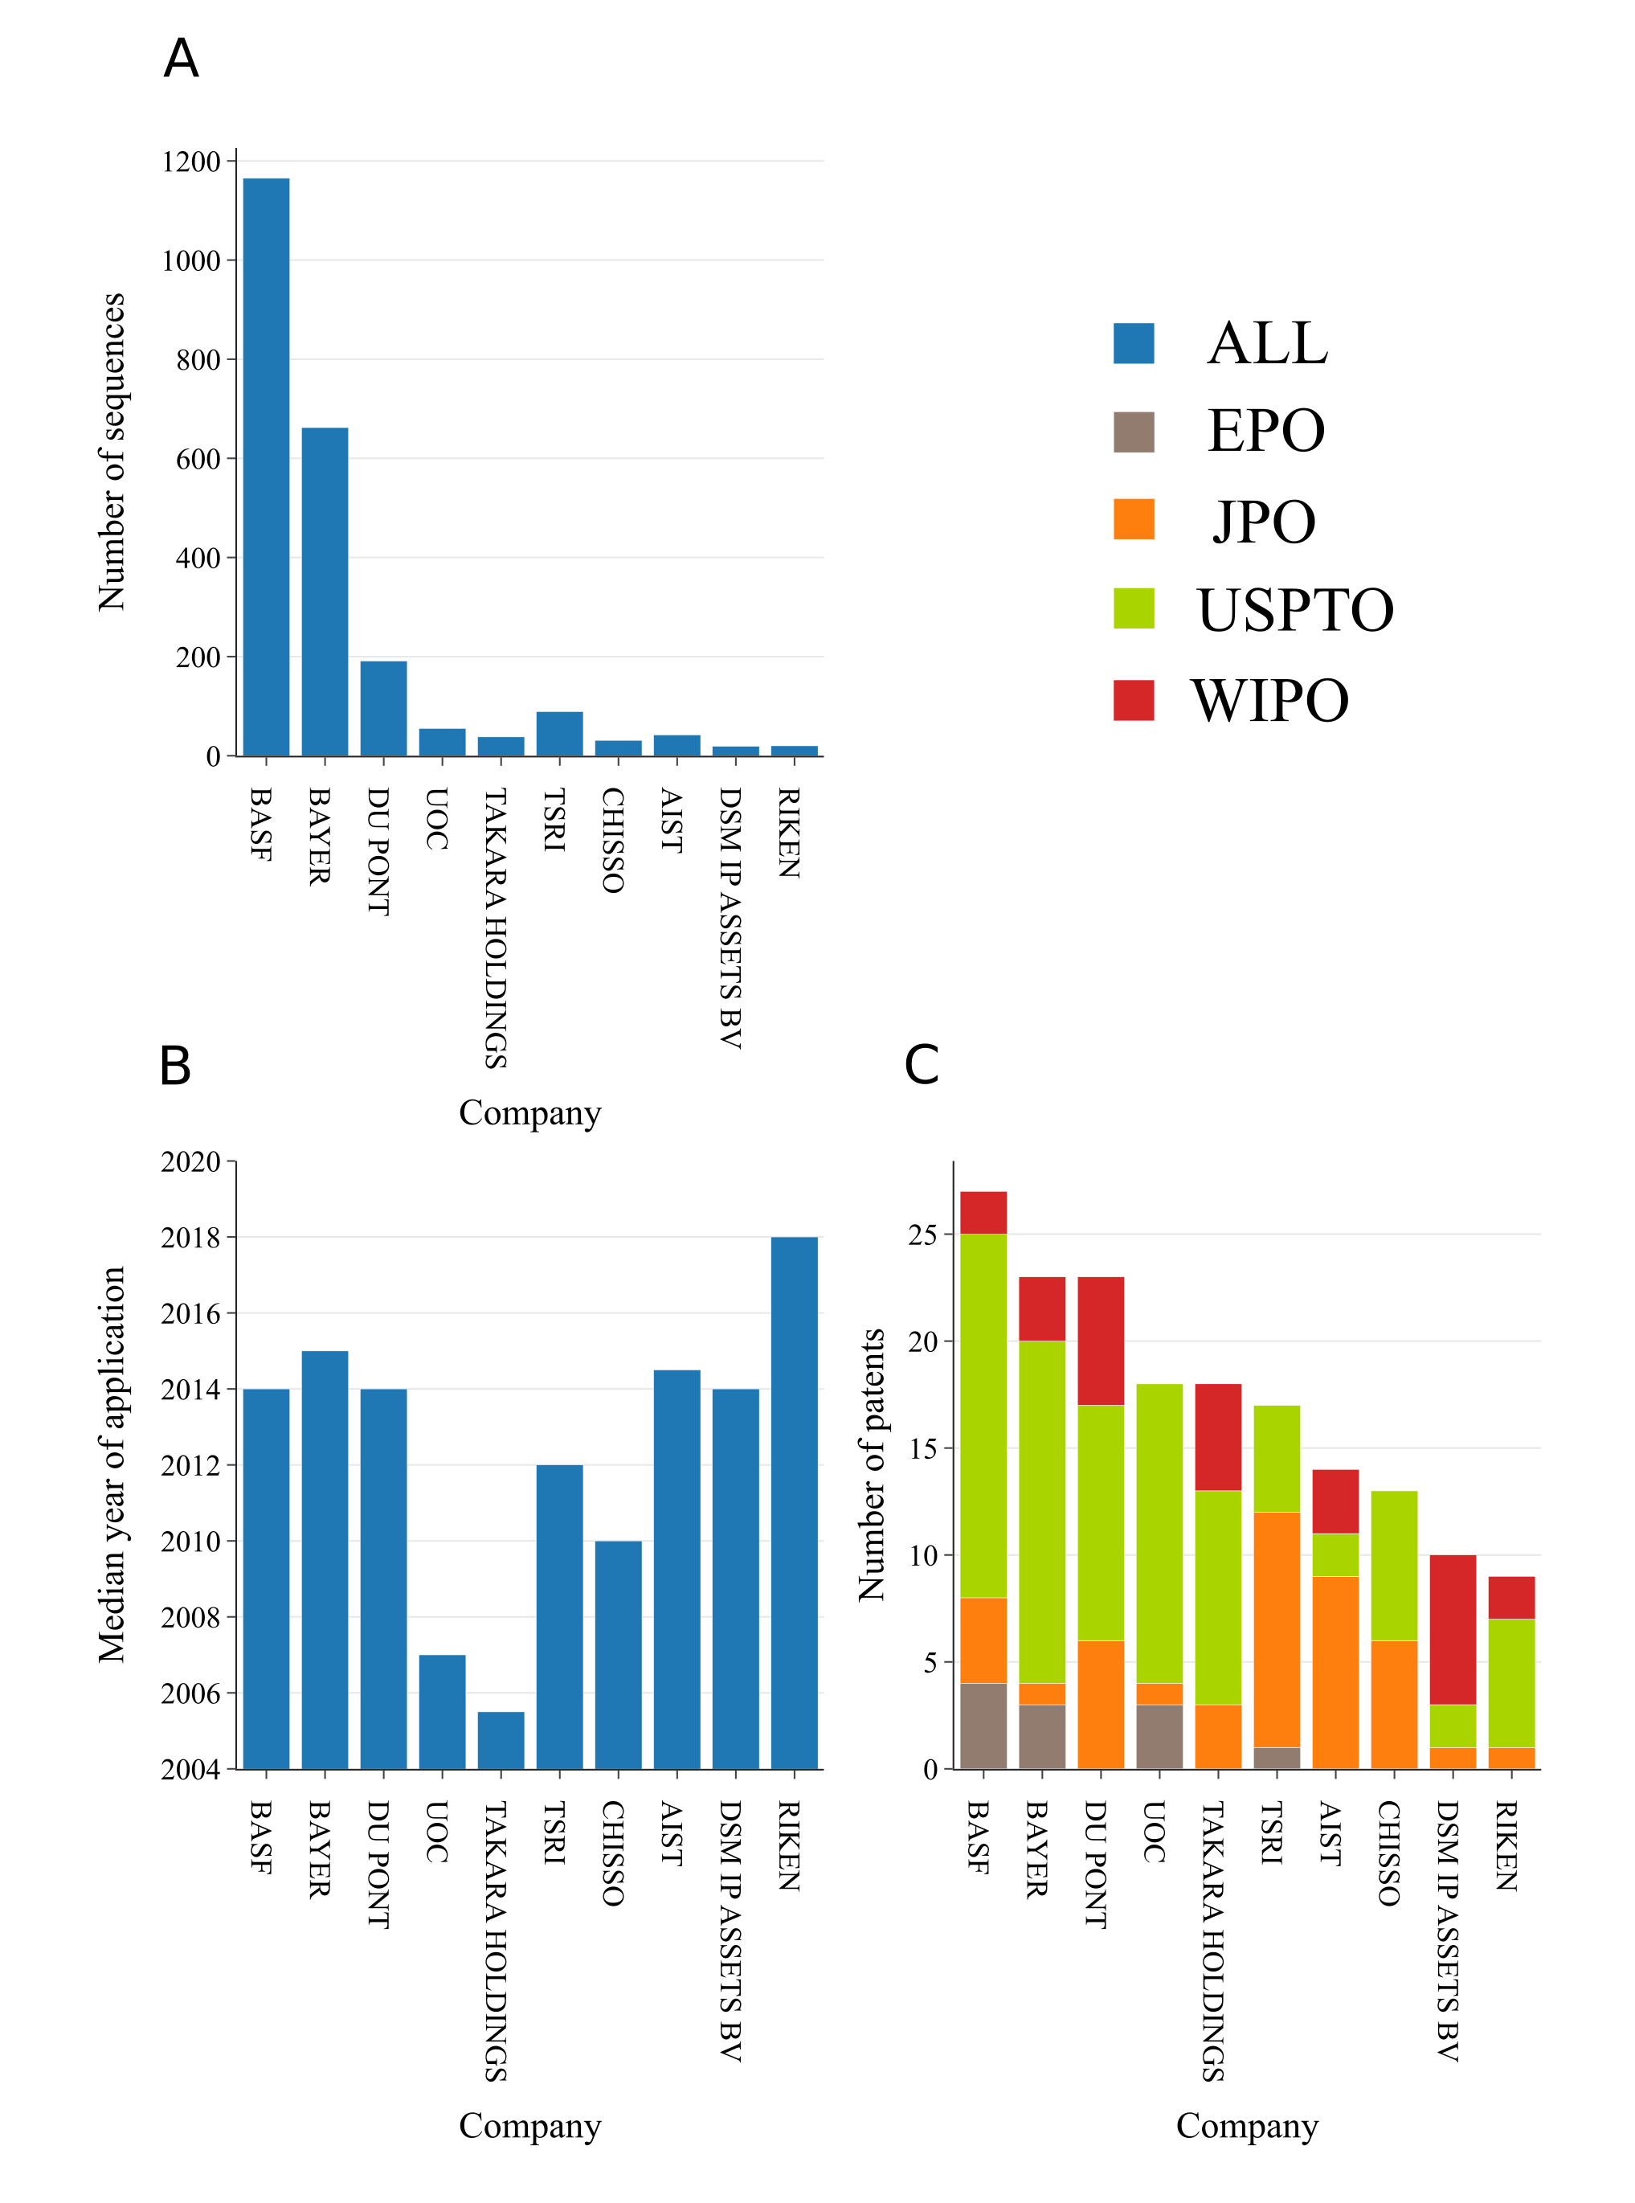

Figure S5. Top 10 largest patent applicants that referenced sequences with predicted marine origin. A Number of sequences included in patent applications. B. Median year of application. C. Number of patent applications color coded by patent system in which application was submitted.
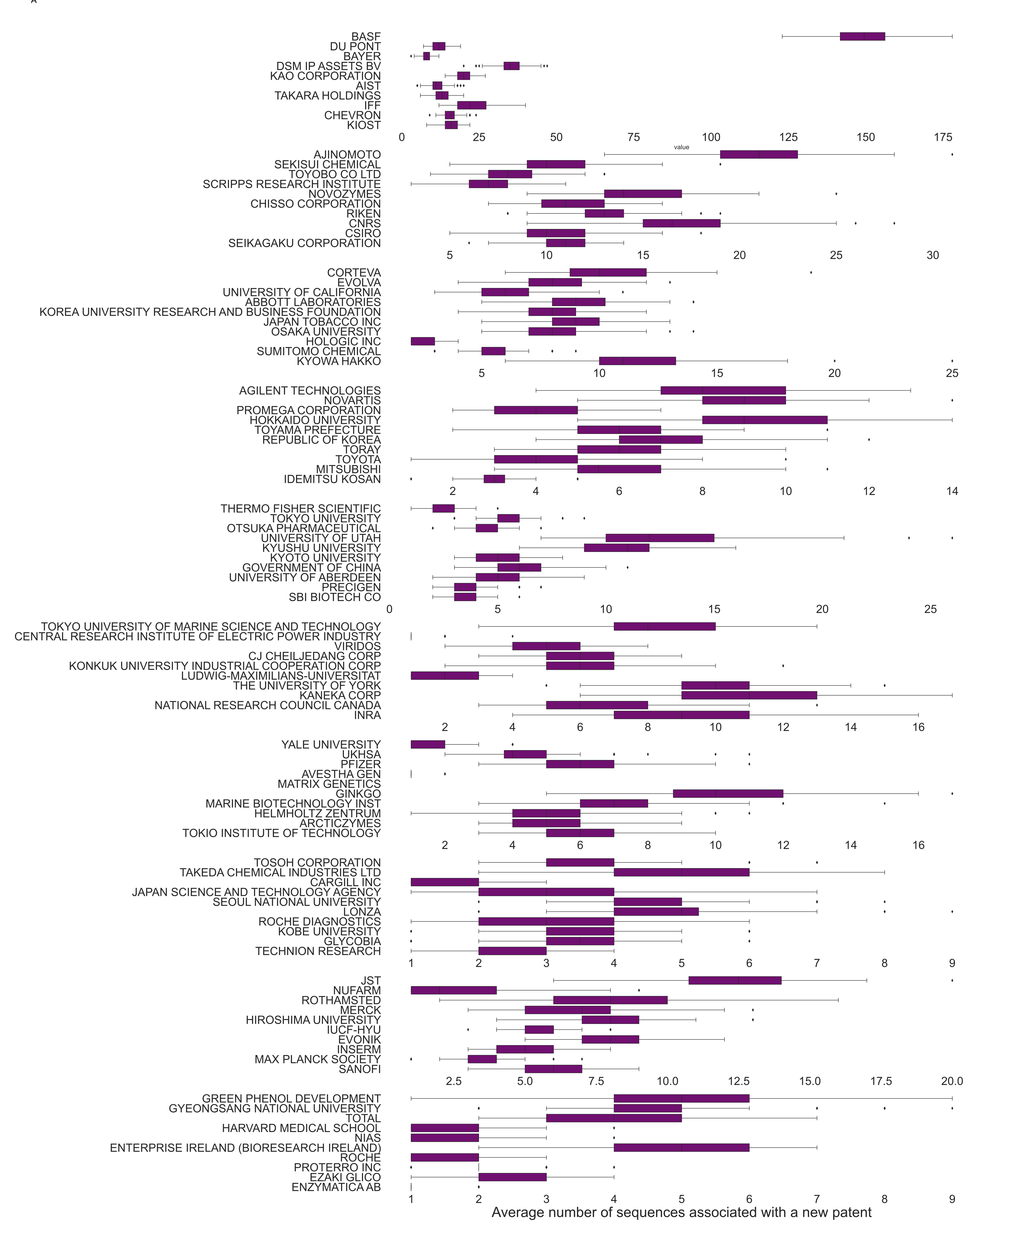

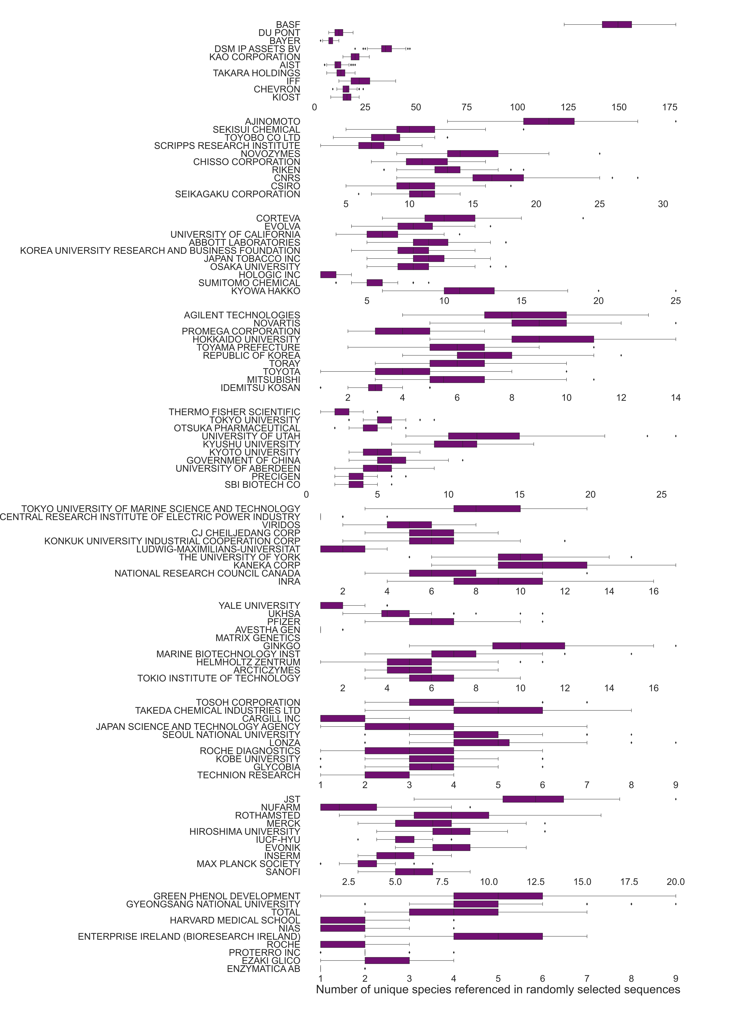

Figure S6. Average number of species and patent numbers referenced by companies in top-100. A total number of sequences with marine origin was used to randomly select sequences submitted by each applicant A. Average number of unique patent numbers referenced in randomly selected set of sequences. B. Average number of unique species referenced in randomly selected sets of sequences.
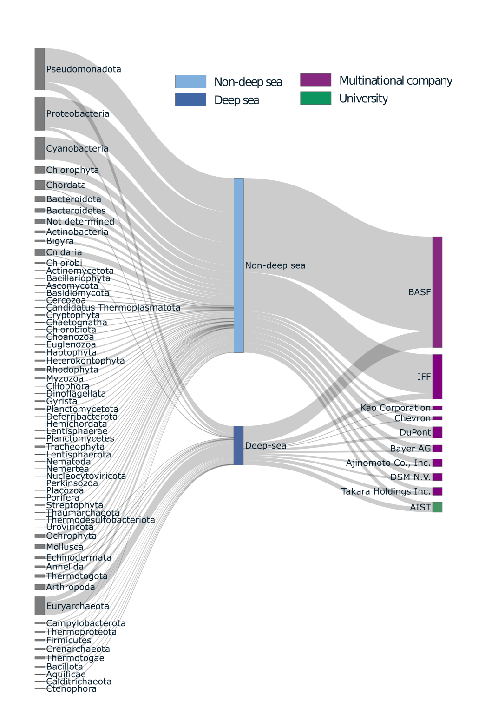

Figure S7. Species of interest in bioprospecting connected to a company of reference in patent application grouped by Phylum and potential presence in deep-sea habitats.
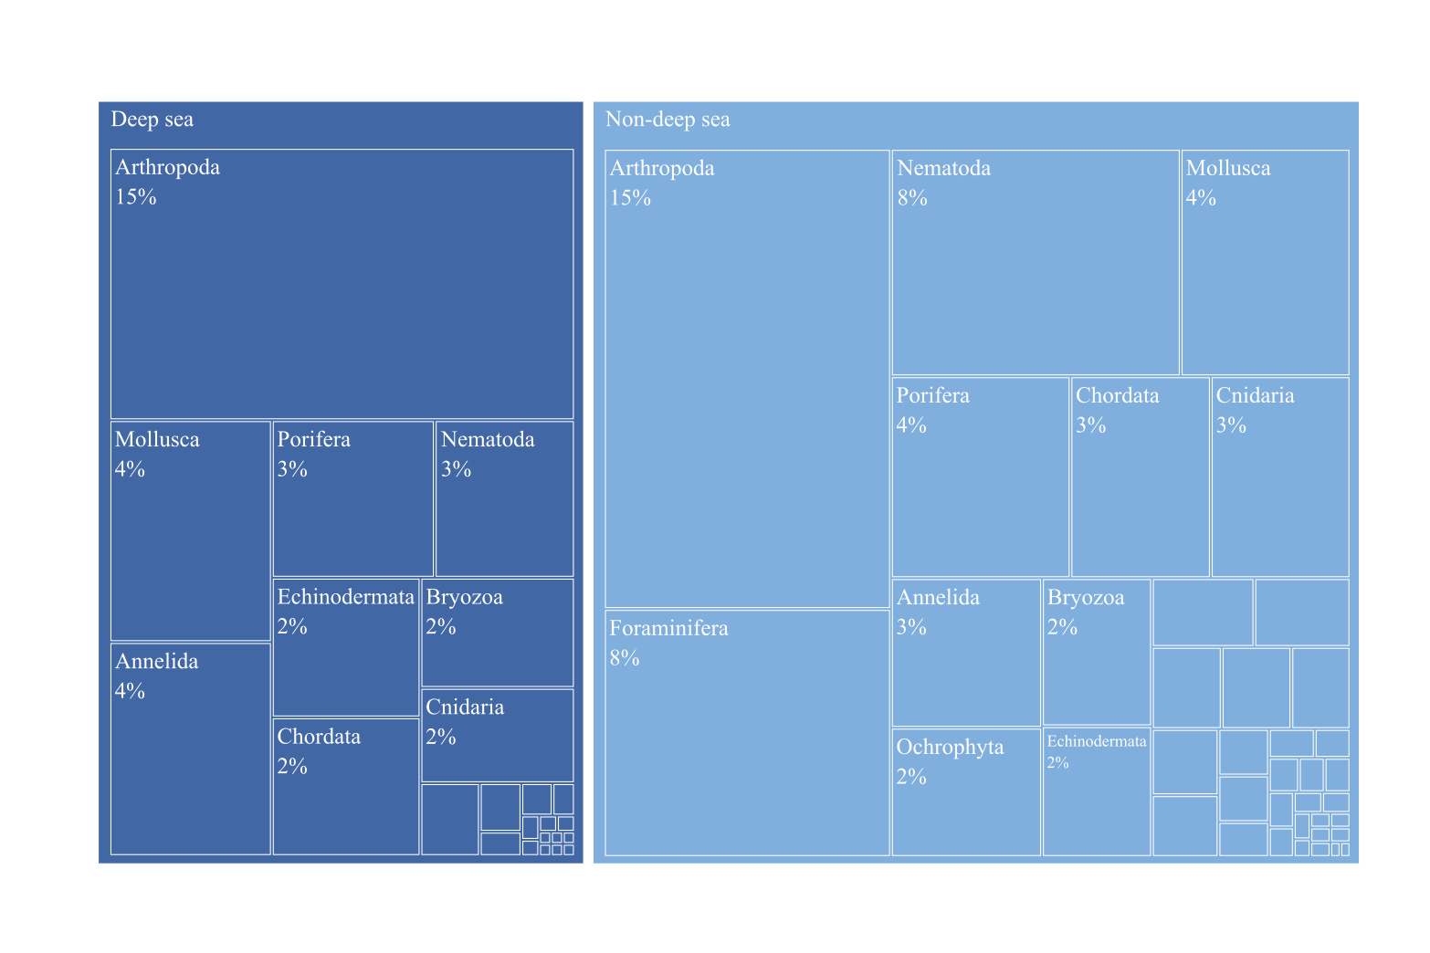
Figure S8. Marine species uniquely present in ABNJ, grouped by Phylum and potential presence in deep-sea habitats. Deep-sea Phyla with low frequencies (less than 2%): Foraminifera (1%), Kinorhyncha (0.238%), Brachiopoda (0.119%), Chaetognatha (0.119%), Nemertea (0.0849%), Tardigrada (0.051%), Dicyemida (0.034%), Ochrophyta 0.034%), Choanozoa (0.034%), Acanthocephala (0.017%), Loricifera (0.017%), Platyhelminthes (0.017%), Hemichordata (0.017%), Proteobacteria (0.017%), Thermotogae (0.017%). Non-deep sea: Myzozoa (1%), Ascomycota (1%), Ciliophora (1%), Rhodophyta (1%), Platyhelminthes (1%), Nemertea (1%), Haptophyta (0.476%), Radiozoa (0.272%), Rotifera (0.272%), Chlorophyta (0.204%), Brachiopoda (0.153%), Amoebozoa (0.119%), Proteobacteria (0.119%), Choanozoa (0.102%), Euglenozoa (0.102%), Xenacoelomorpha (0.102%), Ctenophora (0.0849%), Acanthocephala (0.0679%), Cercozoa (0.0679%), Tardigrada (0.051%), Bacteroidetes (0.034%), Basidiomycota (0.034%), Hemichordata (0.034%), Kinorhyncha (0.034%), Zygomycota (0.034%)

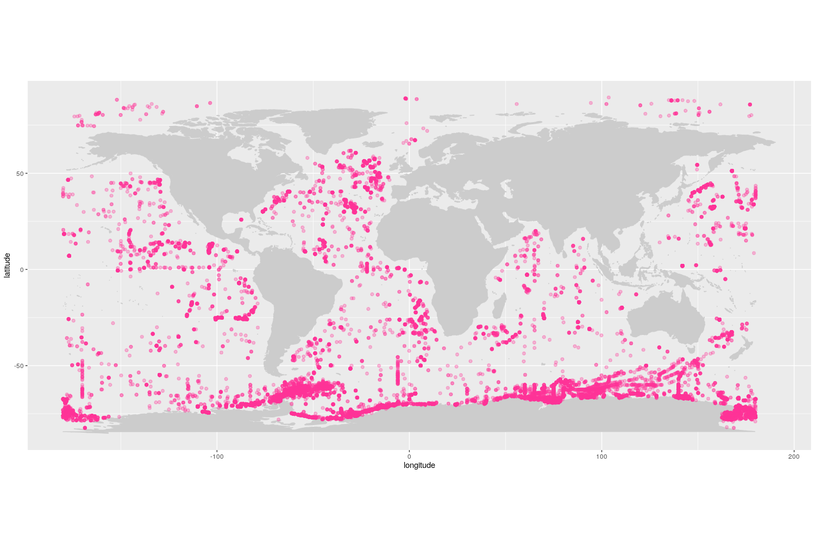
Figure S9. Marine species uniquely present in ABNJ, mapped into the location where they were observed.

