Supplementary materials & methods

Glucagon-like peptide-1 and glucagon-like peptide-2 are potential regulators of lipid metabolism during human liver regeneration
Authors
Markus Ammann ^{1,2}; tellammann@gmail.com
Jonas Santol ³; tellsantol@gmail.com
David Pereyra ²; tellpereyra@gmail.com
Tamara Kalchbrenner ⁴; tamara.kalchbrenner@wienerneustadt.lknoe.at
Tanja Wuerger ⁴; twuerger@live.de
Johannes Laengle ²; johannes.laengle@meduniwien.ac.at
Rory L. Smoot ⁵; smoot.rory@mayo.edu
Wolfgang Hulla ⁴; wolfgang.hulla@wienerneustadt.lknoe.at
Friedrich Laengle ¹; friedrich.laengle@wienerneustadt.lknoe.at
Patrick Starlinger ^{2,5}; tellstarlinger@gmail.com

Table of contents

Figure S1. GLP-1 and GLP-2 plasma concentrations in co-morbidities and histopathological findings of tumour distant liver tissue 2
Supplementary method 3
Figure S2. Representative image of immunohistochemistry staining for DPP4 3
Figure S3. Correlations of Bile acids, IL-6 and DPP4 with GLP-1 and GLP-2 4
Figure S4. Plasma lipid parameter level at perioperative timepoints 5
Supplementary table S1. 6
Supplementary table S2. 7
Supplementary table S3 8
Supplementary table S4 9
Supplementary table S5. 10

Fig. S1. GLP-1 and GLP-2 plasma concentrations in co-morbidities and histopathological findings of tumour distant liver tissue. No observed differences in, neither GLP-1 nor GLP-2 level between patients with a normal and elevated BMI (A), regarding NASH (B), steatosis of a greater extent than 33% of hepatocytes (C), presence of diabetes mellitus (D), presence of fibrosis of any grade f1-4 (E), or inflammatory activity (mild activity: ≤2pts, severe activity: >2pts regarding hepatocyte ballooning and inflammation) (F). Violine-blots with mean and quartiles; Man-Whitney-U test; BMI, body mass index, NASH, non-alcoholic steatohepatitis; *p<0.05.

Supplementary method

Immunohistochemistry staining of DPP4: formalin- fixated paraffin- embedded resection specimens were sliced into 2-3µm sections. Deparaffinization, heating and incubation with the monoclonal DPP4 antibody, TrueMAB™ (1:500, OTI11D7, Thermofisher Scientific, Waltham, MA) were performed automatically using VENTANA BenchMark ULTRA (Roche Diagnostics, Mannheim, Germany). Antigen- antibody reaction was visualized using Ventana UltraView Universal DAB Detection Kit (Roche Diagnostics, Mannheim, Germany). Counterstaining was conducted with hemalum- acetic acid- ddH₂O followed by bluing. Image was interpreted by a trained clinical pathologist.

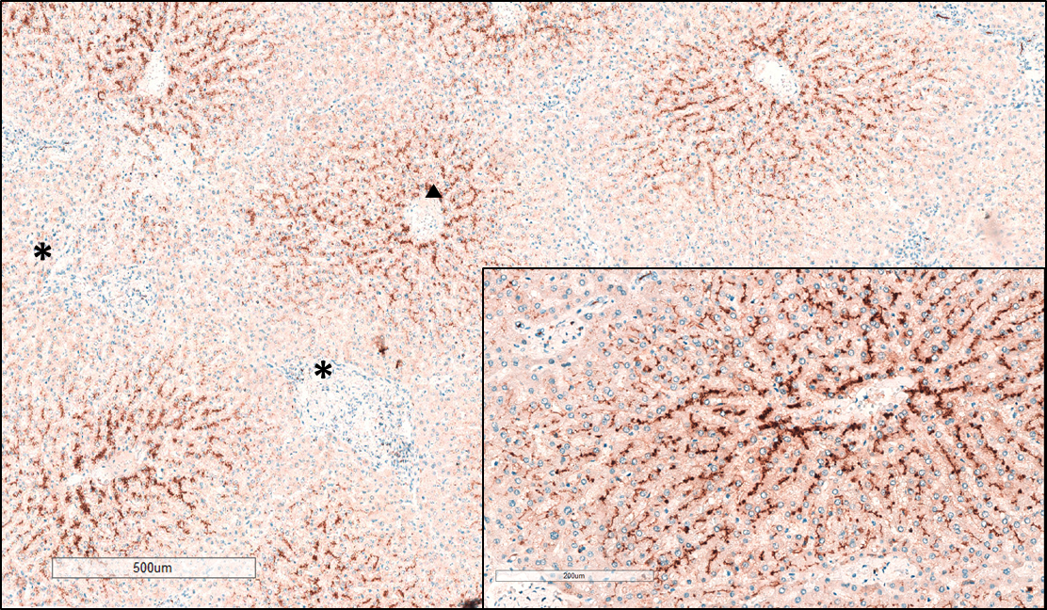
Fig. S2. Representative image of immunohistochemistry staining for DPP4. DPP4 expression in the portal fields of a liver lobule; Magnification of one peri-central field (portal zone 3) displaying DPP4 expression in the bile canaliculi between lines of hepatocytes and missing DPP4 staining in the sinusoids or blood vessels; central vein (black triangle); portal triad (black asterisks). Scale bars for 500µm (main image) and 200µm (insert) are given.

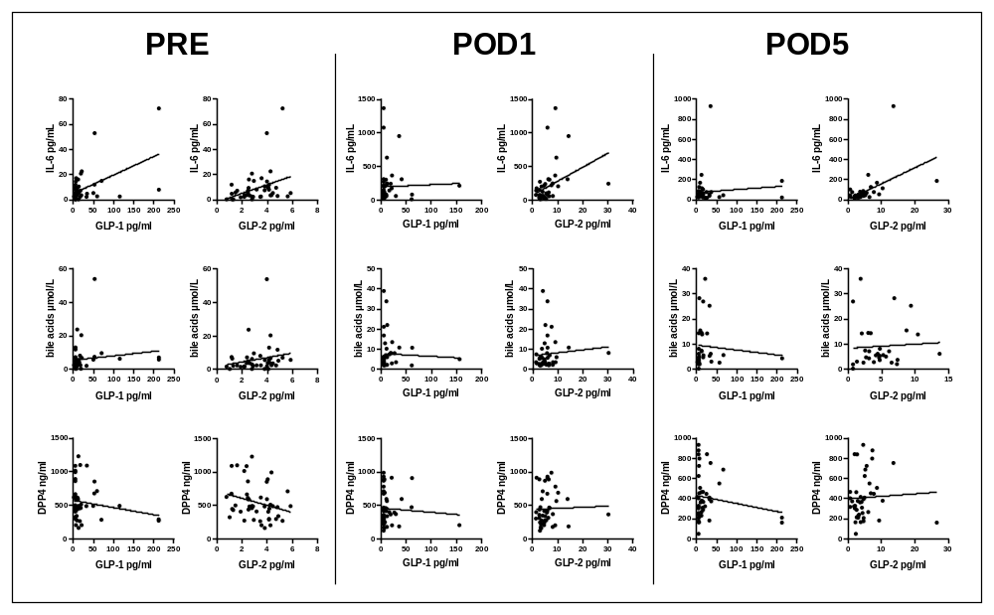
Fig. S3. Correlations of Bile acids, IL-6 and DPP4 with GLP-1 and GLP-2. Scatterplots with regression line for plasma concentration correlations of indicated parameters at perioperative timepoints.

Fig. S4. Plasma lipid parameter level at perioperative timepoints. Violine-blots display plasma lipid parameter level within groups, for triglycerides (A), total cholesterol (B), LDL (C), HDL (D), ApoA1 (E)and ApoB (F) (Mann-Whitney-U test) and changes between timepoints (Wilcoxon signed-rank test). horizontal and dotted lines for means and quartiles; LDL, low-density lipoprotein, ApoB, apolipoprotein B, HDL, high-density lipoprotein; ApoA1, apolipoprotein A1; *p<0.05; **p<0.005; ***p<0.0005.

Supplementary tab. S1. Area under the curve (AUC) analysis of resection extend (minor vs. major liver resection). Patients with PHLF and morbidity ≥3 excluded.
 | minor |  |  | major
 | n | Median (range) |  | n | Median (range) | p-value
GLP-1 (pg/ml) | 22 | 35.46 (22.10- 926.70) |  | 8 | 57.02 (30.51- 318.80) | 0.126
GLP-2 (pg/ml) | 21 | 20.27 (9.17- 51.14) |  | 10 | 29.21 (8.22- 36.29) | 0.820
Bile acids (µmol/l) | 18 | 21.95 (7.00- 81.20) |  | 7 | 49.45 (24.70- 91.30) | 0.845
IL-6 (pg/ml) | 18 | 435.10 (79.00- 3539.00) |  | 10 | 484.90 (152.60- 1676.00) | 0.774
DPP4 (ng/ml) | 21 | 1871.00 (816.90 -4561.00) |  | 10 | 1900.00 (818.10- 4051.00) | 0.028
Triglycerides (mg/dl) | 19 | 517.50 (317.00- 1236.00) |  | 10 | 378.00 (262.0- 792.5) | 0.014
Total cholesterol (mg/dl) | 23 | 651.00 (436.00-1033.00) |  | 10 | 538.75 (372.5- 757.0) | 0.286
LDL (mg/dl) | 17 | 333.50 (169.00- 583.00) |  | 10 | 316.50 (124.5- 493.0) | 0.970
ApoB (g/l) | 20 | 3.09 (1.08- 5.40) |  | 10 | 2.74 (1.665- 4.435) | 0.494
HDL (mg/dl) | 21 | 194.00 (127.50- 348.50) |  | 10 | 170.50 (49.5- 325.0) | 0.441
ApoA1 (g/l) | 21 | 5.19 (3.88- 7.11) |  | 10 | 3.70 (0.655- 8.365) | 0.093
AUC analysis from preoperative (PRE) to POD5. Given are AUCs medians; values in parenthesis indicate rages; DPP4, dipeptidyl peptidase-4; GLP-1, glucagon like peptide-1; GLP-2, glucagon-like peptide-2; IL-6, Interleukin-6; LDL, low-density lipoprotein; ApoB, apolipoprotein B; HDL, high-density lipoprotein; ApoA1, apolipoprotein A1; Man-Whitney-U test.

Supplementary tab. S2. GLP-1, GLP-2 and DPP4 plasma concentrations.
 |  | noPHLF |  |  | PHLF
 |  | n | Median (range) |  | n | Median (range) | p
GLP-1 (pg/ml)
 | PRE | 39 | 7.26 (2.64- 213.71) |  | 7 | 18.47 (9.56- 213-71) | 0.030
 | POD1 | 38 | 6.10 (5.94- 156.98) |  | 7 | 10.55 (6.10- 22.76) | 0.451
 | POD5 | 36 | 7.42 (2.97- 213.71) |  | 7 | 17.15 (8.25- 213.71) | 0.041
GLP-2 (pg/ml)
 | PRE | 39 | 3.18 (0.79- 5.89) |  | 7 | 2.96 (1.64- 5.25) | 0.383
 | POD1 | 38 | 4.75 (1.50- 14.47) |  | 7 | 6.89 (5.10- 30.36) | 0.008
 | POD5 | 36 | 3.83 (0.79- 9.44) |  | 7 | 7.87 (0.79- 26.67) | 0.006
DPP4 (ng/ml)
 | PRE | 39 | 481.20 (157.70- 1087.00) |  | 7 | 506.90 (265.80- 1226.00) | 0.788
 | POD1 | 38 | 359.90 (118.60- 983.00) |  | 7 | 454.20 (198.70- 924.40) | 0.234
 | POD5 | 36 | 361.45 (45.93- 930.10) |  | 7 | 443.60 (157.70- 794.40) | 0.468
Median plasma concentrations at indicated timepoints; values in parenthesis display ranges; GLP-1, glucagon like peptide-1; GLP-2, glucagon-like peptide-2; DPP4, dipeptidyl peptidase-4; Man-Whitney-U test.

Supplementary tab. S3. Area under the curve (AUC) analysis.

 | noPHLF |  |  | PHLF
 | n | Median (range) |  | n | Median (range) | p
GLP-1 (pg/ml) | 35 | 38.09 (22.10- 926.70) |  | 7 | 65.47 (38.67- 591.20) | 0.114
GLP-2 (pg/ml) | 35 | 20.23 (7.3- 57.21) |  | 7 | 43.05 (28.87- 79.94) | <0.001
Bile acids (µmol/l) | 30 | 26.13 (7.00- 156.70) |  | 5 | 77.10 (13.95- 203.20) | 0.299
IL-6 (pg/ml) | 32 | 375.15 (79.0- 3539.0) |  | 5 | 967.90 (646.50- 4535.00) | 0.005
DPP4 (ng/ml) | 35 | 1727.50 (816.9- 4750.0) |  | 7 | 2179.00 (945.1- 4359.0) | 0.323
Triglycerides (mg/dl) | 34 | 495.00 (258.5- 1236.0) |  | 7 | 384.00 (324- 726) | 0.444
Total cholesterol (mg/dl) | 38 | 648.75 (360.5- 1033.0) |  | 7 | 374.50 (269.0- 553.5) | <0.001
LDL (mg/dl) | 32 | 333.00 (124.5- 627.5) |  | 4 | 197.25 (50.0- 256.0) | 0.012
ApoB (g/l) | 34 | 2.99 (1.08- 5.40) |  | 4 | 1.70 (0.75- 2.46) | 0.005
HDL (mg/dl) | 36 | 191.75 (49.5- 348.5) |  | 4 | 115.25 (86.0- 241.5) | 0.135
ApoA1 (g/l) | 36 | 4.95 (0.66- 8.37) |  | 4 | 3.14 (1.93- 4.93) | 0.025
AUC analysis from preoperative (PRE) to POD5. Given are AUCs medians; values in parenthesis indicate rages; DPP4, dipeptidyl peptidase 4; GLP-1, glucagon like peptide-1; GLP-2, glucagon-like peptide-2; IL-6, Interleukin-6; LDL, low-density lipoprotein; ApoB, apolipoprotein B; HDL, high-density lipoprotein; ApoA1, apolipoprotein A1; Man-Whitney-U test.

Supplementary tab. S4. Area under the curve (AUC) analysis of postoperative morbidity according to the Dindo classification. PHLF patients excluded.
 | Morbidity <3 |  |  | Morbidity ≥3
 | n | Median (range) |  | n | Median (range) | p
GLP-1 (pg/ml) | 31 | 41.89 (22.10- 926.70) |  | 5 | 63.66 (30.51- 591.20) | 0.288
GLP-2 (pg/ml) | 31 | 19.56 (8.22- 51.14) |  | 5 | 37.35 (7.20- 57.21) | 0.262
Bile acids (µmol/l) | 25 | 25.45 (7.0- 91.3) |  | 5 | 68.10 (15.25- 156.7) | 0.355
IL-6 (pg/ml) | 28 | 354.6 (79.0- 3539.0) |  | 4 | 669.40 (323.7- 2477.0) | 0.361
DPP4 (ng/ml) | 31 | 1674.00 (816.9- 4561.0) |  | 5 | 2119.50 (913.0- 4750.0) | 0.690
Triglycerides (mg/dl) | 29 | 511.00 (262.0- 1236.0) |  | 5 | 383.00 (258.5- 611.5) | 0.179
Total cholesterol (mg/dl) | 33 | 651.00 (372.5- 1033.0) |  | 5 | 422.50 (360.5- 749.0) | 0.399
LDL (mg/dl) | 27 | 333.50 (124.5- 583.0) |  | 5 | 247.00 (183.0- 627.5) | 1.000
ApoB (g/l) | 30 | 3.05 (1.08- 5.40) |  | 4 | 2.00 (1.90- 3.56) | 0.131
HDL (mg/dl) | 31 | 192.00 (49.5- 348.5) |  | 5 | 144.00 (132.5- 236.0) | 0.348
ApoA1 (g/l) | 31 | 5.00 (0.66- 8.37) |  | 5 | 3.56 (3.16- 5.60) | 0.175
AUC analysis from preoperative (PRE) to POD5. Given are AUCs medians; values in parenthesis indicate rages; DPP4, dipeptidyl peptidase-4; GLP-1, glucagon like peptide-1; GLP-2, glucagon-like peptide-2; IL-6, Interleukin-6; LDL, low-density lipoprotein; ApoB, apolipoprotein B; HDL, high-density lipoprotein; ApoA1, apolipoprotein A1; Man-Whitney-U test.

Supplementary tab. S5. Spearman correlation of areas under the curv (AUC) for GLP-1, GLP-2, triglycerides and total cholesterol
 |  | AUC GLP-1 |  | AUC GLP-2
 |  | p-value | R | p-value | R
Triglycerides AUC | noPHLF | 0.136 | 0.275 | 0.182 | 0.238
 | PHLF | 0.119 | 0.643 | 0.052 | 0.750
total Cholesterol AUC | noPHLF | 0.442 | -0.136 | 0.749 | -0.056
 | PHLF | 0.071 | -0.714 | 0.023 | -0.821
GLP-1, glucagon-like peptide-1; GLP-2, glucagon like peptide-2.

