Additional file 1. The prediction of concentrated epitope of T-cell from four common antigens using DNAStar Protean software.
Figure 1 The prediction of concentrated epitope of T-cell from 14-3-3
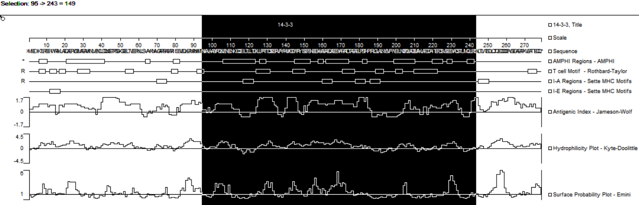

Figure 2 The prediction of concentrated epitope of T-cell from GAPDH
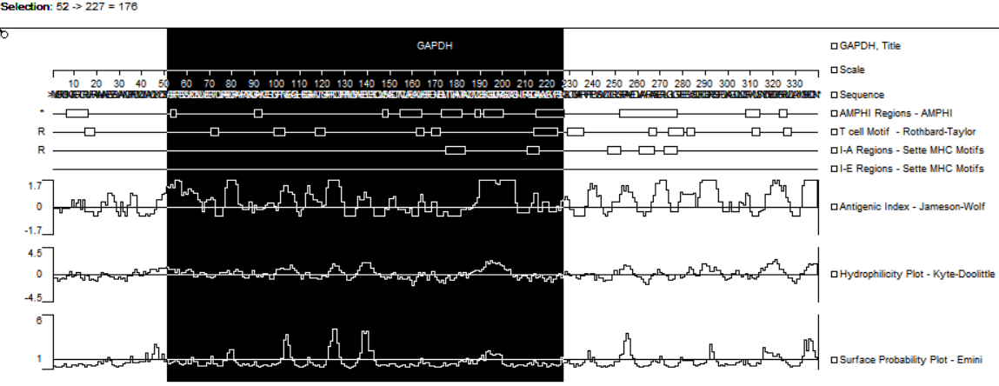

Figure 3 The prediction of concentrated epitope of T-cell from EF2
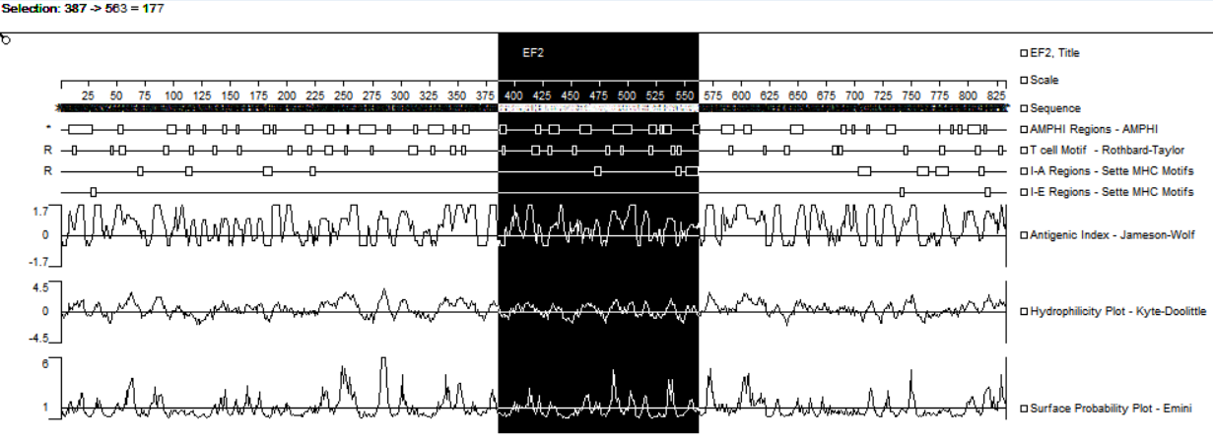

Figure 4 The prediction of concentrated epitope of T-cell from transhydrogenase
