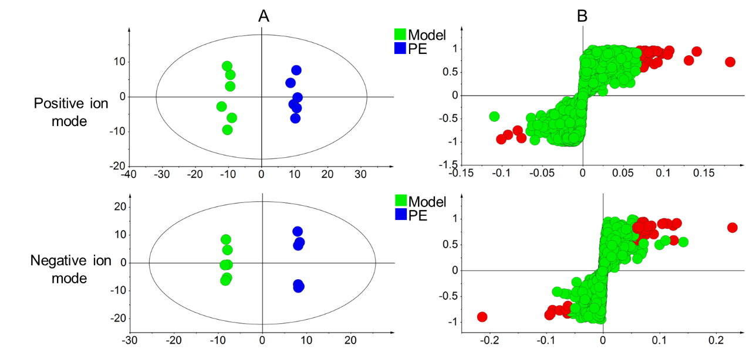
S-1. OPLS-DA score (A) and S-plot (B) of serum metabolites between PE group and model group under positive and negative ion mode

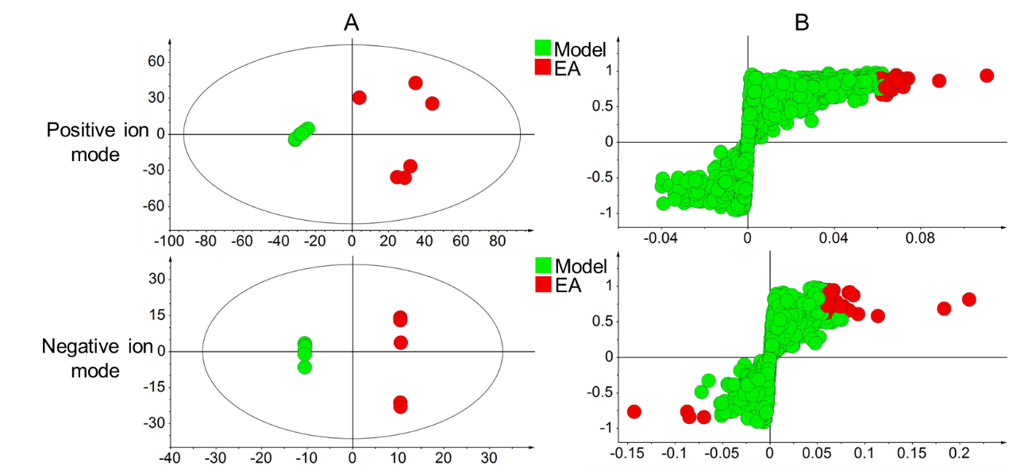
S-2. OPLS-DA score (A) and S-plot (B) of serum metabolites between EA group and model group under positive and negative ion mode

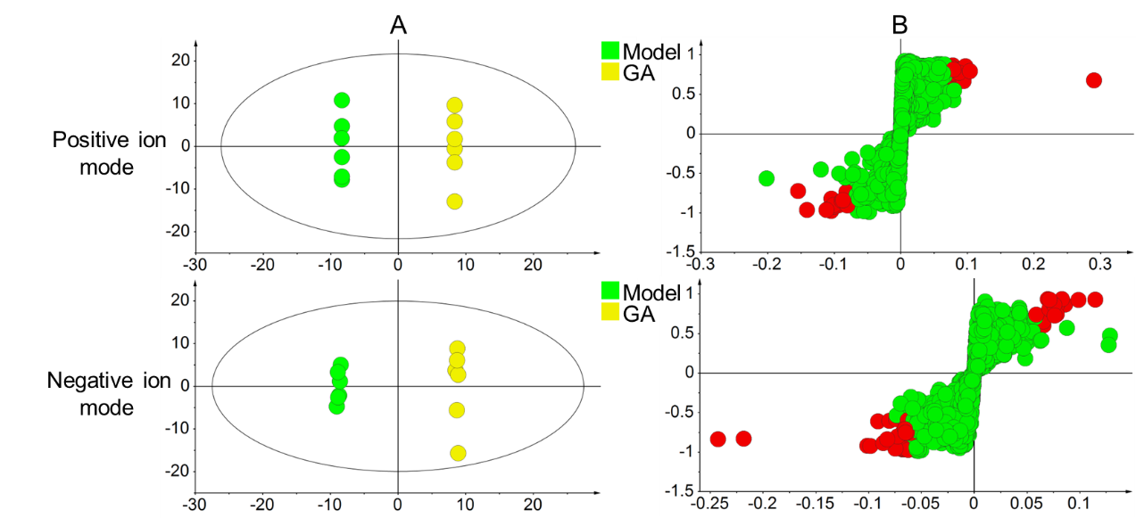
S-3. OPLS-DA score (A) and S-plot (B) of serum metabolites between GA group and model group under positive and negative ion mode

S-4 Differential metabolites in serum of PE and Model group under positive ion mode
Component | Chemical formula | m/z | RT/min | Trend
2-Heptanone | C₇H₁₄O | 153.0663 | 2.00 | ↑
Gibberellin A51 | C₁₉H₂₄O₅ | 682.3621 | 17.17 | ↓
Clupanodonyl carnitine | C₂₉H₄₇NO₄ | 969.6889 | 20.56 | ↓
Moreollin | C₃₅H₄₂O₈ | 623.3257 | 21.18 | ↑
SM(d18:0/20:0) | C₄₃H₈₉N₂O₆P | 799.6156 | 21.55 | ↑
Ganolucidic acid A | C₃₀H₄₄O₆ | 1064.6520 | 22.12 | ↑
Adenosine tetraphosphate | C₁₀H₁₇N₅O₁₆P₄ | 1196.9163 | 22.12 | ↑
CDP-DG(i-24:0/i-24:0) | C₆₀H₁₁₃N₃O₁₅P₂ | 1142.7469 | 23.69 | ↑
5,8-Epoxy-5,8-dihydro-10'-apo-b,y-carotene-3,10'-diol | C₂₇H₃₈O₃ | 424.2973 | 24.63 | ↑
6-Glucopyranosylprocyanidin B2 | C₃₆H₃₆O₁₇ | 758.2212 | 24.89 | ↑
5a-Cholestane-3a,7a,12a,25-tetrol | C₂₇H₄₈O₄ | 911.6784 | 24.93 | ↑
dCDP | C₉H₁₅N₃O₁₀P₂ | 838.0664 | 25.02 | ↑
2-Hydroxyadipic acid | C₆H₁₀O₅ | 201.0176 | 25.04 | ↑
Octadecane | C₁₈H₃₈ | 550.6300 | 25.59 | ↓
6-Methylheptadecane | C₁₈H₃₈ | 550.6293 | 26.58 | ↑
Acarbose | C₂₅H₄₃NO₁₈ | 684.2038 | 26.61 | ↑
Pelargonidin 3-sophoroside 5-glucoside | C₃₃H₄₁O₂₀⁺ | 758.2190 | 27.12 | ↑

S-5 Differential metabolites in serum of PE and Model group under negative ion mode
Component | Chemical formula | m/z | RT/min | Trend
Toremifene | C₃₂H₃₆ClNO₈ | 809.3657 | 13.88 | ↑
7-Hydroxy-6-methyl-8-ribityl lumazine | C₁₂H₁₆N₄O₇ | 327.0915 | 17.15 | ↑
3a,6b,7a,12a-Tetrahydroxy-5b-cholanoic acid | C₂₄H₄₀O₆ | 469.2833 | 18.28 | ↑
alpha-Irone | C₁₄H₂₂O | 457.3353 | 19.53 | ↑
Behenoylglycine | C₂₄H₄₇NO₃ | 378.3334 | 19.77 | ↑
3a,7a,12a-Trihydroxy-5b-cholestanoic acid | C₂₇H₄₆O₅ | 449.3281 | 20.03 | ↑
CDP-DG(18:2(9Z,11Z)/a-25:0) | C₅₅H₉₉N₃O₁₅P₂ | 1138.6343 | 20.26 | ↑
alpha-Chaconine | C₄₅H₇₃NO₁₄ | 832.4833 | 20.31 | ↑
Phenylephrine | C₉H₁₃NO₂ | 500.3833 | 20.34 | ↑
Citronellyl anthranilate | C₁₇H₂₅NO₂ | 824.5510 | 20.51 | ↑
Hexadecanedioic acid mono-L-carnitine ester | C₂₃H₄₃NO₆ | 857.6080 | 21.55 | ↑
PC(16:1(9Z)/22:2(13Z,16Z)) | C₄₆H₈₆NO₈P | 856.6092 | 21.75 | ↑
LysoPC(15:0/0:0) | C₂₃H₄₈NO₇P | 480.4123 | 21.83 | ↑
Biotin | C₁₀H₁₆N₂O₃S | 281.0358 | 22.76 | ↓
N-((Hexahydro-1-azepinyl)carbonyl)-leucyl(1-methyl)-tryptophyl-tryptophan | C₃₄H₄₅N₅O₆ | 654.3126 | 22.85 | ↑
PE(DiMe(11,5)/PGF2alpha) | C₄₇H₈₂NO₁₂P | 928.5477 | 22.99 | ↓
3,28-Dihexadecanoyl 20(29)-lupene-2a,3b,28-triol | C₆₂H₁₁₀O₅ | 969.8093 | 23.22 | ↑
Josamycin | C₄₂H₆₉NO₁₅ | 862.4423 | 24.49 | ↑
N-Lauroyl Lysine | C₁₈H₃₆N₂O₃ | 701.5387 | 24.89 | ↑
Forasartan | C₂₃H₂₈N₈ | 397.2286 | 24.90 | ↓
Cholesterol sulfate | C₂₇H₄₆O4S | 465.4043 | 27.15 | ↑
Protocatechuic acid | C₇H₆O₄ | 188.9943 | 27.19 | ↑

S-6. Differential metabolites in serum of EA and Model group under positive ion mode
Component | Chemical formula | m/z | RT/min | Trend
Camellioside D | C₅₄H₈₈O₂₄ | 583.0235 | 10.55 | ↑
D-Glucosaminide | C₁₈H₃₅N₃O₁₃ | 515.2337 | 11.72 | ↑
PI(18:0/20:4(6Z,8E,10E,14Z)-2OH(5S,12R)) | C₄₇H₈₃O₁₅P | 482.7636 | 14.88 | ↑
CerP(d18:0/16:0) | C₃₄H₇₀NO₆P | 620.5018 | 15.87 | ↑
Sulfacytine | C₁₇H₁₇C_{l2}N | 652.3433 | 16.13 | ↑
(2R)-1-(4-Nonylphenyl)propan-2-amine | C₁₈H₃₁N | 523.4998 | 16.38 | ↑
a-L-threo-4-Hex-4-enopyranuronosyl-D-galacturonic acid | C₂₄H₃₂O₂₄ | 743.0925 | 16.45 | ↑
cyclic GMP-AMP | C₂₀H₂₄N₁₀O₁₃P₂ | 688.5869 | 16.75 | ↑
2-(3,4-Dihydroxyphenyl)-5,6-dihydroxy-7-methoxy-4H-1-benzopyran-4-one | C₁₆H₁₂O₇ | 650.1546 | 17.19 | ↑
Isorhamnetin 3-O-[b-D-glucopyranosyl-(1->2)-[a-L-rhamnopyranosyl-(1->6)]-b-D-glucopyranoside] | C₃₄H₄₂O₂₁ | 828.4306 | 17.20 | ↑
(S)-3-Hydroxytetradecanoyl-CoA | C₃₅H₆₂N₇O₁₈P₃S | 994.1183 | 17.20 | ↑
PC(O-16:0/22:0) | C₄₆H₉₄NO₇P | 817.6804 | 17.82 | ↑

S-7 Differential metabolites in serum of EA and Model group under negative ion mode
Component | Chemical formula | m/z | RT/min | Trend
[(3R,4S)-1,1-Difluoro-3-(hexadecanoylamino)-4-hydroxy-4-phenylbutyl]phosphonic acid | C₂₆H₄₄F₂NO₅P | 554.2631 | 4.53 | ↑
Vignatic acid B | C₂₇H₄₁N₃O₇ | 554.2634 | 5.04 | ↑
alpha-(p-(1,1,3,3-Tetramethylbutyl)phenyl)-omega-hydroxypoly(oxyethylene) | C₁₄H₂₂O | 554.2633 | 9.54 | ↑
Enkephalin L | C₂₈H₃₇N5O₇ | 554.2648 | 10.54 | ↑
Butirosina | C₂₁H₄₁N₅O₁₂ | 554.2623 | 11.04 | ↑
Toremifene | C₂₆H₂₈ClNO | 809.3657 | 13.88 | ↑
N-{(2R)-2-Hydroxy-2-[(8S,11S)-8-isopropyl-6,9-dioxo-2-oxa-7,10-diazabicyclo[11.2.2]heptadeca-1(15),13,16-trien-11-YL]ethyl}-N-isopentylbenzenesulfonamide | C₃₀H₄₃N₃O₆S | 554.2628 | 15.55 | ↑
Phenylacetaldehyde | C₈H₈O | 285.1147 | 15.78 | ↑
Tryptamine | C₁₀H₁₂N₂ | 379.2143 | 16.56 | ↑
Flavomycin | C₆₉H₁₀₇N₄O₃₅P | 790.3225 | 17.02 | ↑
beta-Sinensal | C₁₅H₂₂O | 253.1362 | 17.57 | ↑
L-Tryptophan | C₁₁H₁₂N₂O₂ | 467.1951 | 17.61 | ↑
13'-Hydroxy-gamma-tocotrienol | C₂₈H₄₂O₃ | 471.3147 | 18.73 | ↑
Glycyl-Tryptophan | C₁₃H₁₅N₃O₃ | 581.2419 | 18.75 | ↑
Lubiprostone | C₂₀H₃₂F₂O₅ | 371.2081 | 18.87 | ↑
3a,7a,12a-Trihydroxy-5b-cholestanoic acid | C₂₇H₄₆O₅ | 449.3281 | 20.03 | ↑
Phenylephrine | C₉H₁₃NO₂ | 500.3833 | 20.34 | ↑
Orlistat | C₂₉H₅₃NO₅ | 476.3799 | 20.36 | ↑
3-Hydroxyhexadecanoylcarnitine | C₂₃H₄₅NO₅ | 452.3766 | 20.77 | ↑
Squalamine | C₃₄H₆₅N₃O₅S | 664.4198 | 21.52 | ↓
LysoPC(15:0/0:0) | C₂₃H₄₈NO₇P | 480.4123 | 21.83 | ↑
Dipivefrin | C₁₉H₂₉NO₅ | 396.2008 | 22.91 | ↑
Thalidomide | C₁₃H₁₀N₂O₄ | 747.6929 | 23.47 | ↑
Artomunoxanthentrione | C₂₆H₂₀O₇ | 887.2329 | 27.17 | ↑
Citrusin F | C₂₂H₃₂O₁₄ | 259.5852 | 27.18 | ↑

S-8. Differential metabolites in serum of GA and Model group under positive ion mode
Component | Chemical formula | m/z | RT/min | Trend
Cotinine methonium ion | C₁₁H₁₅N₂O⁺ | 174.1148 | 5.51 | ↓
Porson | C₂₂H₂₆O₆ | 428.2095 | 11.18 | ↑
Histidinyl-Isoleucine | C₁₂H₂₀N₄O₃ | 559.2913 | 13.84 | ↓
Phenazopyridine | C₁₁H₁₁N₅ | 468.2393 | 16.77 | ↑
D-Maltose | C₁₂H₂₂O₁₁ | 343.1215 | 18.82 | ↑
5-Hydroxyflavone | C₂₁H₂₀O₈ | 433.1517 | 19.03 | ↑
4a-Hydroxytetrahydrobiopterin | C₉H₁₅N₅O₄ | 578.2422 | 19.41 | ↓
PC(16:0/22:6(5Z,7Z,10Z,13Z,16Z,19Z)-OH(4)) | C₄₆H₈₀NO₉P | 411.7838 | 19.66 | ↑
Mycophenolic acid | C₁₇H₂₀O₆ | 641.2663 | 19.69 | ↓
DG(16:0/20:4(5Z,8Z,11Z,14Z)/0:0) | C₃₉H₆₈O₅ | 661.4802 | 21.56 | ↑
Hericenone H | C₃₇H₅₄O₆ | 1189.7949 | 21.58 | ↑
3-O-beta-D-glucosyl-brassicasterol | C₃₄H₅₆O₆ | 1159.7907 | 21.91 | ↑
Arginyl-Isoleucine | C₁₂H₂₅N₅O₃ | 638.4069 | 21.99 | ↑
Ganglioside GA2 (d18:1/24:0) | C₆₂H₁₁₆N₂O₁₈ | 1159.8232 | 22.17 | ↑
5-Hydroxycapsanthin | C₃₉H₅₄O₄ | 1173.8027 | 22.18 | ↑
Isofucosterol glucoside | C₃₅H₅₈O₆ | 1187.8206 | 22.18 | ↑
16a-Hydroxydehydroisoandrosterone | C₁₉H₂₈O₃ | 672.4246 | 22.19 | ↑

S-9. Differential metabolites in serum of GA and Model group under negative ion mode
Component | Chemical formula | m/z | RT/min | Trend
Vignatic acid B | C₂₇H₄₁N₃O₇ | 554.2634 | 5.04 | ↓
LysoPC(18:3(6Z,9Z,12Z)/0:0) | C₂₆H₄₈NO₇P | 554.2638 | 6.04 | ↓
L-Aspartic acid | C₄H₇NO₄ | 168.0071 | 6.27 | ↓
Gentisate aldehyde | C₇H₆O₃ | 183.0311 | 6.27 | ↓
LysoPC(18:3(9Z,12Z,15Z)/0:0) | C₂₆H₄₈NO₇P | 554.2637 | 9.04 | ↓
alpha-(p-(1,1,3,3-Tetramethylbutyl)phenyl)-omega-hydroxypoly(oxyethylene) | C₁₄H₂₂O | 554.2633 | 9.54 | ↓
Butirosina | C₂₁H₄₁N₅O₁₂ | 554.2639 | 12.04 | ↓
Tragopogonsaponin K | C₅₀H₇₂O₁₅ | 949.4407 | 13.85 | ↑
Toremifene | C₃₂H₃₆ClNO₈ | 809.3657 | 13.88 | ↓
2-[4,6-Bis(2,4-dimethylphenyl)-1,3,5-triazin-2-yl]-5-(octyloxy)phenol | C₃₃H₃₉N₃O₂ | 530.2837 | 15.90 | ↑
2-Arachidonylglycerol | C₂₃H₃₈O₄ | 423.2767 | 17.24 | ↑
Spironolactone | C₂₄H₃₂O₄S | 415.1995 | 17.25 | ↓
Citronellyl formate | C₁₁H₂₀O₂ | 183.1395 | 17.78 | ↓
Glycyl-Tryptophan | C₁₃H₁₅N₃O₃ | 581.2419 | 18.75 | ↓
PE(DiMe(13,5)/MonoMe(13,5)) | C₅₂H₉₂NO₁₀P | 942.6162 | 18.78 | ↑
PI(16:0/18:0) | C₄₃H₈₃O₁₃P | 837.5570 | 18.79 | ↑
Malvidin 3-rutinoside | C₂₉H₃₅O₁₆⁺ | 660.1714 | 18.81 | ↓
10,11-dihydro-20-trihydroxy-leukotriene B4 | C₂₀H₃₄O₇ | 385.2245 | 19.48 | ↓
Phenylephrine | C₉H₁₃NO₂ | 500.3833 | 20.34 | ↓
Pregnanediol | C₂₁H₃₆O₂ | 365.2731 | 21.36 | ↑
Squalamine | C₃₄H₆₅N₃O₅S | 664.4198 | 21.52 | ↑
LysoPC(15:0/0:0) | C₂₃H₄₈NO₇P | 480.4123 | 21.83 | ↓

