Supplementary Information
Title:
Ligand coupling mechanism of the human serotonin transporter differentiates substrates from inhibitors
Authors:
¹Ralph Gradisch, ²Katharina Schlögl, ¹Erika Lazzarin, ^{1,3}Marco Niello, ¹Julian Maier, ^{4,5,6}Felix P. Mayer, ¹Leticia Alves da Silva, ¹Sophie MC Skopec, ^{4,5}Randy D Blakely, ¹Harald H Sitte, ²Marko D Mihovilovic, ¹Thomas Stockner*
*Corresponding author: Thomas Stockner
Affiliation:
¹ Medical University of Vienna, Institute of Physiology and Pharmacology, Waehringer Straße 13A, 1090 Vienna, Austria
² TU Wien, Institute of Applied Synthetic Chemistry, Getreidemarkt 9, 1060 Vienna, Austria
³ Genetics of Cognition Laboratory, Neuroscience area, Istituto Italiano di Tecnologia, via Morego, 30, 16163 Genova, Italy
⁴ Florida Atlantic University, Department of Biomedical Science, Brain Institute, Jupiter, FL 33458, USA
⁵ Stiles-Nicholson Brain Institute, Jupiter, FL 33458, USA
⁶ Department of Neuroscience, Faculty of Health and Medical Sciences, University of Copenhagen, DK-2200 Copenhagen, Denmark

Contents:
Supplementary Tables
Supplementary Figures
Supplementary Methodology
¹H and either ¹³C NMR or APT NMR spectra
Stability studies of 5HT-derivatives
Supplementary References

SUPPLEMENTARY TABLES
Supplementary Table 1. Input variables for tICA subspace reduction
 | distance | distance | angle
Extracellular gate closure | TM1b-TM9up | TM6a-TM9up | TM9up-TM1b-TM6a
TM6a unwinding | A331-F335
Phenylalanine path | F334-F335 | F334-F548
Hydrophobic gate | I172-Y176 | Y176-F335
Salt bridge | R84-E493

Supplementary Table 2. Calculated kinetic parameters and rate constants.
 | IC₅₀ (µM) | Ratio IC₅₀ | k_{on} (10⁶ M⁻¹ s⁻¹) | k_{off} (s⁻¹) OO | k_{D} (nM) OO | Ratio k_{D} | k_{off} (s⁻¹) total | k_{off} (s⁻¹) IO
M-5HT | 79.35  [69.53, 90.57] | 0.06 | 1.24 | 3.16  [2.01, 5.34] | 2548.39 | 0.03 | 0.24  [0.11,?] | 2.92
5HT | 4.49  [3.92, 5.12] | 1 | 6.30 | 0.55  [0.29, 0.92] | 87.05 | 1 | NA | NA
P-5HT | 0.59  [0.53, 0.68] | 7.5 | 26.06 | 0.31  [0.22, 0.41] | 11.78 | 7.39 | 0.04  [0.02, 0.07] | 0.27
B-5HT | 0.27  [0.23, 0.29] | 15.0 | 20.67 | 0.15  [0.07, 0.24] | 7.02 | 12,4 | 0.03  [0.02, 0.04] | 0.12
OO = outward-open; IO = inward-open. k_{off} IO = k_{off} OO - k_{off} total. Values are represented as mean [95% Confidence Interval]

SUPPLEMENTARY FIGURES
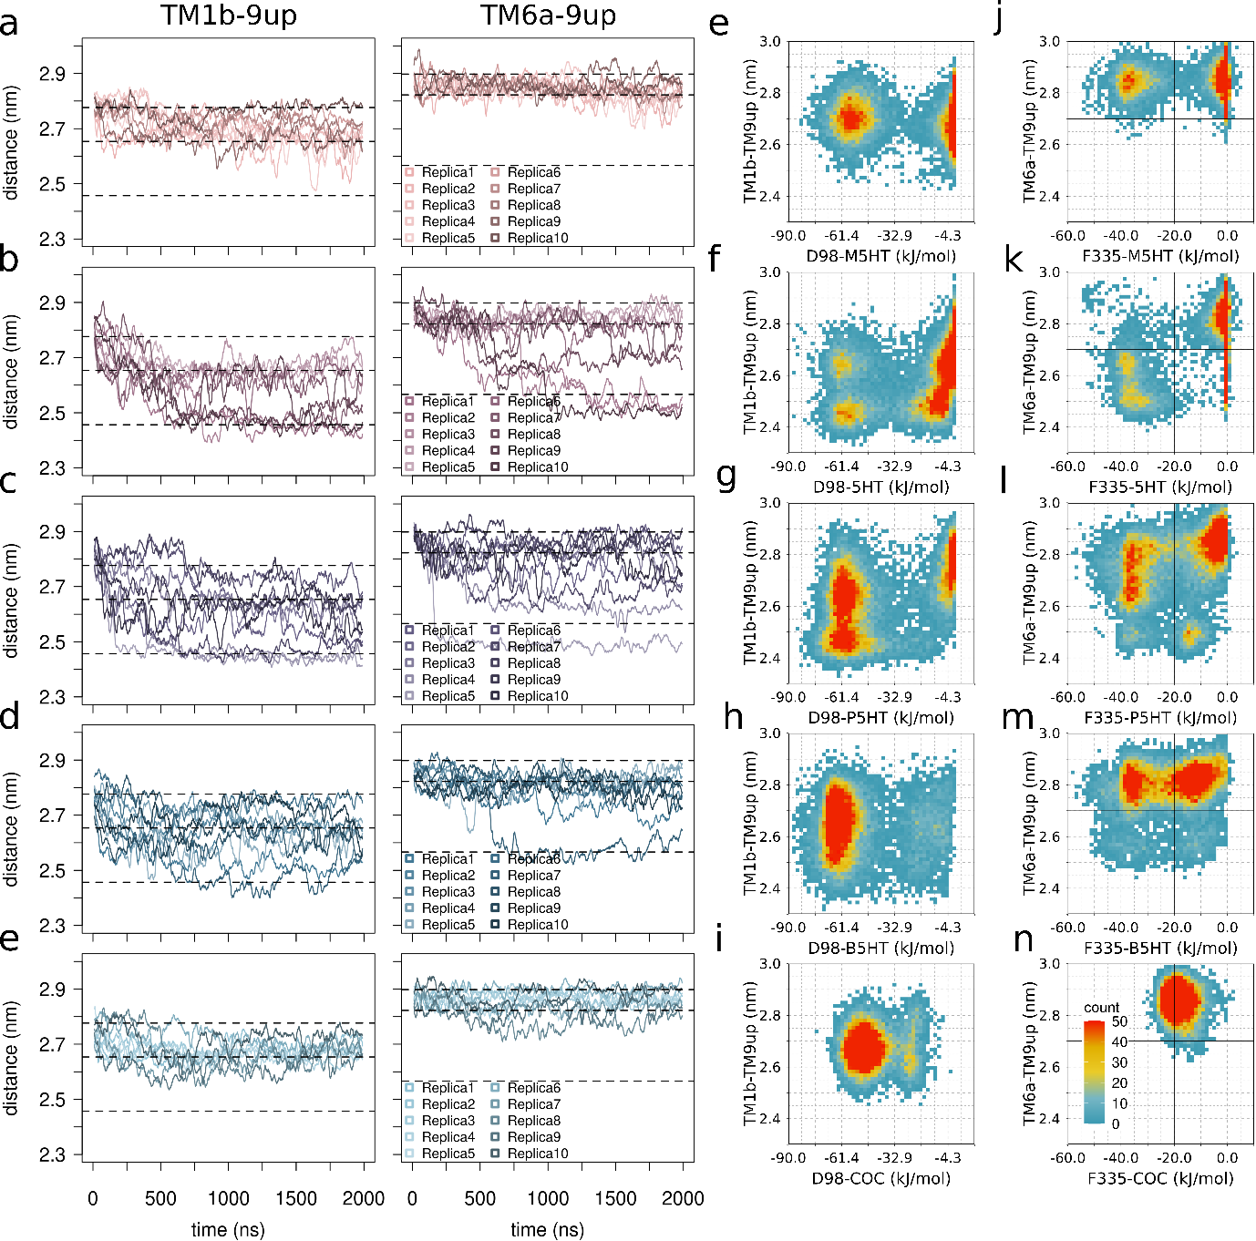
Supplementary Figure 1. Differences in occlusion-behaviour due to alterations of the 5HT’s alkylamine moiety. Change of distance (TM1b-TM9up and TM6a-TM9up) over time of all 10 replicas of a) M-5HT, b) 5HT, c) P-5HT, d) B-5HT and e) cocaine. 3D frequency plot of the change in distance (TM1b-TM9up) and the associated change in the total interaction energy between e) M-5HT, f) 5HT, g) P-5HT, h) B-5HT, i) cocaine and the residue D98. 3D frequency plot of the change in distance (TM6a-TM9up) and the associated change in the total interaction energy between j) M-5HT, k) 5HT, l) P-5HT, m) B-5HT, n) cocaine and the gating residue F335.

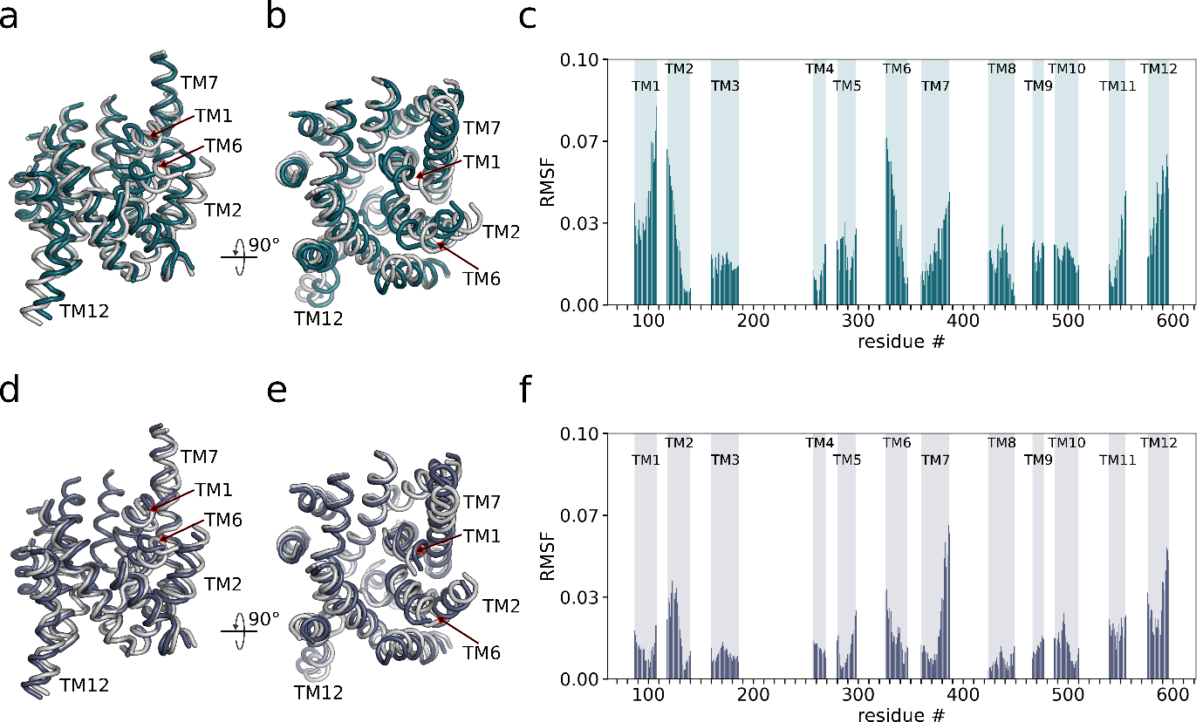
Supplementary Figure 2. Collective motions of hSERT in response to the presence of different compounds. The principal component analysis was carried out using all 50 trajectories on the C_{α}-atoms of all TMHs to identify the largest conformational changes. The largest motion (PC1) is a tilt of TM1, TM2, TM6 and TM7 towards the centre depicted in petrol as a) front view and b) top view. The second largest motion (PC2) represents a rotation mainly of TM2, TM6, TM7 and TM12 highlighted in cyber-grape and shown as c) front view and e) top view. The white structures represent the starting conformation. RMSF per residue of the extremes structures along c) PC1 and f) PC2 are shown.

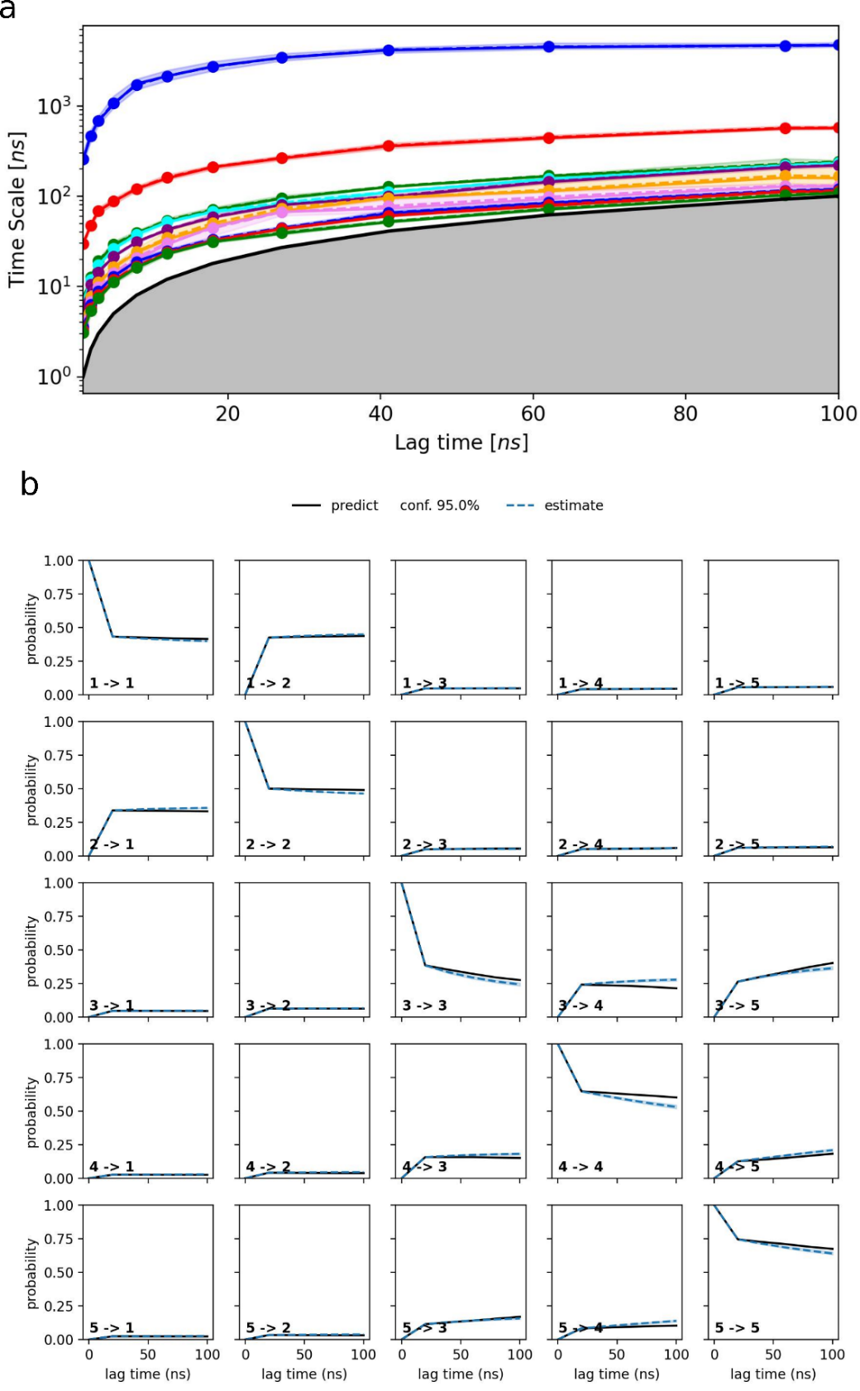
Supplementary Figure 3. Markovian behaviour validation. a) shows the time traces of the relation between the lag time and the implied timescales associated with the ten slowest processes, with the blue trace indicating the slowest process. The solid lines refer to the maximum likelihood result and the dashed lines show the ensemble mean computed with a Bayesian sampling procedure. The black line with the grey area indicates the timescale threshold where the MSM cannot resolve processes. b) displays the Chapman-Kolmogorov (CK) test calculated using a lag time equals to 25 ns and assuming five macrostates. The predicted values obtained from our MSMs are shown by the solid traces while the estimated values for longer lag time are shown by the dashed traces. The superposition of predicted and estimated values indicates that the MSM assures the markovian behavior. In both panels, the non-grey shaded areas indicate 95% confidence intervals computed using the Bayesian sampling procedure mentioned above.

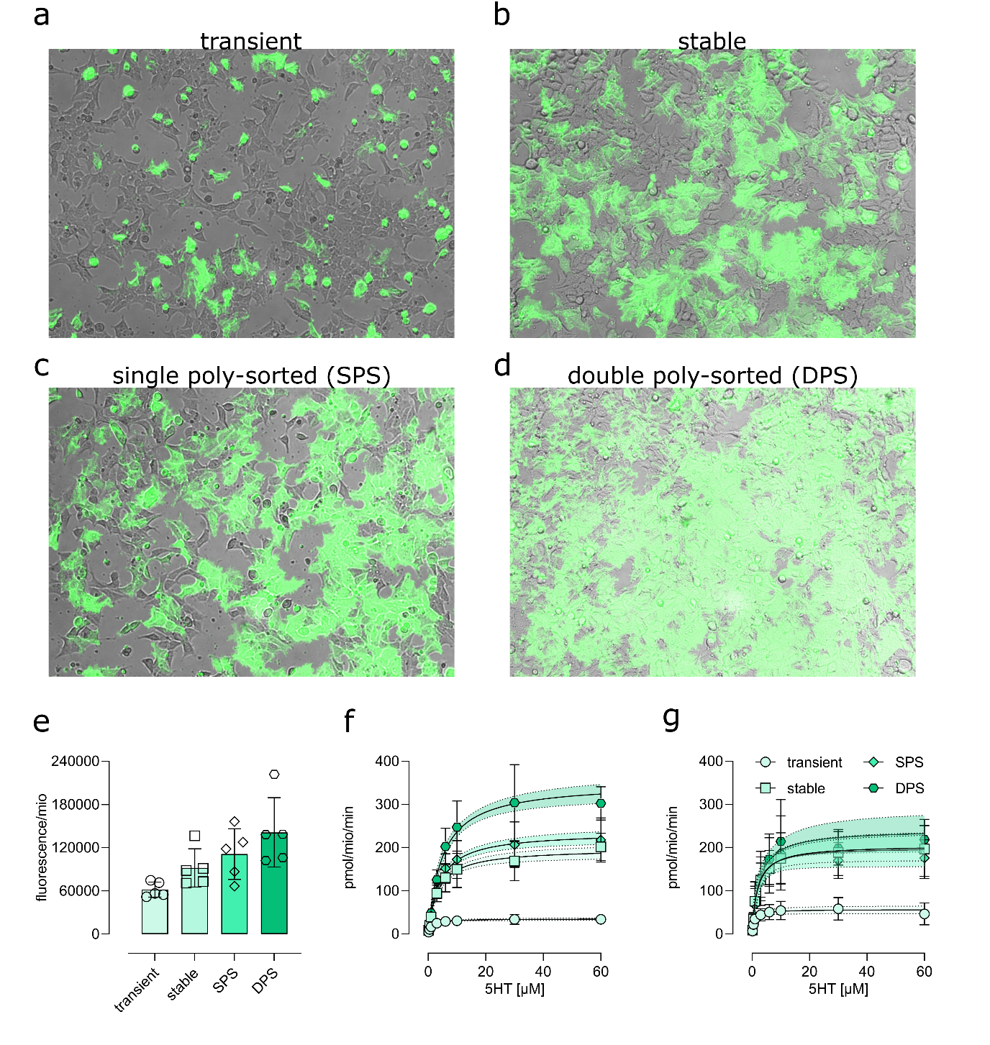
Supplementary Figure 4. Establishing the double poly-sorted (DPS) YhSERT expressing HEK cell line. Expression level of YhSERT in HEK cells a) 24 hours after transfection, b) after maintaining stable expression, c) after the first round of poly-sorting and d) after the second round of poly-sorting. e) Increase of total fluorescence associated with an increase of expression of YhSERT. f) Dose dependent SERT-mediated ³H-5HT uptake within 1 minute of the 4 different cell-lines. g) Plot f normalised to the total fluorescence shown in e.

The dose dependence of the maximal rate of inhibition (K_{app}) allows for detecting, if a compound stabilises SERT in only one conformation of the transport cycle such as cocaine or in multiple states like ibogaine. The K_{app} reaches a stable plateau, if only the one state is stabilised, while it does not saturate, if it binds multiple states of the transport cycle, e.g. ibogaine. 5HT and its derivatives as well as cocaine saturate at a K_{app} of approximately 2 s⁻¹, consistent with a binding mode requiring only one state.
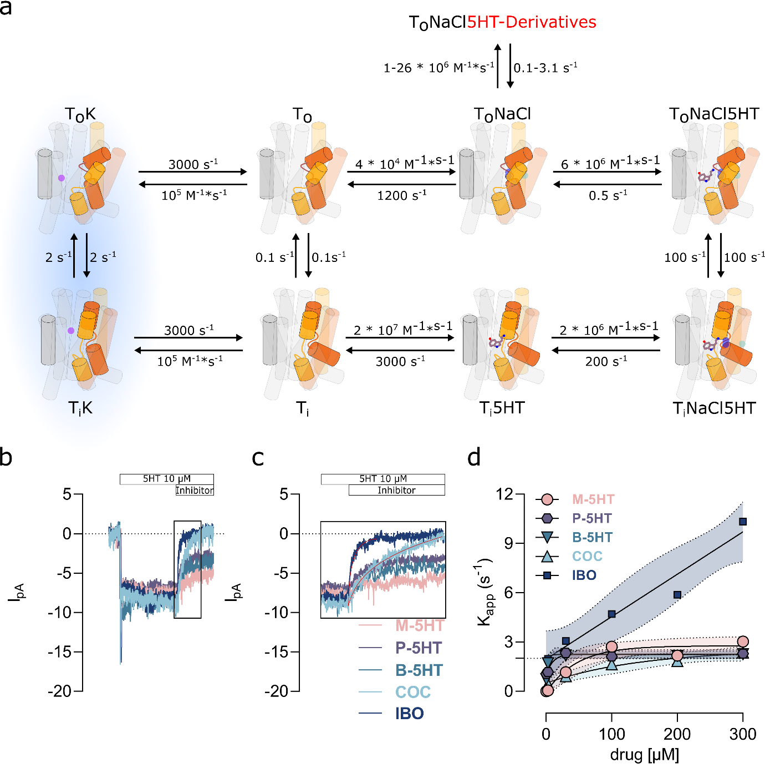
Supplementary Figure 5. Conformational state dependence and its impact on drug binding kinetics. a) Simplified kinetic model of SERT-mediated 5HT reuptake and inhibitor binding adapted from Schicker et al.¹ and Niello et al.². b) Representative trace of the binding kinetics of 5HT-mediated current inhibition (5HT concertation: 10 µM) by saturating concentrations of M-5HT (200 µM), P-5HT (200 µM), B-5HT (200 µM), cocaine (200µM) and ibogaine (200 µM). c) Close up of the kinetics of inhibitor binding shown in b. d) Current inhibition rates (s⁻¹) of cocaine, ibogaine and the 5HT-derivatives as function of the compound concentration. While cocaine and all 5HT-derivatives saturate around the rate-limiting step at 2 s⁻¹. The transition is highlighted in blue in a). In contrast, ibogaine shows a linear dose-dependency, which imply that its binding is not dependent on binding the outward-open conformation³.
SUPPLEMENTARY METHODOLOGY

Synthesis of 5HT analogues with modified alkyl chain length
Analysis of the simulation data generated the testable hypothesis that a modification of the length of the alkyl chain of 5HT should change transport properties of SERT. To experimentally verify this prediction, we developed a synthetic strategy for the compounds M-5HT, P-5HT and B-5HT, as these compounds were rarely investigated^{4,5} and no feasible syntheses were described.

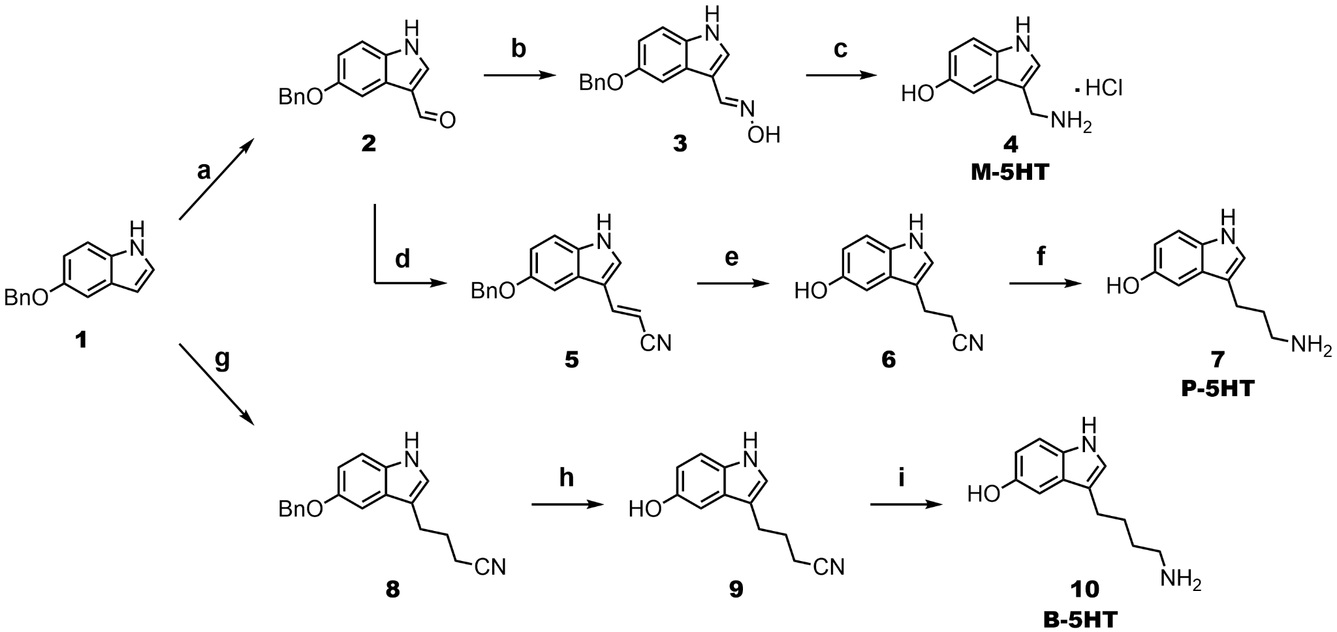
Supplementary Figure 6. Chemical synthesis of 5HT analogues. Synthetic pathway towards M-5HT, P-5HT and B-5HT. Conditions: a) POCl₃, AcOH, DMF, 55°C, b) NH₂OH•HCl, MeOH, rt, c) 10% Pd/C, conc. HCl, H₂, MeOH, rt, d) methyltriphenylphosphonium chloride, DBU, toluene, 115°C, e) 10% Pd/C, H₂, MeOH, 55°C, f) LiAlH₄, THF, 57°C, g) MeMgI, toluene, rt, then 4-brombutyronitrile, 70°C, h) 10% Pd/C, H₂, MeOH, 40°C, i) LiAlH₄, THF, 55°C.

The steps of the chemical syntheses are outlined in Supplementary Fig 6. As starting material, 5-(benzyloxy)-1H-indole (1) was selected, as protecting the 5-hydroxy group was necessary for easier synthetic manipulation and the benzyl group additionally allowed for reductive cleavage, conveniently fitting later synthetic steps. In the first step, an aldehyde moiety was introduced by a regioselective Vilsmeyer-Haack reaction⁶ yielding compound 2. Noteworthy, adding catalytic amounts of acetic acid accelerated the reaction considerably by facilitating acid-catalysed hydrolysis of the imine-intermediate. The obtained aldehyde 2 was interconverted to oxime 3 using hydroxylamine hydrochloride⁶. Deprotection of the 5-hydroxy group and the reduction of the oxime to the amine could be performed simultaneously to reach the hydrochloride salt of M-5HT (4) in 87% yield over 3 steps⁷.
For the synthesis of P-5HT (7), first, a Wittig reaction⁶ was performed on compound 2, simultaneously elongating the carbon chain and introducing a nitrile group yielding compound 5. Next, we had planned to reduce the alkene and the nitrile group while also cleaving the benzyl group by choosing the correct reducing conditions. However, this was not possible as even under harsh conditions the nitrile group would not be reduced. Hence, a sequential approach was employed. First, compound 6 was obtained via reductive hydrogenation that led to deprotection of the 5-hydroxy group and reduction of the double bond⁸. P-5HT (7) was reached through reduction of the nitrile of compound 6 using LiAlH₄^{9,10}. The yield of the synthesis of P-5HT (7) was 71% over three steps. The hydrochloride salt of P-5HT (7) could not be obtained as exposure to conc. HCl in dioxane led to decomposition of the material. However, NMR-based stability studies (Suppl. Spectra 3 A-E) confirmed high chemical stability of the pure P-5HT as free amine base, as no degradation in solution (DMSO) could be observed even after storage up to five weeks at room temperature.
The synthesis of B-5HT (10) required a different synthetic route as analogous Wittig reactions with compound 2 failed, most likely due to lacking conjugation of the ylid to the electron withdrawing nitrile group. Starting from compound 1, compound 8 could be synthesised in 28% yield using Grignard reagent MeMgI as base and a suitable CN-bearing alkyl bromide as reagent¹¹. Next, a similar synthetic cascade as performed for compound P-5HT (7) led to the isolation of B-5HT (10) with an overall yield of 15% over three steps^{8–10}. The stability of B-5HT was comparable to P-5HT as confirmed by NMR stability studies (Suppl. Spectra 4 A-B).

5-(Benzyloxy)-1H-indole-3-carbaldehyde (2)
Compound 2 was prepared according to a modified literature procedure⁶. 5-(Benzyloxy)-1H-indole 1 (2.52 g, 11.28 mmol, 1.0 equiv.) was dissolved in dry DMF (22 mL) under argon. The mixture was cooled to 0°C. POCl₃ (1.55 mL, 16.58 mmol, 1.5 equiv.) was added in portions followed by acetic acid (0.1 mL). The reaction was conducted at 55°C overnight. After TLC monitoring (1:1 LP:EtOAc) confirmed full conversion, the reaction mixture was poured into ice water (150 mL) and 2 N NaOH (50 mL) was added. The product was filtered off as yellow precipitate, washed with water twice and dried in vacuo. The material was obtained as yellow solid (2.53 g, 90%) and used crude (purity ≥ 90%) for the next step.
mp: 240.2-244.7 °C, ¹H NMR (400 MHz, DMSO-d₆) δ = 5.12 (s, 2H), 6.97 (dd, J = 2.5, 8.8 Hz, 1H), 7.29 – 7.35 (m, 1H), 7.36 – 7.44 (m, 3H), 7.46 – 7.50 (m, 2H), 7.69 (d, J = 2.5 Hz, 1H), 8.21 (s, 1H), 9.88 (s, 1H) ppm. ¹³C NMR (101 MHz, DMSO-d₆) δ = 69.7, 104.1, 113.3, 113.9, 118.1, 124.9, 127.6 (2C), 127.8, 128.4 (2C), 132.1, 137.5, 138.6, 154.7, 184.9 ppm.

(E)-5-(Benzyloxy)-1H-indole-3-carbaldehyde oxime (3)
Compound 3 was prepared according to a modified literature procedure⁶. Starting material 2 (403.5 mg, 1.61 mmol, 1.0 equiv.) and hydroxylamine hydrochloride (137.2 mg, 1.97 mmol, 1.2 equiv.) were dissolved in MeOH (16 mL) and stirred at rt overnight. After TLC monitoring (1:2 LP:EtOAc) confirmed full conversion, water (20 mL) was added to the reaction mixture whereupon the product crashed out as pink solid. The material was filtered off, washed with water, and dried under vacuo. The material was obtained as pink solid (432.0 mg, quant.) and used crude (purity ≥ 90%) for the next step.
mp: 174.2-175.3 °C, ¹H NMR (400 MHz, DMSO-d₆) δ = 5.13 (s, 2H), 6.87 (dd, J = 2.4, 8.8 Hz, 1H), 7.33 (d, J = 8.5 Hz, 2H), 7.36 – 7.43 (m, 2H), 7.46 – 7.53 (m, 3H), 7.75 (s, 1H), 8.16 (d, J = 2.8 Hz, 1H), 11.09 (s, 1H), 11.43 (d, J = 2.9 Hz, 1H) ppm. ¹³C NMR (101 MHz, DMSO-d₆) δ = 69.7, 101.8, 106.3, 112.4 (2C), 126.8, 127.7, 127.8 (2C), 128.4 (2C), 130.1, 131.0, 137.7, 138.5, 153.2 ppm. HRMS calcd. [C₁₆H₁₄N₂O₂-H]⁻: 265.0983; found: 265.0980.

3-(Aminomethyl)-1H-indol-5-ol hydrochloride (4)
Compound 4 was prepared according to a modified literature procedure⁷. To starting material 3 (342.9 mg, 1.29 mmol, 1.0 equiv.) and 10% Pd/C (35.1 mg, 5w%), EtOH (11.5 mL) was added. Next, conc. HCl (1 mL) was added. Hydrogen atmosphere of 1 bar was established and the reaction was stirred at rt for 3.5 hours until TLC monitoring (1:1 LP:EtOAc) showed full consumption of the starting material. The reaction mixture was filtered over a pad of Celite and washed with methanol. After evaporation of the solvent in vacuo, compound 4 was obtained as purple oil (246.6 g, 97%).
¹H NMR (600 MHz, MeOD-d₄) δ = 4.24 (s, 2H), 6.75 (dd, J = 2.3, 8.7 Hz, 1H), 7.03 (dd, J = 0.5, 2.3 Hz, 1H), 7.24 (dd, J = 0.6, 8.7 Hz, 1H), 7.35 (s, 1H) ppm. ¹³C NMR (151 MHz, MeOD-d₄) δ = 35.8, 103.0, 107.2, 113.2, 113.4, 127.3, 128.4, 132.9, 152.2 ppm.
¹H NMR (600 MHz, DMSO-d₆) δ = 4.50 (s, 2H), 7.14 (d, J = 8.4 Hz, 1H), 7.43 (s, 1H), 7.62 – 7.68 (m, 1H), 7.85 (s, 1H), 8.73 (t, J = 24.9 Hz, 2H), 9.24 (br s, 1H), 11.49 (s, 1H) ppm.

(E)-3-(5-(Benzyloxy)-1H-indol-3-yl)acrylonitrile (5)
Compound 5 was prepared according to a modified literature procedure⁶. Starting material 2 (1.00 g, 3.99 mmol, 1.0 equiv.) and methyltriphenylphosphonium chloride (2.69 g, 7.94 mmol, 2.0 equiv.) were dissolved in toluene (10 mL) under argon. Next, DBU (1.2 mL, 7.88 mmol, 2.0 equiv.) was added and the reaction mixture was stirred at 115°C until TLC monitoring (1:8 LP:EtOAc) showed full consumption of the starting material after 5.5 hours. After cooling to room temperature, the reaction mixture was distributed between EtOAc (20 mL) and water (20 mL) and the aqueous phase was extracted with EtOAc (4 x 25 mL). The combined organic phase was washed with water (40 mL), dried over anh. Na₂SO₄, filtered, and evaporated to give a brown crude oil. The material was purified by column chromatography over 40 g silica. A gradient of 2:1 LP:EtOAc (300 mL) to 1:1 LP:EtOAc (500 mL) was used. Compound 5 was obtained as slightly yellow solid (768.8 mg, 70%).
mp: 141.4-143.3 °C, ¹H NMR (400 MHz, CDCl₃-d) δ = 5.14 (s, 2H), 5.67 (d, J = 16.6 Hz, 1H), 7.03 (dd, J = 2.4, 8.9 Hz, 1H), 7.27 (d, J = 2.8 Hz, 1H), 7.33 (d, J = 8.8 Hz, 1H), 7.34 – 7.37 (m, 1H), 7.39 – 7.44 (m, 2H), 7.47 – 7.50 (m, 3H), 7.52 (d, J = 16.6 Hz, 3H), 8.47 (s, 1H) ppm. ¹³C NMR (101 MHz, CDCl₃-d) δ = 71.2, 90.3, 104.1, 112.8, 113.4, 114.3, 120.0, 125.5, 127.7 (2C), 128.2, 128.8 (2C), 129.1, 132.2, 137.3, 143.9, 155.1 ppm. HRMS calcd. [C₁₈H₁₄N₂O-H]⁻: 273.1033; found: 273.1036.

3-(5-Hydroxy-1H-indol-3-yl)propanenitrile (6)
Compound 6 was prepared according to a modified literature procedure⁸. MeOH (90 mL) was added to starting material 5 (1.11 g, 4.06 mmol, 1.0 equiv.) and 10% Pd/C (59.0 mg, 5w%). Hydrogen atmosphere of 1 bar was established and the reaction was stirred at 55°C for 7 hours until TLC monitoring (1:1 LP:EtOAc) showed full conversion. The reaction mixture was filtered over a pad of Celite and washed with methanol. After evaporation of the solvent in vacuo, compound 6 was obtained as off-white solid (803.6 mg, 106%, 5w% methanol, 95% purity).
mp: 112.8-115.0 °C,¹H NMR (400 MHz, MeOD-d₄) δ = 2.73 (t, J = 7.2 Hz, 2H), 3.01 (td, J = 1.1, 7.4 Hz, 2H), 6.69 (ddd, J = 0.4, 2.3, 8.7 Hz, 1H), 6.90 (dd, J = 0.6, 2.3 Hz, 1H), 7.09 (d, J = 0.6 Hz, 1H), 7.18 (dd, J = 0.6, 8.7 Hz, 1H) ppm. ¹³C NMR (101 MHz, MeOD-d₄) δ = 19.0, 22.7, 103.1, 112.3, 112.6, 112.8, 121.3, 124.4, 128.7, 133.1, 151.3 ppm. HRMS calcd. [C₁₁H₁₀N₂O-H]⁻: 185.0720; found: 185.0719.

3-(3-Aminopropyl)-1H-indol-5-ol (7)
Compound 7 was prepared according to modified literature procedures^{9,10}. Starting material 6 (64.9 mg, 0.35 mmol, 1.0 equiv. was dissolved in dry THF (3 mL) under argon. The solution was cooled to 0°C and LiAlH₄ (69.8 mg, 1.74 mmol, 5.0 equiv.) was slowly added to it. After complete addition and finished H₂ formation, the reaction mixture was heated to 57°C under argon. After 3 hours, TLC monitoring (1:1 LP:EtOAc and MeOH + 1% NH₃) indicated full conversion. The reaction was cooled with a water bath and quenched by slow addition of MeOH. The heterogeneous grey solution was directly applied on a silica column with about 10 g silica and a diameter of 3 cm for purification with MeOH + 1% NH₃ as solvent. After evaporation of the solvent desired compound 7 was obtained as brown to orange oil (52.7 mg, 79%).
¹H NMR (400 MHz, MeOD-d₄) δ = 1.86 (p, J = 7.4 Hz, 2H), 2.71 (td, J = 4.0, 7.3 Hz, 4H), 6.65 (dd, J = 2.4, 8.6 Hz, 1H), 6.91 (dd, J = 0.5, 2.4 Hz, 1H), 6.96 (s, 1H), 7.14 (dd, J = 0.5, 8.6 Hz, 1H) ppm. ¹³C NMR (101 MHz, MeOD-d₄) δ = 23.5, 33.8, 42.2, 103.6, 112.2, 112.6, 115.1, 123.7, 129.4, 133.2, 151.0 ppm. HRMS calcd. [C₁₁H₁₄N₂O+H]⁺: 191.1179; found: 191.1186.

4-(5-(Benzyloxy)-1H-indol-3-yl)butanenitrile (8)
Compound 8 was prepared according to a modified literature procedure¹¹. 5-(Benzyloxy)-1H-indole 1 (1.01 g, 4.54 mmol, 1.0 equiv.) was dissolved in dry toluene (5 mL) and MeMgI (3.0M in Et₂O, 1.65 mL, 4.95 mmol, 1.1 equiv.) was added. The reaction was run for 20 minutes under argon at rt. Then, 4-bromobutyronitrile (450 µL, 4.49 mmol, 1.0 equiv.) was added. The reaction mixture was heated to 70°C and ran for 24 hours. Then, the reaction was worked up even though TLC (1:4 LP:EtOAc) showed leftover starting material 1. Satd. NH₄Cl (3 mL) was added to the reaction mixture and the reaction mixture was diluted with water and EtOAc. The aqueous phase was extracted with EtOAc (3 x 50 mL). The combined organic phase was dried over Na₂SO_{4,} filtered, and evaporated to give a red oil as crude material. The material was purified by column chromatography over 120 g silica with a gradient of 4:1 LP:EtOAc (500 mL) followed by 3:1 LP:EtOAc (800 mL), 2:1 LP:EtOAc (750 mL) and 1:1 LP:EtOAc (500 mL). Pure compound 8 was obtained as pale colourless to yellow oil (373.9 mg, 28%).
¹H NMR (600 MHz, DMSO-d₆) δ = 1.90 (p, J = 7.2 Hz, 2H), 2.48 (d, J = 7.1 Hz, 2H), 2.74 (t, J = 7.5 Hz, 2H), 5.09 (s, 2H), 6.80 (dd, J = 2.4, 8.7 Hz, 1H), 7.11 (t, J = 2.4 Hz, 2H), 7.24 (d, J = 8.7 Hz, 1H), 7.29 – 7.34 (m, 1H), 7.39 (t, J = 7.5 Hz, 2H), 7.48 (d, J = 7.1 Hz, 2H), 10.69 (s, 1H) ppm. ¹³C NMR (151 MHz, DMSO-d₆) δ = 16.0, 23.7, 25.6, 69.8, 101.7, 111.7, 112.1, 112.4, 120.8, 123.4, 127.3, 127.6, 127.7 (2C), 128.3 (2C), 131.6, 137.8, 152.0 ppm. HRMS calcd. [C₁₉H₁₈N₂O-H]⁻: 289.1346; found: 289.1345.

4-(5-Hydroxy-1H-indol-3-yl)butanenitrile (9)
Compound 8 was prepared according to a modified literature procedure⁸. To starting material 8 (232.8 mg, 0.81 mmol, 1.0 equiv.) and 10% Pd/C (16.2 mg, 7w%), MeOH (15 mL) was added. Hydrogen atmosphere of 1 bar was established and the reaction was stirred at 40°C overnight. As TLC monitoring (1:1 LP:EtOAc) showed leftover starting material 8, more 10% Pd/C (12.1 mg, 5w%) was added and new hydrogen atmosphere was established several times over the course of six more hours by evacuating the flask followed by flushing it with hydrogen. After that, TLC monitoring confirmed full conversion. The reaction mixture was filtered over a pad of Celite and washed with methanol. After evaporation of the solvent in vacuo, compound 9 was obtained as beige oil (172.2 mg, 107%, 7 w% methanol, 90 % purity).
¹H NMR (600 MHz, DMSO-d₆) δ = 1.88 (p, J = 7.2 Hz, 2H), 2.49 (d, J = 7.3 Hz, 2H), 2.69 (t, J = 7.5 Hz, 2H), 6.59 (dd, J = 2.1, 8.6 Hz, 1H), 6.80 (d, J = 1.9 Hz, 1H), 7.04 (d, J = 1.7 Hz, 1H), 7.12 (d, J = 8.6 Hz, 1H), 8.60 (s, 1H), 10.51 (s, 1H) ppm. ¹³C NMR (151 MHz, DMSO-d₆) δ = 16.0, 23.8, 25.6, 102.1, 111.3, 111.7, 111.8, 120.7, 123.1, 127.6, 130.9, 150.2 ppm. HRMS calcd. [C₁₂H₁₂N₂O+H]⁺: 201.1022; found: 201.1024.

3-(4-Aminobutyl)-1H-indol-5-ol (10)
Compound 10 was prepared according to modified literature procedures^{9,10}. Starting material 9 (58.8 mg, 0.29 mmol, 1.0 equiv. was dissolved in dry THF (2.5 mL) under argon. The solution was cooled to 0°C and LiAlH₄ (56.0 mg, 1.48 mmol, 5.0 equiv.) was slowly added to it. After complete addition and finished H₂ formation, the reaction mixture was heated to 55°C under argon. After 3 hours TLC monitoring (1:1 LP:EtOAc and MeOH + 1% NH₃) showed full conversion. The reaction was cooled with a water bath and quenched by slowly adding MeOH. The heterogeneous grey solution was directly applied on a silica column with about 10 g silica and a diameter of 3 cm for purification with MeOH + 1% NH₃ as solvent. After evaporation of the solvent in vacuo desired compound 10 was obtained as yellow to orange oil (33.2 mg, 55%, 4w% methanol, 90% purity).
¹H NMR (600 MHz, DMSO-d₆) δ = 1.39 (p, J = 7.2, 14.4 Hz, 2H), 1.60 (p, J = 7.6 Hz, 2H), 2.55 (dt, J = 7.2, 10.2 Hz, 4H), 6.56 (dd, J = 2.3, 8.6 Hz, 1H), 6.77 (d, J = 2.3 Hz, 1H), 6.97 (d, J = 2.3 Hz, 1H), 7.09 (d, J = 8.6 Hz, 1H), 8.54 (s, 1H), 10.34 – 10.42 (m, 1H) ppm. ¹³C NMR (151 MHz, DMSO-d₆) δ = 24.8, 27.3, 33.5, 41.7, 102.3, 111.0, 111.6, 113.8, 122.6, 127.9, 130.9, 150.0 ppm. HRMS calcd. [C₁₂H₁₆N₂O+H]⁺: 205.1335; found: 205.1341.

¹H AND EITHER ¹³C NMR OR APT NMR SPECTRA
5-(Benzyloxy)-1H-indole-3-carbaldehyde (2) – ¹H and ¹³C spectra
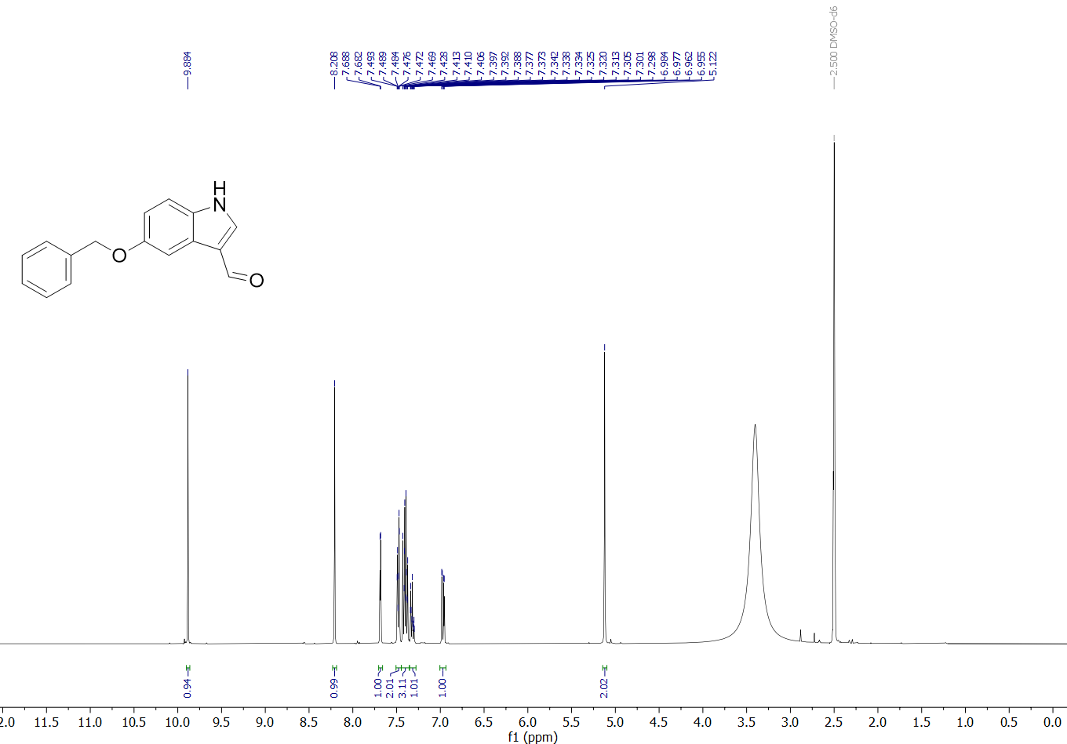
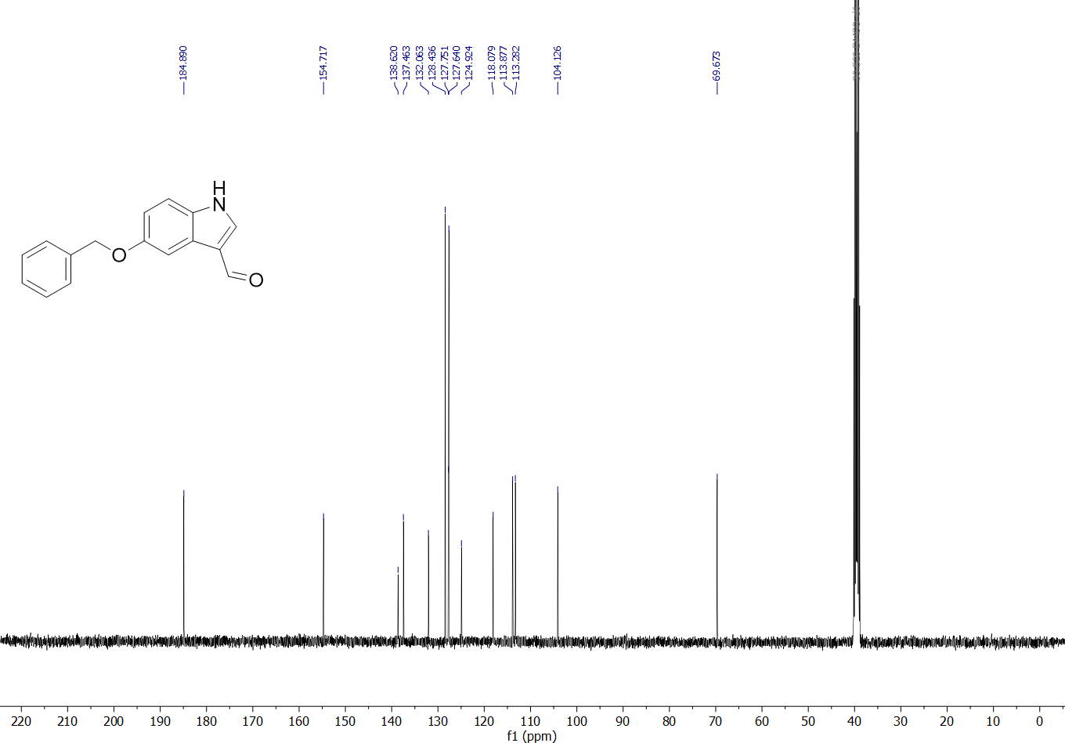
(E)-5-(Benzyloxy)-1H-indole-3-carbaldehyde oxime (3) – ¹H and APT spectra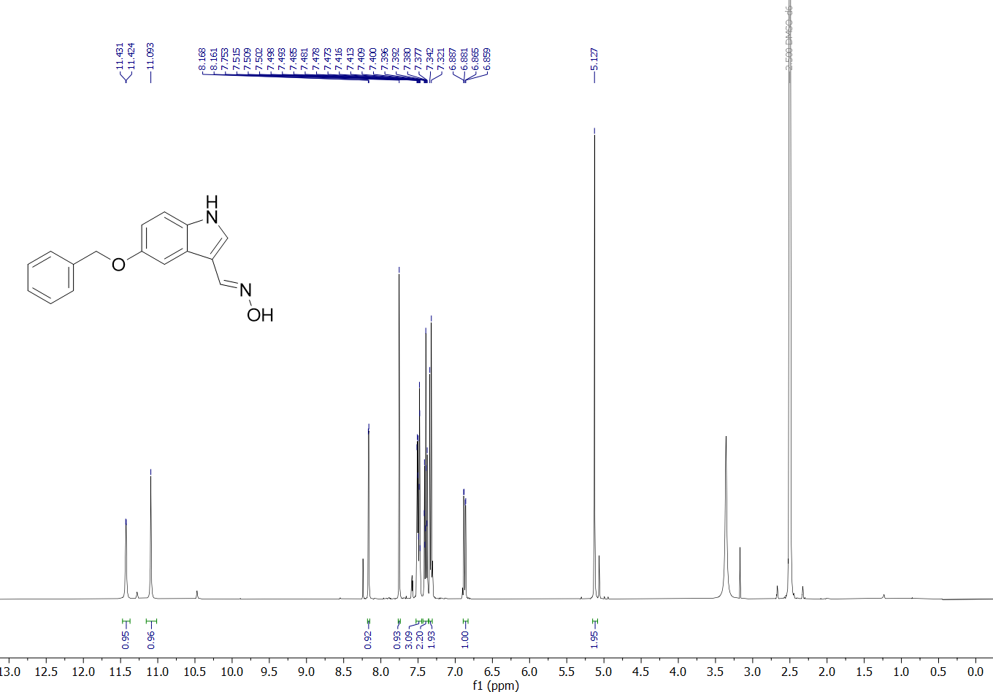
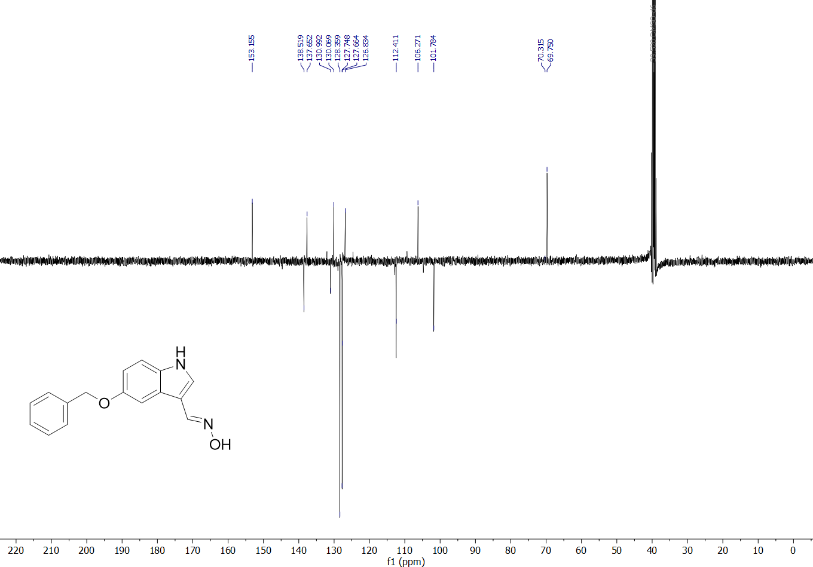
3-(Aminomethyl)-1H-indol-5-ol hydrochloride (4) – ¹H and APT (MeOD-d₄), ¹H (DMSO-d₆) spectra
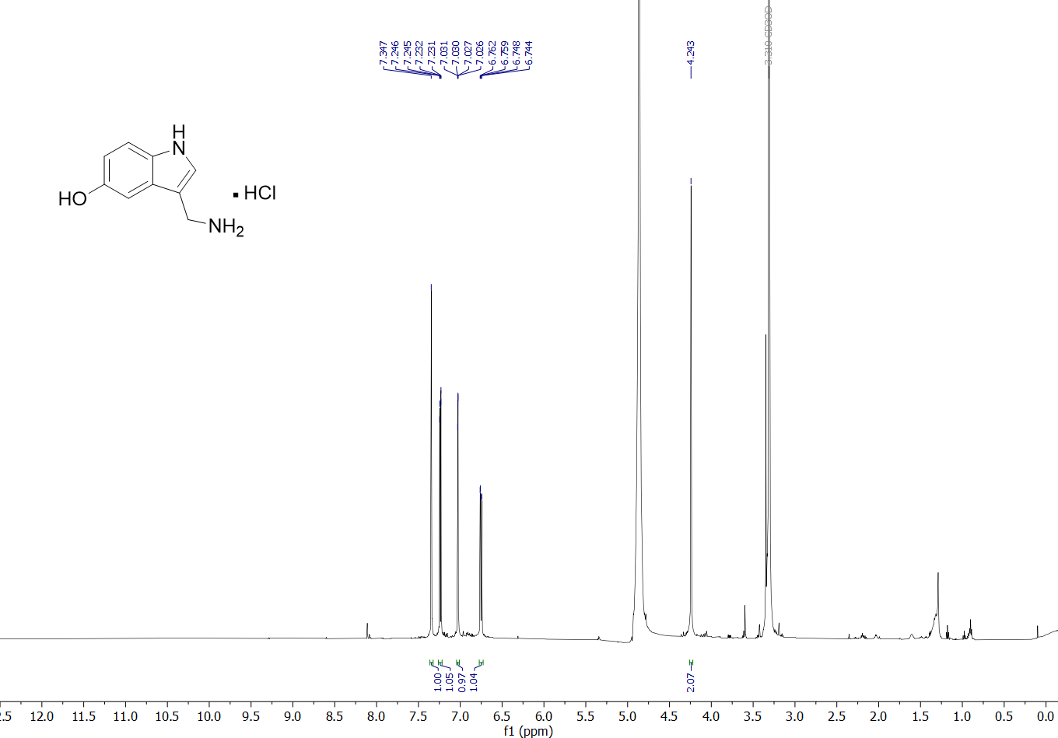
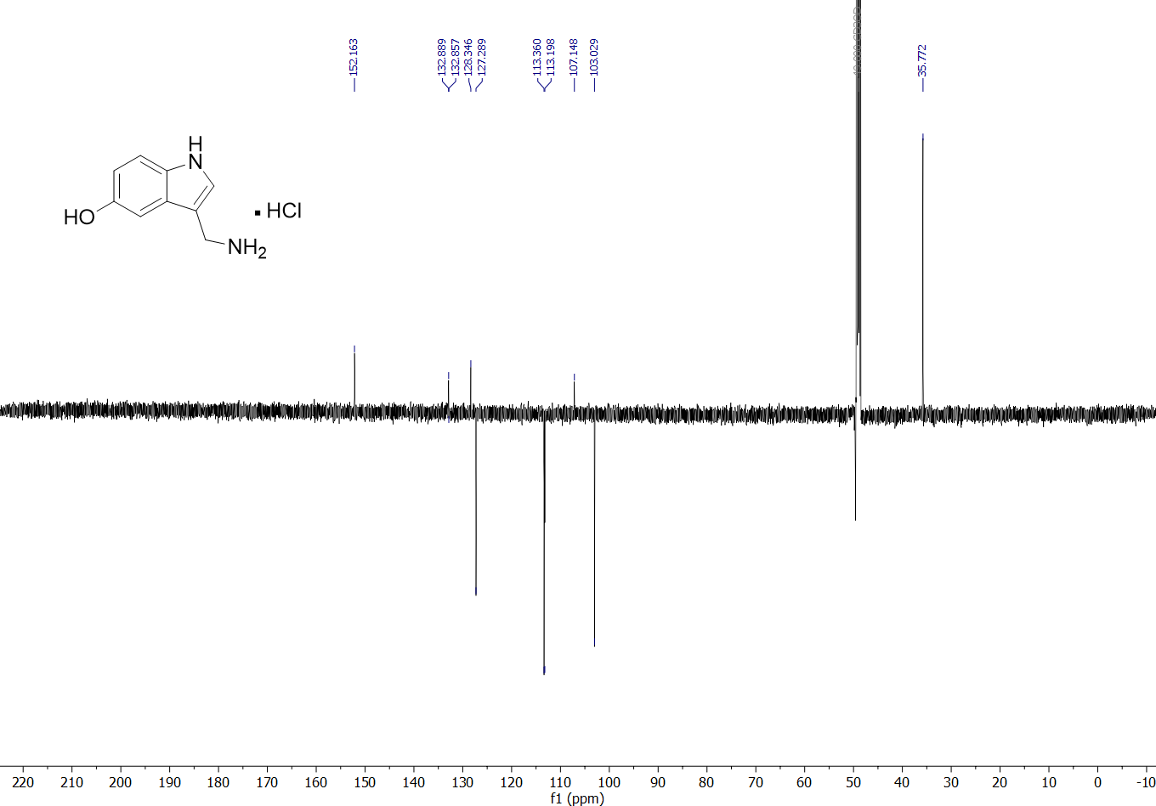
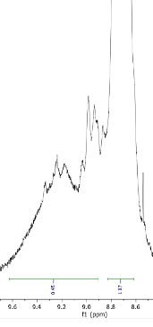
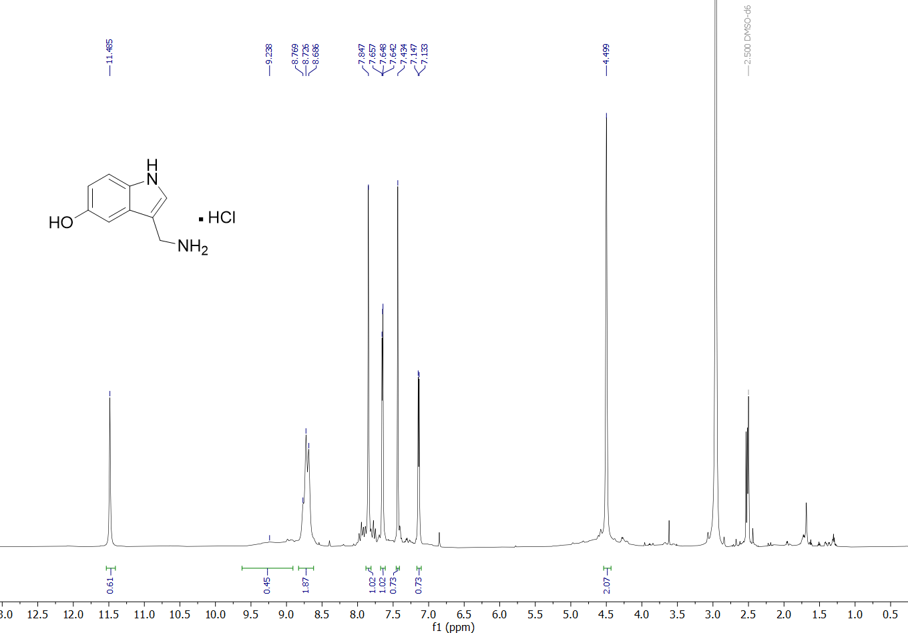
Note: The ¹H spectrum of compound 4 in DMSO-d6 is provided to show the signals of the indole-NH and the sidechain NH₂, as they are not visible in the ¹H (MeOD-d₄) spectrum. The OH-signal (9.24 ppm, (br s)) remains hardly visible even in DMSO-d₆. This can be attributed to the fact that, depending on the NMR solvent and the state of the sample, deuterium exchange between compound 4 and the NMR solvent was observed (Section S3). Therefore, some of the integrals in the ¹H (DMSO-d₆) spectrum are lower as they should be. The mentioned deuterium exchange also leads to a ¹³C-NMR spectrum in DMSO-d₆ with complex coupling patterns. As the APT spectrum of compound 4 in MeOD-d₄ allows for assignment of all peaks, the ¹³C spectrum in DMSO-d₆ is not provided here.

(E)-3-(5-(Benzyloxy)-1H-indol-3-yl)acrylonitrile (5) - ¹H and ¹³C spectra
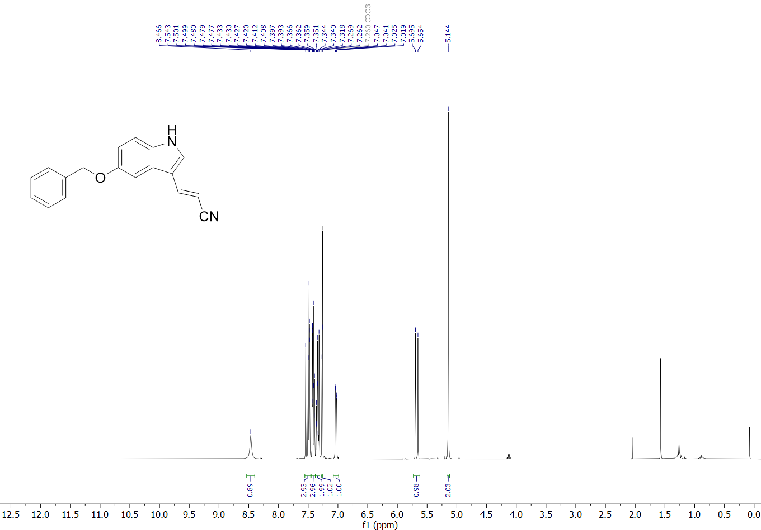
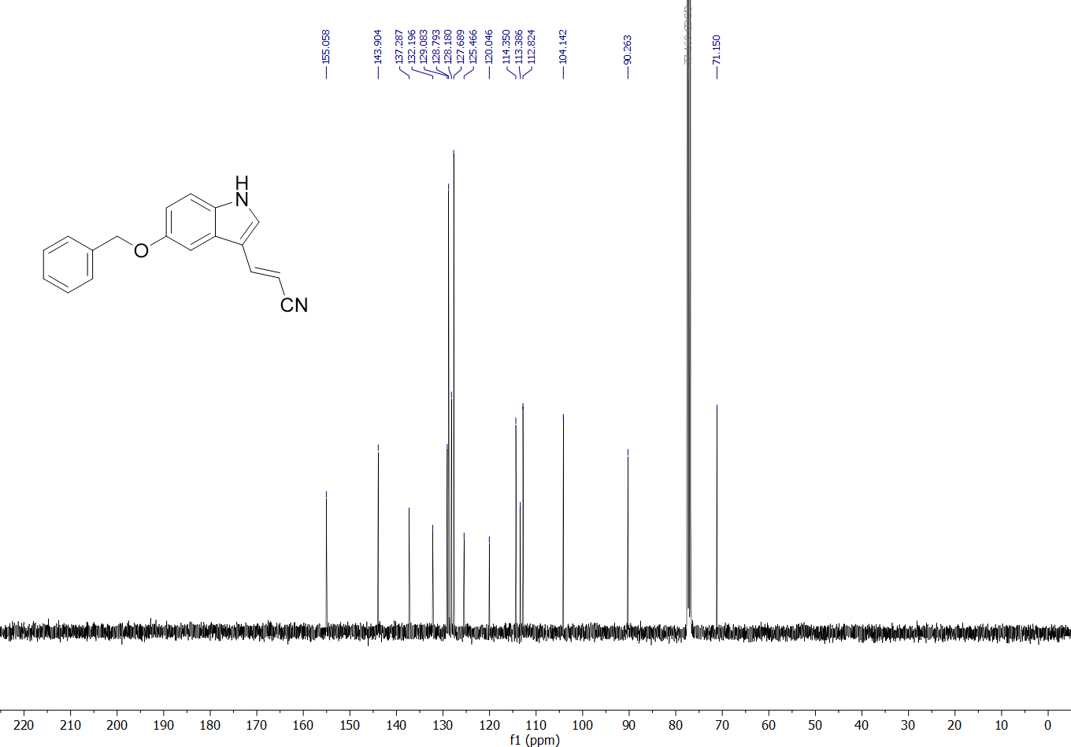
3-(5-Hydroxy-1H-indol-3-yl)propanenitrile (6) - ¹H and APT spectra
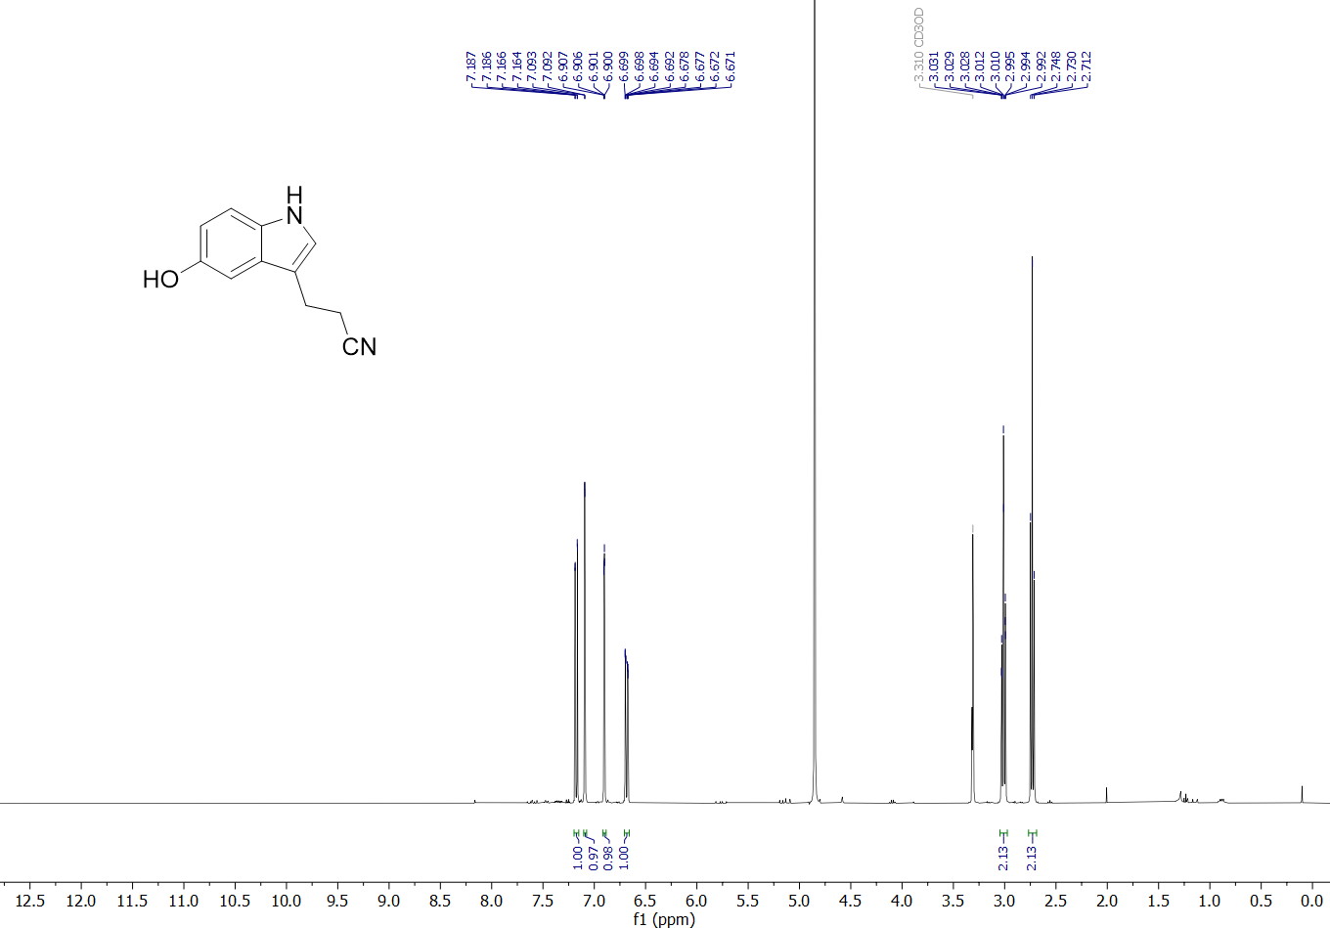
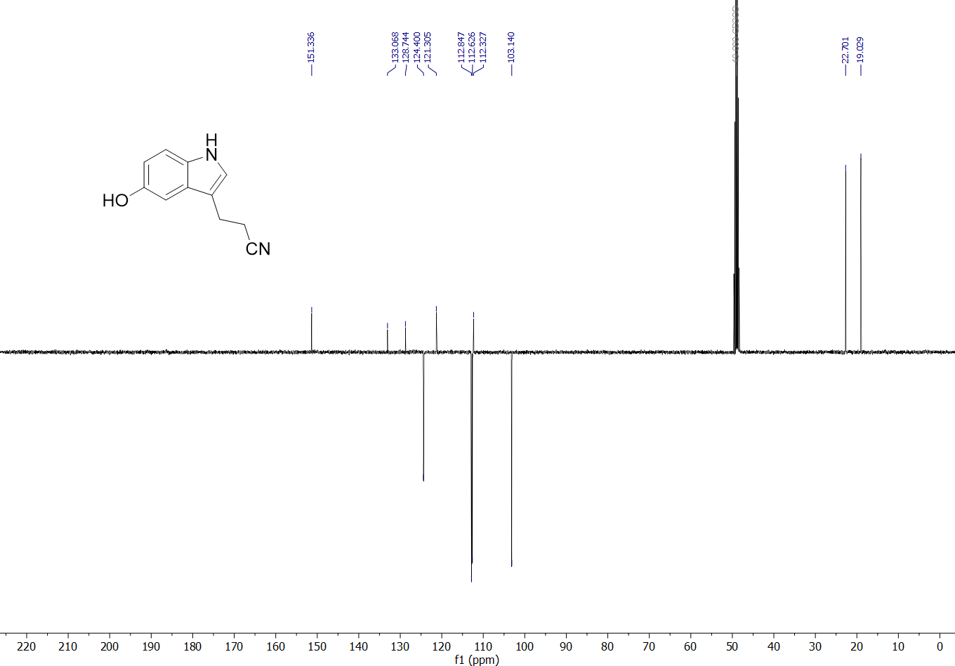
3-(3-Aminopropyl)-1H-indol-5-ol (7) - ¹H and APT spectra
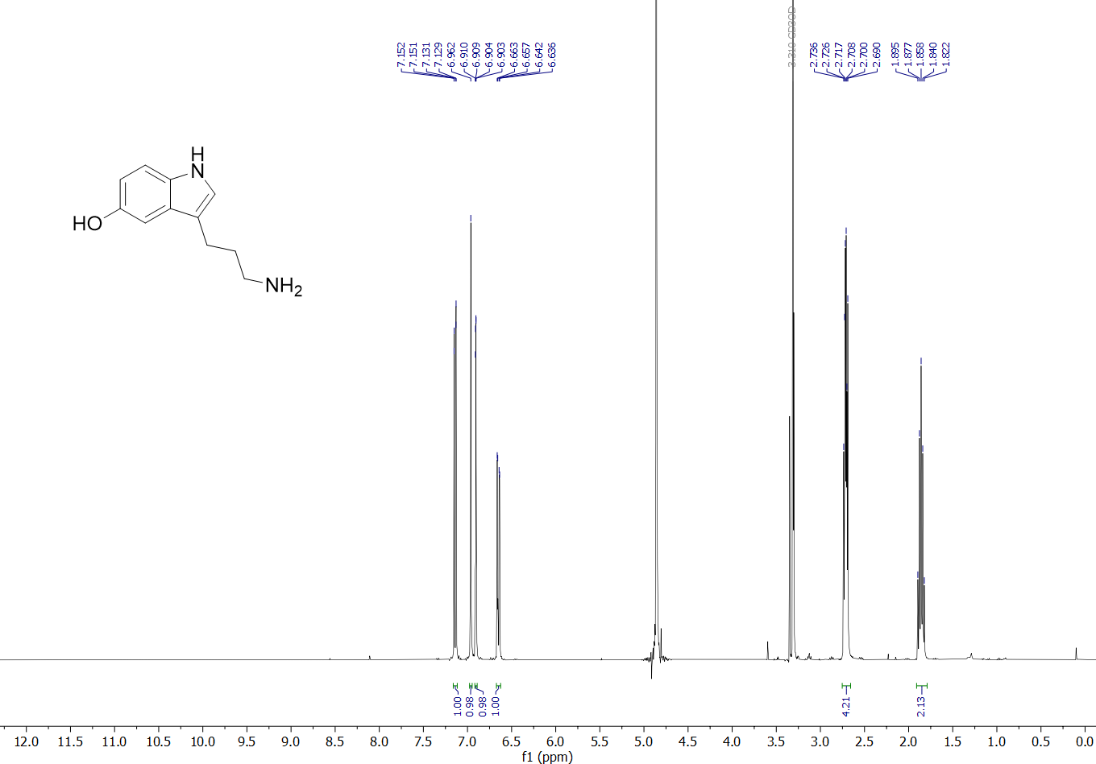
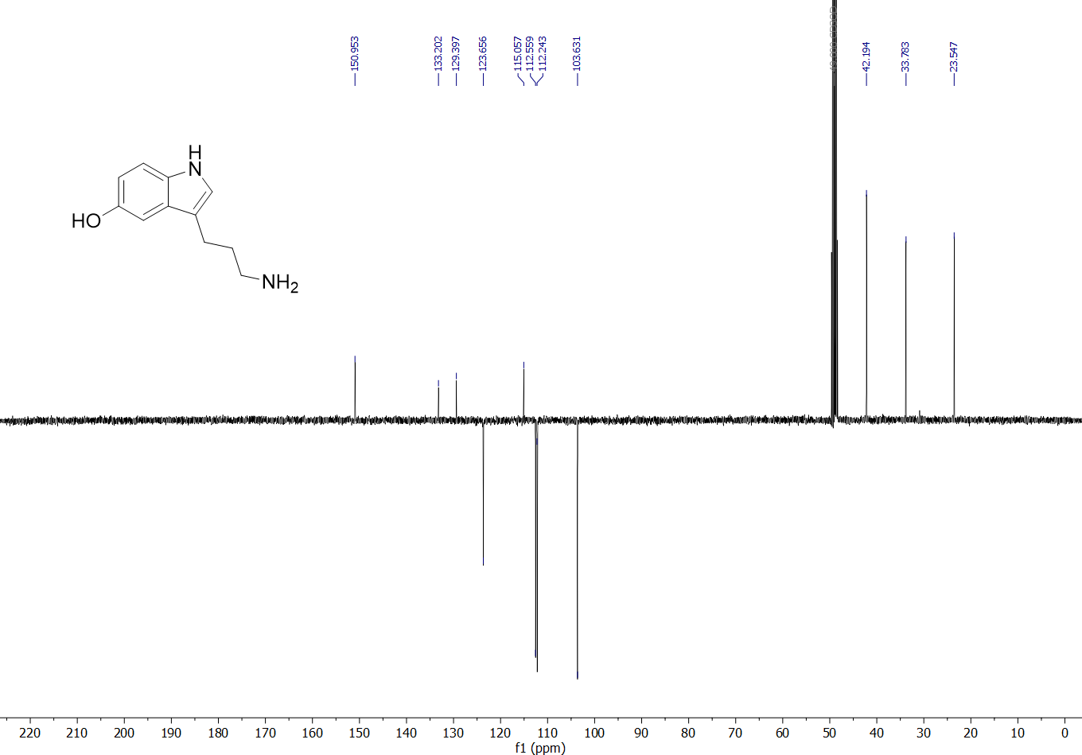

4-(5-(Benzyloxy)-1H-indol-3-yl)butanenitrile (8) - ¹H and APT spectra
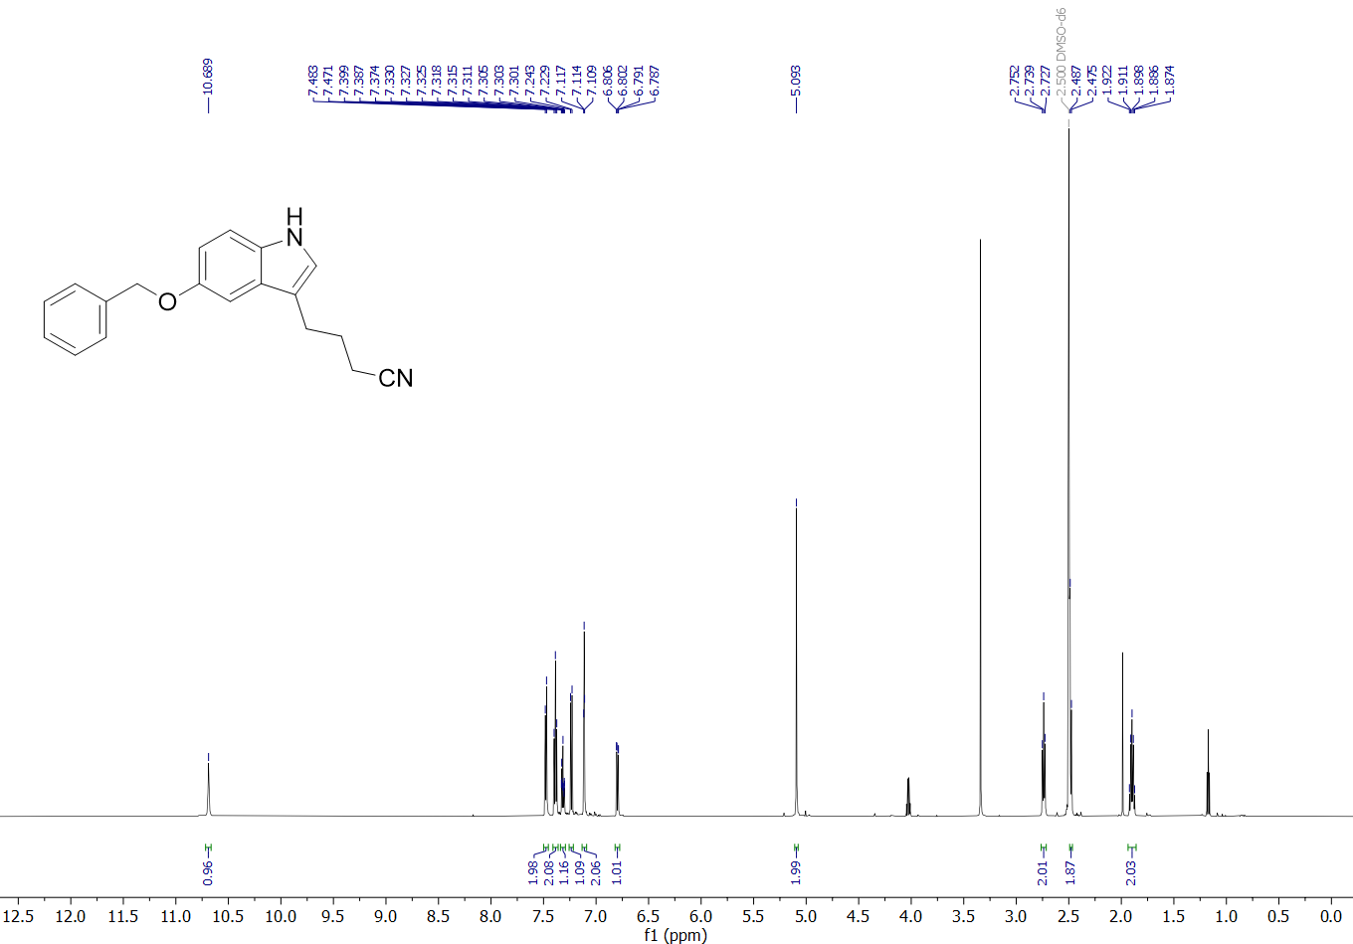
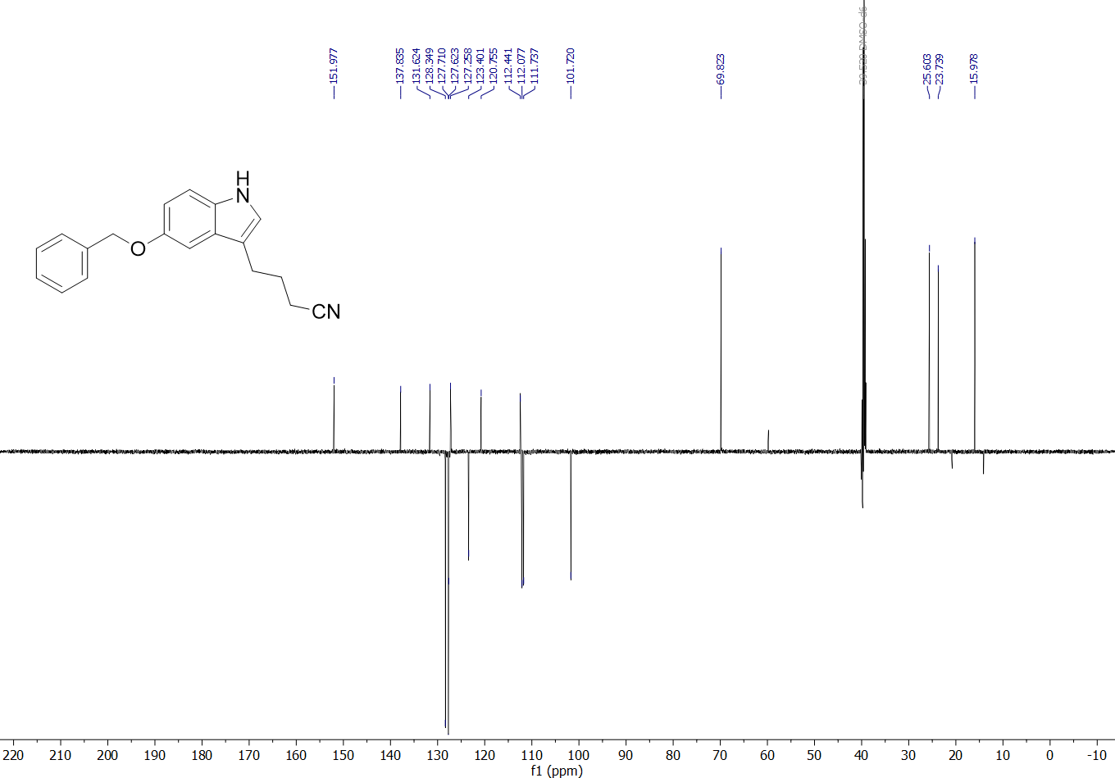

4-(5-Hydroxy-1H-indol-3-yl)butanenitrile (9) – ¹H and APT spectra
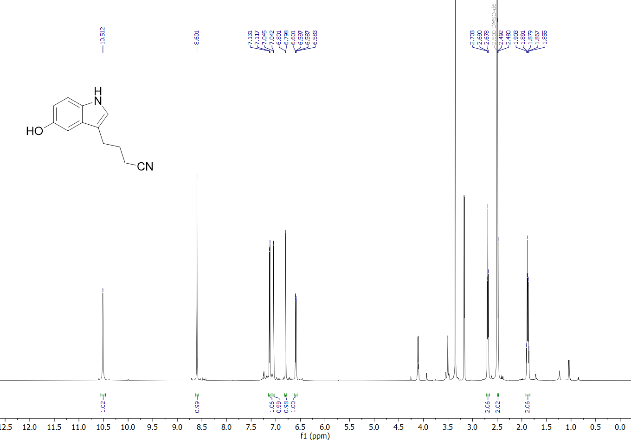
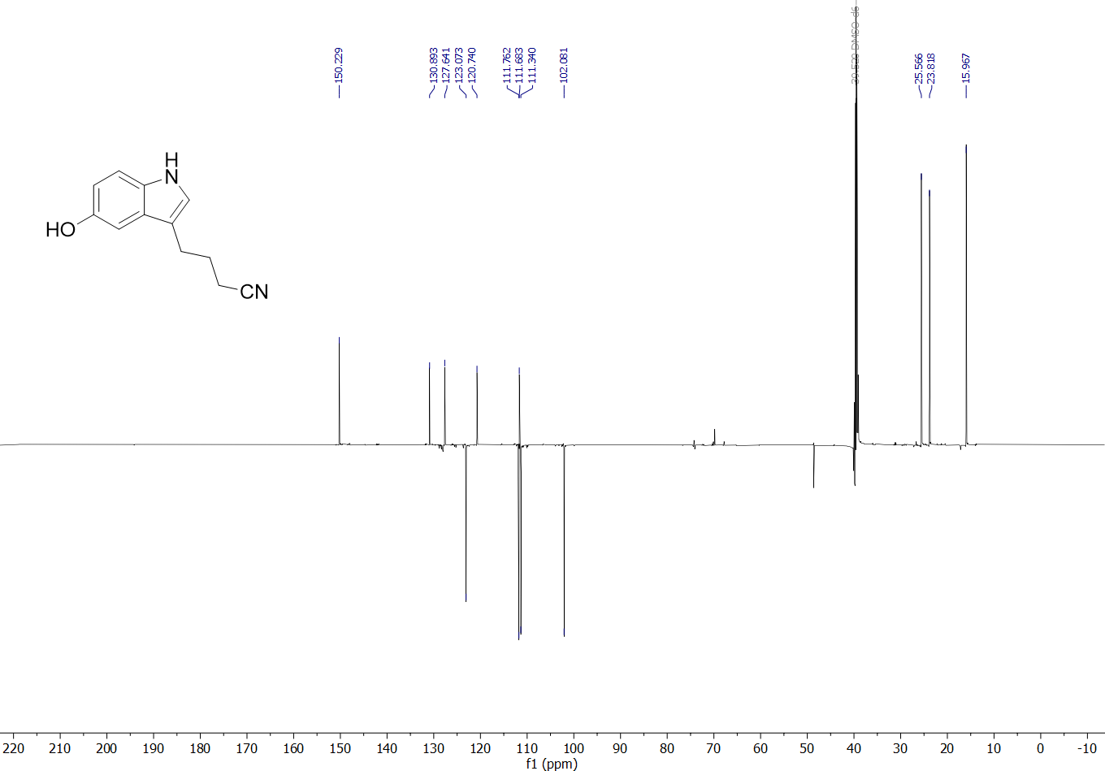

3-(4-Aminobutyl)-1H-indol-5-ol (10) – ¹H and APT spectra
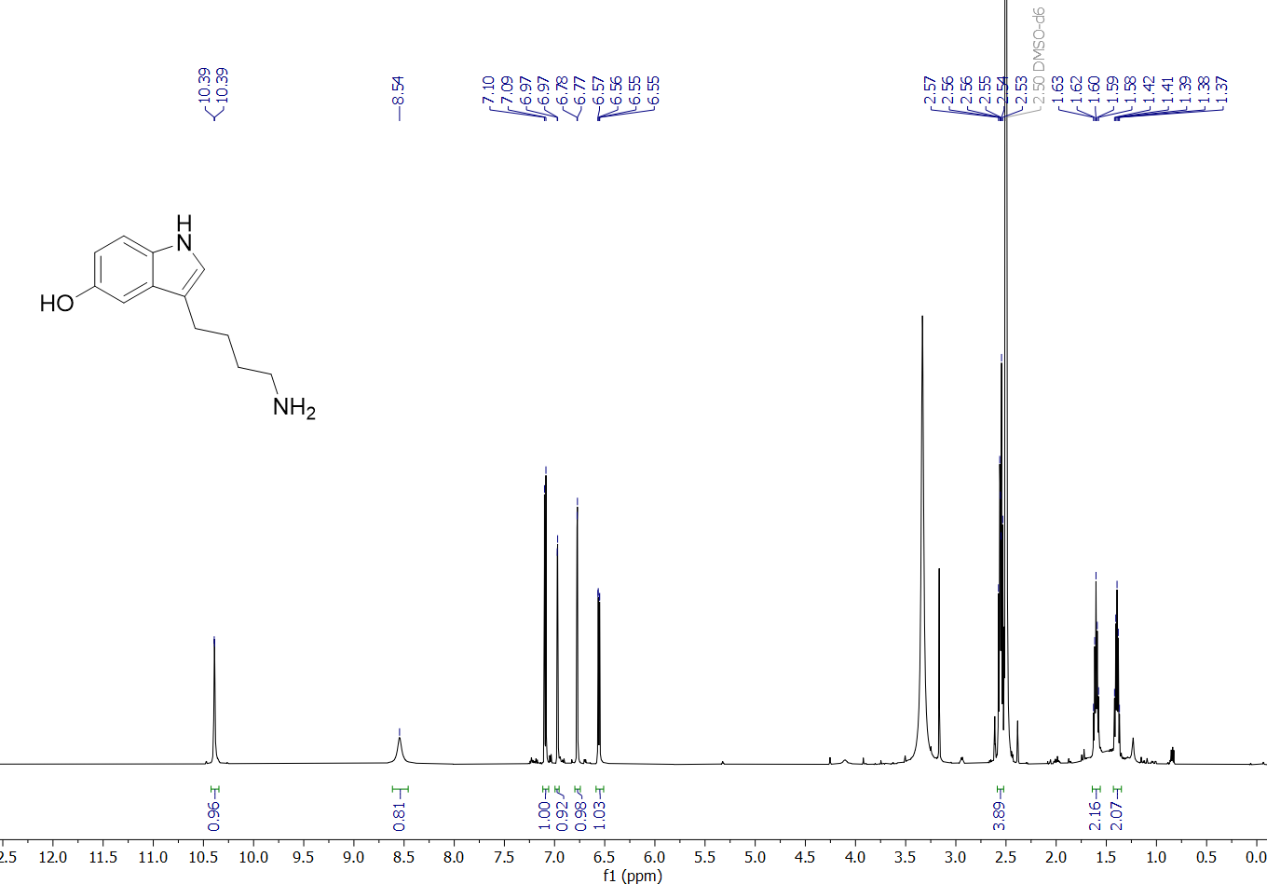
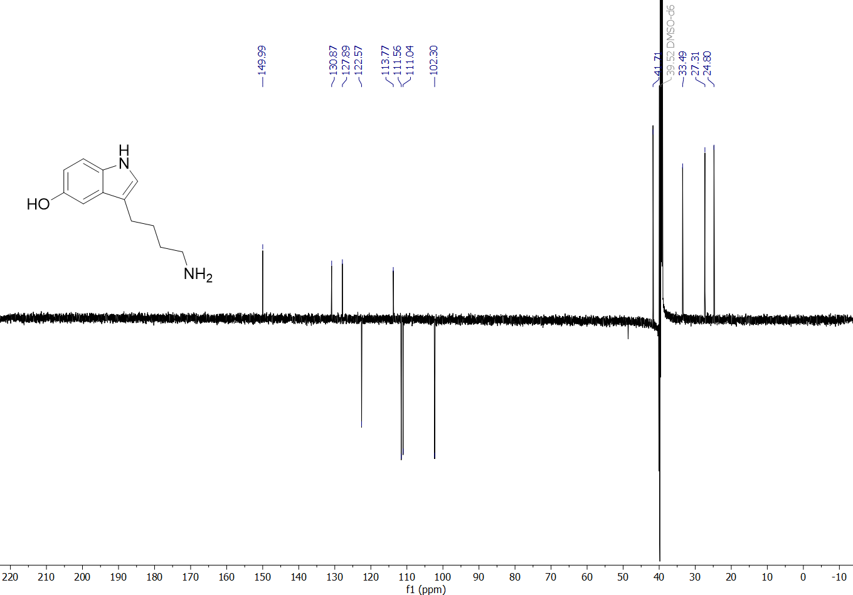

STABILITY STUDIES OF 5HT-DERIVATIVES
As serotonin, as many substrates with free amine and free hydroxyl groups, is known to be a rather unstable compound, we set out to investigate the stability of our synthesised compounds M-5HT (4), P-5HT (7) and B-5HT (10). It was important to us to establish their stabilities to be more confident not only in storage of the pure compounds but also storage and reuse of sample stock solutions for in vitro testing.
Therefore, we conducted stability studies by NMR in several solvents like D₂O and DMSO-d₆. Most importantly, we wanted to check if the samples would show any signs of degradation like non-compound related peaks appearing or decreasing peak integrals in comparison to the solvent peak. NMR samples of the three compounds in the desired solvents were prepared and the same samples in the same tubes remeasured over a timeframe of up to four months. For all the following NMR spectra the integral of the proton H2 peak is set to one.

3-(Aminomethyl)-1H-indol-5-ol hydrochloride (4)
Samples of compound M-5HT (4) in D₂O and DMSO-d₆ were prepared and ¹H-NMRs measured immediately, after 1 week, 2 weeks, 5 weeks, and 4 months.
Stability study in D₂O
Supplement Spectrum 1 shows the obtained stacked spectra for measurement in D₂O. As it can be seen, no additional peaks occur during this time period. However, especially after 4 months, we can observe a decrease in the peak integrals compared to the solvent peak. Moreover, even though the integral for the singlet at 7.44 ppm (H2) still shows an integral of one, the peaks at 7.11 ppm (H4) and 6.84 ppm (H6) show diminished integrals, accounting for deuterium exchange with the deuterated NMR solvent (Supplement Spectrum 1. A-E).
Nevertheless, M-5HT (4) shows good stability in D₂O for at least two weeks. Looking at the full ¹H spectra, we see a slight increase in the integral of the solvent peak after five weeks. This points towards either minor degradation to material not visible in the NMR or precipitation of the compound.

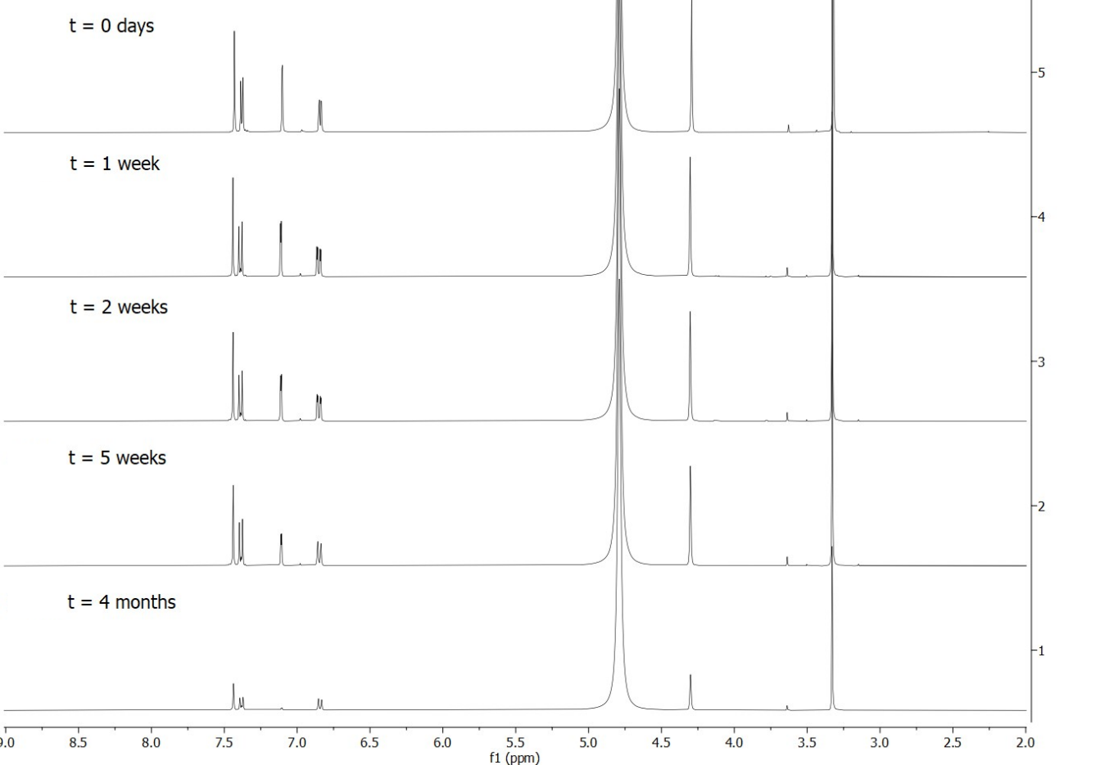
Supplement Spectrum 1. Stacked ¹H-NMR spectra of compound M-5HT (4) measured after up to 4 months in D₂O
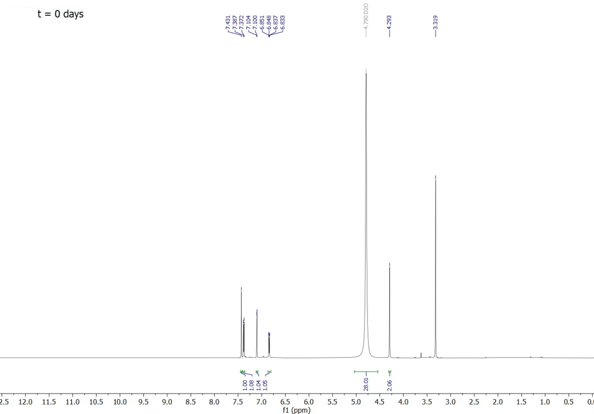
Supplement Spectrum 1. A) ¹H-NMR spectra of compound M-5HT (4) freshly prepared in D₂O
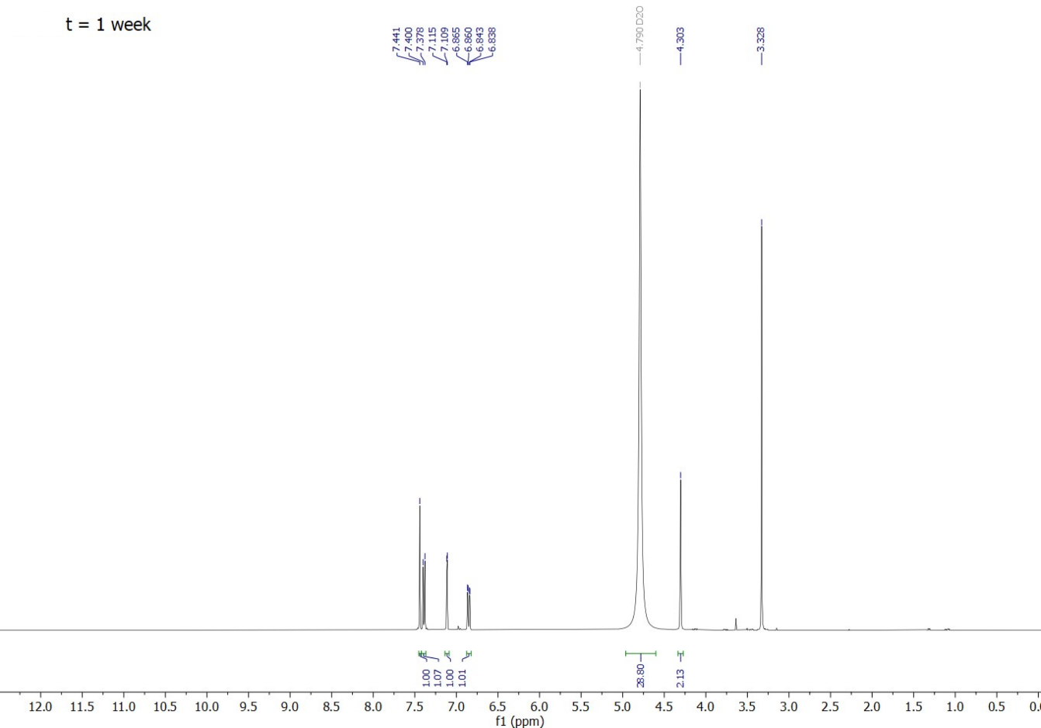
Supplement Spectrum 1. B) ¹H-NMR spectra of compound M-5HT (4) in D₂O after 1 week
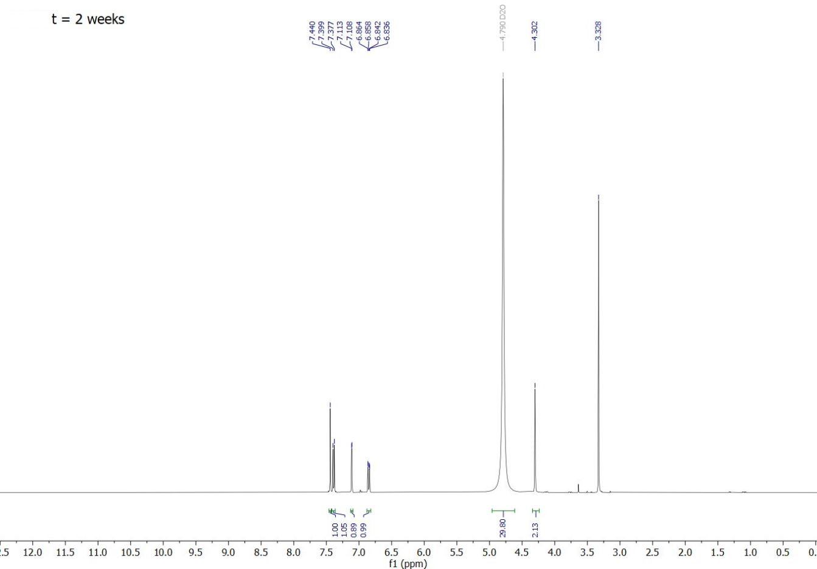
Supplement Spectrum 1. C) ¹H-NMR spectra of compound M-5HT (4) in D₂O after 2 weeks
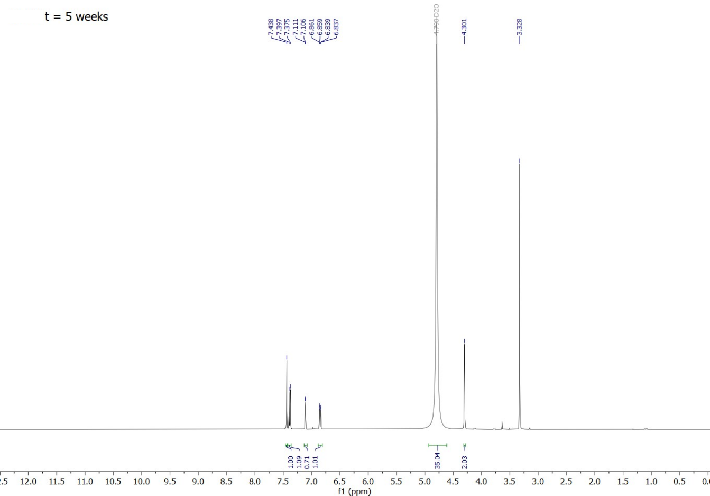
Supplement Spectrum 1. D) ¹H-NMR spectra of compound M-5HT (4) in D₂O after 5 weeks
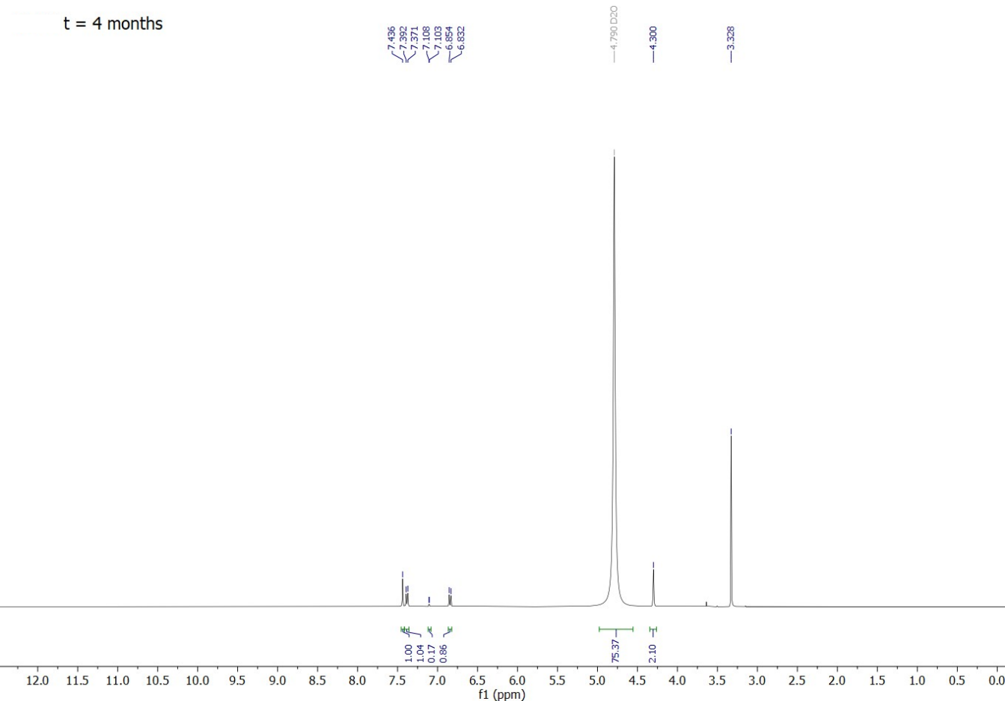
Supplement Spectrum 1. E) ¹H-NMR spectra of compound M-5HT (4) in D₂O after 4 months
Stability study in DMSO-d₆
The NMR sample of M-5HT (4) in DMSO was re-measured after 1.5 weeks, 2.5 weeks, 5.5 weeks, and 4 months. Again, no new peaks appear during this time except for an increasing water peak as can be seen in Supplement Spectrum 2. Like the measurements in D₂O, deuterium exchange can be observed. This also explains the seemingly rapidly growing solvent peak comparing day 0 and week 1.5, which would normally suggest precipitation of the sample. However, the integral of the methanol peak in the sample staying consistent throughout all measurements and the DMSO-d₆ peak integral not changing much anymore after reaching 2.77 at 1.5 weeks, indicate that the sample is not precipitating but deuterium exchange happens (Supplement Spectrum 2. A-E).
Therefore, the stability of sample M-5HT (4) in DMSO-d₆ could also be shown to be very good with hardly any changes in the NMR spectra for 5.5 weeks.

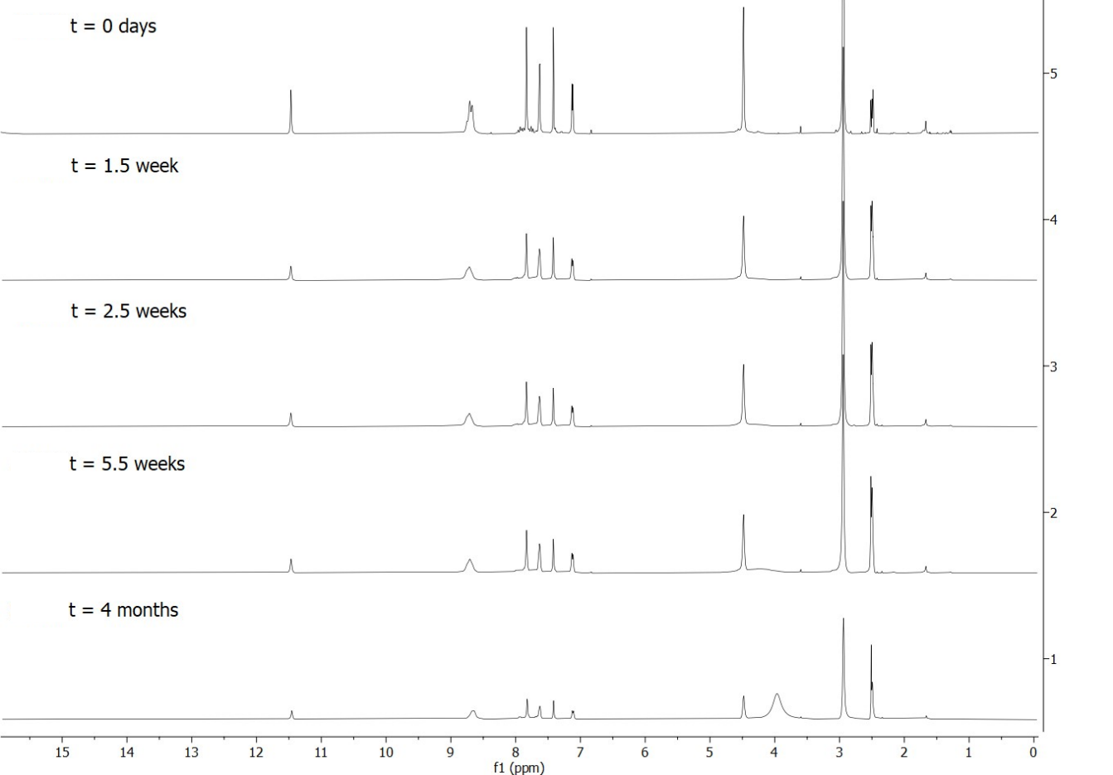
Supplement Spectrum 2. Stacked ¹H-NMR spectra of compound M-5HT (4) measured after up to 4 months in DMSO-d₆
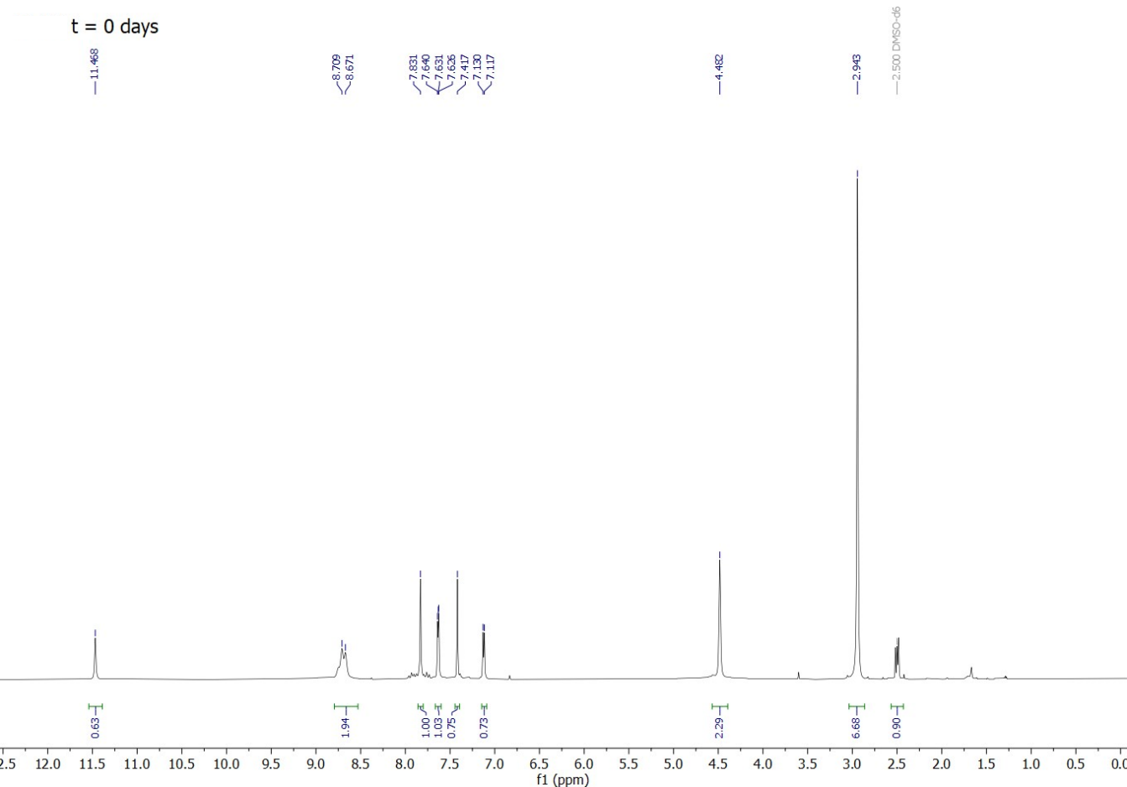
Supplement Spectrum 2. A) ¹H-NMR spectra of compound M-5HT (4) in DMSO-d₆ freshly prepared
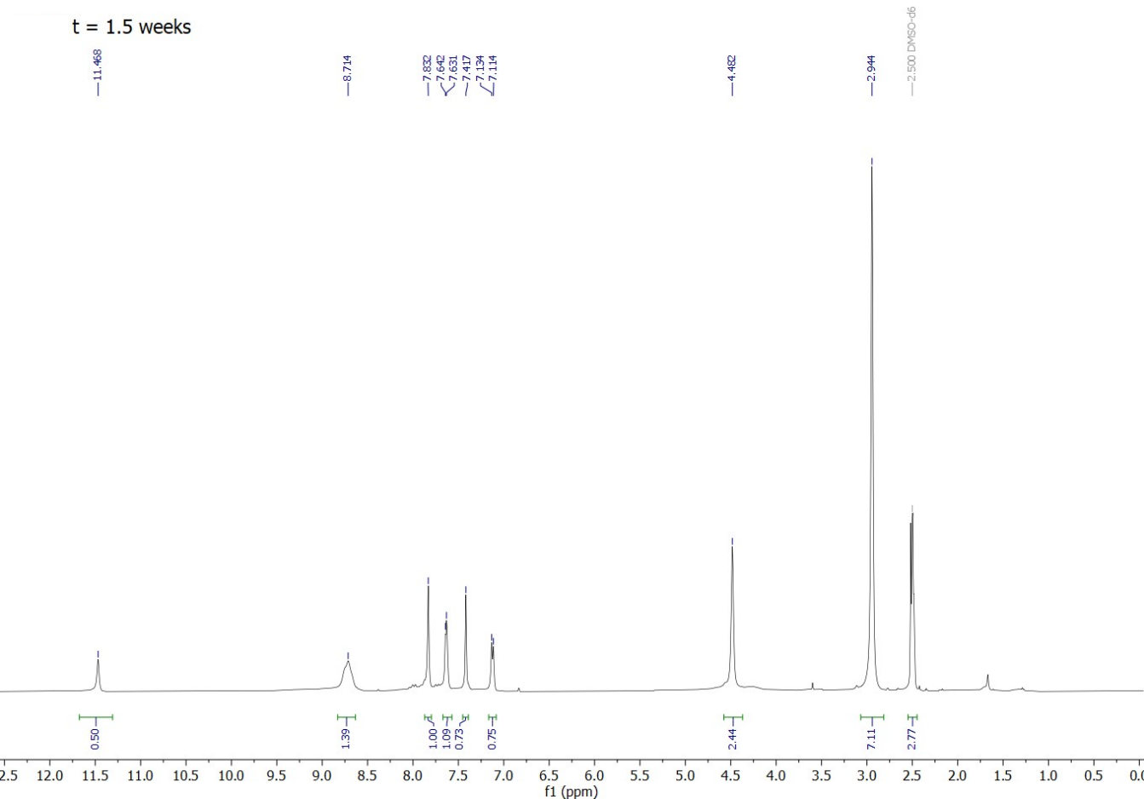
Supplement Spectrum 2. B) ¹H-NMR spectra of compound M-5HT (4) in DMSO-d₆ after 1.5 weeks
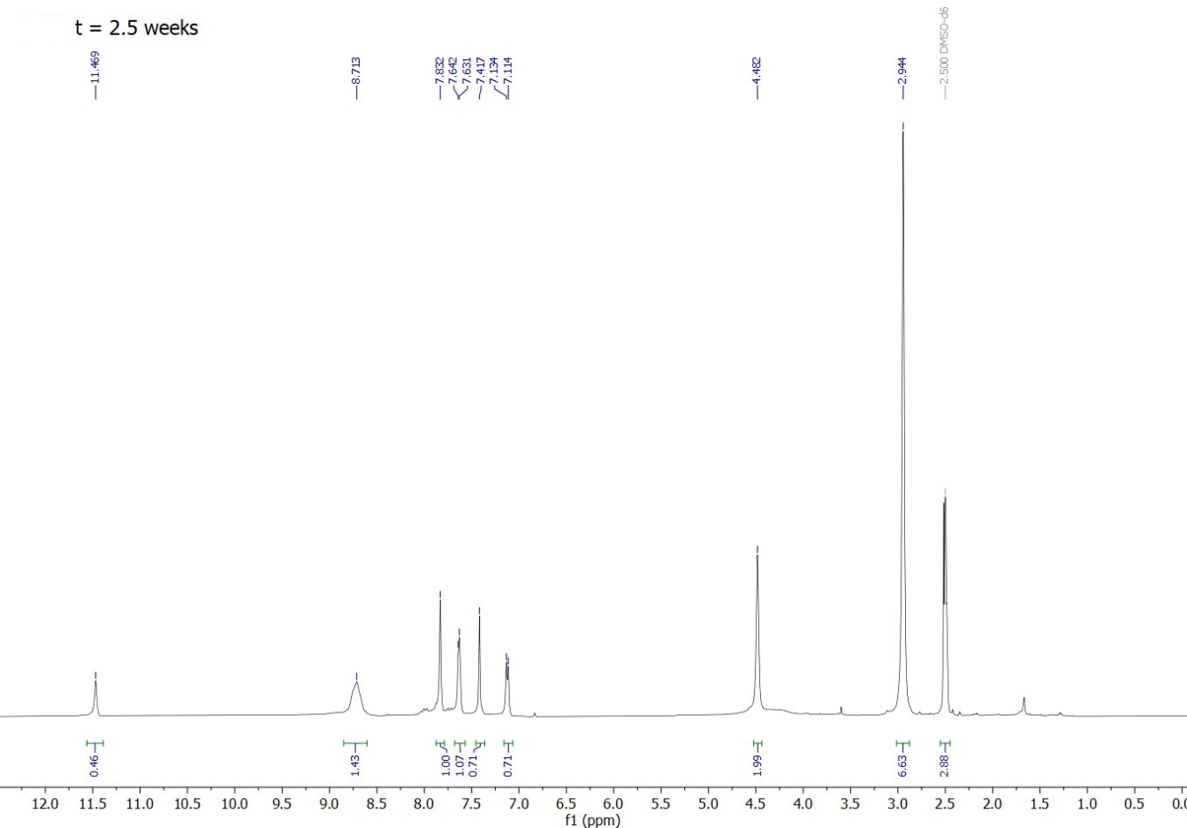
Supplement Spectrum 2. C) ¹H-NMR spectra of compound M-5HT (4) in DMSO-d₆ after 2.5 weeks
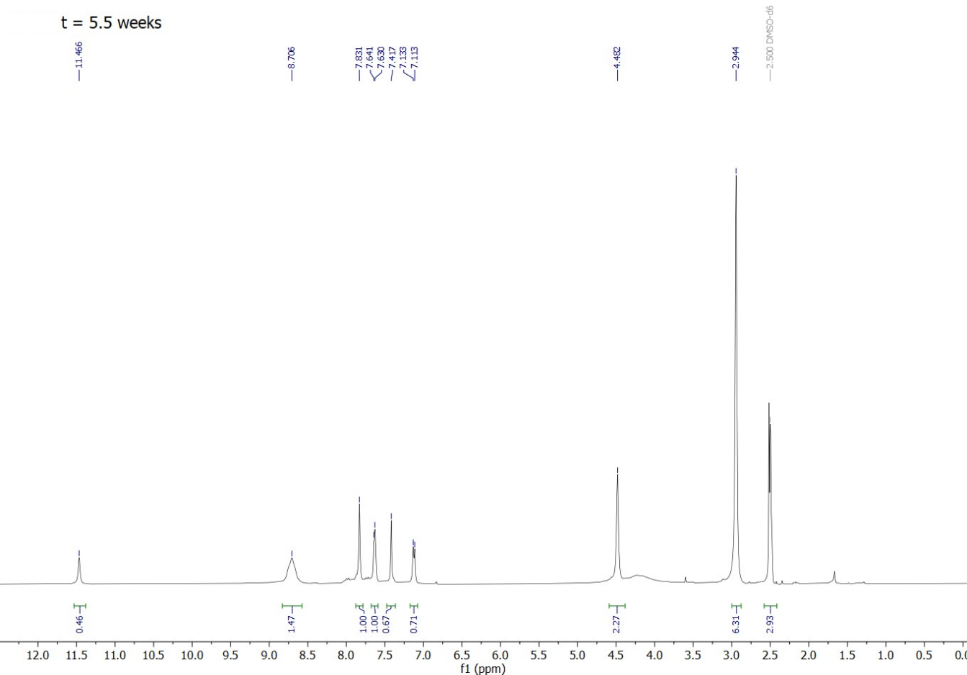
Supplement Spectrum 2. D) ¹H-NMR spectra of compound M-5HT (4) in DMSO-d₆ after 5.5 weeks
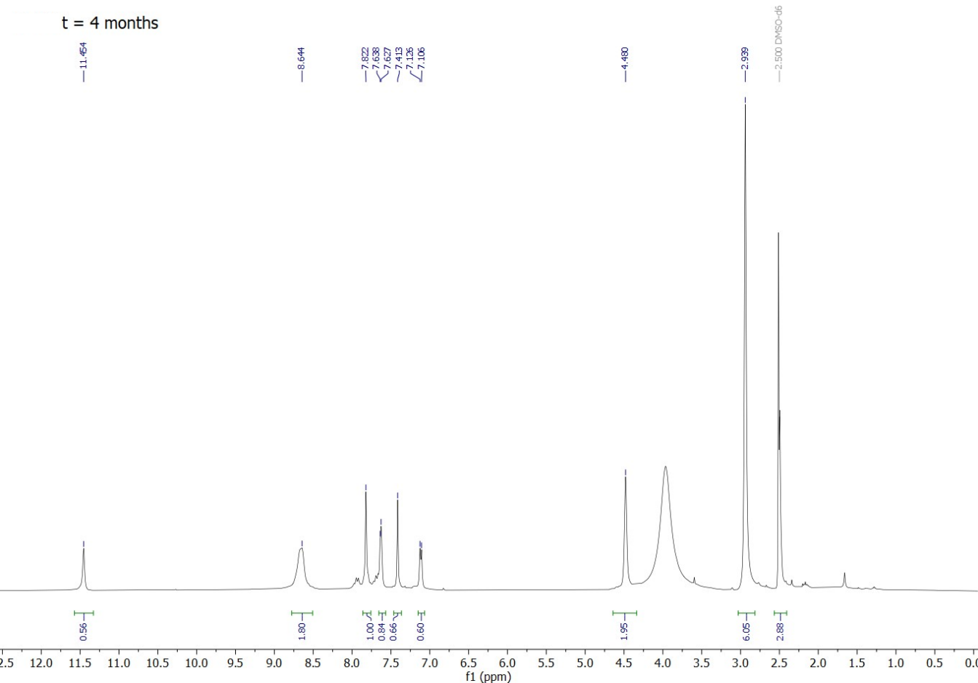
Supplement Spectrum 2. E) ¹H-NMR spectra of compound M-5HT (4) in DMSO-d₆ after 4 months
3-(3-Aminopropyl)-1H-indol-5-ol (7)
A sample of compound P-5HT (4) in DMSO-d₆ was prepared and ¹H-NMRs measured immediately, after 2 weeks, 3 weeks, and 4 months.
Supplement Spectrum 3 shows the obtained stacked spectra for measurement in DMSO-d₆. As the stability studies were performed on preliminary material, the proton NMR shows some solvent and minor impurity peaks next to the compound peaks. Nevertheless, similar to the behaviour of compound M-5HT (4), no additional peaks occur during the observed time frame of 4 months. Deuterium exchange seems to be happening here too, as many peaks except the 7.09 ppm (H2) peak show slightly decreasing integrals and the ¹H-NMR after 4 months does suggest some precipitation. However, good stability of P-5HT (7) in DMSO-d₆ for at least three weeks was found (Supplement Spectrum 3. A-D).

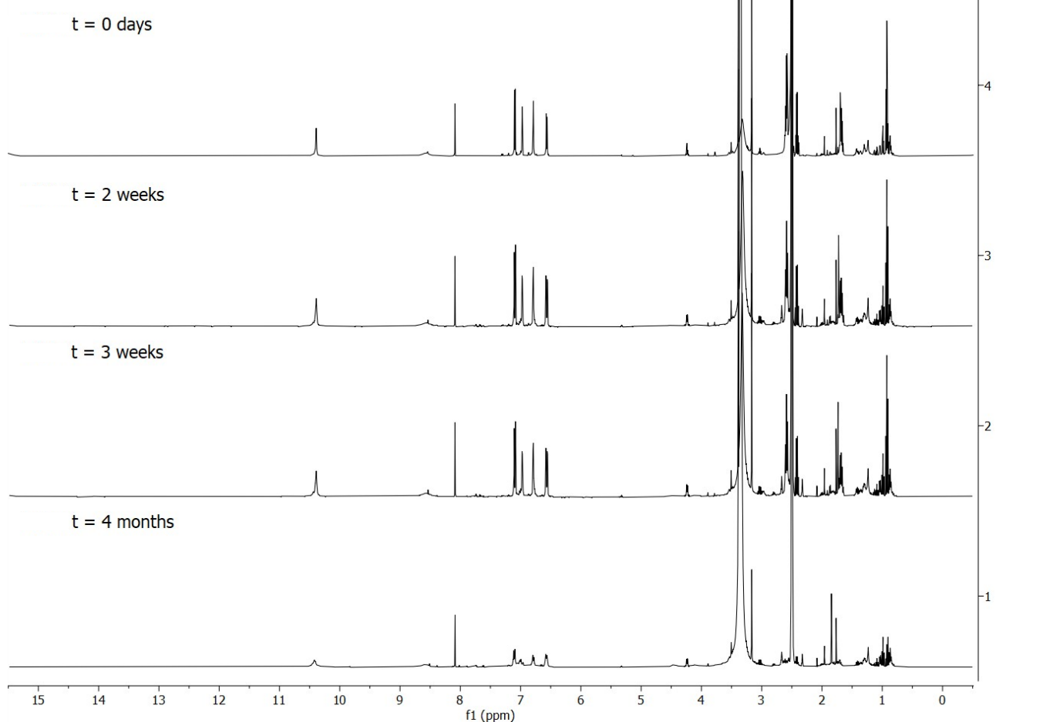
Supplement Spectrum 3. Stacked ¹H-NMR spectra of compound P-5HT (7) measured after up to 4 months in DMSO-d₆
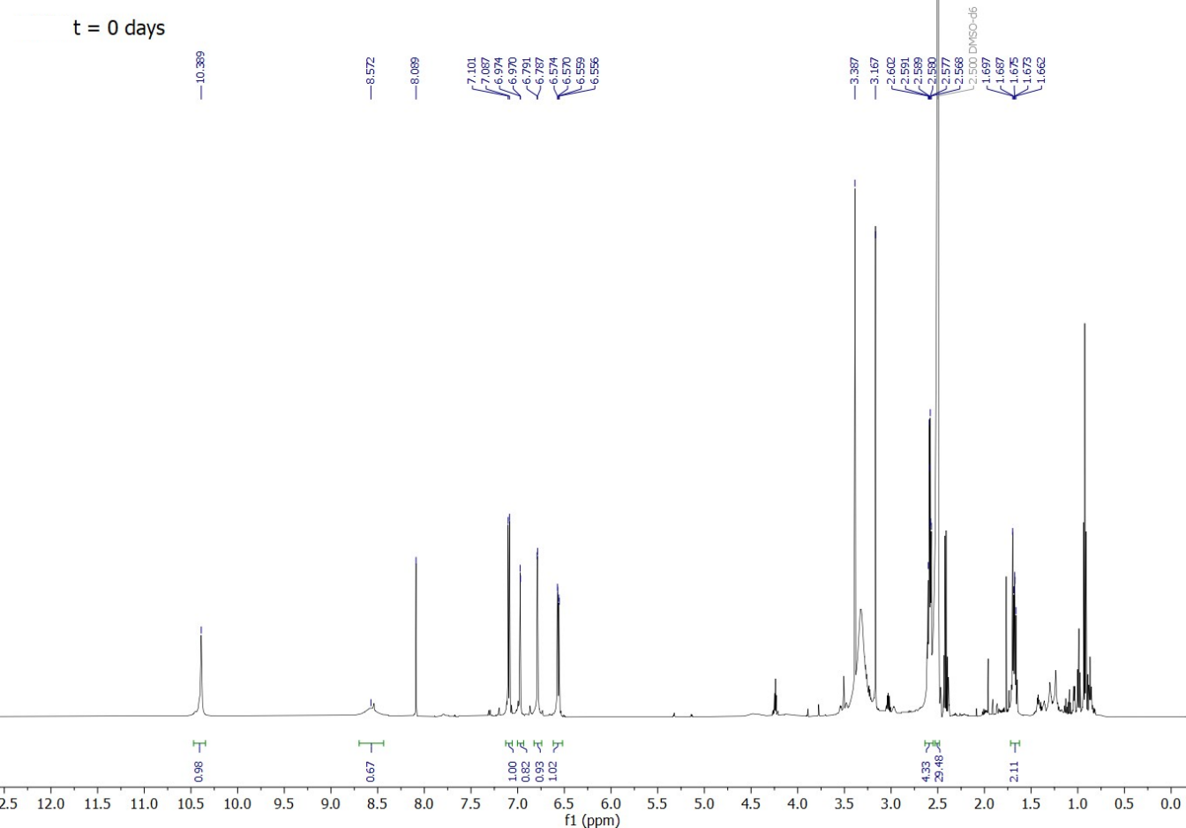
Supplement Spectrum 3. A) ¹H-NMR spectra of compound P-5HT (7) in DMSO-d₆ freshly prepared
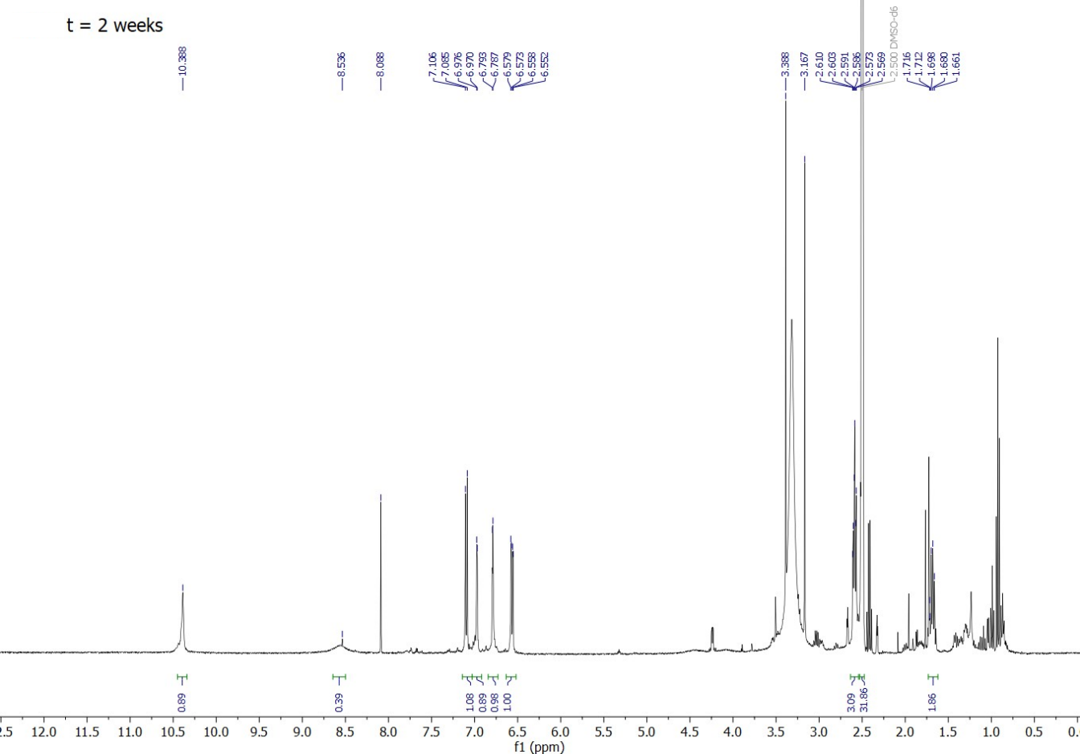
Supplement Spectrum 3. B) ¹H-NMR spectra of compound P-5HT (7) in DMSO-d₆ after 2 weeks
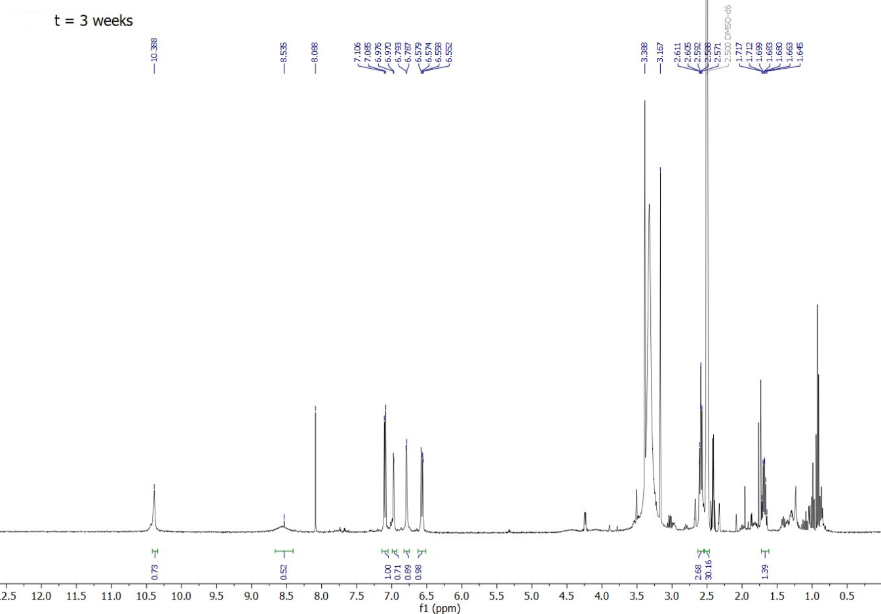
Supplement Spectrum 3. C) ¹H-NMR spectra of compound P-5HT (7) in DMSO-d₆ after 3 weeks
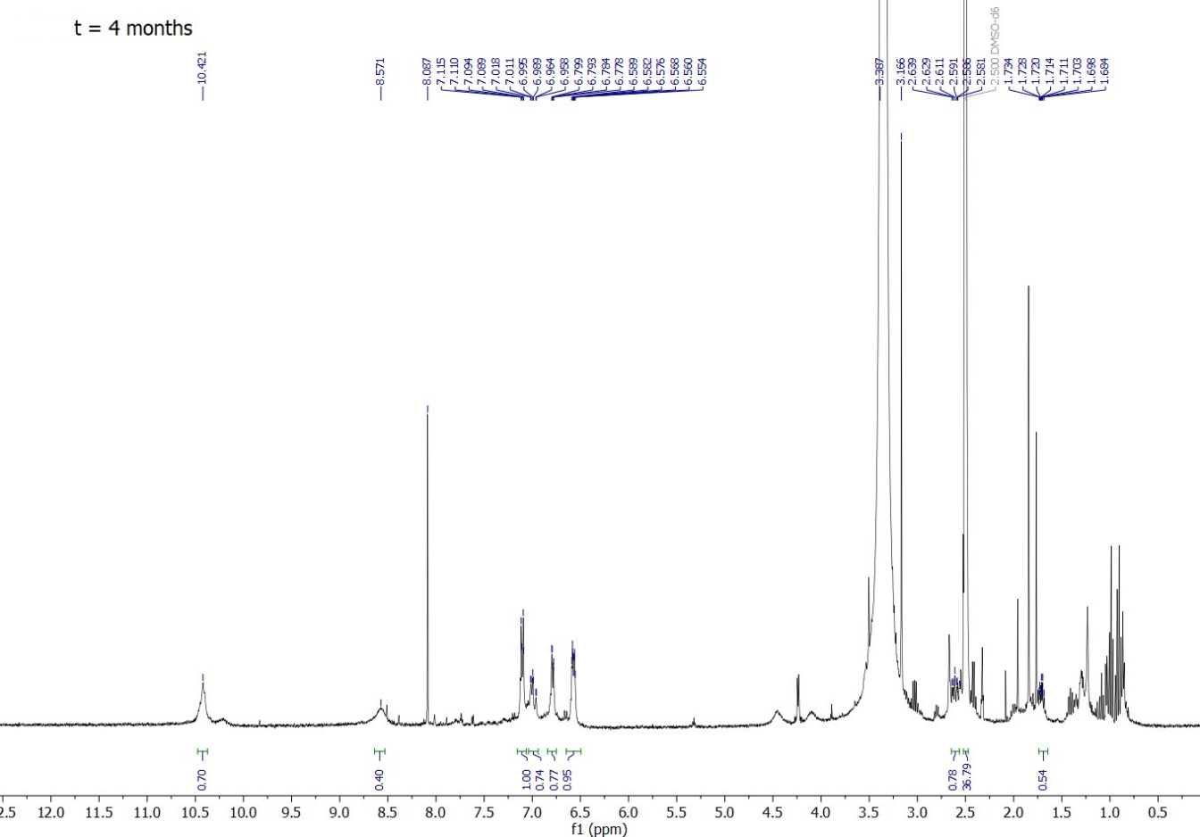
Supplement Spectrum 3. D) ¹H-NMR spectra of compound P-5HT (7) in DMSO-d₆ after 4 months

3-(4-Aminobutyl)-1H-indol-5-ol (10)
A sample of compound B-5HT (10) in DMSO-d₆ was prepared and ¹H-NMRs measured immediately and after 1 month. Like compounds M-5HT (4) and P-5HT (7), no decomposition or significant change in the integrals could be observed. Thereby, we found that B-5HT (10) shows good stability in DMSO-d₆ for at least 1 month (Supplement Spectrum 4, 4 A and 4 B).

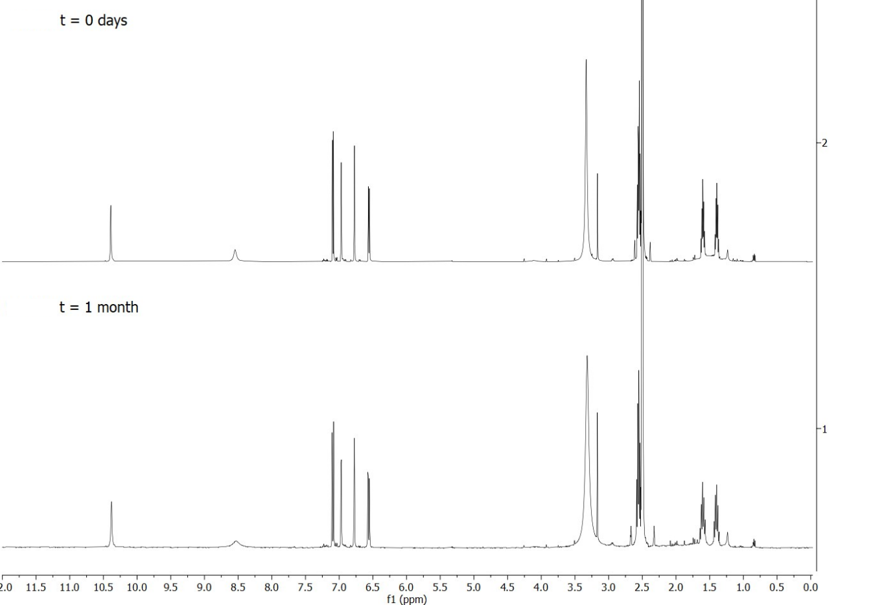
Supplement Spectrum 4. Stacked ¹H-NMR spectra of compound B-5HT (10) measured immediately and after 1 month in DMSO-d₆
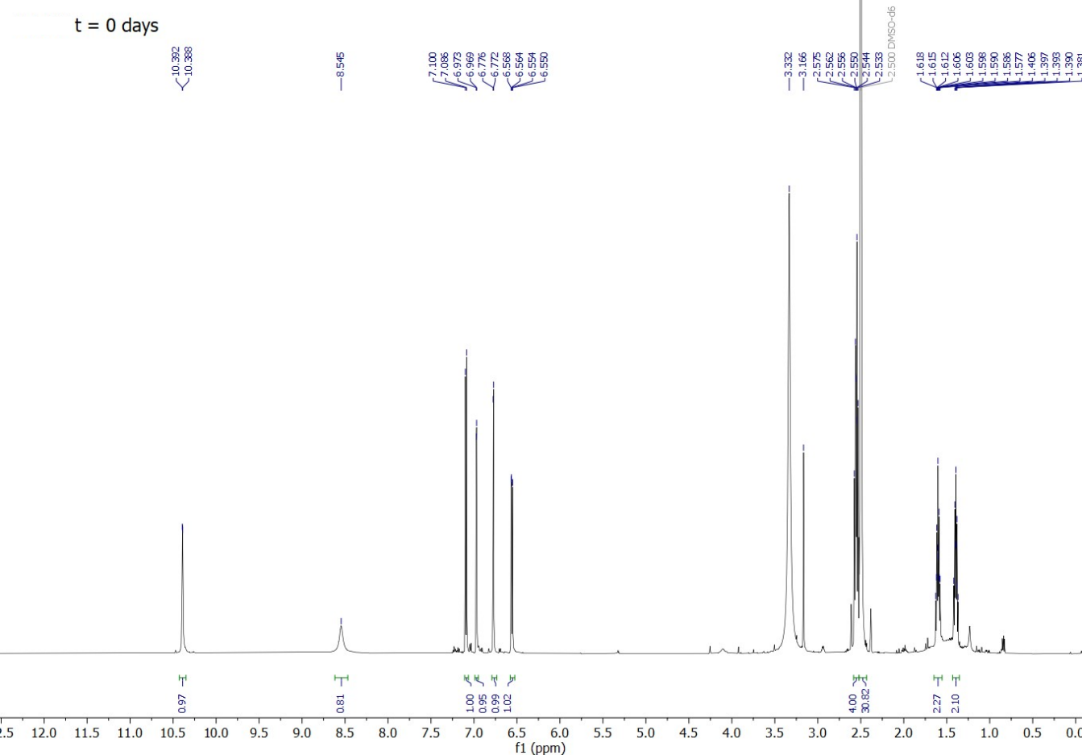
Supplement Spectrum 4. A) ¹H-NMR spectra of compound B-5HT (10) in DMSO-d₆ freshly prepared
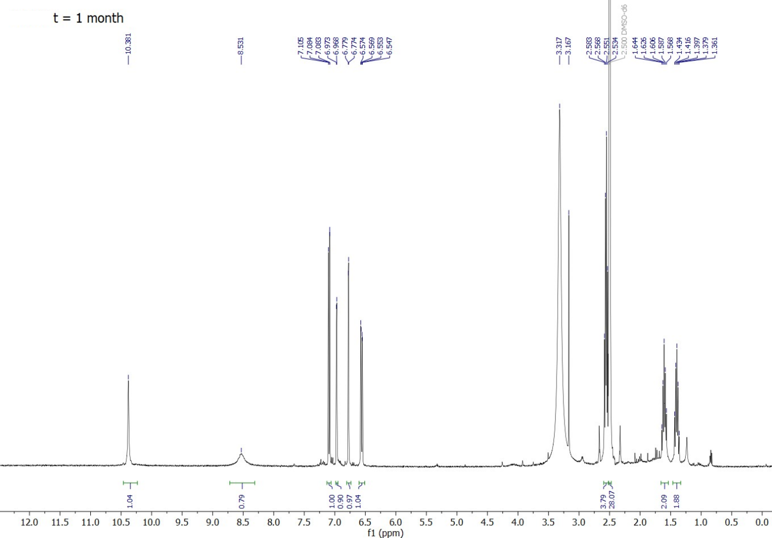
Supplement Spectrum 4. B) ¹H-NMR spectra of compound B-5HT (10) in DMSO-d₆ after 1 month
SUPPLEMENTARY REFERENCES
1. Schicker, K. et al. Unifying Concept of Serotonin Transporter-associated Currents. J. Biol. Chem. 287, 438–445 (2012).
2. Niello, M. et al. Persistent binding at dopamine transporters determines sustained psychostimulant effects. Proc. Natl. Acad. Sci. 120, (2023).
3. Bulling, S. et al. The Mechanistic Basis for Noncompetitive Ibogaine Inhibition of Serotonin and Dopamine Transporters. J. Biol. Chem. 287, 18524–18534 (2012).
4. Pinder, R. M., Green, D. M., Brewster, K. & Thompson, P. B. J. The influence of chain length upon the activity of 5-hydroxytryptamine. J. Pharm. Pharmacol. 25, 847–848 (2011).
5. Adkins, E. M., Barker, E. L. & Blakely, R. D. Interactions of Tryptamine Derivatives with Serotonin Transporter Species Variants Implicate Transmembrane Domain I in Substrate Recognition. Mol. Pharmacol. 59, 514–523 (2001).
6. Karuvalam, R. P., Pakkath, R., Haridas, K. R., Rishikesan, R. & Kumari, N. S. Synthesis, characterization, and SAR studies of new (1H-indol-3-yl)alkyl-3-(1H-indol-3-yl)propanamide derivatives as possible antimicrobial and antitubercular agents. Med. Chem. Res. 22, 4437–4454 (2013).
7. Katz, A. H. et al. Synthesis and analgesic activity of pemedolac [cis-1-ethyl-1,3,4,9-tetrahydro-4-(phenylmethyl)pyrano[3,4-b]indole-1-acetic acid]. J. Med. Chem. 31, 1244–1250 (1988).
8. Stornaiuolo, M. et al. Structure-Based Lead Optimization and Biological Evaluation of BAX Direct Activators as Novel Potential Anticancer Agents. J. Med. Chem. 58, 2135–2148 (2015).
9. Salonen, L. M. et al. Molecular Recognition at the Active Site of Factor Xa: Cation-π Interactions, Stacking on Planar Peptide Surfaces, and Replacement of Structural Water. Chem. - A Eur. J. 18, 213–222 (2012).
10. Bender, C. F. & Widenhoefer, R. A. Room Temperature Hydroamination of N -Alkenyl Ureas Catalyzed by a Gold(I) N -Heterocyclic Carbene Complex. Org. Lett. 8, 5303–5305 (2006).
11. Youn, S. W., Pastine, S. J. & Sames, D. Ru(III)-Catalyzed Cyclization of Arene-Alkene Substrates via Intramolecular Electrophilic Hydroarylation. Org. Lett. 6, 581–584 (2004).

