Supplementary information
The Genome of Medicinal Leech (Whitmania pigra) for Exploration of Bioactive Ingredients
Lei Tong^{1, #}, Shao-Xing Dai^{2, #}, De-Jun Kong^{1, #}, Peng-Peng Yang², Xin Tong², Xiang-Rong Tong¹, Xiao-Xu Bi¹, Yuan Su¹, Yu-Qi Zhao³, Zi-Chao Liu^{1, *}
¹Engineering Research Center for Exploitation and Utilization of Leech Resources in Universities of Yunnan Province, School of Agronomy and Life Sciences, Kunming University, Kunming 650214, China
²Yunnan Key Laboratory of Primate Biomedicine Research, Institute of Primate Translational Medicine, Kunming University of Science and Technology, Kunming 650500, China
³Department of Integrative Biology and Physiology, University of California, Los Angeles, Los Angeles, CA 90095, USA
Authors email:
Lei Tong: 1501159559@qq.com
Shao-Xing Dai: daishx08@gmail.com
De-Jun Kong: kongdj05@hotmail.com
Peng-Peng Yang: yangpp@lpbr.cn
Xin Tong: tongxin0013@163.com
Xiang-Rong Tong: txiangrong@163.com
Xiao-Xu Bi: 279781667@qq.com
Yuan Su: suyuankm@163.com
Yu-Qi Zhao: zhaoyuqi616@gmail.com
Zi-Chao Liu: abclzc@aliyun.com
#These authors contributed equally to this work
*Corresponding author: Zi-Chao Liu

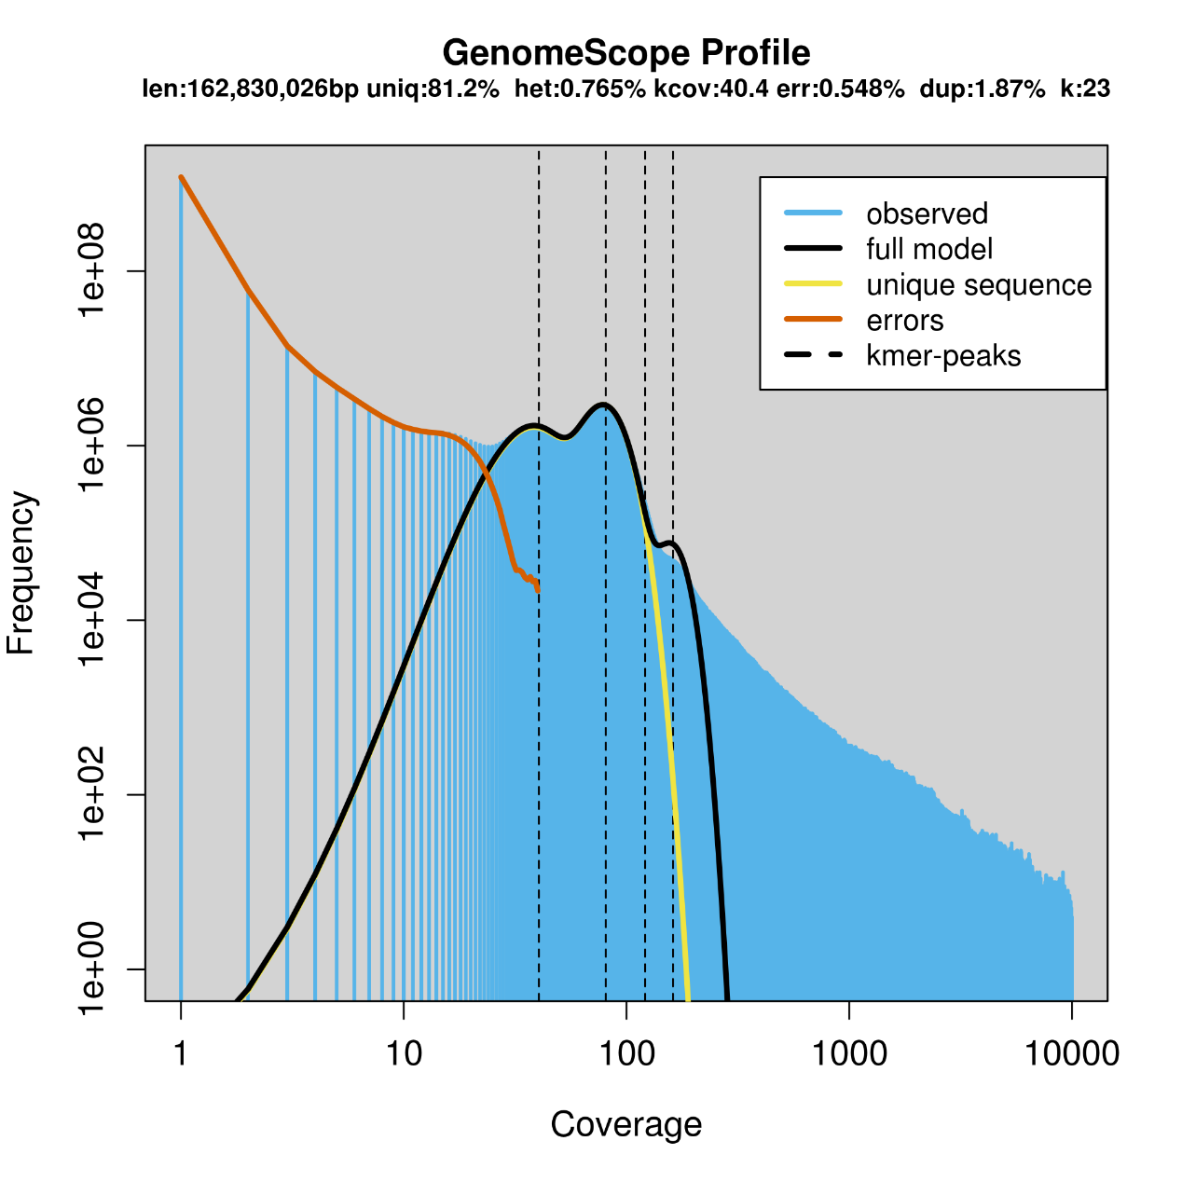
Figure S1. GenomeScope Analysis of the 23-mers for W. Pigra genome sequencing data. Estimate of the heterozygous portion is 0.765%. The estimated genome size of W. Pigra was ~ 162Mbp

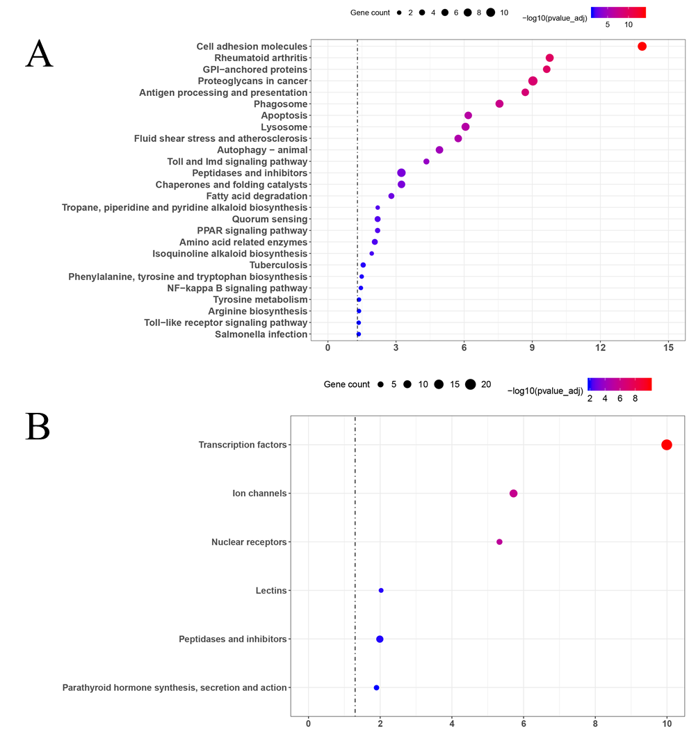
Figure S2. Enrichment analysis of expanded gene families between two species W. pigra (A) and H. robusta (B) using KEGG terms.

