Supplementary Information

Preparation and Study of Straw Porous Biochar with Aromatic Ring Structure for Adsorption Performance and Mechanism towards TNT Red Water

Nengsheng Liu, Jiangzhou Qin, Xinrui Ge, Yanyu Lu, Jihan Zhang, Quanlin Zhao, and Zhengfang Ye∗

The Key Laboratory of Water and Sediment Sciences, Ministry of Education, College of Environmental Sciences and Engineering, Peking University, Beijing, 100871, P. R. China

Number of pages: 15

Number of tables: 4

Number of figures: 8

Table of Contents

Index | Caption | Page
Test S1. | Details of chemicals. | S3
Text S2. | Details of characterization instruments. | S3
Text S3. | Details of kinetics curve fitting. | S4
Table S1. | Details of compounds in TNT red water. | S5-S6
Table S2. | Element information of Spectrum 7. | S7
Table S3. | Element information of Spectrum 8. | S7
Table S4. | Element information of Spectrum 9. | S7
Fig. S1. | Crushed rice straw and TNT red water. | S8
Fig. S2. | High resolution XPS spectra of O 1 s. | S9
Fig. S3. | High resolution XPS spectra of N 1 s. | S10
Fig. S4. | EDS spectra of SBC. | S11
Fig. S5. | EDS spectra of element information on Spectrum 7. | S12
Fig. S6. | EDS spectra of element information on Spectrum 8. | S13
Fig. S7. | EDS spectra of element information on Spectrum 9. | S14
Fig. S8. | Zeta potential of straw-derived biochar at different pH. | S15

Text S1
The initial COD of TNT red water is 50,000-53,000mg /L, and the pH range is between 6.5 and 7.4. (NH₄)₂HPO₄, NaOH, HCl, were purchased from Tongguang Chemical Co., Ltd.(Beijing, China). KOH, acetone and other chemicals with analytical grade used in this study were from Sigma-Aldrich chemical company.

Text S2
Scanning electron microscopy (SEM, Gemini 300, ZEISS, Germany) was employed to determine the surface morphology of synthesized biochar. Energy Dispersive X-ray Spectroscopy (EDS, INCA X Act, Oxford) was used to determine elemental information on synthesized biochar surface. Fourier transformation infrared (FT-IR, Nicolet NEXUS 670, Thermo Fisher, USA) spectroscopy spectra was obtained to further confirm the organic structure and functional groups on the surface of biochar. The BET analysis was obtained from N₂ adsorption-desorption isotherms using Porosimetry System (Quantachrome, Autosorb-iQ). X-ray photoelectron spectroscopy (XPS, ESCALAB 250xi, Jiaodahongrui Analytical Ltd., Shanghai, CN) were utilized to determine the elemental quantitative results and chemical state of P after pretreatment by (NH₄)₂HPO₄. A zeta potential analyzer (Brookhaven Instruments ZetaPlus) was used to analyze the charge of the biochar. The pH values of the solutions were determined by an acidity meter (PHBJ-261L). The chemical oxygen demand (COD) was measured by HASH (DR 200). The organic components of TNT red water were measured using a High-Resolution Liquid Chromatography-Mass Spectrometry (LC-MS, Thermo Fisher, USA) system.

Text S3
To better describe the adsorption of COD of TNT red water, the kinetics experimental data were fitted with four kinetic models (pseudo-first order kinetic model, pseudo-second order kinetic model, Elovich kinetic model, and intraparticle diffusion model).
The fitted equation are as follows:
Pseudo-first order kinetic model: Y=3.92267-0.04679x
Pseudo-second order kinetic model: Y=0.00856+0.00707x
Elovich kinetic model: Y=80.05591+12.89518x
Intraparticle diffusion model: Y=19.38558+49.20495x; Y=117.93382+2.29331x.

Table S1. The organic components in TNT red water.
 | Molecular Formula | Name | Structure
1 | C₆H₃N₃O₇ | 2,4,6-Trinitrophenol | 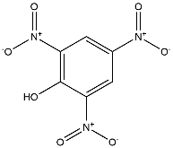
2 | C₆H₃N₃O₈ | 2,4,6-TRINITRORESORCINOL | 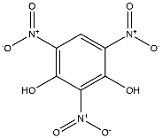
3 | C₆H₄N₂O₄ | 1,3-Dinitrobenzene | 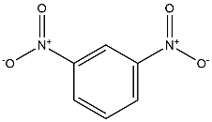
4 | C₆H₄N₂O₅ | 2,4-Dinitrophenol | 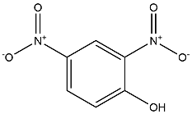
5 | C₆H₄N₂O₇S | 2,4-Dinitrobenzenesulfonic acid hydrate | 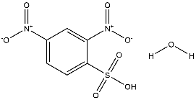
6 | C₆H₄N₂O₈S | 4-Hydroxy-3,5-dinitrobenzenesulphonic acid | 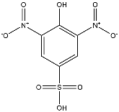
7 | C₆H₄N₄O₆ | 2,3,4,6-Tetranitroaniline | 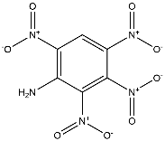
8 | C₆H₅N₃O₄ | 2,4-Dinitroaniline | 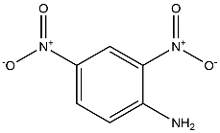
9 | C₆H₅N₃O₇S | 4-Amino-3,5-dinitrobenzenesulfonic acid | 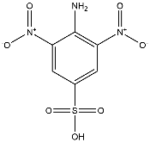
10 | C₇H₃N₃O₉ | 3-Hydroxy-2,4,6-trinitrobenzoic acid | 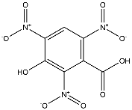
11 | C₇H₄N₂O₇ | 3,5-Dinitrosalicylic acid | 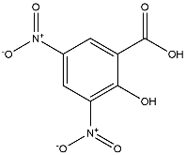
12 | C₇H₄N₂O₉S | 3,5-Dinitro-4-sulfobenzoic acid | 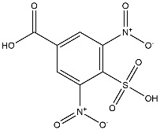
13 | C₇H₅N₃O₆ | 2,4,6-Trinitrotoluene | 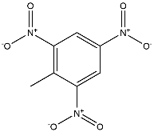
14 | C₇H₅N₃O₇ | 5-Methoxy-1,2,3-trinitrobenzene | 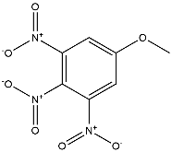
15 | C₇H₅N₃O₉S | 2,4,6-Trinitrophenol
16 | C₇H₆N₂O₅ | 4,6-Dinitro-O-cresol | 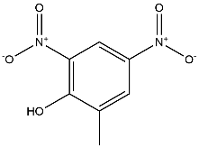
17 | C₇H₆N₂O₇S | 2,6-Dinitrotoluene-4-sulfonic acid | 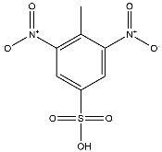
18 | C₇H₆N₂O₇S | 2,4-Dinitrotoluene-6-sulfonic acid | 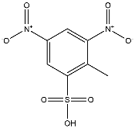
19 | C₇H₇NO₆S | 3-amino-2-hydroxy-5-sulfobenzoic acid | 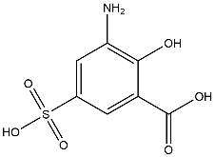
20 | C₇H₇N₃O₄ | 2-Amino-4,6-dinitrotoluene | 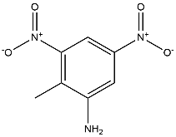

Table S2. Element information of Spectrum 7.
Element | Apparent Concentration | Wt% | Wt% Sigma
C | 188.64 | 88.41 | 0.20
N | 0.00 | 0.00 | 0.63
O | 13.60 | 11.51 | 0.20
P | 0.29 | 0.08 | 0.03
Total |  | 100

Table S3. Element information of Spectrum 8.
Element | Apparent Concentration | Wt% | Wt% Sigma
C | 171.18 | 82.07 | 0.59
N | 0.70 | 0.59 | 0.66
O | 22.69 | 17.22 | 0.24
P | 0.41 | 0.11 | 0.03
Total |  | 100

Table S4. Element information of Spectrum 9.
Element | Apparent Concentration | Wt% | Wt% Sigma
C | 170.24 | 86.02 | 0.22
N | 0.00 | 0.00 | 0.71
O | 16.09 | 13.84 | 0.22
P | 0.46 | 0.14 | 0.03
Total |  | 100

Fig. S1. (a) crushed rice straw; (b) TNT red water, on the far left is the initial TNT red water (COD: ~53000 mg/L), diluted 5 times from left to right.

Fig. S2. High resolution XPS spectra of O 1 s.

Fig. S3. High resolution XPS spectra of N 1 s.

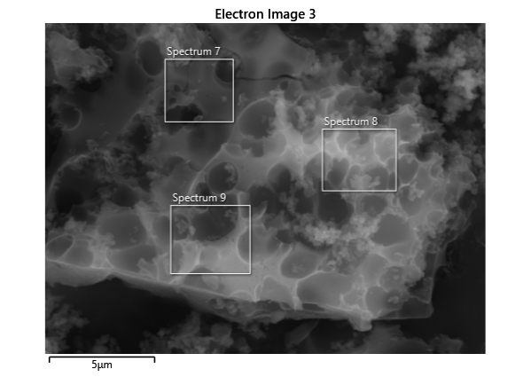
Fig. S4. EDS spectra of SBC.
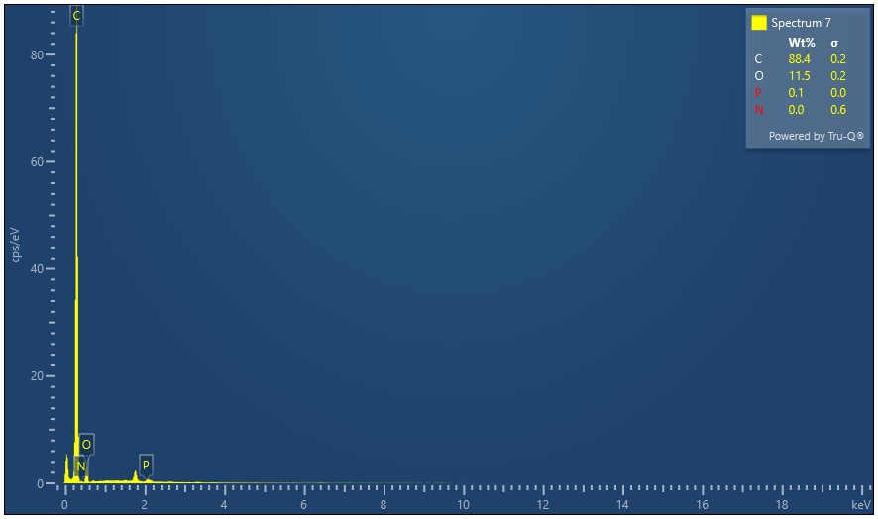

Fig. S5. EDS spectra of element information on Spectrum 7.
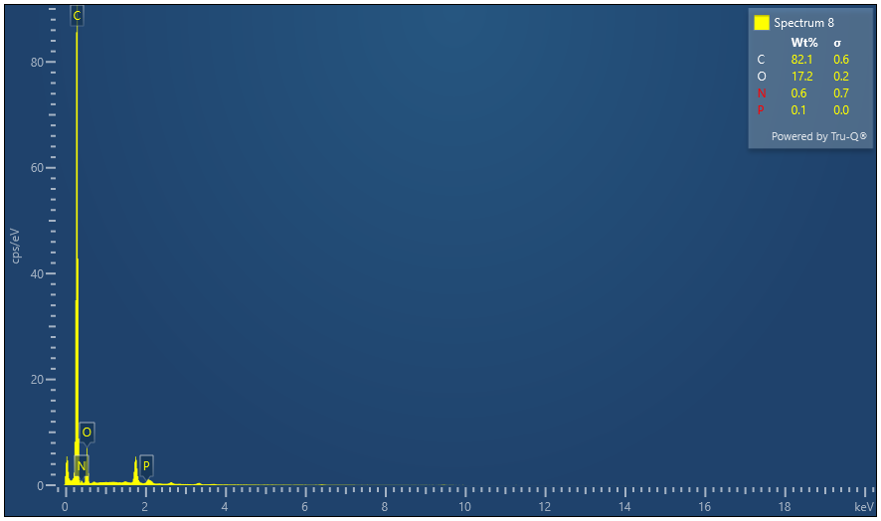
Fig. S6. EDS spectra of element information on Spectrum 8.
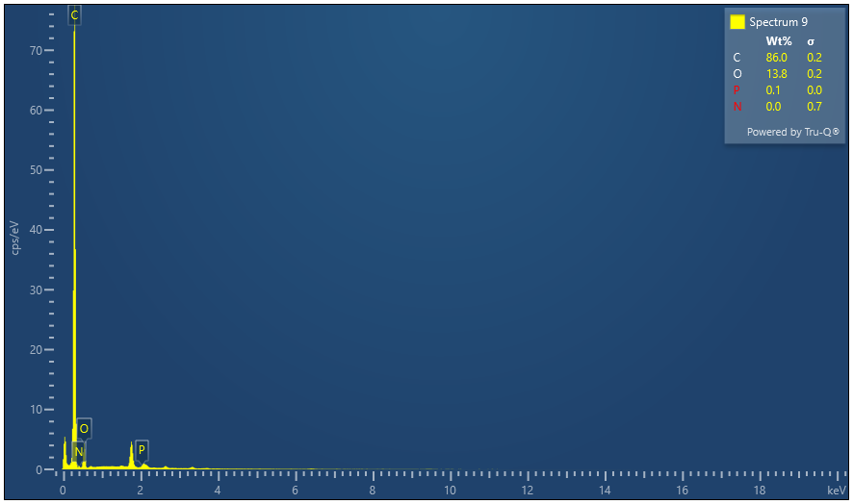
Fig. S7. EDS spectra of element information on Spectrum 9.
Fig. S8. Zeta potential of straw-derived biochar at different pH values.

* Corresponding author: E-mail address: zhengfangye@163.com

