Supplementary Information

Computing with Heat Using Biocompatible Mott Neurons

Gwangmin Kim¹, Jae Hyun In¹, Younghyun Lee¹, Hakseung Rhee¹, Woojoon Park¹, Hanchan Song¹, Juseong Park¹, Jae Bum Jeon¹, Timothy D. Brown², A. Alec Talin², Suhas Kumar²* and Kyung Min Kim¹*

¹Department of Materials Science and Engineering, Korea Advanced Institute of Science and Technology (KAIST), Daejeon, Republic of Korea.
²Sandia National Laboratories, Livermore, CA, USA
E-mail: suhkuma@sandia.gov, km.kim@kaist.ac.kr
Supplementary Information I
Supplementary Figures
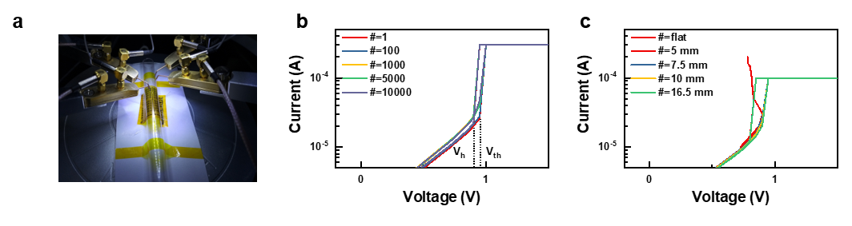
Fig. S1 Bending stability of the flexible NbO_{x}-based Mott memristor. (a) The measurement setup for testing the flexible Mott memristor. (b) The threshold switching curves after repeated bendings up to 10⁴ cycles at 10 mm bending radius. (c) The threshold switching curves while increasing the curvature from 5 mm to 16.5 mm bending radius. The current-controlled negative differential resistance (CC-NDR) at a flat state is also shown.

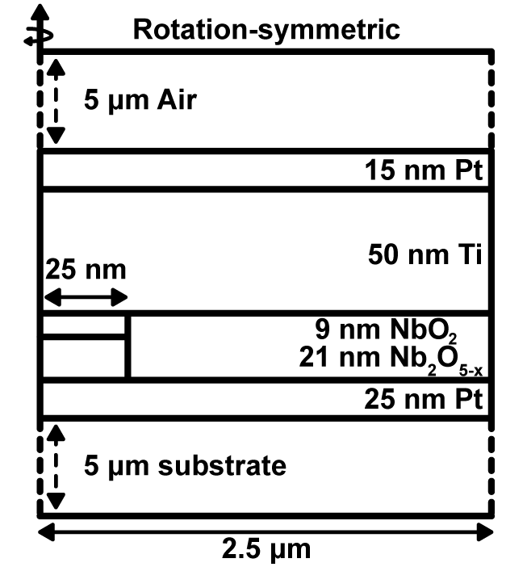
Fig. S2 The geometry used in COMSOL simulation. The geometry of the Mott memristor modeled in the simulation where the thickness and width are based on our integrated device, but the substrate thickness (50 µm for PI substrate and 600 µm for Si substrate) is reduced to 5 µm for quicker simulation. Likewise, the air cap on top was assumed to be 5 µm. A filamentary conducting path is formed during the initial electroforming. Here, the ${NbO}_{2}$ is responsible for TS, while the ${{Nb}_{2}O}_{5-x}$ acts as a series resistor in the filament, and they are assumed to be 9 nm, and 21 nm, respectively. The radius of the filament was set to 25 nm, and the whole device was laterally extended to 5 µm having a rotational symmetry with a 2.5 µm radius.

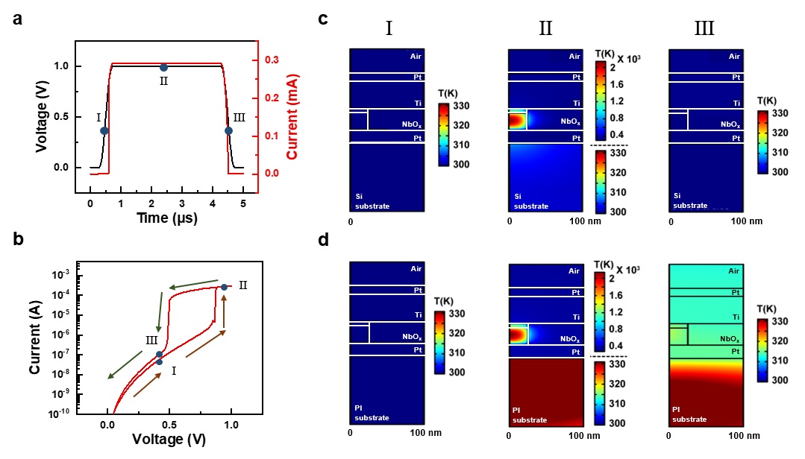
Fig. S3 Comparisons of temperature evolution on Si and PI substrates via multi-physics simulations using COMSOL. (a) Input voltage and current schemes used in the simulation and (b) the threshold switching (TS) I - V curve reproduced by the voltage and current. I, II, and III indicate the points at 0.4 V of the rising period (Ⅰ), 1.0 V of the plateau (Ⅱ), and 0.4 V of the falling period (Ⅲ), respectively. Here, a 1 V amplitude pulse was applied with a rising time of 0.4 µs, a holding time of 3.6 µs, and a falling time of 0.4 µs. Simulated temperature distributions of (c) the Si-device and (d) the PI-device at the specified points above. At point II, the temperature scale of the substrate is magnified for easy comparison between Si-device and PI-device.
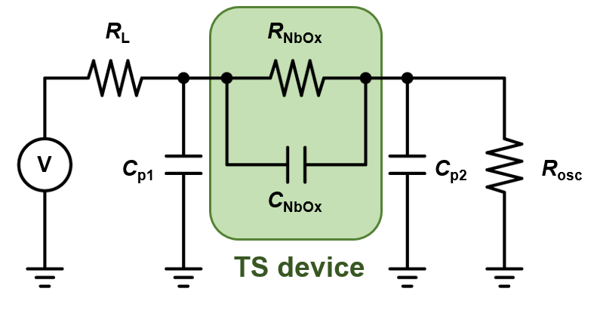
Fig. S4 A relaxation oscillator circuit comprising a Mott memristor (TS device). The $R_{NbOx}$ denotes the device resistance, while $C_{NbOx}$ is the device internal capacitor. A load resistor ($R_{L}$), the internal resistance of the oscilloscope ($R_{osc}$), and parasitic capacitors ($C_{p1}$ and $C_{p2}$) are also comprising the oscillator.

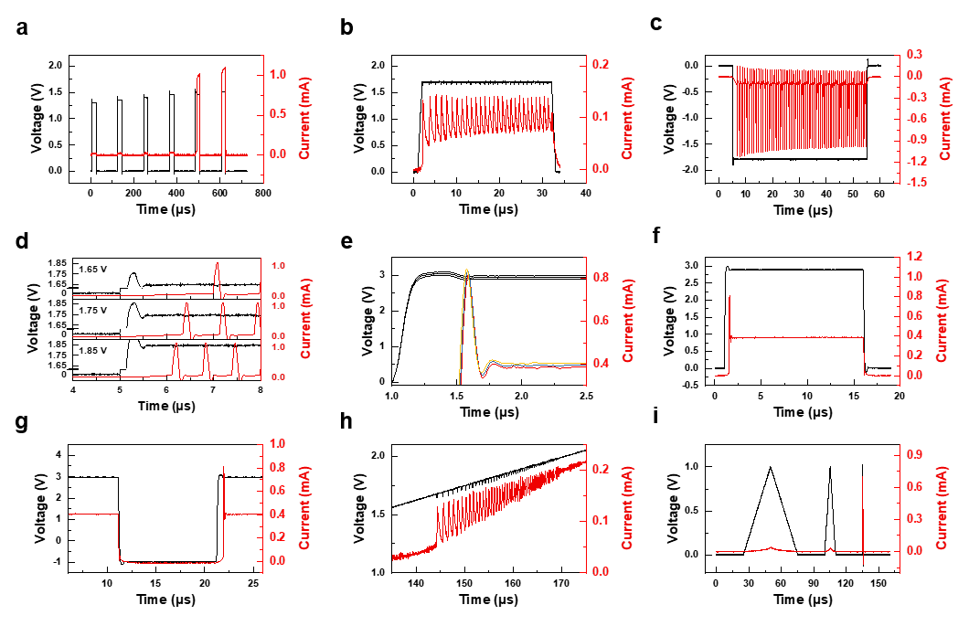
Fig. S5 Supplementary neuronal behaviors. (a) All or nothing, (b) tonic spikes, (c) inhibition-induced spiking, (d) spike latency, (e) depolarization after potential, (f) phasic spike, (g) rebound spike, (h) excitability, and (i) accommodation. These measurements were performed by a single Mott memristor and a single load resistor (the relaxation oscillator in Fig. S4).

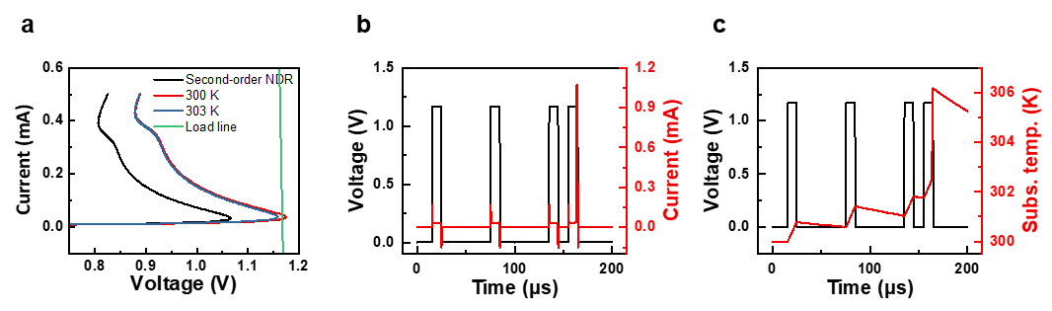
Fig. S6 Details of integrator and threshold variability neuronal behaviors. Numerically simulated integrator behavior. (a) The second-order NDR (black), and the first-order NDRs at the $T_{sub}$ of 300 K (red), and 303 K (blue) are shown. At 300 K of $T_{sub}$, the threshold voltage exceeds the load line (green), meaning it could not switch to the ON state. However, when the $T_{sub}$ is 303 K, the threshold voltage is reduced below the load line, enabling it switch to ON state. (b) The time versus current, and (c) the substrate temperature with the applied voltage schemes. When the voltage pulse interval was long, the substrate temperature was not significantly raised as heat dissipated during the interval. But under the consecutive short interval pulses, the substrate temperature is increased over 303 K, and the Mott memristor switches to the ON state. The threshold variability behavior is similar to the integrator behavior, but the preceding heating voltage bias is negative.

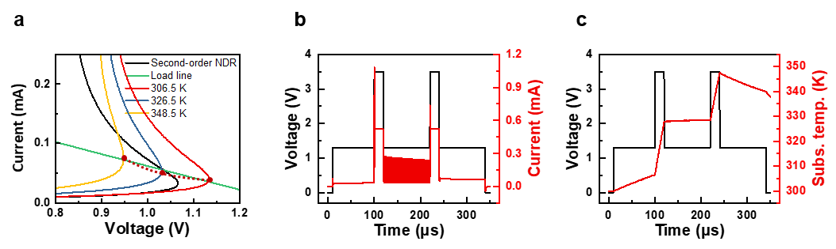
Fig. S7 Details of bistability neuronal behavior. Numerically simulated bistability behavior. (a) The second-order NDR (black), and the first-order NDRs at the $T_{sub}$ of 306.5 K (red), 326.5 K (blue), and 348.5 K (yellow) with the load line (green) are shown. The red dots indicate the threshold points ($V_{th},I_{th}$). Note that the threshold points are over the load line at 306.5 K, and 348.5 K but it is below the load line at 326.5 K, meaning the operating point is at the positive differential resistance (PDR) region of OFF state at low and high $T_{sub}$ while it is at the NDR region at intermediate $T_{sub}$. (b) The time versus current, and (c) the substrate temperature with the applied voltage schemes. At the beginning, the $T_{sub}$ is low, and no oscillation is observed. The $T_{sub}$ is increased to 326.5 K after the first ramping pulse enabling the Mott memristor to generate an oscillation (operates at the NDR region). However, the second ramping pulse raises the $T_{sub}$ to 348.5 K, where the threshold point passes over the load line again, ceasing the oscillation (operates at the OFF state).

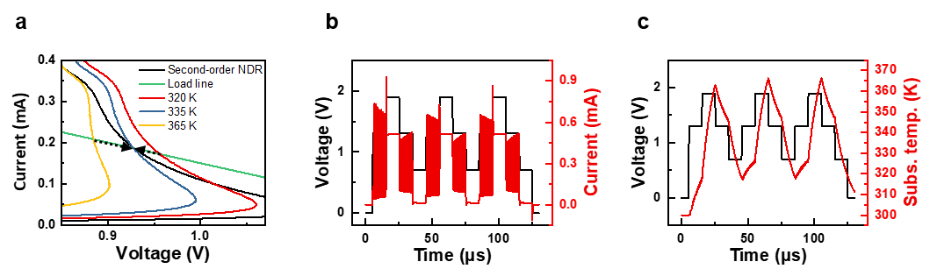
Fig. S8 Details of frequency adaptation neuronal behavior. Numerically simulated frequency adaptation behavior. (a) The second-order NDR (black), and the first-order NDRs at the $T_{sub}$ of 320 K (red), 335 K (blue), and 365 K (yellow) with the load line (green) are shown. There is a single possible operating point at the NDR region where the dynamic equilibrium $T_{sub}$ is 335 K at the read voltage (1.3 V). When the 1.9 V heating voltage pulse was preceded, the $T_{sub}$ goes up to 365 K. (b) The time versus current, and (c) the time versus substrate temperature with the applied voltage schemes. During the following read voltage, the substrate temperature decreases until it becomes saturated to the steady-state $T_{sub}$ which is 335 K, accompanying frequency reduction. However, the $T_{sub}$ decreases to 320 K after the 0.7 V cooling voltage pulse. Then, the $T_{sub}$ increases with the frequency increment during the subsequent read voltage. As such, regardless of the initial $T_{sub}$, the frequency is adapted to the steady-state frequency showing the frequency adaptation behavior.

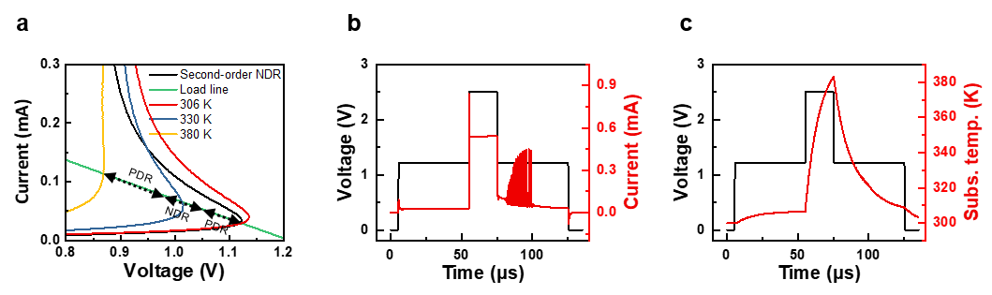
Fig. S9 Details of phasic bursting and rebound burst neuronal behaviors. Numerically simulated phasic bursting behavior. (a) The second-order NDR (black), and the first-order NDRs at the $T_{sub}$ of 306 K (red), 330 K (blue), and 380 K (yellow) with the load line (green) are shown. There is single possible operating point at the OFF state where the steady-state $T_{sub}$ is 306 K, at the subthreshold voltage (1.21 V). (b) The time versus current, and (c) the time versus substrate temperature with the applied voltage schemes. When the heating voltage (2.5 V) was applied, the $T_{sub}$ was increased to 380 K. Afterwards, the substrate temperature decreased to achieve the steady-state $T_{sub}$ during the subthreshold voltage. Meanwhile, the operating point moves down along the load line, and it temporally located at the NDR region (see the blue-colored first-order NDR at the $T_{sub}$ of 330 K), making the Mott memristor generate an oscillation. This oscillation is ceased when the $T_{sub}$ is further decreased to the steady-state $T_{sub}$ of 306 K. In the rebound burst behavior, the heating voltage bias is negative.

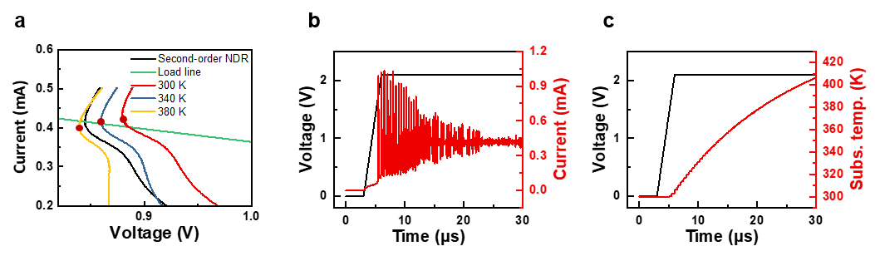
Fig. S10 Details of mixed mode neuronal behavior. Numerically simulated mixed mode behavior. (a) The second-order NDR (black), and the first-order NDRs at the $T_{sub}$ of 300 K (red), 340 K (blue), and 380 K (yellow) with the load line (green) are shown. Here, the red dots indicate the hold points ($V_{h},I_{h}$). Note that the operating point is at the NDR region at the $T_{sub}$ of 300 K while its location changes to the PDR region at a higher $T_{sub}$ (380 K) by hold point shifting. (b) The time versus current, and (c) the time versus substrate temperature with the applied voltage schemes. The $T_{sub}$ continuously increases at the given bias (2.09 V). At first, the oscillation is constantly generated as the operating point is at the NDR region at low $T_{sub}$(300 K). The hold point shifts by $T_{sub}$, and the operating point gets near the hold point which is the boundary of the NDR and PDR regions. Here, the thermal fluctuation plays an important role in tonic bursting and tonic spiking behaviors. When the operating point is at the NDR region below the hold point, the positive (heat inflow) thermal fluctuation stops the oscillation. In this case, the constant oscillation temporally ceased generating a tonic bursting. When the $T_{sub}$ is increased, and the operating point moves to the PDR region over the hold point, the negative (heat outflow) thermal fluctuation occasionally generates tonic spikes, showing the mixed mode behaviors (transition from tonic bursting to spikes).

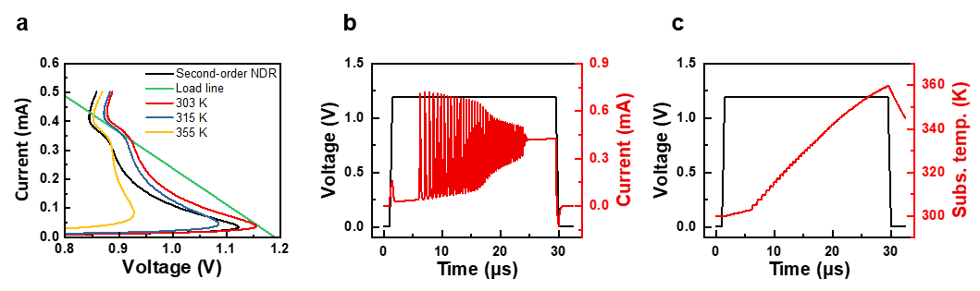
Fig. S11 Details of damped oscillation neuronal behavior. Numerically simulated damped oscillation behavior. (a) The second-order NDR (black), and the first-order NDRs at the $T_{sub}$ of 303 K (red), 315 K (blue), and 355 K (yellow) with the load line (green) are shown. Note that there is only one possible operating point at the ON state. (b) The time versus current, and (c) the time versus substrate temperature with the applied voltage schemes. Under the given bias (1.19 V), the $T_{sub}$ continuously increases. When the $T_{sub}$ is lower than 303 K, the actual operating point is at the OFF state, and no oscillation is observed. Above 303 K, the $V_{th}$ is decreased below the load line, and the operating point becomes to be placed at the NDR region, enabling an oscillation. The oscillation gets faster, accompanying the amplitude decrement as $T_{sub}$ increases, similar to the frequency adaptation behavior in Fig. S8. When the $T_{sub}$ is further increased and the actual operating point is formed at the PDR region, the oscillation is halted, completing a damped oscillation.

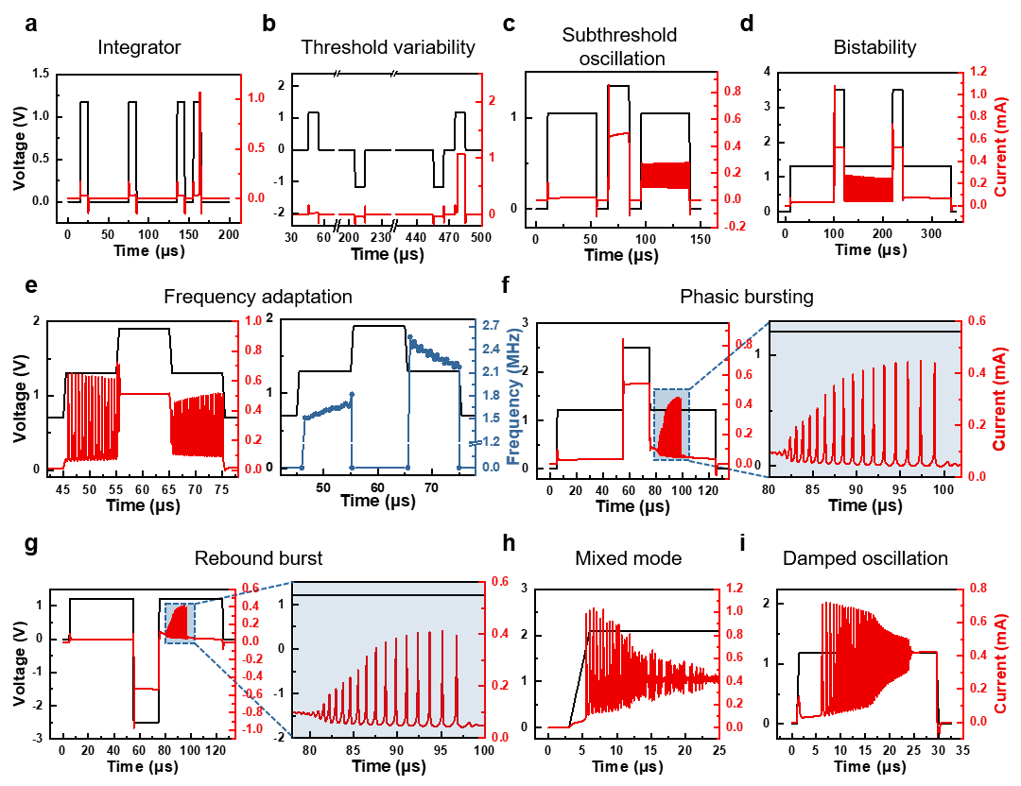
Fig. S12 Numerical simulation results of the neuronal behaviors reproducing the experimental neuronal bahviors in Fig. 2. These results are acquired by numerical simulation based on the equation (5), (6), (7) and (8) in Supplementary Information Ⅲ.

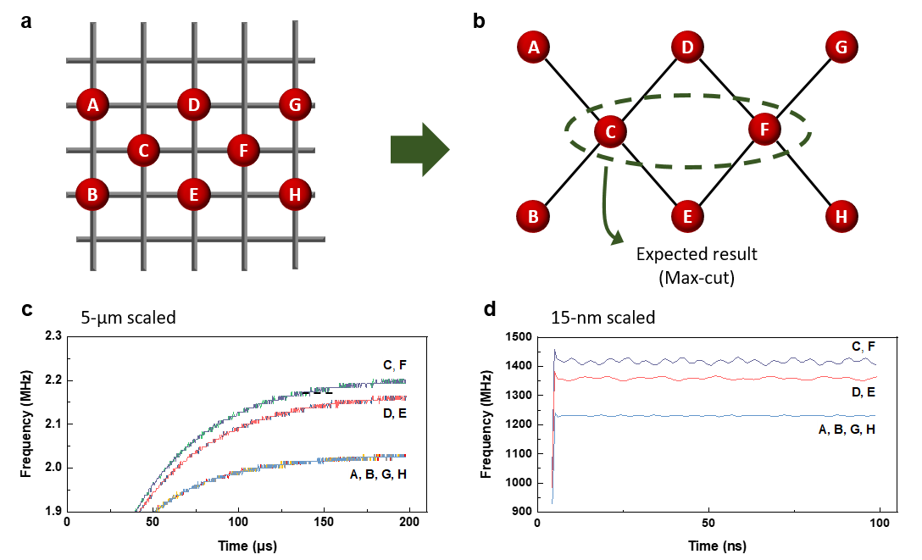
Fig. S13 Thermal computing for a 8-vertices graph problem. (a) A 8-device network representing the graph of (b). The inter-cell heat diffusion dynamics enable the thermal computer to solve the 8-vertices graph problems. (c) When the thermal computing device has a large dimension of 5 μm, the cells are distinguished by the oscillation frequencies from 100 μs. (d) When the thermal computer is scaled down to 15 nm, the electrical RC constant is reduced resulting in a higher oscillation frequency, as well as the inter-cell thermal RC constant is reduced (especially the effective thermal capacitance of the system), giving reduced frequency converging time. In the scaled thermal computer, the time to solution can be significantly reduced, leading to lower required energy to solve.

Supplementary Information Ⅱ
Field-Triggered Thermal Runaway (FTTR) model used in COMSOL simulation

We adopted a Field-Triggered Thermal Runaway model to emulate the Mott device. The electrical conductivity of the elements was calculated as below.
$$σ_{{NbO}_{2}}=σ_{Th}=σ_{0}e^{-\frac{E_{a}}{k_{b}T}}e^{\frac{β\sqrt{E}}{k_{b}T}}$$ | (1)
$$σ_{{{Nb}_{2}O}_{5-x}}=σ_{M}=\frac{1}{R_{M}}\frac{L_{M}}{πγ^{2}}$$ | (2)
Here, the $E_{a}$ and $β$ are mateiral constatns, while $k_{b}$ is the Boltzmann constant, and $E$ denotes the electric field. The $γ$ is the radius of the memory element in Fig. S2, and $L_{M}$ is the length of it . The $R_{M}$ is the resistance of the memory element.
The thermal conductivities of the elements were calculated considering the contribution of the free electrons on the thermal conductivity via Wiedemann-Franz law.
$$k_{{NbO}_{2}}=k_{Th}=k_{ph, { NbO}_{2}}+LTσ_{Th}$$ | (3)
$$k_{{{Nb}_{2}O}_{5-x}}=k_{M}=k_{ph, { Nb}_{2}O_{5-x}}+LTσ_{M}$$ | (4)
, where the $k_{ph, { NbO}_{2}}$, and the $k_{{{Nb}_{2}O}_{5-x}}$denote the phonon contribution on the thermal conductivity in the TS element and memory element, respectively, while $L$ is the Lorenz number.

Supplementary Information Ⅲ
Detailed description on third-order numerical model

We adapted 3D-modified Poole-Frenkel conduction for the NbO_{x}-based Mott memristor as described in the following equation.
$$i_{m}=AV_{m}\left[σ_{0}e^{-\frac{E_{a}}{k_{b}T}}\left\{{\left(\frac{k_{b}T}{β\sqrt{V_{m}}}\right)}^{2}\left(1+\left(\frac{β\sqrt{{V_{m}}/d}}{k_{b}T}-1\right)e^{\frac{β\sqrt{{V_{m}}/d}}{k_{b}T}}\right)+\frac{1}{2d}\right\}\right]$$ | (5)
, where the $σ_{0}$, $β$, and $E_{a}$ are material constants while $k_{b}$ is the Boltzmann constant, $d$ and $A$ are the thickness and area of the switching region, respectively. To represent the Mott transition, we introduced a continuous change of effective thermal resistance of the device as described below.¹
$$R_{th,m}\left(T_{m}\right)=\frac{R_{th, ins}}{1+e^{-α\left(T_{Mott}-T_{m}\right)}}+\frac{R_{th, met}}{1+e^{α\left(T_{Mott}-T_{m}\right)}}$$ | (6)
, where $R_{th, ins}$ and $R_{th, met}$ are the effective thermal resistance of the Mott memristor at the insulating phase and metallic phase, respectively. The $T_{Mott}$ is Mott transition temperature of NbO₂, and $α$ is the smoothing parameter. Most importantly, the heat flows in the system were calculated based on Newton’s cooling law as follows.
$$C_{th,m}\frac{dT_{m}}{dt}=i_{m}v_{m}-\frac{T_{m}-T_{sub}}{R_{th,m}}-\frac{T_{m}-T_{surr}}{R_{th,m}}$$ | (7)
$$C_{th,sub}\frac{dT_{sub}}{dt}=\frac{T_{m}-T_{sub}}{R_{th,m}}-\frac{T_{sub}-T_{surr}}{R_{th,sub}}$$ | (8)
The $C_{th,m}$ denotes the effective specific heat capacity of the Mott memristor, and $C_{th,sub}$ is that of the substrate while $R_{th,sub}$ is the effective thermal resistance of the substrate. Here, the surrounding temperature, $T_{surr}$, is kept at 300 K while $T_{m}$ and $T_{sub}$ change by heat generation and dissipation in the system.

Supplementary Information Ⅳ
Detailed description on spatiotemporal thermal computing

Based on the Newton’s cooling law, we developed the following inter-cell thermal equations for spatiotemporal thermal computing.
$$C_{th,sub}\frac{dT_{sub,A}}{dt}=\frac{T_{A}-T_{sub,A}}{R_{th,m}}-\frac{T_{sub,A}-T_{surr,AB }}{R_{th,AB}}$$ | (9)
$$C_{th,sub}\frac{dT_{sub,B}}{dt}=\frac{T_{B}-T_{sub,B}}{R_{th,m}}-\frac{T_{sub,B}-T_{surr,AB }}{R_{th,AB}}$$ | (10)
$$C_{th,surr,AB}\frac{dT_{surr,AB}}{dt}=-\frac{T_{surr,AB}-T_{amb}}{R_{th,surr,AB}}-\frac{T_{surr,AB }-T_{sub,A}}{R_{th,AB}}-\frac{T_{surr,AB }-T_{sub,B}}{R_{th,AB}}$$ | (11)
Here, $T_{sub,A}$ and $T_{sub,B}$ are the subtrate temperature of cell A and B, respectivley, and $T_{surr,AB}$ is the temperature of heat medium between the cell A and B. The $R_{th,AB}$ is the effective thermal resistance between the cell A (or B) and the heat medium, while $R_{th,surr,AB}$ denotes the effective thermal resistance between the heat medium and the ambient.
In the crossbar array structured thermal computing device, the heat medium is the metal edges (thermal conductivity is a thousand times larger than PI), and the inter-cell distance affects the $R_{th,AB}$, $R_{th,surr,AB}$, and $C_{th,surr,AB}$. If the cells are far apart, the thermal coupling becomes weak; $R_{th,AB}$ increases as the heat should propagate more metal edges (heat transfer from one to another becomes hard), the $R_{th,surr,AB}$ decreases as more heat is dissipated while transferring to other cells, and the $C_{th,surr,AB}$ increases as the volume (number) of heat medium (metal edges) increases. For thermal computing simulations, these thermal dynamics can be simply introduced by giving equation (11) to each metal edge in a crossbar array, in this way, the thermal dynamics of (9) and (10) can be natureally included in the system. Also, each cell has inherent electro-thermal dynamics of (5) to (8) in Supplementary Information Ⅲ.
Reference
1 Messaris, I. et al. in 2020 IEEE International Symposium on Circuits and Systems (ISCAS). 1-5.

