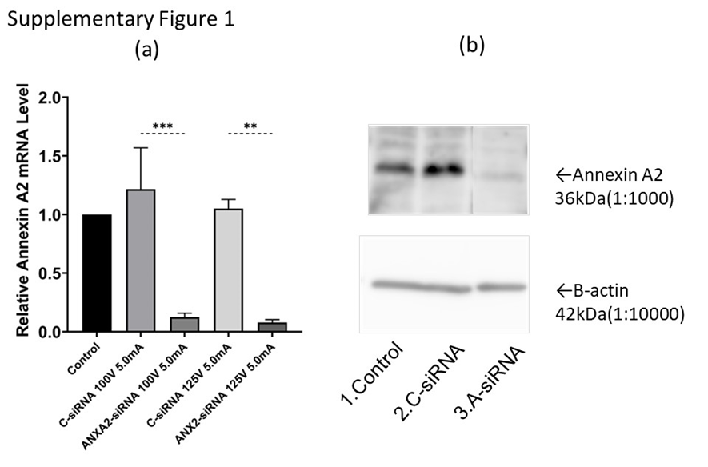

Supplementary Figure 1. Effects of knocking down ANXA2 expression in HepG2 cells. (a) RT-qPCR results of comparison of electroporation under conditions with a single electron pulse of 125 V or 100 V for 5.0 ms. (b) Results of Western blotting analysis of ANXA2 protein expression levels in ANXA2 knockdown HepG2 cells compared to control cells.

