Supplementary Information
Oxophilic Ce single atoms-triggered active sites reverse for superior alkaline hydrogen evolution
Fengyi Shen,^{1,#} Zhihao Zhang,^{2,#} Zhe Wang,^{1,#} Hao Ren,¹ Xinhu Liang,¹ Zengjian Cai,¹ Shitu Yang,¹ Guodong Sun,¹ Yanan Cao,¹ Xiaoxin Yang,¹ Mingzhen Hu,^{1,2,}* Zhengping Hao,^{2,}* and Kebin Zhou^{1,2,}*
¹School of Chemical Sciences, ²National Engineering Laboratory for VOCs Pollution Control Material & Technology, Research Center for Environmental Material and Pollution Control Technology, University of Chinese Academy of Sciences, Beijing, 100049, PR China.
#These authors contributed equally to this work.

*E-mail: humingzhen12@ucas.ac.cn; zphao@ucas.ac.cn; kbzhou@ucas.ac.cn

Characterizations and experiment details
Supplementary Figure S1 to S28
Supplementary Table S1 to S3
Supplementary Reference 1-8

Characterizations and experiment details
Details of characterizations
The crystallographic structures of materials were analyzed by the powder X-ray diffraction (XRD, Rigaku SmartLab, Cu Kα radiation, λ =1.54 Å). The oxidation states of Ru were studied by the X-ray photoelectron spectroscopy (XPS, Thermo escalab 250XI Al Kα (hv =1486.6 eV)). Transmission electron microscopy (TEM) analysis was performed on the FEI Talos F200X. The high angle annular dark field scanning TEM was operated at 200 kV. Atomic resolved STEM observation was carried out on ThemisZ (Titancubed·ThemisZ:300kV·Thermo-Fisherscientific). The element amounts of samples were determined by the inductively coupled plasma optical emission spectrometer (ICP-OES) of Aligent ICPOES730. Both the Ru K-edge and Ce L_{III}-edge X-ray absorption spectra were collected at the XAS station (BL14W1) of the Shanghai Synchrotron Radiation Facility (SSRF). The electron storage ring was carried out at 3.5 GeV with a maximum current of 250 mA. By a Si (311) double-crystal monochromator, the data was collected in fluoresce mode for both L_{III}-edge of Ce and K-edge of Ru. All the spectra data were recorded in room temperature. By utilization of a third ionization chamber, the standard of Ru foil, RuO₂, and CeO₂ were measured simultaneously with the sample for energy calibration purposes. The extended X-ray absorption fine structure (EXAFS) profiles for Ru K-edge and Ce L_{III}-edge were processed based on the standard procedures of the ATHENA module implemented in the IFEFFIT software packages. The k²-weighted EXAFS spectra were acquired by subtracting the post-edge background from the overall absorption and subsequently normalizing with respect to the edge-jump step. The k²-weighted χ(k) profiles of were Fourier transformed to real (R) space using a hanning windows (dk=1.0 Å⁻¹) to separate the EXAFS contributions from different coordination shells. To acquire quantitative structural parameters around central atoms, least-squares curve parameter fitting was carried out using the ARTEMIS module of IFEFFIT software packages.
Details of theoretical calculations
The slab structural models of the Ce₁-Ru_{n}/NC and the Ru_{n}/NC were constructed by taking consideration of the EXAFS fitting data in Table S1 to build the Ce-N and Ru-N coordination. A 20 Å-thick vacuum was introduced in the z-direction to avoid artificial interaction between periodic images. Periodic spin-polarized DFT calculations were conducted by virtue of the Vienna Ab-initio simulation package (VASP 5.4.4) with the Perdew-Burke-Ernzerhof (PBE) exchange-correlation function.¹ The core electrons were demonstrated through the projected augmented wave (PAW) method.² Wherein, the valence electrons (Ce: 5s5p4f5d6s, Ru: 4p5s4d, O: 2s2p, N: 2s2p, C: 2s2p, H: 1s) were expanded on plane-wave basis sets with a cutoff energy of 520 eV. A gamma point sampling based on the Monkhorst-Pack method was employed to calculate the slab structures. The self-consistent calculations applied a convergence energy threshold of 10⁻⁶ eV and a force threshold of 0.02 eV Å⁻¹. In another respect, the Van der Waals corrections with zero damping DFT-D3 method³ of Grimme were taken in all structures. The Bader charge analysis was carefully carried out after each relaxation. The climbing image nudge elastic band (CI-NEB) method was conducted to demonstrate the energy barriers of the transition states during the H₂O dissociation. The Gibbs free energy changes were acquired by the equation G = E + ZPE – TS, where ZPE and S were the changes in zero-point energy and entropy, as determined by taking into account of the adsorbed species and water molecules in the harmonic vibrational mode.⁴ The climbing image nudged elastic band method⁵ was employed to explore the TS and determine corresponding reaction barriers. The Raman spectra were calculated through DFT calculations implemented by Gaussian 16 (A.03) program. The cluster model centered on a cerium atom was built based on the periodic model with the edge carbon atoms fixed and saturated by hydrogen atoms. Geometry optimization and frequency analysis were performed at the PBE0/(6-311G*+SDD)⁶ level of theory. Raman spectra were plotted by the Multiwfn package⁷ with the frequency scaling factor of 0.988 and the full width at half maximum of peaks of 40 cm⁻¹.
Details of electrochemical measurements for alkaline HER
Electrochemical measurements for alkaline HER were carried out through an Autolab electrochemical station (Metrohm, Switzerland) in 1 M KOH solution at room temperature. The modules of electrochemical tests were managed by the computer software Nova 2. A typical three electrode system was used to study the electrochemical performance, in which the counter electrode and reference electrode were graphite rod and mercury/mercuric oxide electrode, respectively. All the potential value used in this work were calibrated to the reversible hydrogen electrode (RHE), using the following equation:
E_{RHE} = E_{Hg|HgO|KOH} + 0.098+0.059 × pH
To prepare the catalyst ink, 4 mg of catalyst was homogeneously dispersed in 550 μl solution composed of 375 μl H₂O, 125 μl ethanol and 50 μl Nafion under sonication. 2.5 μl of the above-mentioned ink was then loaded on the glass carbon electrode with a diameter of 3 mm for alkaline HER tests. Alternatively, 20 μl of the catalyst ink was loaded onto 1 cm² hydrophilic carbon paper for stability testing. During all the alkaline HER evaluations, H-cell was used to eliminate the impacts of anode. The polarization curves were obtained by sweeping the potential from 0.1 to −0.325 V versus reversible hydrogen electrode (RHE) at room temperature with a sweep rate of 9 mV s⁻¹ using the iR compensation. The stability of the Ce₁-Ru_{n}NC was performed at 150 mA/cm⁻² via a chronopotentiometric technique. The calculation of the turnover frequency (TOF, s⁻¹) for alkaline HER of the catalysts was shown below:
$$TOF=\frac{{I_{product}}/{NF}}{{ω×m_{ cat}}/{M_{Ru or Pt}}}×d$$
I_{Product}: Measured hydrogen currents, A;
N: Number of electron transfer (2 for H₂);
F: Faradaic constant, 96485 C mol⁻¹;
m_{cat}: Mass of catalyst on electrode, g;
$ω$: Metal loading of the catalyst according to the ICP-OES results;
M_{Ru}: Atomic mass of Ru, 101.07 g mol⁻¹;
M_{Pt}: Atomic mass of Pt, 195.05 g mol⁻¹;
d: Mean particle size.
Details of in situ Raman measurements
Raman spectra were performed on an inVia Reflex instrument integrated with a confocal microscope. All spectra were acquired under room temperature with a 532 nm excitation. Calibration was performed with 520 cm⁻¹ peak (silicon wafer standard). To avoid damaging samples, the power of laser was decreased by a factor of 10. In situ Raman measurements were carried out on a home-made electrochemical reaction cell using a standard three-electrode system in 1.0 M KOH electrolyte. Wherein, the Ag/AgCl electrode was used as the reference electrode, and the platinum wire served as the counter electrode. To prepare the working electrode, 4 mg of catalyst was firstly ultrasonically dispersed in 550 ml solvent (125 μl water, 375 μl ethanol and 50 μl Nafion solution). After which, 10 μl of the homogeneous ink was loaded onto a carbon paper with an area of 1 cm². The in situ Raman data were acquired from the chronoamperometry measurements performed in the potential range from 0 mV to -80 mV versus RHE. The spectra were recorded at steady-state conditions by holding at the desired potential for at least 120 s.
Supplementary Figures

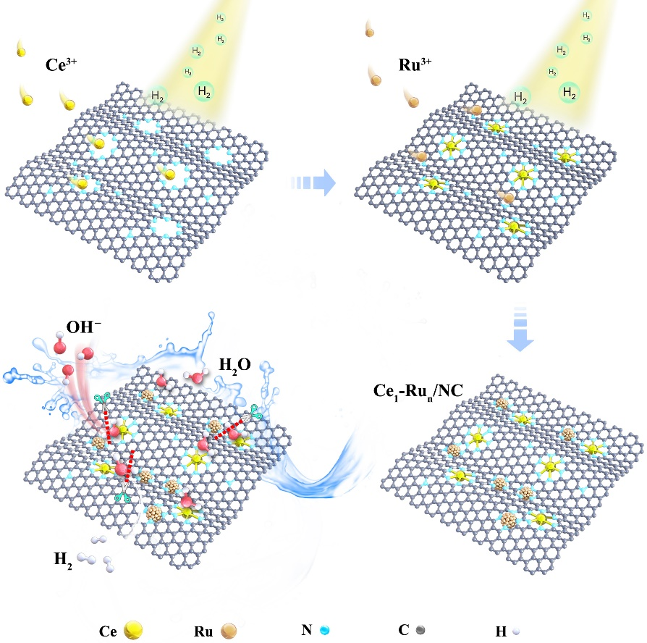
Figure S1. Schematic illustration of the synthetic process for the Ce₁-Ru_{n}/NC catalyst. To be noted, the Ce³⁺ species were firstly introduced to the NC support and then reduced by hydrogen at 700 °C for 2 hours (see methods of main text). After which, the uniformly dispersed CeO₂ was formed on the NC support (CeO₂/NC) as displayed in Figure S2 and then etched to Ce single atoms (Ce₁/NC) with acid treatment (pH=1). Subsequently, the Ru³⁺ cations were introduced to the Ce₁/NC via impregnation and further reduced with hydrogen at 250 °C for 2 hours.

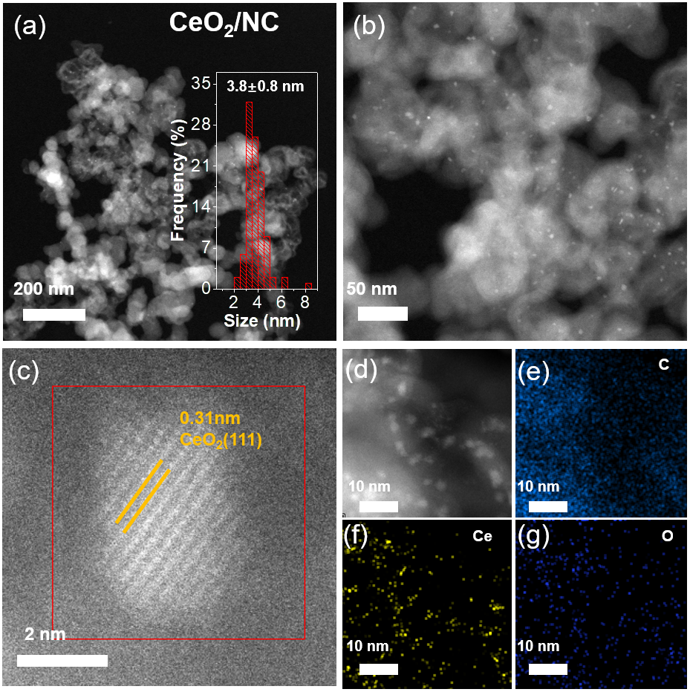
Figure S2. (a) and (b) Dark-field STEM images of the CeO₂/NC (CeO₂, PDF no. 34-0394). (c) High resolution STEM image of the CeO₂/NC. (d)-(g) Dark-field STEM image and corresponding EDS elementary mapping images of a nanoparticle in the CeO₂/NC.

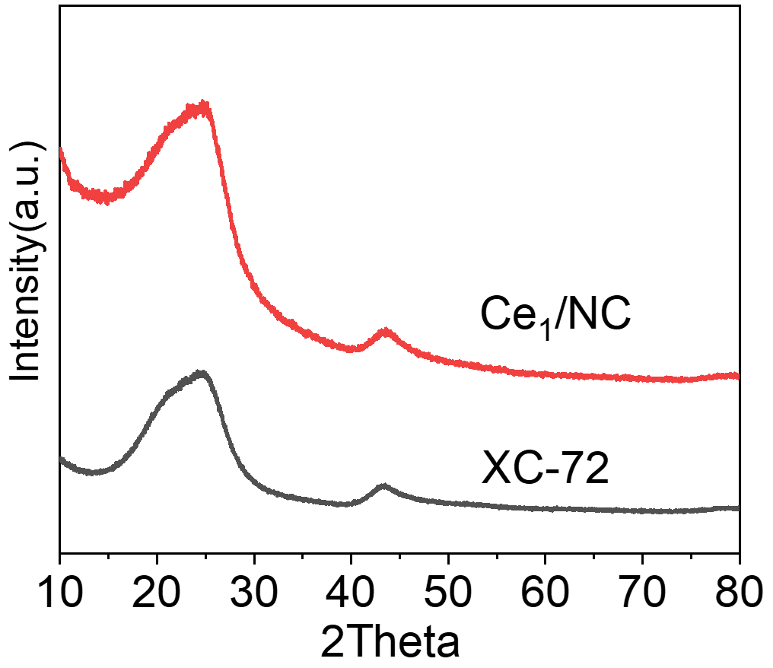
Figure S3. The XRD patterns of the Ce₁/NC catalyst. It was demonstrated that no XRD peaks were found for the Ce₁/NC catalyst except for the broad diffraction peaks of carbon support in it.⁸

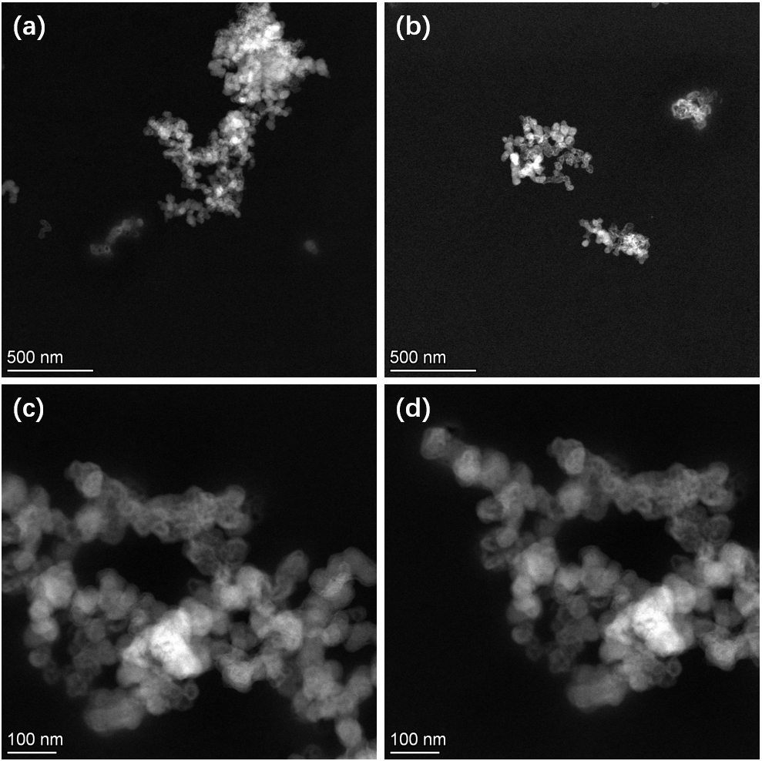
Figure S4. (a)-(d) Low-magnification high-angle annular dark-field scanning transmission electron microscopy (HAADF-STEM) images of the Ce₁/NC catalyst. It was found that there were no particles in the Ce₁/NC catalyst from an overall observation.
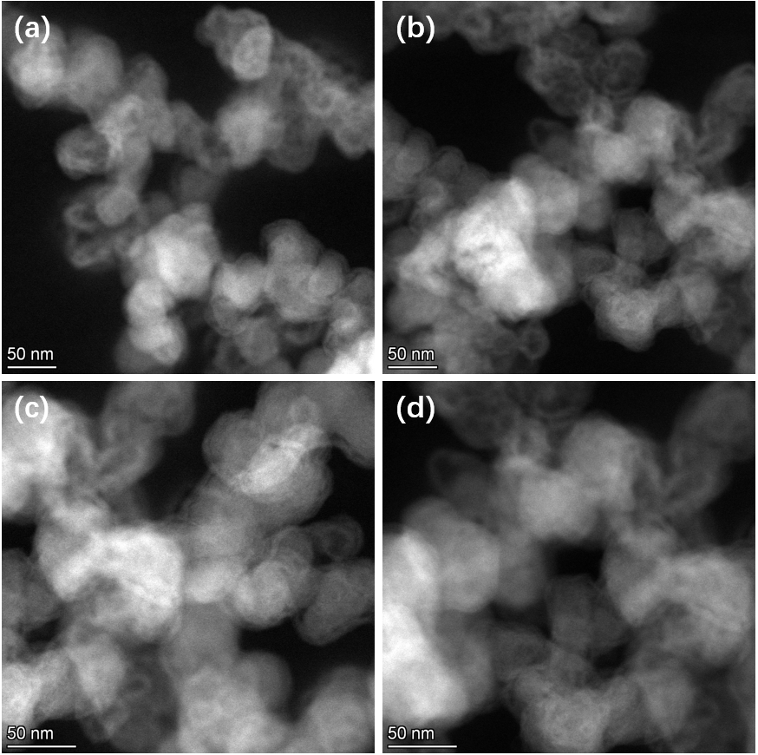
Figure S5. (a)-(d) Medium-magnification high-angle annular dark-field scanning transmission electron microscopy (HAADF-STEM) images of the Ce₁/NC catalyst. It was identified that when enlarging different regions of the Ce₁/NC, no particles were observed either.
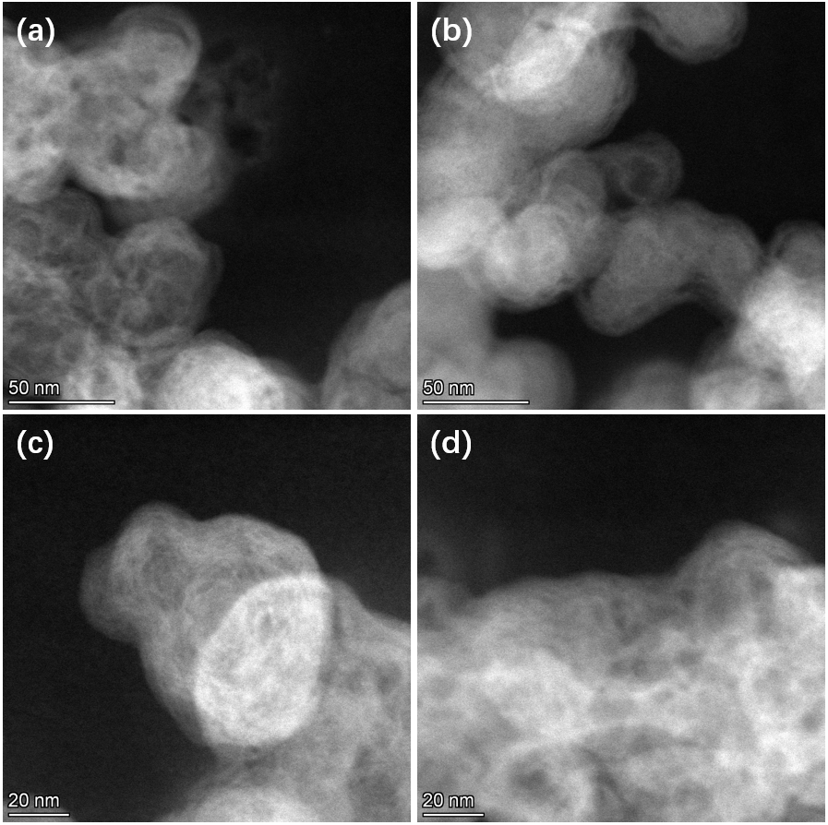
Figure S6. High-magnification high-angle annular dark-field scanning transmission electron microscopy (HAADF-STEM) images of the Ce₁/NC catalyst. It was further excluded any particles on the Ce₁/NC catalyst by the high-magnification observation.

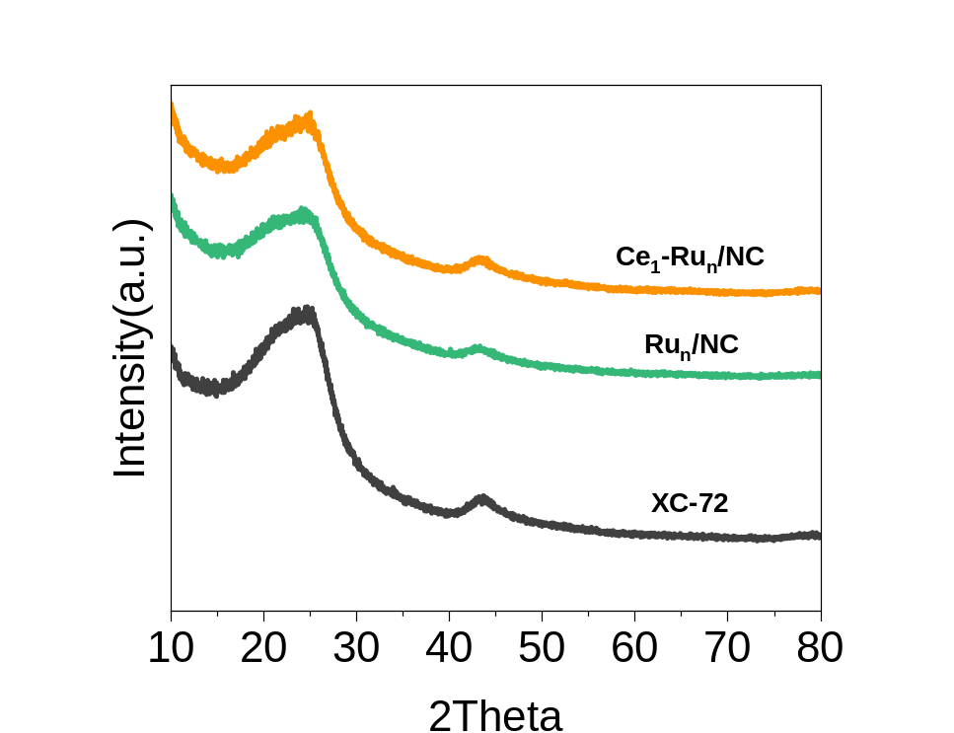
Figure S7. The XRD patterns of the Ru_{n}/NC, Ce₁-Ru_{n}/NC, and XC-72 support, respectively. It was unveiled that no Ru XRD peaks were found for the Ru_{n}/NC and the Ce₁-Ru_{n}/NC catalysts except for the broad diffraction peaks of carbon support, due to the ultrasmall Ru nanoclusters in them.

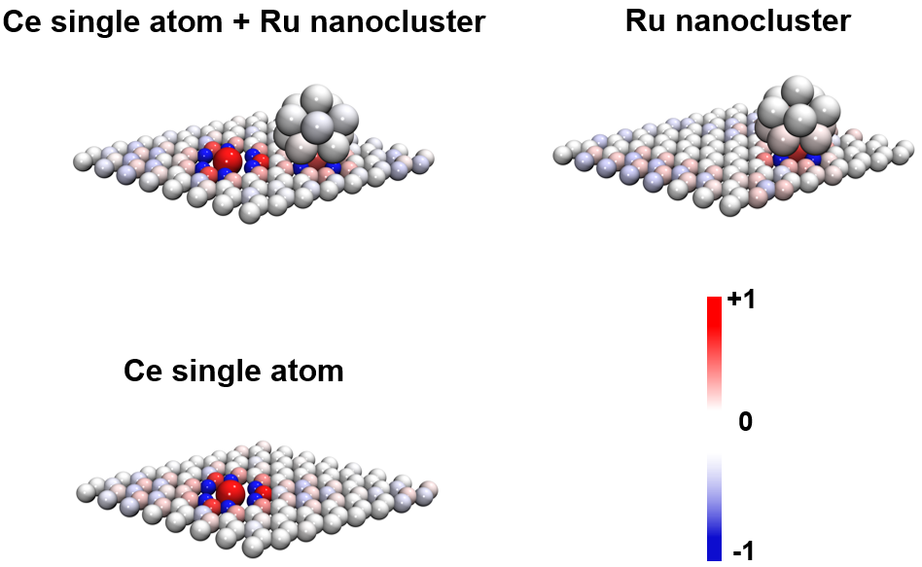
Figure S8. Colored Bader charge analysis for the Ce₁-Ru_{n}/NC, Ru_{n}/NC, and Ce₁/NC catalysts, respectively. As revealed by the Bader charge analysis, the electrons of Ce could be facilely transferred to Ru and the net electron transfer number from Ce single atom to Ru nanocluster was calculated to be 0.05.

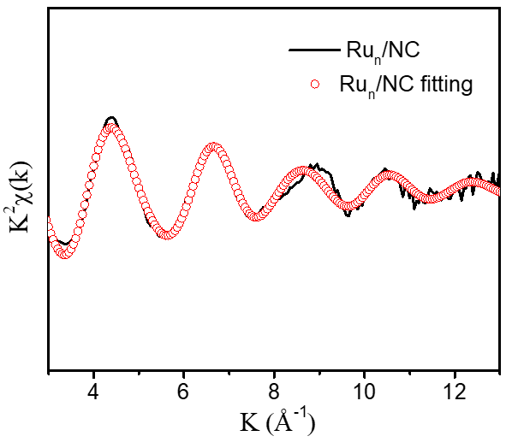
Figure S9. The Ru K-edge EXAFS fitting (red line) for the Ru_{n}/NC, shown in k² weighted k-space. To make it clear, the detailed fitting results of the Ru_{n}/NC was also provided in Table S1.

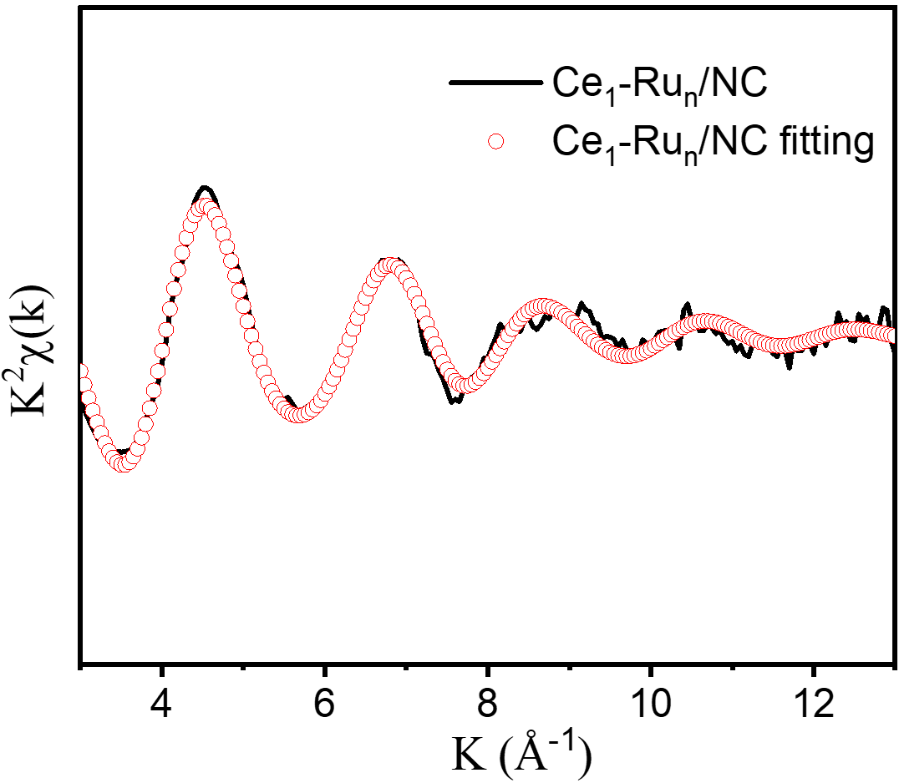
Figure S10. The Ru K-edge EXAFS fitting line for the Ce₁-Ru_{n}/NC (red line), shown in k² weighted k-space. The coordination information of Ru in Ce₁-Ru_{n}/NC was further indicated in Table S1.

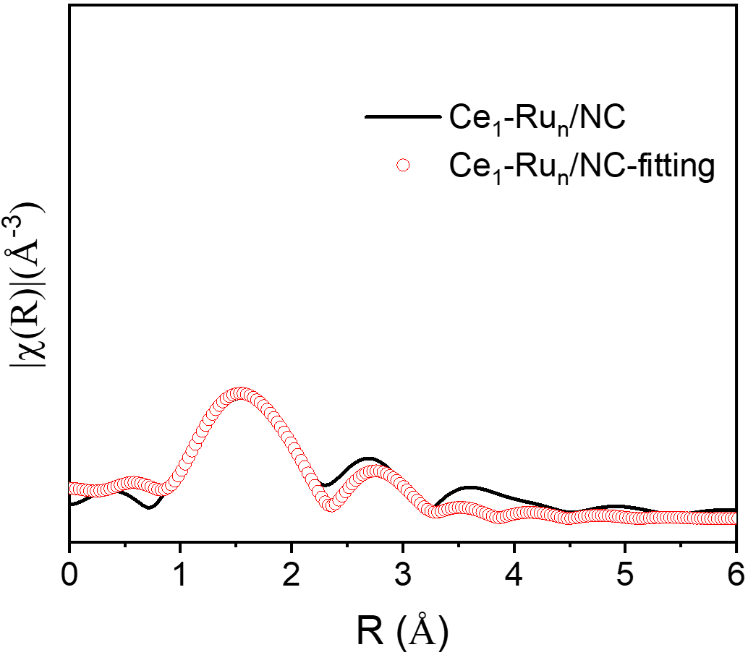
Figure S11. The Ce L_{III}-edge EXAFS fitting curve for the Ce₁-Ru_{n}/NC (red line), shown in k² weighted R-space. In addition to the fitting curves here, the exact Ce-N coordination was also shown in Table S1.

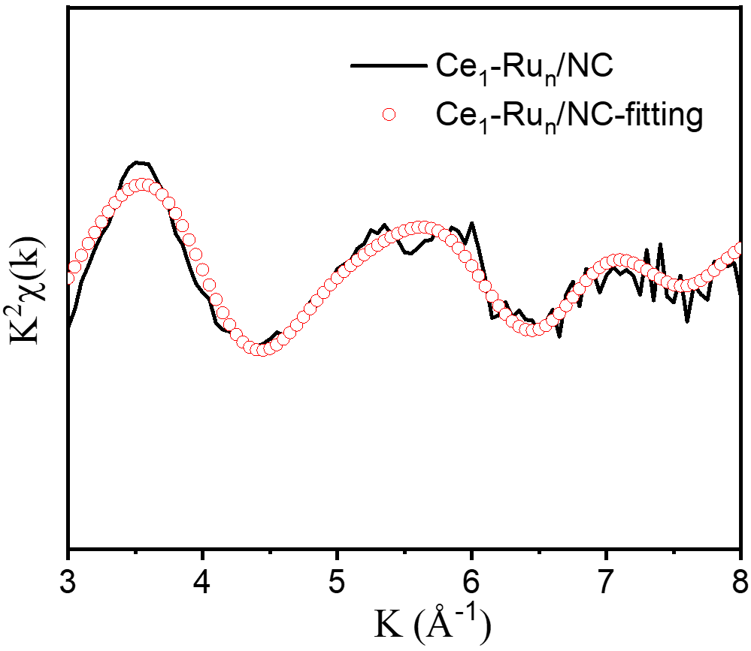
Figure S12. The Ce L_{III}-edge EXAFS fitting line for the Ce₁-Ru_{n}/NC (red line), shown in k² weighted k-space. Besides the fitting results, the Ce-N coordination information was also displayed in Table S1.

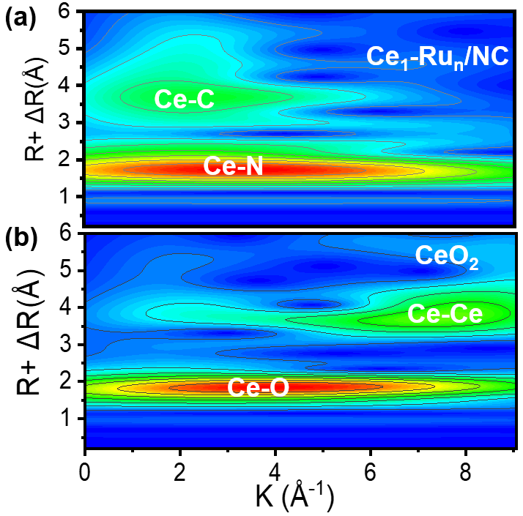
Figure S13. Wavelet transformation for the EXAFS signals of Ce₁-Ru_{n}/NC, and CeO₂. The EXAFS wavelet transform results showed that in Ce₁-Ru_{n}/NC, The Ce was coordinated with N in the first shell and C in the second shell, without presenting the Ce-Ce coordination, which further disclosed the Ce single atom nature in Ce₁-Ru_{n}/NC.

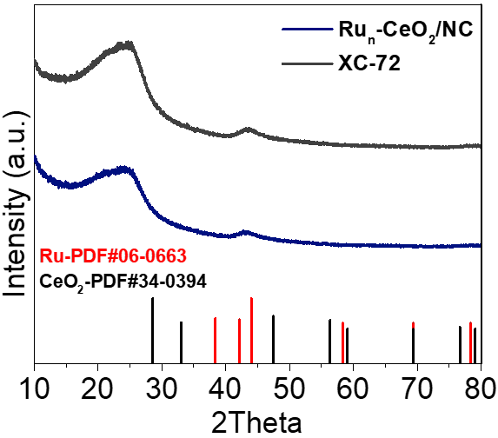
Figure S14. The XRD patterns of the Ru_{n}-CeO₂/NC control sample. Wherein, no XRD peaks of Ru and CeO₂ were found for the Ru_{n}-CeO₂/NC catalyst due to the ultrafine particle size of them.

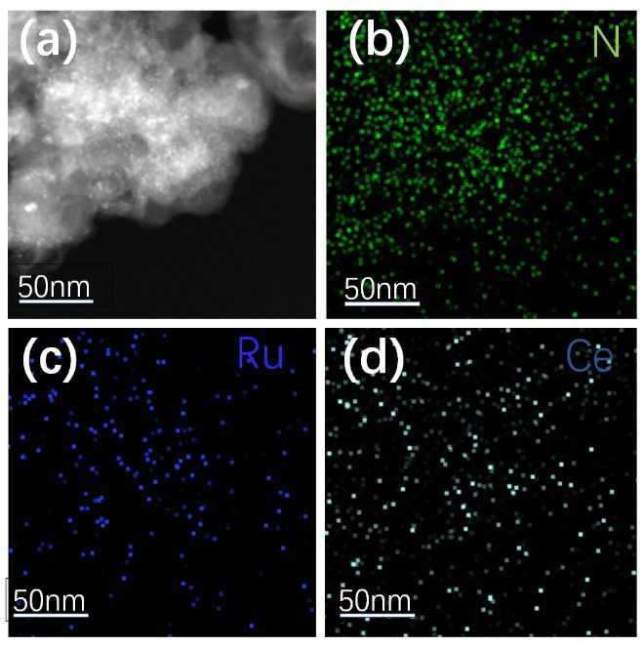
Figure S15. (a) HAADF-STEM image and (b)-(d) corresponding EDS mapping images of the Ru_{n}-CeO₂/NC catalyst, which presented uniform dispersion of Ce and Ru element signals in the Ru_{n}-CeO₂/NC catalyst.

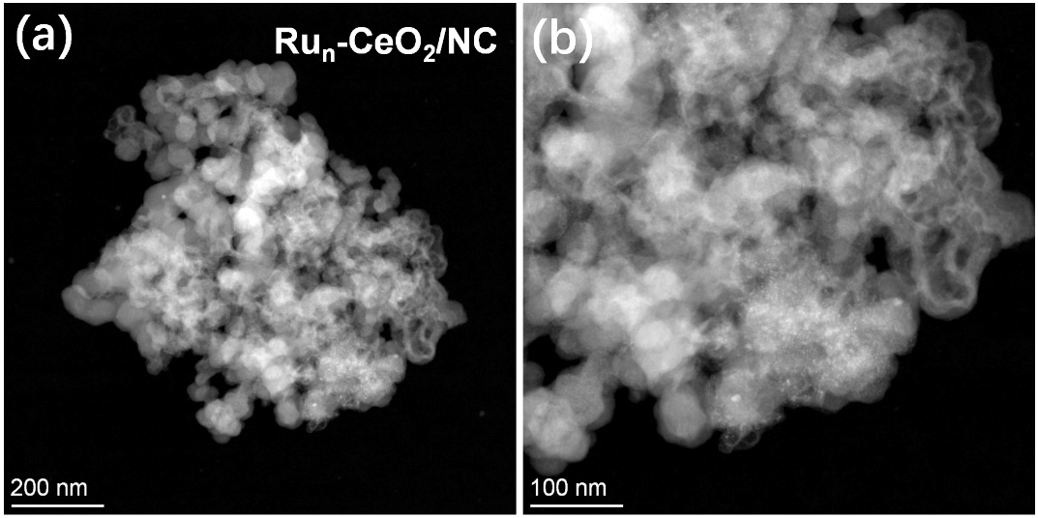
Figure S16. (a) and (b) HAADF-STEM images of the Ru_{n}-CeO₂/NC catalyst. The Ru_{n}-CeO₂/NC was prepared by reducing the Ru cations impregnated CeO₂/NC. Since the hydrogen reduction was carried out at 250 °C, it was hardly to reduce the CeO₂ nanoparticles and only made fine-size Ru nanoclusters around 1 nm while the CeO₂ nanoparticles were as large as 3.8±0.8 nm as displayed in Figure S2.

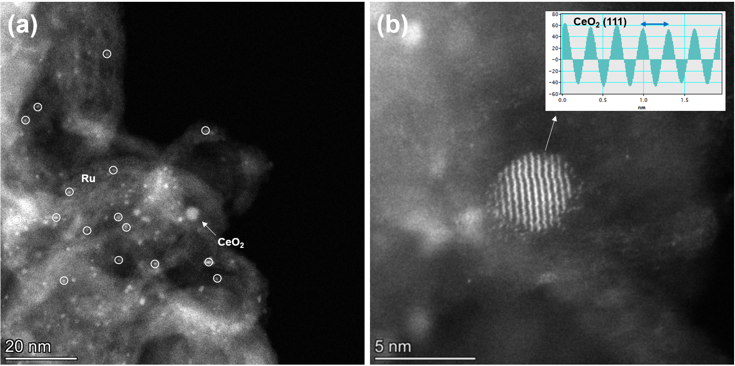
Figure S17. (a) The aberration-corrected HAADF-STEM image of the Ru_{n}-CeO₂/NC catalyst, which displayed the uniformly dispersed CeO₂ and Ru nanoparticles. (b) High-resolution HAADF-STEM image of a CeO₂ nanoparticle. It was identified that the lattice fringe of the relatively bigger particles was assigned to the (111) plane of CeO₂ (PDF no. 34-0394).

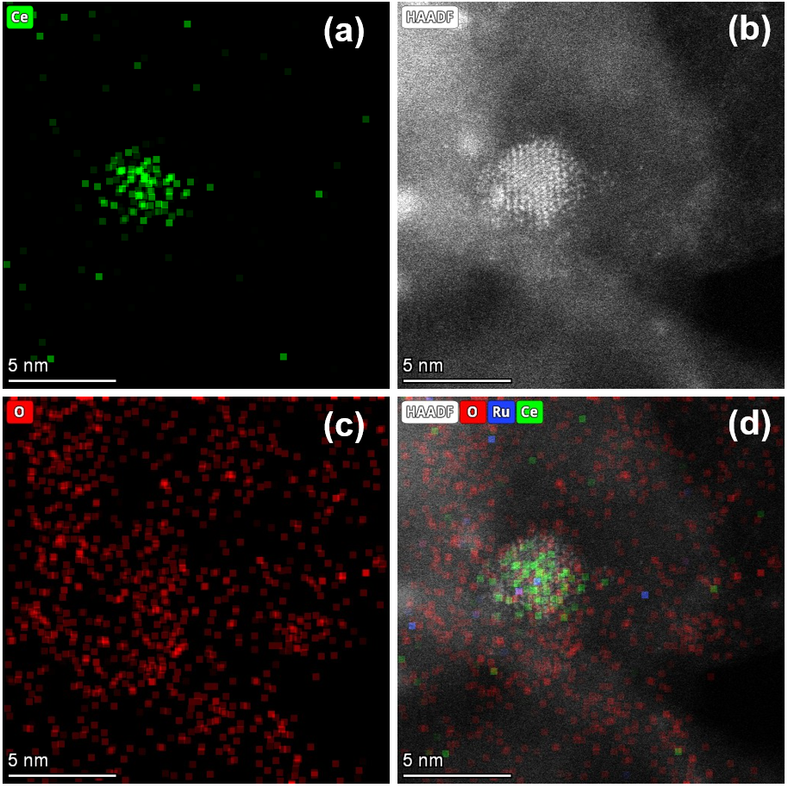
Figure S18. (a)-(d) aberration-corrected HAADF-STEM image and corresponding EDS mapping images of Ru_{n}-CeO₂/NC catalyst. Wherein, the relatively bigger particles in Ru_{n}-CeO₂/NC were confirmed to be the CeO₂, which was in line with the above high-resolution HAADF-STEM observation in Figure S17.

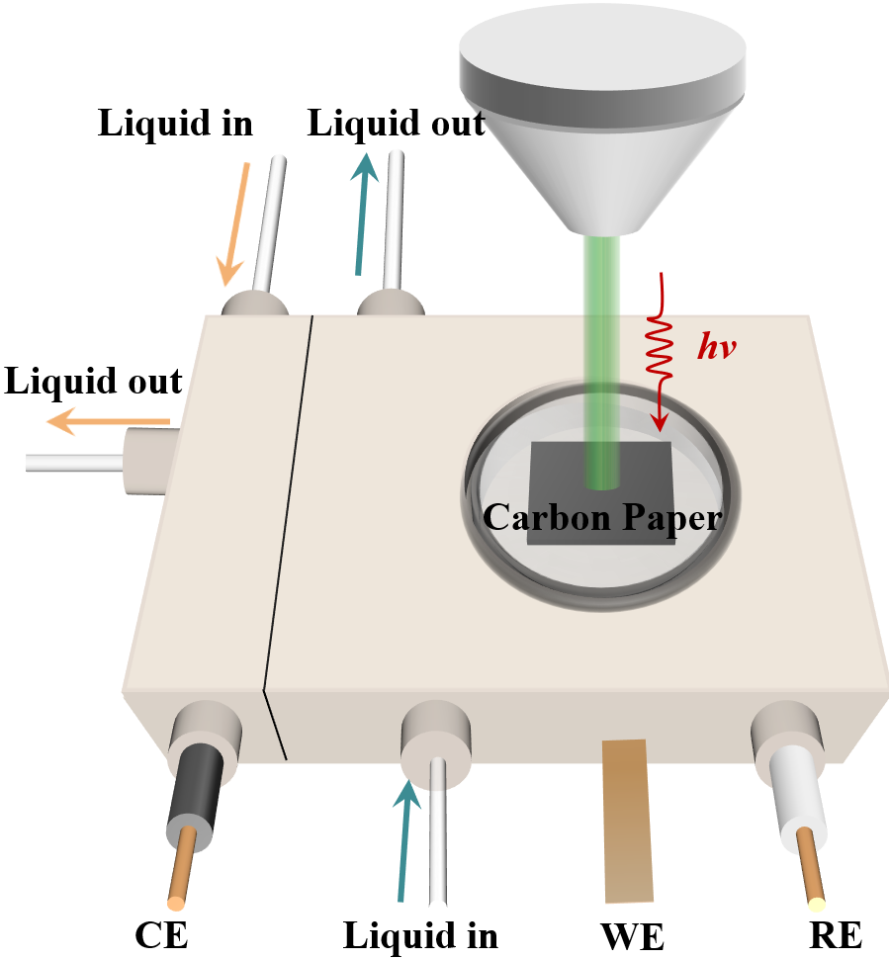
Figure S19. Schematic illustration of home-made electrochemical reaction cell for in situ Raman test using a standard three-electrode system in 1.0 M KOH electrolyte. The Ag/AgCl electrode was used as the reference electrode (RE), the platinum wire served as the counter electrode (CE) and the catalyst was loaded on the carbon paper (WE).

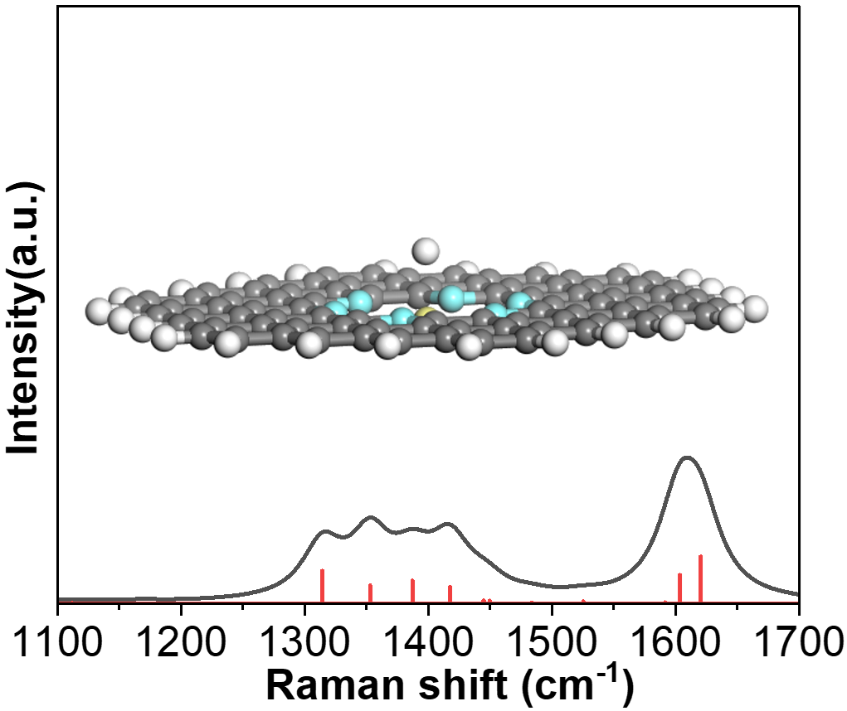
Figure S20. Theoretically fitted Raman curves of the Ce-N stretching vibration in Ce₁-Ru_{n}/NC in the presence of H species. Sharply different from the OH-promoting effect on the Ce-N stretching vibration, it was found that the H had a negligible impact on intensifying the Ce-N stretching vibration at 1533 cm⁻¹ and 1390 cm⁻¹, respectively.

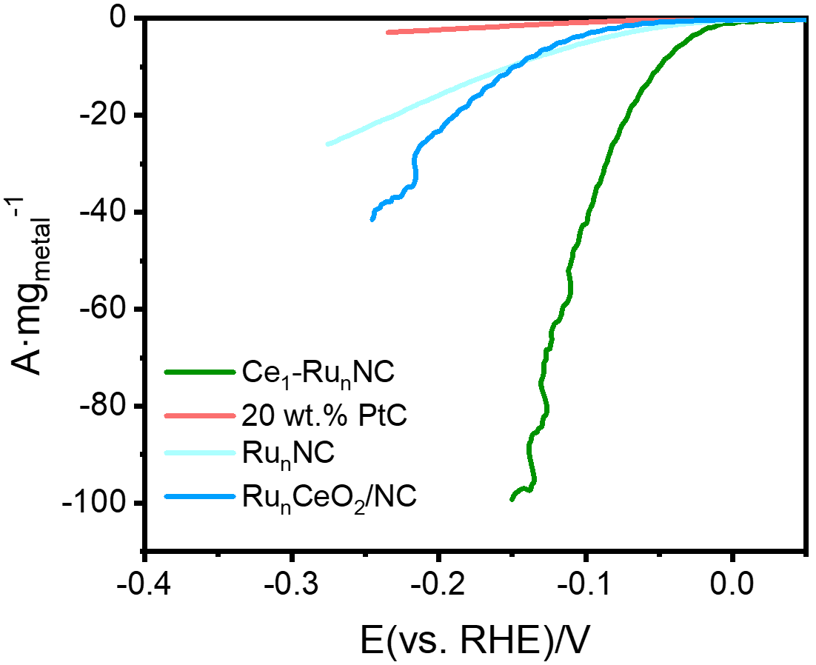
Figure S21. The mass activities of the Ce₁-Ru_{n}/NC, Ru_{n}/NC, Ru_{n}-CeO₂/NC and the commercial 20wt.% Pt/C catalyst. It was found that the mass activity of the Ce₁-Ru_{n}/NC was much larger than the commercial 20wt.% Pt/C. More importantly, the metal price of Ru (ca. 15 $ g⁻¹) was less than half of Pt (ca. 37 $ g⁻¹), making the Ce₁-Ru_{n}/NC particularly attractive for alkaline HER in terms of cost-effectiveness.

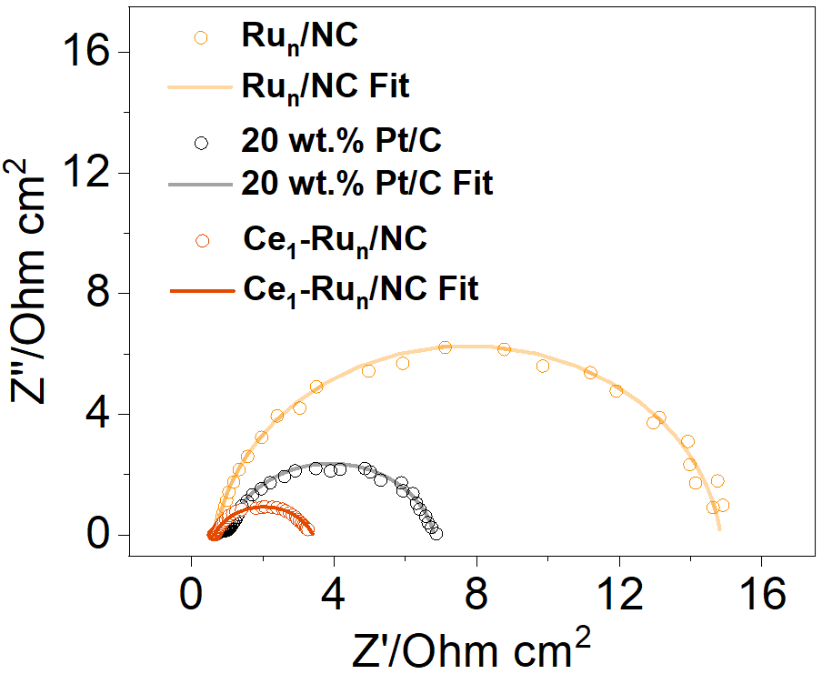
Figure S22. Nyquist curves for the Ce₁-Ru_{n}/NC, Ru_{n}/NC, and the commercial 20wt.% Pt/C, respectively. It was demonstrated that the charge transfer resistance (R_{ct}) of the Ce₁-Ru/NC was the lowest among these catalysts, revealing more rapid HER kinetics of the Ce₁-Ru_{n}/NC than other control catalyst.

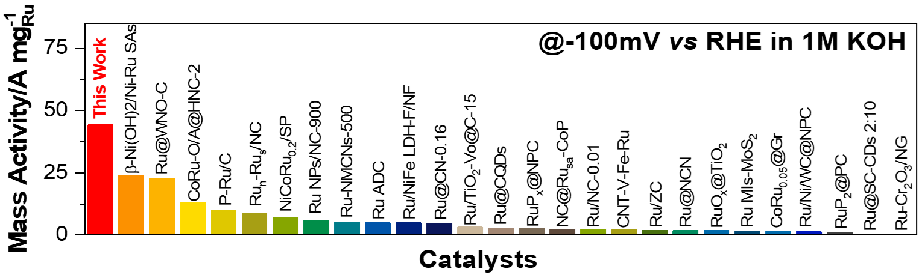
Figure S23. Comparison of the alkaline HER mass activity of the Ce₁-Ru_{n}/NC with previously reported Ru-based catalysts at –0.1 V vs. RHE. Clearly, the Ce₁-Ru_{n}/NC catalyst was superior to all the Ru-based alkaline HER catalysts to date to the best of our knowledge in terms of mass activity at –0.1 V vs. RHE.

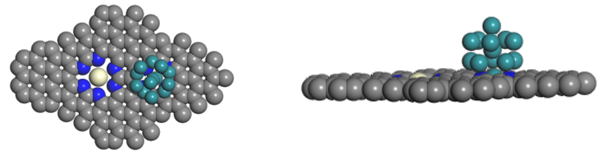
Figure S24. Top view and side view structures of the Ce₁-Ru_{n}/NC catalyst.

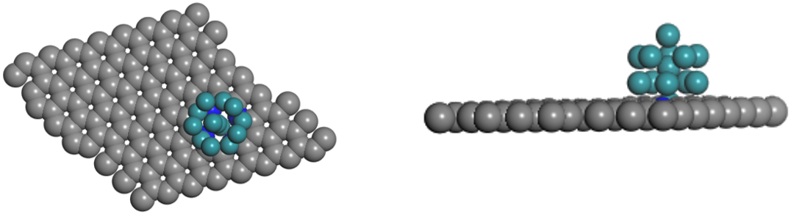
Figure S25. Top view and side view structures of the Ru_{n}/NC catalyst.

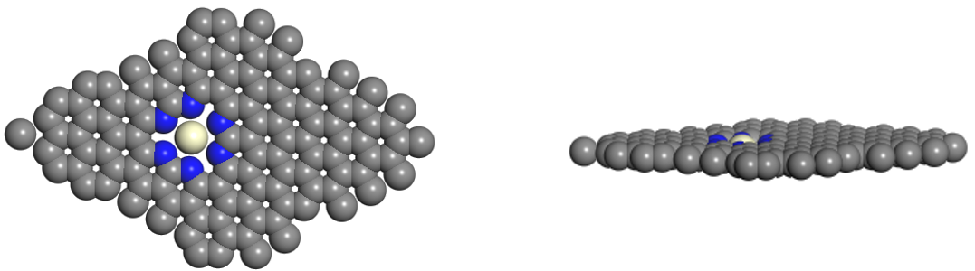
Figure S26. Top view and side view structures of the Ce₁/NC catalyst.

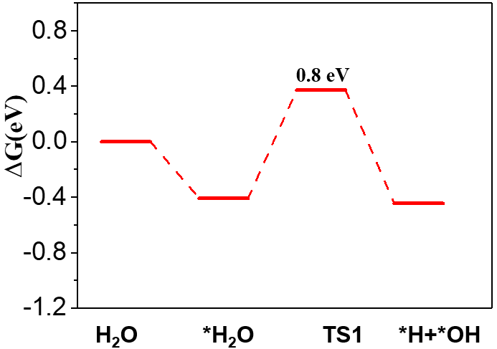
Figure S27. The Gibbs free energy diagrams for water dissociation over the Ce₁/NC catalyst. This result disclosed that the Ce₁/NC catalyst presented a huge Gibbs free energy barrier for water dissociation, which accounted for its low reactivity for alkaline HER.

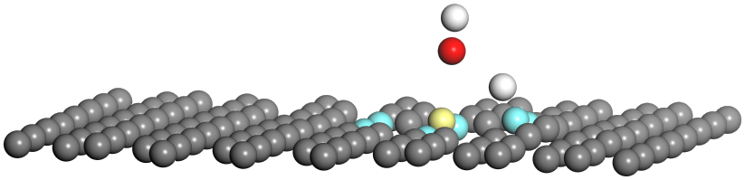
Figure S28. Corresponding structure files of the water dissociation over the Ce₁/NC catalyst.
Supplementary Tables
Table S1. The best-fitted EXAFS results of Ru_{n}/NC and Ce₁-Ru_{n}/NC.
Sample | Shell | CN | R (Å) | σ^² (10⁻² Å² ) | ∆E₀ (eV) | r-factor (%)
Ru foil | Ru-Ru | 12 | 2.67 | 0.4 | 4.1 | 1.6
Ru_{n}/NC | Ru-N | 3.8 | 2.03 | 0.5 | -6.2 | 1.3
 | Ru-Ru | 2.3 | 2.73 | 2.0 | -6.2
Ce₁-Ru_{n}/NC | Ru-N | 4.3 | 2.03 | 0.8 | -4.3 | 0.7
 | Ru-Ru | 2.1 | 2.67 | 2.2 | -4.3
Ce₁-Ru_{n}/NC | Ce-N | 6.1 | 2.11 | 1.2 | 6.5 | 1.8

CN is the coordination number, R is the average distance for different coordination pairs, σ² is the Debye-Waller factor, and ∆E₀ is the inner potential correction. The accuracies of the above parameters are estimated as CN, ±20%; R, ±1%; σ², ± 20%; ∆E₀ , ±20%. The data range used for data fitting in k-space (∆k) and R-space (∆R) are 3.0-13.0 Å⁻¹ and 1.0-2.9 Å for Ru, 3.0-8.0 Å⁻¹ and 1.0-2.0 Å for Ce, respectively.
Table S2. The mass activity comparison between the Ce₁-Ru_{n}/NC catalyst and previously reported Ru-based catalyst at -0.05 V vs. RHE.
Catalysts | Ru loading (wt.%) | Mass activity  /A mg_{Ru}⁻¹ | References
Ce₁-Ru_{n}/NC | 1 | -10.11 | This work
P-Ru/C | 11.9 | -5.20 | ACS Catal. 2020, 10, 11751−11757
CoRu-O/A@HNC-2 | 1.28 | -4.10 | ACS Appl. Mater. Interfaces 2020, 12, 51437−51447
β-Ni(OH)₂/Ni-Ru SAs | 1.17 | -4.08 | Adv. Funct. Mater. 2023, 2301343
Ru/Co@OG | 6.9 | -3.99 | Angew.Chem. Int.Ed. 2021, 60,16044– 16050
Ru NPs/NC-900 | 10.5 | -2.65 | J. Am. Chem. Soc. 2022, 144, 19619−19626
Ru ADC | 4.25 | -2.55 | Small 2021, 17, 2101163
Ru_{n}-Ru_{s}/NC | 4.01 | -2.45 | Small 2023, 2206949
Ru_{1,n}-ZnFe2O_{x}-C | 8.3 | -2.21 | Small 2022, 18, 2204155
Ru-NMCNs-500 | 3.04 | -2.10 | Int. J. Hydrogen Energy, 2020, 45, 18840e18849
MSOR₁ | 4.09 | -2.07 | Adv. Funct. Mater. 2023, 33, 2210939
Ru@CN-0.16 | 3.18 | -1.99 | Energy Environ. Sci., 2018, 11, 800--806
NiCoRu_{0.2}/SP | 0.9 | -1.83 | Appl. Catal., B., 2023, 331, 122710
Ru(3mL)-MC | 2.65 | -1.61 | ChemElectroChem 2022, 9, e202101580
Ru@CQDs | 3.78 | -1.61 | Adv. Mater., 2018, 30, 1800676
Ru/TiO2-Vo@C-15 | 2.9 | -1.29 | J. Mater. Chem. A,2021, 9,10160–10168
Ru/NiFe LDH-F/NF | 10 | -1.24 | Nanoscale,2020, 12, 9669–9679
Ru/NC-0.01 | 16.7 | -0.83 | J. Mater. Chem. A,2019, 7,18072–18080
NC@Ru_{sa}-CoP | 13.87 | -0.74 | Small 2023, 2301403
Ru/ZC | 4 | -0.71 | J. Mater. Chem. A, 2022, 10, 17730–17739
Ru/Ni/WC@NPC | 4.13 | -0.60 | Adv. Energy Mater. 2022, 12, 2200332
Ru@NCN | 9.1 | -0.58 | J. Mater. Chem. A,2021, 9,13958–13966
Ru MIs-MoS₂ | 10 | -0.55 | Chem. Eng. J. 2023, 453, 139803
RuO_{x}@TiO₂ | 10 | -0.43 | Chem. Eng. J., 2022, 446, 137248
CoRu_{0.05}@Gr | 2.48 | -0.42 | Appl. Surf. Sci., 2022, 580, 152294
CNT-V-Fe-Ru | 17.84 | -0.40 | ACS Catal. 2023, 13, 49−59
RuPx@NPC | 12.64 | -0.30 | ChemSusChem 2018, 11,743 –752
Ru_{NP}-Ru_{SA}@CFN-800 | 12 | -0.21 | Adv. Funct. Mater. 2023, 2213058
Ru@SC-CDs2:10 | 21.6 | -0.20 | Nano Energy 2019, 65 104023
Ru/Co₄N-CoF₂ | 5 | -0.17 | Chem. Eng. J. 2021, 414, 128865
RuP₂@PC | 14.6 | -0.14 | J. Mater. Chem. A,2021, 9, 12276–12282
Ru₁Ni₁-NCNFs | 28.2 | -0.12 | Adv. Sci. 2020, 7, 1901833
Ru-Cr₂O₃/NG | 17 | -0.08 | RSC Adv.,2021, 11,6107–6113
Cu_{1.94}S@Ru | 55 | -0.04 | Small 2017, 13, 1700052
Table S3. The mass activity comparison between the Ce₁-Ru_{n}/NC catalyst and previously reported Ru-based catalyst at -0.1 V vs. RHE.
Catalysts | Ru loading (wt.%) | Mass activity  /A mg_{Ru}⁻¹ | References
Ce₁-Ru_{n}/NC | 1 | -44.30 | This work
β-Ni(OH)₂/Ni-Ru SAs | 1.17 | -23.95 | Adv. Funct. Mater. 2023, 2301343
Ru@WNO-C | 0.9 | -22.72 | Nano Energy 2021, 80, 105531
P-Ru/C | 11.9 | -12.89 | ACS Catal. 2020, 10, 11751−11757
CoRu-O/A@HNC-2 | 1.28 | -10.05 | ACS Appl. Mater. Interfaces 2020, 12, 51437−51447
Ru_{n}-Ru_{s}/NC | 4.01 | -8.79 | Small 2023, 2206949
NiCoRu_{0.2}/SP | 0.9 | -7.03 | Appl. Catal., B., 2023, 331, 122710
Ru NPs/NC-900 | 10.5 | -5.83 | J. Am. Chem. Soc. 2022, 144, 19619−19626
Ru-NMCNs-500 | 3.04 | -5.19 | Int. J. Hydrogen Energy. 2020, 45, 18840e18849
Ru ADC | 4.25 | -4.89 | Small 2021, 17, 2101163
Ru/NiFe LDH-F/NF | 10 | -4.79 | Nanoscale,2020, 12, 9669–9679
Ru@CN-0.16 | 3.18 | -4.52 | Energy Environ. Sci., 2018, 11, 800--806
Ru/TiO₂-Vo@C-15 | 2.9 | -3.17 | J. Mater. Chem. A,2021, 9,10160–10168
Ru@CQDs | 3.78 | -2.82 | Adv. Mater., 2018, 30, 1800676
RuP_{x}@NPC | 12.64 | -2.68 | ChemSusChem 2018, 11,743 –752
NC@Ru_{sa}-CoP | 13.87 | -2.21 | Small 2023, 2301403
Ru/NC-0.01 | 16.7 | -2.15 | J. Mater. Chem. A,2019, 7,18072–18080
CNT-V-Fe-Ru | 17.84 | -2.07 | ACS Catal. 2023, 13, 49−59
Ru/ZC | 4 | -1.88 | J. Mater. Chem. A, 2022, 10, 17730–17739
Ru@NCN | 9.1 | -1.83 | J. Mater. Chem. A,2021, 9,13958–13966
RuO_{x}@TiO₂ | 10 | -1.81 | Chem. Eng. J., 2022, 446 137248
Ru MIs-MoS₂ | 10 | -1.45 | Chem. Eng. J., 2023, 453 139803
CoRu_{0.05}@Gr | 2.48 | -1.35 | Appl. Surf. Sci., 2022, 580, 152294
Ru/Ni/WC@NPC | 4.13 | -1.29 | Adv. Energy Mater. 2022, 12, 2200332
RuP₂@PC | 14.6 | -0.93 | J. Mater. Chem. A,2021, 9, 12276–12282
Ru@SC-CDs2:10 | 21.6 | -0.39 | Nano Energy 2019,65, 104023
Ru-Cr₂O₃/NG | 17 | -0.36 | RSC Adv.,2021, 11,6107–6113
Ru/Co₄N-CoF₂ | 5 | -0.28 | Chem. Eng. J., 2021, 414, 128865
Cu_{1.94}S@Ru | 55 | -0.11 | Small 2017, 13, 1700052

Supplementary reference:
(1) Perdew, J. P., et al., Generalized Gradient Approximation Made Simple. Phys. Rev. Lett. 1996, 77, 3865-3868.
(2) Blöchl, P. E., Projector augmented-wave method. Phys. Rev. B 1994, 50, 17953-17979.
(3) Grimme, S., et al., A consistent and accurate ab initio parametrization of density functional dispersion correction (DFT-D) for the 94 elements H-Pu. J. Chem. Phys. 2010, 132.
(4) Grimme, S., Supramolecular Binding Thermodynamics by Dispersion-Corrected Density Functional Theory. Chem. - Eur. J. 2012, 18, 9955-9964.
(5) Henkelman, G., et al., Improved tangent estimate in the nudged elastic band method for finding minimum energy paths and saddle points. J. Chem. Phys. 2000, 113, 9978-9985.
(6) Perdew, J. P., et al., Rationale for mixing exact exchange with density functional approximations. J. Chem. Phys. 1996, 105, 9982-9985.
(7) Lu, T., et al., Multiwfn: A multifunctional wavefunction analyzer. J. Comput. Chem. 2012, 33, 580-592.
(8) Chen, Y., et al., Isolated Single Iron Atoms Anchored on N-Doped Porous Carbon as an Efficient Electrocatalyst for the Oxygen Reduction Reaction. Angew. Chem. Int. Ed. 2017, 56, 6937-6941.

