Supplemental Figure 1. Distribution of ex vivo drug testing results. Stacked bar graph of agents tested against each patient sample distributed by DSS score group (insensitive, DSS = 0 (in white); intermediate sensitivity, 0 < DSS ≤ 10 (in light green); sensitive, DSS > 10 (in dark green)).

Supplemental Figure 2. Additional outcome analysis. a) OR distributions of therapeutic response prior to trial enrollment in PC cohort and FPM-guided patients, showing no significant difference in ORR between treatment cohorts at enrollment. b) Kaplan-Meier survival curves of therapeutic regimens in PC and FPM-guided patients, showing no significant difference in PFS between treatment cohorts at enrollment. c) OR distributions of previous regimen versus trial regimen in PC patients, showing no significant difference in ORR in the PC cohort. d) Kaplan-Meier survival curves of the previous regimen versus the trial regimen in PC patient cohort, showing no significant difference in PFS in the PC cohort. e) Side-by-side bar graphs comparing PFS of previous regimen and trial regimen for both FPM-guided cohort and PC cohort. * Indicates patients with PFS ratio ≥ 1.3x. The golden star above EV013 indicates the patient with continuing response following bone marrow transplant.

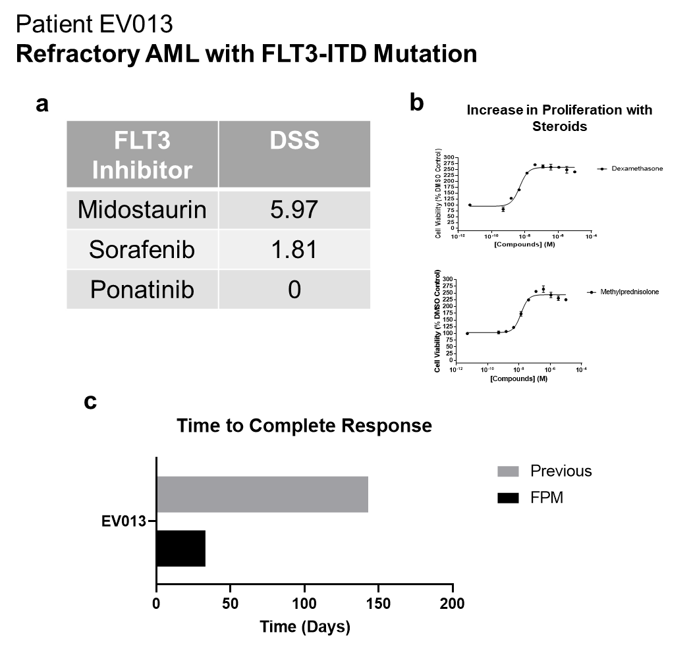
Supplemental Figure 3. Details of ex vivo drug testing results and treatment response in Patient EV013. a) DST testing of FLT3 inhibitors showed midostaurin to be most effective with highest DSS. b) Dose response curves of steroids; dexamethasone and methlyprednisone showing increase in cell proliferation over 3 days. c) Bar graph comparing time to complete response of FPM-guided approach versus previous regimen that is PC.

Supplemental Figure 4. Expanded clinical correlation analysis including observational study data. a) Distribution of treatment DSS by response type (left) and objective response (right). (PD = progressive disease, SD = stable disease, PR = partial response, CR = complete response, NR = non-responders, R = responders). b) Plot of the relationship between treatment DSS and PFS categorizing patients according to the trial objective response. The blue dashed line represents the line of simple linear regression. c) ROC curve of true positive rate and false positive rate of DSS-based response prediction. d) Precision-Recall curve of DSS-based response prediction. e) Confusion matrix and associated statistics of DSS predicted and actual objective response in FPM-guided patients and PC patients at optimal threshold (DSS > 25). Prediction performance metrics (MCC, F1, Accuracy, Precision, Recall) are provided below the confusion matrix.

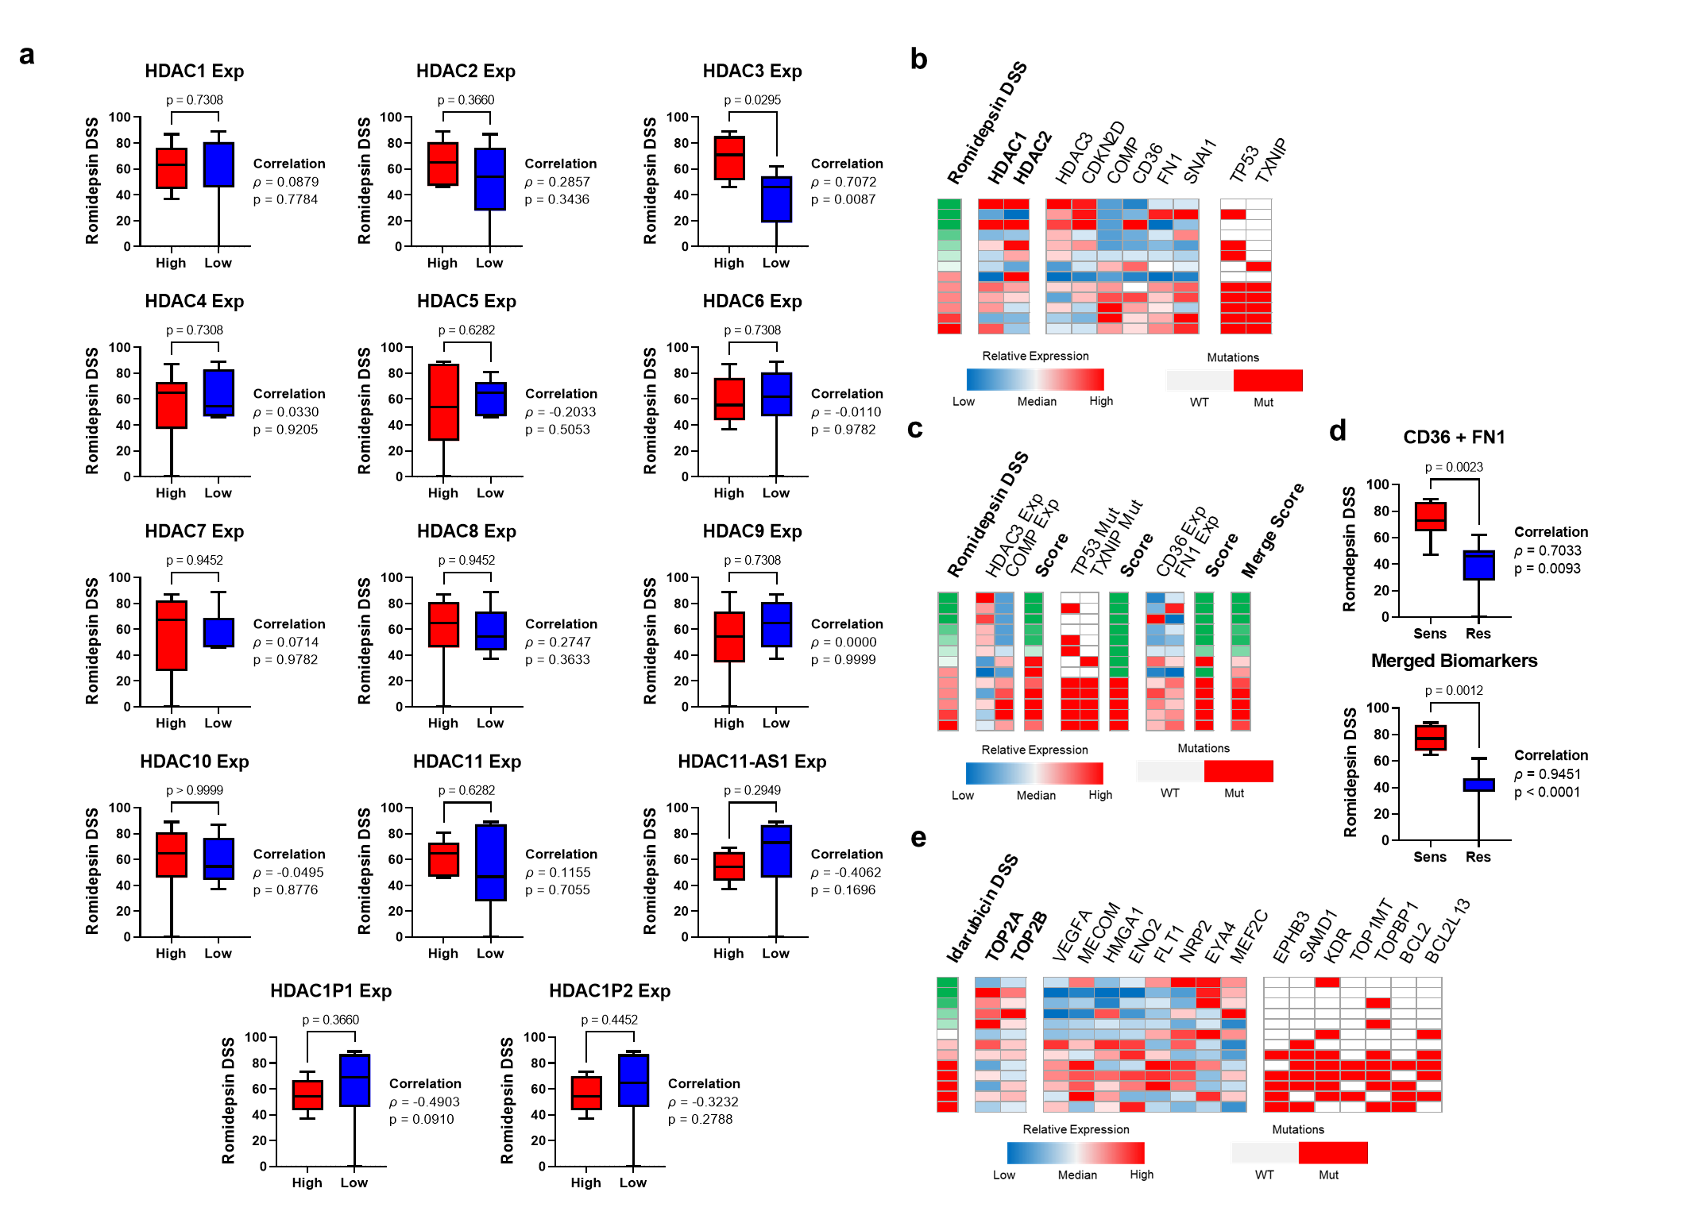
Supplemental Figure 5. Data supporting explainable AI/ML multi-omics biomarkers. a) Distribution of romidepsin DSS scores by expression of all sequenced HDAC isoforms. b) Canonical drug targets and top gene features identified by AI/ML biomarker analysis of romidepsin. Heatmap of gene expression is visualized around median expression. c) Extended romidepsin biomarkers including CD36-FN1 expression biomarker and updated merged biomarker. d) DSS distribution of CD36-FN1 biomarker and updated merged biomarker. Pearson correlation coefficient and p-value is provided alongside distribution plots. e) Canonical drug targets and top gene features identified by AI/ML biomarker analysis of idarubicin. Heatmap of gene expression is visualized around median expression. P-values above all distribution plots are from Mann-Whitney U tests.

Supplemental Figure 6. Comparison of testing and clinical outcomes between genomics-guided and FPM-guided precision medicine studies. All comparisons are performed between three study groups: aggregated genomics studies published between 2012 and 2016, NCI-MATCH genomics study published in 2023, and aggregated FPM studies published since 2022. a) Per study comparison of percentage of successfully tested patients versus all enrolled patients, percentage of evaluable patients versus all enrolled patients, and percentage of objective responses versus all enrolled patients. b) Comparison of objective responses versus evaluable patients per study.

