Supporting Information
Highly eefficient, stable, and easily detachable cellulose-based membrane system iinspired by water hyacinth
Fang Zhang,¹ Yuxin Sun, ¹ Xinye Qian, ¹ Xiaoyan Tan, ¹ Chunling Zheng*^{1,2}, Yonghong Hu* ¹
¹College of Food Science and Light Industry, Nanjing Tech University, Nanjing, Jiangsu, 211800, China
²Institute of Textile Chemicals and Ecological Dyeing & Finishing, Nanjing Tech University, Nanjing, Jiangsu 211800, China
Email: C.L.Z. zhengchunling@njtech.edu.cn; Y.H.H.chemywg@126.com

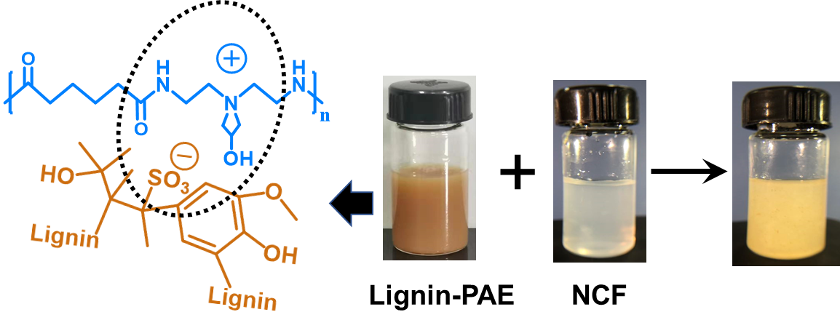
Figure S1. The lignin-PAE/NCF mixture suspension used for the ultrasonic atomization. Left the complex mechanism between lignin and PAE. Lignin-PAE was prepared by mixing equal vlolume of the 2wt%lignin and 2wt%PAE, NCF concentration was 2wt%.

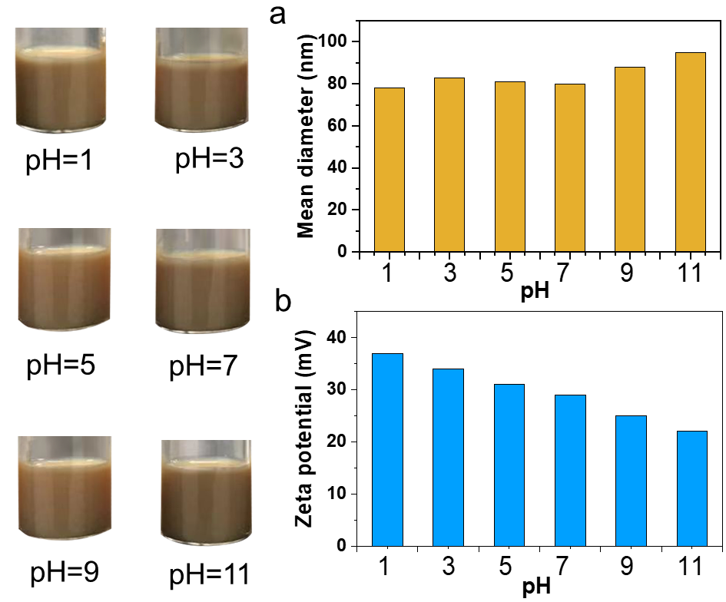
Figure S2. The (a) diameter (b) zeta potential values of lignin-PAE aggregates under different pH values. Lignin-PAE was prepared by mixing equal vlolume of the 2wt%lignin and 2wt%PAE, NCF concentration was 2wt%.

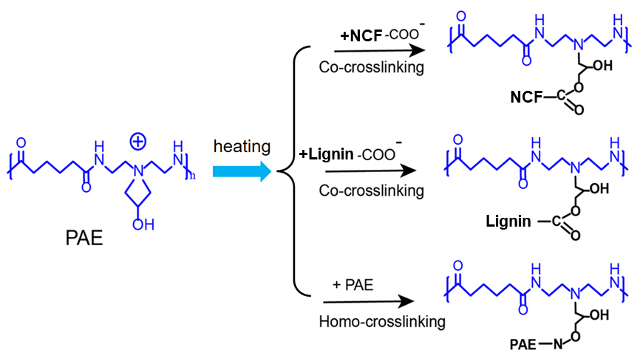
Figure S3. The reaction mechanism between lignin-PAE and NCF by the heat-actuated crosslinking.

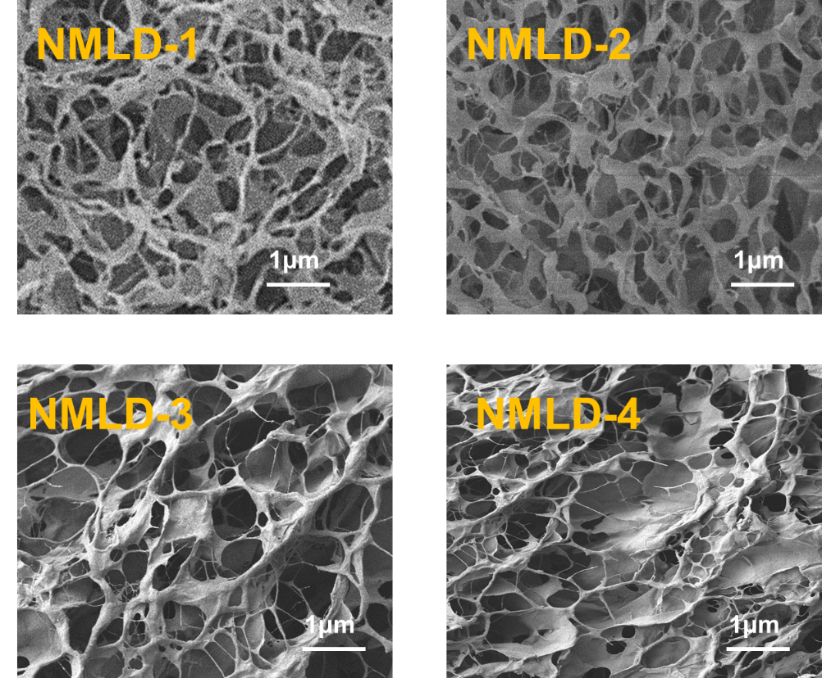
Figure S4. SEM of NMLD with different lignin-PAE content, showing different porous and structure morphologies.

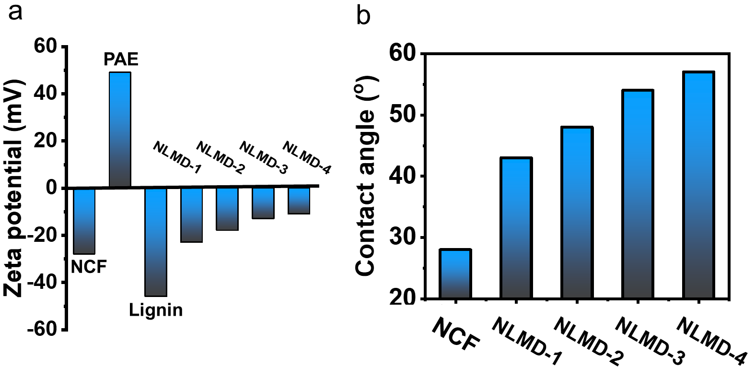
Figure S5. (a) Zeta potential (b) water contact angles of NCF and different NLMD samples. NLMD-1, -2, -3, -4 are on behalf of the NMLDs with different lignin contents.

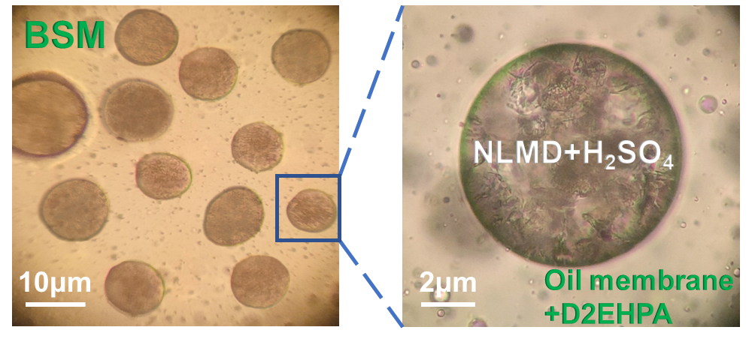
Figure S6. The optical microscopic images of BMS (H₂SO₄ absorbed NLMD that is dispersed in oil phase containing D2EHPA), in which oil phase as a membrane phase for the transporting the metal ions and the NLMD as a receiving phase for the accommodation of the metal ions. The volume ratio of NLMD to oil is 1:2.

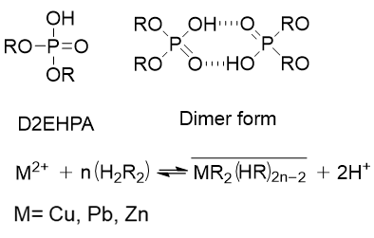
Figure S7. The chemical structure of D2EHPA and its dimer form, where R=2-ethylhexyl group. The extraction by D2EHPA can be expressed as the equation in the Figure.

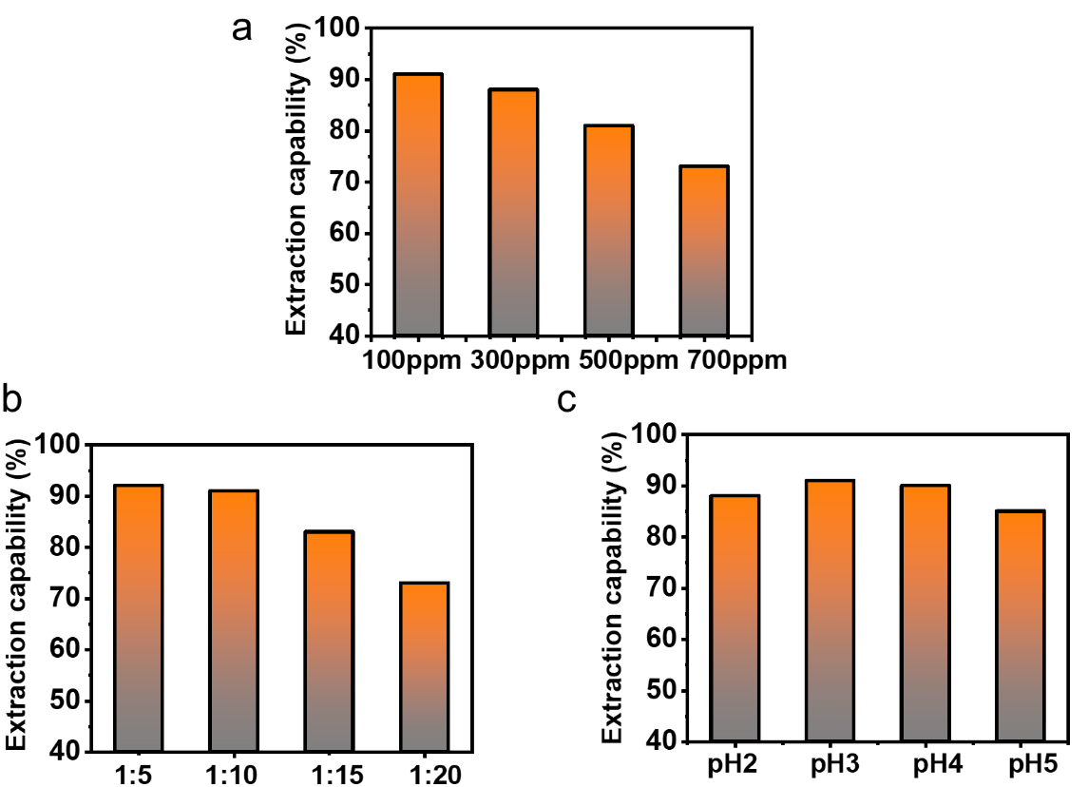
Figure S8. The BMS extraction capabilities toward (a) different external Cu²⁺ concentrations. The volume ratio was 1:10, pH was 3. (b) The volume ratio of BMS to external water. The concentration of external Cu²⁺ is 100ppm, pH of external water is 3. (c) pH values of the external water. The concentration of external Cu²⁺ is 100ppm, the volume ratio was 1:10.

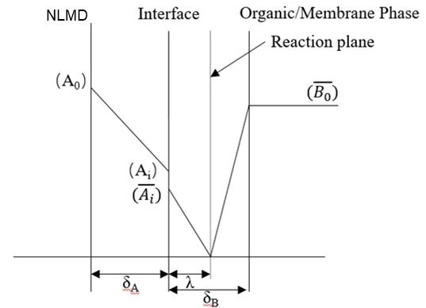
Figure S9. Mass transfer with instantaneous chemical reaction in the BMS.
Yadav and Mahajani have developed a realistic model to aid in the process design of extraction via emulsion liquid membrane(Yadav & Mahajani, 2007). This extraction is a process of mass transfer accompanied by chemical reaction. Doraiswamy and Sharma have presented a comprehensive account of the theoretical aspects of mass transfer with chemical reactions(Doraiswamy & Sharm, 1985). The reactions involved at the interfaces in this process are expected to be instantaneous, and the overall rates of the reaction components are to be controlled by the diffusion of reaction components to the reaction plane in the aqueous phase, as depicted in Figure S9.
(1)$A+ZB⇋C$
where A) Metal ions, B) D2EHPA, Z) stoichiometric coefficient, and C) metal-D2EHPA complex. Mass transfer in bulk of aqueous
$${Metal ions}^{2+}+2D2EHPA⇌{Metal ions(D2EHPA)}_{2}$$
(2)$R_{A}\underline{a}=\frac{-d(A_{0})}{dt}=k_{LA}\underline{a}(\left(A_{0}\right)-\left(A_{i}\right))$
An instantaneous complexation reaction in the diffusion film of the membrane phase.
(3)$R_{A}\underline{a}=k_{LB}\underline{a}×(\overline{A_{i}})(1+\frac{(\overline{B_{0}})×\overline{D_{B}}}{Z×(\overline{A_{i}})×\overline{D_{A}}})$
Solving eq 6 along with eq 7 gives the value of (Ai) explicitly
(4)$\left(A_{i}\right)=(\frac{k_{LA}\underline{a}×\left(A_{0}\right)-k_{LB}\underline{a}\frac{\left(\overline{B_{0}}\right)×\overline{D_{B}}}{Z×\overline{D_{A}}}}{k_{LA}\underline{a}+k_{LB}\underline{a}×K_{D}})$
Substituting eq 8 in eq 6 and solving further we get
(5)$-\frac{d\left(A_{0}\right)}{dt}=\left[\frac{(\left(A_{0}\right)×K_{D}+(\frac{\left(\overline{B_{0}}\right)×\overline{D_{B}}}{Z×\overline{D_{A}}}))}{(\frac{K_{D}}{k_{LA}\underline{a}}+\frac{1}{k_{LB}\underline{a}})}\right]$
Integrating eq 9, we get
(6)$ln（\frac{α_{1}}{α_{2}}）=K_{L}\underline{a}(t_{2}-t_{1})$
where
(11)$K_{L}\underline{a}$
(7)$\frac{1}{K_{L}\underline{a}}=\frac{1}{k_{LA}\underline{a}}+\frac{1}{K_{D}×k_{LB}\underline{a}}$
and
(8)$α_{1}=（（A_{0.1}）×K_{D}+\frac{（\overline{B_{0}}）×\overline{D_{B}}}{Z×\overline{D_{A}}}）$
(9)$α_{2}=（（A_{0.2}）×K_{D}+\frac{（\overline{B_{0}}）×\overline{D_{B}}}{Z×\overline{D_{A}}}）$
The stoichiometric coefficient (Z) is 2. The diffusivity of Zn ions in aqueous phase is 7.2 × 10⁻¹⁰ m² ·s⁻¹ and the diffusivity of the D2EHPA in organic phase estimated to be 6.19 × 10⁻¹⁰ m² ·s ⁻¹ by the Wilke-Chang correlation(Chang, 1955). Thus, the performance of the BMS for zinc (II) extraction can be predicted. Figure S10 shows a plot of experimental data directly compared to a plot of eq6.

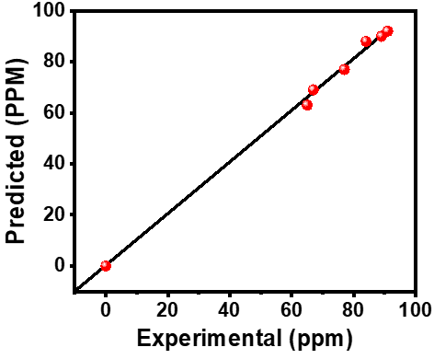
Figure S10. Plot of experimental data compared from the predicted from equation mentioned above.
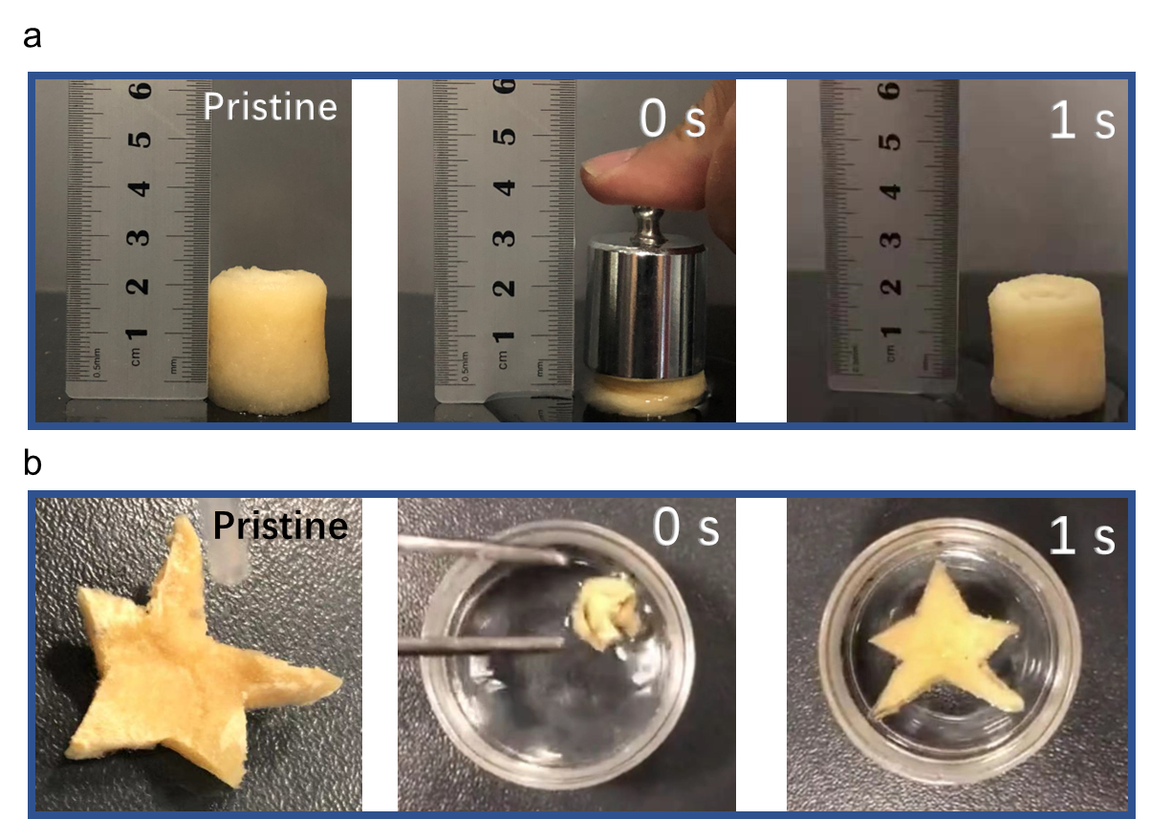
Figure S11. The shape-recovery performance of NLMD that presented by an NCF/lignin-PAE monolithic material. (a) The pressed sample could recover its shape by reabsorbing water within 1s. (b) The kneaded sample could recover its shape by immersing and reabsorbing water within 1s.

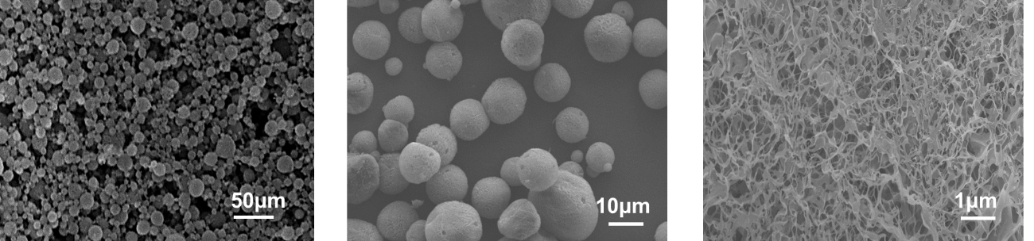
Figure S12. NLMD morphologies after being treated with the BMS extraction for 50 recyclings.
References
Chang CRWA (1955) Correlation of diffusion coefficients in dilute solutions. Aiche Journal 1: 264-270. https://doi.org/10.1002/aic.690010222
Doraiswamy LK, Sharm MM (1985) Heterogeneous reactions analysis examples and reactor design. Aiche Journal 31: 1405
Yadav SV, Mahajani VV (2007) Liquid emulsion membrane (lem) process for vanadium (iv) enrichment: process intensification. Separation Science and Technology 42: 1283-1303. https://doi.org/10.1080/01496390601174331

