Supplement for
Three-dimensional thermomechanical modeling beneath southeastern Mexico, and its relation to the occurrence of interplate seismic events

Nobuaki Suenaga^{1,*}, Shoichi Yoshioka^{1,2}, Vlad C. Manea³, Marina Manea³,
and Erika J. Moreno¹

1. Research Center for Urban Safety and Security, Kobe University, Rokkodai-cho 1-1, Nada ward, Kobe 657-8501, Japan
2. Department of Planetology, Graduate School of Science, Kobe University, Rokkodai-cho 1-1, Nada ward, Kobe 657-8501, Japan
3. Computational Geodynamics Laboratory, Centro de Geociencias, Universidad
Nacional Autónoma de México, Campus Juriquilla, Querétaro, 76230, Mexico

*corresponding author

e-mail: shikoku.1025@gmail.com
Contents
Tables S1-S2
Figures and figure captions S1-S3
References

Table S1 Assumed subduction history of the subducting Cocos plate

Period（Ma） | Migration rate of the Cocos  plate in the across-arc direction  [-x direction]  （cm/yr） | Plate motion velocity of the Cocos plate in the along-arc direction  [±y direction]  （cm/yr） | Trench retreat velocity of the Cocos plate in the across-arc direction  [+x direction]  （cm/yr） | Migration direction of the Cocos plate
25.0-21.5 | 4.3 | -1.2 | 0.0 | Northeastward
21.5-18.0 | 7.1 | -1.8 | 0.0 | Northeastward
18.0-15.0 | 8.5 | -2.0 | 0.0 | Northeastward
15.0-14.5 | 8.5 | -1.4 | 1.5 | North-Northeastward
14.5-11.0 | 8.6 | -1.4 | 1.5 | North-Northeastward
11.0-10.0 | 6.2 | -1.0 | 1.5 | North-Northeastward
10.0-7.5 | 6.2 | -1.0 | 1.0 | North-Northeastward
7.5-5.0 | 4.6 | -0.7 | 1.0 | North-Northeastward
5.0-4.0 | 4.6 | -1.1 | 0.5 | North-Northeastward
4.0-0.0 | 6.6 | -1.1 | 0.5 | North-Northeastward

Table S2 RMS values between the observed and calculated Curie point depth distributions

Downdip limit of the high  viscosity region  (in km) with viscosity of 10²³ Pas | Pore pressure ratio  (Frictional cofficient μ‘) | 0.970  (0.0255) | 0.975  (0.02125) | 0.980  (0.017) | 0.985  (0.01275) | 0.990  (0.0085) | 0.995  (0.00425) | 1.00  (0.0)
35 km |  | 18.98 | 18.80 | 18.51 | 18.20 | 17.97 | 17.57 | 17.85
40 km |  | 17.75 | 17.54 | × | 17.85 | × | 17.13 | 17.54
45 km |  | × | × | 17.56 | 17.43 | 17.67 | × | 17.10
50 km |  | × | × | 17.11 | × | × | 16.42 | ×
55 km |  | 16.63 | 15.81 | 17.54 | × | 16.85 | × | 16.24
60 km |  | 16.17 | 15.98 | 17.99 | 17.66 | × | 15.96 | 15.42
Downdip limit of the high viscosity region
(in km)
with viscosity of 10²⁸ Pas
35 km |  | × | × | 16.75 | × | 16.41 | × | ×
40 km |  | 16.23 | × | × | 16.26 | 15.97 | 15.82 | ×
45 km |  | 15.98 | 15.71 | × | 16.04 | 15.21 | × | 15.64
50 km |  | 15.65 | 15.62 | 15.99 | × | × | 14.87 | 15.12
55 km |  | × | 15.43 | 15.11 | 14.87 | 14.31 | 14.67 | 15.33
60 km |  | 15.76 | × | 14.93 | × | × | 14.61 | ×

Figure S1
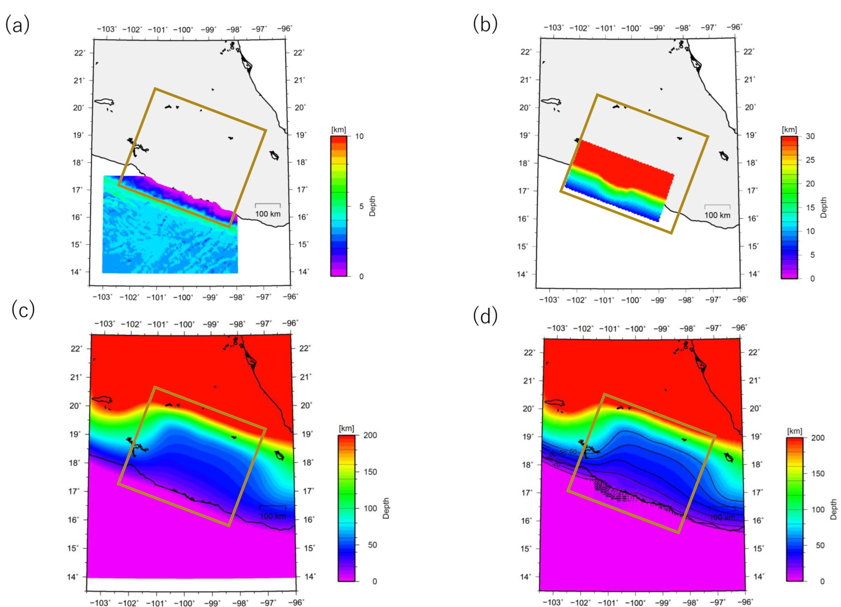

Figure S1 Seafloor bathymetry and slab geometry used in this study. The brown frame represents the model region for numerical simulations. (a) Seafloor bathymetry taken from ETOPO1¹⁴. (b) Slab geometry model by Kostoglodov et al. (1996)¹⁵. (c) Slab geometry by slab 2.0 model^{S1}. (d) The seafloor bathymetry and slab geometry model used for the numerical simulation in this study, by combining the geometries of (a), (b), and (c). Black solid lines represent the isodepth contour lines of the slab geometry at 10km intervals.

Figure S2
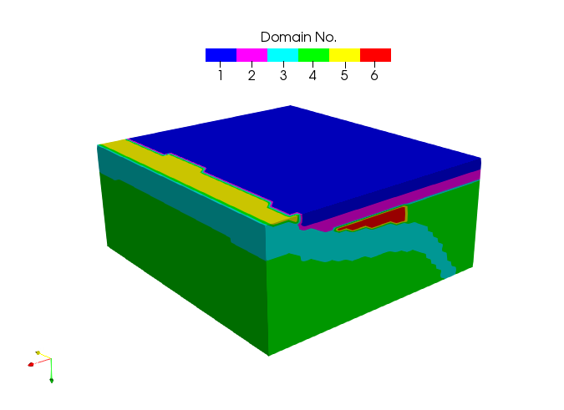
Figure S2 Bird’s eye view of the 3-D thermomechanical subduction model consisting of six portions. Domains 1, 2, 3, 4, 5, and 6 denote the upper crust, lower crust, slab, mantle, accretionary prism, and high-viscous region in the mantle wedge, respectively.

Figure S3
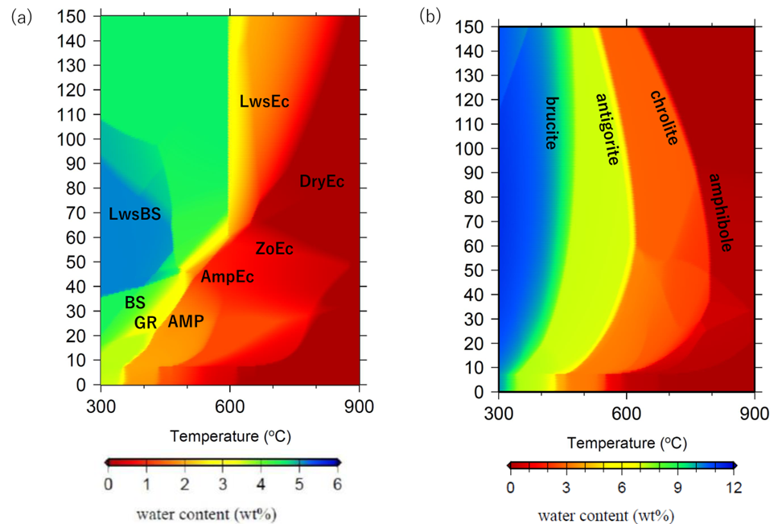

Figure S3 Phase diagrams of hydrous minerals within the oceanic crust and the ultramafic rock.²⁶ (a) Phase diagrams of MORB within the oceanic crust. The mineral names indicated by each abbreviation are as follows: BS: Blue Schist; GS: Green schist; LwsBS: Lawsonite Blueschist; AMP: Amphibolite; AmpEc: Amphibole eclogite; ZoEc: Zoesite Eclogite; LwsEc: Lawsonite Eclogite; DryEc: Dry Eclogite. (b) Phase diagrams of the ultramafic rock in the mantle wedge.

References
S1 Hayes, P. G., Moore, L. G., Portner, E. D., Hearne, M., Flamme, H., Furtney, M., & Smoczyk, M. G., 2018. Slab2, a comprehensive subduction zone geometry model. Science 362, 58-61.

