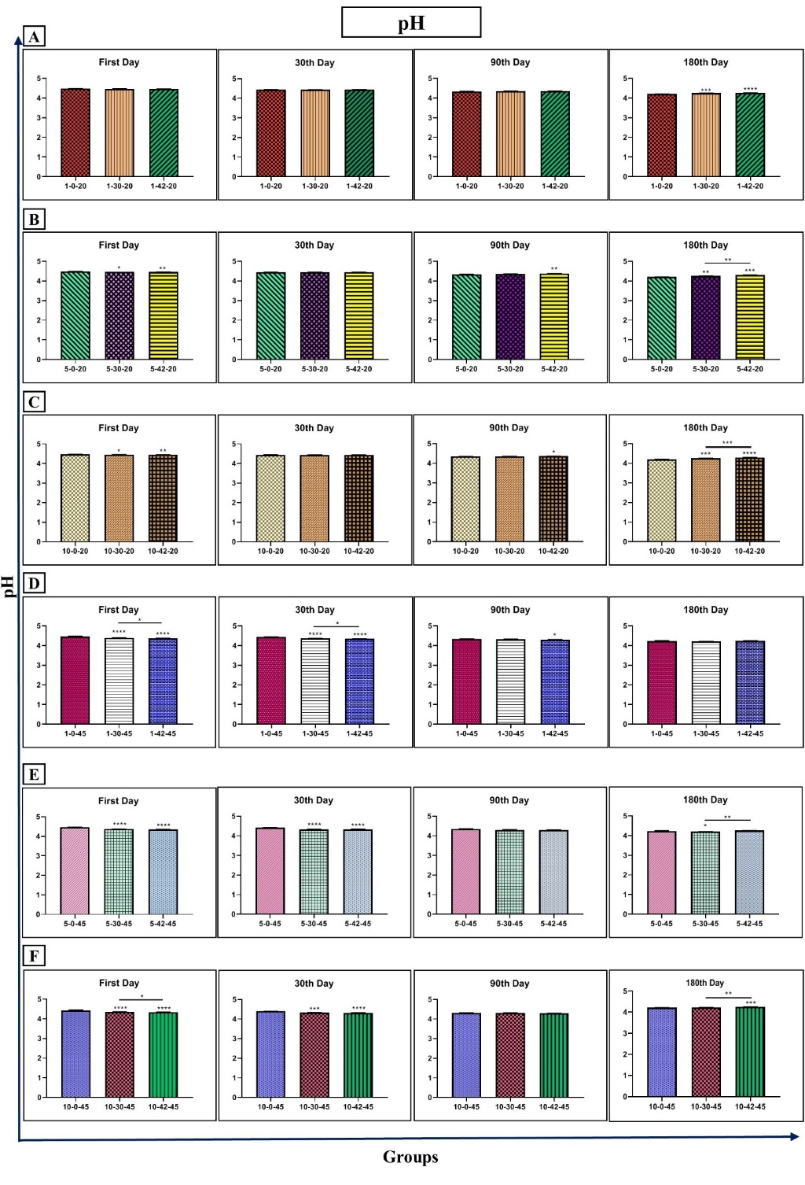
Figure SF1. Effect of 0 (as control), 30, and 42 kHz ultrasound on the industrial Iranian honey pH. The samples that treated at 30 kHz for 1 (A), 5 (B), 10 (C) minutes, and 20 °C. The samples that treated at 45 kHz for 1 (D), 5 (E), 10 (F) minutes, and 45 °C. Data are shown as the mean ± SD. The mean values with asterisks are significantly different (p≤ 0.05). (* P<0.05, ** P<0.01, *** P<0.001, **** P<0.0001).
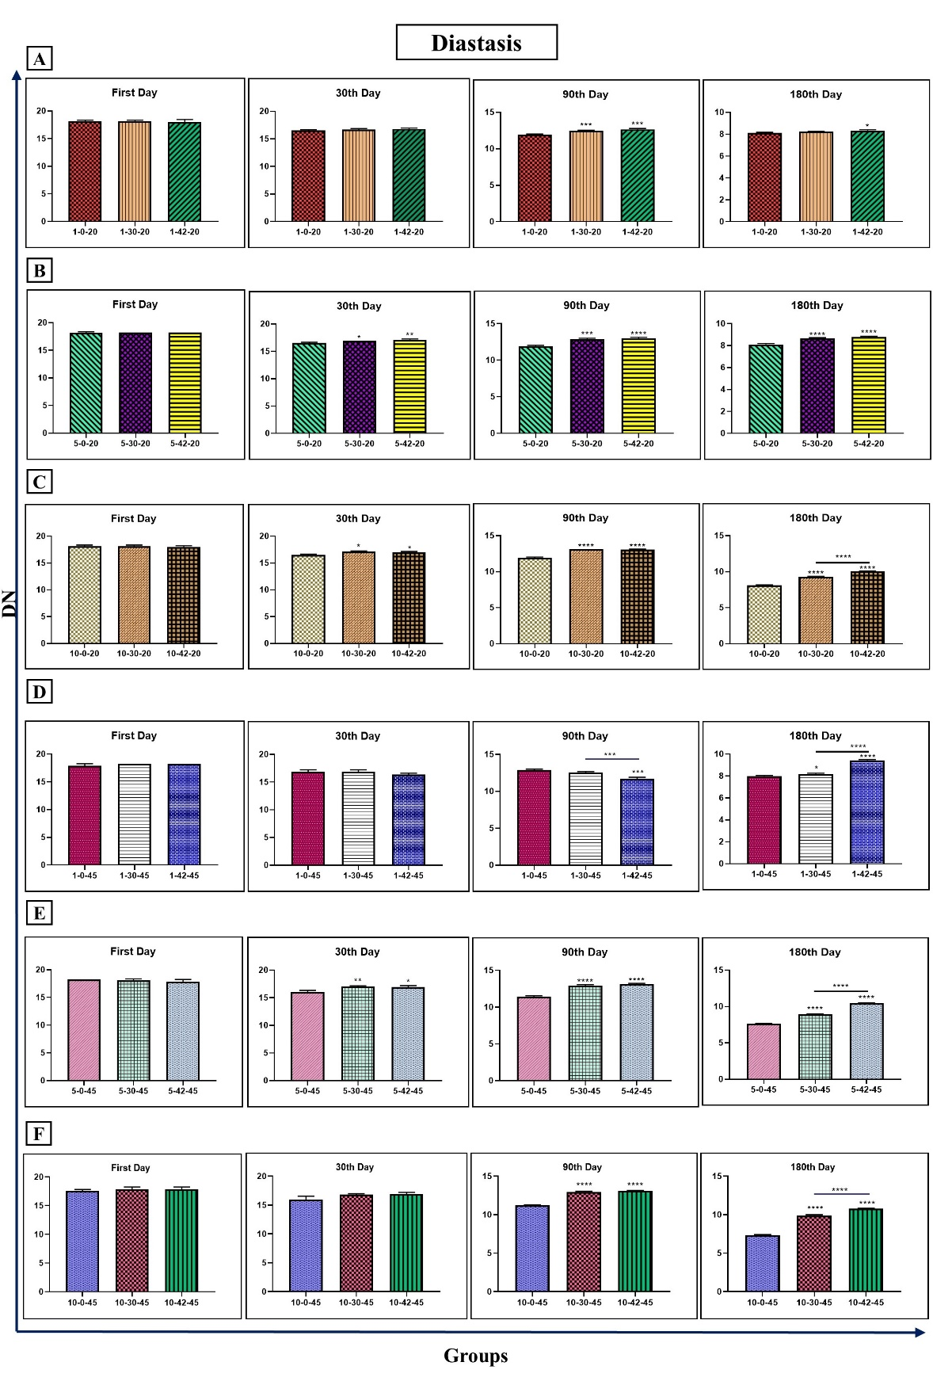
Figure SF2. Effect of 0 (as control), 30, and 42 kHz ultrasound on the industrial Iranian honey diastasis. The samples that treated at 30 kHz for 1 (A), 5 (B), 10 (C) minutes, and 20 °C. The samples that treated at 45 kHz for 1 (D), 5 (E), 10 (F) minutes, and 45 °C. Data are shown as the mean ± SD. The mean values with asterisks are significantly different (p≤ 0.05). (* P<0.05, ** P<0.01, *** P<0.001, **** P<0.0001).
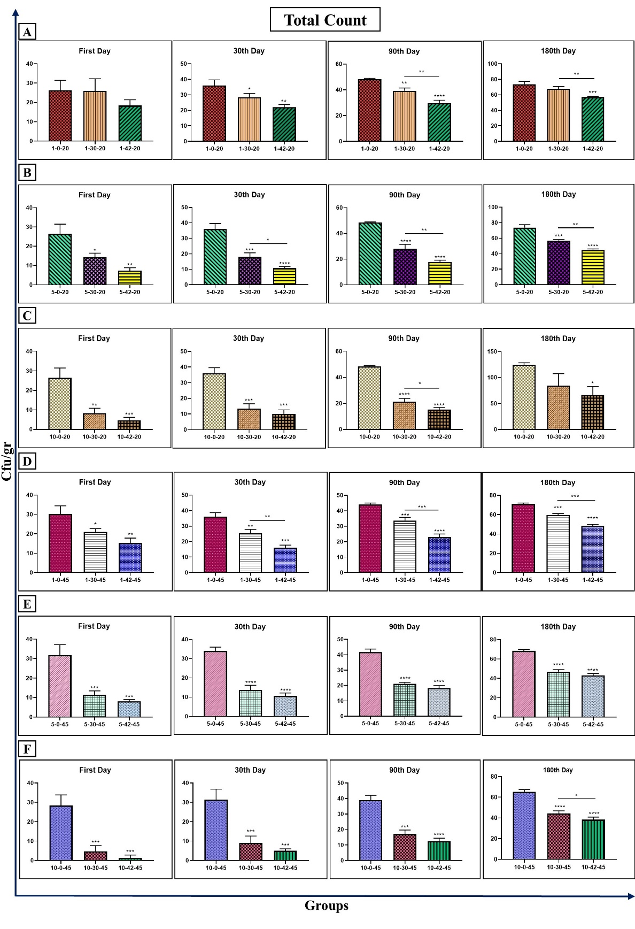
Figure SF3. Effect of 0 (as control), 30, and 42 kHz ultrasound on the industrial Iranian honey total count. The samples that treated at 30 kHz for 1 (A), 5 (B), 10 (C) minutes, and 20 °C. The samples that treated at 45 kHz for 1 (D), 5 (E), 10 (F) minutes, and 45 °C. Data are shown as the mean ± SD. The mean values with asterisks are significantly different (p≤ 0.05). (* P<0.05, ** P<0.01, *** P<0.001, **** P<0.0001).

