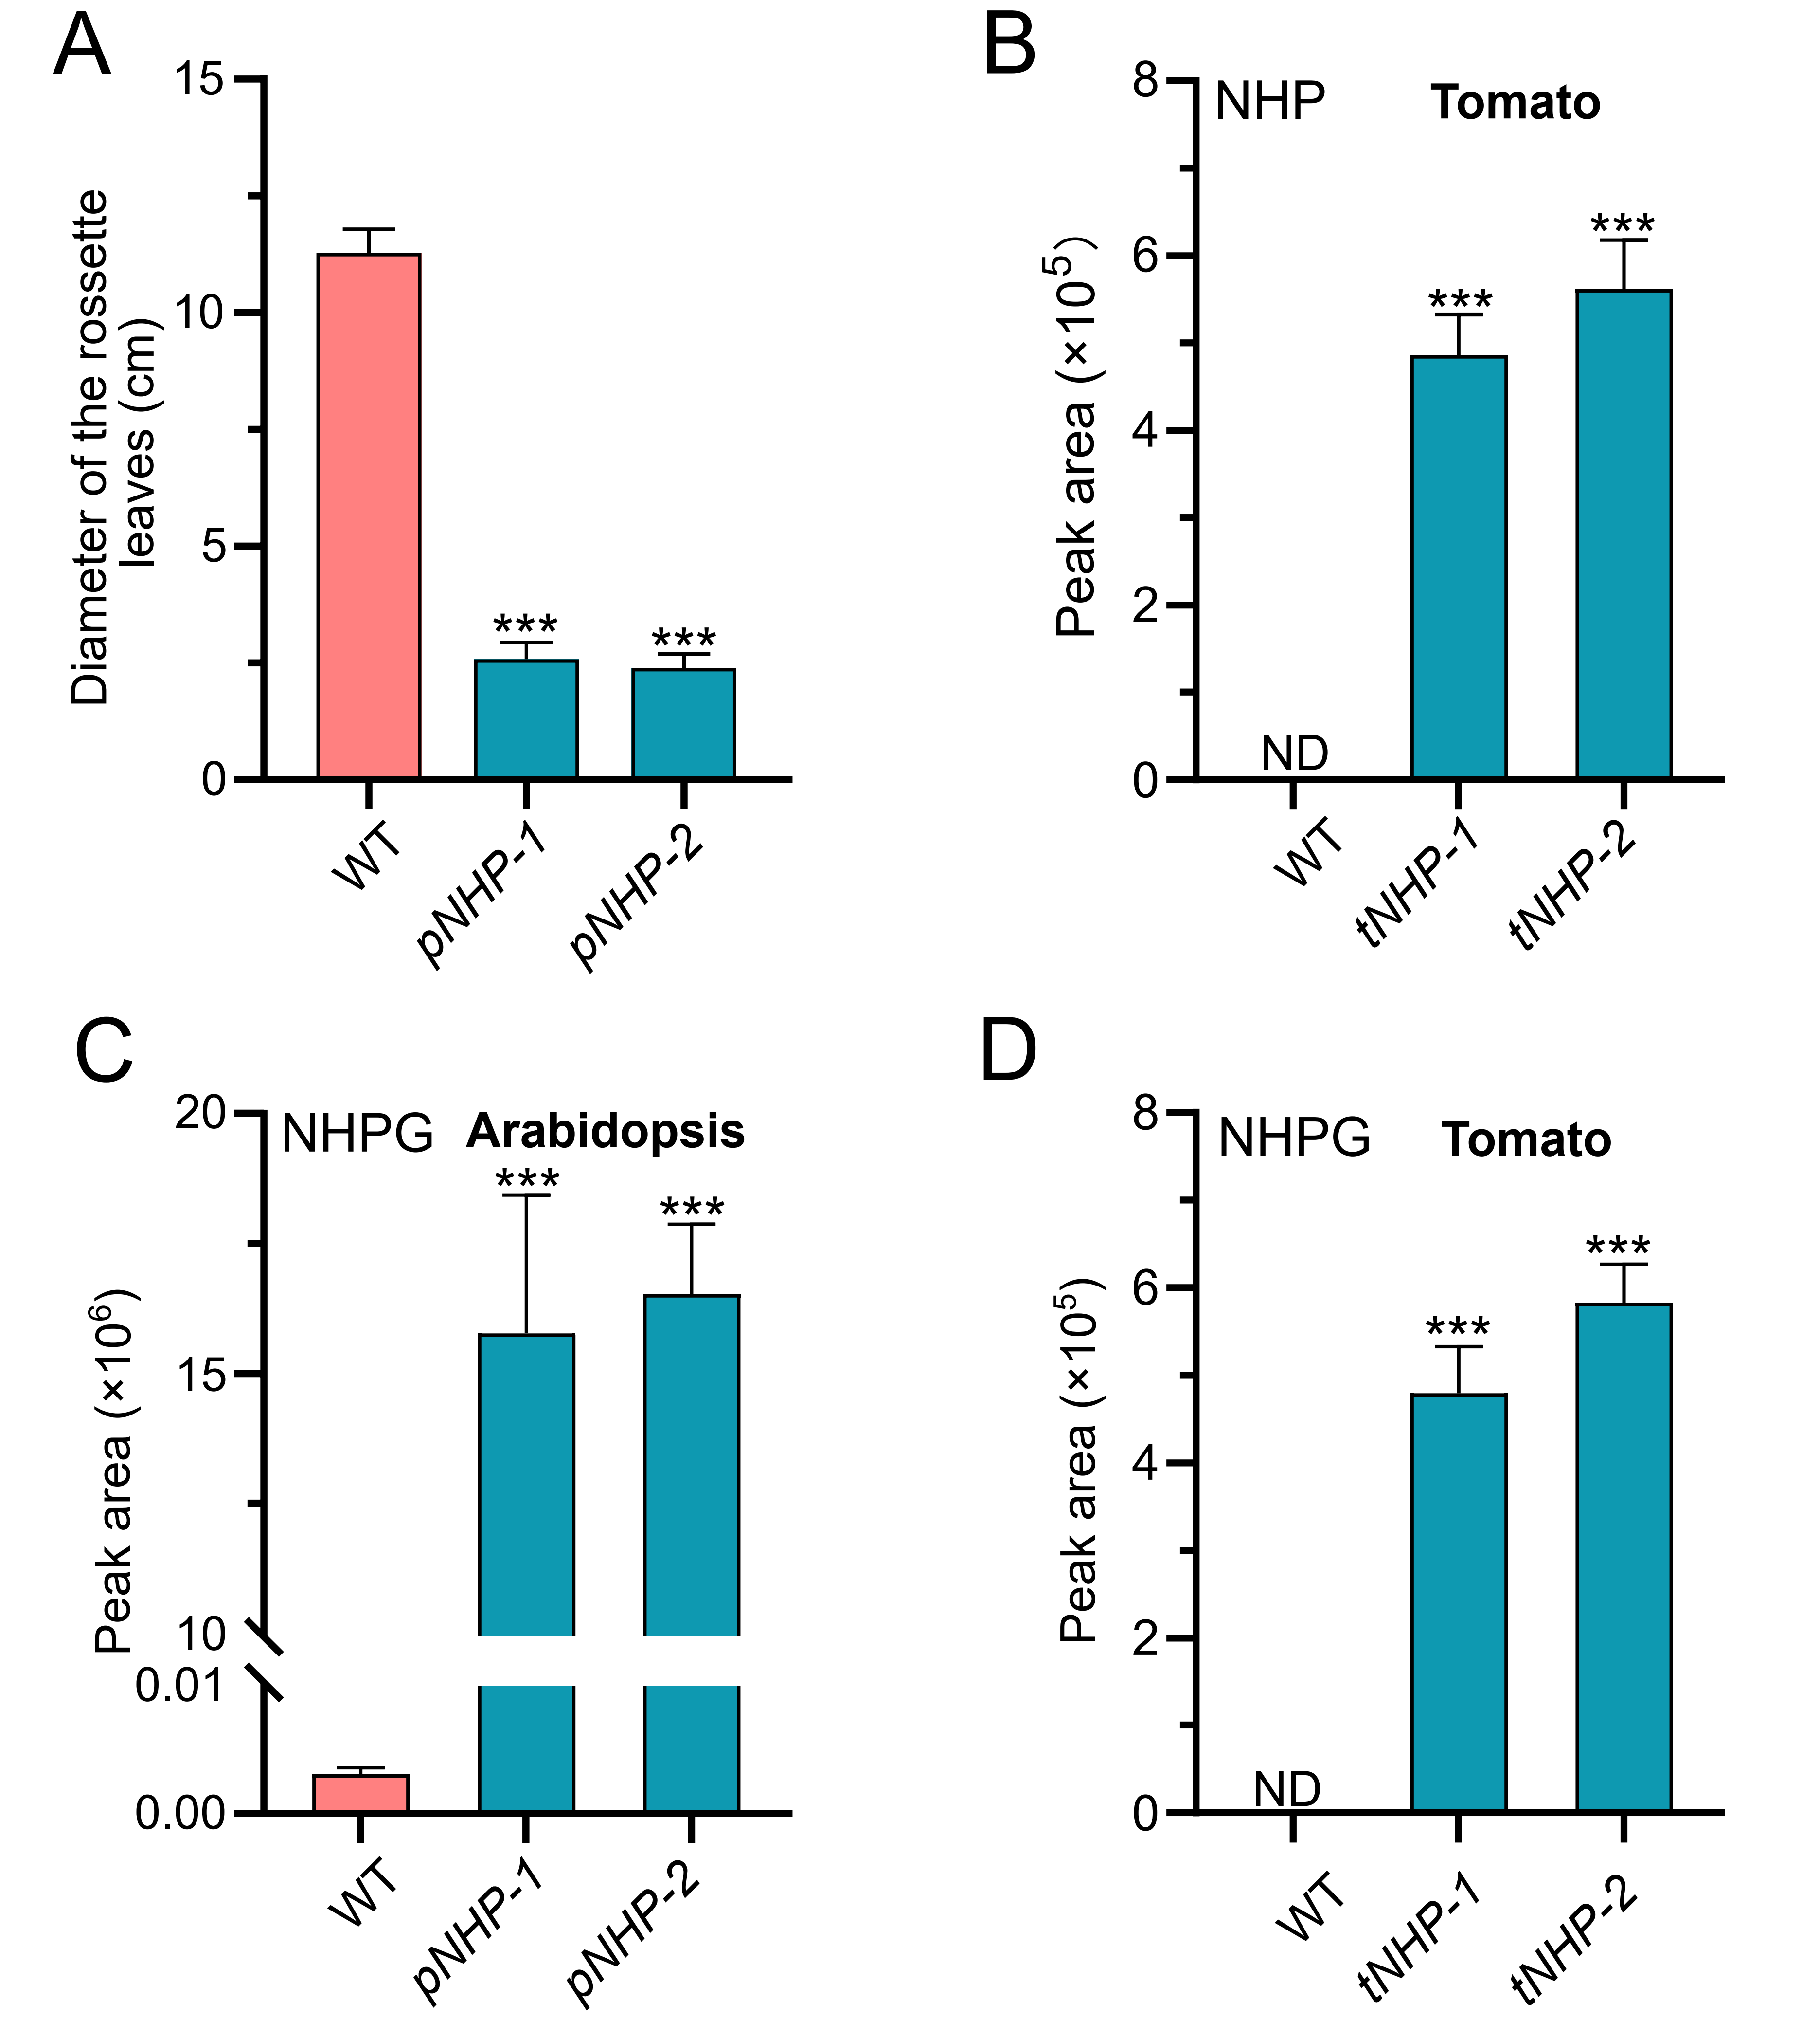
Fig. S1. Engineering the N-hydroxy pipecolic acid (NHP) biosynthetic pathway in Arabidopsis and tomato plants. (A) The diameter of wild-type (WT) and Arabidopsis pNHP plants (pNHP-1 and pNHP-2) rosette leaves. pNHP-1 and pNHP-2 are two different independent Arabidopsis lines overexpressing the NHP biosynthetic pathway genes that accumulate NHP. Data was obtained from the mean ±SD of 18 plants for each genotype. (B) Relative abundance of NHP in leaves of WT and NHP producing tomato plants (tNHP-1 and tNHP-2). tNHP-1 and tNHP-2 are two different independent tomato lines overexpressing the NHP biosynthesis pathway genes. (C) and (D) Relative abundance of N-hydroxy pipecolic glycoside (NHPG) in the leaves of WT, pNHP-1, pNHP-2, tNHP-1, and tNHP-2 plants. Leaves of WT, pNHP-1, pNHP-2, tNHP-1, and tNHP-2 plants were collected at 28 days and subjected to Xevo TQ-S micro Triple Quadrupole Mass Spectrometry analysis. Error bars represent the SDs of three independent biological replicates. ND, not detectable. Asterisks indicate significant changes compared to WT samples as calculated by a Student’s t test (*** p value < 0.001).

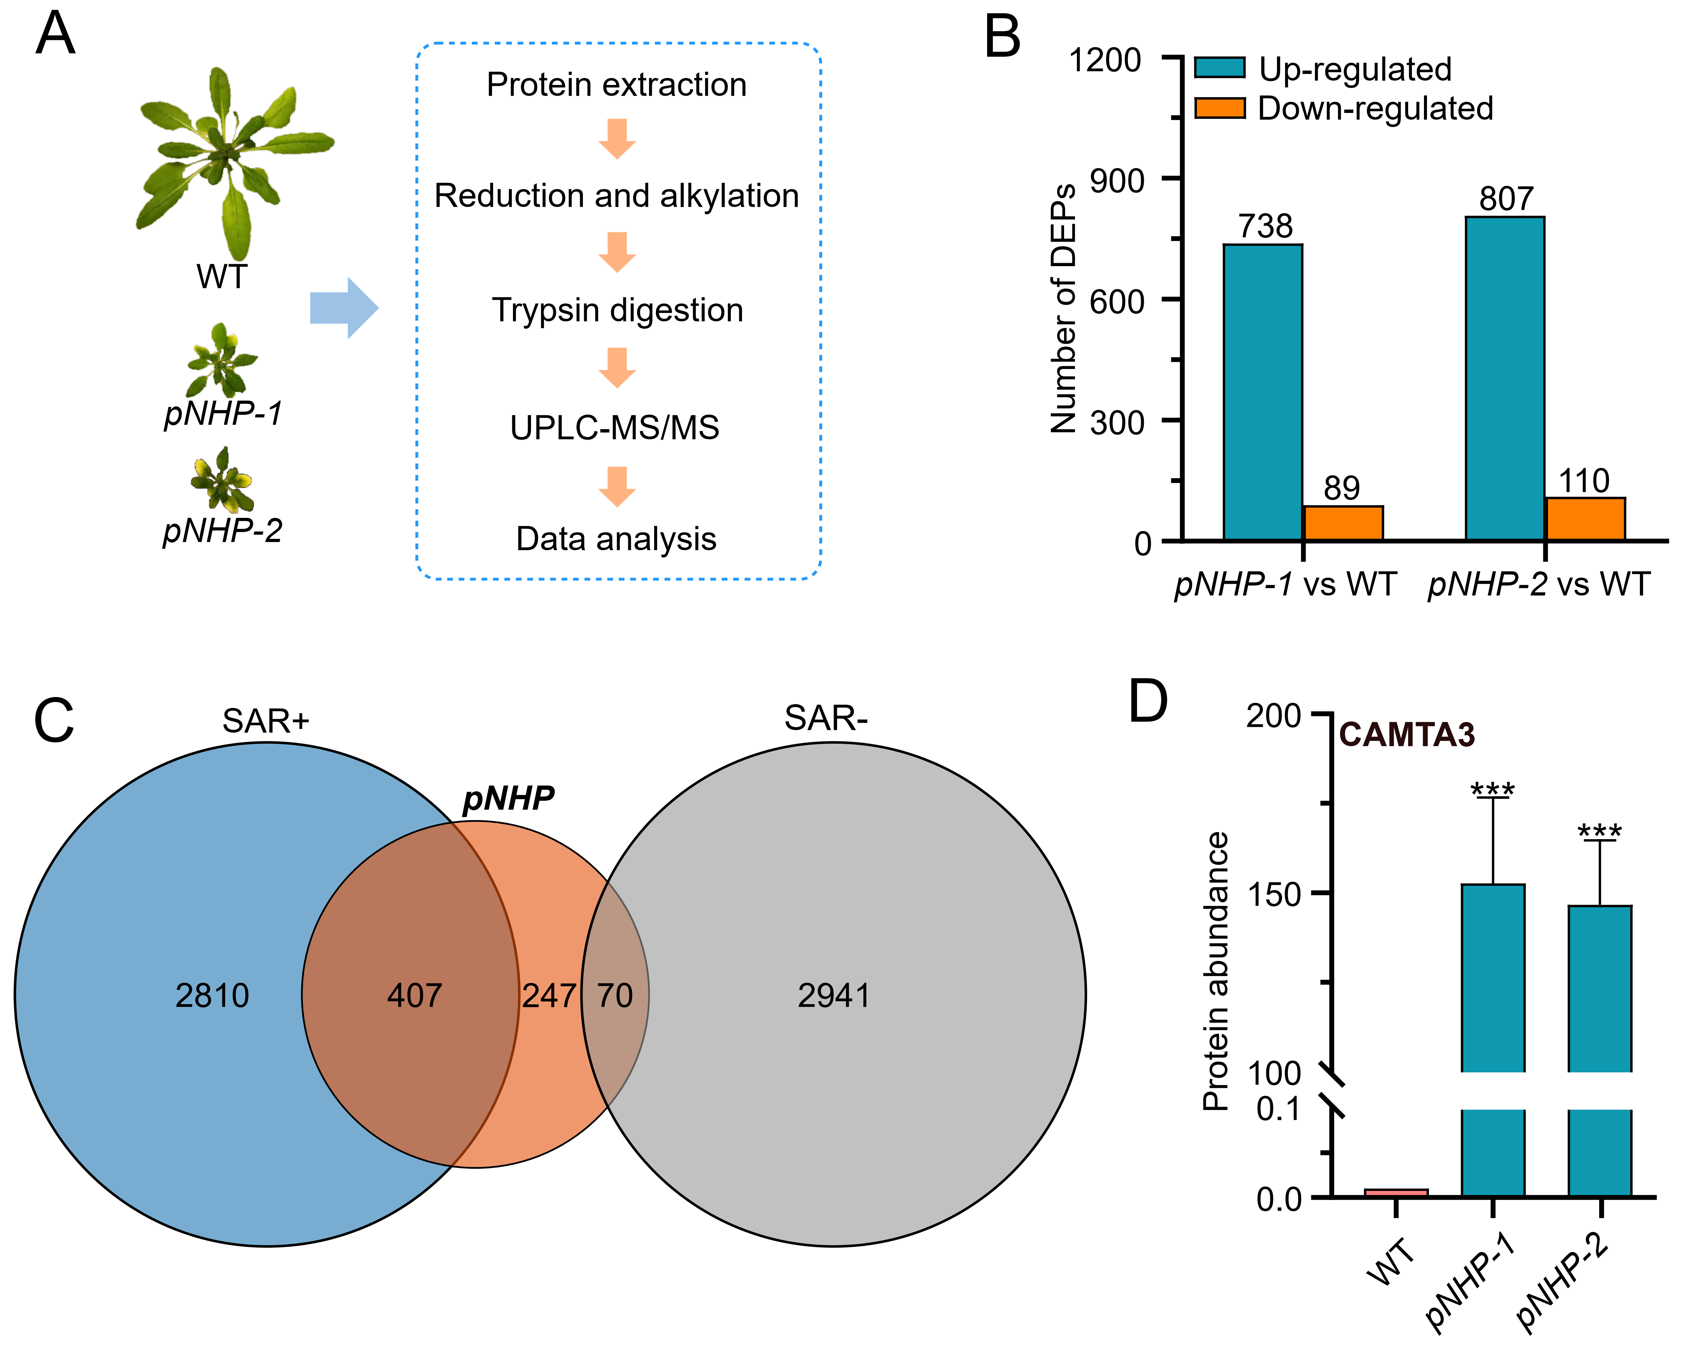
Fig. S2. Overview of proteomics data obtained from leaves of wild-type and pNHP plants. (A) Workflow of proteomics analysis perfomed in this study. Total proteins were extracted from the leaves of wild -type (WT), pNHP-1, and pNHP-2 plants at 28 days and subjected for label-free proteomics analysis. (B) Number of differentially accumulated proteins (DAP) detected in leaves of pNHP plants relative to WT ones. Blue and yellow colors indicate up- and down- regulated proteins in the pNHP leaves relative to WT (i.e. pNHP-1 vs WT and pNHP-2 vs WT). The numbers above the bar represent the amount of differentially accumulated proteins. (C) Venn diagram displaying the common and differential transcripts/proteins between the ones detected in pNHP plants here and those reported as systemic acquired resistance (SAR) response genes (30). SAR+ and SAR- indicate up-and down-regulation of genes during the SAR response, respectively. The blue, red and brown colors represent the number of SAR+ genes, differentially accumulated proteins in pNHP plants, and SAR- genes, respectively. (D) Relative abundance of CALMODULIN-BINDING TRANSCRIPTION ACTIVATOR 3 (CAMTA3) protein in the leaves of WT, pNHP-1, and pNHP-2 plants. Values showed here were the average of three biological replicates and error bars represent the SDs of three independent biological replicates. Asterisks indicate significant changes compared to WT samples as calculated by a Student’s t test (*** p value < 0.001).

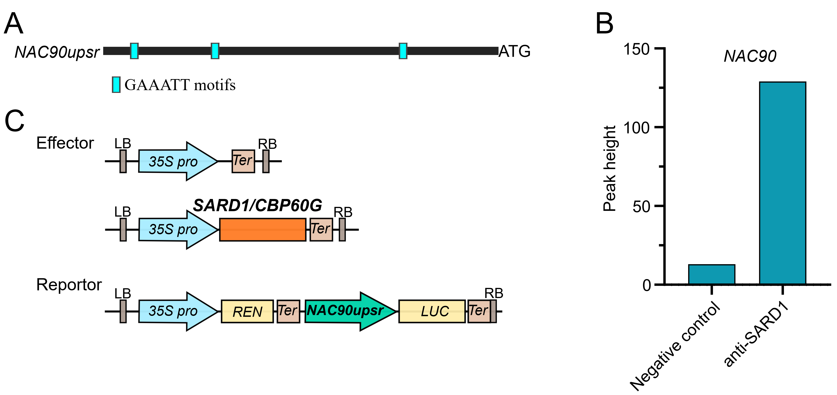
Fig. S3. NAC90 putative upstream region activity assays. (A) Scheme of NAC90 upstream region. Two thousand base pairs upstream of the ATG codon were considered as the upstream region (upsr) of NAC90. Blue bars are GAAATT motifs, which have been reported as binding sites of SARD1 or CBP60g²⁷. (B) Chromatin immunpercitation sequencing peak height of the NAC90 upstream regions enriched by the SARD1 antibody or negative control (IgG). Data was obtained from ChIP-sequencing results²⁷. (C) Effector and reporter vectors used in the dual luciferase promoter activity assays. 35S pro, 35S promoter of the cauliflower mosaic virus; Ter, Nopaline synthase terminator; REN, RENILLA LUCIFERASE; LUC, FIREFLY LUCIFERASE.
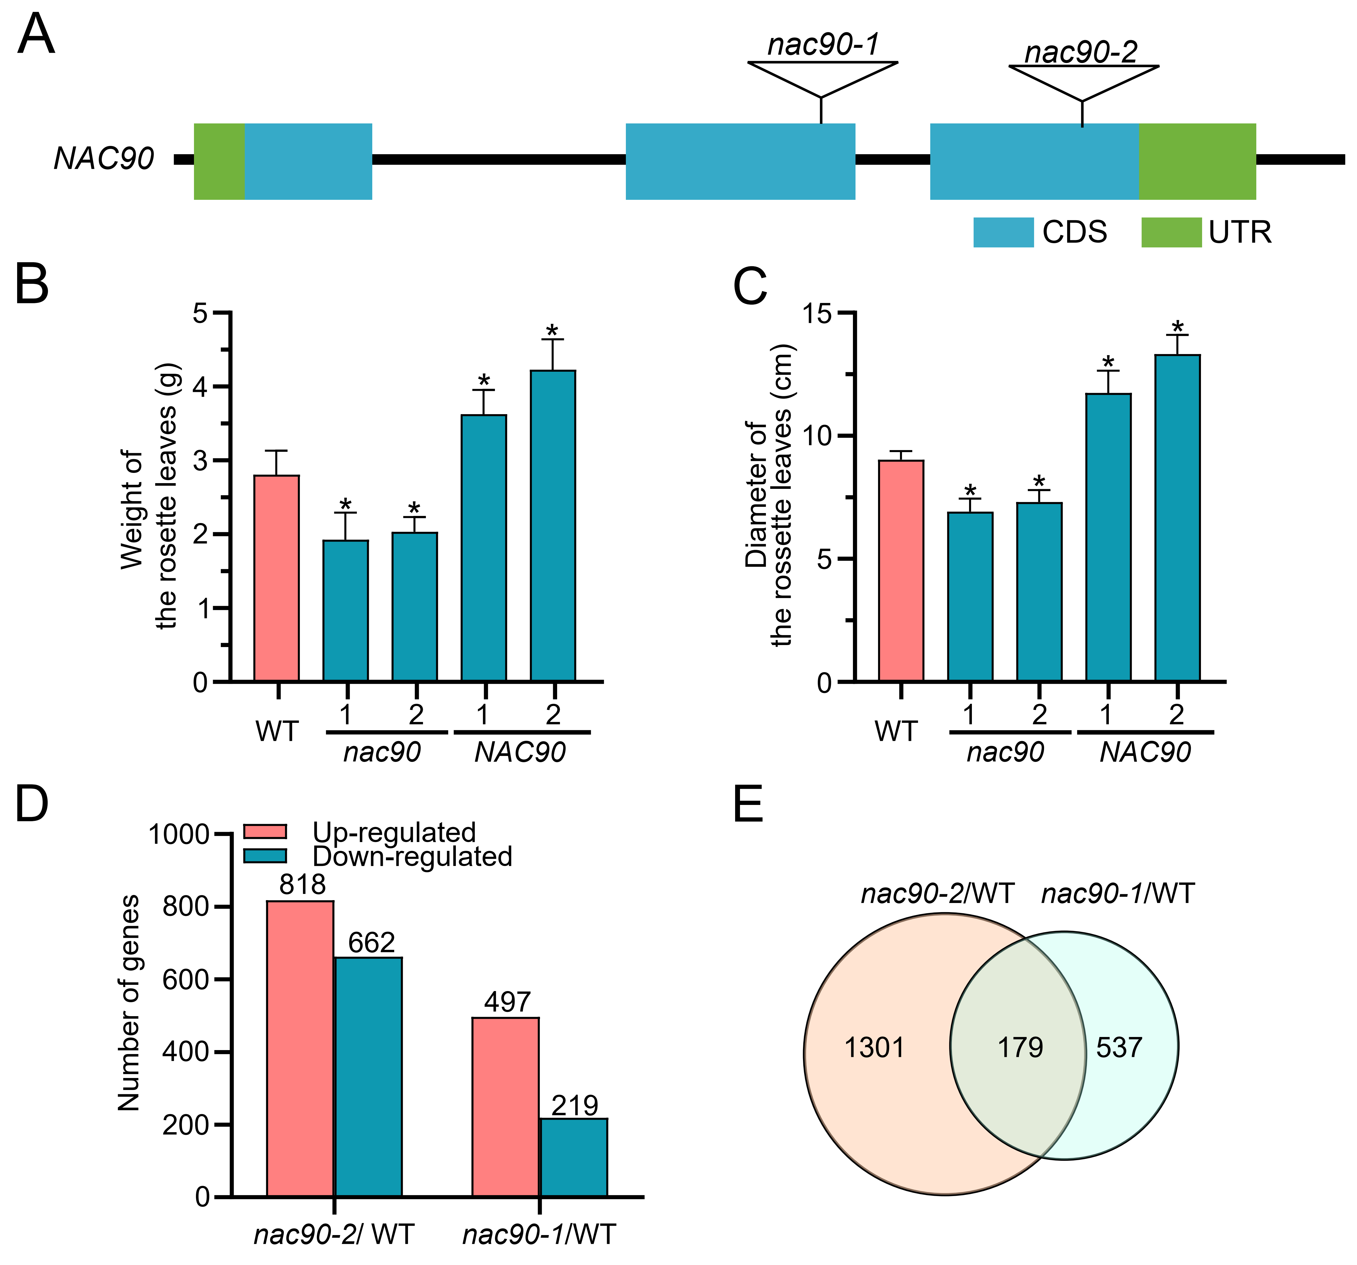Fig. S4. Phenotypic and transcriptome changes in NAC90 altered plants. (A) Scheme of the nac90 mutants (nac90-1 and nac90-2). Blue and green colors indicate the coding (CDSs) and untranslated (UTRs) regions, respectively. (B) Fresh weight of above-ground parts of WT, nac9-1, nac90-2, NAC90 overexpression (NAC90-1 and NAC90-2) plants. Data present the mean ± SD of 18 plants for each genotype. (C) The diameter of WT, nac9-1, nac90-2, NAC90 overexpression (NAC90-1 and NAC90-2) plants. Data represents the mean ± SD of 18 plants for each genotype. (D) The number of differentially expressed genes in nac90 mutants (nac90-1 and nac90-2) relative to WT (nac90-2/WT and nac90-1/WT). The red and blue colors represent up- and down- regulated genes in nac90 mutants relative to the WT. The numbers above the bar are the differentially expressed genes identified in transcriptome of nac90 mutants. (E) The overlapped differentially expressed genes (DEGs) in both nac90 mutants relative to WT. The pink and blue circles represent the number of differentially expressed genes in nac90-2/WT and nac90-1/WT, respectively. Asterisks indicate significant changes compared to WT samples as calculated by Student’s t test (*p value < 0.05).

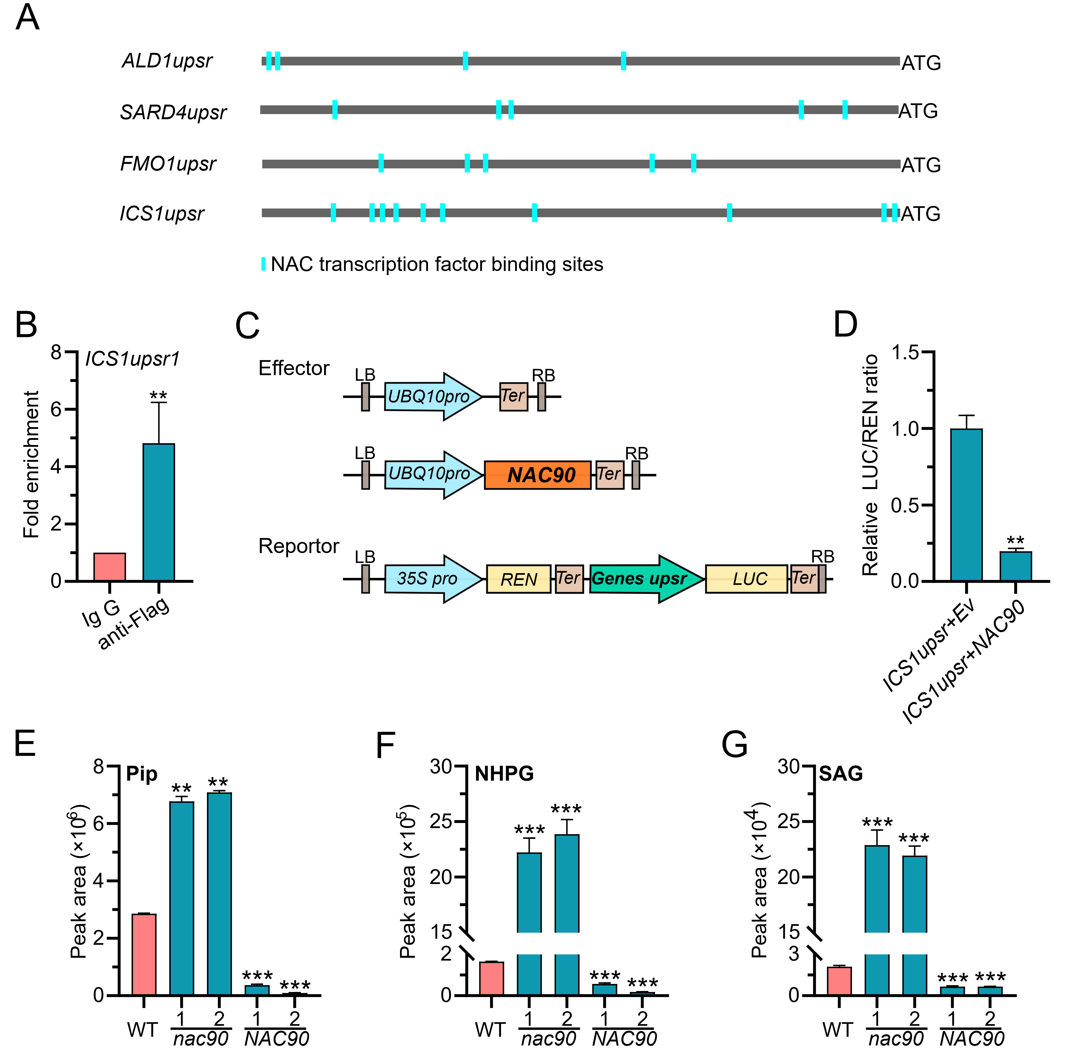
Fig. S5. NAC90 negatively regulates NHP and SA related gene expression and metabolites level. (A) A scheme representing the ALD1, SARD4, FMO1, and ICS1 upstream region. Roughly two thousand base pairs upstream of the ATG codon were extracted and considered as the upstream region (upsr) of target genes. Blue bars indicate NAC transcription factor binding motifs. (B) The effector and reporter vectors used in the dual luciferase promoter activity assay for NAC90. (C) Chromatin immunpercitation-qPCR assay indicates that NAC90 directly binds to the putative promoter of the ICS1 gene. (D) Dual luciferase promoter activity assays showed that NAC90 represses expression driven by the ICS1 gene promoter region. (E-G) Relative abundance of Pip (E), NHPG (F), and SAG (G) in leaves of 4-week-old wild-type (WT), nac90-1, nac90-2, and NAC90 overexpression (NAC90-1 and NAC90-2) plants. Leaves of WT, nac90-1, nac90-2, and NAC90 overexpression (NAC90-1 and NAC90-2) plants were collected at 28 days and subjected to Xevo TQ-S micro Triple Quadrupole Mass Spectrometry analysis. Values showed here represent average of three biological replicates and error bars represent the SDs of three biological replicates. Asterisks indicate significant changes compared to WT samples as calculated by a Student’s t test (** p value < 0.01; *** p value < 0.001).
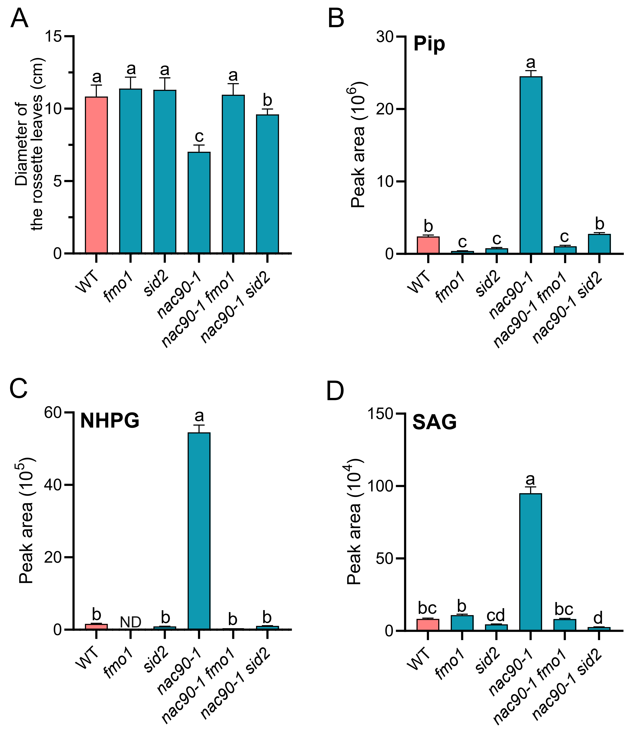
Fig. S6. FMO1 is required for constitutive activation of defense response in the nac90 mutant background (A) The diameter of wild-type (WT), fmo1, nac90-1, nac90-1 fmo1, and nac90-1 sid2 rosette leaves. Data represents the mean ±SD of 18 plants for each genotype. (B-D) Abundance of Pip (B), NHPG (C), and SAG (D) in the leaves of 4-week-old wild-type (WT), fmo1, nac90-1, nac90-1 fmo1, and nac90-1 sid2 plants. Leaves of WT, fmo1, nac90-1, nac90-1 fmo1, and nac90-1 sid2 plants were collected at 28 days and subjected to Xevo TQ-S micro Triple Quadrupole Mass Spectrometry analysis. Values showed here are the average of three biological replicates and error bars represent the SDs of three biological replicates. Different letters above the bars denote significant differences among treatments (p < 0.05, ANOVA).

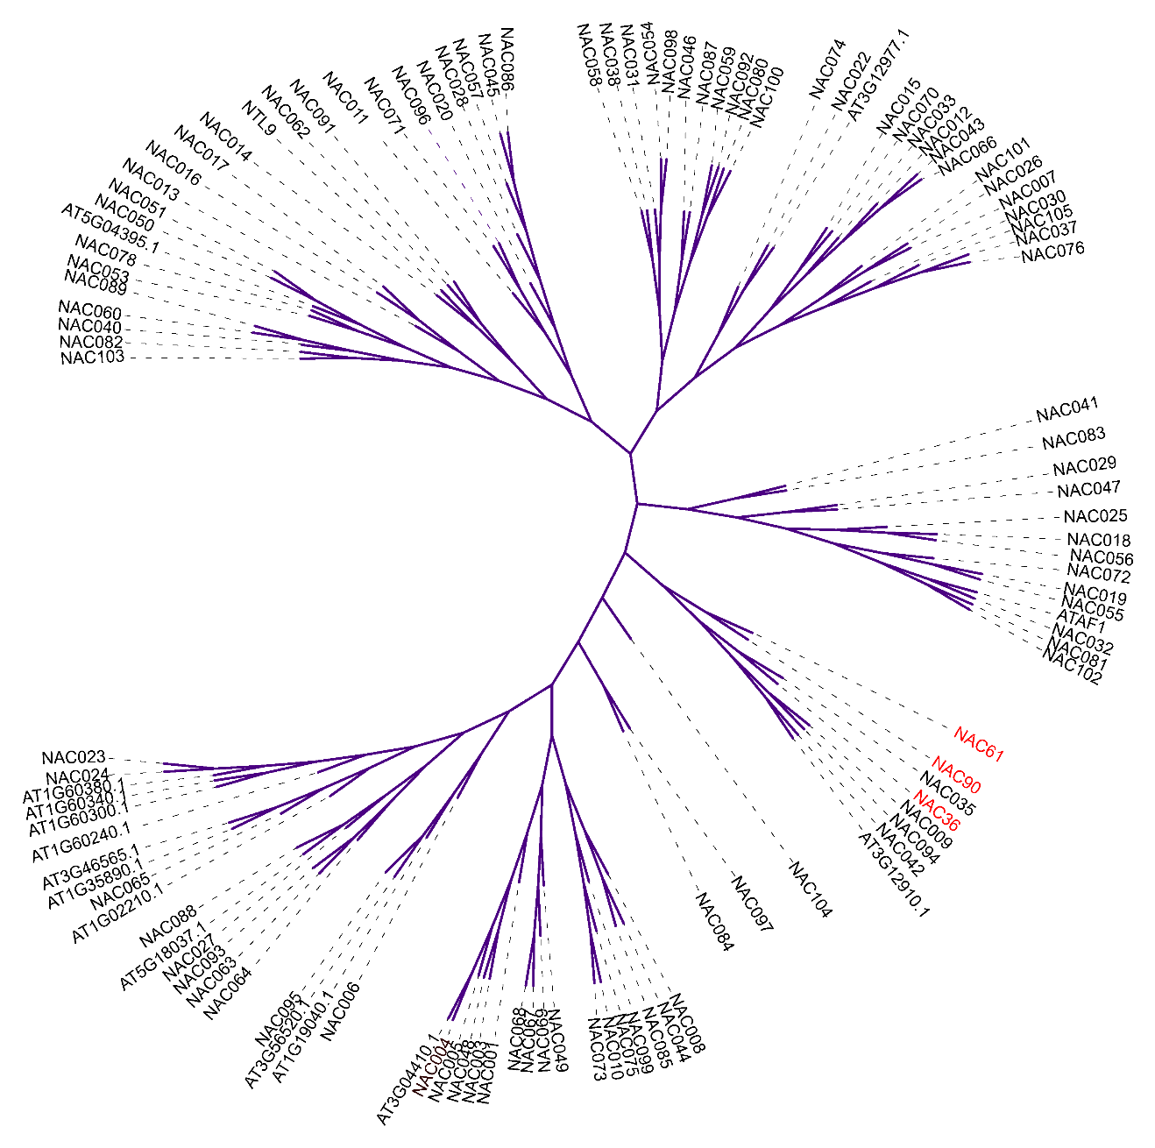
Fig. S7. Phylogenetic tree of NAC transcription factors in Arabidopsis. All the NAC transcription factors protein sequences were obtained from TAIR and used to construct the phylogenetic tree using MEGA version X (https://www.arabidopsis.org/).
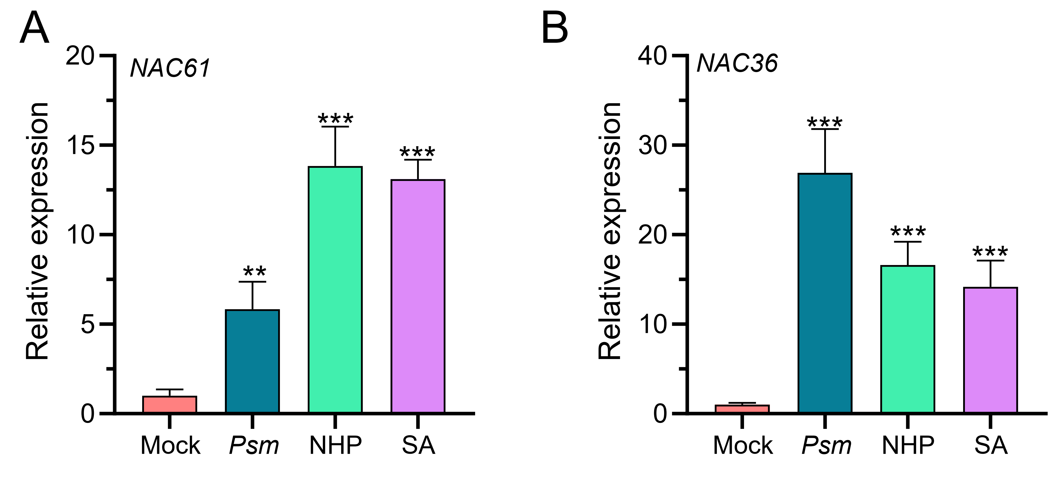
Fig. S8. NAC16 and NAC36 are induced by Psm ES4326, SA and NHP. Transcript levels of NAC61 (A) and NAC36 (B) in response to Psm ES4326, SA and NHP treatments. Transcript levels of NAC61 and NAC36 in WT Arabidopsis plants in response to Psm ES4326, NHP, and SA treatments. Leaves of 4-week-old WT Arabidopsis plants were treated with 10 mM MgCl₂ (Mock), Psm ES4326 (OD₆₀₀ = 0.001) (Psm), 1 mM NHP (NHP), and 200 μM SA (SA) solution, harvested at 24 hours post treatments, and subjected for qRT-PCR analysis. All the values showed here were the average of three biological replicates and error bars represent the SDs of three biological replicates. Asterisks indicate significant changes compared to WT or Mock samples as calculated by a Student’s t test (*p value < 0.05; **p value < 0.01; ***p value < 0.001).

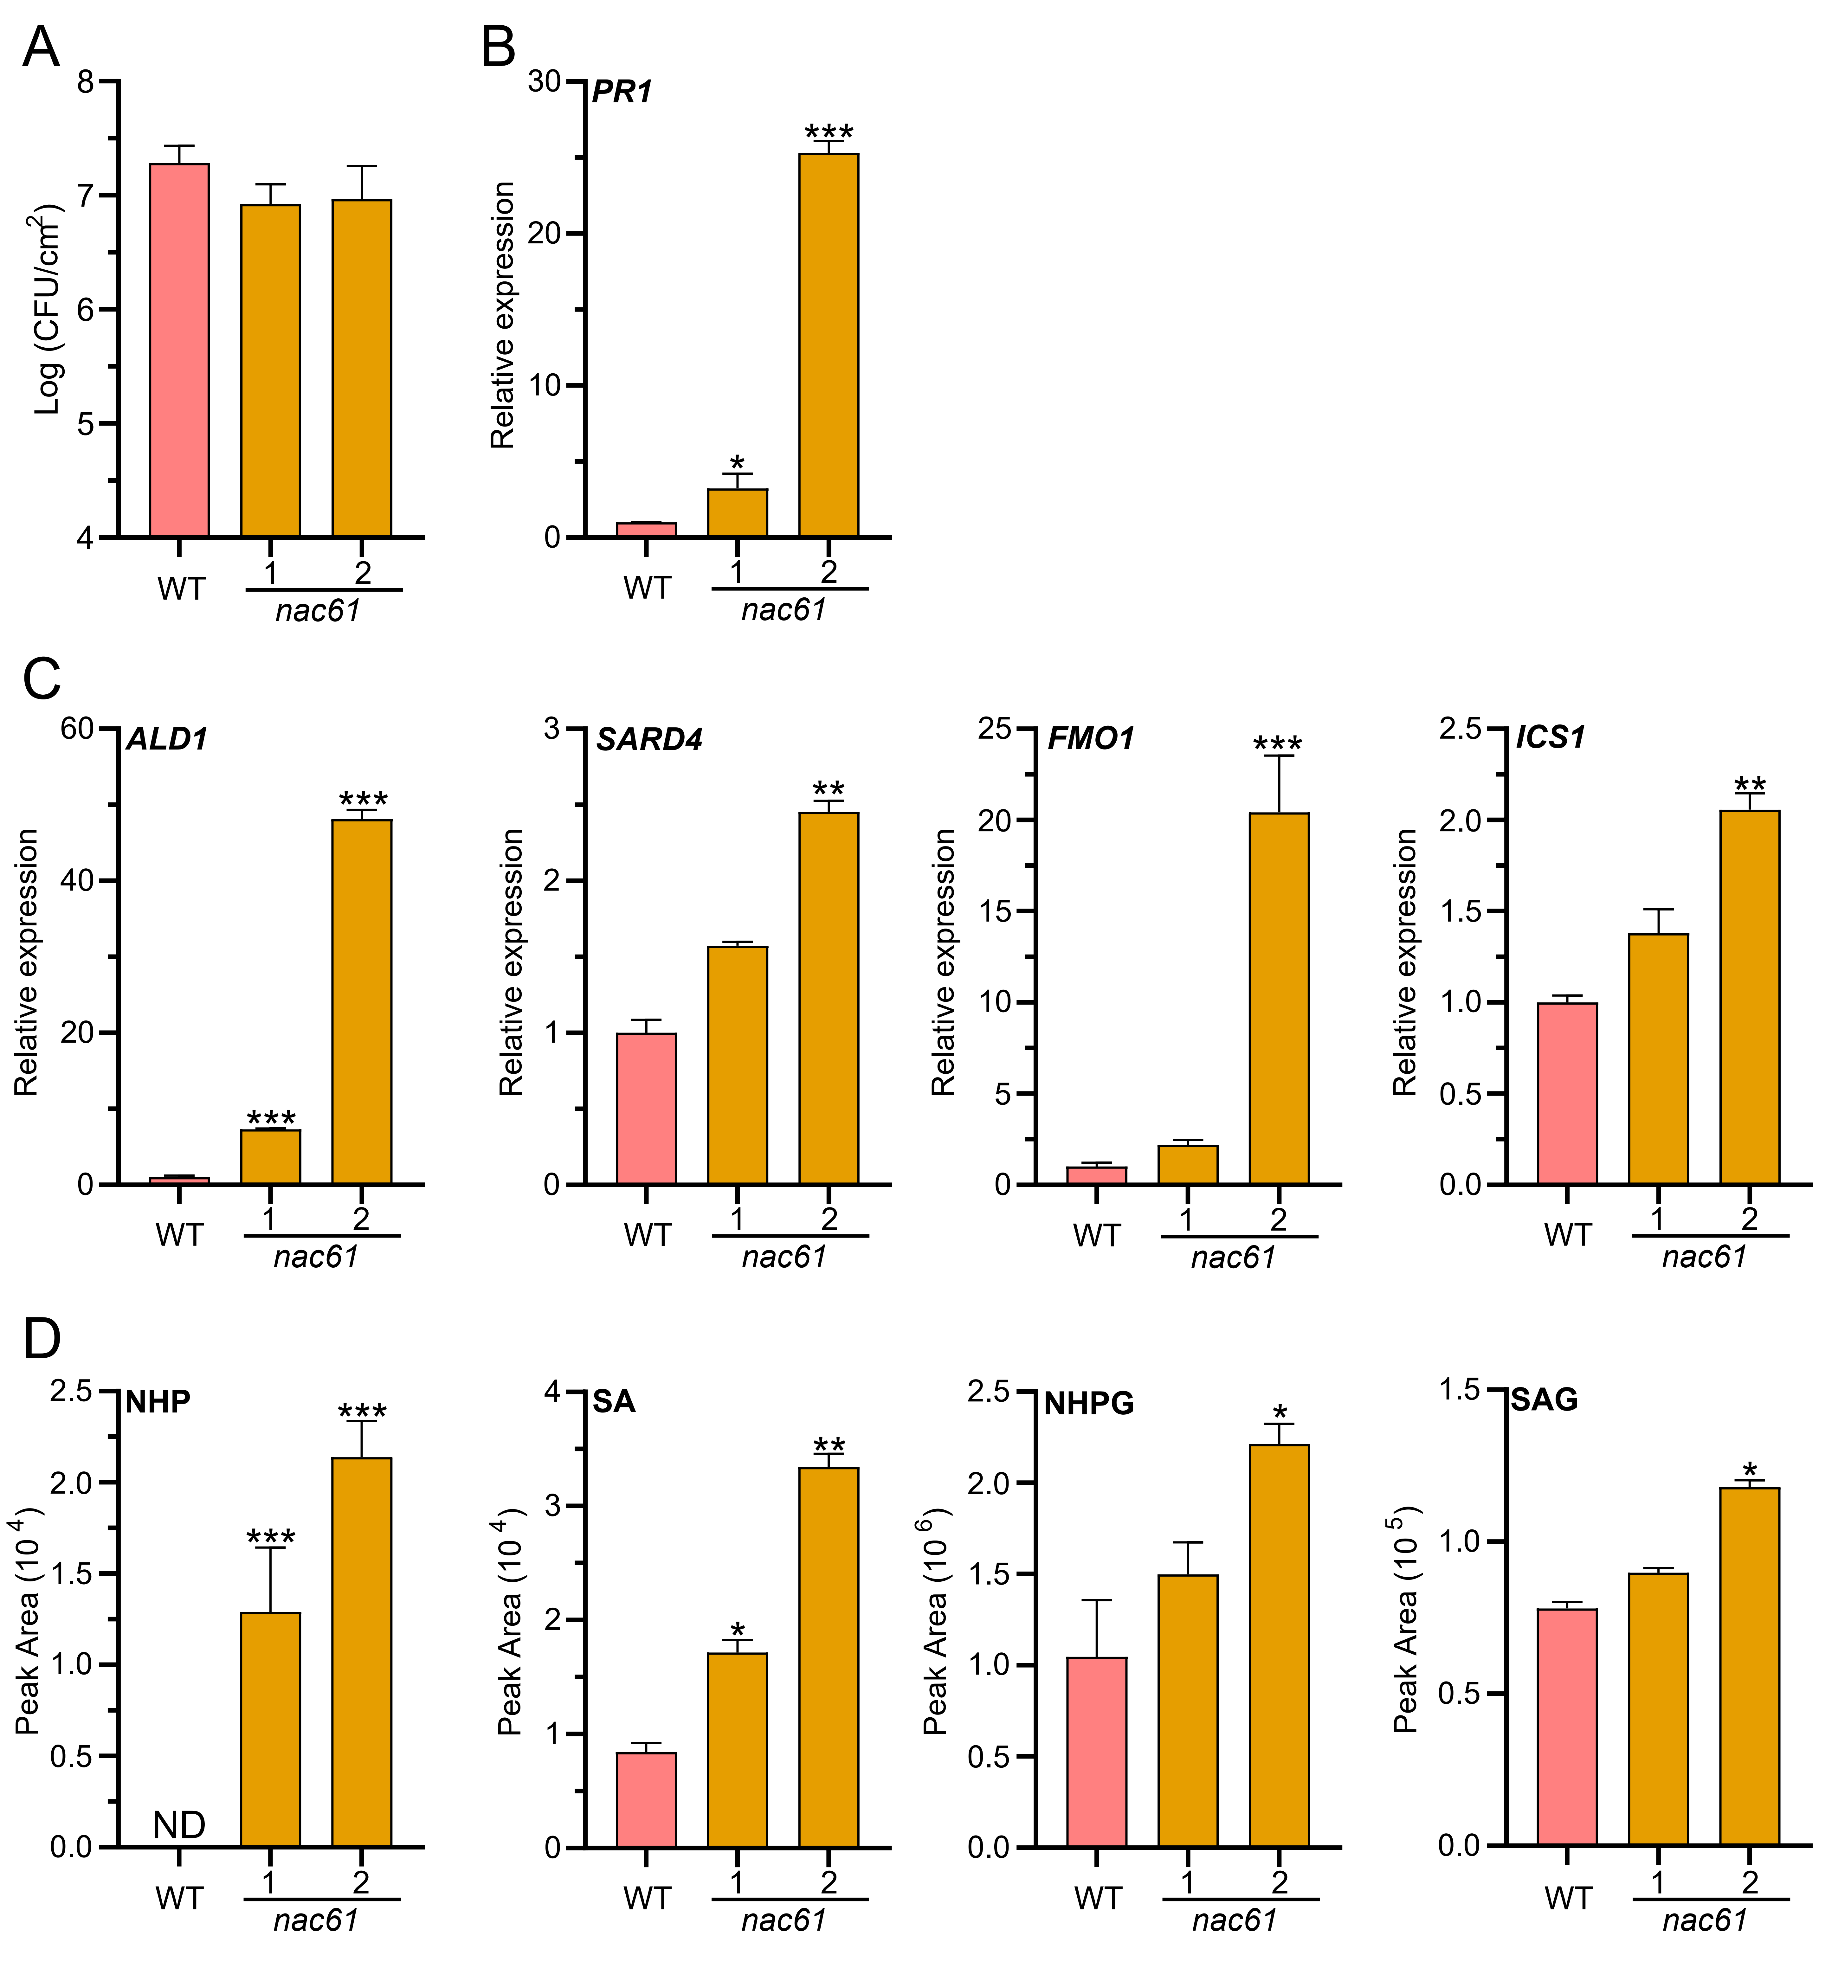
Fig. S9. The abundance of defense-related transcripts and metabolites in nac61 mutants. (A) Growth of Psm ES4326 on leaves of 4-week-old WT and nac61 mutants. (B) and (C) Transcript levels of PR1, ALD1, SARD4, FMO1, and ICS1 in leaves of 4-week-old WT and nac61 plants. (D) Abundance of NHP, SA, NHPG, and SAG in the leaves of WT and nac61 plants. Leaves of WT, nac61-1, and nac61-2 mutants were harvested at 28 days and subjected to transcript levels analysis by RT-PCR and metabolites abundance analysis by Xevo TQ-S micro Triple Quadrupole Mass Spectrometry. Values showed here were the average of three biological replicates and error bars represent the SDs of three independent biological replicates. Asterisks indicate significant changes compared to WT or control samples as calculated by a Student’s t test (*p value < 0.05; **p value < 0.01; ***p value < 0.001).

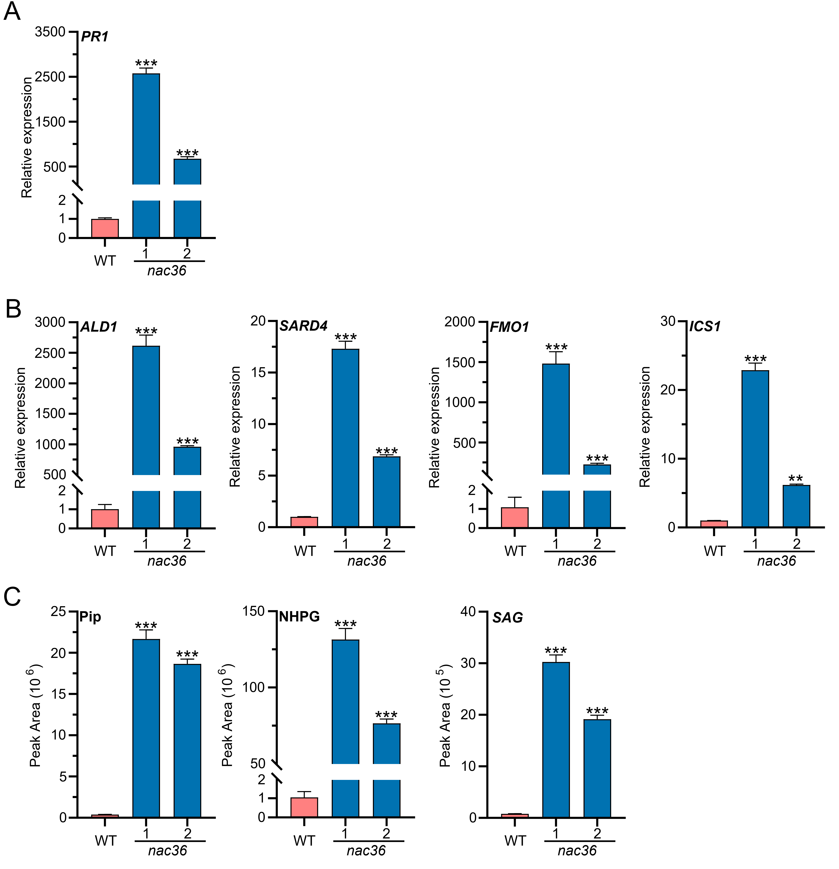
Fig. S10. The abundance of defense-related transcripts and metabolites in the nac36 mutants. (A) and (B) Transcript levels of PR1, ALD1, SARD4, FMO1, and ICS1 in leaves of 4-week-old WT and nac36 plants. (C) Abundance of Pip, NHPG, and SAG in the leaves of WT and nac36 plants. Leaves of WT, nac36-1, and nac36-2 mutants were harvested at 28 days and subjected to transcript levels analysis by RT-PCR and metabolites abundance analysis by Xevo TQ-S micro Triple Quadrupole Mass Spectrometry. Values represent average of three biological replicates and error bars the SDs of three independent biological replicates. Asterisks indicate significant changes compared to WT or control samples as calculated by a Student’s t test (*p value < 0.05; **p value < 0.01; ***p value < 0.001).

